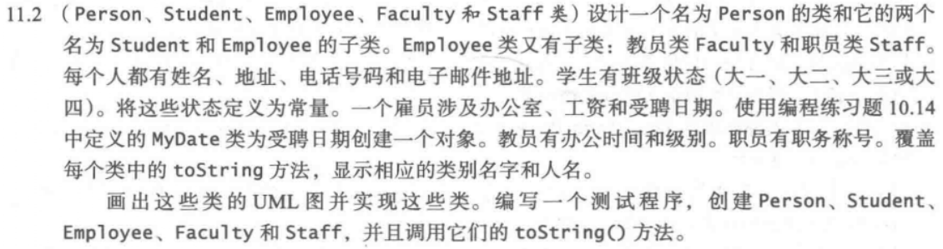

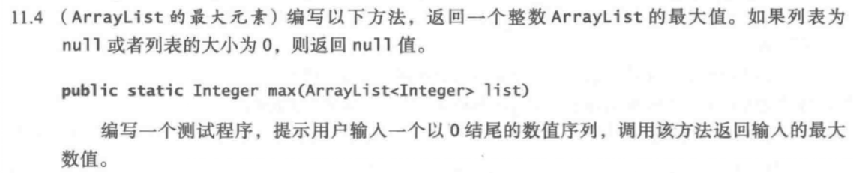

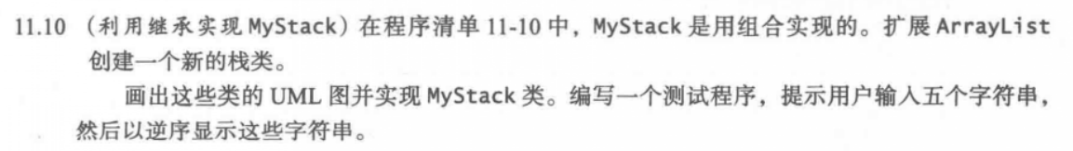

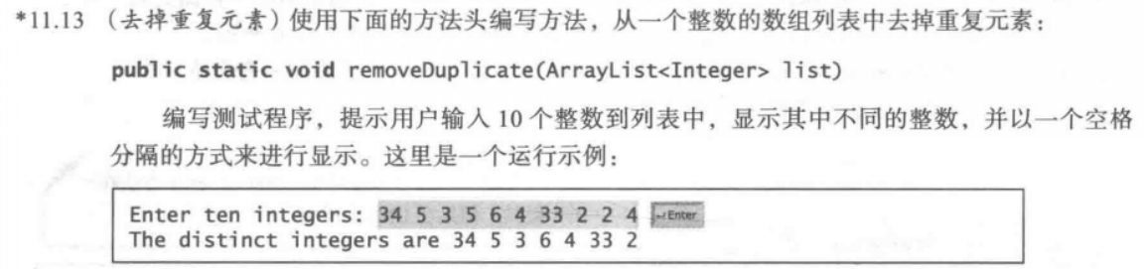

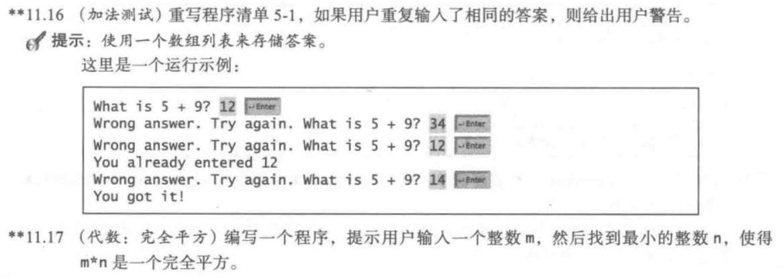

11.2

UML图：

|  |
| --- |
| Person |
| -name:String  -address:String  -number:String  -email:String |
| +Person()  +Person(a:String,b:String,c:String,d:String)  +toString():String |

|  |
| --- |
| Student |
| -grade:int |
| +Student()  +Student(a:int)  +toString():String |

|  |
| --- |
| Employee |
| -office:String  -wage:double  -day:java.util.Date |
| +Employee()  +Employee(a:String,b:double,c:java.util.Date)  +toString():String |

|  |
| --- |
| Faculty |
| -time:int  -rank:String |
| +Faculty()  +Faculty(a:int,b:String)  +toString():String |

|  |
| --- |
| Staff |
| -position:String |
| +Staff()  +Staff(a:String)  +toString():String |

代码：

**import** java.util.Date;

**public** **class** one {

**public** **static** **void** main(String[] args)

{

Person person=**new** Person("zhang","小区","0535","qq.com");

System.***out***.println(person.toString());

Student student=**new** Student(2);

System.***out***.println(student.toString());

Employee employee=**new** Employee("济南",3000,**new** Date(System.*currentTimeMillis*()));

System.***out***.println(employee.toString());

Faculty faculty=**new** Faculty(10,"干部");

System.***out***.println(faculty.toString());

Staff staff=**new** Staff("学生");

System.***out***.println(staff.toString());

}

}

**class** Person{

**private** String name;

**private** String address;

**private** String number;

**private** String email;

**public** Person()

{

}

**public** Person(String a,String b,String c,String d)

{

name=a;

address=b;

number=c;

email=d;

}

**public** String toString()

{

**return** "name:"+name+",address:"+address+",number:"+number+",email:"+email;

}

}

**class** Student **extends** Person{

**private** **int** grade;

**private** **final** **int** Fresh=1;

**private** **final** **int** Sophomore=2;

**private** **final** **int** Junior=3;

**private** **final** **int** Senior=4;

**public** Student()

{

}

**public** Student(**int** a)

{

**if**(a==1)grade=Fresh;

**else** **if**(a==2)grade=Sophomore;

**else** **if**(a==3)grade=Junior;

**else** grade=Senior;

}

**public** String toString()

{

**return** "grade:"+grade;

}

}

**class** Employee **extends** Person{

**private** String office;

**private** **double** wage;

**private** Date day;

**public** Employee()

{

}

**public** Employee(String a,**double** b,Date c)

{

office=a;

wage=b;

day=c;

}

**public** String toString()

{

**return** "office:"+office+",wage:"+wage+",day:"+day;

}

}

**class** Faculty **extends** Employee{

**private** **int** time;

**private** String rank;

**public** Faculty()

{

}

**public** Faculty(**int** a,String b)

{

time=a;

rank=b;

}

**public** String toString()

{

**return** "time:"+time+",rank:"+rank;

}

}

**class** Staff **extends** Employee{

**private** String position;

**public** Staff()

{

}

**public** Staff(String a)

{

position=a;

}

**public** String toString()

{

**return** "position:"+position;

}

}

截图：

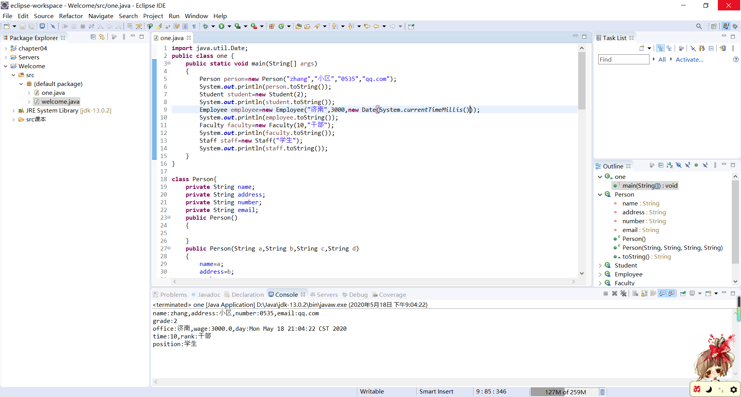

11.4

代码：

**import** java.util.ArrayList;

**import** java.util.Scanner;

**public** **class** two {

**public** **static** **void** main(String[] args)

{

ArrayList<Integer> list=**new** ArrayList<>();

Scanner input=**new** Scanner(System.***in***);

System.***out***.println("Enter the number:");

**int** n =input.nextInt();

**for**(**int** i=1;i<=n;i++)

{

list.add(i);

}

**for**(**int** i=0;i<n;i++)

{

System.***out***.print(list.get(i)+" ");

}

System.***out***.println("\nThe max is "+*max*(list));

}

**public** **static** Integer max(ArrayList<Integer> list)

{

**if**(list.isEmpty()||list.size()==0)

{

**return** 0;

}

Integer max=list.get(0);

**for**(**int** i=0;i<list.size();i++)

{

**if**(max<list.get(i))

max=list.get(i);

}

**return** max;

}

}

截图：

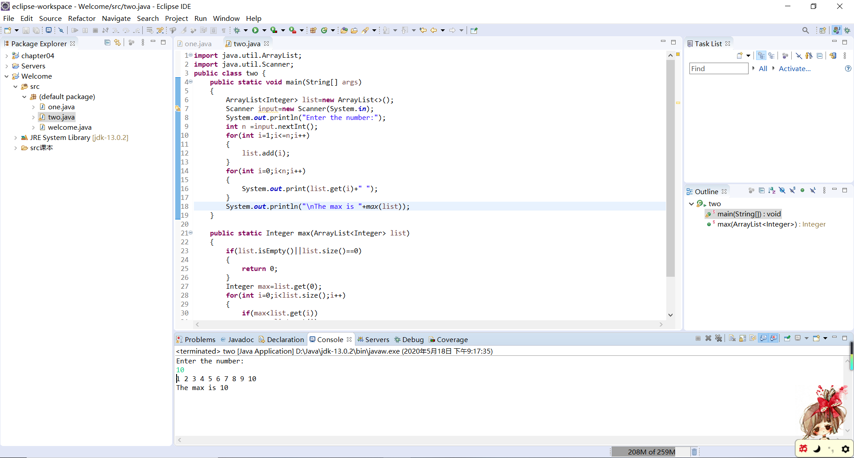

11.10

UML图：

|  |
| --- |
| Mystack |
|  |
| +getSize():int  +peek():Object  +pop():Object  +push(o:Object):void  +toString():String |

代码：

**import** java.util.ArrayList;

**import** java.util.Scanner;

**public** **class** three {

**public** **static** **void** main(String[] args)

{

System.***out***.println("Enter five string:");

Scanner input=**new** Scanner(System.***in***);

Mystack stack=**new** Mystack();

**for**(**int** i=0;i<5;i++)

{

String x=input.next();

stack.push(x);

}

**for**(**int** i=4;i>=0;i++)

{

**if**(!stack.isEmpty())

System.***out***.print(stack.pop().toString()+",");

}

}

}

**class** Mystack **extends** ArrayList<Object> {

/*public boolean isEmpty() {

return isEmpty();

}*/

**public** **int** getSize() {

**return** size();

}

**public** Object peek() {

**return** get(getSize() - 1);

}

**public** Object pop() {

Object o = get(getSize() - 1);

remove(getSize() - 1);

**return** o;

}

**public** **void** push(Object o) {

add(o);

}

@Override

/** Override the toString in the Object class */

**public** String toString() {

**return** "stack: " + toString();

}

}

截图：

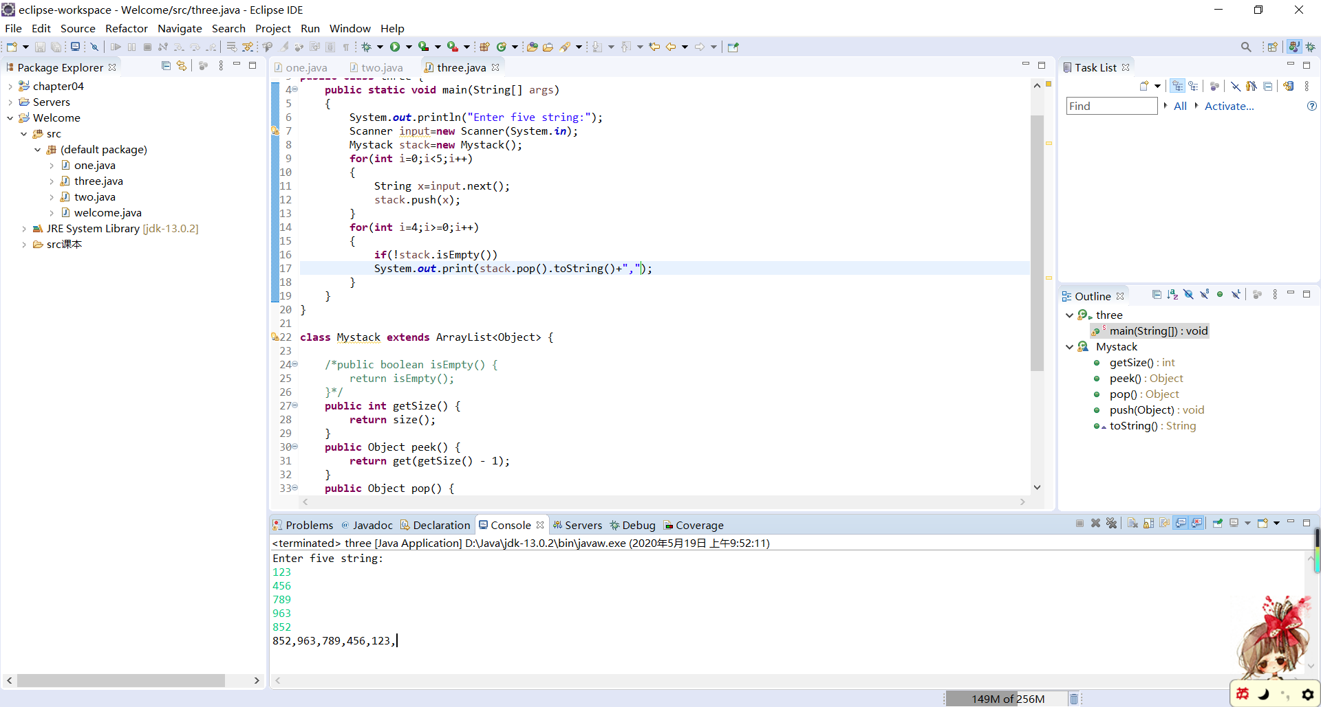

11.13

代码：

**import** java.util.ArrayList;

**import** java.util.Scanner;

**public** **class** four {

**public** **static** **void** main(String[] args) {

Scanner input = **new** Scanner(System.***in***);

System.***out***.print("Enter 10 integers:");

ArrayList<Integer> list = **new** ArrayList<>();

**for** (**int** i = 0; i < 10; i++) {

**int** value = input.nextInt();

list.add(value);

}

*removeDuplicate*(list);

**for** (**int** i = 0; i < list.size(); i++)

System.***out***.print(list.get(i) + " ");

}

**public** **static** **void** removeDuplicate(ArrayList<Integer> list) {

**for** (**int** i = 0; i < list.size(); i++) {

**if**(list.lastIndexOf(list.get(i))!=i)

list.remove(list.lastIndexOf(list.get(i)));

}

}

}

截图：

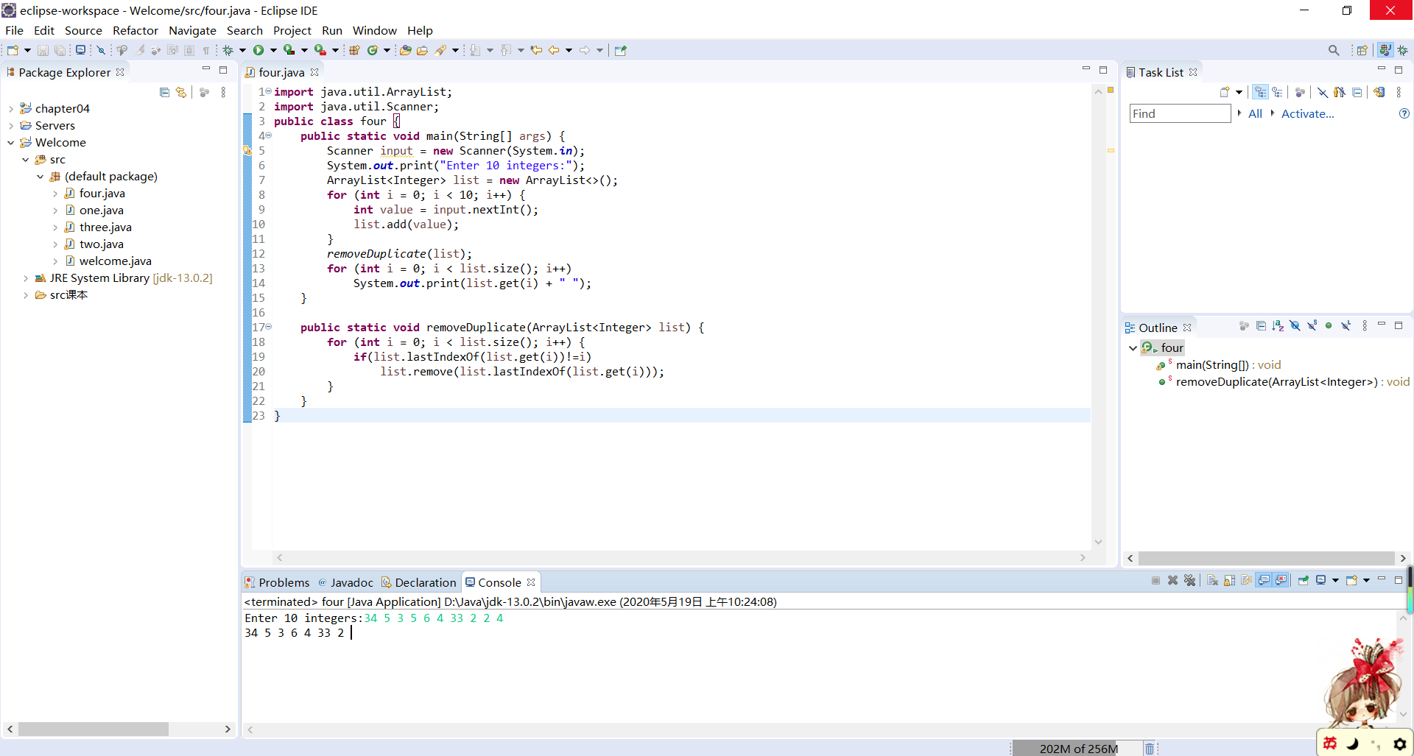

11.16

代码：

**import** java.util.ArrayList;

**import** java.util.Scanner;

**public** **class** five {

**public** **static** **void** main(String[] args) {

**int** number1 = (**int**) (Math.*random*() * 10);

**int** number2 = (**int**) (Math.*random*() * 10);

ArrayList<Integer> list = **new** ArrayList<>();

Scanner input = **new** Scanner(System.***in***);

System.***out***.print("What is " + number1 + " + " + number2 + "? ");

**int** answer=input.nextInt();

list.add(answer);

**while** (number1 + number2 != answer) {

System.***out***.print("Wrong answer. Try again. What is " + number1 + " + " + number2 + "? ");

answer=input.nextInt();

**if**(list.contains(answer))

System.***out***.println("You already entered "+answer);

**else**

list.add(answer);

}

System.***out***.println("You got it!");

}

}

截图：

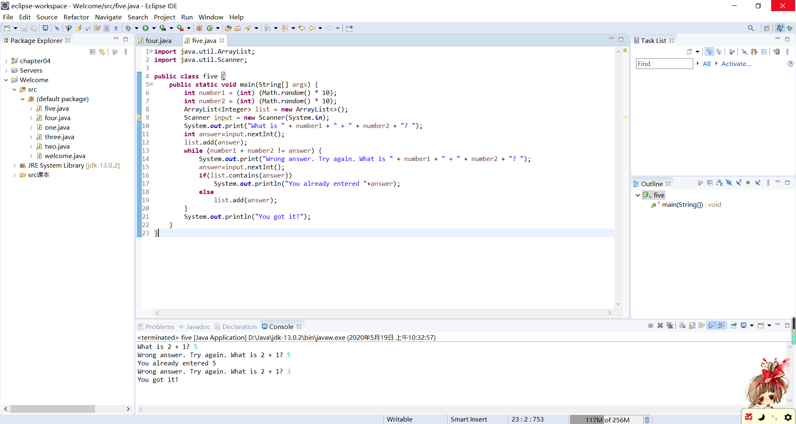

11.17

代码：

**import** java.util.ArrayList;

**import** java.util.Scanner;

**public** **class** six {

**public** **static** **void** main(String[] args) {

ArrayList<Integer> list = **new** ArrayList<>();

Scanner input = **new** Scanner(System.***in***);

System.***out***.println("Enter an integer m:");

**int** m = input.nextInt();

**int** n = 1;

list = *Factor*(m);

**for** (**int** j = 0; j < list.size(); j++) {

**int** count = 0;

**for** (**int** i = 0; i < list.size(); i++) {

**if** (list.get(i) == list.get(j))

count++;

}

**if** (count%2!=0 &&(j==0||list.get(j)!=list.get(j-1)))

n *= list.get(j);

}

System.***out***.println("The smallest number n for m*n to be a perfect square is " + n);

System.***out***.println("m*n is " + m * n);

}

**public** **static** ArrayList<Integer> Factor(**int** m) {

ArrayList<Integer> list = **new** ArrayList<>();

**int** i = 2;

**while** (m != 1) {

**if** (m % i == 0) {

list.add(i);

m = m / i;

// System.out.println(i);

}

**else** {

i++;

**continue**;

}

}

**return** list;

}

}

截图：

