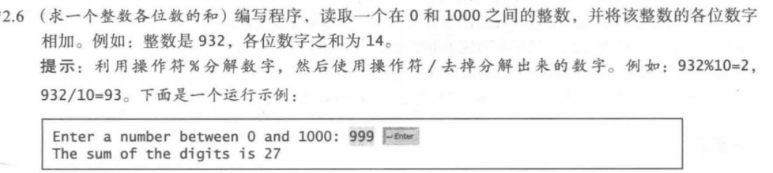

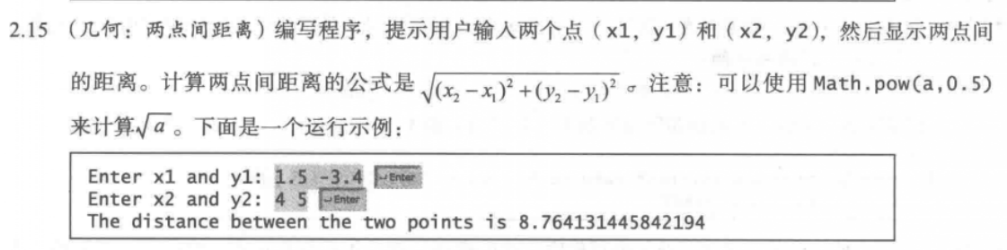

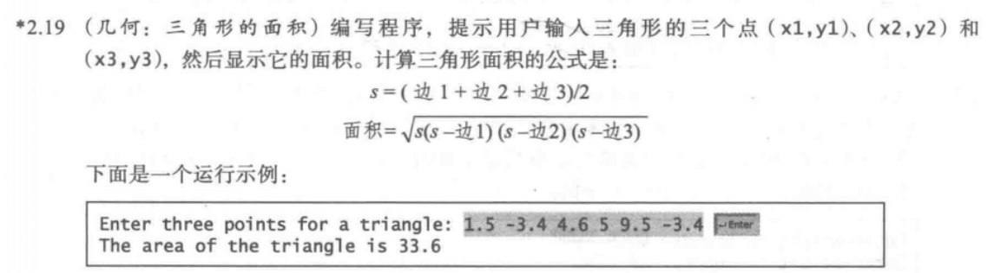

2.6

代码：

**import** java.util.Scanner;

**public** **class** Welcome {

**public** **static** **void** main(String[] args) {

Scanner input=**new** Scanner(System.***in***);

System.***out***.println("Enter a number between 0 and 1000:");

**int** x=input.nextInt();

**int** y;

**if**(x<10)

{

y=x;

}

**else** **if**(x>=10&&x<100)

{

y=x%10+x/10;

}

**else**

{

y=x%10+x/10%10+x/100;

}

System.***out***.println("The sun of the digits is "+y);

}

}

截图：

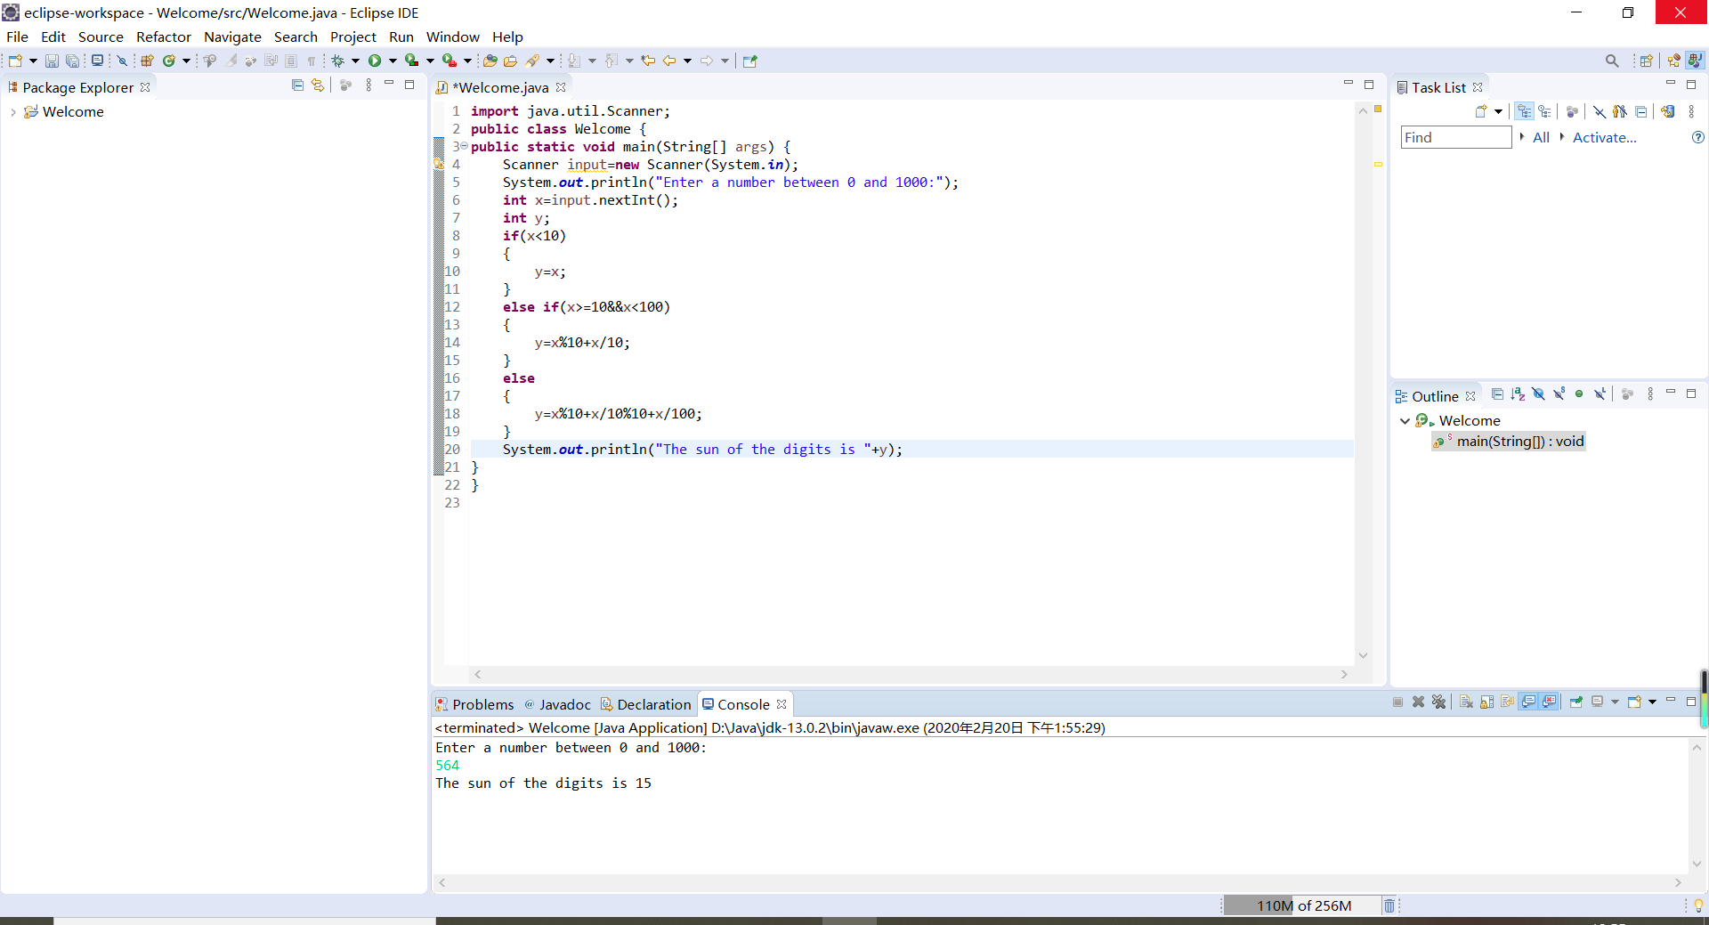

2.15

代码：

**import** java.util.Scanner;

**public** **class** Welcome {

**public** **static** **void** main(String[] args) {

Scanner input=**new** Scanner(System.***in***);

System.***out***.println("Enter x1 and y1:");

**double** x1=input.nextDouble();

**double** y1=input.nextDouble();

System.***out***.println("Enter x2 and y2:");

**double** x2=input.nextDouble();

**double** y2=input.nextDouble();

**double** z=(x2-x1)*(x2-x1)+(y2-y1)*(y2-y1);

**double** dist=Math.*pow*(z,0.5);

System.***out***.println("The distance between the two points is "+dist);

}

}

截图：

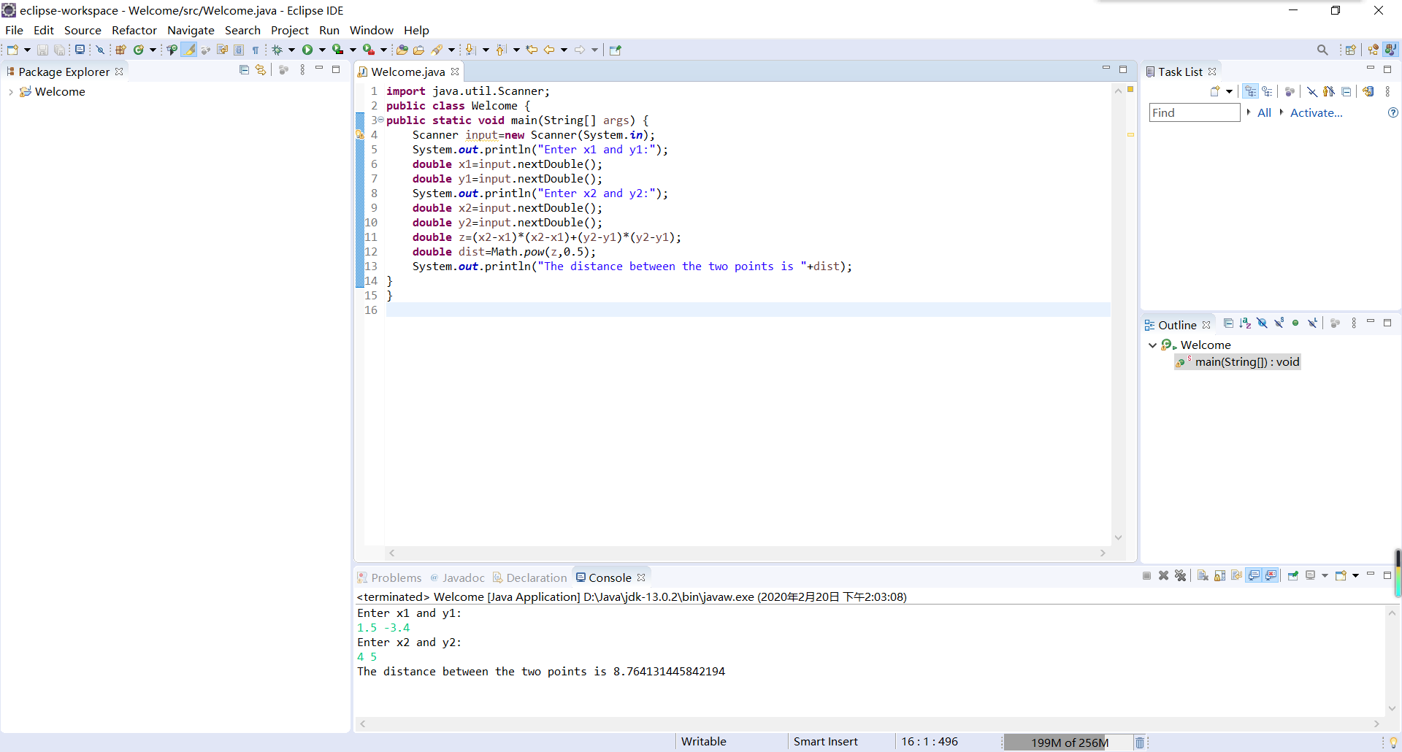

2.19

代码：

**import** java.util.Scanner;

**public** **class** Welcome {

**public** **static** **void** main(String[] args) {

Scanner input=**new** Scanner(System.***in***);

System.***out***.println("Enter three points for a triangle:");

**double** x1=input.nextDouble();

**double** y1=input.nextDouble();

**double** x2=input.nextDouble();

**double** y2=input.nextDouble();

**double** x3=input.nextDouble();

**double** y3=input.nextDouble();

**double** a1=(x2-x1)*(x2-x1)+(y2-y1)*(y2-y1);

**double** d1=Math.*pow*(a1,0.5);

**double** a2=(x3-x1)*(x3-x1)+(y3-y1)*(y3-y1);

**double** d2=Math.*pow*(a2,0.5);

**double** a3=(x2-x3)*(x2-x3)+(y2-y3)*(y2-y3);

**double** d3=Math.*pow*(a3,0.5);

**double** s=(d1+d2+d3)/2;

**double** area=Math.*pow*(s*(s-d1)*(s-d2)*(s-d3),0.5);

System.***out***.println("The area of the triangle is "+area);

}

}

截图：

