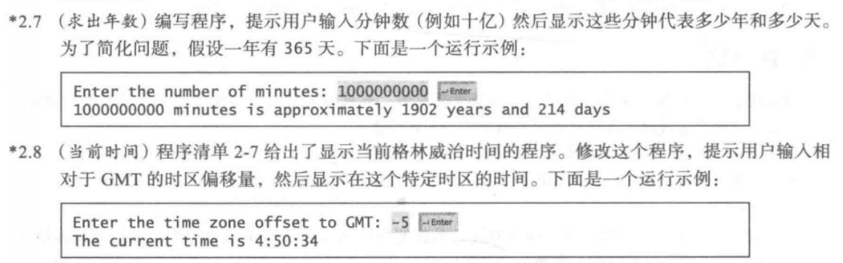

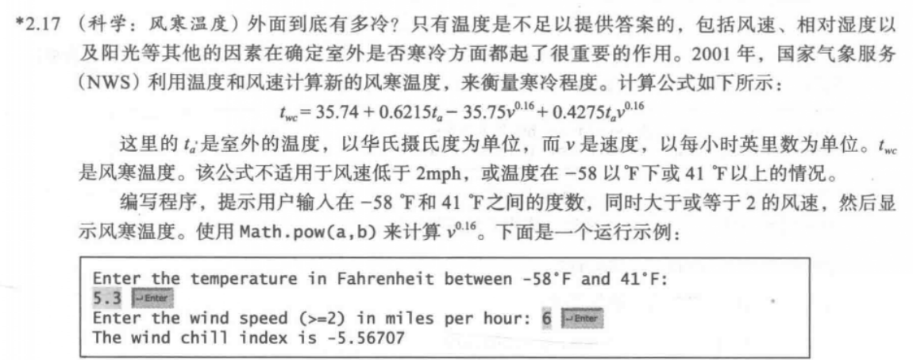

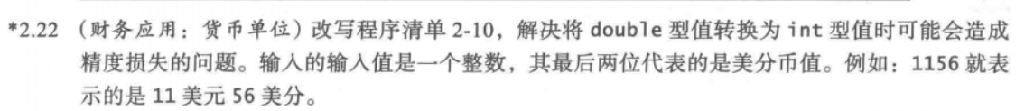

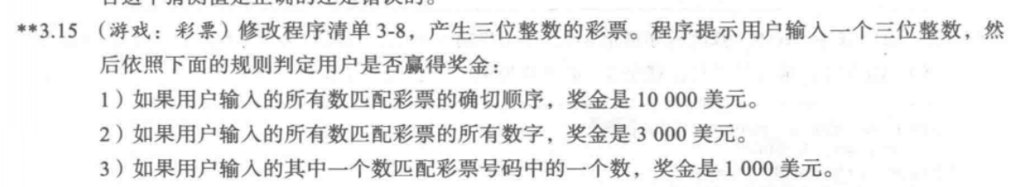

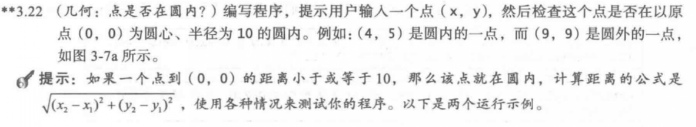

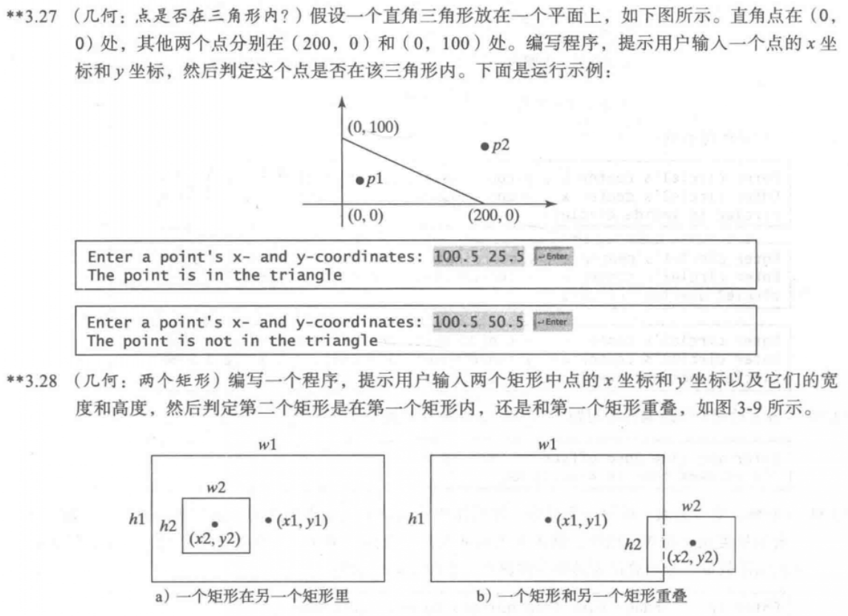

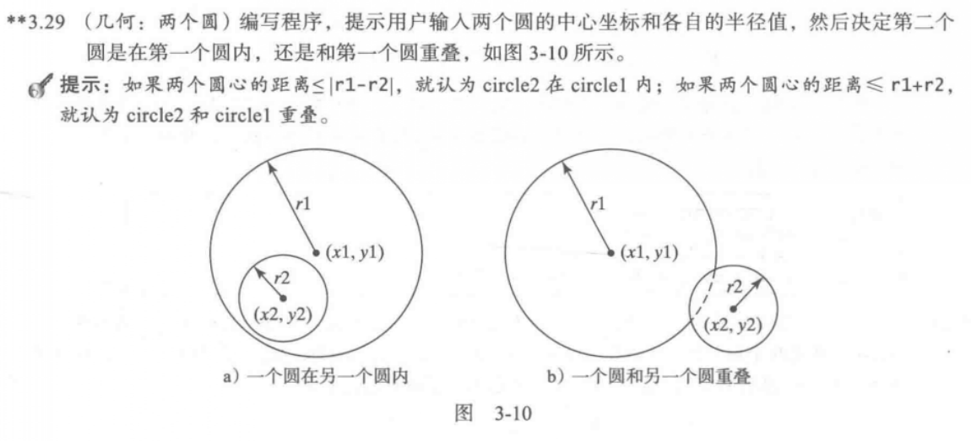

2.7

代码：

**import** java.util.Scanner;

**public** **class** Welcome {

**public** **static** **void** main(String[] args) {

Scanner input = **new** Scanner(System.***in***);

System.***out***.println("Enter the minutes:");

**long** minutes = input.nextLong();

**long** hours = minutes/60;

**long** totaldays = hours/24;

**long** years = totaldays/365;

**long** currentdays = totaldays%365;

System.***out***.println(minutes+"minutes is approximately "+years+" years and "+currentdays+" days");

}

}

截图：

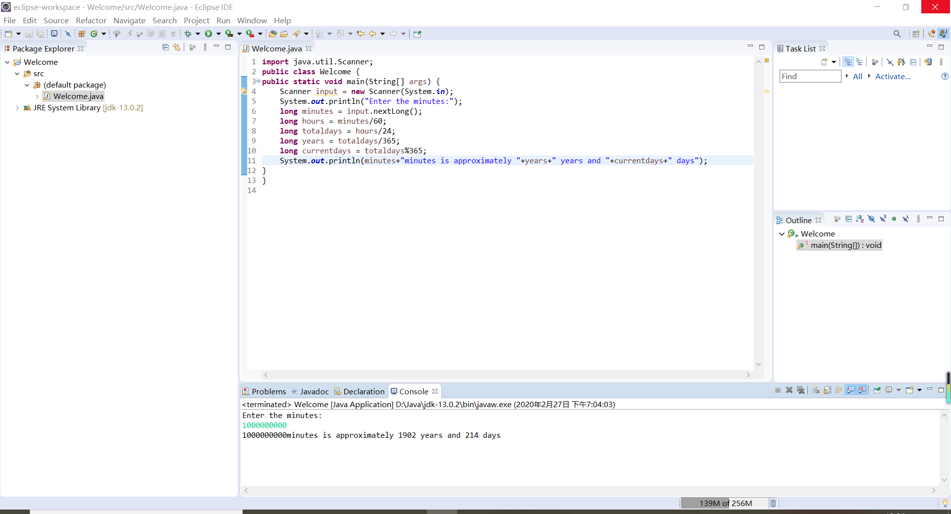

2.8

代码：

**import** java.util.Scanner;

**public** **class** Welcome {

**public** **static** **void** main(String[] args) {

Scanner input = **new** Scanner(System.***in***);

System.***out***.println("Enter the time zone offset to GMT:");

**int** zone = input.nextInt();

**long** totalseconds = System.*currentTimeMillis*()/1000;

**long** currentseconds = totalseconds%60;

**long** totalminutes = totalseconds/60;

**long** currentminutes = totalminutes%60;

**long** totalhours = totalminutes/60;

**long** currenthours = totalhours%24;

**long** hours = currenthours + zone;

System.***out***.println("The current time is " + hours + ":" + currentminutes + ":" + currentseconds);

}

}

截图：

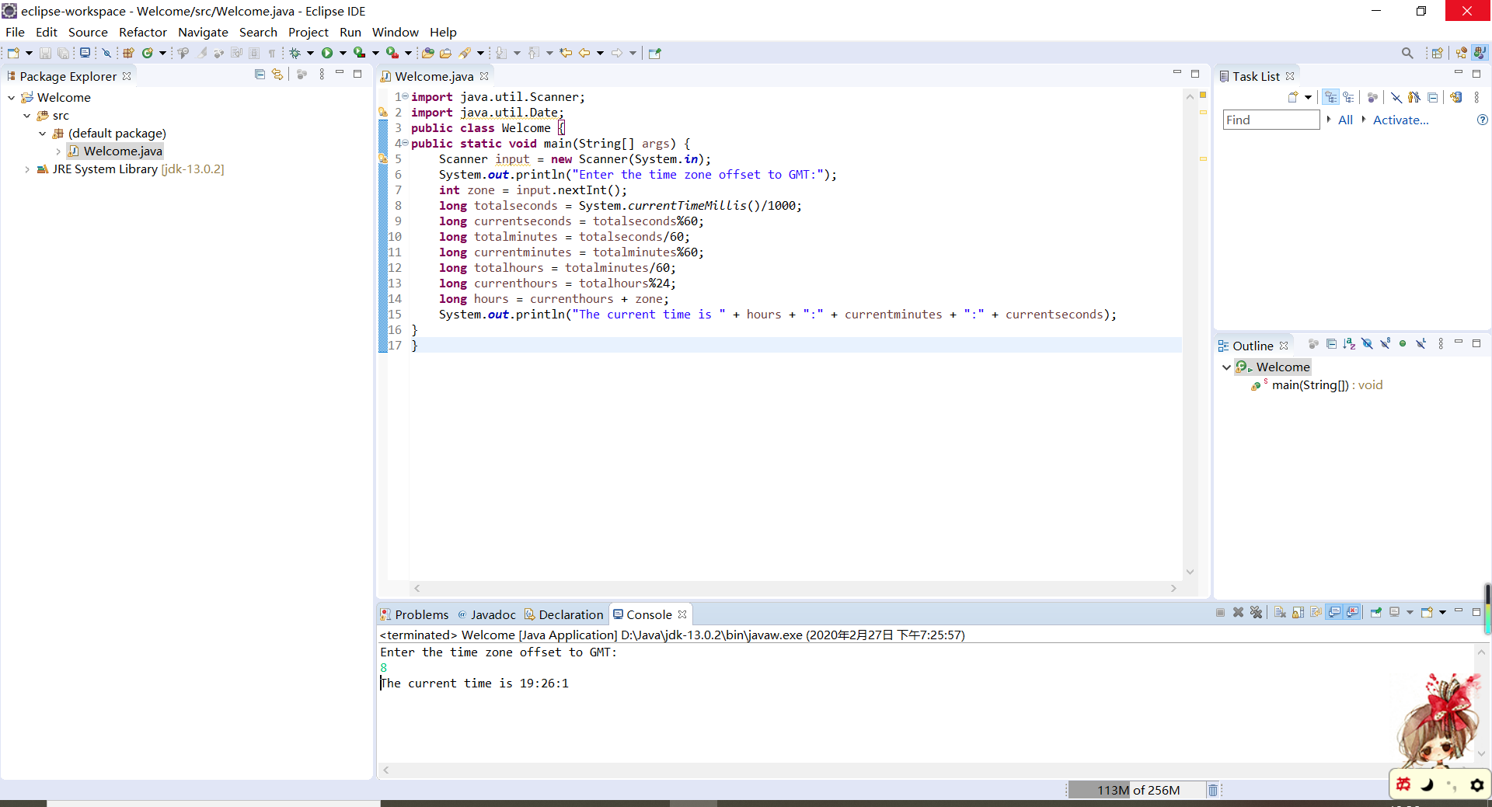

2.17

代码：

**import** java.util.Scanner;

**public** **class** Welcome {

**public** **static** **void** main(String[] args) {

Scanner input = **new** Scanner(System.***in***);

System.***out***.println("Enter the temperature in Fahrenheit between -58°F and 41°F:");

**double** t = input.nextDouble();

System.***out***.println("Enter the wind speed (>=2) in miles per hour:");

**double** v = input.nextDouble();

**if** (t>=-58 && t<=41 && v>=2) {

**double** tem = 35.74+0.6215*t-35.75*Math.*pow*(v,0.16)+0.4275*t*Math.*pow*(v,0.16);

System.***out***.println("The wind chill index is " + tem);

}

**else**

System.***out***.println("input error!");

}

}

截图：

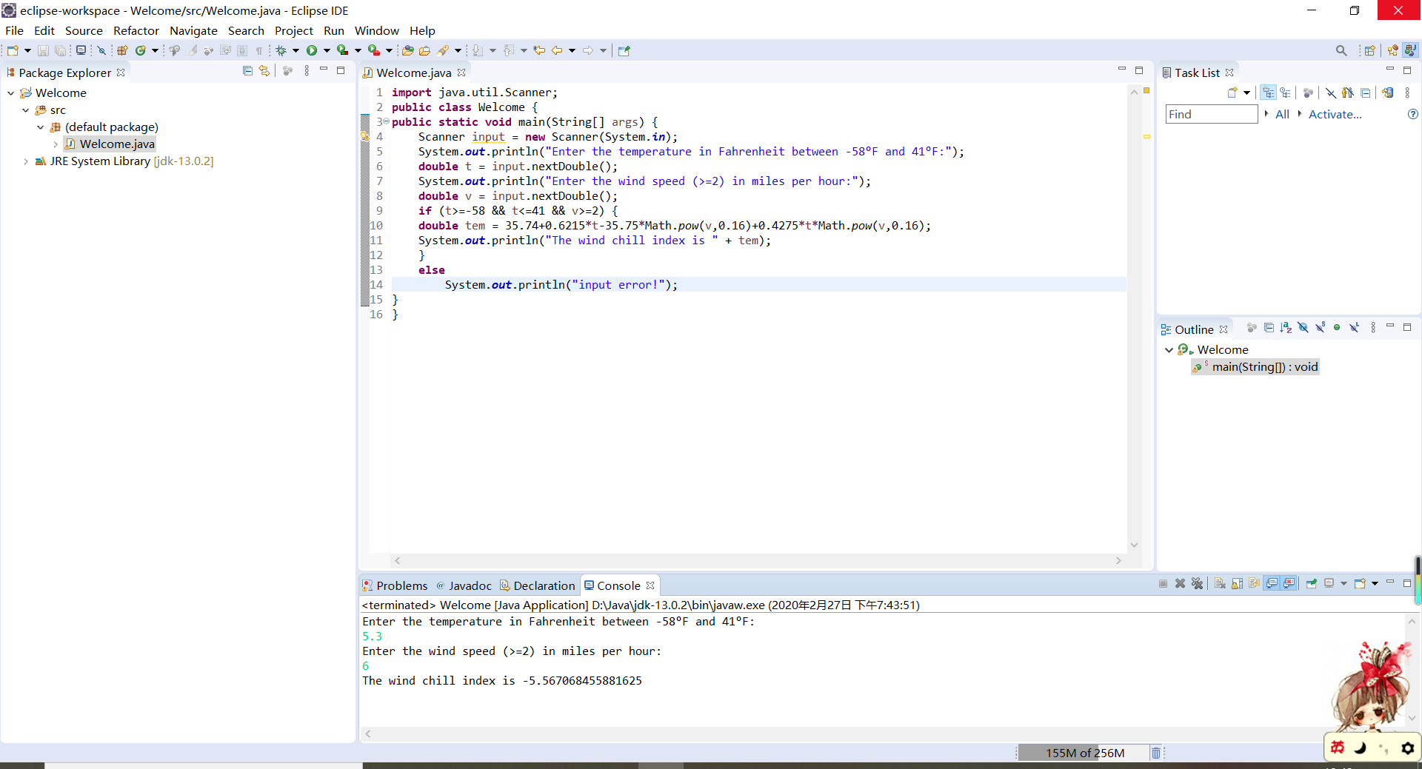

2.22

代码：

**import** java.util.Scanner;

**public** **class** Welcome {

**public** **static** **void** main(String[] args) {

Scanner input = **new** Scanner(System.***in***);

System.***out***.print("Enter an amount in double, for example 1156: ");

**int** amount = input.nextInt();

**int** numberOfOneDollars = amount / 100;

amount = amount % 100;

**int** numberOfQuarters = amount / 25;

amount = amount % 25;

**int** numberOfDimes = amount / 10;

amount = amount % 10;

**int** numberOfNickels = amount / 5;

amount = amount % 5;

**int** numberOfPennies = amount;

System.***out***.println("Your amount " + amount + " consists of");

System.***out***.println(" " + numberOfOneDollars + " dollars");

System.***out***.println(" " + numberOfQuarters + " quarters ");

System.***out***.println(" " + numberOfDimes + " dimes");

System.***out***.println(" " + numberOfNickels + " nickels");

System.***out***.println(" " + numberOfPennies + " pennies");

}

}

截图：

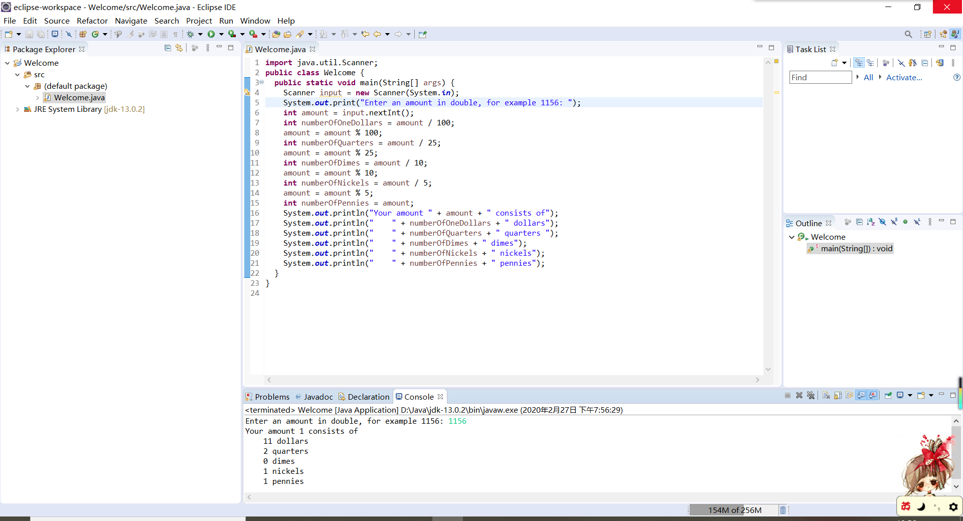

3.15

代码：

**import** java.util.Scanner;

**public** **class** Welcome {

**public** **static** **void** main(String[] args) {

**int** lottery = (**int**)(Math.*random*() * 1000);

Scanner input = **new** Scanner(System.***in***);

System.***out***.print("Enter your lottery pick (three digits): ");

**int** guess = input.nextInt();

**int** lotteryDigit1 = lottery /100;

**int** lotteryDigit2 = lottery /10%10;

**int** lotteryDigit3 = lottery %10;

**int** guessDigit1 = guess /100;

**int** guessDigit2 = guess /10%10;

**int** guessDigit3 = guess %10;

System.***out***.println("The lottery number is " + lottery);

**if** (guess == lottery)

System.***out***.println("Exact match: you win $10,000");

**else** **if** (guessDigit3 == lotteryDigit1

&& guessDigit2 == lotteryDigit2

&& guessDigit1 == lotteryDigit3

|| guessDigit3 == lotteryDigit1

&& guessDigit1 == lotteryDigit2

&& guessDigit2 == lotteryDigit3

|| guessDigit2 == lotteryDigit1

&& guessDigit3 == lotteryDigit2

&& guessDigit1 == lotteryDigit3

|| guessDigit2 == lotteryDigit1

&& guessDigit1 == lotteryDigit2

&& guessDigit3 == lotteryDigit3

|| guessDigit1 == lotteryDigit1

&& guessDigit3 == lotteryDigit2

&& guessDigit2 == lotteryDigit3)

System.***out***.println("Match all digits: you win $3,000");

**else** **if** (guessDigit1 == lotteryDigit1

|| guessDigit1 == lotteryDigit2

|| guessDigit1 == lotteryDigit3

|| guessDigit2 == lotteryDigit1

|| guessDigit2 == lotteryDigit2

|| guessDigit2 == lotteryDigit3

|| guessDigit3 == lotteryDigit1

|| guessDigit3 == lotteryDigit2

|| guessDigit3 == lotteryDigit3 )

System.***out***.println("Match one digit: you win $1,000");

**else**

System.***out***.println("Sorry, no match");

}

}

截图：

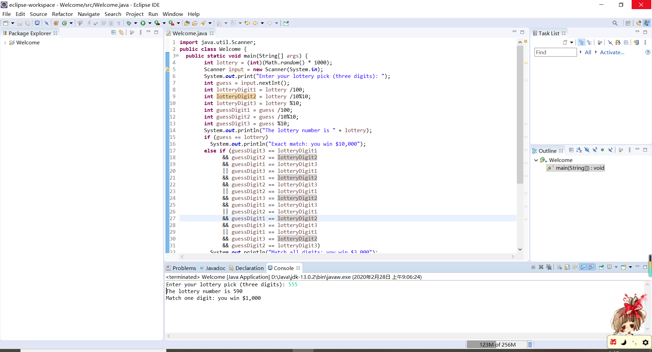

3.22

代码：

**import** java.util.Scanner;

**public** **class** Welcome {

**public** **static** **void** main(String[] args) {

Scanner input = **new** Scanner(System.***in***);

System.***out***.print("Enter a point with two coordinates:");

**int** x = input.nextInt();

**int** y = input.nextInt();

**double** d = Math.*pow*(x*x+y*y, 0.5);

**if** (d<= 10)

System.***out***.println("Point ( "+ x +".0 ,"+ y +".0 ) is in the circle");

**else**

System.***out***.println("Point ( "+ x +".0 ,"+ y +".0 ) is not in the circle");

}

}

截图：

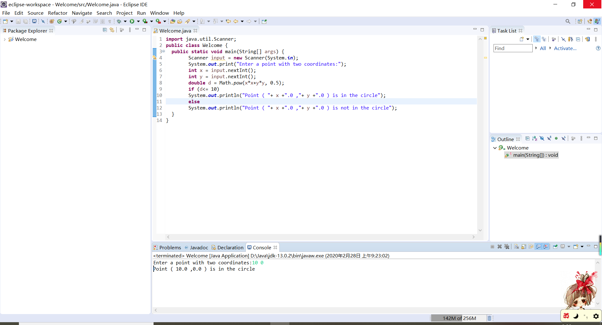

3.27

代码：

**import** java.util.Scanner;

**public** **class** Welcome {

**public** **static** **void** main(String[] args) {

Scanner input = **new** Scanner(System.***in***);

System.***out***.print("Enter a point's x- and y-coordinates:");

**double** x = input.nextDouble();

**double** y = input.nextDouble();

**if** (x>=0 && y>=0 && y<=-0.5*x+100)

System.***out***.println("The point is in the triangle");

**else**

System.***out***.println("The point is not in the triangle");

}

}

截图：

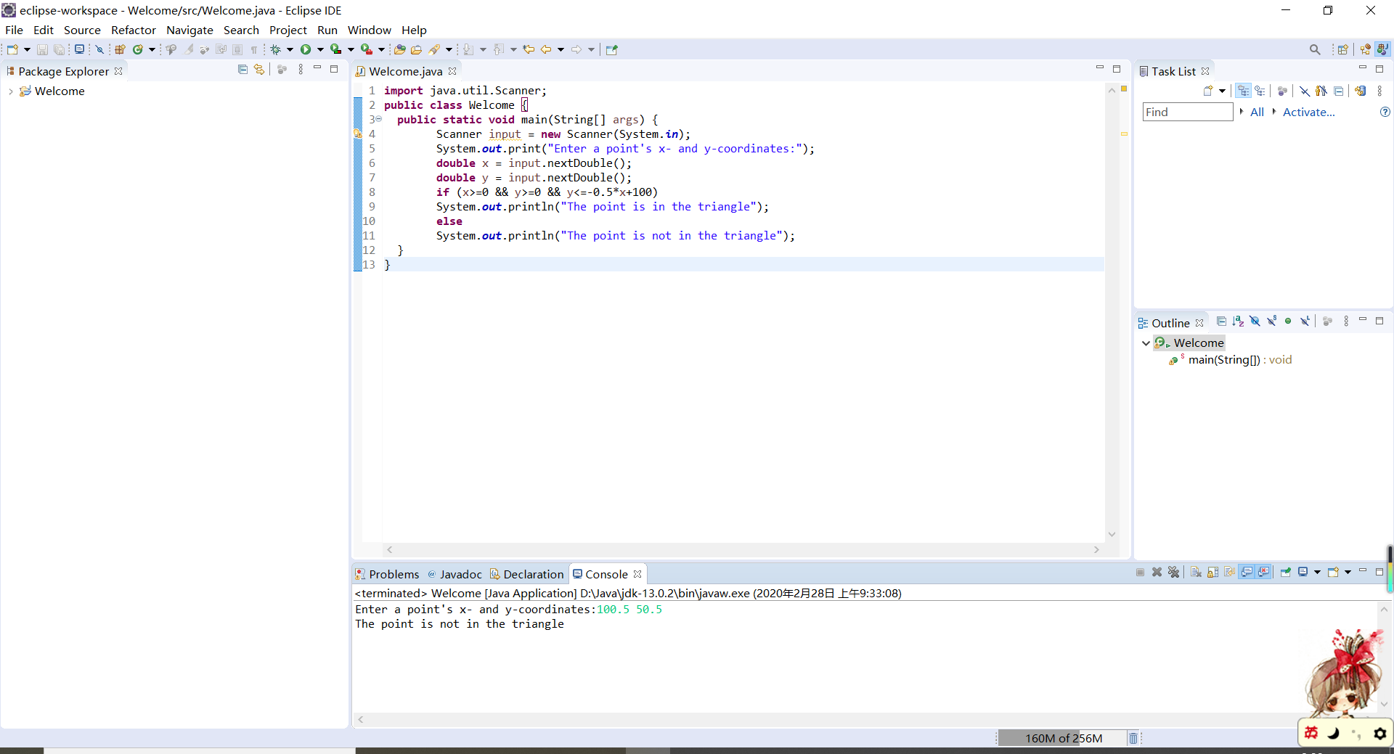

3.28

代码：

**import** java.util.Scanner;

**public** **class** Welcome {

**public** **static** **void** main(String[] args) {

Scanner input = **new** Scanner(System.***in***);

System.***out***.print("Enter r1's center x-, y-coordinates, width, and height:");

**double** x1 = input.nextDouble();

**double** y1 = input.nextDouble();

**double** width1 = input.nextDouble();

**double** height1 = input.nextDouble();

System.***out***.print("Enter r2's center x-, y-coordinates, width, and height:");

**double** x2 = input.nextDouble();

**double** y2 = input.nextDouble();

**double** width2 = input.nextDouble();

**double** height2 = input.nextDouble();

**if** ((Math.*abs*(x2-x1)<=(width1-width2)/2)&&(Math.*abs*(y2-y1)<=(height1-height2)/2))

System.***out***.println("r2 is inside r1");

**else** **if** ((Math.*abs*(x2-x1)<=(width1+width2)/2)&&(Math.*abs*(y2-y1)<=(height1+height2)/2))

System.***out***.println("r2 overlaps r1");

**else**

System.***out***.println("r2 does not overlap r1");

}

}截图：

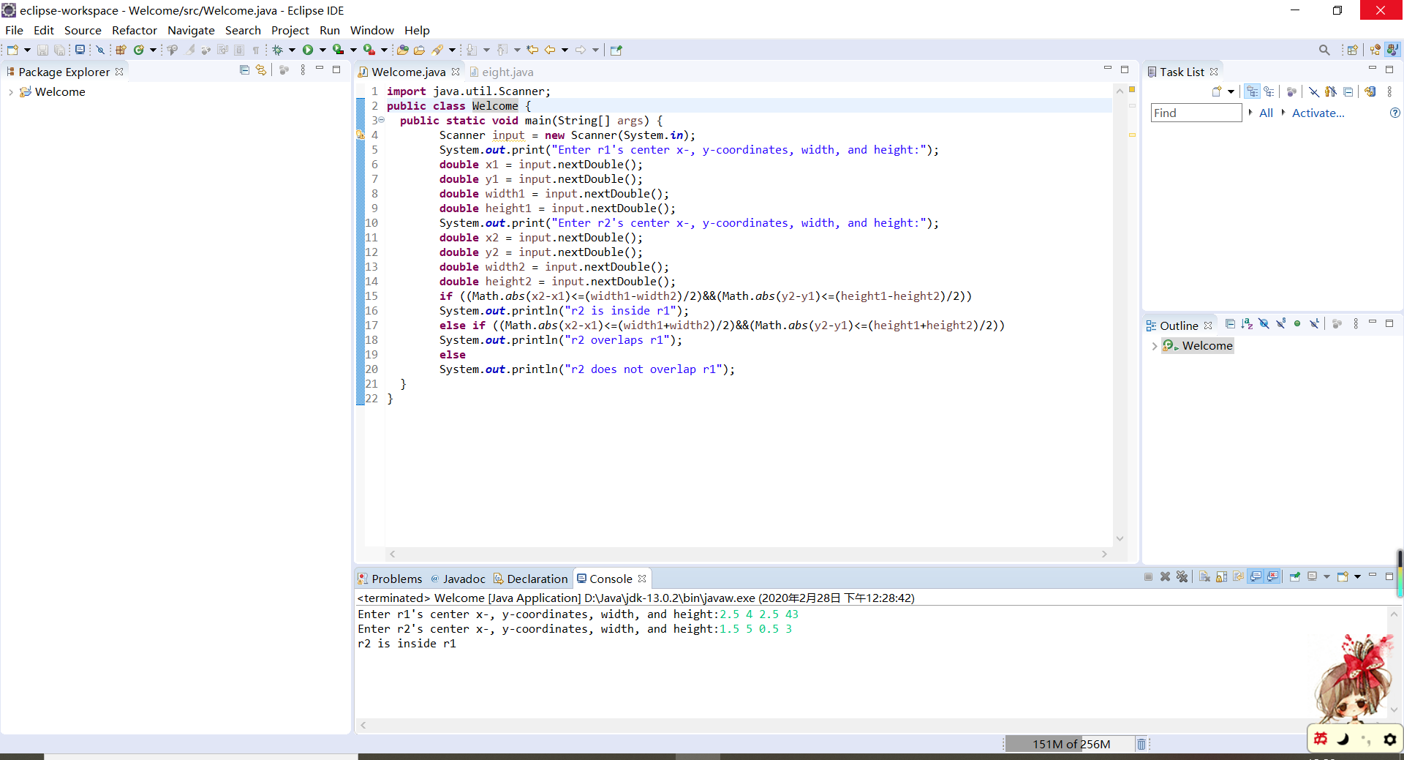

3.29

代码：

**import** java.util.Scanner;

**public** **class** Welcome {

**public** **static** **void** main(String[] args) {

Scanner input = **new** Scanner(System.***in***);

System.***out***.print("Enter circle1's center x-, y-coordinates, and radius:");

**double** x1 = input.nextDouble();

**double** y1 = input.nextDouble();

**double** radius1 = input.nextDouble();

System.***out***.print("Enter circle2's center x-, y-coordinates, and radius:");

**double** x2 = input.nextDouble();

**double** y2 = input.nextDouble();

**double** radius2 = input.nextDouble();

**if** (Math.*pow*((x2-x1)*(x2-x1)+(y2-y1)*(y2-y1),0.5)<=Math.*abs*(radius1-radius2))

System.***out***.println("circle2 is inside circle1");

**else** **if** (Math.*pow*((x2-x1)*(x2-x1)+(y2-y1)*(y2-y1),0.5)<=(radius1+radius2))

System.***out***.println("circle2 overlaps circle1");

**else**

System.***out***.println("circle2 does not overlap circle1");

}

}

截图：

