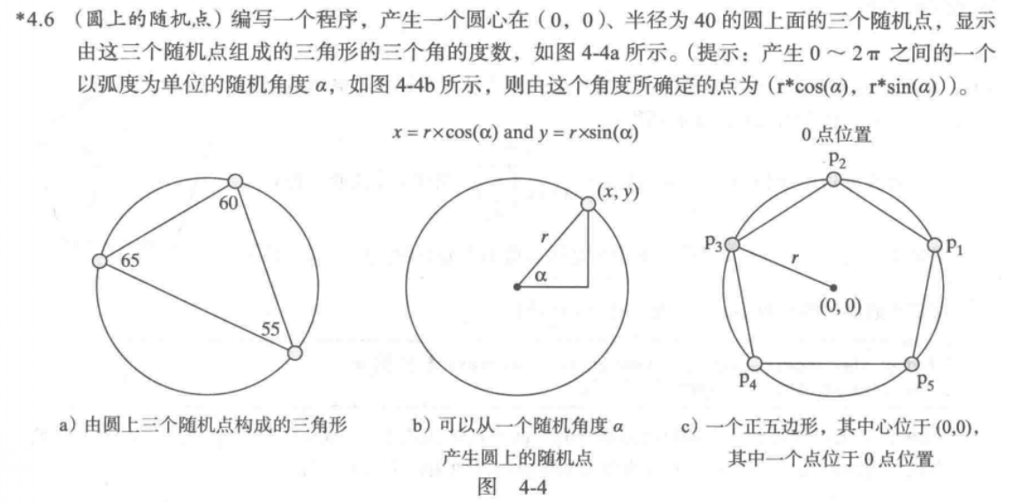





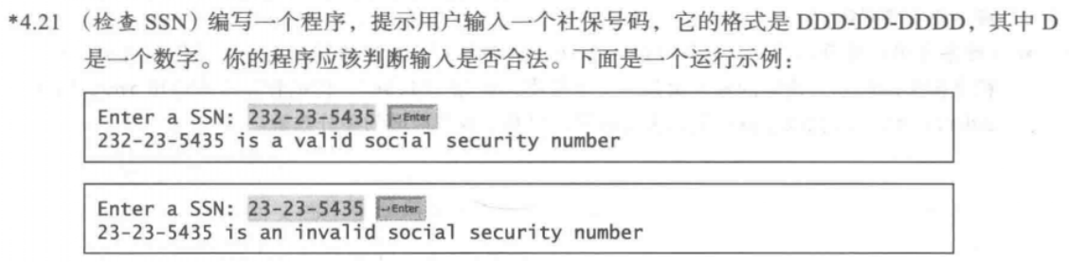

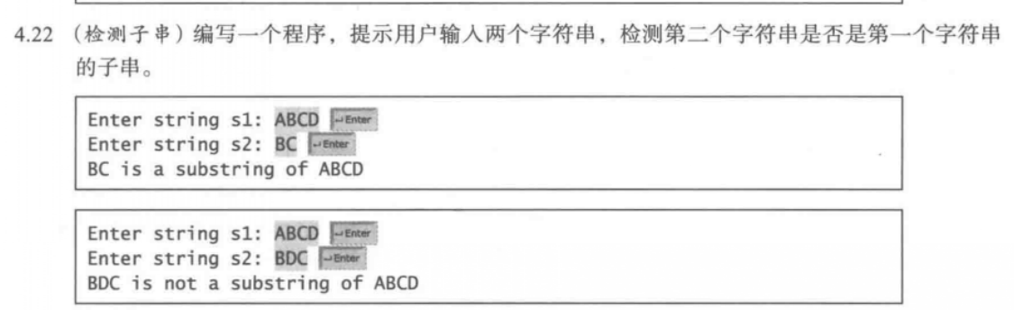

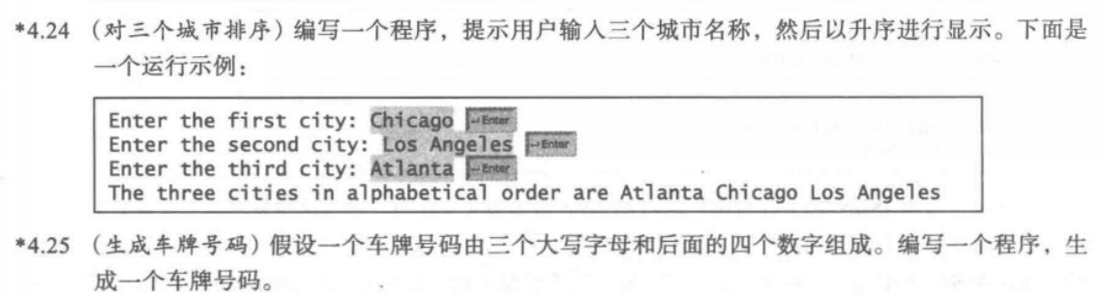

4.6

代码：

**public** **class** one {

**public** **static** **void** main(String[] args) {

**double** a1=Math.*toRadians*(Math.*random*()*180);

**double** a2=Math.*toRadians*(Math.*random*()*180);

**double** a3=Math.*toRadians*(Math.*random*()*180);

**double** x1=40*Math.*cos*(a1);

**double** y1=40*Math.*sin*(a1);

**double** x2=40*Math.*cos*(a2);

**double** y2=40*Math.*sin*(a2);

**double** x3=40*Math.*cos*(a3);

**double** y3=40*Math.*sin*(a3);

**double** a=Math.*pow*((x1-x2)*(x1-x2)+(y1-y2)*(y1-y2),0.5);

**double** b=Math.*pow*((x1-x3)*(x1-x3)+(y1-y3)*(y1-y3),0.5);

**double** c=Math.*pow*((x3-x2)*(x3-x2)+(y3-y2)*(y3-y2),0.5);

**double** anglea=Math.*toDegrees*(Math.*acos*((a*a-b*b-c*c)/(-2*b*c)));

**double** angleb=Math.*toDegrees*(Math.*acos*((b*b-a*a-c*c)/(-2*a*c)));

**double** anglec=Math.*toDegrees*(Math.*acos*((c*c-a*a-b*b)/(-2*a*b)));

System.***out***.print("The three angles are: "+Math.*round*(anglea*100)/100.0+","+Math.*round*(angleb*100)/100.0+","+Math.*round*(anglec*100)/100.0);

}

}

截图：

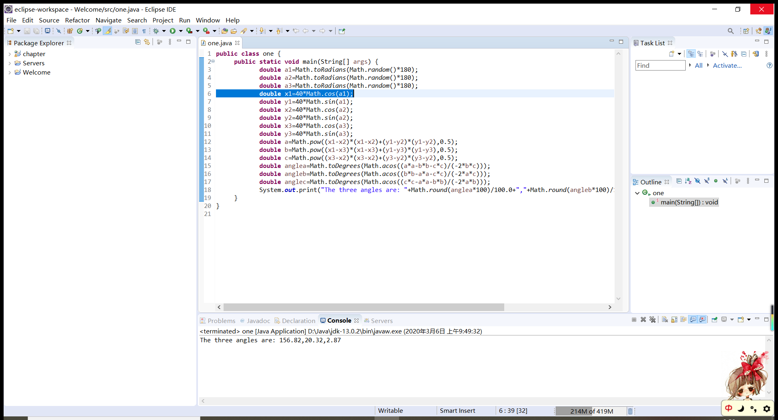

4.11

代码：

**import** java.util.Scanner;

**public** **class** two {

**public** **static** **void** main(String[] args)

{

Scanner input=**new** Scanner(System.***in***);

System.***out***.println("Enter a decimal value(0 to 15): ");

**int** number=input.nextInt();

**switch**(number)

{

**case** 0:

**case** 1:

**case** 2:

**case** 3:

**case** 4:

**case** 5:

**case** 6:

**case** 7:

**case** 8:

**case** 9:System.***out***.println("The hex value is "+number);**break**;

**case** 10:System.***out***.println("The hex value is A");**break**;

**case** 11:System.***out***.println("The hex value is B");**break**;

**case** 12:System.***out***.println("The hex value is C");**break**;

**case** 13:System.***out***.println("The hex value is D");**break**;

**case** 14:System.***out***.println("The hex value is E");**break**;

**case** 15:System.***out***.println("The hex value is F");**break**;

**default**:System.***out***.println(number+" is an invalid input");

}

}

}

截图：

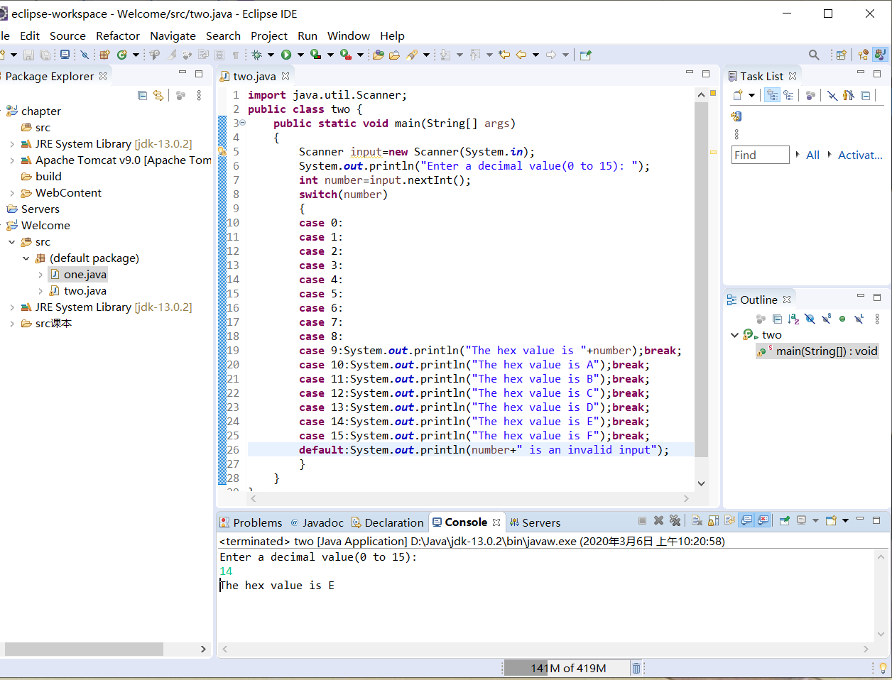

4.16

代码：

**public** **class** three {

**public** **static** **void** main(String[] args)

{

**int** asc=(**int**)(Math.*random*()*(90-65+1)+65);

**char** letter=(**char**)asc;

System.***out***.println("the letter is "+letter);

}

}

截图：

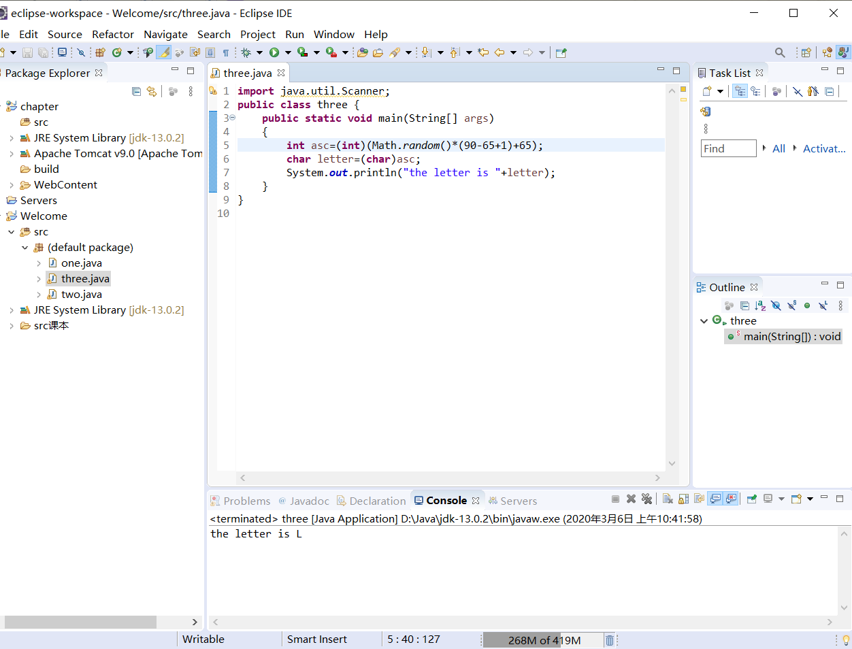

4.21

代码：

**import** java.util.Scanner;

**public** **class** four {

**public** **static** **void** main(String[] args)

{

Scanner input=**new** Scanner(System.***in***);

System.***out***.println("Enter a SSN:");

String ssn=input.next();

**if**(ssn.charAt(3)=='-'&&ssn.charAt(6)=='-')

System.***out***.println(ssn+" is a valid social security number");

**else**

System.***out***.println(ssn+" is a invalid social security number");

}

}

截图：

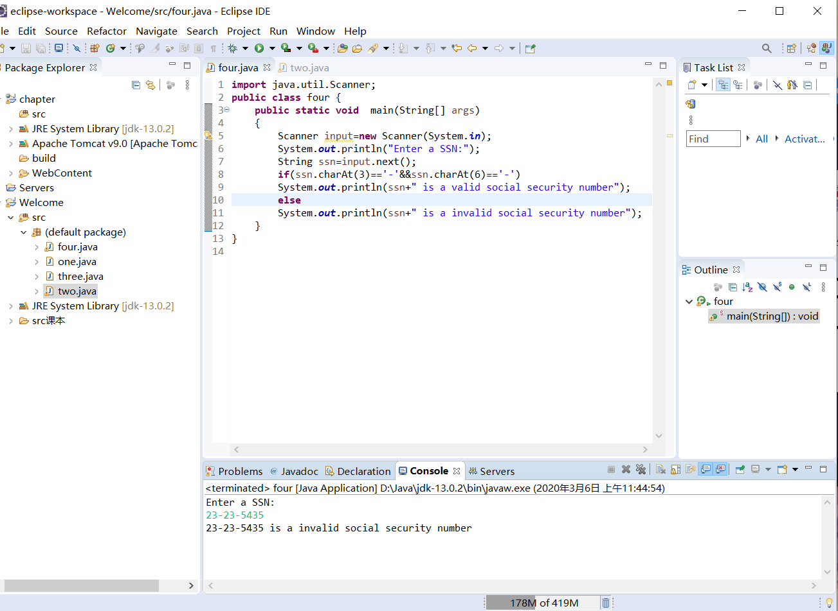

4.22

代码：

**import** java.util.Scanner;

**public** **class** five {

**public** **static** **void** main(String[] args)

{

Scanner input=**new** Scanner(System.***in***);

System.***out***.println("Enter string s1:");

String s1=input.next();

System.***out***.println("Enter string s2:");

String s2=input.next();

**if**(s1.contains(s2))

{

System.***out***.println(s2+" is a substring of "+s1);

}

**else**

{

System.***out***.println(s2+" is not a substring of "+s1);

}

}

}

截图：

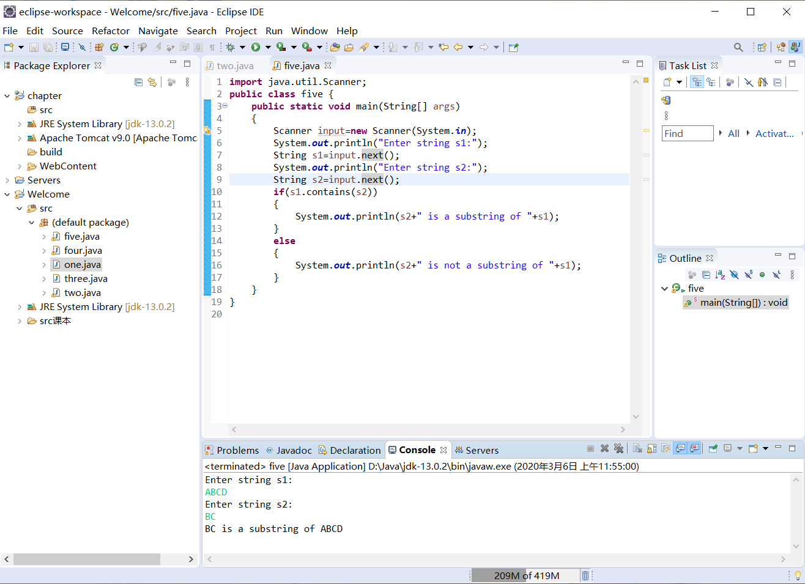

4.24

代码：

**import** java.util.Scanner;

**public** **class** six {

**public** **static** **void** main(String[] args)

{

Scanner input=**new** Scanner(System.***in***);

System.***out***.println("Enter the first city:");

String city1=input.nextLine();

System.***out***.println("Enter the second city:");

String city2=input.nextLine();

System.***out***.println("Enter the third city:");

String city3=input.nextLine();

**if**(city1.compareTo(city2)<0)

{

**if**(city2.compareTo(city3)<0)

System.***out***.println("The three cities in alphabetical order are "+city1+","+city2+","+city3);

**else**

{

**if**(city1.compareTo(city3)<0)

System.***out***.println("The three cities in alphabetical order are "+city1+","+city3+","+city2);

**else**

System.***out***.println("The three cities in alphabetical order are "+city3+","+city1+","+city2);

}

}

**else**

{

**if**(city1.compareTo(city3)<0)

System.***out***.println("The three cities in alphabetical order are "+city2+","+city1+","+city3);

**else**

{

**if**(city2.compareTo(city3)<0)

System.***out***.println("The three cities in alphabetical order are "+city2+","+city3+","+city1);

**else**

System.***out***.println("The three cities in alphabetical order are "+city3+","+city2+","+city1);

}

}

}

}

截图：

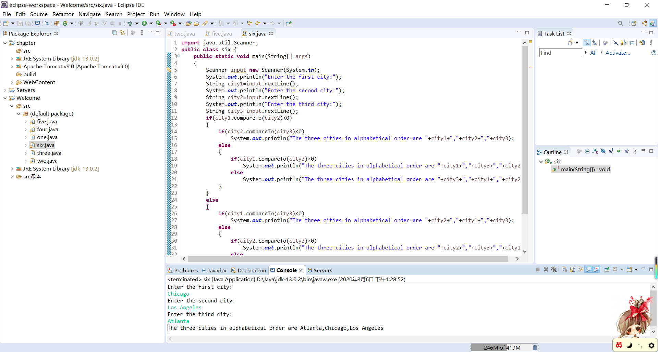

4.25

代码：

**public** **class** seven {

**public** **static** **void** main(String[] args)

{

**int** asc1=(**int**)(Math.*random*()*(90-65+1)+65);

**char** letter1=(**char**)asc1;

**int** asc2=(**int**)(Math.*random*()*(90-65+1)+65);

**char** letter2=(**char**)asc2;

**int** asc3=(**int**)(Math.*random*()*(90-65+1)+65);

**char** letter3=(**char**)asc3;

**int** number=(**int**)(Math.*random*()*10000);

System.***out***.println("The License plate is:"+letter1+letter2+letter3+String.*format*("%04d",number));

}

}

截图：

