









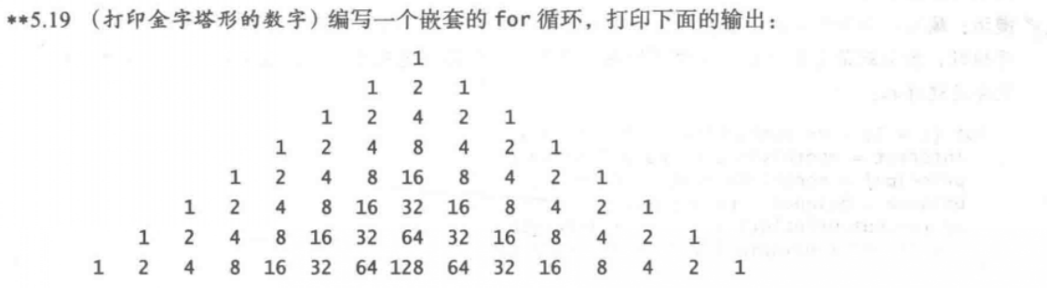

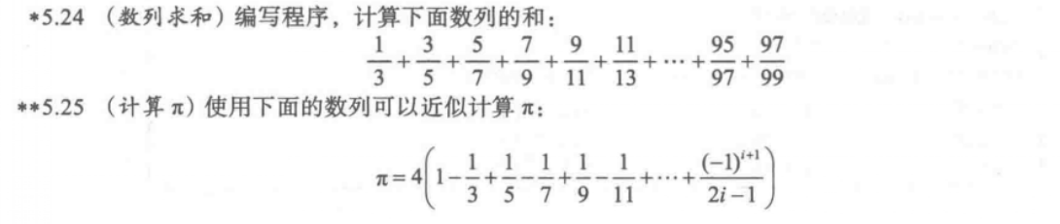

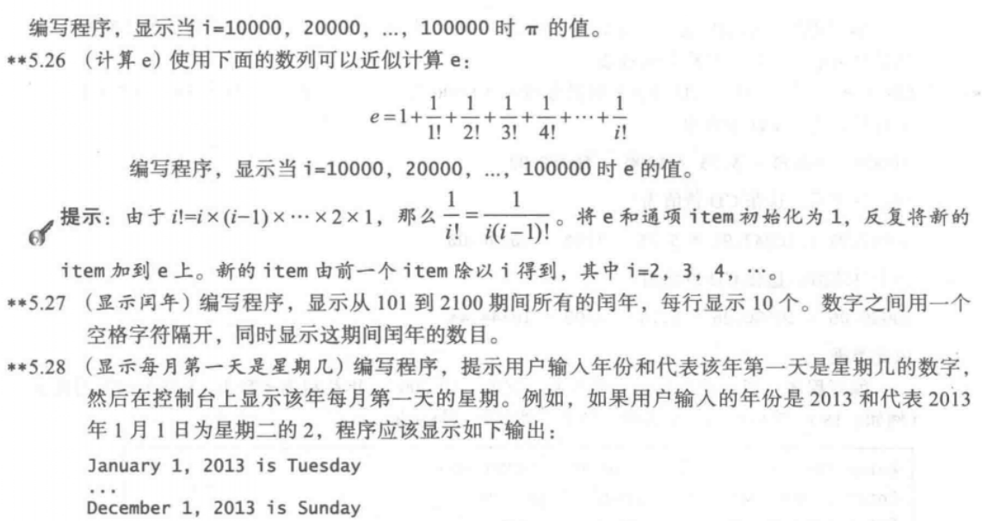

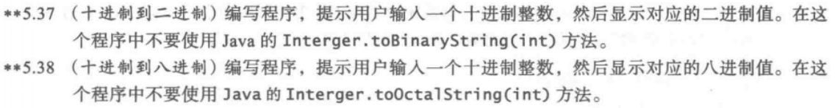

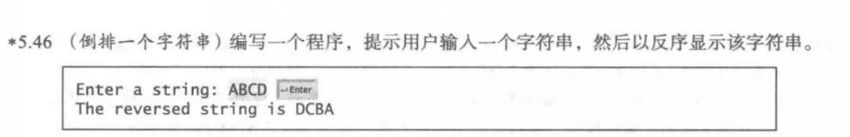

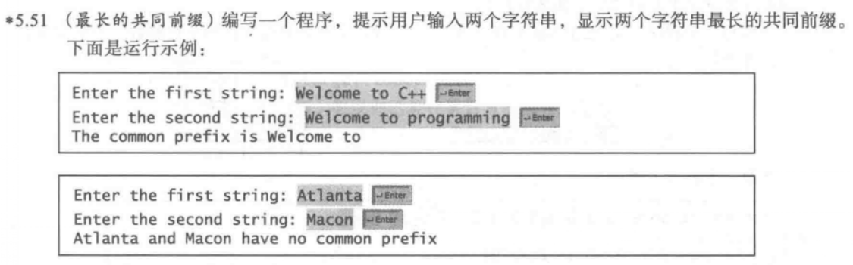

5.9

代码：

**import** java.util.Scanner;

**public** **class** one {

**public** **static** **void** main(String[] args)

{

Scanner input=**new** Scanner(System.***in***);

System.***out***.println("Enter the number of students:");

**int** number=input.nextInt();

**double** max1=0,max2=0;

String name1="",name2="";

**for**(**int** i=0;i<number&&number>=2;i++)

{

System.***out***.println("Enter the name and score of the student"+i+":");

String n1=input.next();

**double** s1=input.nextDouble();

**if**(s1>=max1)

{

max2=max1;

name2=name1;

max1=s1;

name1=n1;

}

**else** **if**(s1>=max2)

{

max2=s1;

name2=n1;

}

}

System.***out***.println("The first highest score is:"+name1+" "+max1);

System.***out***.println("The second highest score is:"+name2+" "+max2);

}

}

截图：

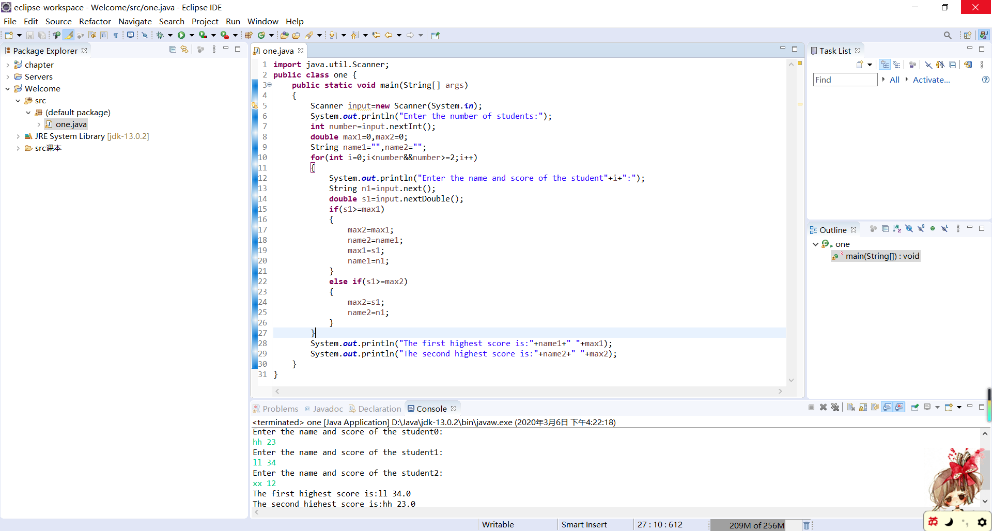

5.11

代码：

**public** **class** two {

**public** **static** **void** main(String[] args) {

**int** count = 0;

**int** number = 100;

**while** (number <= 200) {

**if** ((number % 5 == 0 || number % 6 == 0) && number % 30 != 0) {

count++;

**if** (count % 10 == 0) {

System.***out***.println(number);

} **else**

System.***out***.print(number + " ");

}

number++;

}

}

}

截图：

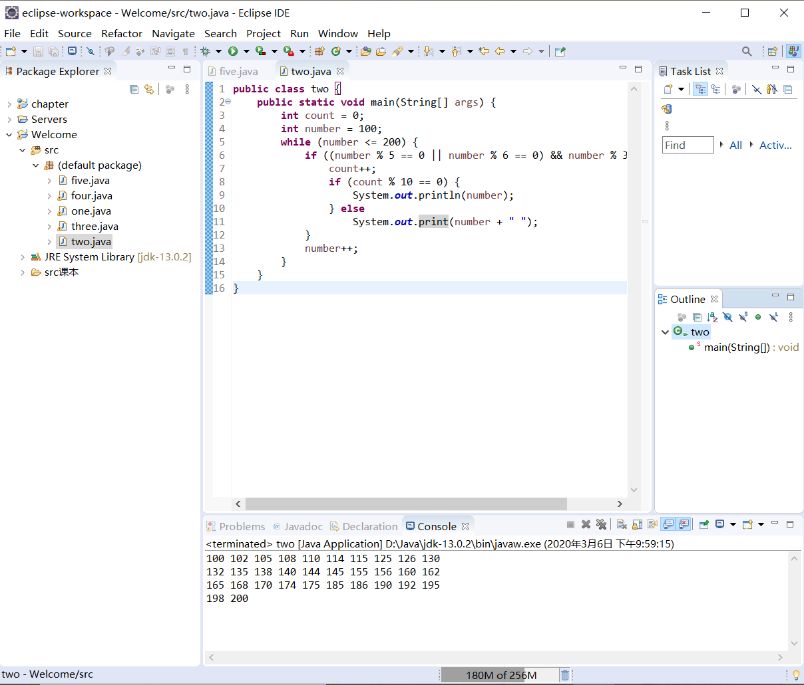

5.14

代码：

**import** java.util.Scanner;

**public** **class** three {

**public** **static** **void** main(String[] args)

{

Scanner input=**new** Scanner(System.***in***);

System.***out***.println("Enter the first integer:");

**int** n1=input.nextInt();

System.***out***.println("Enter the second integer:");

**int** n2=input.nextInt();

**int** d;

**if**(n1<n2) d=n1;

**else** d=n2;

**for**(;d>0;d--)

{

**if**(n1%d==0&&n2%d==0) **break**;

}

System.***out***.println("The greatest common divisor is "+d);

}

}

截图：

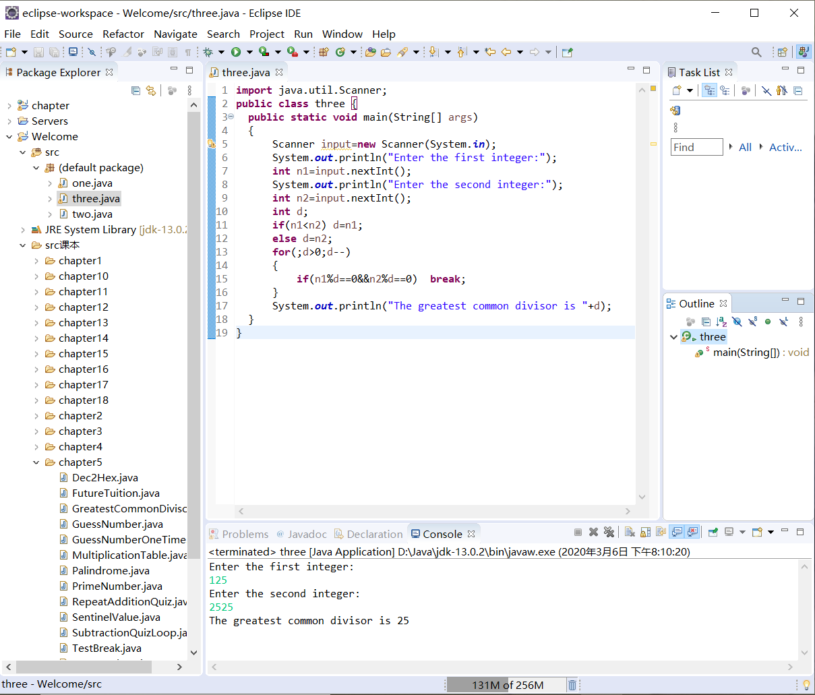

5.16

代码：

**import** java.util.Scanner;

**public** **class** four {

**public** **static** **void** main(String[] args) {

Scanner input=**new** Scanner(System.***in***);

System.***out***.println("Enter an integer:");

**int** a=input.nextInt();

**int** i = 2;

**while** (**true**) {

**if** (a % i == 0)

{

System.***out***.println(i + " ");

a /= i;

}

**else**

i++;

**if** (a == 1) **break**;

}

}

}

截图：

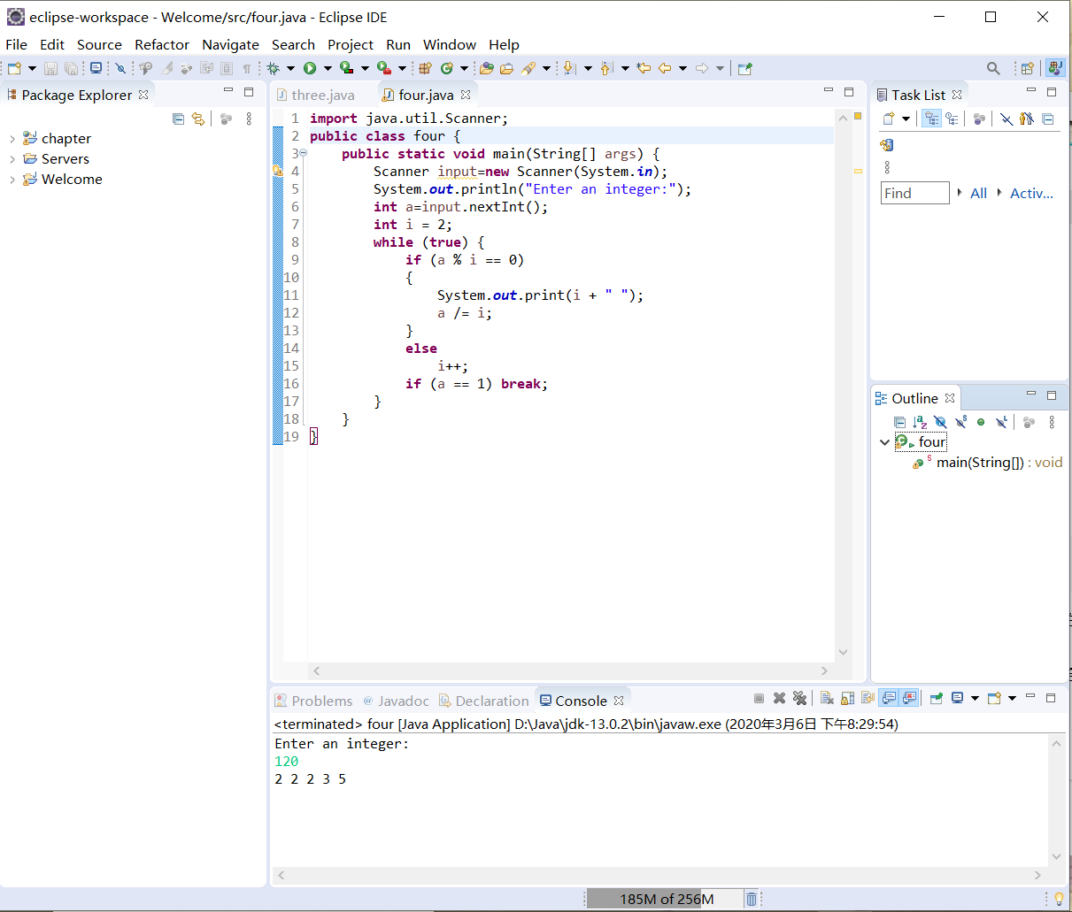

5.19

代码：

**public** **class** five {

**public** **static** **void** main(String[] args)

{

String s="";

**for**(**int** i=0;i<8;i++)

{

**for**(**int** j=7-i;j>0;j--)

{

System.***out***.print(s+" ");

}

**for**(**int** k=0;k<=i;k++) {System.***out***.printf("%4d",(**int**)Math.*pow*(2, k));}

**for**(**int** k=i-1;k>=0;k--) {System.***out***.printf("%4d",(**int**)Math.*pow*(2, k));}

**for**(**int** j=7-i;j>0;j--)

{

System.***out***.print(s+" ");

}

System.***out***.println("\n");

}

}

}

截图：

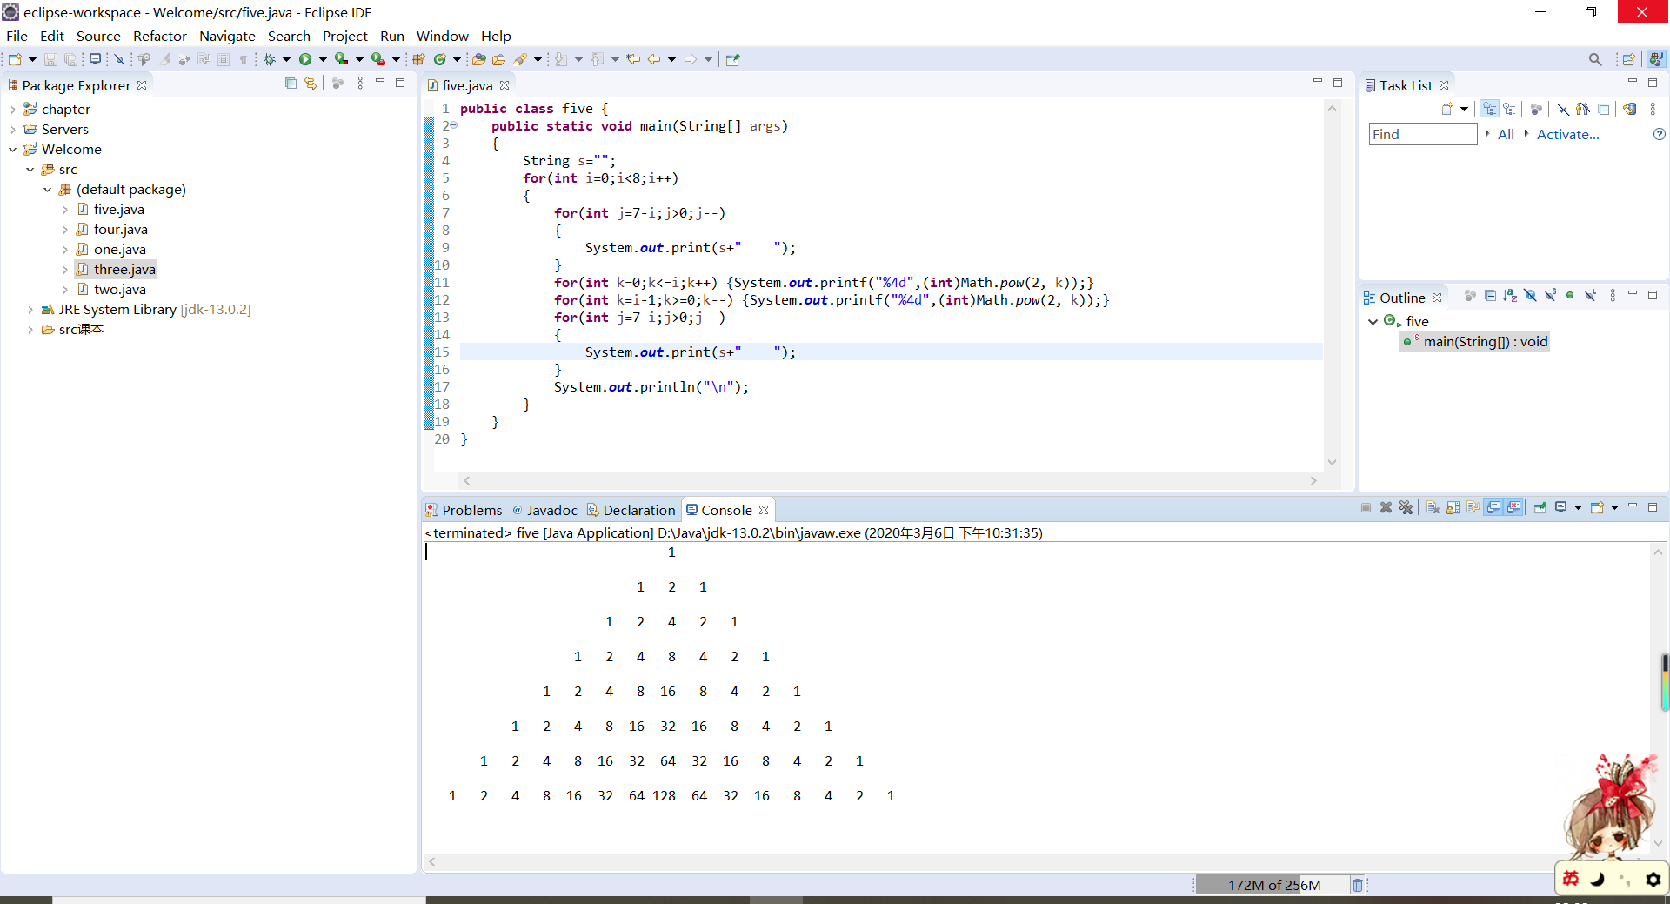

5.24

代码：

**public** **class** six {

**public** **static** **void** main(String[] args)

{

**double** sum=0;

**for**(**double** i=1;i<98;i++)

{

sum+=i/(i+2);

}

System.***out***.println("The sum is:"+sum);

}

}

截图：

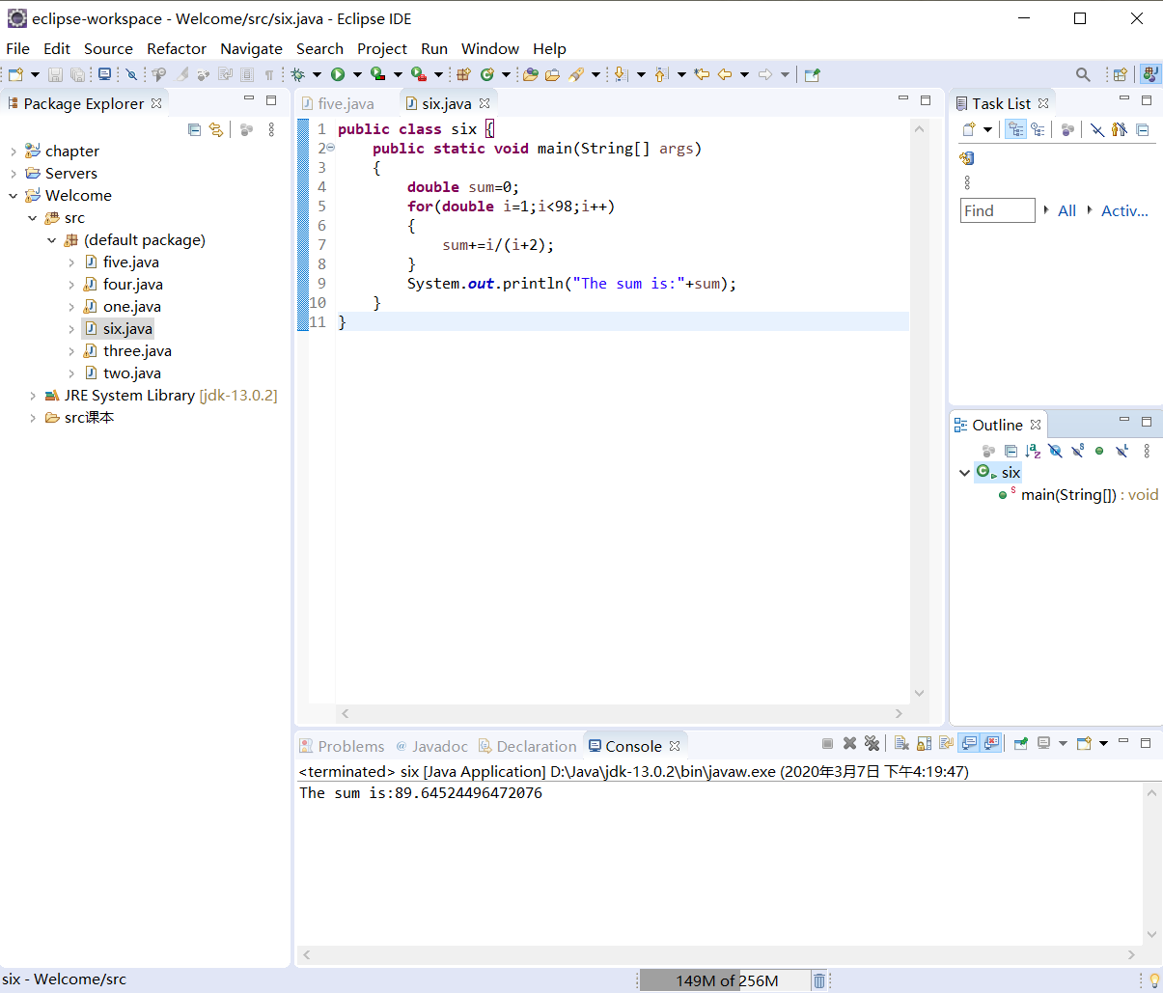

5.25

代码：

**public** **class** seven {

**public** **static** **void** main(String[] args)

{

**double** pi;

**for**(**int** i=10000;i<=100000;i+=10000)

{

pi=0;

**for**(**int** j=1;j<=i;j++)

{

pi+=(Math.*pow*(-1, j+1))/(2*j-1)*1.0;

}

pi=pi*4;

System.***out***.println("i="+i+",The value of PI is:"+pi);

}

}

}

截图：

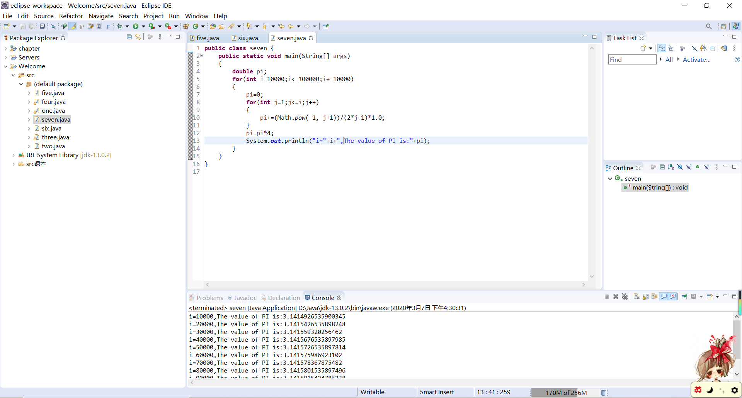

5.26

代码：

**public** **class** eight {

**public** **static** **void** main(String[] args)

{

**for**(**int** j=10000;j<=100000;j=j+10000)

{

**double** e=1;

**double** item=1;

**for**(**int** i=1;i<=j;i++)

{

item/=i*1.0;

e+=item;

}

System.***out***.println("j="+j+",the value of e is:"+e);

}

}

}

截图：

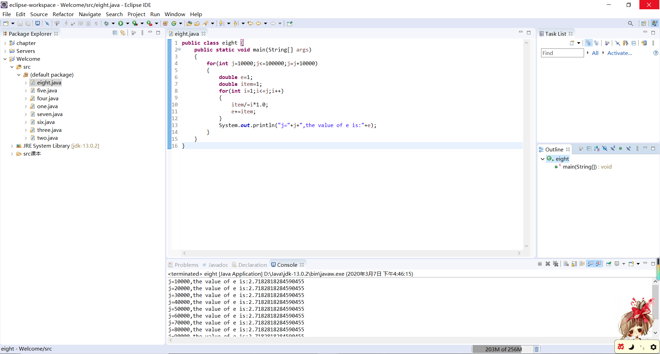

5.27

代码：

**public** **class** nine {

**public** **static** **void** main(String[] args)

{

**int** count=0;

**for**(**int** year=101;year<=2100;year++)

{

**if**((year%4==0&&year%100!=0)||year%400==0)

{

count++;

**if**(count%10==0)

{

System.***out***.println(year);

}

**else**

System.***out***.print(year+" ");

}

}

System.***out***.println("The number of leap year is "+count);

}

}

截图：

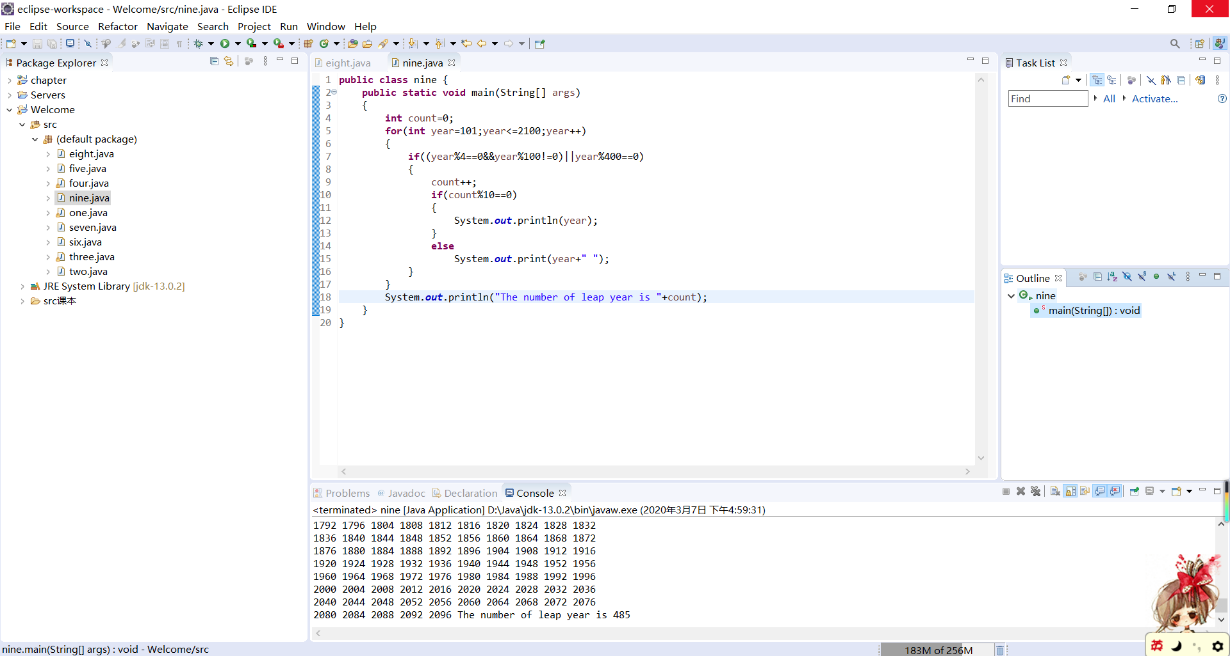

5.28

代码：

**import** java.util.Scanner;

**public** **class** ten {

**public** **static** **void** main(String[] args) {

Scanner input = **new** Scanner(System.***in***);

System.***out***.println("Enter the year and what the day is the first dat of the year:");

**int** year = input.nextInt();

**int** week = input.nextInt();

**int** day=0;

**boolean** leap = (year % 4 == 0 && year % 100 != 0) || year % 400 == 0;

**if** (leap) {

**for** (**int** i = 1; i <= 12; i++) {

**switch** (i) {

**case** 1:System.***out***.print("January 1,"+year+" is ");**break**;

**case** 2:day+=31;System.***out***.print("Febuary 1,"+year+" is ");**break**;

**case** 3:day+=29;System.***out***.print("March 1,"+year+" is ");**break**;

**case** 4:day+=31;System.***out***.print("April 1,"+year+" is ");**break**;

**case** 5:day+=30;System.***out***.print("May 1,"+year+" is ");**break**;

**case** 6:day+=31;System.***out***.print("June 1,"+year+" is ");**break**;

**case** 7:day+=30;System.***out***.print("July 1,"+year+" is ");**break**;

**case** 8:day+=31;System.***out***.print("August 1,"+year+" is ");**break**;

**case** 9:day+=31;System.***out***.print("September 1,"+year+" is ");**break**;

**case** 10:day+=30;System.***out***.print("October 1,"+year+" is ");**break**;

**case** 11:day+=31;System.***out***.print("November 1,"+year+" is ");**break**;

**case** 12:day+=30;System.***out***.print("December 1,"+year+" is ");**break**;

}

**int** weeks=(day%7+week)%7;

**switch**(weeks)

{

**case** 0:System.***out***.println("Sunday");**break**;

**case** 1:System.***out***.println("Monday");**break**;

**case** 2:System.***out***.println("Tuesday");**break**;

**case** 3:System.***out***.println("Wednesday");**break**;

**case** 4:System.***out***.println("Thursday");**break**;

**case** 5:System.***out***.println("Friday");**break**;

**case** 6:System.***out***.println("Saturday");**break**;

}

}

}

**else**

{

**for** (**int** i = 1; i <= 12; i++) {

**switch** (i) {

**case** 1:System.***out***.print("January 1,"+year+" is ");**break**;

**case** 2:day+=31;System.***out***.print("Febuary 1,"+year+" is ");**break**;

**case** 3:day+=28;System.***out***.print("March 1,"+year+" is ");**break**;

**case** 4:day+=31;System.***out***.print("April 1,"+year+" is ");**break**;

**case** 5:day+=30;System.***out***.print("May 1,"+year+" is ");**break**;

**case** 6:day+=31;System.***out***.print("June 1,"+year+" is ");**break**;

**case** 7:day+=30;System.***out***.print("July 1,"+year+" is ");**break**;

**case** 8:day+=31;System.***out***.print("August 1,"+year+" is ");**break**;

**case** 9:day+=31;System.***out***.print("September 1,"+year+" is ");**break**;

**case** 10:day+=30;System.***out***.print("October 1,"+year+" is ");**break**;

**case** 11:day+=31;System.***out***.print("November 1,"+year+" is ");**break**;

**case** 12:day+=30;System.***out***.print("December 1,"+year+" is ");**break**;

}

**int** weeks=(day%7+week)%7;

**switch**(weeks)

{

**case** 0:System.***out***.println("Sunday");**break**;

**case** 1:System.***out***.println("Monday");**break**;

**case** 2:System.***out***.println("Tuesday");**break**;

**case** 3:System.***out***.println("Wednesday");**break**;

**case** 4:System.***out***.println("Thursday");**break**;

**case** 5:System.***out***.println("Friday");**break**;

**case** 6:System.***out***.println("Saturday");**break**;

}

}

}

}

}

截图：

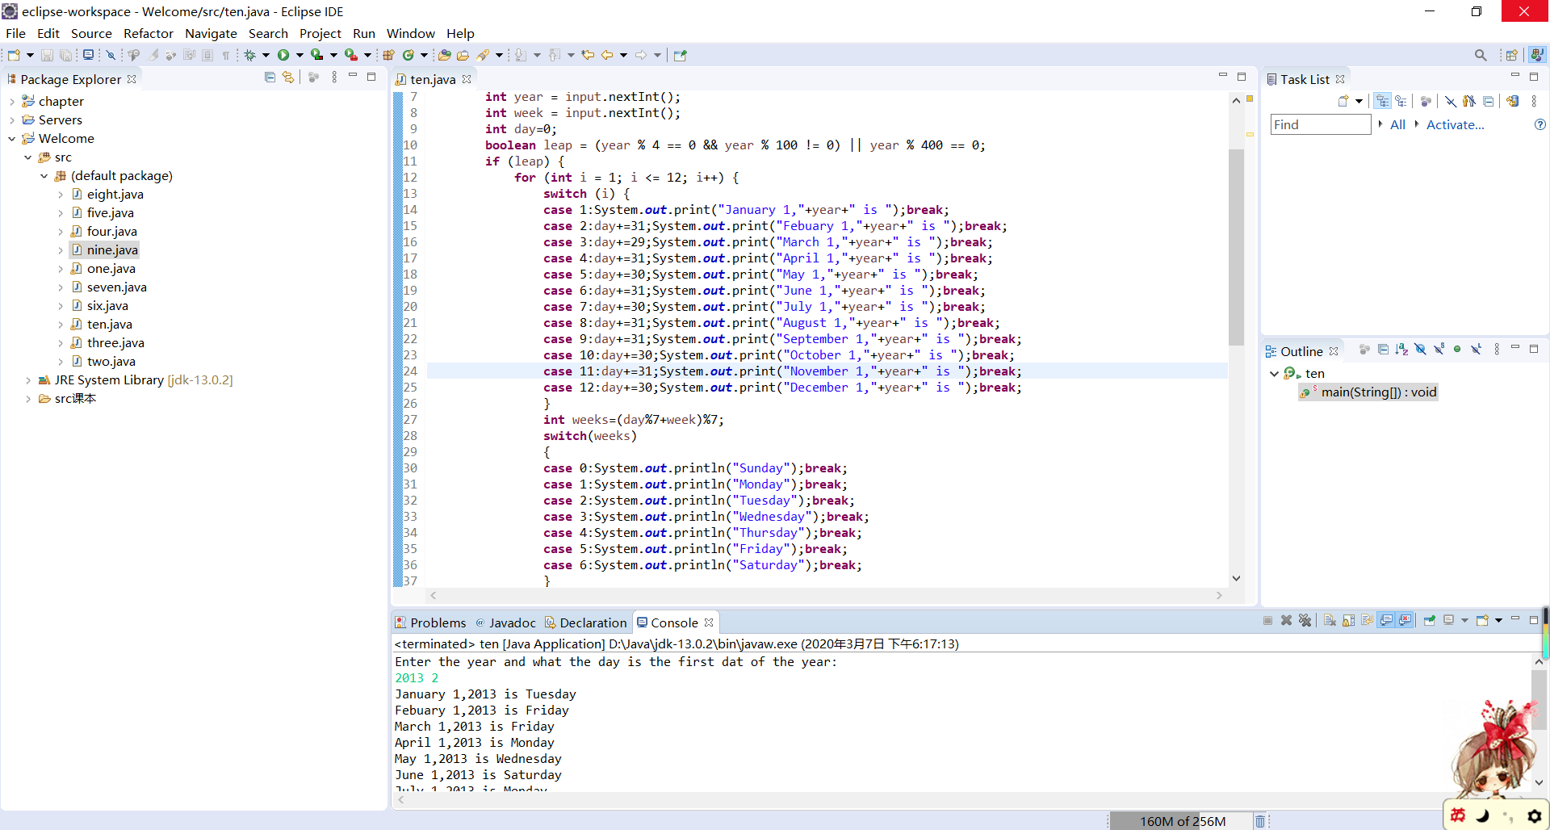

5.37

代码：

**import** java.util.Scanner;

**public** **class** eleven {

**public** **static** **void** main(String[] args) {

Scanner input = **new** Scanner(System.***in***);

System.***out***.print("Enter a decimal number: ");

**int** decimal = input.nextInt();

String bin = "";

**while** (decimal != 0) {

**int** binValue = decimal % 2;

bin = (**char**)(binValue+'0') + bin;

decimal = decimal / 2;

}

System.***out***.println("The bin number is " + bin);

}

}

截图：

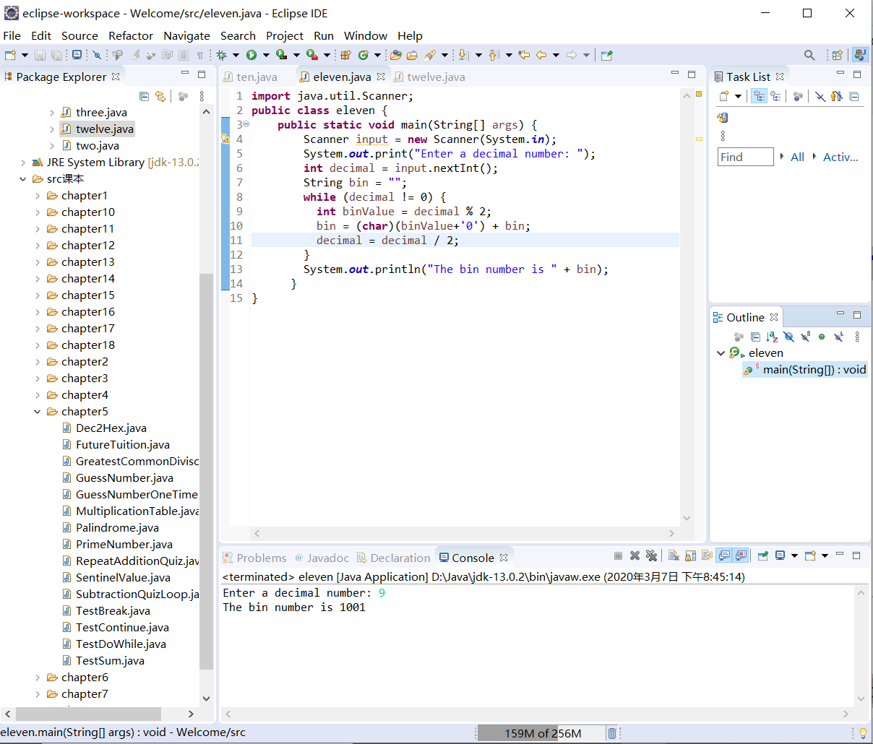

5.38

代码：

**import** java.util.Scanner;

**public** **class** twelve {

**public** **static** **void** main(String[] args) {

Scanner input = **new** Scanner(System.***in***);

System.***out***.print("Enter a decimal number: ");

**int** decimal = input.nextInt();

String oct = "";

**while** (decimal != 0) {

**int** octValue = decimal % 8;

oct = (**char**)(octValue+'0') + oct;

decimal = decimal / 8;

}

System.***out***.println("The oct number is " + oct);

}

}

截图：

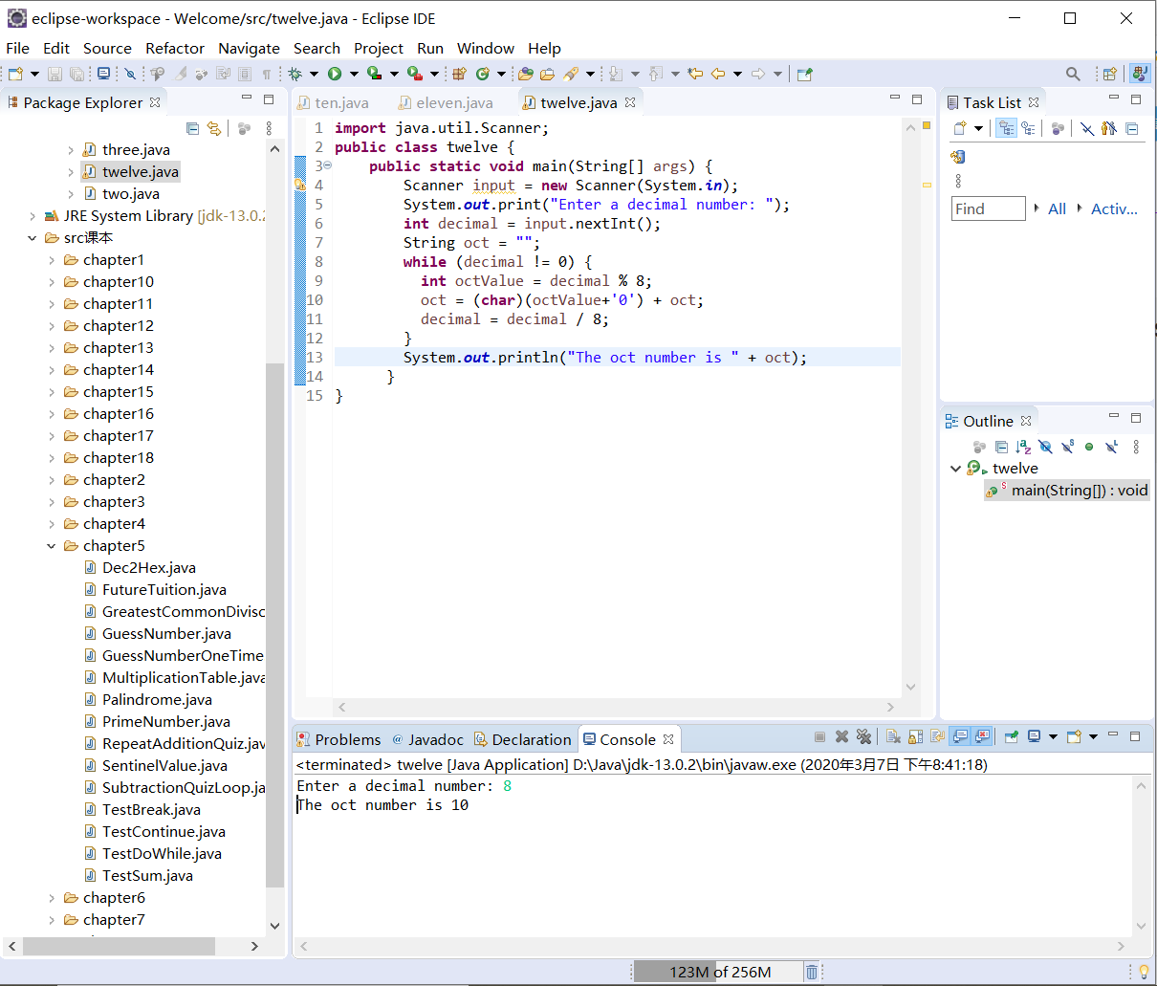

5.46

代码：

**import** java.util.Scanner;

**public** **class** thirteen {

**public** **static** **void** main(String[] args)

{

Scanner input=**new** Scanner(System.***in***);

System.***out***.println("Enter a srting:");

String s=input.next();

**int** n=0;

String ss="";

**while**(n<s.length())

{

ss=s.charAt(n)+ss;

n++;

}

System.***out***.println("The reversed string is "+ss);

}

}

截图：

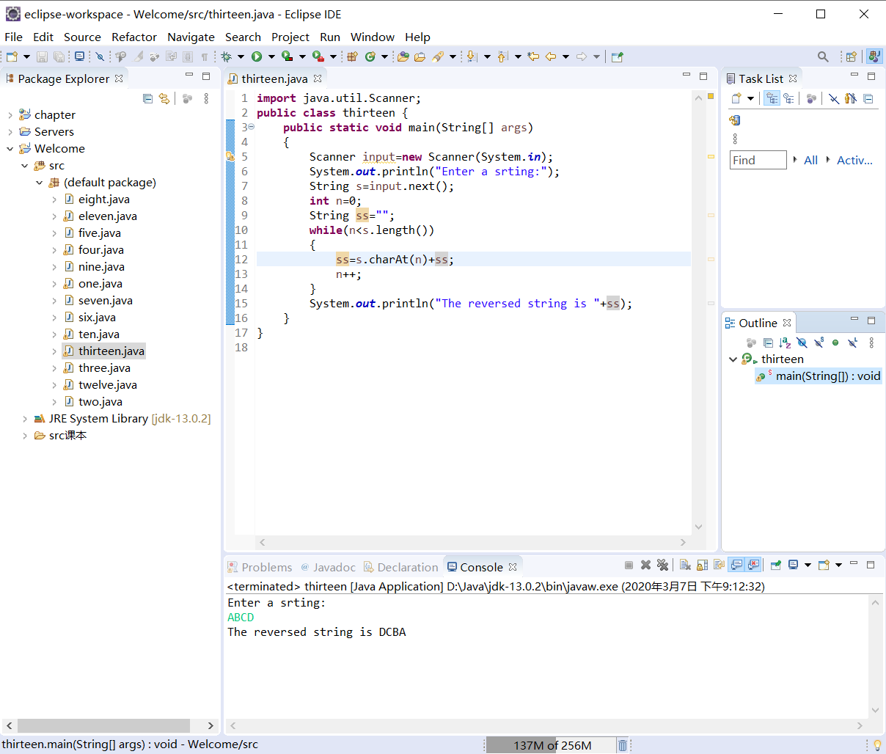

5.51

代码：

**import** java.util.Scanner;

**public** **class** fourteen {

**public** **static** **void** main(String[] args)

{

Scanner input =**new** Scanner(System.***in***);

System.***out***.println("Enter the first string:");

String s1=input.nextLine();

System.***out***.println("Enter the second string:");

String s2=input.nextLine();

**int** n1=s1.length();

**int** n2=s2.length();

**int** min;

**if**(n1>n2)min=n2;

**else** min=n1;

String str="";

**for**(**int** i=0;i<min;i++)

{

**if**(s1.charAt(i)==s2.charAt(i))

str=str+s1.charAt(i);

**else** **break**;

}

**if**(str.length()!=0)

System.***out***.println("The common prefix is "+str);

**else** System.***out***.println(s1+" and "+s2+"have no common prefix");

}

}

截图：

