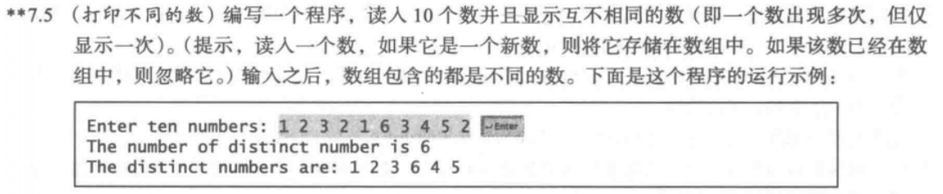

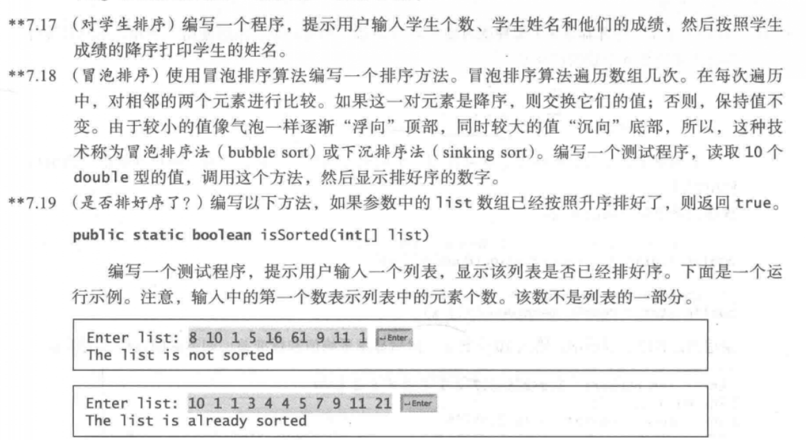

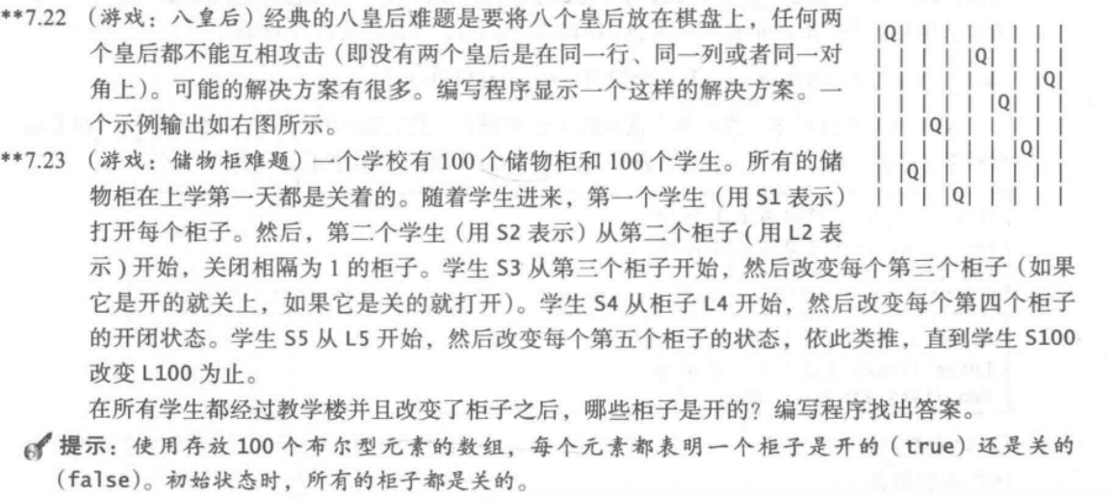

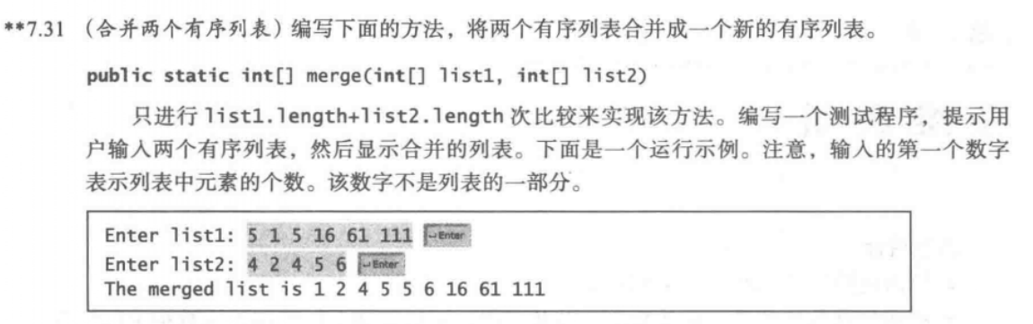

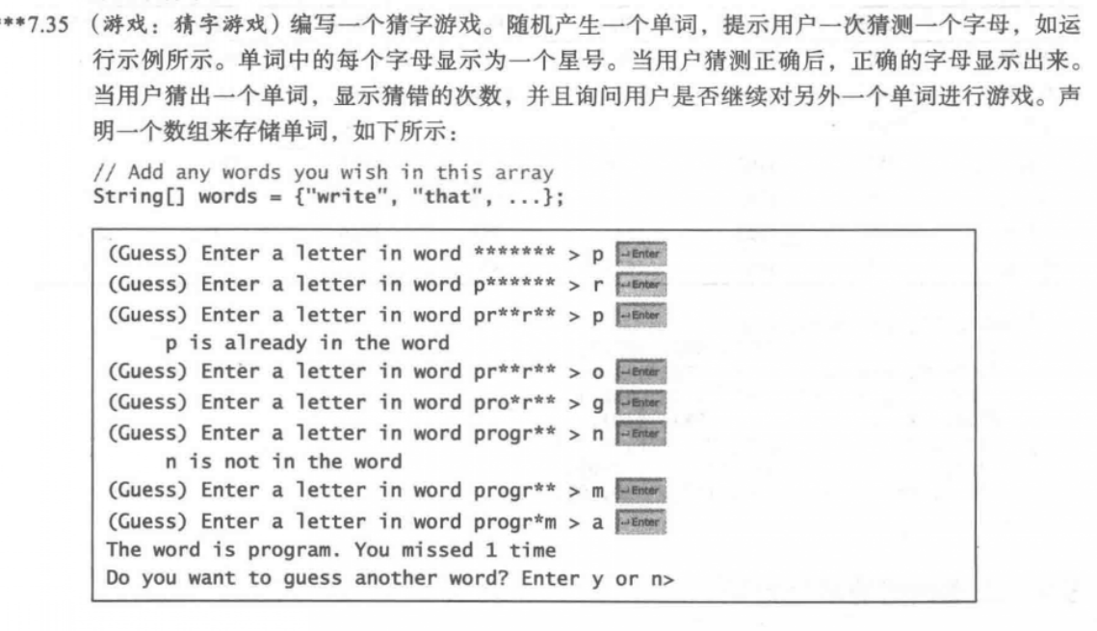

7.5：

代码：

**import** java.util.Scanner;

**public** **class** one {

**public** **static** **void** main(String[] args) {

Scanner input = **new** Scanner(System.***in***);

System.***out***.println("Enter ten numbers:");

**int**[] a = **new** **int**[10];

**int** count = 0;

**int**[] b = **new** **int**[10];

**for** (**int** i = 0; i < 10; i++) {

a[i] = input.nextInt();

**boolean** flag = **true**;

**for** (**int** j = 0; j < i; j++) {

**if** (a[j] == a[i]) {

flag = **false**;

**break**;

}

}

**if** (flag) {

b[count++] = a[i];

}

}

System.***out***.println("the number of distinct number is "+count);

System.***out***.print("the distinct numbers are: ");

**for**(**int** i=0;i<b.length&&b[i]!=0;i++)

{

System.***out***.print(b[i]+" ");

}

}

}

截图：

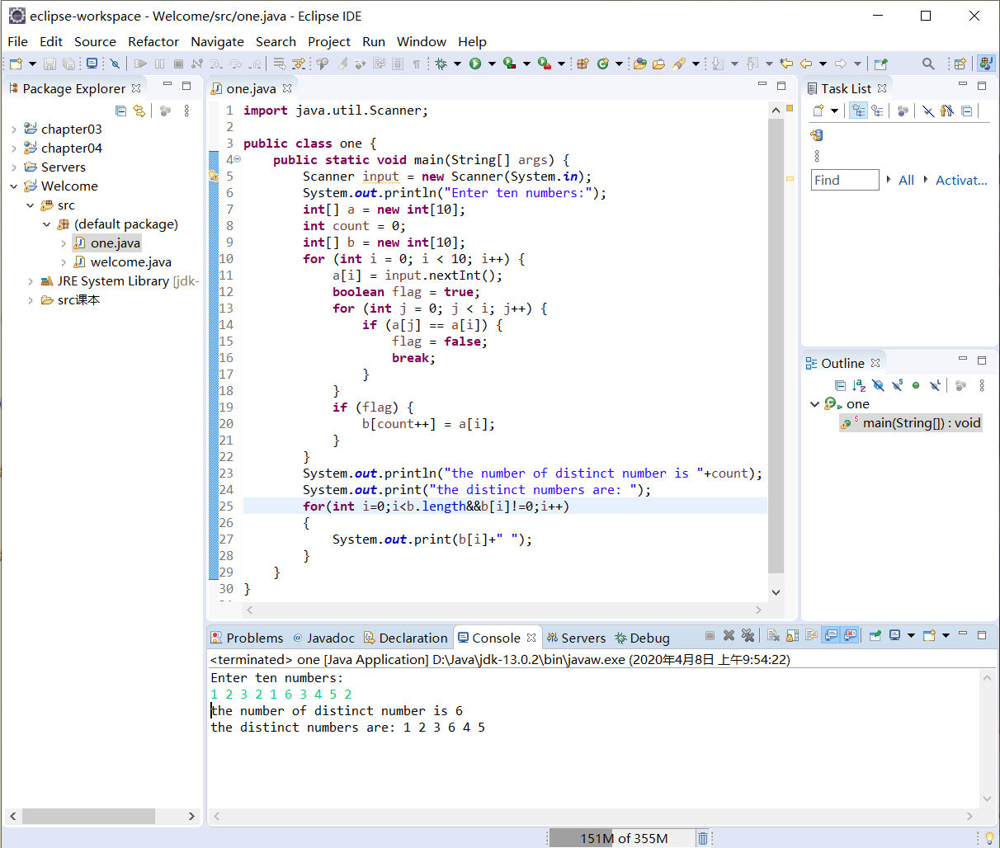

7.17：

代码：

**import** java.util.Scanner;

**public** **class** two {

**public** **static** **void** main(String[] args)

{

Scanner input =**new** Scanner(System.***in***);

System.***out***.println("Enter the number of students:");

**int** number=input.nextInt();

String[] name=**new** String[number];

**double**[] score=**new** **double**[number];

System.***out***.println("Enter the name and score:");

**for**(**int** i=0;i<number;i++)

{

name[i]=input.next();

score[i]=input.nextDouble();

}

**for**(**int** i=0;i<number;i++) {

**int** m=i;

**double** min=score[i];

**for**(**int** j=i+1;j<number;j++)

{

**if**(score[m]>score[j])

{

m=j;

min=score[j];

}

}

**if**(m!=i)

{

score[m]=score[i];

score[i]=min;

String temp=name[i];

name[i]=name[m];

name[m]=temp;

}

}

**for**(**int** i=0;i<number;i++)

{

System.***out***.print(name[i]+" ");

}

}

}

截图：

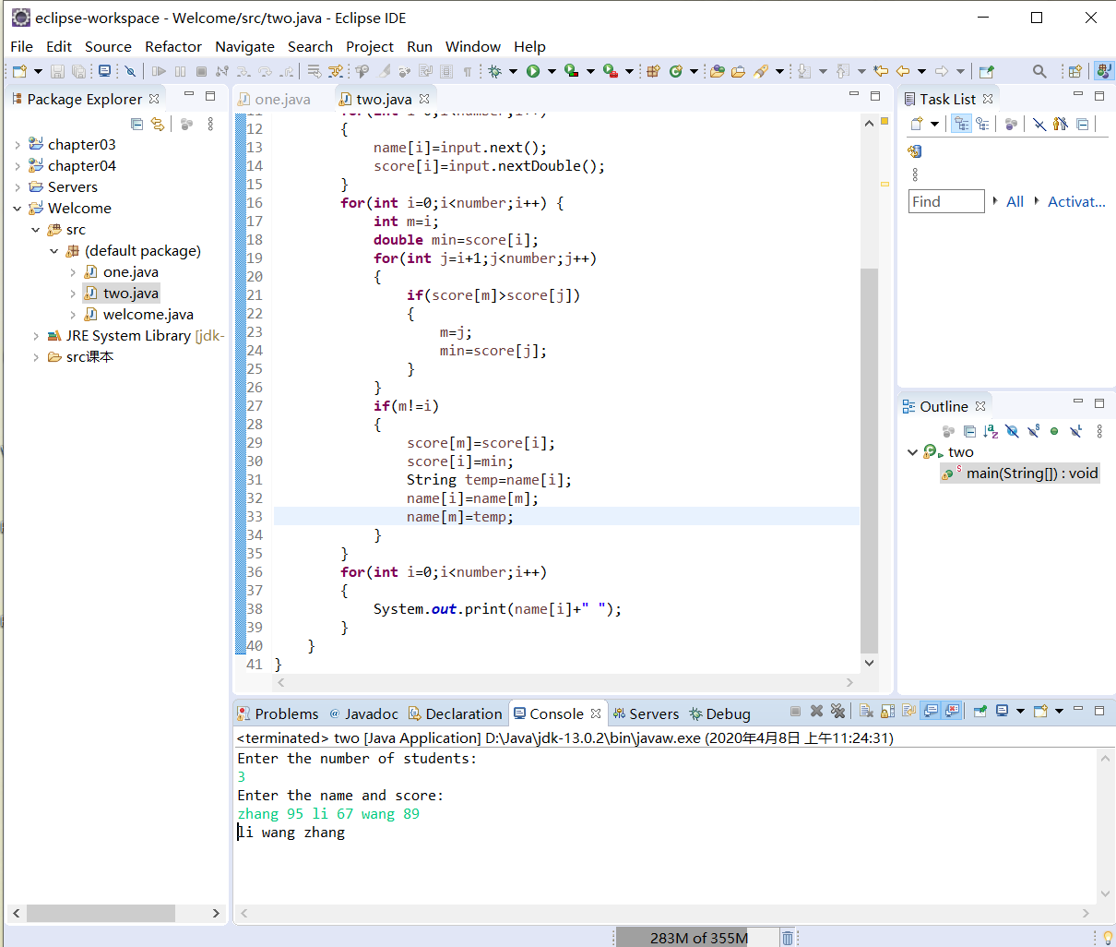

7.18：

代码：

**import** java.util.Scanner;

**public** **class** three {

**public** **static** **void** main(String[] args)

{

Scanner input=**new** Scanner(System.***in***);

System.***out***.println("Enter the number:");

**int** number=input.nextInt();

**double**[] s=**new** **double**[number];

**for**(**int** i=0;i<number;i++)

{

s[i]=input.nextDouble();

}

**for**(**int** i=0;i<number-1;i++)

{

**int** m=i;

**double** min=s[i];

**for**(**int** j=i+1;j<number;j++)

{

**if**(min>s[j])

{

m=j;

min=s[j];

}

}

**if**(m!=i)

{

s[m]=s[i];

s[i]=min;

}

}

**for**(**int** i=0;i<number;i++)

System.***out***.print(s[i]+" ");

}

}

截图：

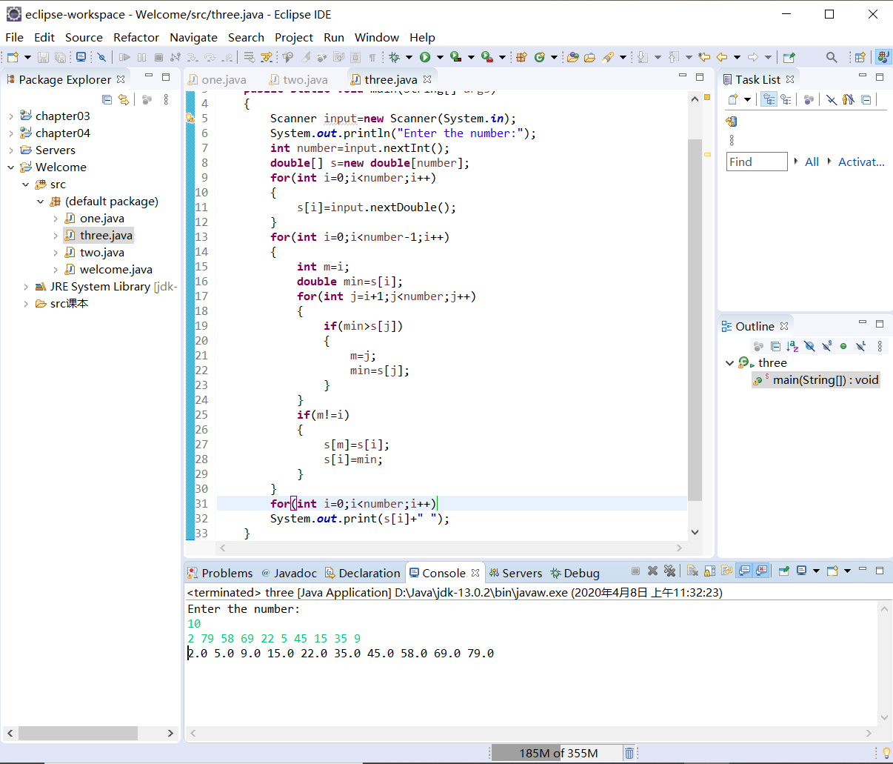

7.19：

代码：

**import** java.util.Scanner;

**public** **class** four {

**public** **static** **void** main(String[] args)

{

Scanner input=**new** Scanner(System.***in***);

System.***out***.print("Enter list:");

**int** number=input.nextInt();

**int**[] s=**new** **int**[number];

**for**(**int** i=0;i<number;i++)

s[i]=input.nextInt();

**if**(*isSorted*(s))

{

System.***out***.println("The list is already sorted");

}

**else** System.***out***.println("The list is not sorted");

}

**public** **static** **boolean** isSorted(**int**[] list)

{

**for**(**int** i=0;i<list.length-1;i++)

{

**if**(list[i]>list[i+1])

{

**return** **false**;

}

}

**return** **true**;

}

}

截图：

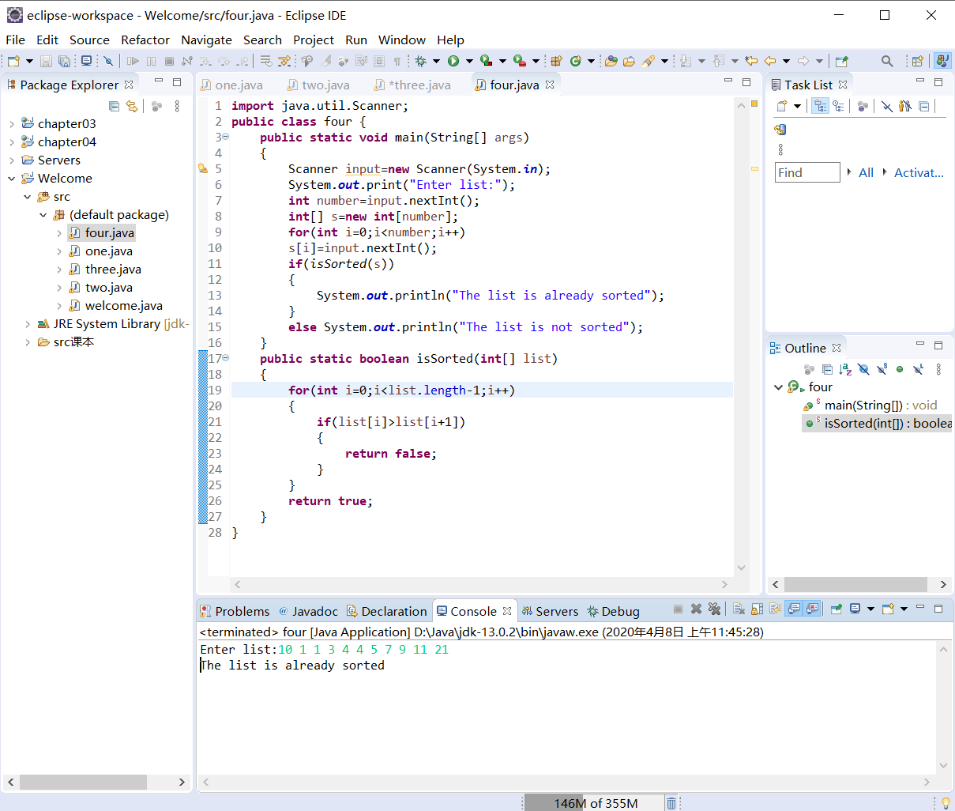

7.22：

代码：

**public** **class** fifth {

**public** **static** **void** main(String[] args) {

**int**[][] queen = **new** **int**[8][8];

**for** (**int** i = 0; i < 8; i++) {

**for** (**int** j = 0; j < 8; j++) {

queen[i][j] = 0;

}

}

*settle*(queen, 0);

**for** (**int** i = 0; i < 8; i++) {

System.***out***.print("|");

**for** (**int** j = 0; j < 8; j++) {

**if**(queen[i][j]==1)

System.***out***.print("Q|");

**else** System.***out***.print(" |");

}

System.***out***.println();

}

}

**public** **static** **boolean** check(**int**[][] queen, **int** i, **int** j) {//检查

**for** (**int** x = 0; x < i; x++) {

**if** (queen[x][j] == 1)

**return** **false**;// 同一列

}

//从第一行往下执行，斜向的点只需考虑左上或者右上

**for** (**int** x = 0; x < j; x++) {//x循环检查前面的行

**if** (queen[i][x] == 1)

**return** **false**;// 同一行 （点按照行来，可以不检查行）

**if** (i - 1 - x >= 0 && queen[i - 1 - x][j - 1 - x] == 1)

**return** **false**;// 左上侧斜向

**if** (i + 1 + x < 8 && queen[i + 1 + x][j - 1 - x] == 1)

**return** **false**;// 右上侧斜向

}

**return** **true**;

}

**public** **static** **boolean** settle(**int**[][] queen, **int** x) {//递归回溯

**if** (x == 8) {

**return** **true**;//行数超过8，已经得到答案

}

**for** (**int** i = 0; i < 8; i++) {

**for** (**int** j = 0; j < 8; j++) {

queen[j][x] = 0;// 当前行清零

}

**if** (*check*(queen, i, x)) {

queen[i][x] = 1;

**if** (*settle*(queen, x + 1)) {

**return** **true**;

}

}

}

**return** **false**;

}

}

截图：

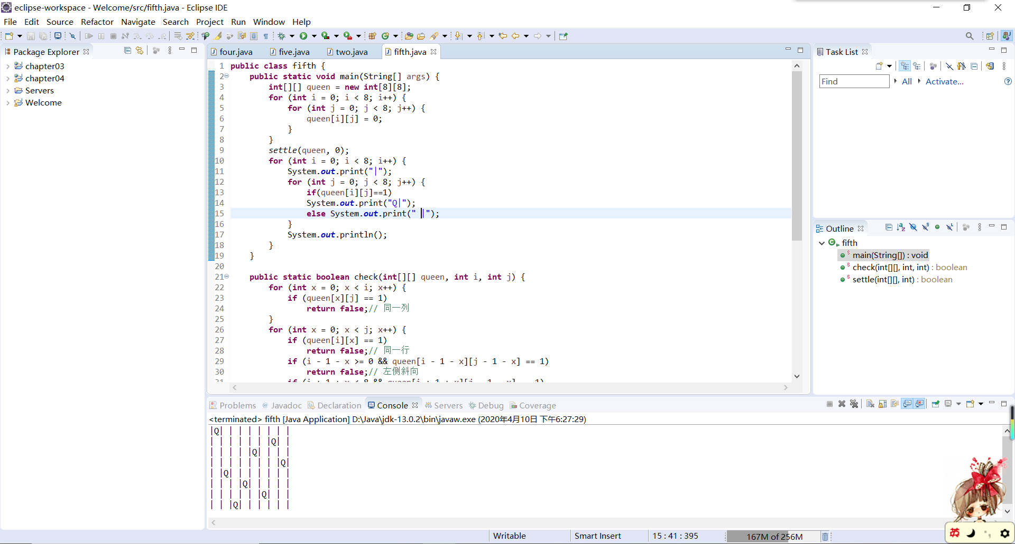

7.23：

代码：

**public** **class** six {

**public** **static** **void** main(String[] args) {

**boolean**[] l=**new** **boolean**[100];

**for**(**int** i=0;i<100;i++)

{

l[i]=**false**;

}

**for**(**int** i=1;i<=100;i++)

{

**for**(**int** j=i;j<=100;j=j+i)

{

l[j-1]=!l[j-1];

}

}

**for**(**int** i=0;i<100;i++)

{

**if**(l[i])

System.***out***.print(i+1+" ");

}

}

}

截图：

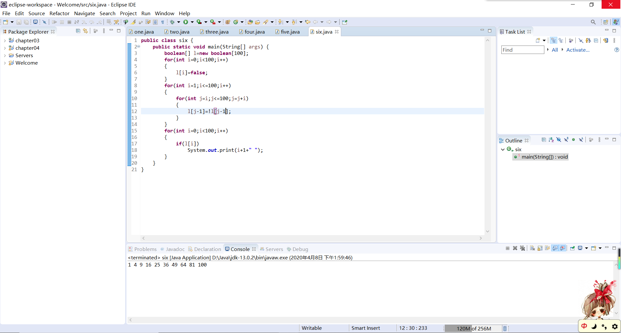

7.31：

代码：

**import** java.util.Scanner;

**public** **class** seven {

**public** **static** **void** main(String[] args) {

Scanner input = **new** Scanner(System.***in***);

System.***out***.println("Enter list1:");

**int** n1 = input.nextInt();

**int**[] list1 = **new** **int**[n1];

**for** (**int** i = 0; i < n1; i++)

list1[i] = input.nextInt();

System.***out***.println("Enter list2:");

**int** n2 = input.nextInt();

**int**[] list2 = **new** **int**[n2];

**for** (**int** i = 0; i < n2; i++)

list2[i] = input.nextInt();

**int**[] list = **new** **int**[n1 + n2];

**int** m = 0;

**int** n = 0;

**for** (**int** i = 0; i < n1 + n2; i++) {

**if** (m < n1 && n < n2) { //1、2均未遍历完

**if** (list1[m] <= list2[n]) {

list[i] = list1[m];

m++;

} **else** **if** (list1[m] > list2[n]) {

list[i] = list2[n];

n++;

}

}

**else** **if** (m<n1) //1未遍历完

{

list[i]=list1[m++];

}

**else** **if** (n<n2) //2未遍历完

{

list[i]=list2[n++];

}

}

System.***out***.print("The merged list is ");

**for** (**int** i = 0; i < n1 + n2; i++) {

System.***out***.print(list[i] + " ");

}

}

}

截图：

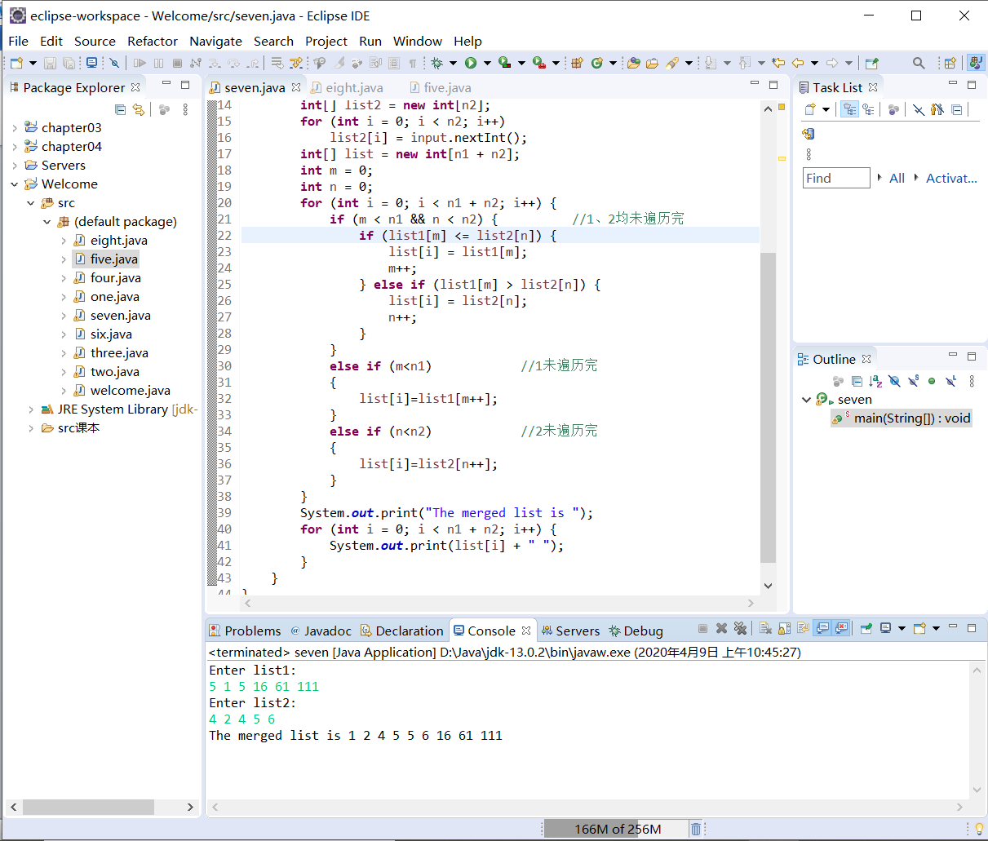

7.35：

代码：

**import** java.util.Scanner;

**public** **class** eight {

**public** **static** **void** main(String[] args) {

String[] words = { "write", "that", "program" ,"java","compile"};

Scanner input = **new** Scanner(System.***in***);

String action = "y";// 测试开始

**while** (action == "y") {

**int** n = (**int**) (Math.*random*() * 5);//随机选择单词

**int** length = words[n].length();//该单词的长度

**char**[] ans = **new** **char**[length];//答案数组

**int** count = 0;// 错误计数

System.***out***.print("(Guess)Enter a letter in word ");

**for** (**int** i = 0; i < length; i++) {

ans[i] = '*';

System.***out***.print("*");

}

System.***out***.print(" > ");

**while** (!words[n].equals(**new** String(ans))) { // 比较char数组与string字符串是否相等

String x = input.next();

**boolean** flag = **false**;// 测试单词中字母不存在

**for** (**int** i = 0; i < length; i++) {

**if** (words[n].charAt(i) == x.charAt(0)) {

**if** (ans[i]!='*') // 测试单词中字母已经存在

{

System.***out***.println(x.charAt(0) + " is already in the word");

flag=**true**;

**break**;

}

ans[i] = x.charAt(0);

flag = **true**;

}

}

**if** (words[n].equals(**new** String(ans)))//答案正确，退出猜字

**break**;

**if** (!flag) {

count++;

System.***out***.println(x.charAt(0) + " is not in the word");

}

System.***out***.print("(Guess)Enter a letter in word ");

**for** (**int** ii = 0; ii < length; ii++) {

System.***out***.print(ans[ii]);

}

System.***out***.print(" > ");

}

System.***out***.println("The word is " + words[n] + ". You missed " + count + " time");

System.***out***.println("Do you want to guess another word? Enter y or n >");

action = input.next();

}

}

}

截图：

