12.1
（1）非异常处理器
代码：
public class one1 {
public static void main(String[] args) {
if (args.length != 3) {
System.out.println("Usage: java Calculator operand1 operator operand2");
System.exit(0);
}
for (int i = 0; i <= 2; i += 2) {
for (int j = 0; j < args[i].length(); j++) {
if (args[i].charAt(j) >= 48 && args[i].charAt(j) <= 57) {
continue;
}
else {
System.out.println("Wrong Input: " + args[i]);
System.exit(1);
}
}
}
int result = 0;
switch (args[1].charAt(0)) {
case '+':
result = Integer.parseInt(args[0]) + Integer.parseInt(args[2]);
break;
case '-':
result = Integer.parseInt(args[0]) - Integer.parseInt(args[2]);
break;
case '.':
result = Integer.parseInt(args[0]) * Integer.parseInt(args[2]);
break;
case '/':
result = Integer.parseInt(args[0]) / Integer.parseInt(args[2]);
}
System.out.println(args[0] + ' ' + args[1] + ' ' + args[2] + " = " + result);
}
}
截图：
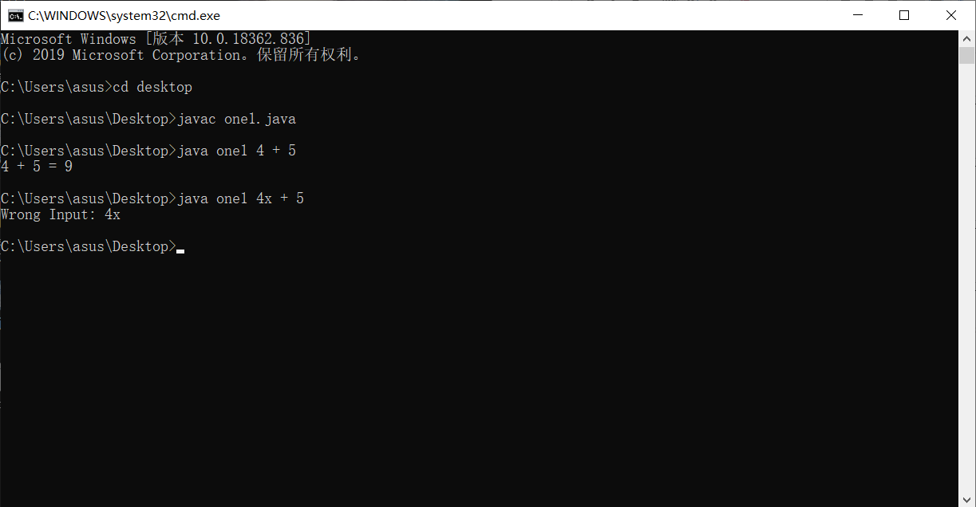
（2）异常处理器
代码：
public class one2 {
public static void main(String[] args) {
if (args.length != 3) {
System.out.println("Usage: java Calculator operand1 operator operand2");
System.exit(0);
}
try {
int result = 0;
switch (args[1].charAt(0)) {
case '+':
result = Integer.parseInt(args[0]) + Integer.parseInt(args[2]);
break;
case '-':
result = Integer.parseInt(args[0]) - Integer.parseInt(args[2]);
break;
case '.':
result = Integer.parseInt(args[0]) * Integer.parseInt(args[2]);
break;
case '/':
result = Integer.parseInt(args[0]) / Integer.parseInt(args[2]);
}
System.out.println(args[0] + ' ' + args[1] + ' ' + args[2] + " = " + result);
}
catch (NumberFormatException ex) {
System.out.println("Wrong Input: "+ex.getMessage());
}
}
}
截图：
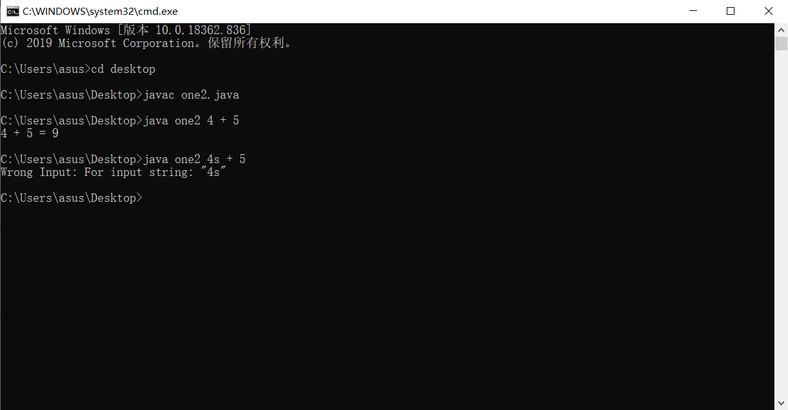
12.2
代码：
import java.util.*;
public class two {
public static void main(String args[]) {
Scanner input = new Scanner(System.in);
while (true) {
System.out.println("Enter the integers:");
try {
int a = input.nextInt();
int b = input.nextInt();
int sum = a + b;
System.out.println("the sum of the two integers is " + sum);
break;
}
catch (InputMismatchException ex) {
input.nextLine();//input.next();//input.reset();
}
}
}
}
截图：
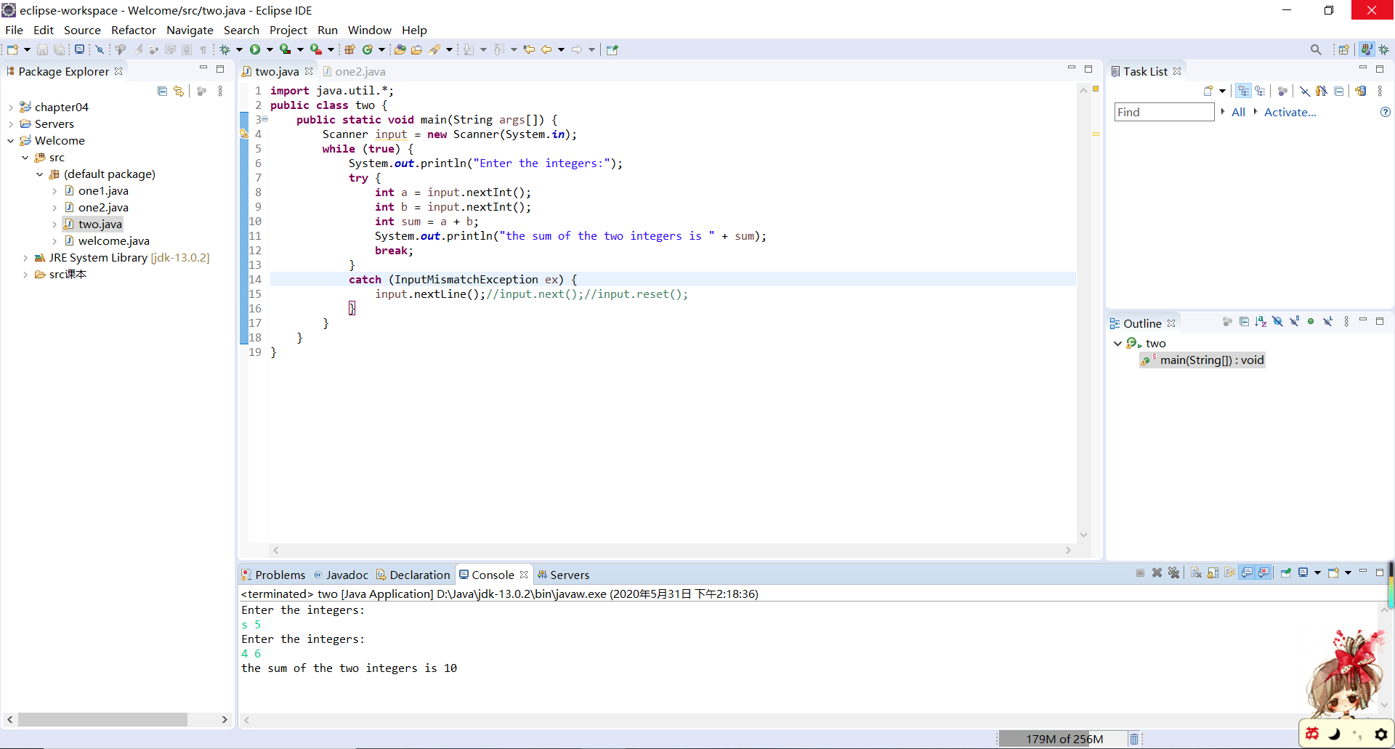
12.5
代码：
public class three {
public static void main(String[] args)
{
try {
Triangle A=new Triangle(3,4,5);
System.out.println("A: the area: "+A.getArea()+",the perimeter: "+A.getPerimeter()+"\n"+A.toString());
Triangle B=new Triangle(1,2,3);
System.out.println("B: the area: "+B.getArea()+",the perimeter: "+B.getPerimeter()+"\n"+B.toString());
}
catch(IllegalTriangleException ex)
{
System.out.println(ex);
}
}
}

class IllegalTriangleException extends Exception {
public IllegalTriangleException() {
super("the illegal input!");
}
}

class GeometricObject {
private String color = "white";
private boolean filled;
private java.util.Date dateCreated;
public GeometricObject() {
dateCreated = new java.util.Date();
}
public GeometricObject(String color, boolean filled) {
dateCreated = new java.util.Date();
this.color = color;
this.filled = filled;
}
public String getColor() {
return color;
}
public void setColor(String color) {
this.color = color;
}
public boolean isFilled() {
return filled;
}
public void setFilled(boolean filled) {
this.filled = filled;
}
public java.util.Date getDateCreated() {
return dateCreated;
}
public String toString() {
return "created on" + dateCreated + "\ncolor:" + color + "and filled:" + filled;
}
}

class Triangle extends GeometricObject {
private double side1 = 1.0;
private double side2 = 1.0;
private double side3 = 1.0;
public Triangle() throws IllegalTriangleException {

}
public Triangle(double side1, double side2, double side3) throws IllegalTriangleException {
if (side1 + side2 > side3 && side1 + side3 > side2 && side2 + side3 > side1) {
this.side1 = side1;
this.side2 = side2;
this.side3 = side3;
}
else
throw new IllegalTriangleException();
}
public void setSide1(double side1) {
this.side1 = side1;
}
public void setSide2(double side2) {
this.side2 = side2;
}
public void setSide3(double side3) {
this.side3 = side3;
}
public double getSide1() {
return side1;
}
public double getSide2() {
return side2;
}
public double getSide3() {
return side3;
}
public double getArea() {
double result;
double s = (side1 + side2 + side3) / 2;
result = Math.sqrt(s * (s - side1) * (s - side2) * (s - side3));
return result;
}
public double getPerimeter() {
return side1 + side2 + side3;
}
public String toString() {
return "Triangle:side1=" + side1 + "side2=" + side2 + "side3=" + side3;
}
}
截图：
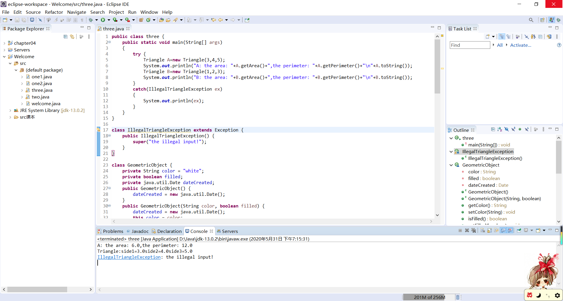
12.8
代码：
import java.util.Scanner;
public class four {
public static void main(String[] args) {
Scanner input = new Scanner(System.in);
System.out.print("Enter a hex number: ");
try
{
String hex = input.nextLine();
System.out.println("The decimal value for hex number "+ hex + " is " + hexToDecimal(hex.toUpperCase()));
}
catch(HexFormatException ex)
{
System.out.println(ex);
}
}
public static int hexToDecimal(String hex) throws HexFormatException {
int decimalValue = 0;
for (int i = 0; i < hex.length(); i++) {
char hexChar = hex.charAt(i);
decimalValue = decimalValue * 16 + hexCharToDecimal(hexChar);
}
return decimalValue;
}
public static int hexCharToDecimal(char ch) throws HexFormatException {
if (ch >= 'A' && ch <= 'F')
return 10 + ch - 'A';
else if((ch>='a')&&(ch<='f'))
return 10 + ch - 'a';
else if(ch>='0'&&ch<='9')
return ch - '0';
else
throw new HexFormatException();
}
}

class HexFormatException extends Exception{
public HexFormatException() {
super("The string is not hexadecimal!");
}
}
截图：
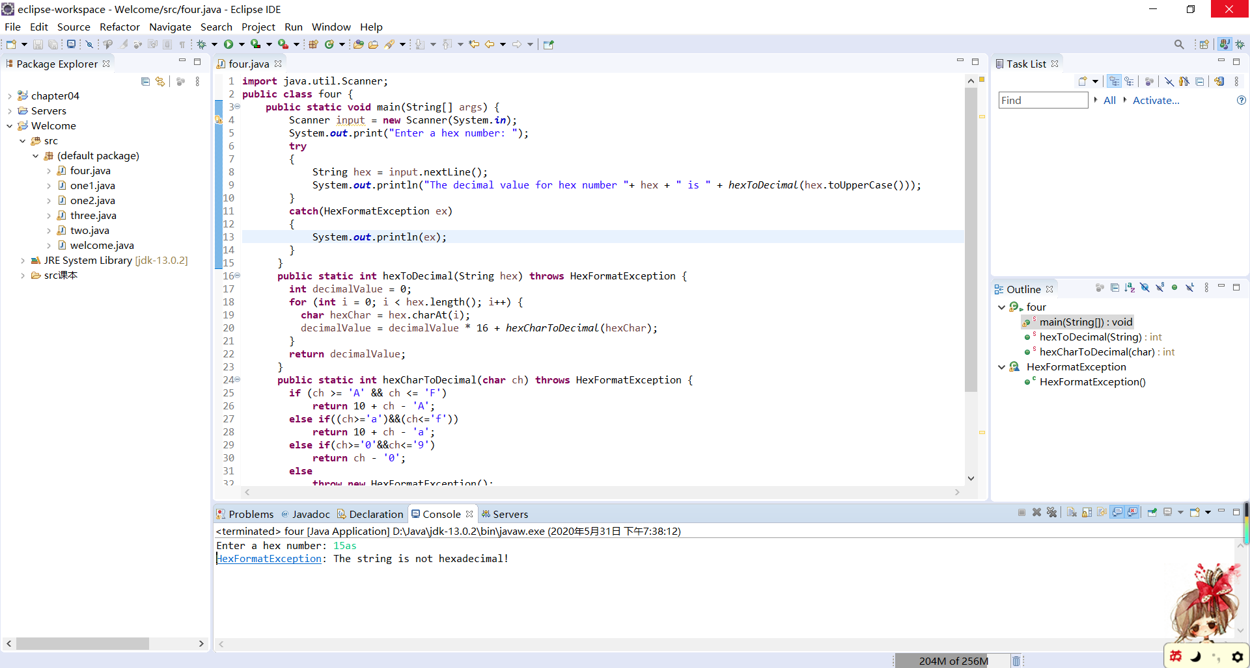
12.15
代码：
import java.io.File;
import java.io.FileNotFoundException;
import java.io.PrintWriter;
import java.util.Scanner;

public class five {
public static void main(String[] args) {
int[] random1 = new int[100];
int[] random2 = new int[100];
for (int i = 0; i < 100; i++) {
random1[i] = (int) (Math.random() * 101);
}
File file = new File("Exercise12_15.txt");
if (file.exists()) {
System.out.println("File already exists");
System.exit(1);
}
try{
PrintWriter output = new PrintWriter(file);
for (int i = 0; i < 100; i++) {
output.print(random1[i]);
output.print(" ");
}
output.close();
Scanner input = new Scanner(file);
int j = 0;
while (input.hasNext()) {
random2[j++] = input.nextInt();
}
input.close();
}
catch(FileNotFoundException ex){
System.out.println(ex);
System.exit(0);
}
for (int i = 0; i < random2.length - 1; i++) {
int min = random2[i];
int a = i;
for (int k = i + 1; k < random2.length; k++) {
if (min > random2[k]) {
min = random2[k];
a = k;
}
}
if (a != i) {
random2[a] = random2[i];
random2[i] = min;
}
}
for (int i = 0; i < random2.length; i++) {
if(i%10==0)
System.out.println();
System.out.print("\t"+random2[i]);
}
}
}
截图：
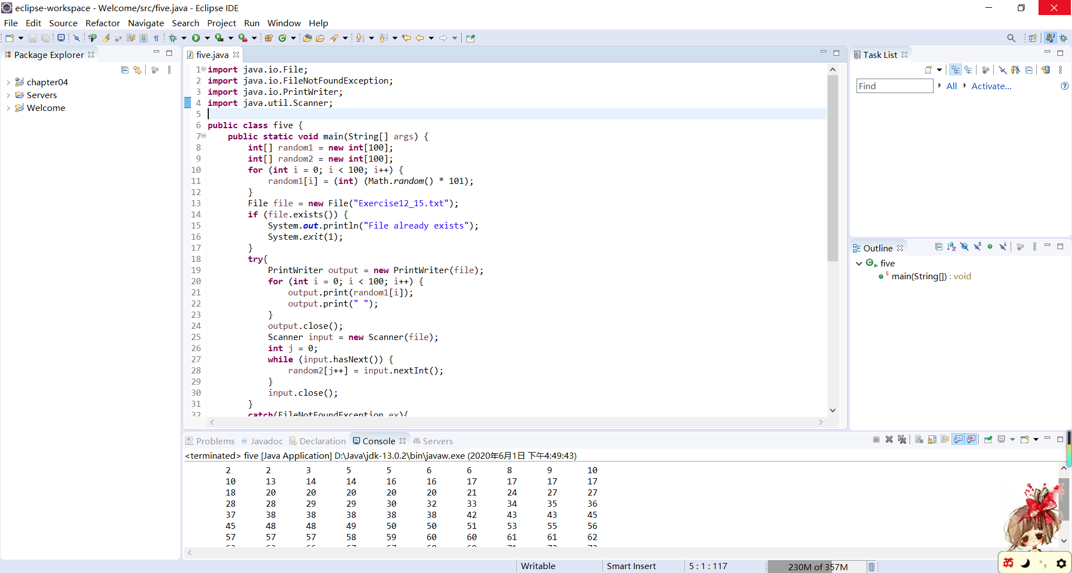
12.19
代码：
import java.io.IOException;
import java.net.MalformedURLException;
import java.net.URL;
import java.util.Scanner;

public class six {
public static void main(String[] args)
{
try {
//URL url=new URL("http://cs.armstrong.edu/liang/data/Lincoln.txt");
URL url=new URL("http://guidetogrammar.org/grammar/gettysburg.htm");
int count=0;
Scanner input=new Scanner(url.openStream());
while(input.hasNext())
{
String line=input.next();
count++;
}
System.out.println("the number of words is "+count);
}
catch(MalformedURLException ex)
{
System.out.println("Invalid URL");
}
catch(IOException ex)
{
System.out.println("I/O Errors: no such file");
}
}
}
截图：
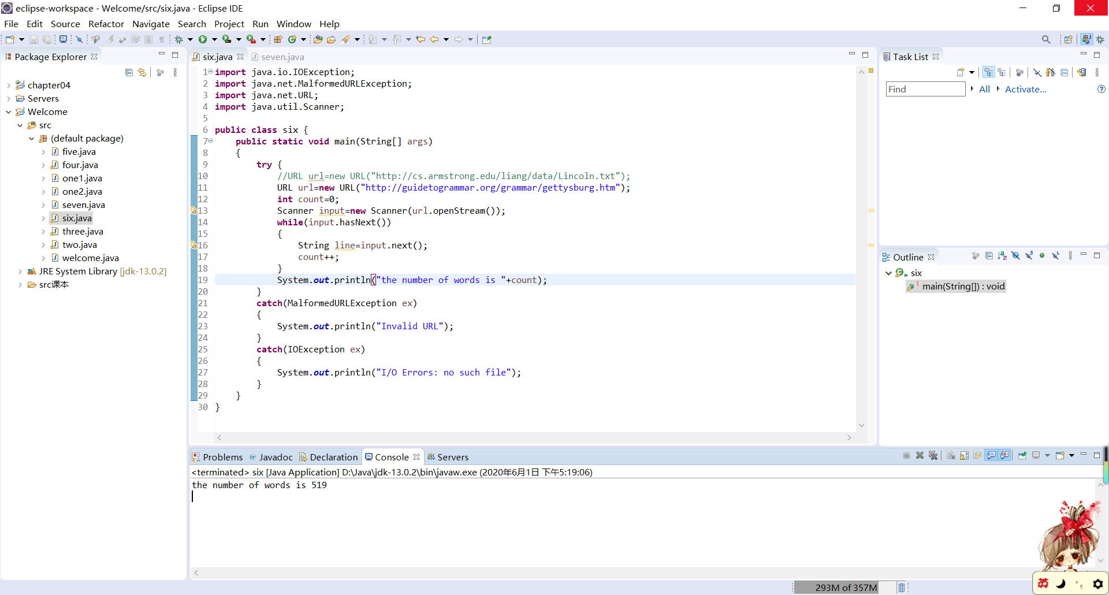
12.23
代码：
import java.io.File;
import java.io.FileNotFoundException;
import java.util.Scanner;
public class seven {
public static void main(String[] args) {
File file = new File("src/Lincoln.txt");
/*1 2 3 4 5 6 7 8 9
9 8 7 6 5 4 3 2 1
1 1 1 1 1 1 1 1 1
9 9 9 9 9 9 9 9 9 */
if (!file.exists()) {
System.out.println("File doesn't exist");
System.exit(1);
}
try{
Scanner input = new Scanner(file);
double sum=0;
double aver=0;
double count=0;
while (input.hasNext()) {
String line=input.next();
if(line.charAt(0)>=48&&line.charAt(0)<=57)
{
sum+=line.charAt(0)-48;
count++;
}
}
aver=sum/count;
input.close();
System.out.println("the sum is:"+sum+",the average is:"+aver);
}
catch(FileNotFoundException ex){
System.out.println(ex);
System.exit(0);
}
}
}
截图：
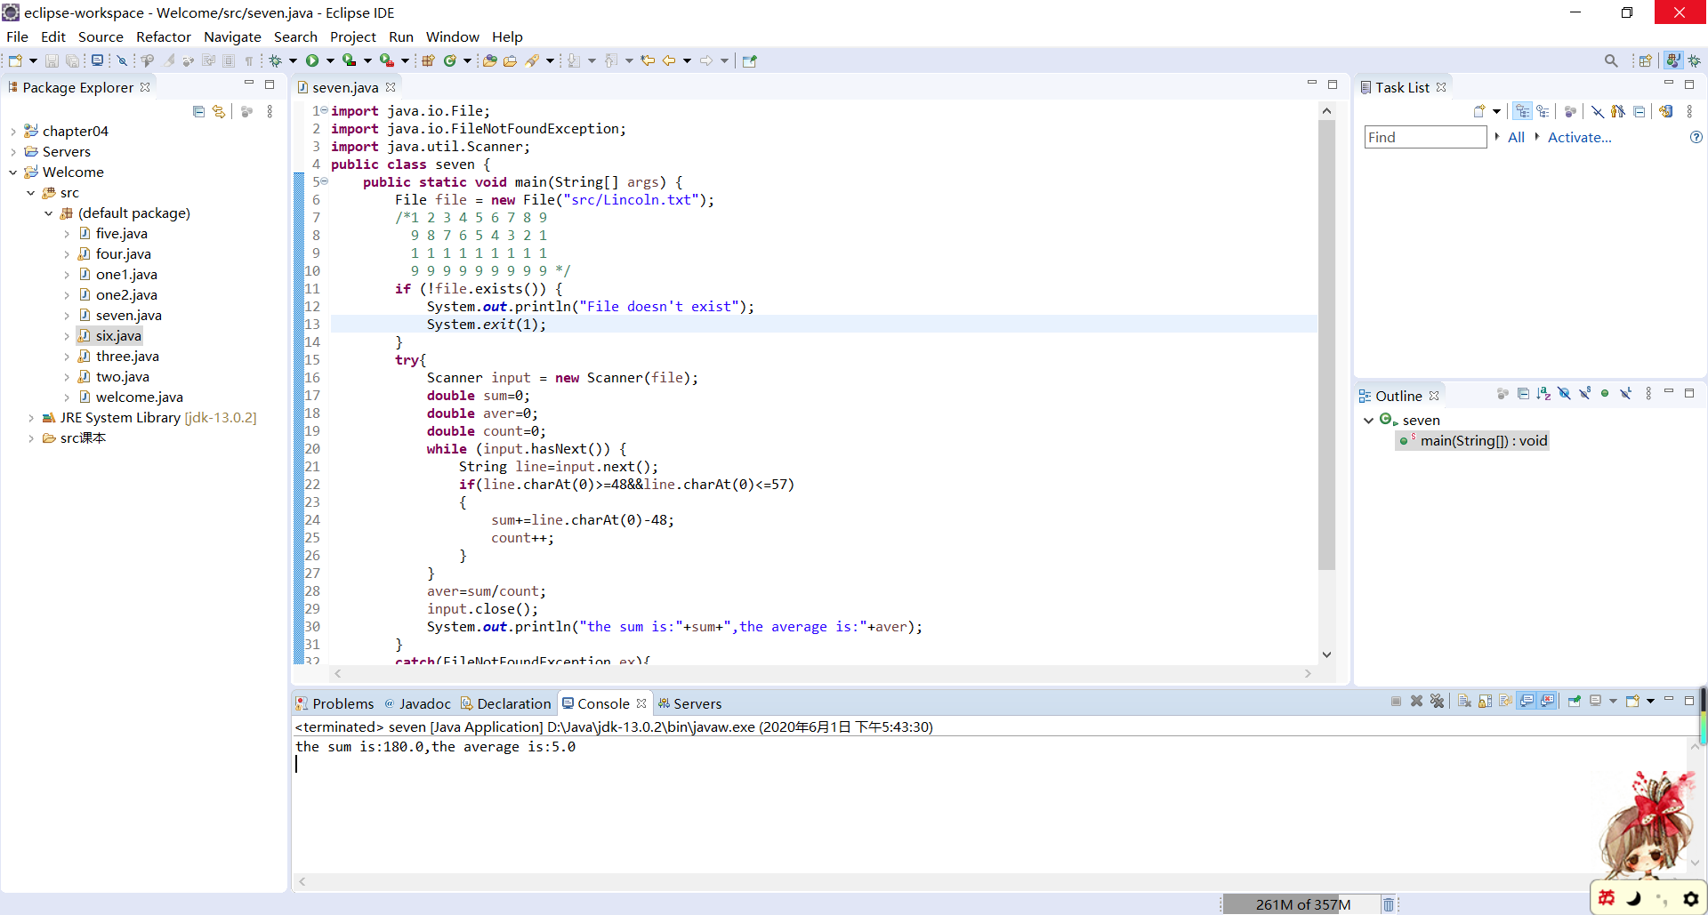
12.30
代码：
import java.io.File;
import java.io.FileNotFoundException;
import java.util.Scanner;
public class eight {
public static void main(String[] args) {
Scanner in =new Scanner(System.in);
System.out.println("Enter a filename:");
File file = new File(in.nextLine());
int[] count=new int[26];
if (!file.exists()) {
System.out.println("File doesn't exist");
System.exit(1);
}
try{
Scanner input = new Scanner(file);
while (input.hasNext()) {
String line=input.next().toUpperCase();
for(int i=0;i<line.length();i++)
{
if(line.charAt(i)>=65&&line.charAt(i)<=90)
count[line.charAt(i)-'A']++;
}
}
for(int i=0;i<26;i++)
{
char word=(char)('A'+i);
System.out.println("Number of "+word+"'s: "+count[i]);
}
}
catch(FileNotFoundException ex){
System.out.println(ex);
System.exit(0);
}
}
}
截图：
