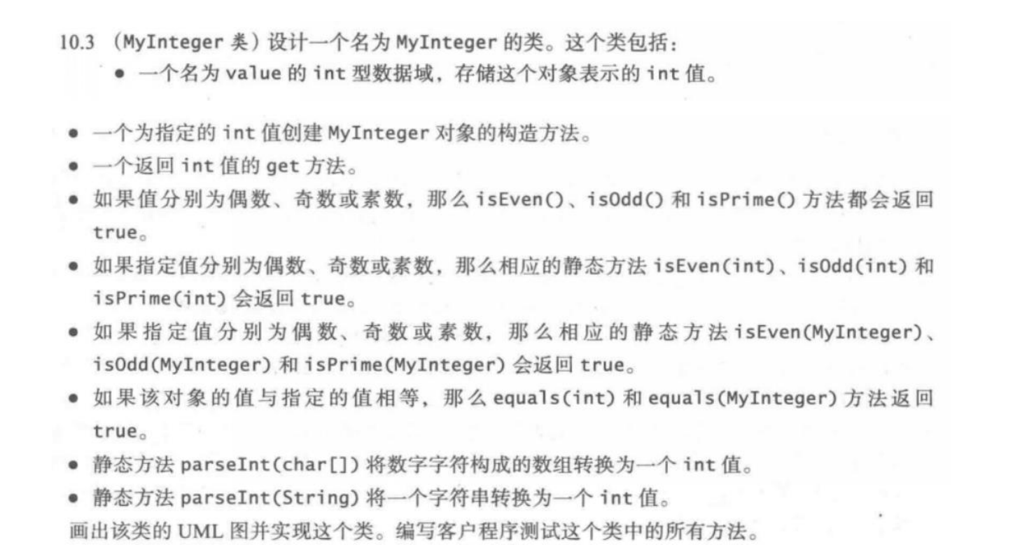
UML图：
MyInteger
-value:int
+MyInteger(x:int)
+getValue():int
+isEven():boolean
+isOdd():boolean
+isPrime():boolean
+isEven(v:int):boolean
+isOdd(v:int):boolean
+isPrime(v:int):boolean
+isEven(x: MyInteger):boolean
+isOdd(x: MyInteger):boolean
+isPrime(x: MyInteger):boolean
+equals(v:int):boolean
+equals(x: MyInteger):boolean
+parseInt(a:char[]):int
+parseInt(a:String):int
代码：
public class one {
public static void main(String[] args)
{
MyInteger a=new MyInteger(5);
MyInteger b=new MyInteger(7);
int value=a.getValue();
System.out.println("the value of a is "+value);
System.out.println("a isEven? "+a.isEven()+" isOdd? "+a.isOdd()+" isPrime? "+a.isPrime());
System.out.println("6 isEven? "+MyInteger.isEven(6)+" isOdd? "+MyInteger.isOdd(6)+" isPrime? "+MyInteger.isPrime(6));
System.out.println("b isEven? "+MyInteger.isEven(b)+" isOdd? "+MyInteger.isOdd(b)+" isPrime? "+MyInteger.isPrime(b));
System.out.println("a=6? "+a.equals(6));
System.out.println("a=b? "+a.equals(b));
char[] x={1,2,3};
System.out.println(MyInteger.parseInt(x));
String y="456";
System.out.println(MyInteger.parseInt(y));
}
}

class MyInteger{
private int value;
public MyInteger(int x)
{
value=x;
}
public int getValue()
{
return value;
}
public boolean isEven()
{
return value%2==0;
}
public boolean isOdd()
{
return value%2!=0;
}
public boolean isPrime()
{
for(int i = 2 ; i < Math.sqrt(value) ; i++)
{
if(value % i == 0)
return false;
}
return true;
}
public static boolean isEven(int v)
{
return v%2==0;
}
public static boolean isOdd(int v)
{
return v%2!=0;
}
public static boolean isPrime(int v)
{
for(int i = 2 ; i < Math.sqrt(v) ; i++)
{
if(v % i == 0)
return false;
}
return true;
}
public static boolean isEven(MyInteger x)
{
return x.value%2==0;
}
public static boolean isOdd(MyInteger x)
{
return x.value%2!=0;
}
public static boolean isPrime(MyInteger x)
{
for(int i = 2 ; i < Math.sqrt(x.value) ; i++)
{
if(x.value % i == 0)
return false;
}
return true;
}
public boolean equals(int v)
{
return value==v;
}
public boolean equals(MyInteger x)
{
return value==x.value;
}
public static int parseInt(char[] a)
{
int x=0;
for(int i=0;i<a.length;i++)
{
x=x*10+a[i];
}
return x;
}
public static int parseInt(String a)
{
int y=Integer.parseInt(a);
return y;
}
}
截图：
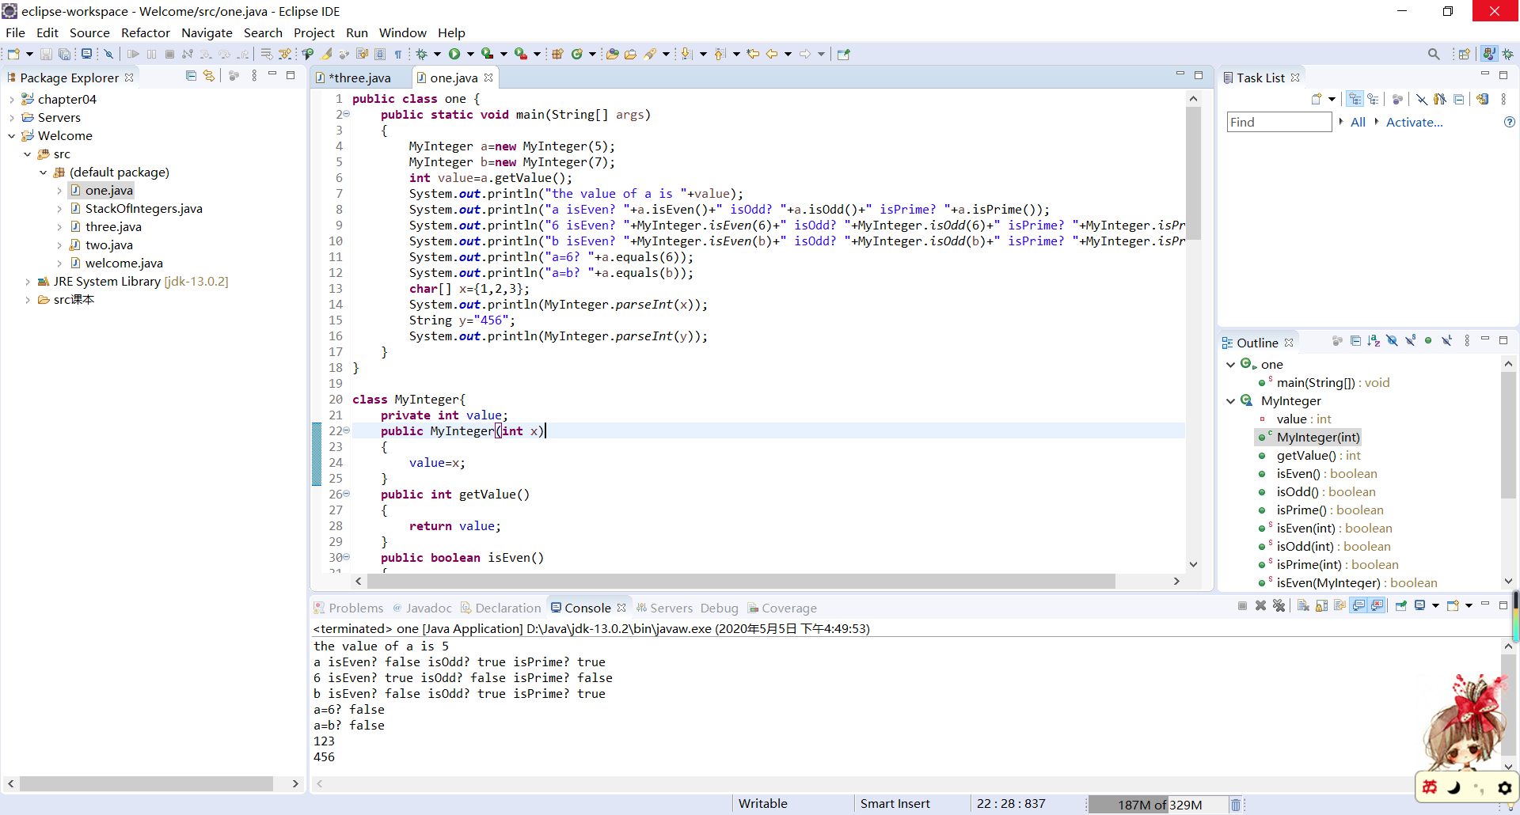
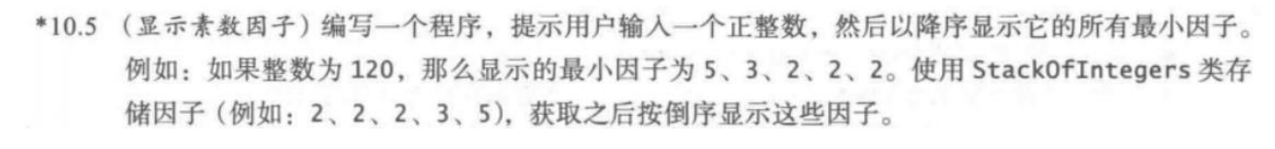
代码：
import java.util.Scanner;
public class two {
public static void main(String[] args)
{
Scanner input=new Scanner(System.in);
System.out.println("Enter a positive integer:");
int x=input.nextInt();
StackOfIntegers m=new StackOfIntegers();
int i=2;
while(x!=1)
{
if(x%i==0)
{
m.push(i);
x/=i;
}
else
{
i++;
}
}
while(!m.empty())
{
System.out.print(m.pop()+" ");
}
}
}
截图：
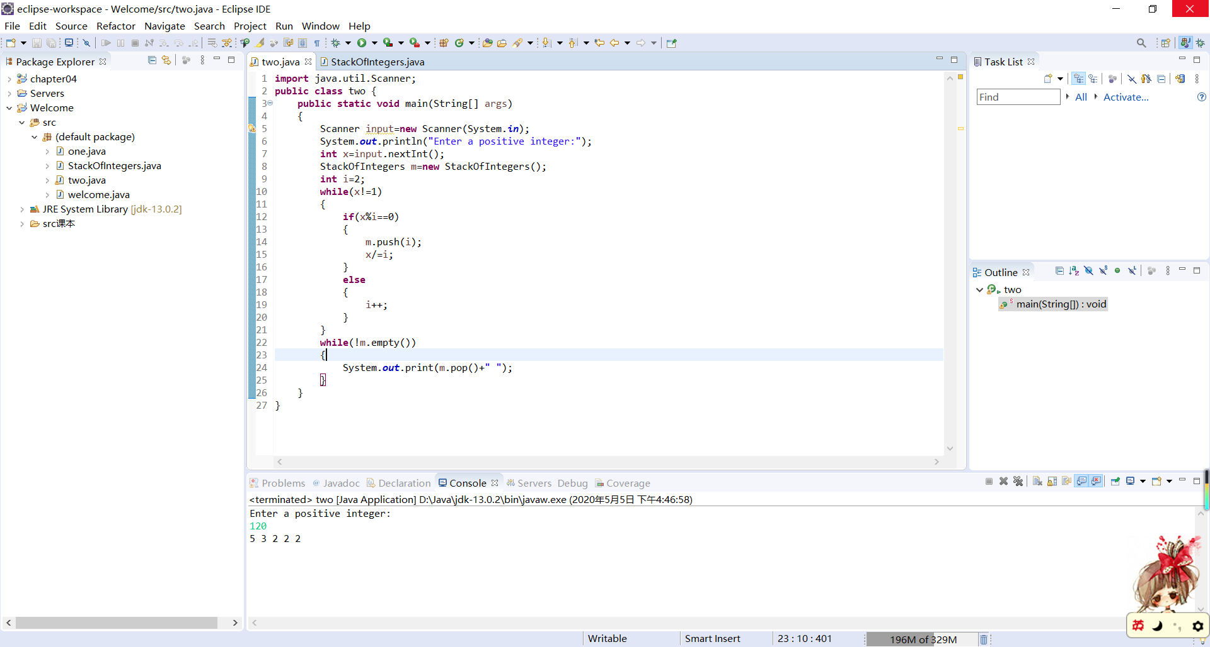
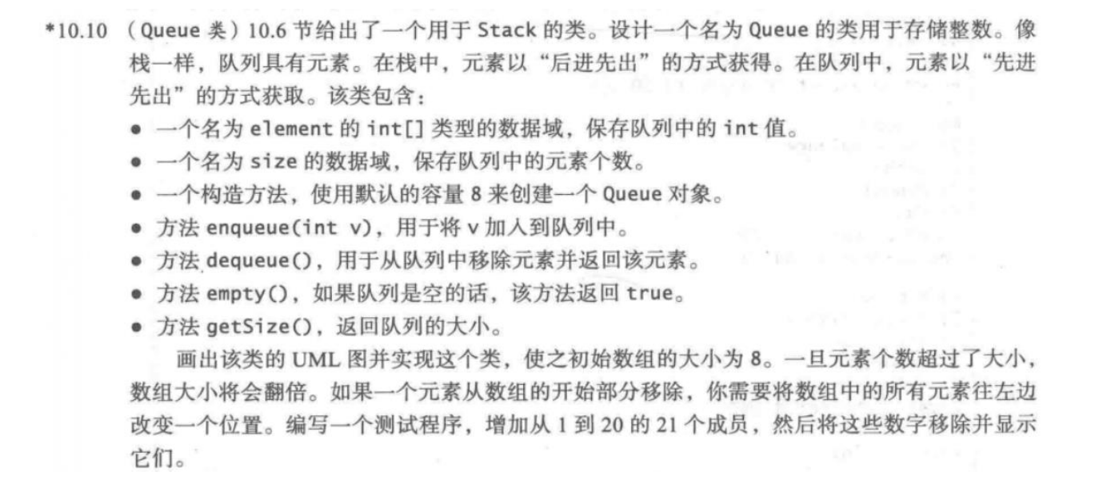
UML图：
Queue
-elements:int[]
-size:int
+Queue()
+enqueue(v:int):void
+dequeue():int
+empty():boolean
+getSize():int
代码：
public class three {
public static void main(String[] args)
{
Queue q=new Queue();
for(int i=1;i<21;i++)
{
q.enqueue(i);
}
for (int i=1;i<21;i++)
{
while(!q.empty())
{
System.out.print(q.dequeue()+" ");
}
}
}
}

class Queue {
private int[] elements;
private int size;
public static final int DEFAULT_CAPACITY = 8;
public Queue() {
elements = new int[DEFAULT_CAPACITY];
}
public void enqueue(int v) {
if (size >= elements.length) {
int[] temp = new int[elements.length * 2];
System.arraycopy(elements, 0, temp, 0, elements.length);
elements = temp;
}
elements[size++] = v;
}
public int dequeue() {
return elements[--size];
}
public boolean empty() {
return size == 0;
}
public int getSize() {
return size;
}
}
截图：
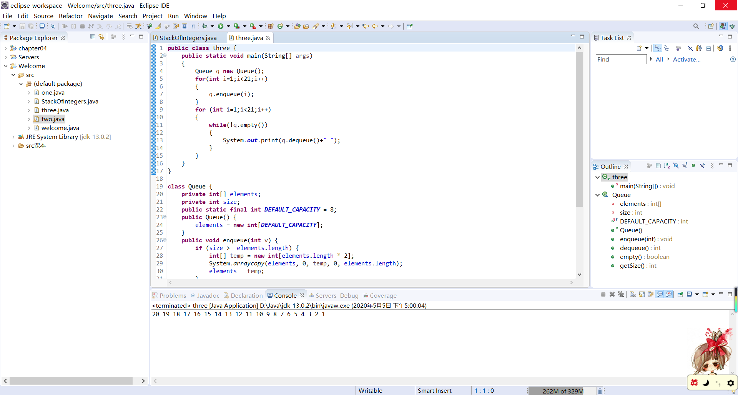
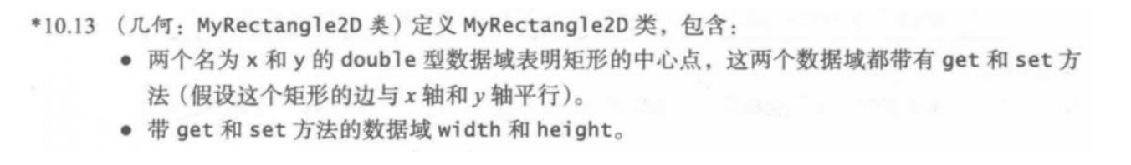
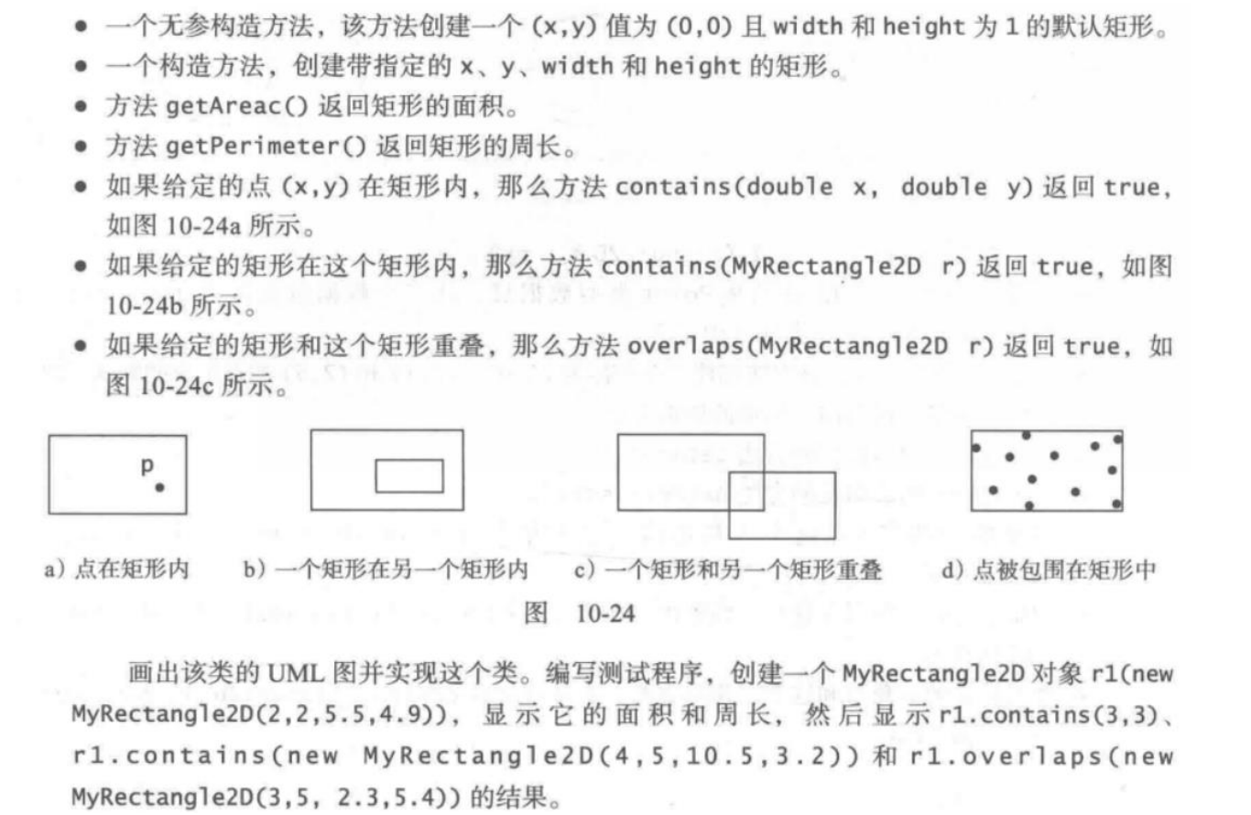
UML图：
MyRectangle2D
-x:double
-y:double
-width:double
-height:double
+getX():double
+setX(xx:double):void
+getY():double
+setY(yy:double):void
+getWidth():double
+setWidth(w:double):void
+getHeight():double
+setHeight(h:double):void
+MyRectangle2D()
+MyRectangle2D(xx:double,yy:double,w:double,h:double)
+getAreac():double
+getPerimeter():double
+contains(x1:double,y1:double):boolean
+contains(r:MyRectangle2D):boolean
+overlaps(r:MyRectangle2D):boolean
代码：
public class four {
public static void main(String[] args)
{
MyRectangle2D r1= new MyRectangle2D(2,2,5.5,4.9);
System.out.println("the area is "+r1.getAreac()+"\nthe perimeter is "+r1.getPerimeter());
System.out.println("r1.contains(3, 3) "+r1.contains(3, 3)+",r1.contains(new MyRectangle2D(4,5,10.5,3.2)) "+r1.contains(new MyRectangle2D(4,5,10.5,3.2)));
System.out.println("r1.overlaps(new MyRectangle2D(3,5,2.3,5.4)) "+r1.overlaps(new MyRectangle2D(3,5,2.3,5.4)));
}
}

class MyRectangle2D{
private double x;
private double y;
private double width;
private double height;
public double getX()
{
return x;
}
public void setX(double xx)
{
x=xx;
}
public double getY()
{
return y;
}
public void setY(double yy)
{
y=yy;
}
public double getWidth()
{
return width;
}
public void setWidth(double w)
{
width=w;
}
public double getHeight()
{
return height;
}
public void setHeight(double h)
{
height=h;
}
public MyRectangle2D()
{
x=y=0;
width=height=1;
}
public MyRectangle2D(double xx,double yy,double w,double h)
{
x=xx;
y=yy;
width=w;
height=h;
}
public double getAreac()
{
return width*height;
}
public double getPerimeter()
{
return (width+height)*2;
}
public boolean contains(double x1,double y1)
{
if((x1>=x-width/2&&x1<=x+width/2)&&(y1>=y-height/2&&y1<=y+height/2))
return true;
return false;
}
public boolean contains(MyRectangle2D r)
{
if ((Math.abs(r.x-x)<=Math.abs(r.width-width)/2)&&(Math.abs(r.y-y)<= Math.abs(r.height-height)/2))
return true;
return false;
}
public boolean overlaps(MyRectangle2D r)
{
if ((Math.abs(r.x-x)<=(r.width+width)/2)&&(Math.abs(r.y-y)<=(r.height+height)/2))
return true;
return false;
}
}
截图：
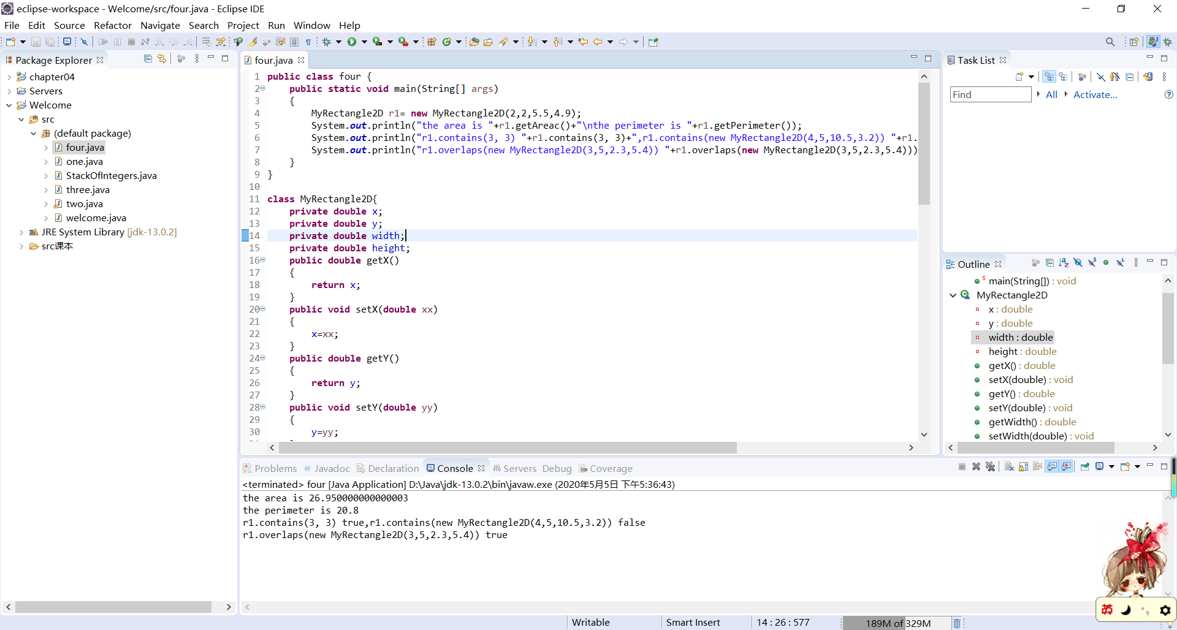
代码：
import java.math.*;
public class five {
public static void main(String[] args) {
BigInteger x = new BigInteger("9223372036854775807");
int count = 0;
while (count < 5) {
/*
* BigInteger i=BigInteger.TWO; while(x.subtract(i)!=BigInteger.ZERO) {
* if(x.mod(i)==BigInteger.ZERO) break; }
*/
if (x.isProbablePrime(10)) {
count++;
System.out.println(x);
}
x=x.nextProbablePrime();
}
}
}
截图：
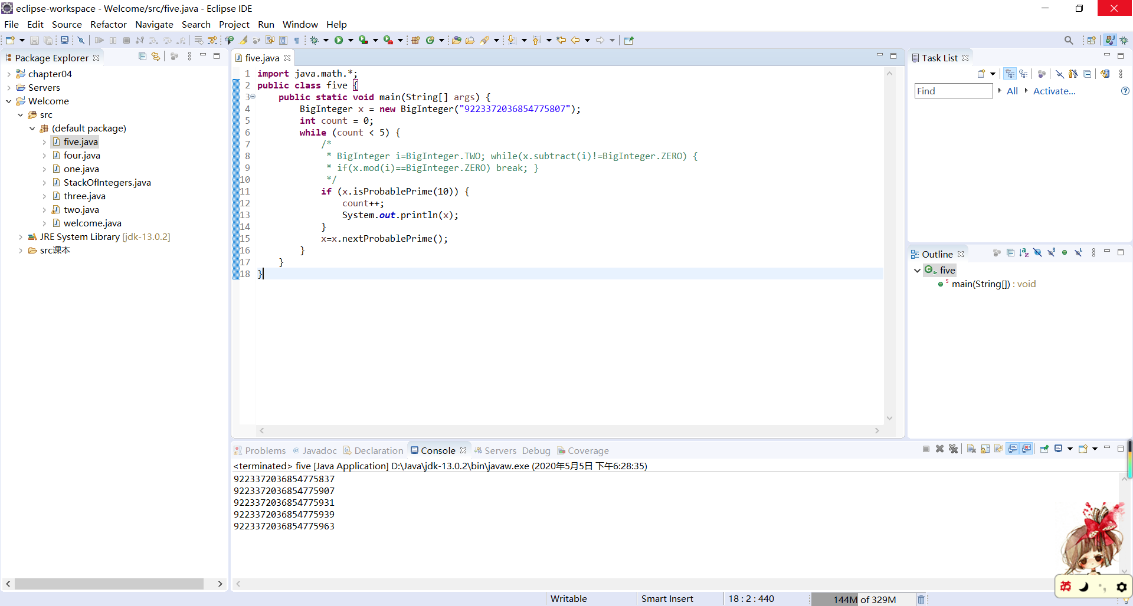
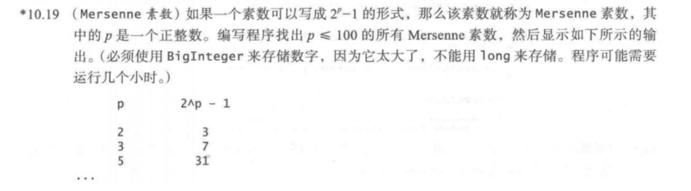
代码：
import java.math.BigInteger;
public class six {
public static void main(String[] args) {
System.out.println("p\t2^p-1");
BigInteger x=BigInteger.ONE;
for (int p = 1; p <= 100; p++) {
x=x.multiply(new BigInteger("2"));
BigInteger y=x.subtract(new BigInteger("1"));
if(y.isProbablePrime(100))
{
System.out.println(p+"\t"+y);
}
}
}
}
截图：
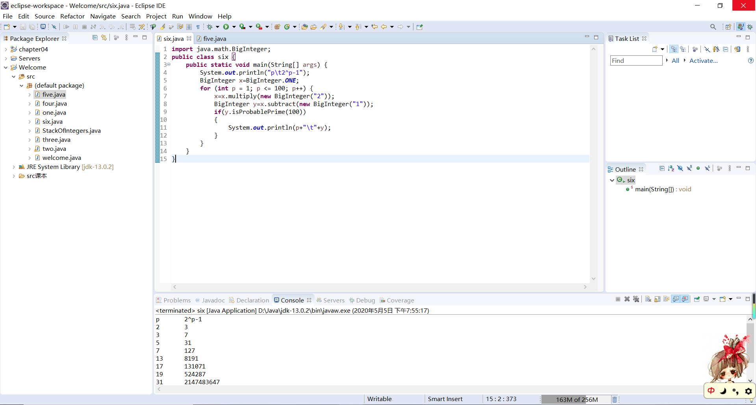
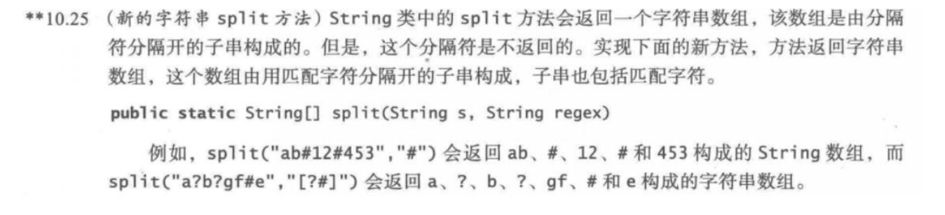
代码：
public class seven {
public static void main(String[] args) {
String[] token1 = split("ab#12#453", "#");
for (int i = 0; i < token1.length; i++)
System.out.print(token1[i] + " ");
/*
System.out.println();
String[] token2 = split("a?b?gf#e", "[?#]");
for (int i = 0; i < token2.length; i++)
System.out.print(token2[i] + " ");
*/
}
public static String[] split(String s, String regex) {
/*
* String[] str=new String[10]; int n=0; for(int j=0;j<regex.length();j++) { int
* count=0; for(int i=0;i<s.length();i++) { if(s.charAt(i)==regex.charAt(j)) {
* str[n++]=s.substring(count,i); count=i+1; } } } return str;
*/
String str = "";
for (int i = 0; i < s.length(); i++) {
int index = s.indexOf(regex);
if (index == -1) {
str = str + s;
break;
}
else {
if (index != 0)
str = str + s.substring(0, index) + ",";
str = str + s.substring(index, index + regex.length()) + ",";//加上分隔符
s = s.substring(index + regex.length(), s.length());
i = 0;
}
}
String[] sub = str.split(",");
return sub;
}
}
截图：
