Ömer Başar Özgüven | 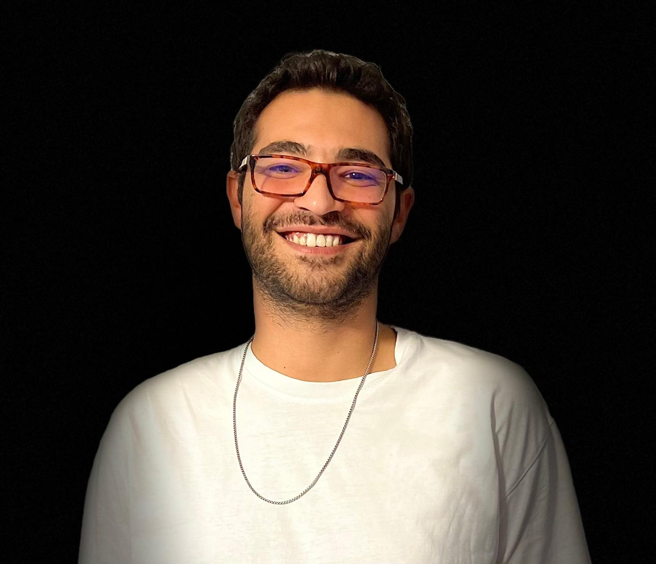
omerbasarozguven.com | +90 531 269 11 05 | omerbasarozguven@gmail.com | linkedin.com/in/omerbasarozguven | github.com/omer-basar-ozguven
SUMMARY
Product engineer and one of the founders of Bronix, where I owned the full loop of defining, building, launching, and iterating on consumer software. I have shipped more than ten products across mobile and web, including subscription apps, AI tools, and enterprise platforms. I pair hands on engineering across the stack with a real sense of what to build next and why it matters. I watch how people actually use a product, and I let that decide what gets built and what gets cut.
EXPERIENCE
Co-Founder & Lead Software Engineer · Bronix Software Inc. · 50+ completed projects 2021 – 2026
• Defined product vision and led full-stack engineering for 10+ consumer apps across mobile (Flutter/Expo) and web (Next.js).
• Shipped subscription products with RevenueCat billing; managed App Store and Google Play lifecycle.
• Built AI-powered tools integrating OpenRouter, Fal.ai, and VoltAgent for generative and agentic workflows.
• Owned roadmap and engineering from zero to launch, iterating on product analytics, funnels, and churn.
SELECTED PROJECTS
YükAl Live on iOS, Android & Web
Freight marketplace connecting cargo owners with truck drivers nationwide, with free listing and a carrier subscription model. — Expo, Next.js, Supabase
Walkable Live on iOS
Privacy-first walking navigation that color-codes streets by safety, with no account and location that never leaves the device. — Flutter, VoltAgent, Firebase
Next2Me Live on iOS
Couples relationship app with daily streaks, conversation questions, swipe-to-match on movies and activities, and private chat. Unique shared-subscription model where one partner upgrading unlocks premium for both. — Flutter, Firebase, OpenRouter
Banana Labs Live on Web
AI creative studio for videos, product shoots, and images, generating across several models in parallel for comparison. — Next.js, Fal.ai, Supabase
NextRoom Live on iOS
AI interior design that redesigns any space from a single photo using 12+ curated styles or a custom prompt. — Flutter, Firebase, Fal.ai
SKILLS
Product: Product Definition, Roadmapping, User Research, App Store Optimisation, Subscription Monetisation
Engineering: Flutter, Expo, Next.js, React, Node.js, Go, Python, FastAPI
AI & Agents: VoltAgent, OpenRouter, Fal.ai, LangChain, Claude API, OpenAI API
Infra: Firebase, Supabase, PostgreSQL, Docker, AWS, Railway, Vercel
EDUCATION
B.Sc. Mechanical Engineering · Bilkent University, Ankara, Turkey · 2016 – 2021
High School Diploma (International Baccalaureate) · TED Ankara College, Ankara, Turkey · 2012 – 2016
RESEARCH
Undergraduate Researcher · Bilkent University — Miniature Robotics Laboratory 2018 – 2021
• Researched miniature modular robotics: foldable mechanisms and flexible spine module design.
• Best Paper Award, TORK 2019, for "Flexible Spine Module Design for Foldable Modular Miniature Robots".

