WEEK 3
ADVANCED DATA ANALYSIS AND VISUALIZATION IN LOGISTICS
Exploratory Analysis of Delivery Performance Drivers in the Logistics Delivery Dataset
Prepared by: Mohammed Omer Farooq
Task: Week 3 — Advanced Data Analysis and Visualization
Domain: Logistics & Supply Chain Analytics

1. Introduction and Objective
This report presents the exploratory data analysis (EDA) and visualization phase of the logistics analytics project, carried out on the cleaned and validated dataset from Week 2. The objective is to move beyond summary statistics and visually examine how operational factors — distance, traffic level, weather, vehicle type, and order quantity — relate to delivery time, delivery delays, and delivery cost, in order to surface insights that inform the predictive modeling stage in Week 4.
The dataset used throughout this analysis contains 120 delivery records with 10 variables, as documented in the Week 1 and Week 2 submissions.

2. Central Tendency and Key Statistics
Before examining relationships between variables, the central tendency of the core delivery metrics is calculated directly from the dataset:
average_delivery_time = df['Delivery_Time_hr'].mean()
average_cost = df['Delivery_Cost'].mean()
on_time_rate = (df['Delivery_Status'] == 'On-Time').mean() * 100
delay_rate = (df['Delivery_Status'] == 'Delayed').mean() * 100
Metric | Value
Average Delivery Time | 3.99 hours
Average Delivery Cost | 183.41
On-Time Delivery Rate | 27.5%
Delivery Delay Rate | 72.5%

The delay rate of 72.5% is a striking finding: nearly three out of every four deliveries in this dataset arrived later than their expected delivery time. This single statistic motivates the deeper analysis in the sections that follow, which investigate which operational conditions are driving that delay rate.

3. Distance vs. Delivery Time
A scatter plot of distance against delivery time is used to examine whether longer deliveries take proportionally longer. A scatter plot is the appropriate choice here because both variables are continuous and the goal is to detect a linear or non-linear relationship between them.
plt.scatter(df['Distance_km'], df['Delivery_Time_hr'], color='red')
plt.xlabel('Distance (km)')
plt.ylabel('Delivery Time (hours)')
plt.title('Distance vs Delivery Time')
plt.show()
correlation = df['Distance_km'].corr(df['Delivery_Time_hr'])
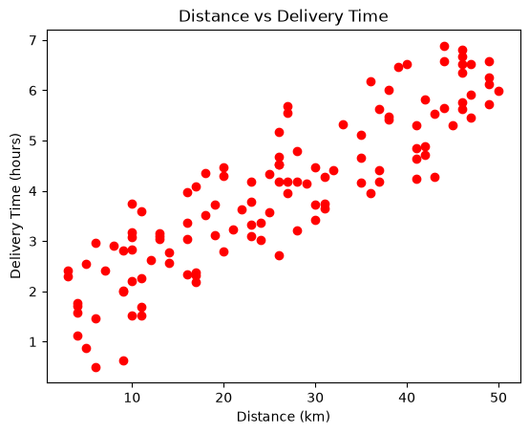
Figure 1: Distance vs. Delivery Time
The chart shows a clear upward trend, confirmed by a Pearson correlation coefficient of 0.89 between distance and delivery time. This is a strong positive correlation, indicating that distance is the single strongest driver of delivery time in this dataset and is a natural leading feature for the regression model planned in Week 4.

4. Traffic Level vs. Delivery Delay Rate
A bar chart is used to compare delay rate across the three traffic categories, since delay rate is a single aggregated percentage per category and bar charts are well suited to comparing a metric across a small number of discrete groups.
delay_rate = (
df.groupby('Traffic_Level')['Delivery_Status']
.apply(lambda x: (x == 'Delayed').mean() * 100)
)
delay_rate = delay_rate.reindex(['Low', 'Medium', 'High'])
delay_rate.plot(kind='bar')
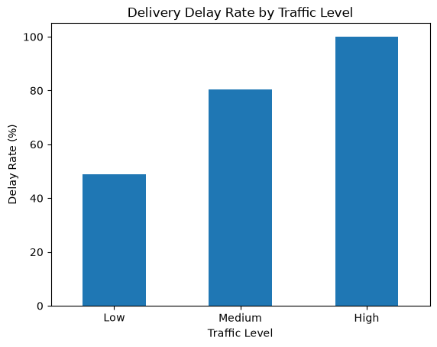
Figure 2: Delivery Delay Rate by Traffic Level
Traffic Level | Delay Rate
Low | 48.98%
Medium | 80.49%
High | 100.00%

The relationship is unambiguous: every single delivery made under High traffic conditions in this dataset was delayed (100%), compared to roughly half of deliveries made under Low traffic. This identifies traffic level as a critical, near-deterministic bottleneck in the delivery process.

5. Vehicle Type vs. Average Delivery Cost
A bar chart compares average delivery cost across the three vehicle types, again because the metric being compared is a single aggregated value (mean cost) per discrete category.
vehicle_cost = df.groupby('Vehicle_Type')['Delivery_Cost'].mean()
vehicle_cost.plot(kind='bar')
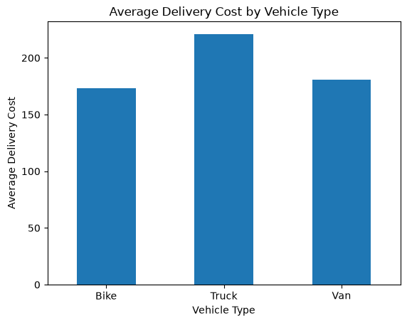
Figure 3: Average Delivery Cost by Vehicle Type
Vehicle Type | Average Delivery Cost
Bike | 173.29
Van | 181.05
Truck | 220.91

Truck deliveries cost noticeably more on average (220.91) than Bike (173.29) or Van (181.05) deliveries. This is consistent with trucks typically being used for larger or heavier orders, and suggests vehicle assignment is an area where cost-efficiency gains could be explored — for example, verifying that trucks are reserved for orders that genuinely require their capacity.

6. Weather vs. Delivery Delay Rate
As with traffic level, a bar chart compares delay rate across the three weather conditions recorded in the dataset.
weather_delay = pd.crosstab(
df['Weather'], df['Delivery_Status'], normalize='index'
) * 100
weather_delay['Delayed'].plot(kind='bar')
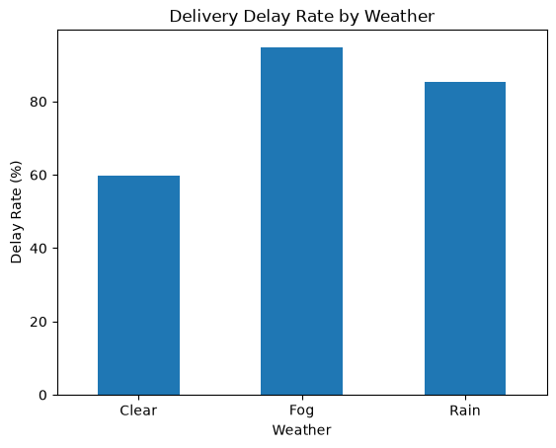
Figure 4: Delivery Delay Rate by Weather
Weather | Delay Rate
Clear | 59.70%
Rain | 85.29%
Fog | 94.74%

Delay rate rises sharply as weather conditions worsen — from 59.7% under Clear conditions to 94.7% under Fog. Combined with the traffic finding in Section 4, this indicates that delays in this operation are driven predominantly by external environmental conditions rather than by the delivery process itself, which has implications for how realistic delivery-time estimates should be communicated to customers.

7. Order Quantity vs. Delivery Time
A scatter plot examines whether larger orders take longer to deliver, following the same reasoning as Section 3: both variables are continuous.
plt.scatter(df['Order_Quantity'], df['Delivery_Time_hr'])
quantity_corr = df['Order_Quantity'].corr(df['Delivery_Time_hr'])
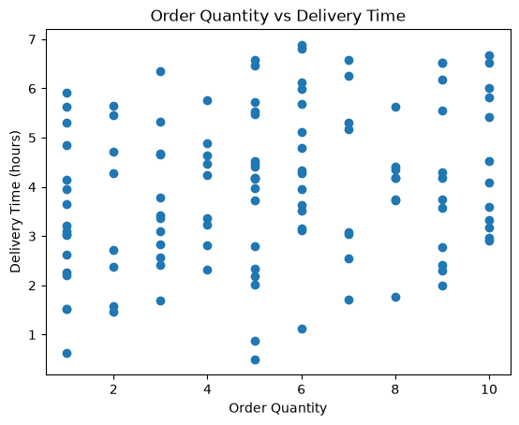
Figure 5: Order Quantity vs. Delivery Time
Unlike distance, order quantity shows only a weak correlation with delivery time (0.23), and the scatter plot shows no clear visual trend. This suggests that, in this operation, the number of items in an order has little bearing on how long the delivery takes — a useful negative finding, since it means order quantity is unlikely to be a strong predictive feature for the Week 4 regression model.

8. Delay Magnitude and Most-Delayed Orders
A derived feature, Delay_Hours, is calculated as the difference between actual and expected delivery time, allowing delay severity — not just delay/on-time status — to be examined.
df['Delay_Hours'] = df['Delivery_Time_hr'] - df['Expected_Time_hr']
most_delayed = df.sort_values('Delay_Hours', ascending=False)
The ten most delayed orders in the dataset are shown below:
Order ID | Delay (hrs) | Distance (km) | Traffic | Weather | Vehicle
1096 | 1.87 | 27 | High | Rain | Van
1068 | 1.58 | 20 | High | Rain | Truck
1038 | 1.57 | 39 | High | Fog | Bike
1055 | 1.39 | 10 | Medium | Rain | Bike
1045 | 1.38 | 27 | High | Fog | Truck
1058 | 1.37 | 16 | High | Rain | Bike
1031 | 1.37 | 44 | High | Clear | Bike
1012 | 1.34 | 26 | High | Rain | Bike
1015 | 1.32 | 26 | Medium | Rain | Van
1075 | 1.26 | 33 | High | Rain | Bike

Nine of the ten most delayed orders occurred under High traffic, and eight involved Rain or Fog. This reinforces the traffic and weather findings above: the worst delays in the dataset are concentrated almost entirely among deliveries facing both congested traffic and poor weather simultaneously, suggesting a compounding effect between the two factors.

9. Analytical Insights and Recommendations
- Distance is the strongest single predictor of delivery time (r = 0.89) and should anchor the Week 4 regression model.
- Traffic level is the strongest driver of delay risk: High traffic corresponds to a 100% delay rate in this dataset.
- Weather compounds the traffic effect: Fog and Rain conditions show substantially higher delay rates than Clear conditions.
- Order quantity has negligible impact on delivery time (r = 0.23) and is a low-priority feature for prediction.
- Truck deliveries are the most expensive vehicle category on average, warranting a review of when trucks are assigned to orders.
- The worst-delayed orders overwhelmingly combine High traffic with adverse weather, suggesting operational teams should treat that combination as a high-risk flag for proactive customer communication or rerouting.

Conclusion
This exploratory analysis has identified traffic level and weather condition as the dominant drivers of delivery delay in this dataset, with distance as the dominant driver of delivery duration itself, while order quantity plays a comparatively minor role. These findings directly inform the predictive modeling and optimization work planned for Week 4, where distance, traffic, and weather will be prioritized as model features, and the traffic–weather interaction identified in Section 8 will be considered as a candidate risk flag for operational decision-making.

