IE310 - Fall 2019 -

Assingment Report

Ömer Faruk Özdemir 2016400048

1a.

**Decision Variables:**

x(i,j) amount of flow from plant i to customer j

z objective;

positive variable x;

free variable z;

**Constraints:**

cost is objective function

constraint1(i) is constraint of production

constraint2(j) is constaraint of monthly demand

constraint1(i).. sum(j,x(i,j)) =l= a(i)*1000;

constraint2(j).. sum(i,x(i,j)) =g= b(j)*1000;

**Objective:**

cost.. sum(j,sum(i,x(i,j)*C(i,j)))=e=z;

Min z with positive variable x(i,j)s;

Objective Value:



Shipment amounts:

Plants/Customers

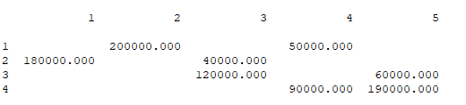

1b.

In this question we merge shipment tables with rail table where shipment is infeasible

**Decision Variables:**

x(i,j) is amount of flow from plant i to customer j

z is objective;

positive variable x;

free variable z;

**Constraints:**

cost is objective function

constraint1(i) is constraint of production

constraint2(j) is constaraint of monthly demand

constraint1(i).. sum(j,x(i,j)) =l= a(i)*1000;

constraint2(j).. sum(i,x(i,j)) =g= b(j)*1000;

**Objective:**

cost.. sum(j,sum(i,x(i,j)*(F(i,j)+G(i,j)/20)))=e=z;

Min z with positive variable x(i,j)s;

Objective Value:



Shipment Amounts:

Plants/Customers

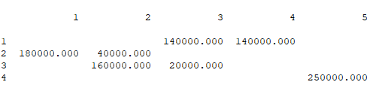

1c.

**Decision Variables:**

x(i,j) is amount of flow from plant i to customer j via rails

y(i,j) is amount of flow from plant i to customer j via ships

z is objective;

positive variable x;

positive variable y;

free variable z;

**Constraints:**

cost objective function

constraint1(i) is constraint of production

constraint2(j) is constaraint of monthly demand

constraint1(i).. sum(j,x(i,j)+y(i,j)) =l= a(i)*1000;

constraint2(j).. sum(i,x(i,j)+y(i,j)) =g= b(j)*1000;

**Objective**:

cost.. sum(j,sum(i,x(i,j)*C(i,j) + y(i,j)*(D(i,j)+E(i,j)/20)))=e=z;

Min z, where x and y are positive

Objective Value**:**



Shipment Amounts:

Plants/Customers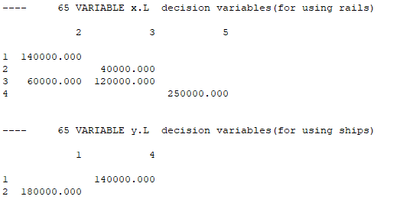

2- Minimum cost is achieved on 1c, 6125000

2a.

Shadow variable of constraint second plant’s capacity is -0.5, increasing it by 10k units will decrease our objective function 5k, so we will get a cost of 6125000-5000=6120000 with calculation via shadow variable.

Real one is also 6120000

2b.

Shadow variable of constraint second plant’s capacity is -0.5, increasing it by 280k units will decrease our objective function 5k, so we will get a cost of 6125000-280000=5845000 with calculation via shadow variable.

Real one is 6055000

Since the increase in the constraint is too much other constraints limit the increase with respect to shadow variable.

2c.

Reduced cost of x(3,1) is 5.5000. So this is also the minimum amount of money necessary to produce it. In other words cost decrease necessary to make it profitable.

Since shipment is not possible via this route we can just consider the amount with rails.

3a.

**Added variables and constraints:**

r(i,j) checks flow from plant i to customer j

r(i,j) is 1 if there is a flow from plant i to customer j.

**Constraint:**

constraint3(i,j) constraint of renting or not renting the ship on (i,j) route

constraint3(i,j): x(i,j) =l= r(i,j)*M;

The flow is 0 if the binary variable is 0.

**Objective:**

Cost: sum(j,sum(i,(x(i,j)*F(i,j) + H(i,j)*r(i,j)))) =e= z;

Min z where x is positive.

Objective value:

5 380 000

Shipment Amounts:

Plants/Customers

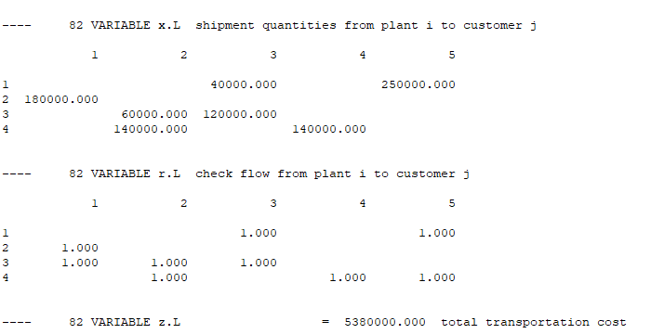

3b.

**Added Constraints:**

constraint4: the maximum number of ships rented cannot exceed 5

constraint5: constraint of 3-3 and 1-4 route

constraint4: sum(i,sum(j,r(i,j)))-r('1','3')-r('3','1')-r('3','2')-r('4','5') =l= 5;

constraint5: r('3','3')+r('1','4') =l= 1;

We need to remove 4 of the binary variables from the constraint4 because they do not use shipment but use rails.

Objective Value:

5 380 000

Shipment Amounts:

Plants/Customers

