
USER MANUAL
Aziz HRM – User Manual
Complete Guide to Human Resources Management
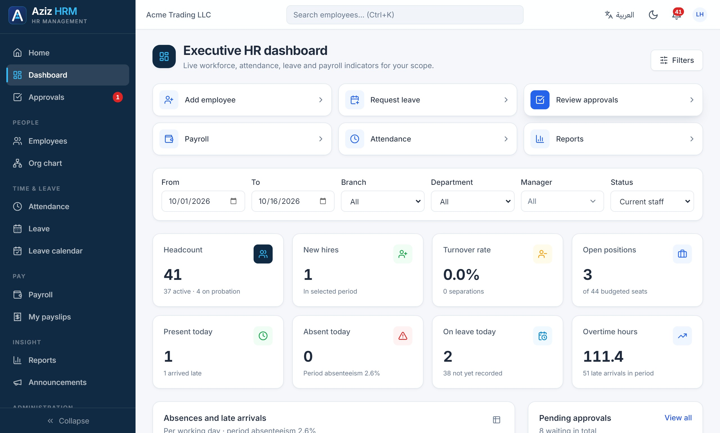
Version 1.0 · Aziz HRM 0.1.0 · Published 16 October 2026

Contents

Document information
Item | Details
Document | Aziz HRM – User Manual
Version | Version 1.0
Last updated | 16 October 2026
Applies to | Aziz HRM 0.1.0
Screenshots | 84 annotated screenshots captured from the live application (demonstration company, fictitious data; national IDs, bank details and phone numbers blurred)
Audience | Employees, managers, HR, payroll and finance teams, and system administrators
NOTE
To update this document after application changes, edit the text, replace screenshots from the Aziz_HRM_Screenshot_Assets folder, and update the table of contents (right-click it → Update Field → Update entire table).
CHAPTER 1

1. Introduction to Aziz HRM
Aziz HRM is an integrated human resources management system. It brings employee records, attendance, leave, approvals, payroll, reports and company settings together in one secure web application that works in English and Arabic, in light and dark mode, on desktop, tablet and mobile.

Who this manual is for
- Employees — checking in, requesting leave, viewing payslips and keeping personal details up to date (Chapters 2–4, 6, 7, 10, 19).
- Managers — reviewing their team and approving requests (Chapters 3, 6, 7, 18).
- HR teams — maintaining employee records, organization structure, attendance and leave policies (Chapters 5–7, 15–17, 20).
- Payroll and finance — preparing, approving and paying payroll (Chapter 8).
- System administrators — users, roles, workflows, settings and auditing (Chapters 18, 21, 23).

What is available in this version
This manual documents version 0.1.0 of Aziz HRM exactly as it works today. Some modules described in the product roadmap are not built yet; their chapters say so clearly rather than describing screens that do not exist.
Module | Status | Chapter
Employee management | Available | 5
Attendance and time tracking | Available | 6
Leave management | Available | 7
Payroll and salary management | Available | 8
Recruitment and applicant tracking | Not available in this version | 9
Employee self-service portal | Available | 10
Performance management | Not available in this version | 11
Training and development | Not available in this version | 12
Benefits and compensation | Partly available | 13
Expense and reimbursement management | Not available in this version | 14
Employee documents and contracts | Partly available | 15
Organization structure and workforce planning | Available | 16
Onboarding and offboarding | Partly available | 17
Approval workflows | Available | 18
Notifications and announcements | Available | 19
Reports and analytics | Available | 20
Settings, users and permissions | Available | 21

How to read this manual
- Each module chapter follows the same structure: A. Purpose, B. Accessing the module, C. Step-by-step instructions, D. Screenshot guide, E. Expected result, F. Common errors and G. Tips and best practices.
- Numbered amber markers on screenshots match the numbered steps or notes beside them.
- Button, menu and field names appear in bold, exactly as they are labelled in the application.
- What you can see and do depends on your role. If a menu item or button described here is missing, see Chapter 21 for roles and permissions.
NOTE
All screenshots were taken from the real application using the built-in demonstration company, Acme Trading LLC. The people, salaries and figures are fictitious, and national ID numbers, bank details and phone numbers are additionally blurred.
CHAPTER 2

2. System Access and Login

A. Purpose
Every user signs in with a personal account. Your account determines your role, which menus you see and which employees’ data you can access.

B. Accessing the module
Open the Aziz HRM web address provided by your administrator in a modern browser (Chrome, Edge, Firefox or Safari). If you are not signed in, the Sign in page opens automatically.

C. Step-by-step instructions
- Enter your work email address in Email (1).
- Enter your password in Password (2).
- Click Sign in (3).
- To switch the language before signing in, click العربية / English (4).
- If two-step verification is enabled on your account, enter the 6-digit code from your authenticator app and click Verify.
- If you are signing in for the first time with a temporary password, you are asked to choose a new one before continuing (at least 8 characters, including a letter and a digit).

D. Screenshot guide
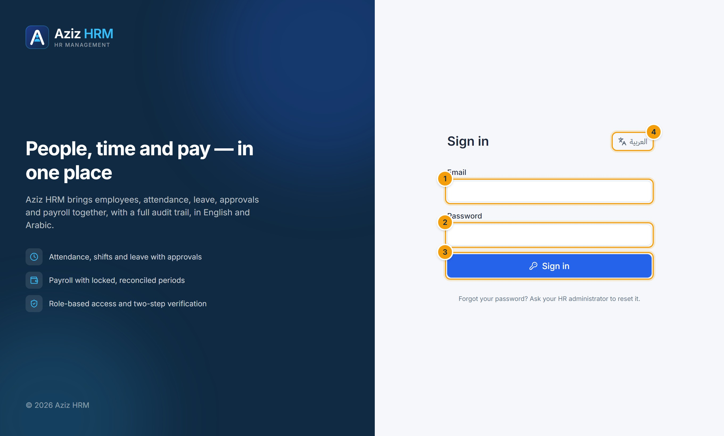
Figure 2.1 — The Sign in page. (1) Email, (2) Password, (3) Sign in button, (4) language switch.

E. Expected result
E. EXPECTED RESULT
You arrive on the Home page, which shows your attendance, leave balances, requests, announcements and latest payslip.

F. Common errors
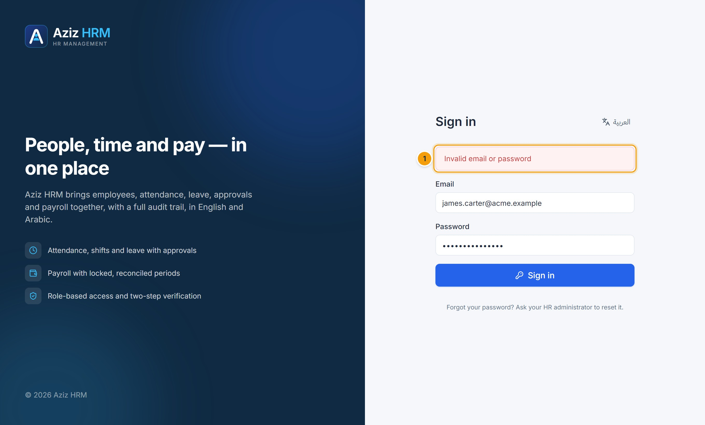
Figure 2.2 — Unsuccessful sign-in. (1) The message “Invalid email or password” appears above the form. For security it does not say which of the two was wrong.
Message | Meaning and action
Invalid email or password | The email or password is wrong, or the account is inactive. Check Caps Lock and try again.
Account locked after repeated failed sign-ins… | Five wrong passwords lock the account for 15 minutes. Wait, or ask an administrator to unlock it (Users → ⋯ → Unlock).
Too many sign-in attempts. Try again later. | Too many attempts from your network in a short time. Wait 15 minutes.
Session expired / Session has ended | You were signed out (inactivity, password change, or an administrator ended the session). Sign in again.

G. Tips and best practices
- Forgot your password? There is no self-service reset: ask your HR or system administrator to use Reset password. You receive a temporary password and must change it at first sign-in.
- Turn on two-step verification in Account settings (Chapter 23).
- Always use Sign out from the account menu on shared computers.
CHAPTER 3

3. Dashboard Overview

A. Purpose
The Executive HR dashboard gives managers and HR a live view of headcount, attendance, leave, payroll cost, approvals and upcoming deadlines. Every figure is calculated from real system data, limited to the employees you are allowed to see.

B. Accessing the module
Click Dashboard in the sidebar. It is available to roles with the View the executive dashboard permission (HR, payroll, finance, managers, administrators and auditors).

C. Step-by-step instructions
- Use the quick actions (1) to jump straight to common tasks such as Add employee, Request leave, Review approvals, Payroll, Attendance and Reports. You only see the actions your role allows.
- Click Filters (2) to show or hide the filter bar.
- Set the period with From and To, and narrow the data by Branch, Department, Manager or Status (3). All cards and charts update immediately.
- Read the KPI cards (4): headcount, new hires, turnover rate, open positions, present/absent/on leave today and overtime hours.
- Click Reset filters to return to the current month and all employees.

D. Screenshot guide
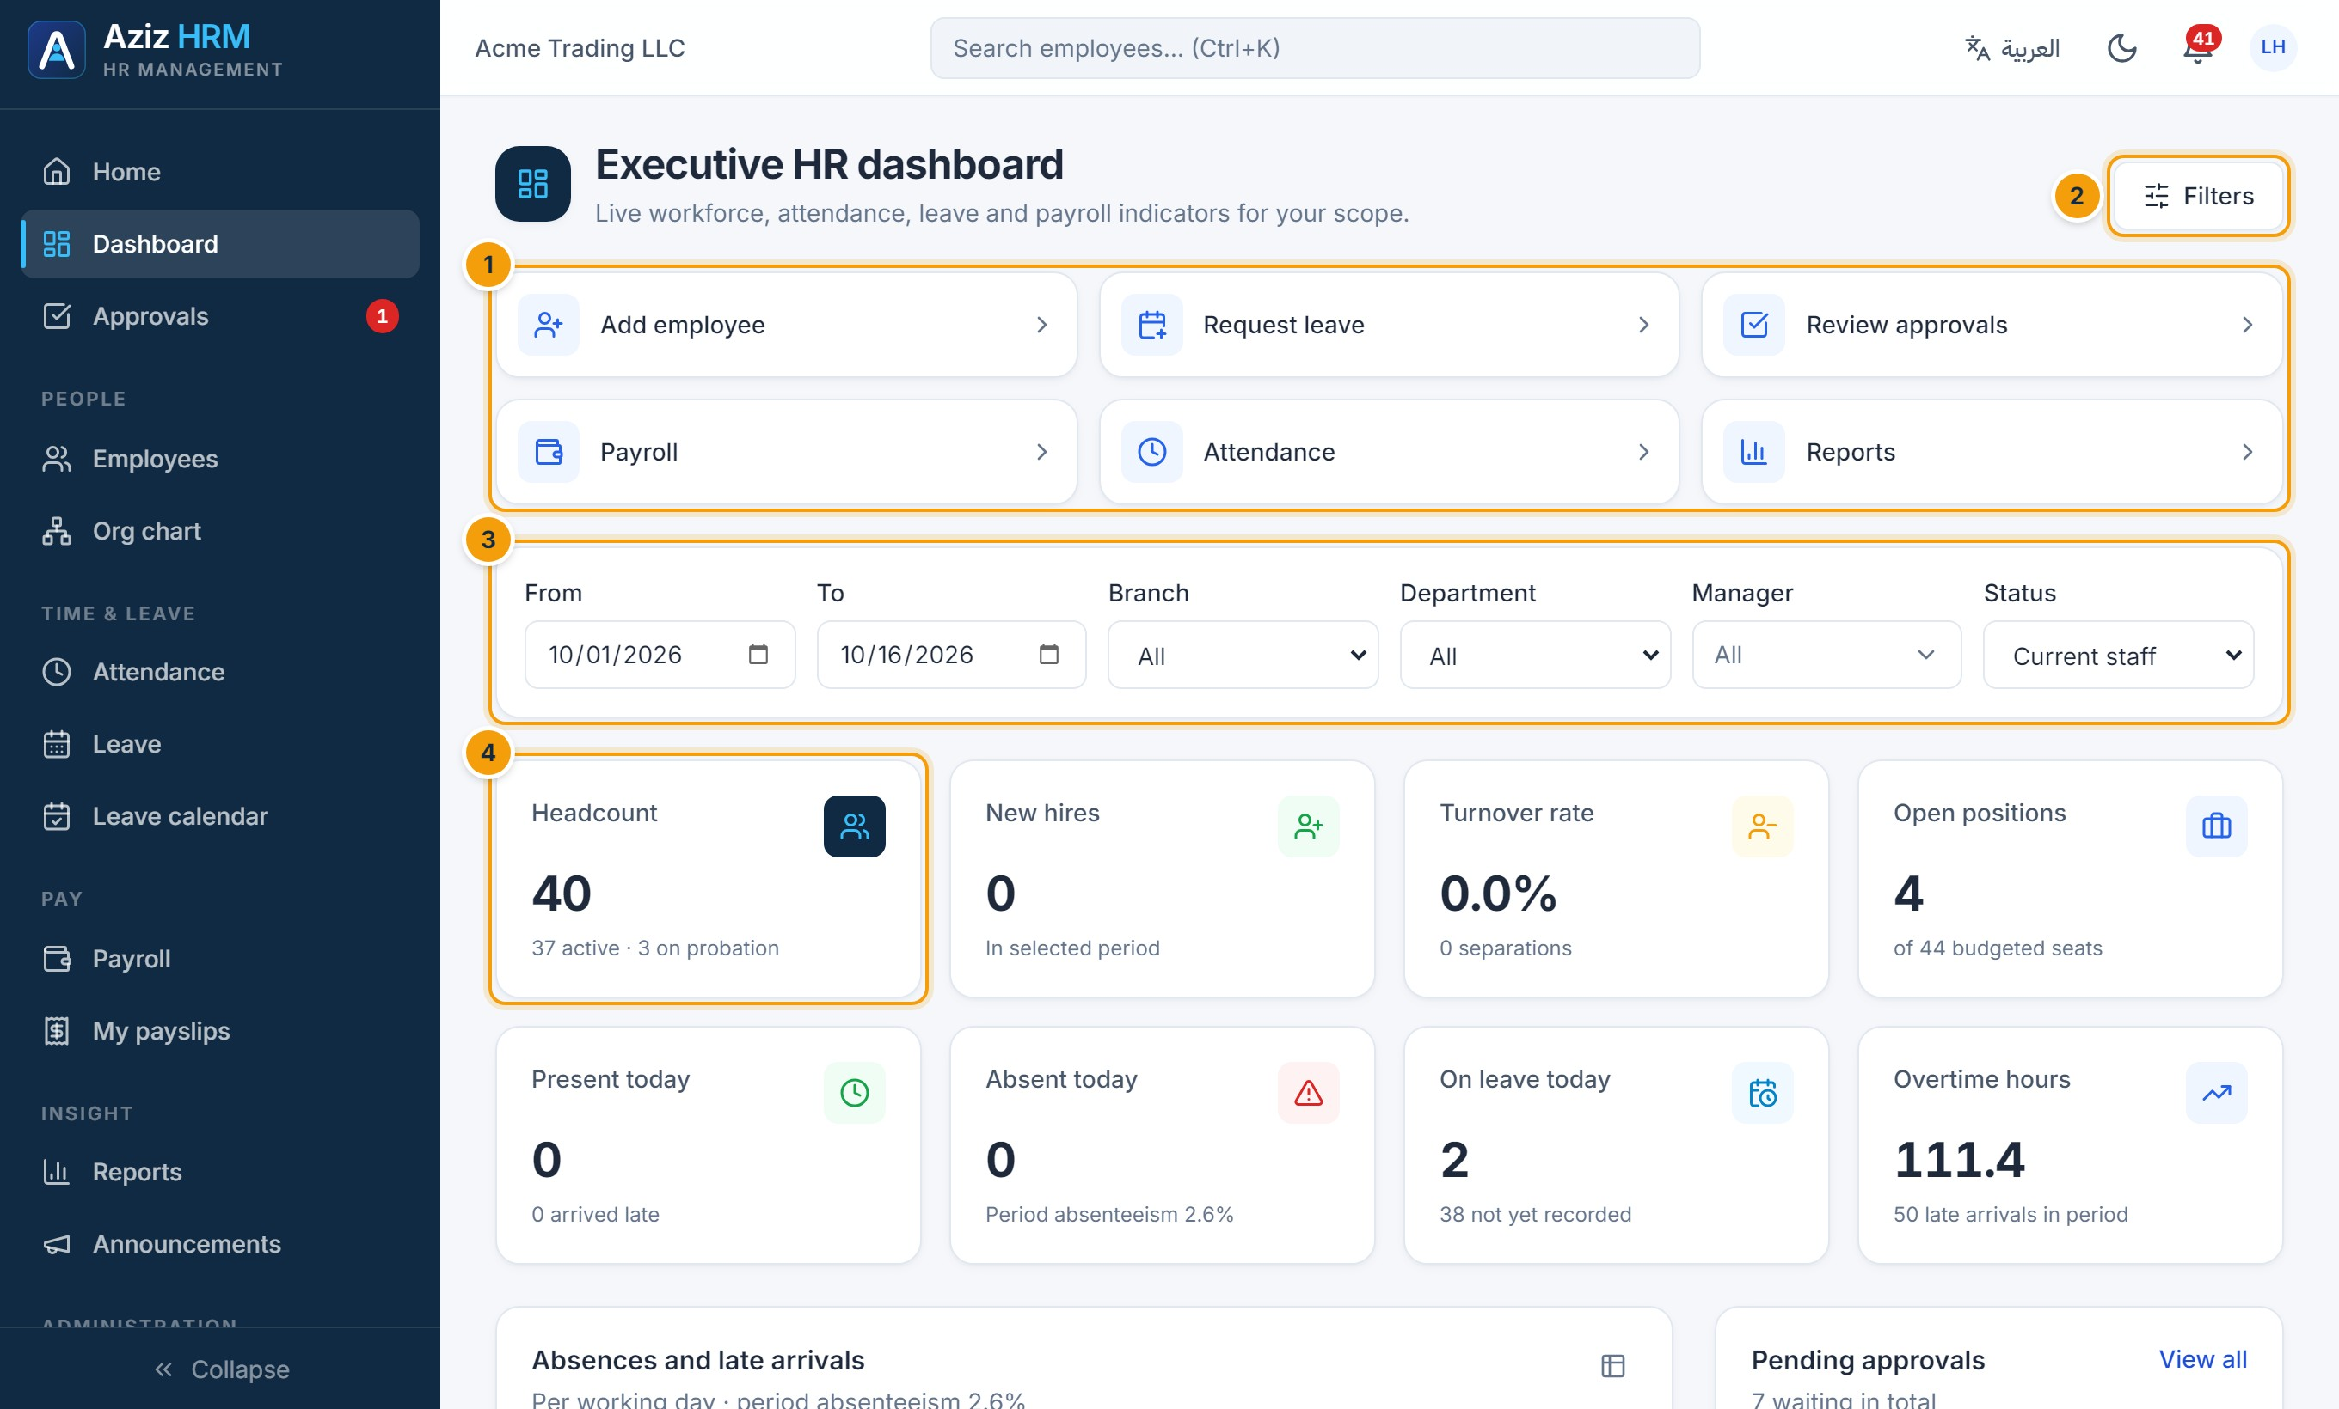
Figure 3.1 — Executive HR dashboard. (1) Quick actions, (2) Filters button, (3) filter bar, (4) KPI cards.
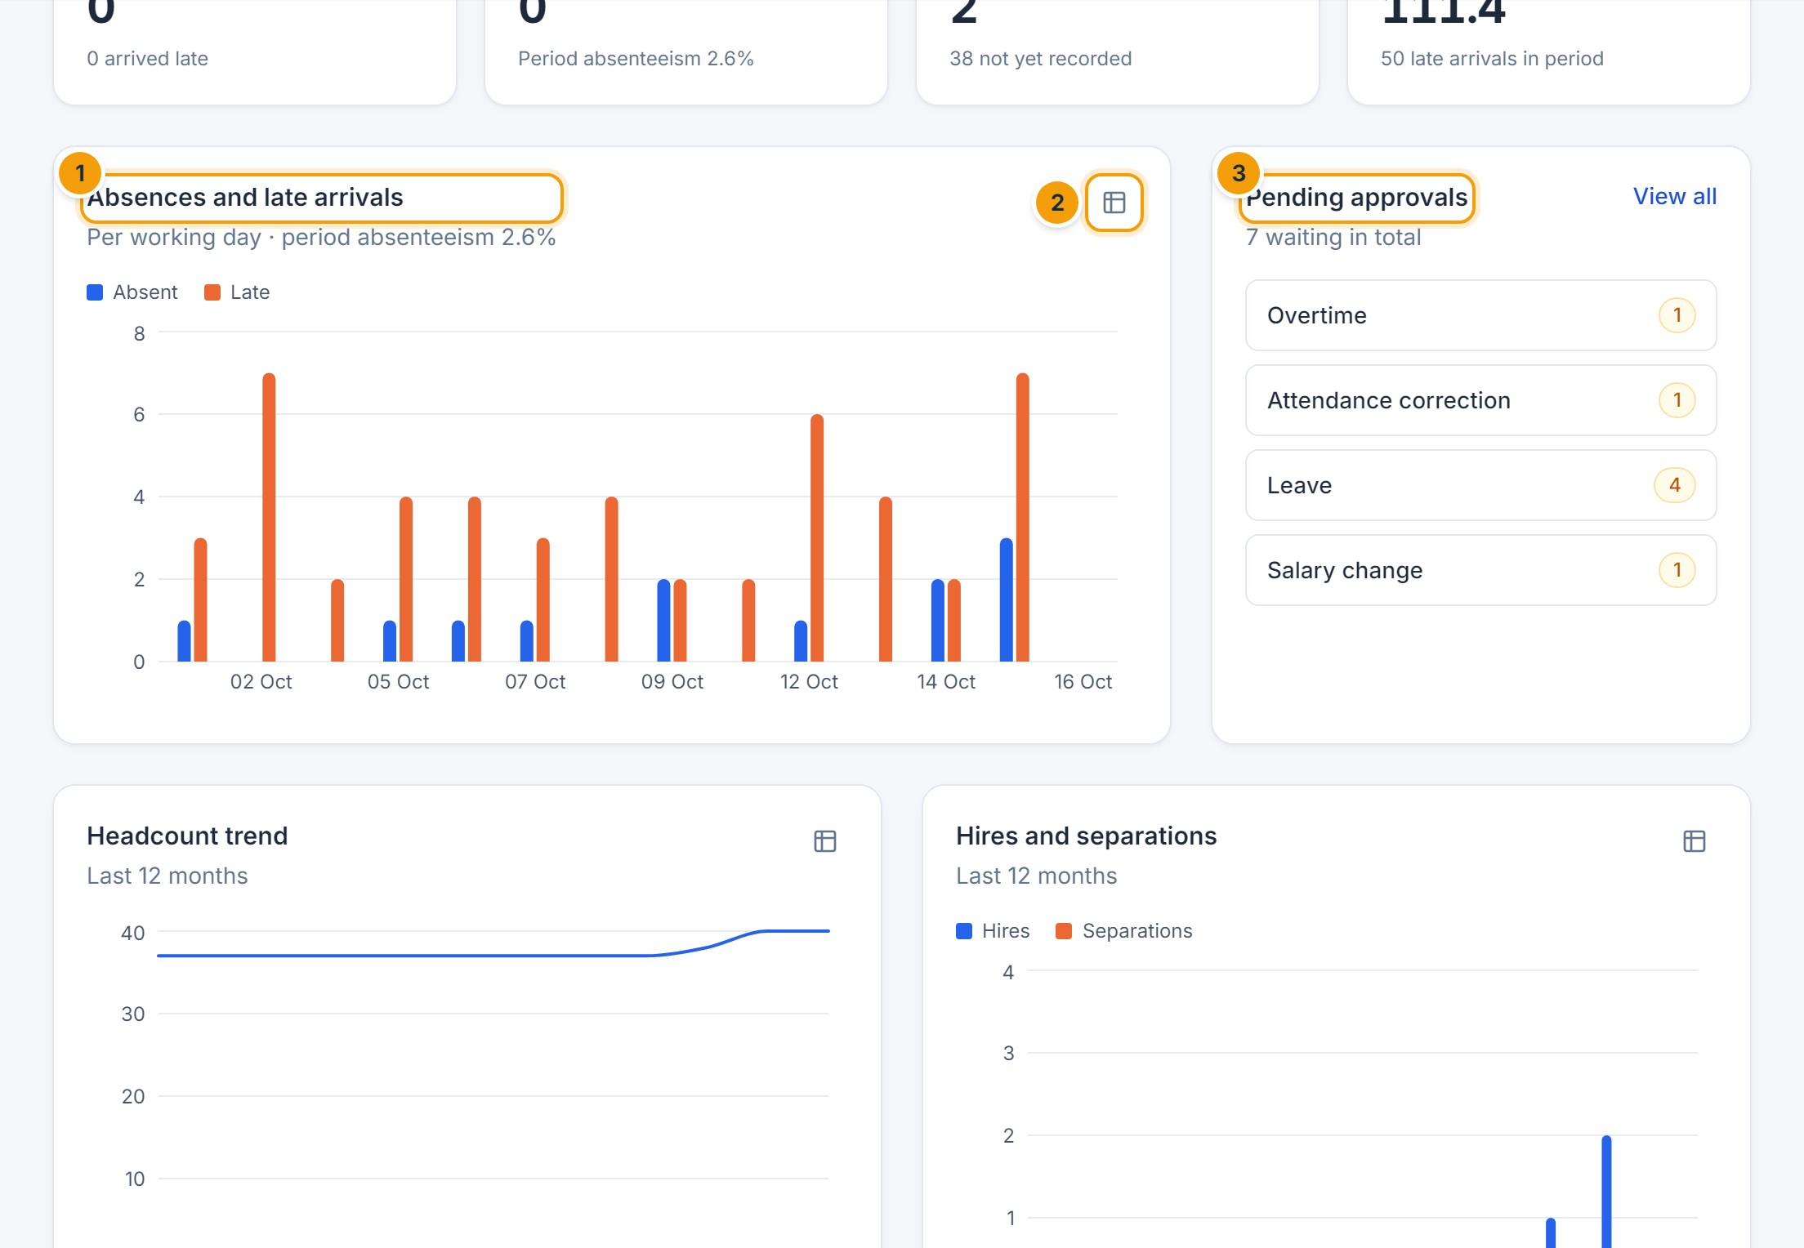
Figure 3.2 — Attendance trend and pending approvals. (1) Absences and late arrivals per working day, (2) switch any chart to a table view, (3) pending approvals by request type.
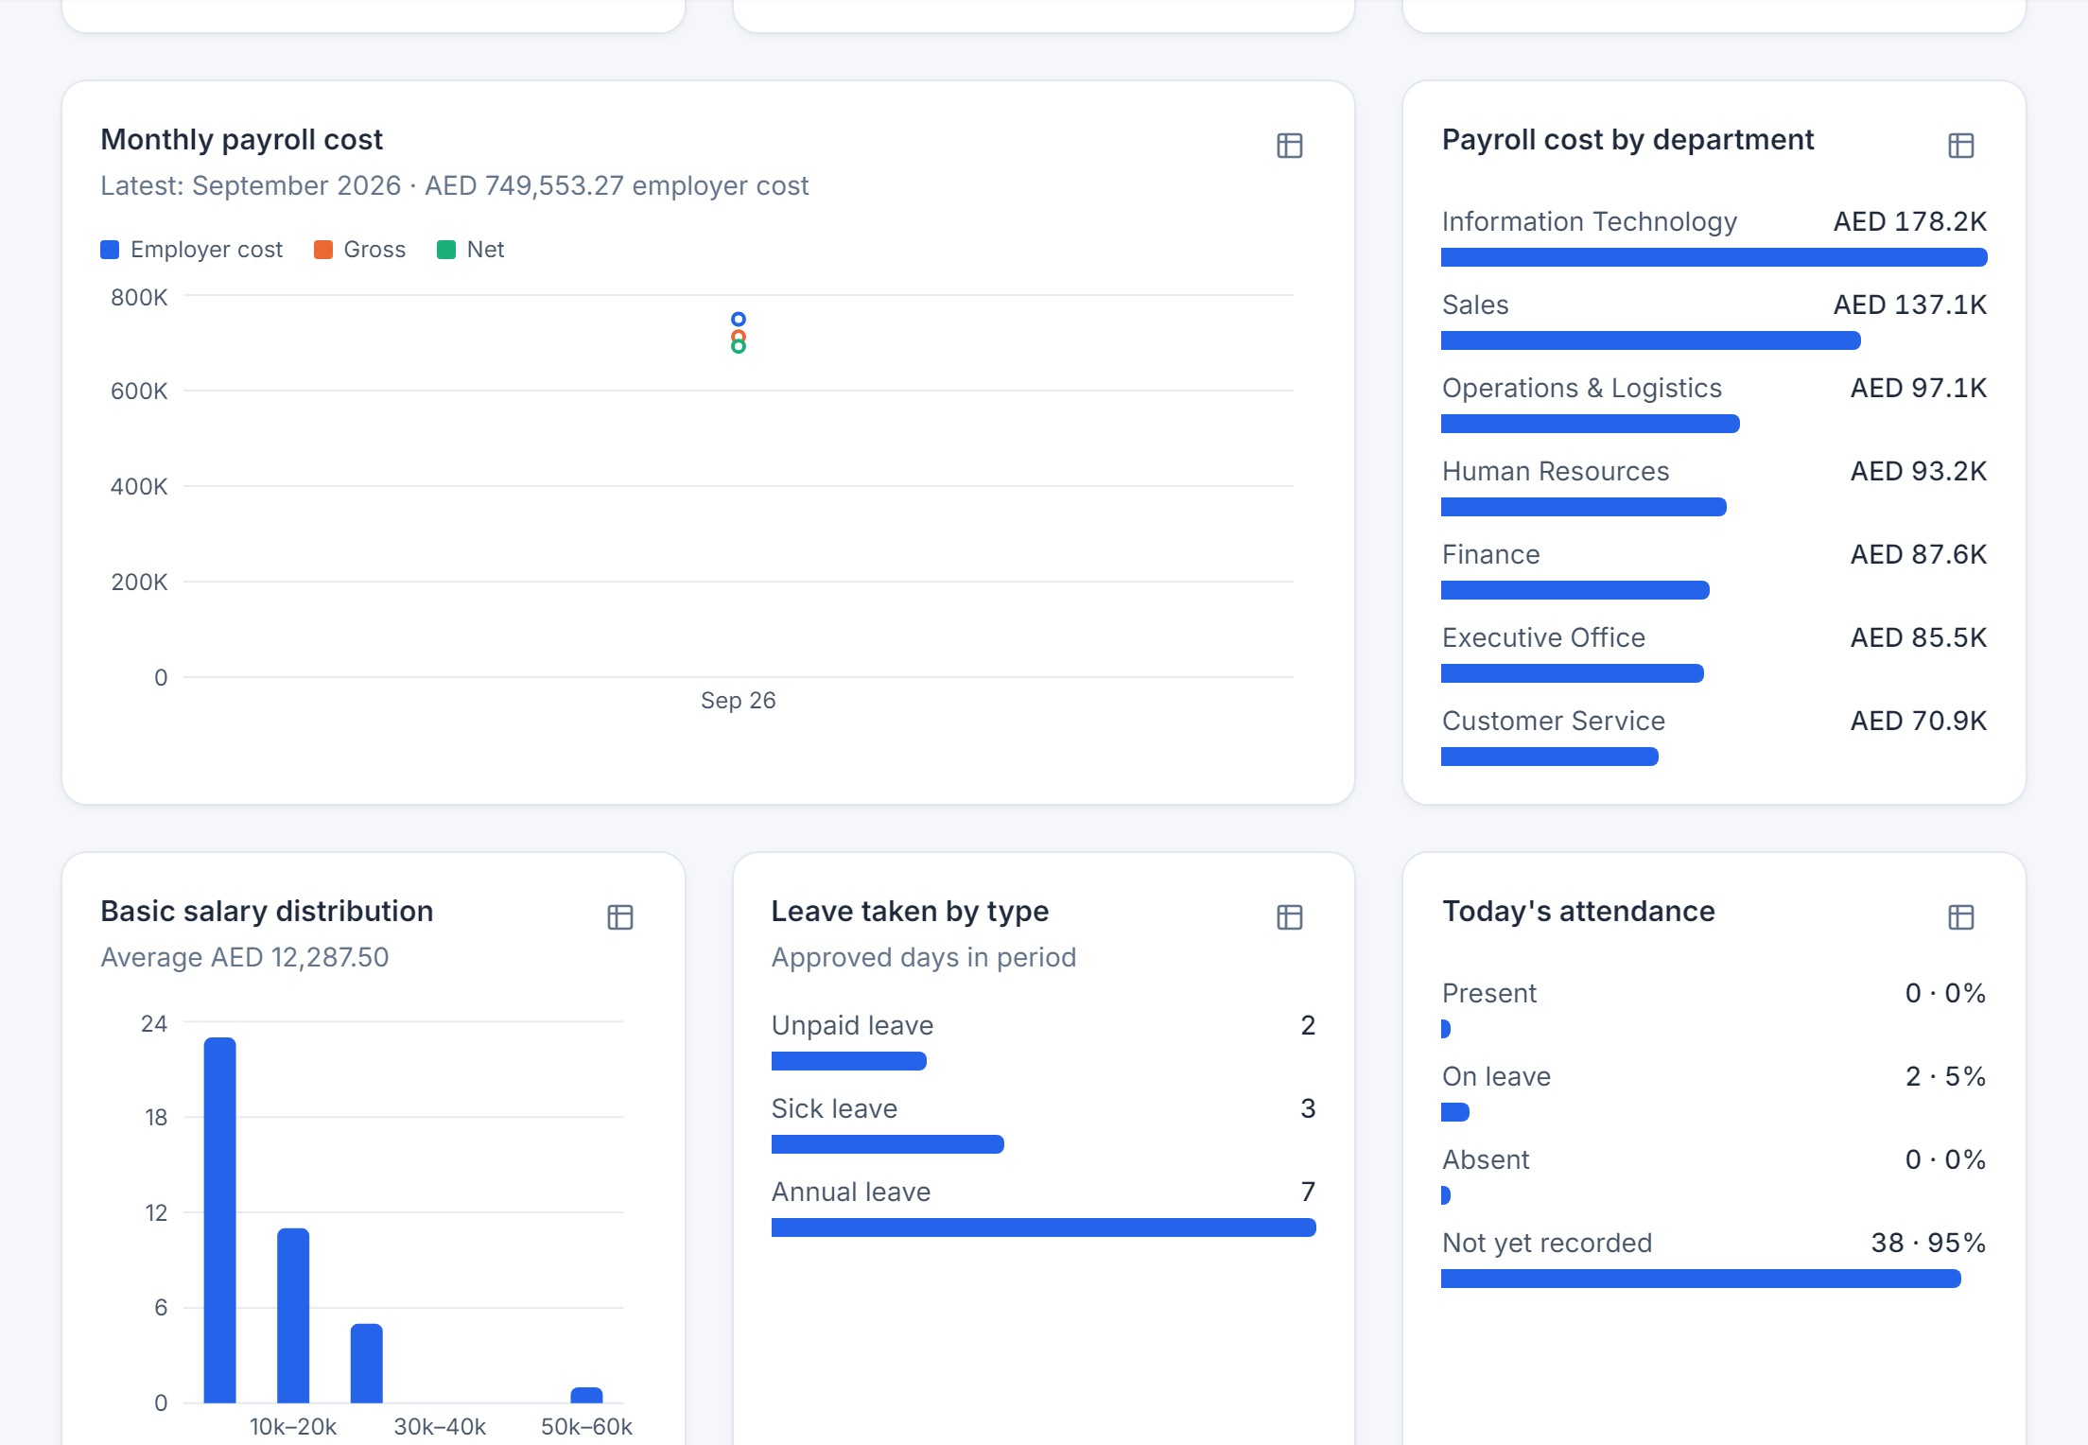
Figure 3.3 — Events and expirations. (1) Upcoming events: holidays, leave starting soon and birthdays, (2) contracts ending in the next 60 days, (3) documents expiring.
Card or chart | What it shows
Headcount | Current staff (active, on probation and suspended) within your filters and scope.
New hires / Turnover rate | Hires and separations in the selected period; turnover = separations ÷ average headcount.
Open positions | Budgeted seats on positions minus the people currently holding them.
Present / Absent / On leave today | Today’s attendance status; “not yet recorded” means no check-in yet.
Overtime hours | Recorded overtime in the period, with the number of late arrivals.
Headcount trend, Hires and separations | The last 12 months.
Monthly payroll cost, Payroll cost by department, Basic salary distribution | Shown only to roles with payroll or salary access; based on approved payroll.
Leave taken by type, Today’s attendance | Approved leave days in the period and today’s attendance breakdown.

E. Expected result
E. EXPECTED RESULT
Cards and charts reflect your filters. Hover over a chart for exact values, or click the table icon to see the numbers.

F. Common errors
- Payroll charts are missing — your role has no payroll or salary access; this is expected.
- Numbers look too low — check the filters, and remember the dashboard only includes employees within your data scope (for example your own department).
- Recruitment, training and performance metrics are not shown — those modules are not available in this version.

G. Tips and best practices
- Use the Manager filter to review one team at a time.
- Click a contract, document or event to open the related employee record.
CHAPTER 4

4. Navigation and User Interface

A. Purpose
This chapter explains the parts of the screen you will use everywhere: the sidebar, top bar, search, notifications, language and theme, and the common way tables and forms behave.

The application layout
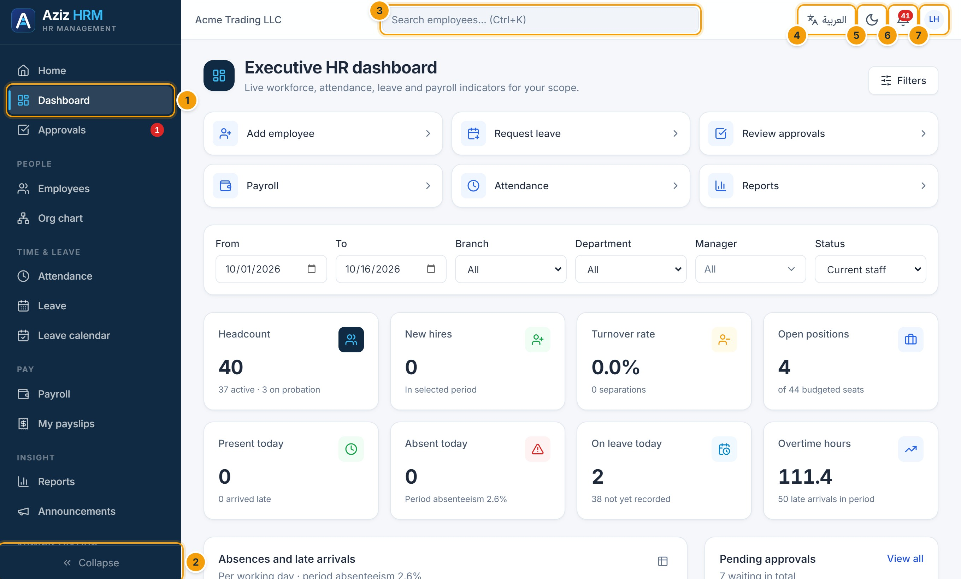
Figure 4.1 — Main layout. (1) Sidebar with the active page highlighted, (2) collapse/expand the sidebar, (3) global employee search, (4) language switch, (5) light/dark theme, (6) notification bell with unread count, (7) account menu.
- The sidebar (1) groups pages into People, Time & leave, Pay, Insight and Administration. It only lists pages your role can open. The cyan bar marks the current page.
- Click Collapse (2) to show icons only; your choice is remembered on this device. On phones, open the sidebar with the menu button at the top left.
- Type at least two letters in the search box (3), or press Ctrl+K, to find an employee by name, number, email or phone. Press Enter to see all matches in the employee list.
- Click العربية / English (4) to change language. Arabic switches the whole interface to right-to-left. Your choice is saved to your account.
- Click the moon/sun icon (5) to switch between light and dark mode.
- The bell (6) shows your latest notifications (Chapter 19).
- The account menu (7) contains My profile, Account settings, API documentation and Sign out.
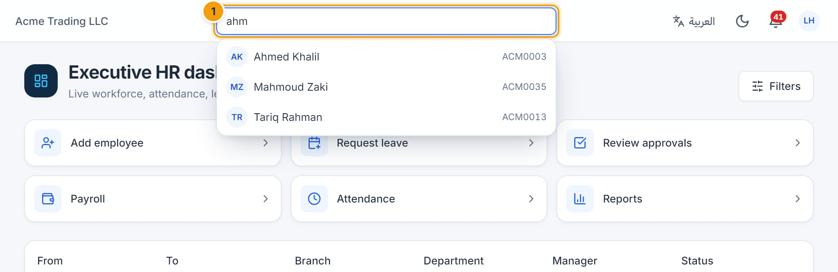
Figure 4.2 — Global search. (1) Results appear as you type; click a person to open their profile.
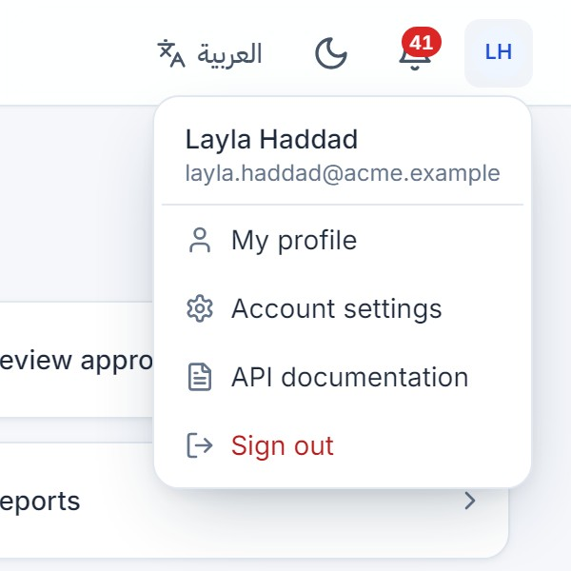
Figure 4.3 — Account menu. Access your profile, account settings and sign out.
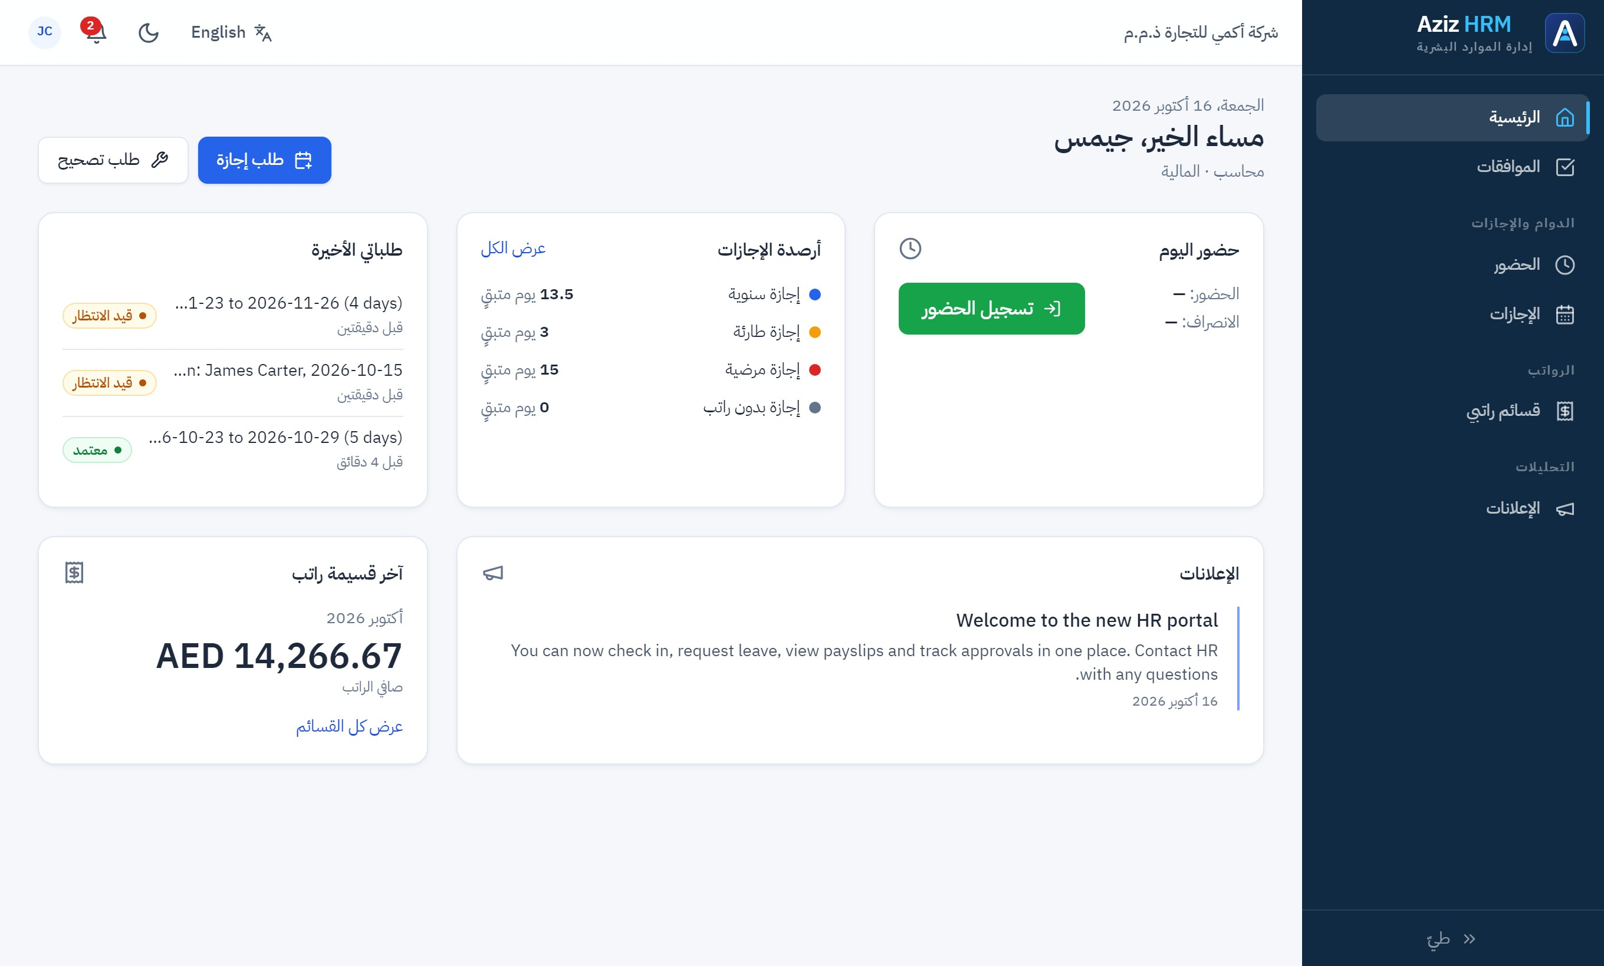
Figure 4.4 — Arabic, right-to-left layout. The full interface mirrors for Arabic, including the sidebar, tables and forms.

Working with tables
- Click a column heading with arrows to sort; click again to reverse the order.
- Use the search box and filter dropdowns above a table to narrow the rows.
- Use the arrows under the table to move between pages and the Rows per page selector to show more rows.
- Click a row to open the record, where rows are clickable.
- Charts on the dashboard and in reports have a table icon that switches to an accessible table view.

Working with forms and dialogs
- Required fields are marked with a red asterisk (*). The save button stays disabled until required fields are filled in.
- While a save is in progress the button shows a spinner and cannot be clicked again, so duplicate records are not created.
- If the server rejects a value, the reason appears under the relevant field and in a red message at the top of the screen.
- Deleting, cancelling and other sensitive actions always ask for confirmation first; some also ask for a reason.
- Press Esc or click Cancel to close a dialog without saving.
TIP
Date fields use your browser’s date picker. Dates and times are shown in the company’s time zone and currency.
CHAPTER 5

5. Employee Management

A. Purpose
The Employees module holds the official record of every employee: personal and contact details, job, department, branch, manager, contract dates, bank details, documents and a complete history of changes.

B. Accessing the module
Click Employees in the sidebar. You see only the employees within your data scope. Creating, editing, importing and exporting require the matching permissions (HR roles).

Search and filter employee records
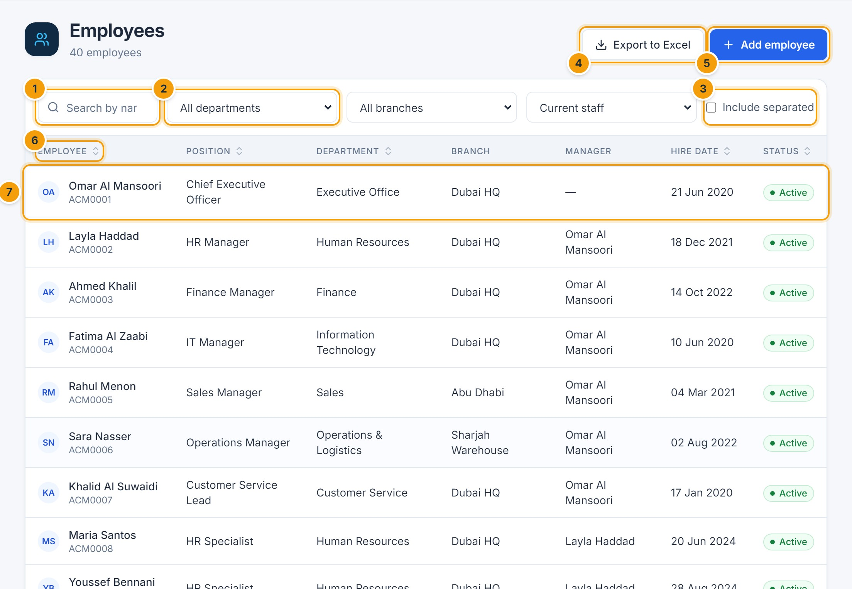
Figure 5.1 — Employee list. (1) Search, (2) department, branch and status filters, (3) include separated employees, (4) export to Excel, (5) add an employee, (6) sortable columns, (7) click a row to open the profile.
- Type in the search box (1) to search by name (English or Arabic), employee number, email or phone.
- Use the filters (2) to narrow by department, branch or status. By default only current staff are listed; tick Include separated (3) to include resigned, terminated and retired employees.
- Click a column heading (6) to sort.
- Click Export to Excel (4) to download the filtered list. National IDs and bank details are only included if your role may see them.

Create a new employee
- Click Add employee (list toolbar, or the dashboard quick action).
- Fill in Personal details: first and last name (required), optional Arabic names, Work email (required, must be unique), phone, gender, date of birth, nationality and marital status.
- Fill in Employment: Branch, Department, Position, Job grade, Manager, category, employment type, cost center, shift and Hire date (required). Leave Shift empty to use the company default. Probation ends is calculated from the company’s probation period if left empty.
- Optionally add an emergency contact and bank details (bank details and national ID are stored encrypted).
- If your role allows it, tick Create a user account so they can use self-service.
- Click Create employee.
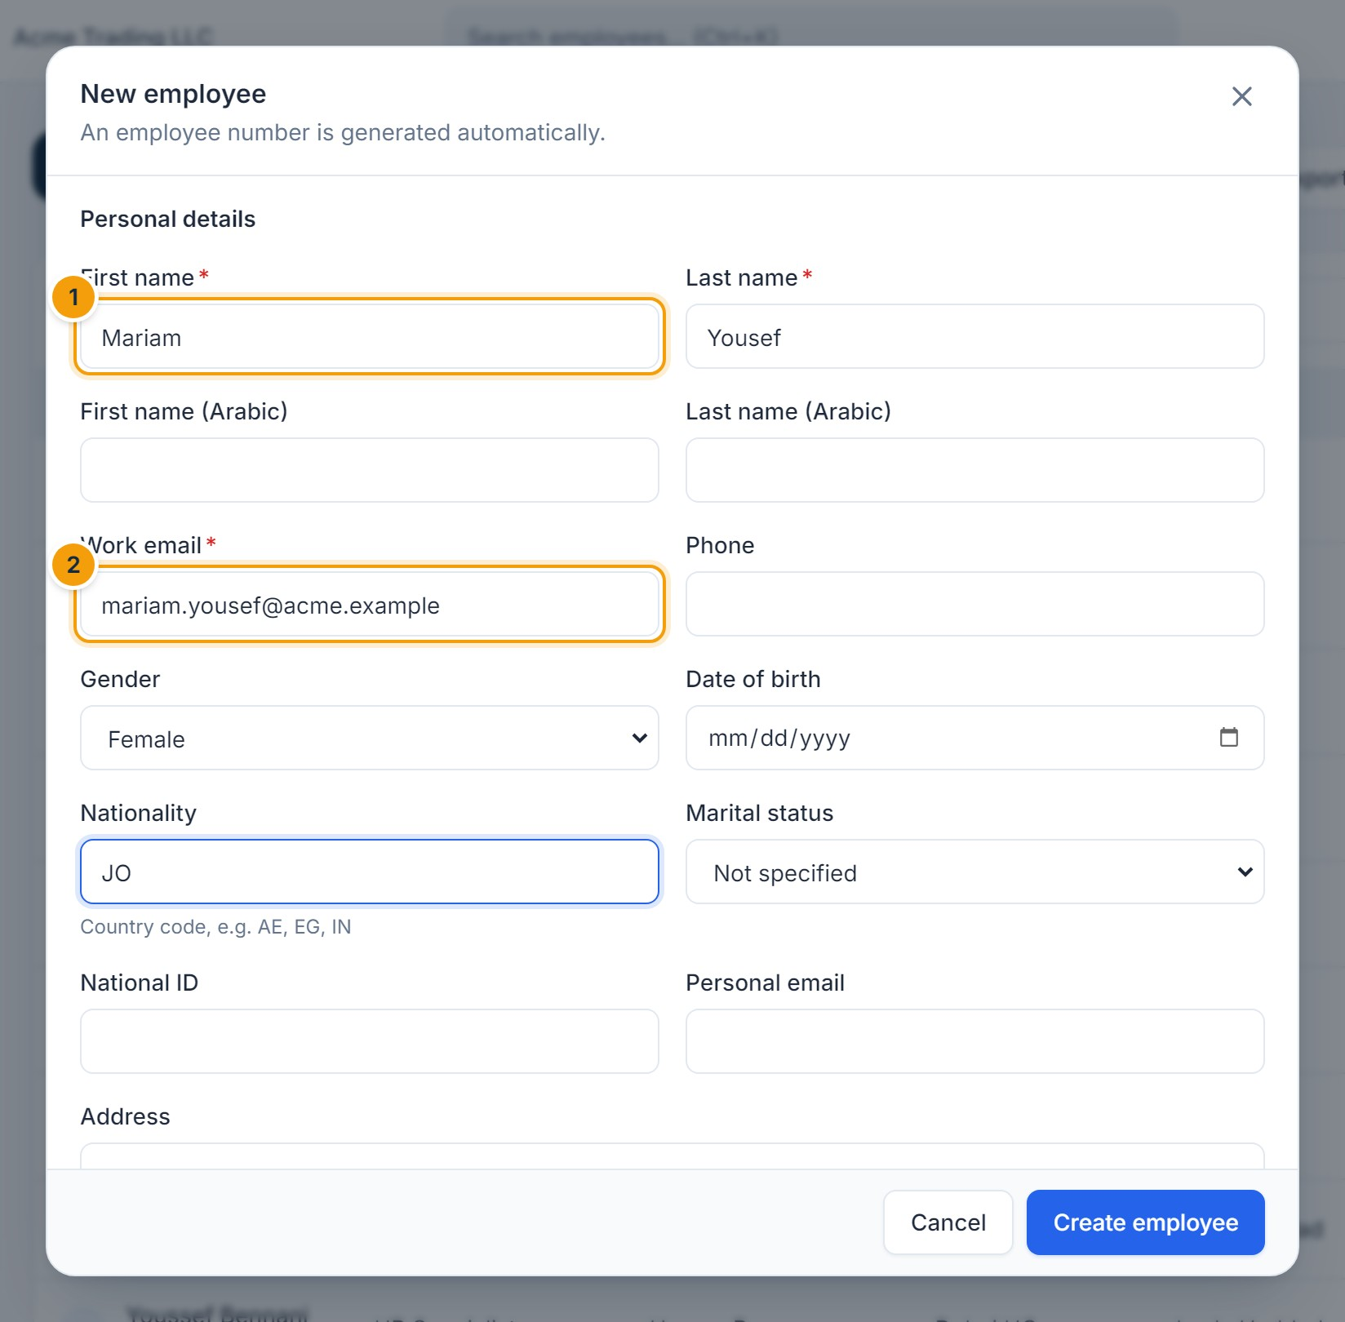
Figure 5.2 — New employee — personal details. (1) First name, (2) work email. The employee number is generated automatically.
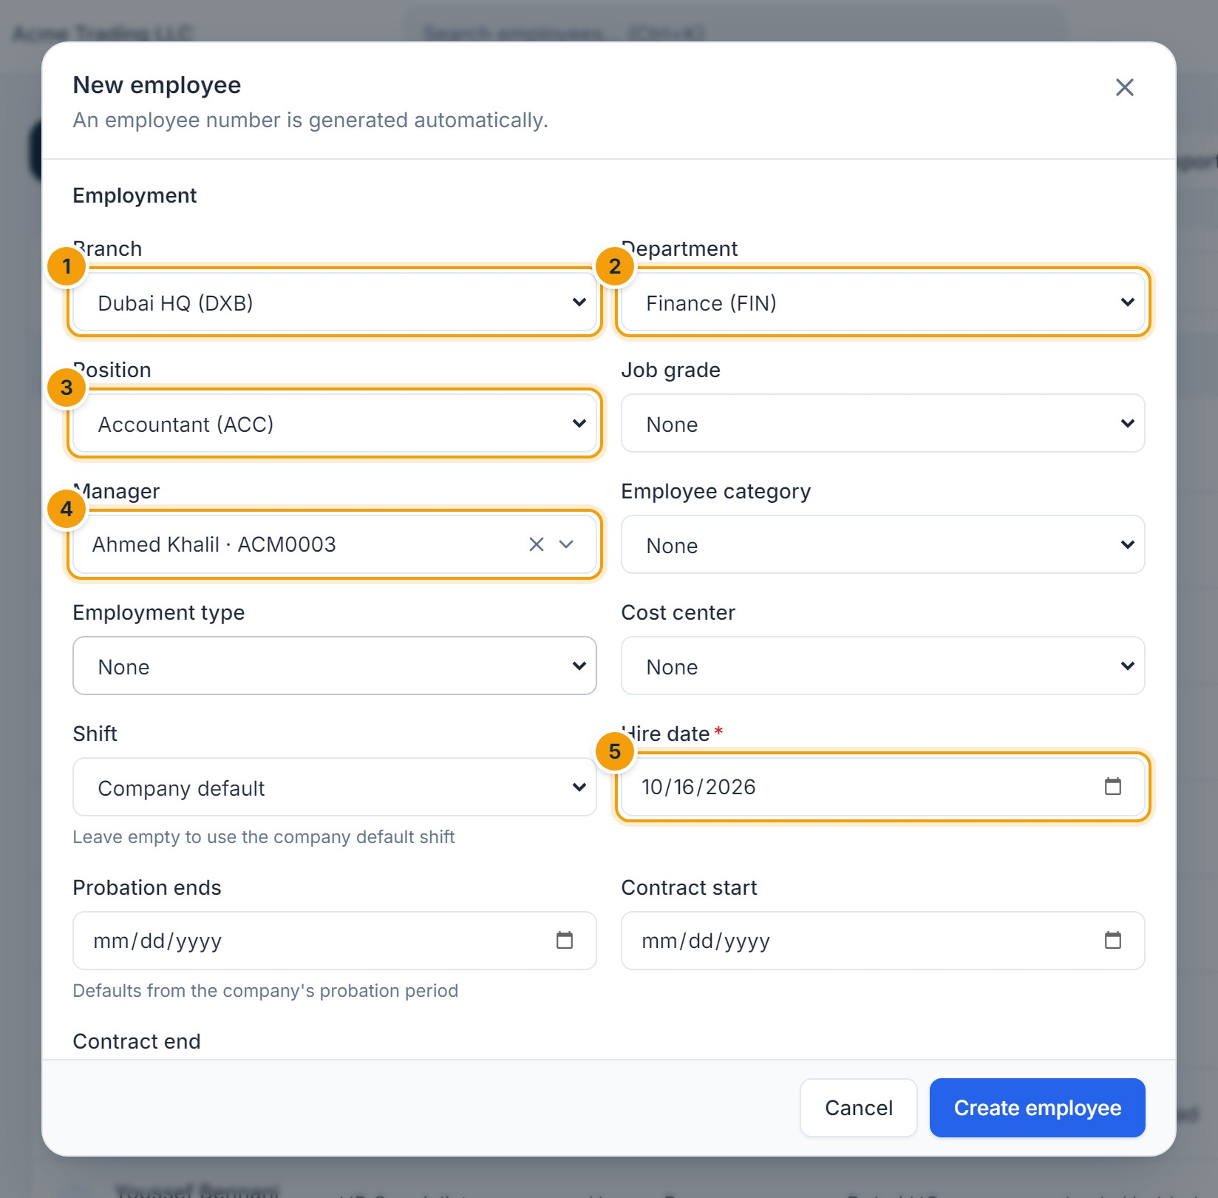
Figure 5.3 — New employee — employment details. (1) Branch, (2) Department, (3) Position, (4) Manager — search and pick a person, (5) Hire date.
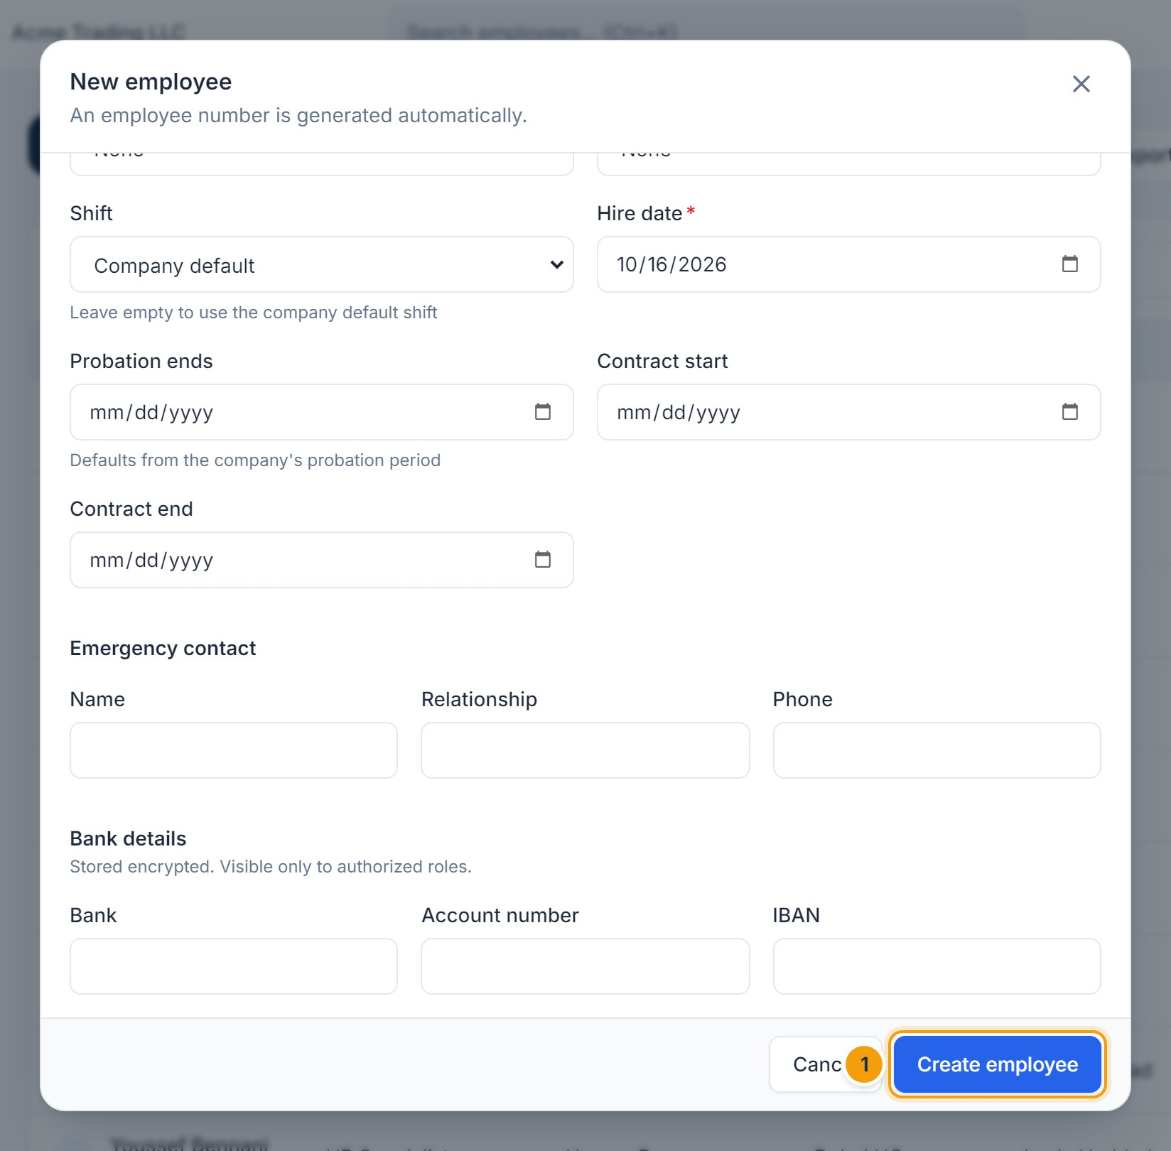
Figure 5.4 — Saving the new employee. (1) Create employee saves the record.
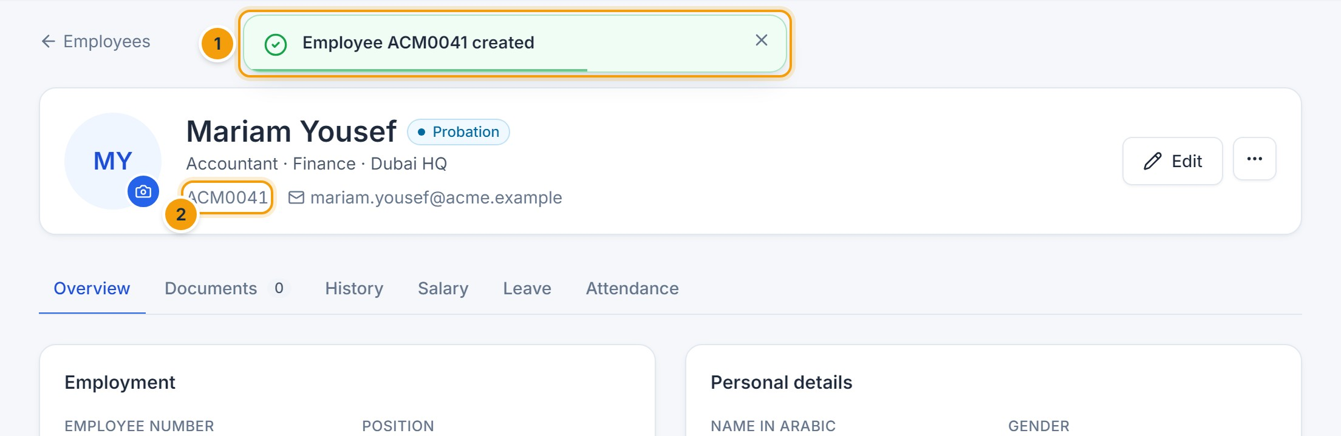
Figure 5.5 — Employee created. (1) Confirmation message with the new employee number, (2) the generated employee number on the profile.
E. EXPECTED RESULT
The employee receives the next employee number (for example ACM0041), a hire entry in their history, and leave balances for the current year. If a user account was created, a temporary password is shown once — copy it and share it securely.

Open and edit an employee profile
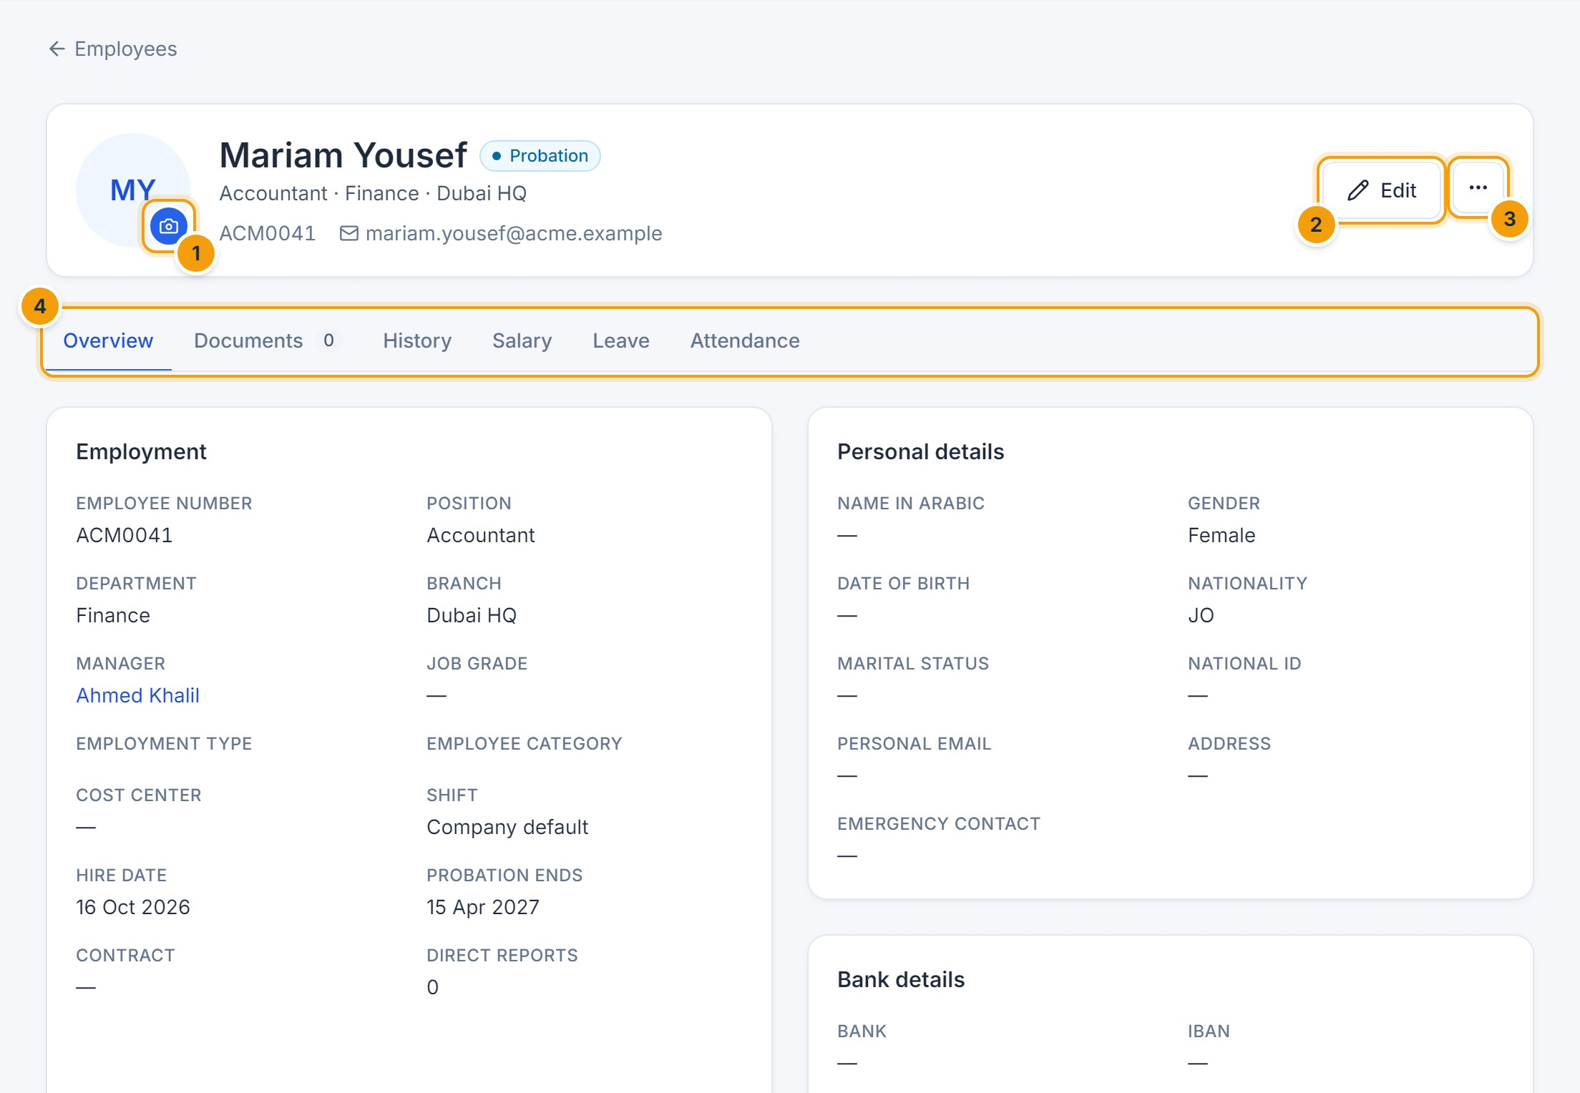
Figure 5.6 — Employee profile. (1) Change photo, (2) Edit, (3) more actions (record separation, archive), (4) tabs: Overview, Documents, History, Salary, Leave and Attendance.
- Open the employee from the list or global search.
- Click Edit (2), change the fields you need, and click Save.
- When changing department, branch, position, grade or manager, enter a Reason for change and an Effective date so the change is recorded correctly in the history.
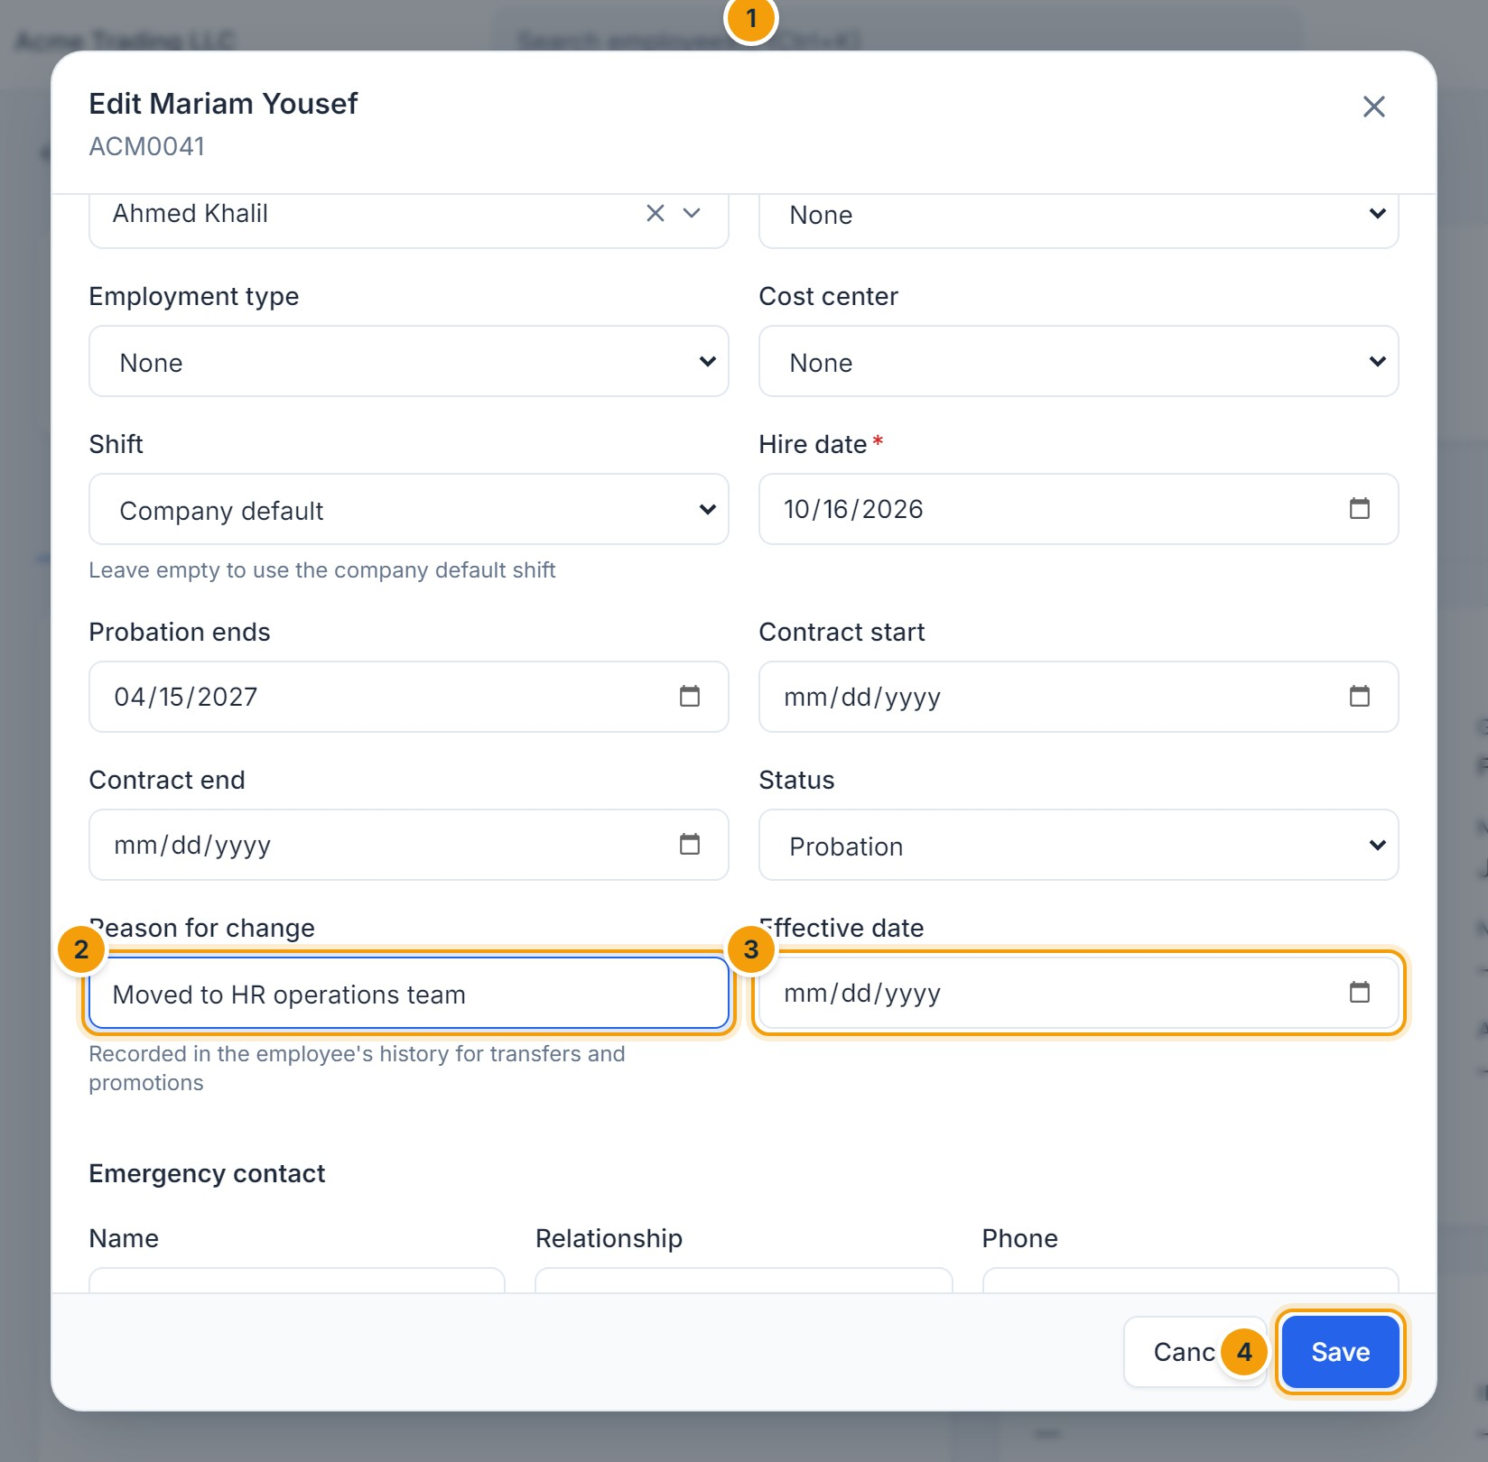
Figure 5.7 — Recording a transfer. (1) New department, (2) reason for change, (3) effective date, (4) Save.
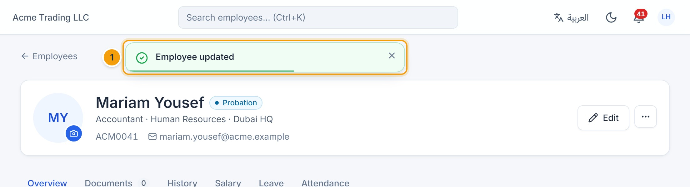
Figure 5.8 — Save confirmation. (1) “Employee updated” confirms the change was stored.

View employee history
Open the History tab. Every hire, transfer, promotion, manager change, status change and salary change is listed with its effective date, the old and new values, and the reason.
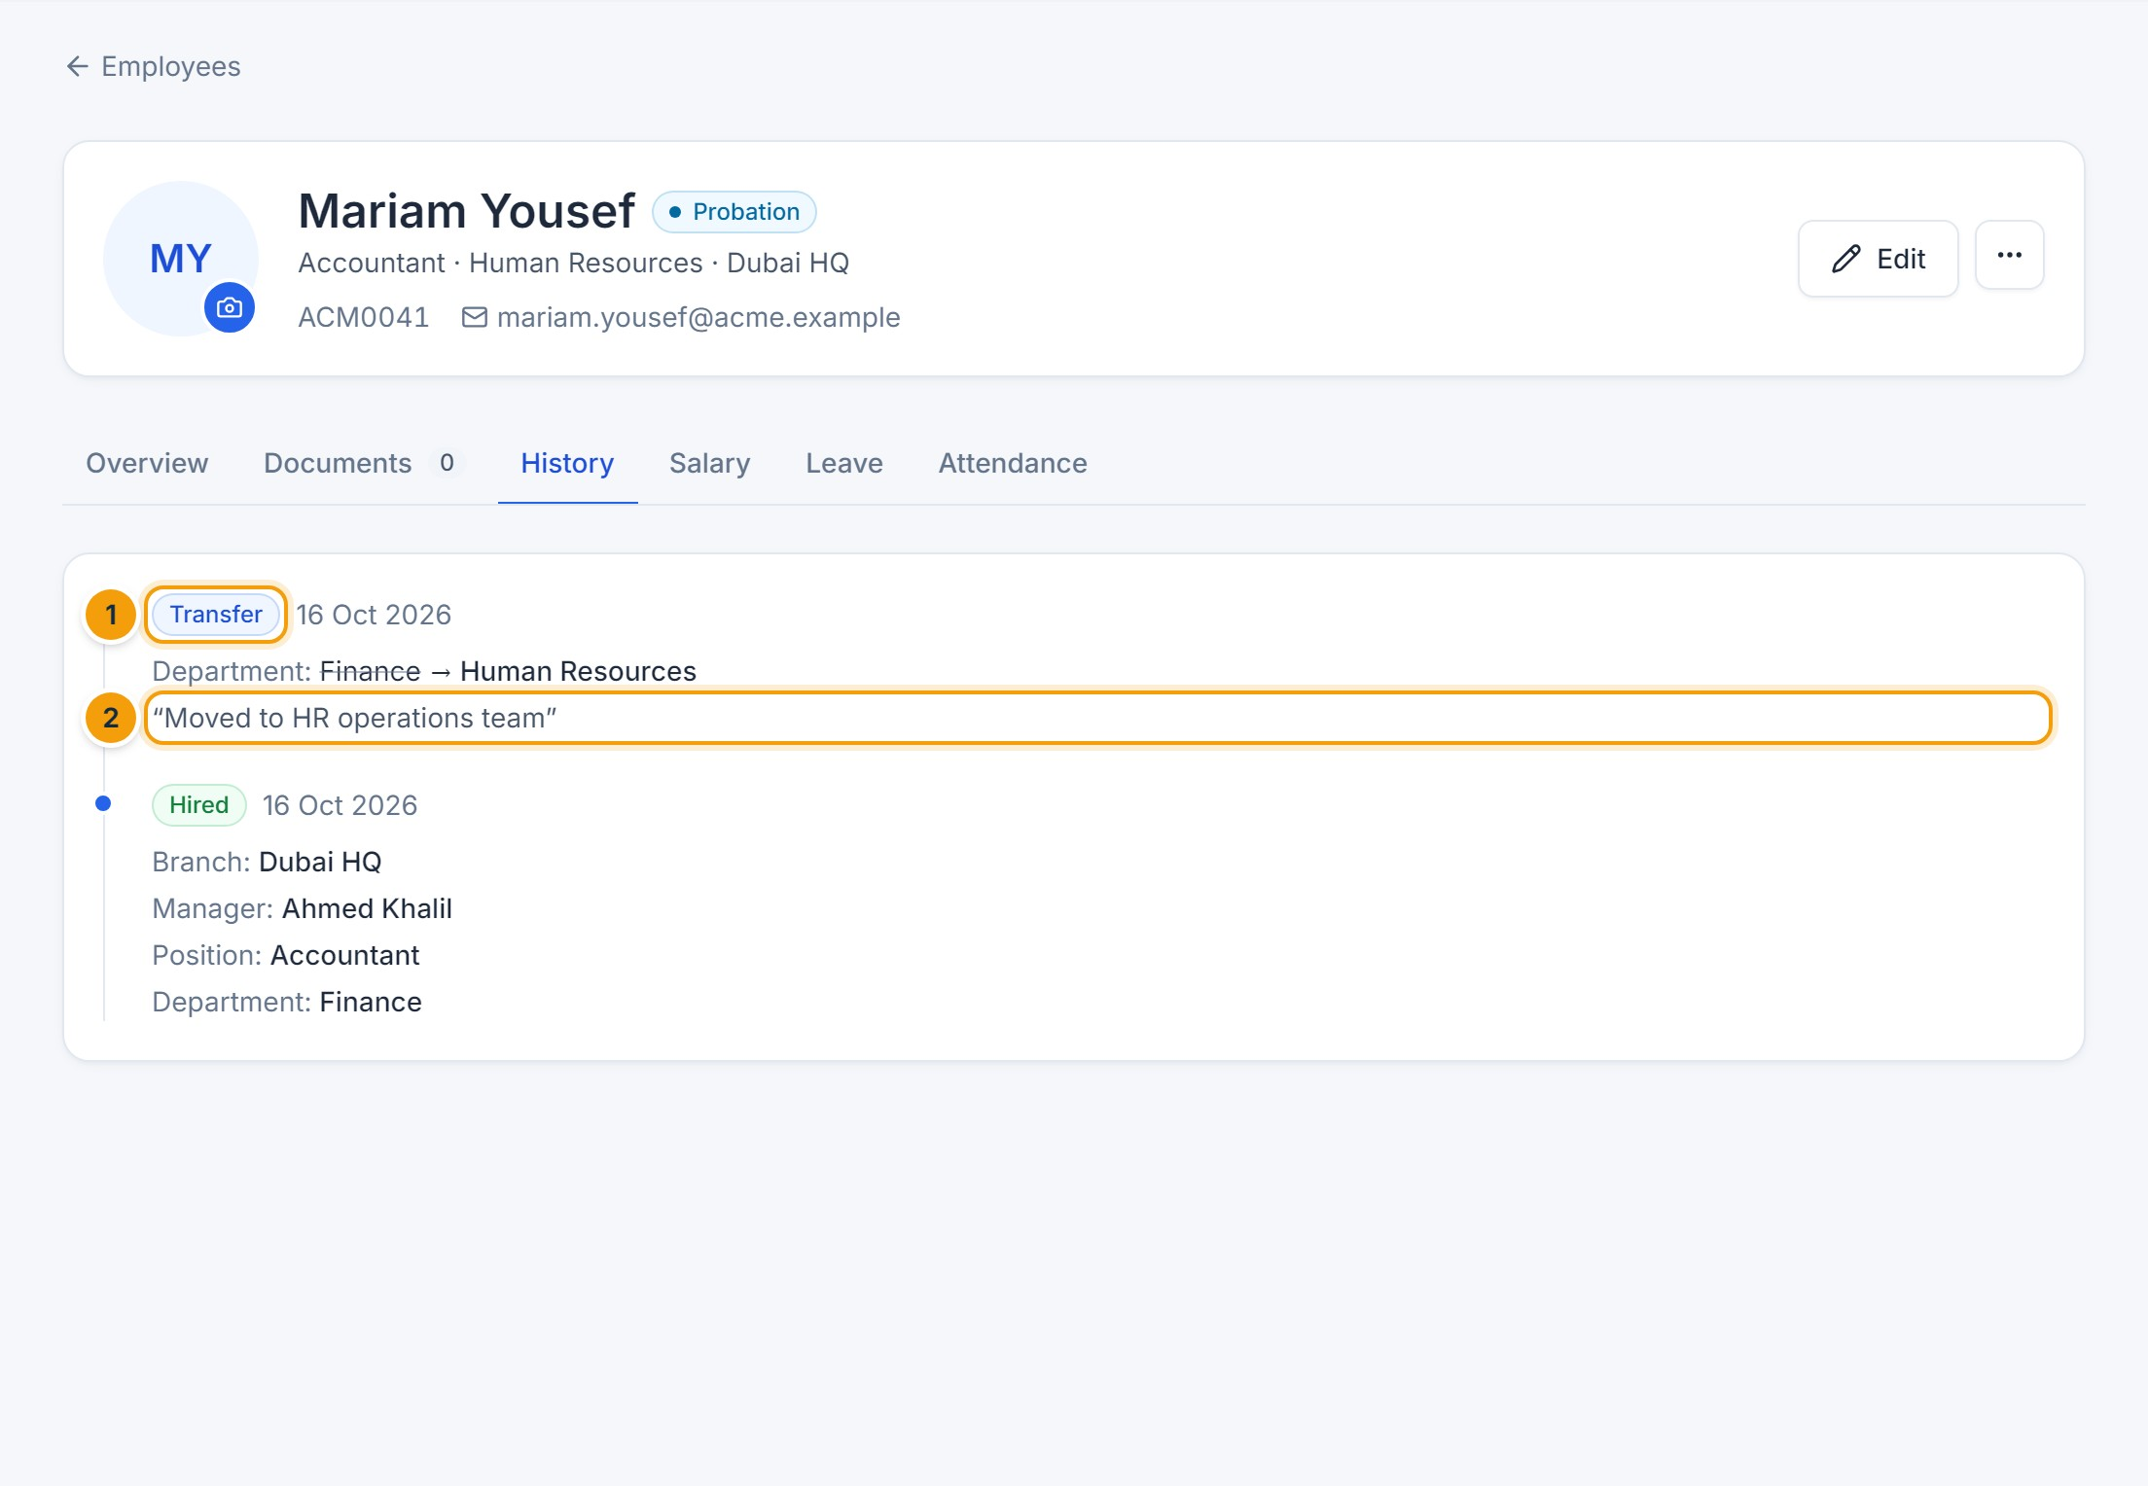
Figure 5.9 — Employment history. (1) The transfer just recorded, (2) the reason entered.

Upload employee documents
See Chapter 15 for the full procedure. In short: open the Documents tab, click Upload document, choose the file, type, title and expiry date, then click Upload document.

Bulk import from Excel
- Click Import on the employee list (HR Administrator and above).
- Click Download template (1), fill in one row per employee and save the file.
- Click Choose File (2) and select your file, then click Validate (4).
- Fix every row reported with an error (3) and validate again. Nothing is saved while any row has an error.
- When all rows are valid, click Import N rows.
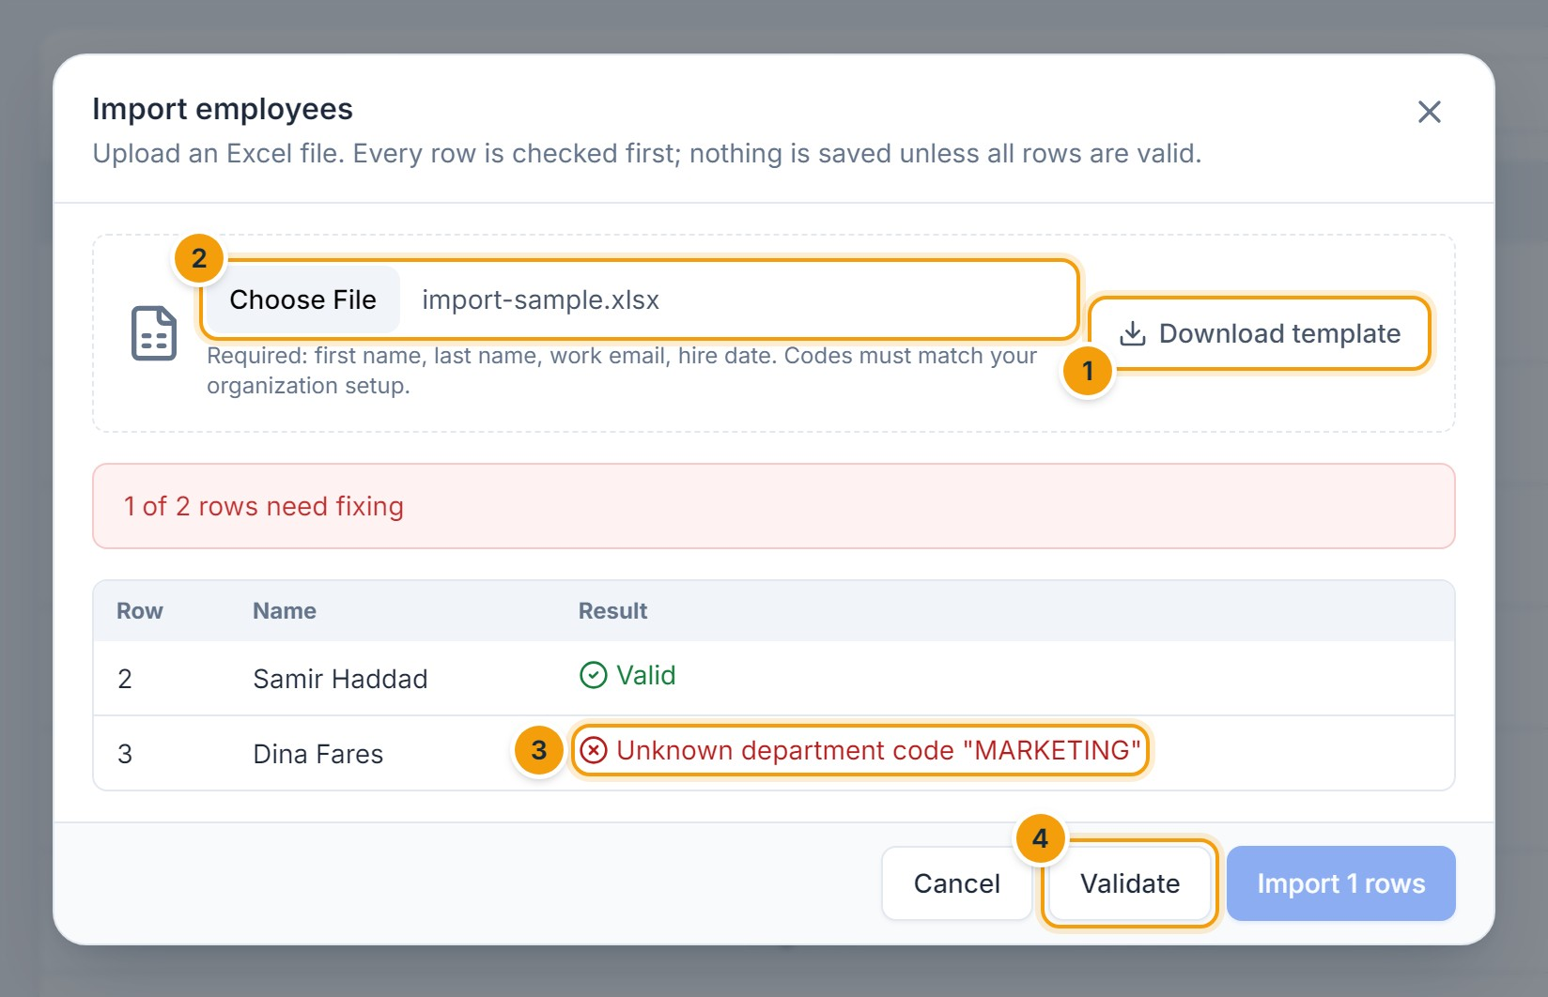
Figure 5.10 — Import with validation. (1) Download template, (2) select the file, (3) a row with an unknown department code, (4) Validate.

Record a separation (resignation, termination, retirement)
- On the profile, click ⋯ → Record separation.
- Choose the Type (1) and Last working day (2), enter the Reason (3), and confirm.
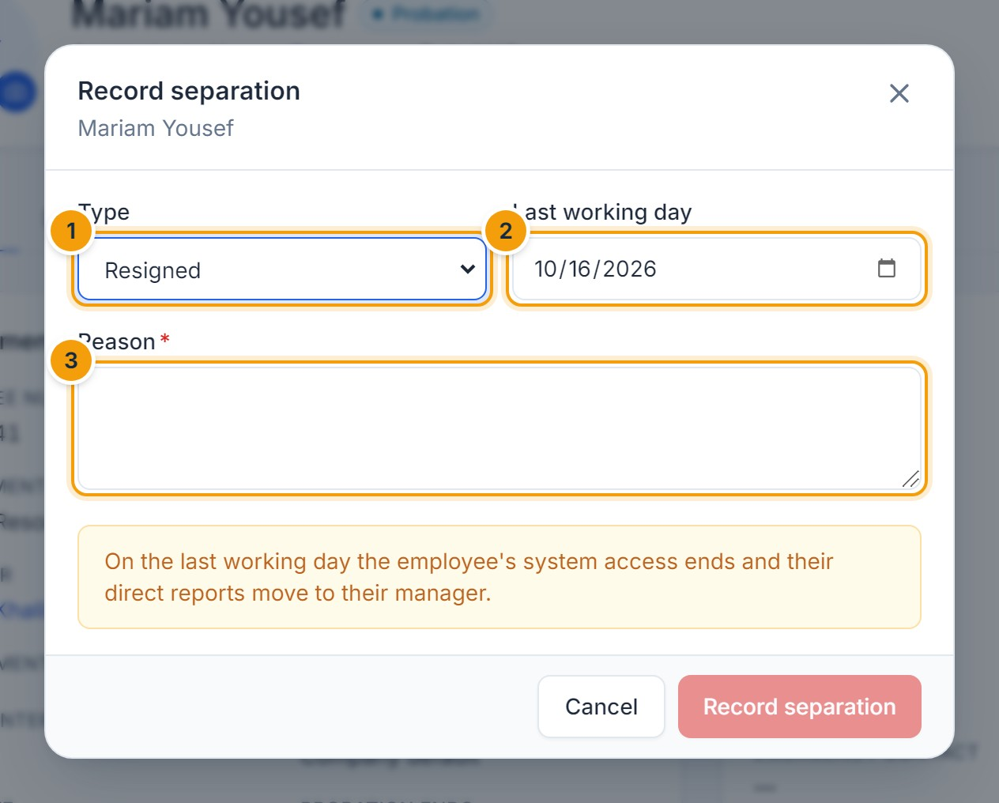
Figure 5.11 — Record separation. (1) Type, (2) last working day, (3) reason.
IMPORTANT
On the last working day the employee’s system access ends and their direct reports move to their manager. Use Archive record only for records created by mistake; employees who have left must be separated so their history and payroll remain intact.

F. Common errors
Message | Cause and resolution
An employee with the same email … already exists | Work email and national ID must be unique. Search for the existing record instead of creating a new one.
Possible duplicate — Create anyway | Another employee has the same name and date of birth. Check it is a different person before confirming.
The selected department does not belong to this company | Pick values from the current company only.
This manager reports to the employee… | You chose a manager who is already in this employee’s reporting line.
Changing national ID or bank details requires access to sensitive data | Only roles with sensitive-data access can change these fields.
This employee has approved payroll records and cannot be archived | Record a separation instead.

G. Tips and best practices
- Always enter a reason for organizational changes — it appears in the history and audit log.
- Validate imports with a small file first.
- Keep contract end dates up to date so reminders and the dashboard work.
CHAPTER 6

6. Attendance and Time Tracking

A. Purpose
Attendance records each employee’s check-in and check-out and automatically calculates worked hours, late arrivals, early departures, overtime and absences against the employee’s shift, weekends and public holidays.

B. Accessing the module
- Employees: Home (check in/out) and Attendance → My attendance.
- HR and managers: Attendance → Records and Summary.
- Shifts, holidays and attendance policy: Settings (HR administrators).

Check in and check out
- On Home, find Today’s attendance (1).
- Click Check in when you start and Check out when you finish. A confirmation appears at the top (2).
- On a phone, your browser may ask for your location; if the company restricts mobile check-in to an area, you must be inside it.
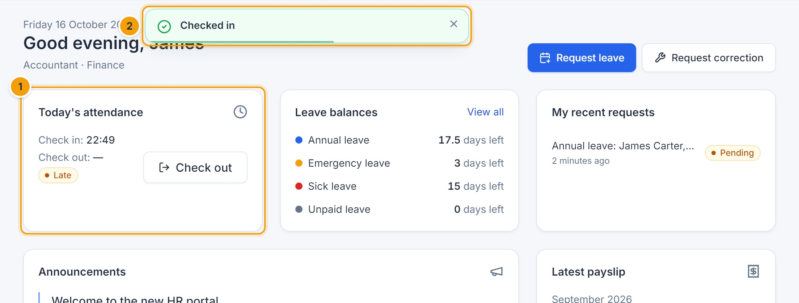
Figure 6.1 — Checking in from the Home page. (1) Today’s attendance card, (2) confirmation message.

View your attendance records
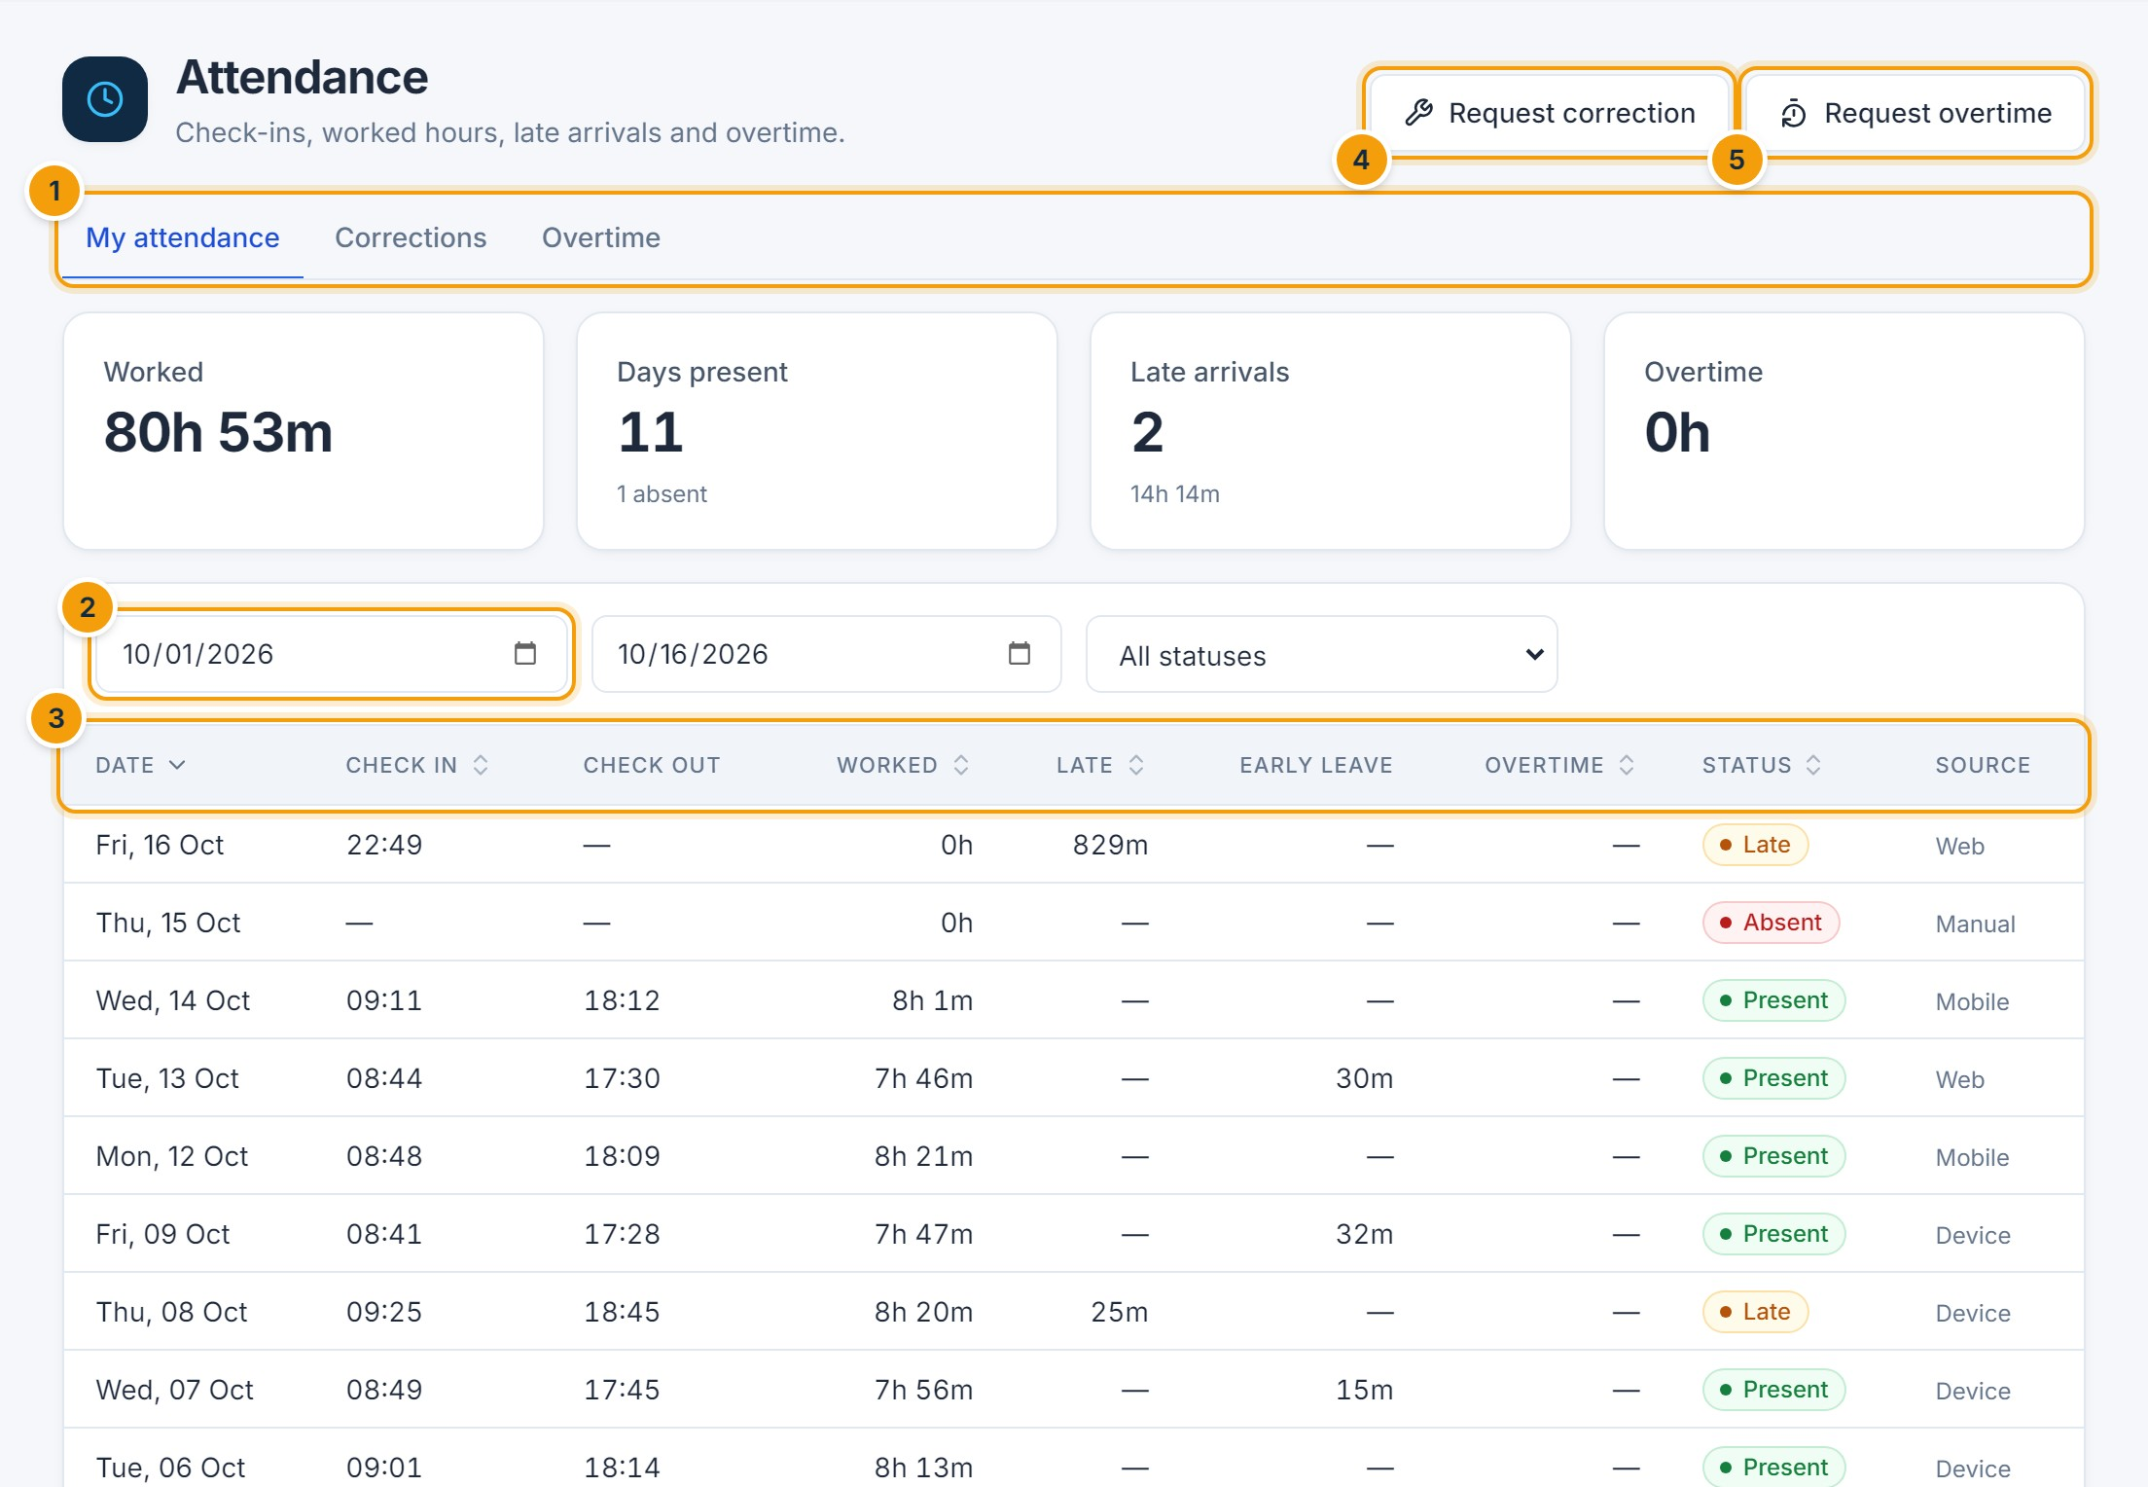
Figure 6.2 — My attendance. (1) Tabs, (2) date range, (3) daily records with worked hours, lateness, overtime and status, (4) request a correction, (5) request overtime.
Status | Meaning
Present / Late | Checked in and out; Late when the check-in was after the shift start plus the grace period.
Half day | Worked less than the half-day threshold.
Absent | No punches on a working day (marked automatically after the day ends).
Missed punch | Only a check-in or only a check-out was recorded for a completed day.
On leave / Holiday / Weekend | Approved leave, public holiday or non-working day.

Submit an attendance correction request
- Click Request correction.
- Select the Date (1) and enter the correct check-in (2) and/or check-out time.
- Explain the reason (3) and click Submit (4).
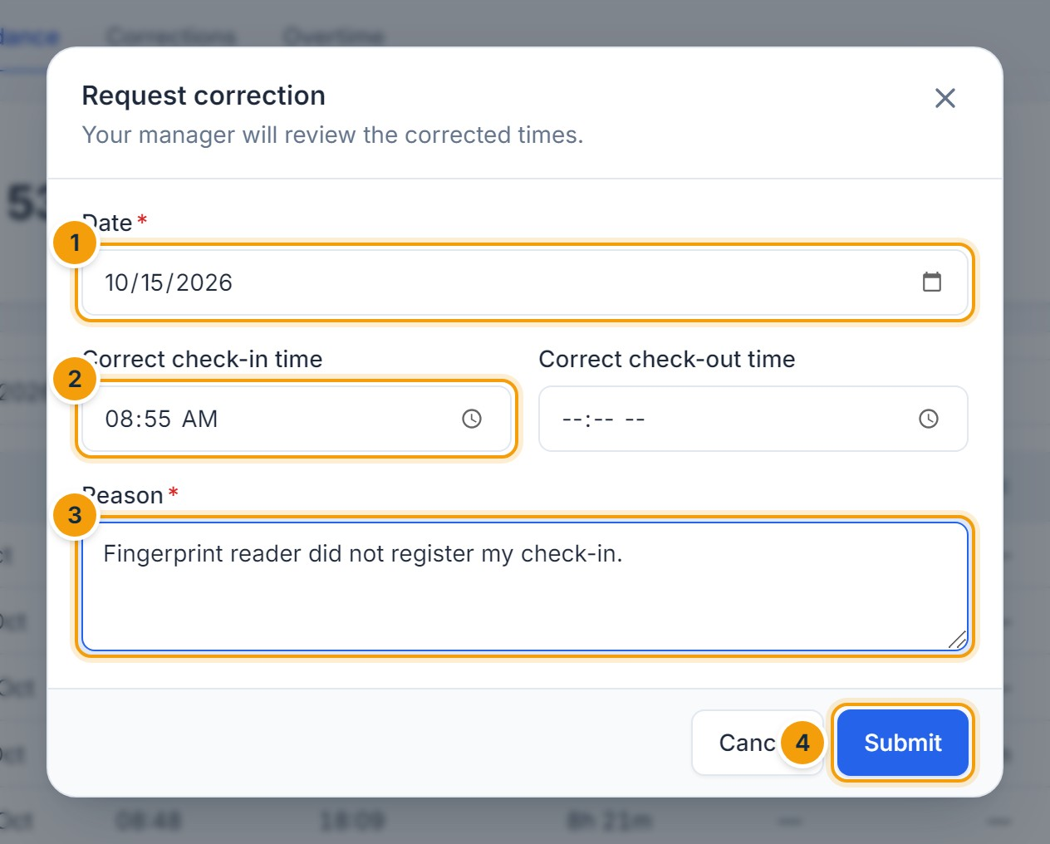
Figure 6.3 — Attendance correction request. (1) Date, (2) correct check-in time, (3) reason, (4) Submit.
E. EXPECTED RESULT
The request goes to your approvers (Chapter 18). When approved, the record is updated and recalculated automatically, and you are notified.
Request overtime works the same way: choose the date, enter the hours and a reason. Depending on company policy, overtime may only be paid after approval.

Review team attendance (HR and managers)
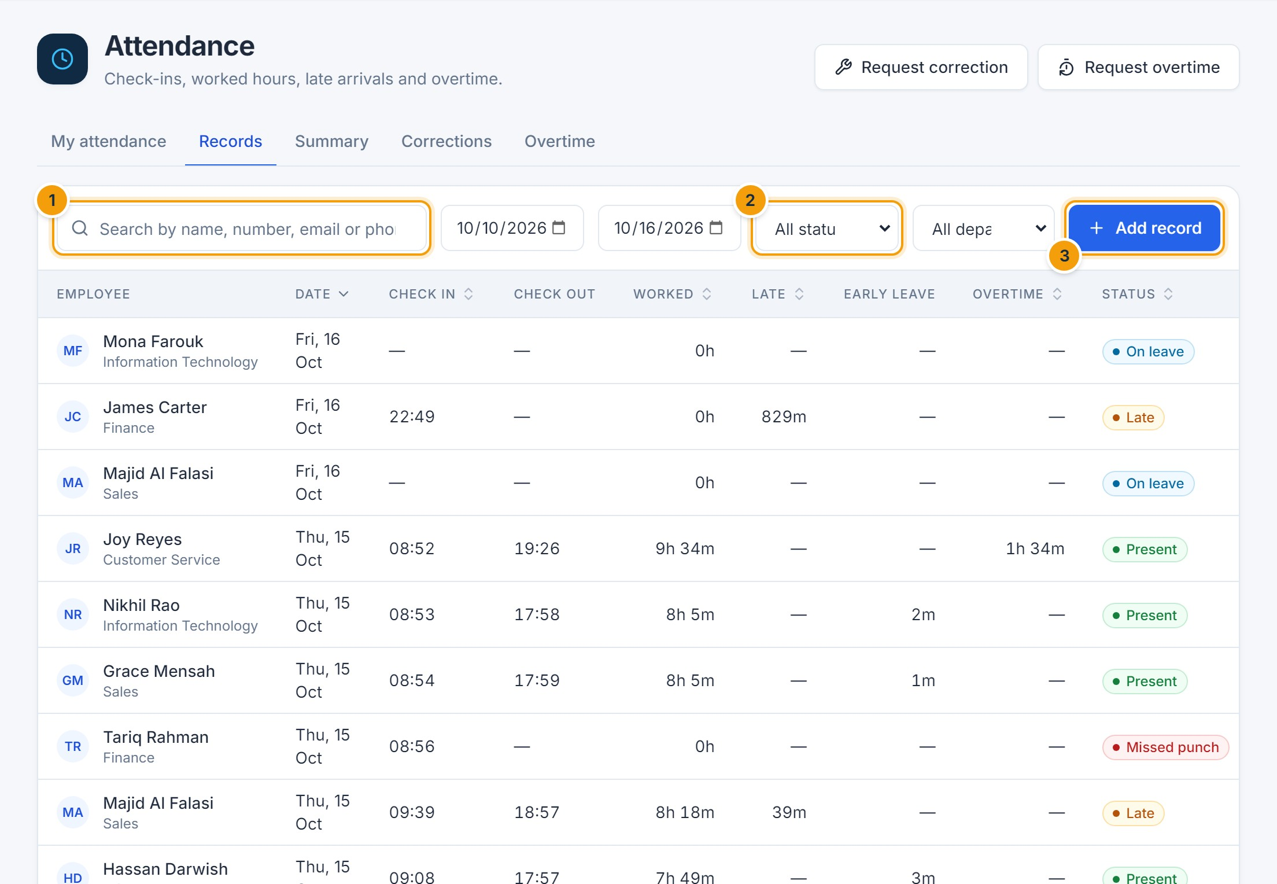
Figure 6.4 — Attendance records. (1) Search employees, (2) date, status and department filters, (3) add a record (HR), (4) edit a record (HR).
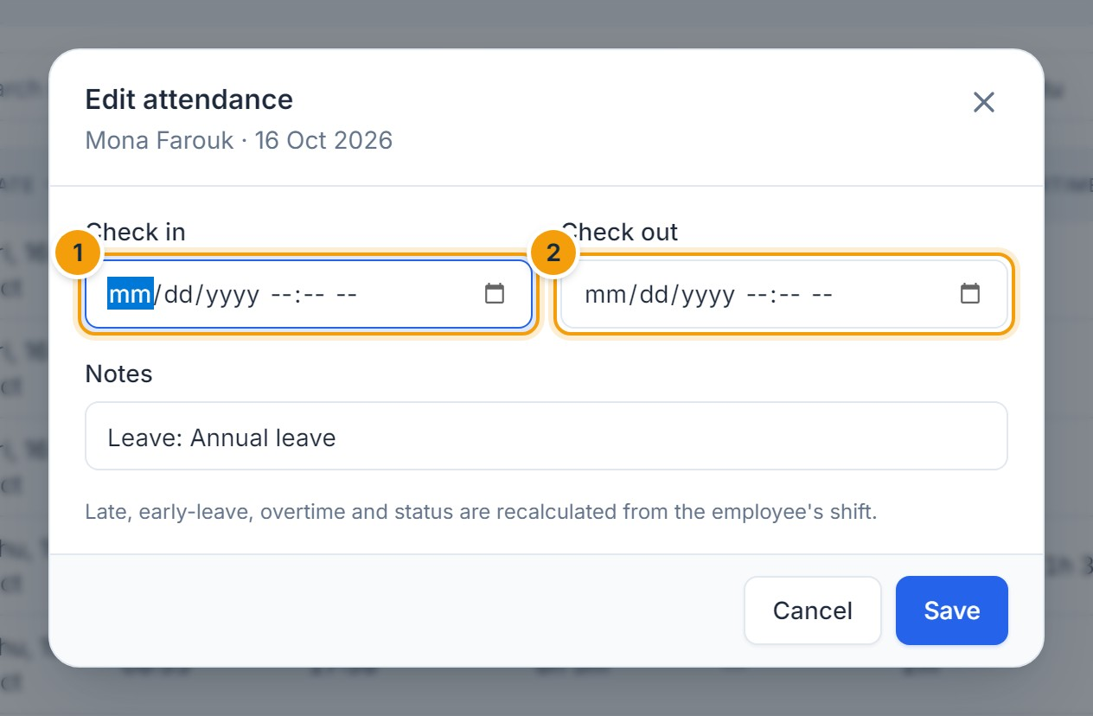
Figure 6.5 — Editing an attendance record (HR). (1) Check in, (2) check out. Late, early leave, overtime and status are recalculated from the shift.
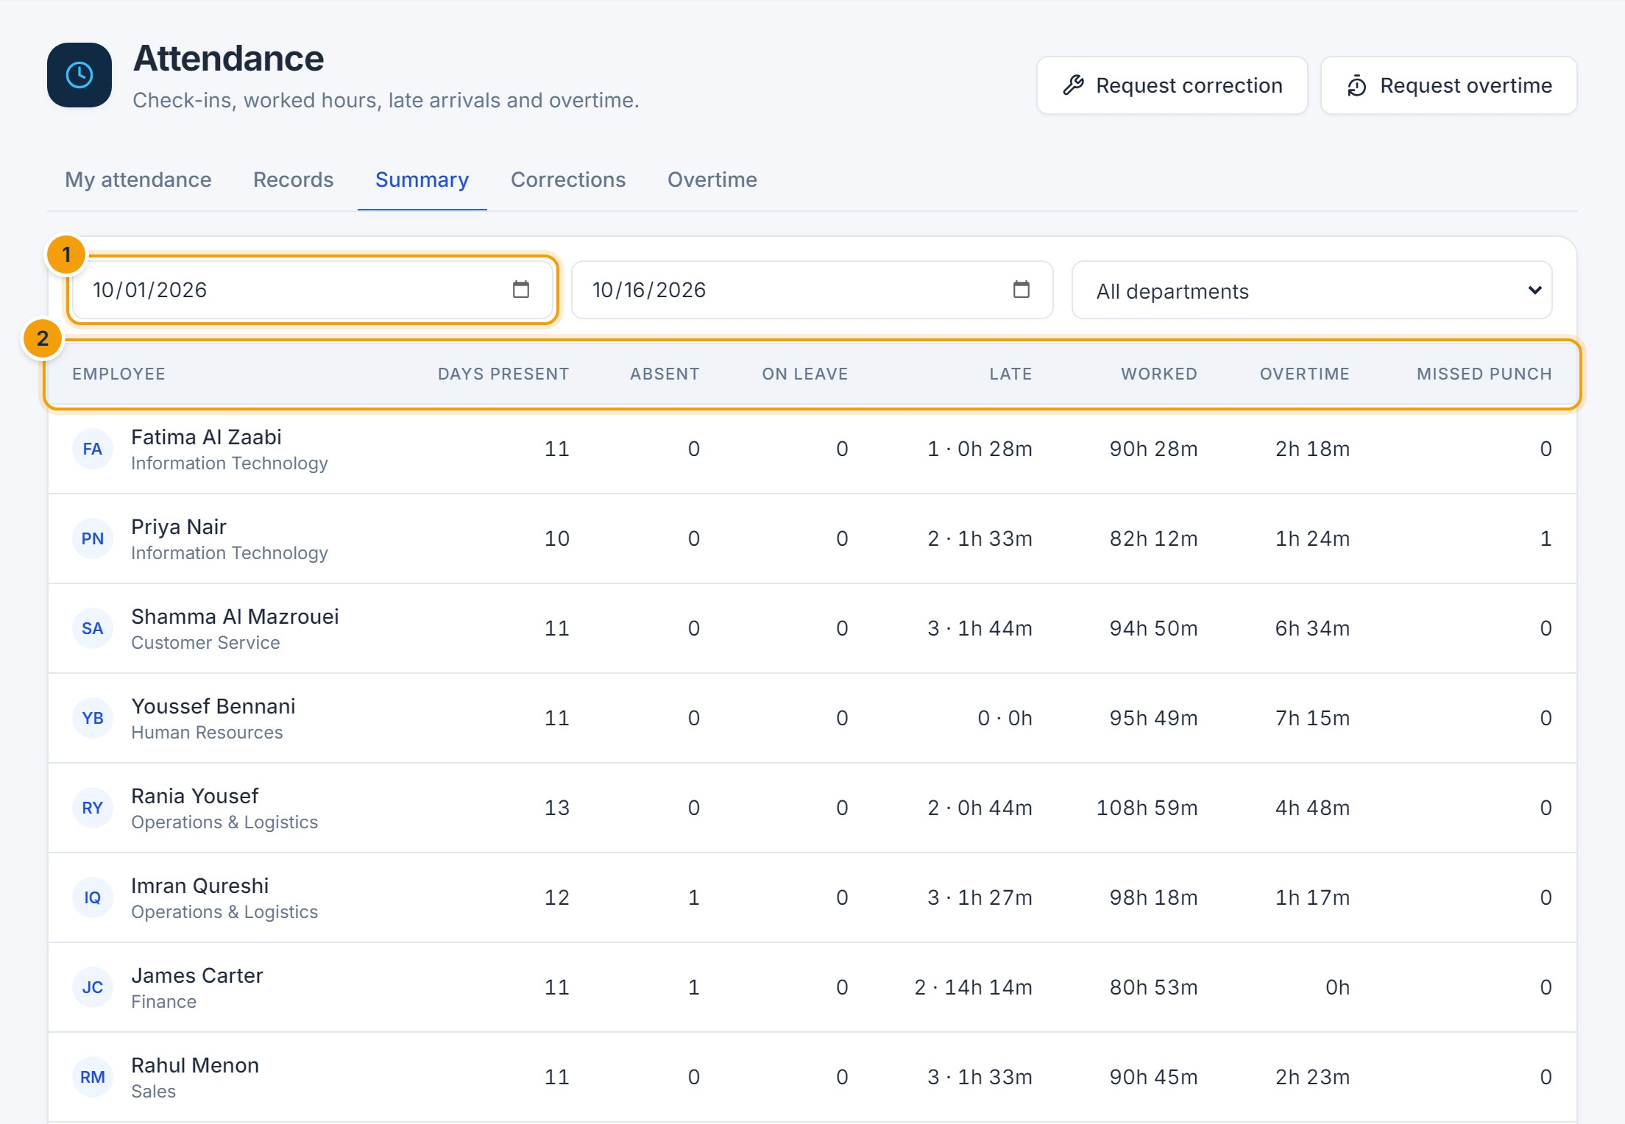
Figure 6.6 — Attendance summary. (1) Period, (2) totals per employee: days present, absences, leave, late time, worked hours, overtime and missed punches.

Shifts, holidays and policy (administrators)
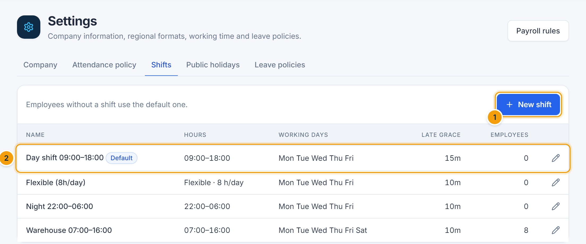
Figure 6.7 — Shifts. (1) New shift, (2) the default shift used by employees without an assigned shift.
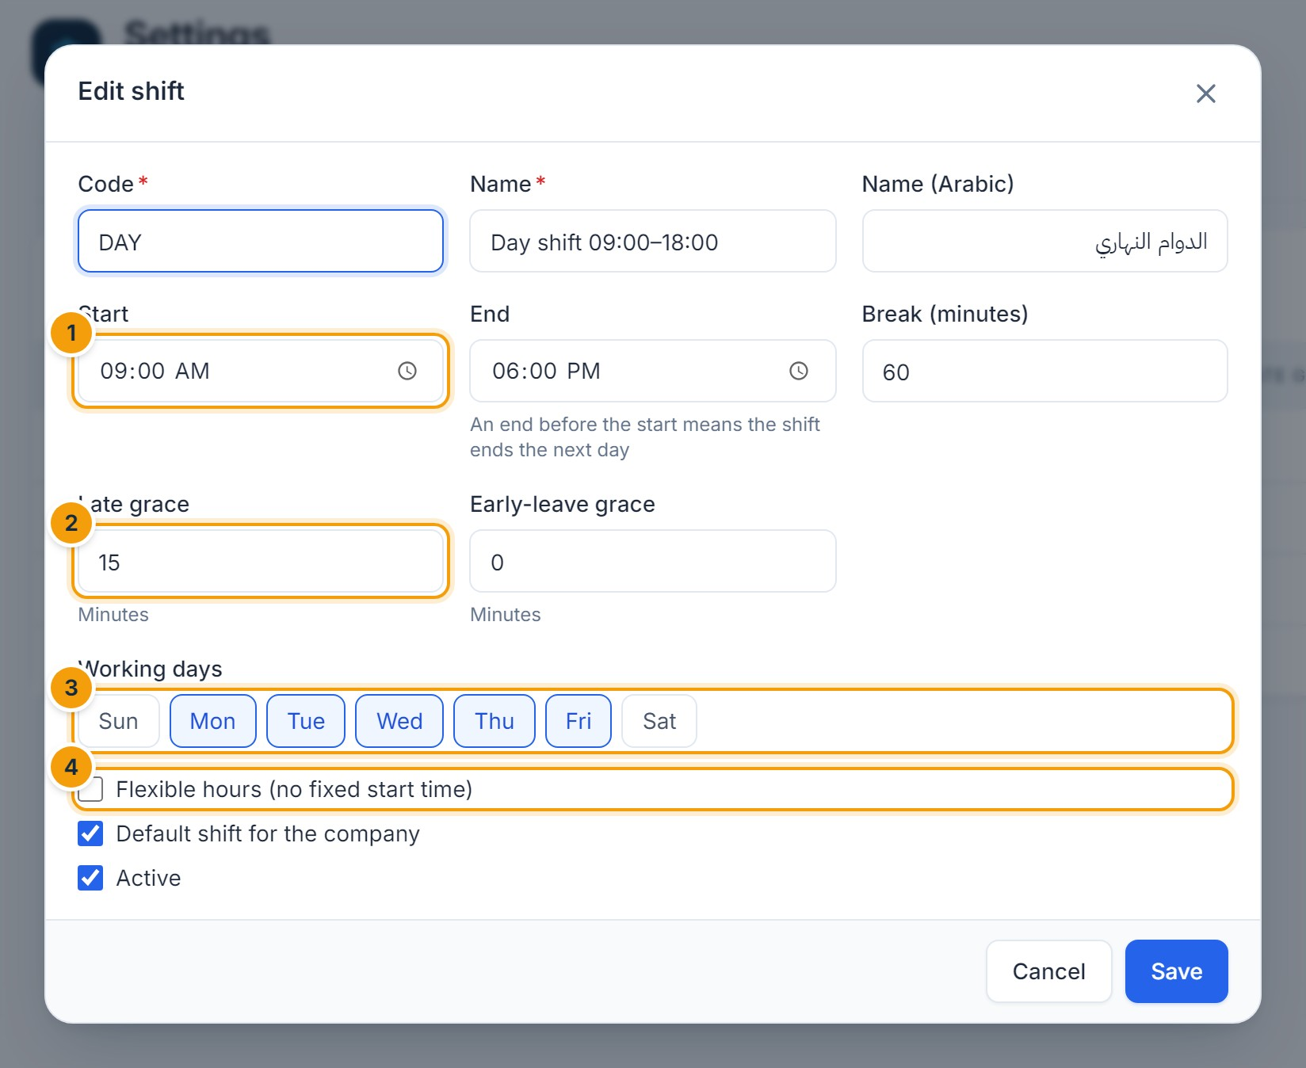
Figure 6.8 — Editing a shift. (1) Start and end time (an end before the start means an overnight shift), (2) late grace, (3) working days, (4) flexible hours.
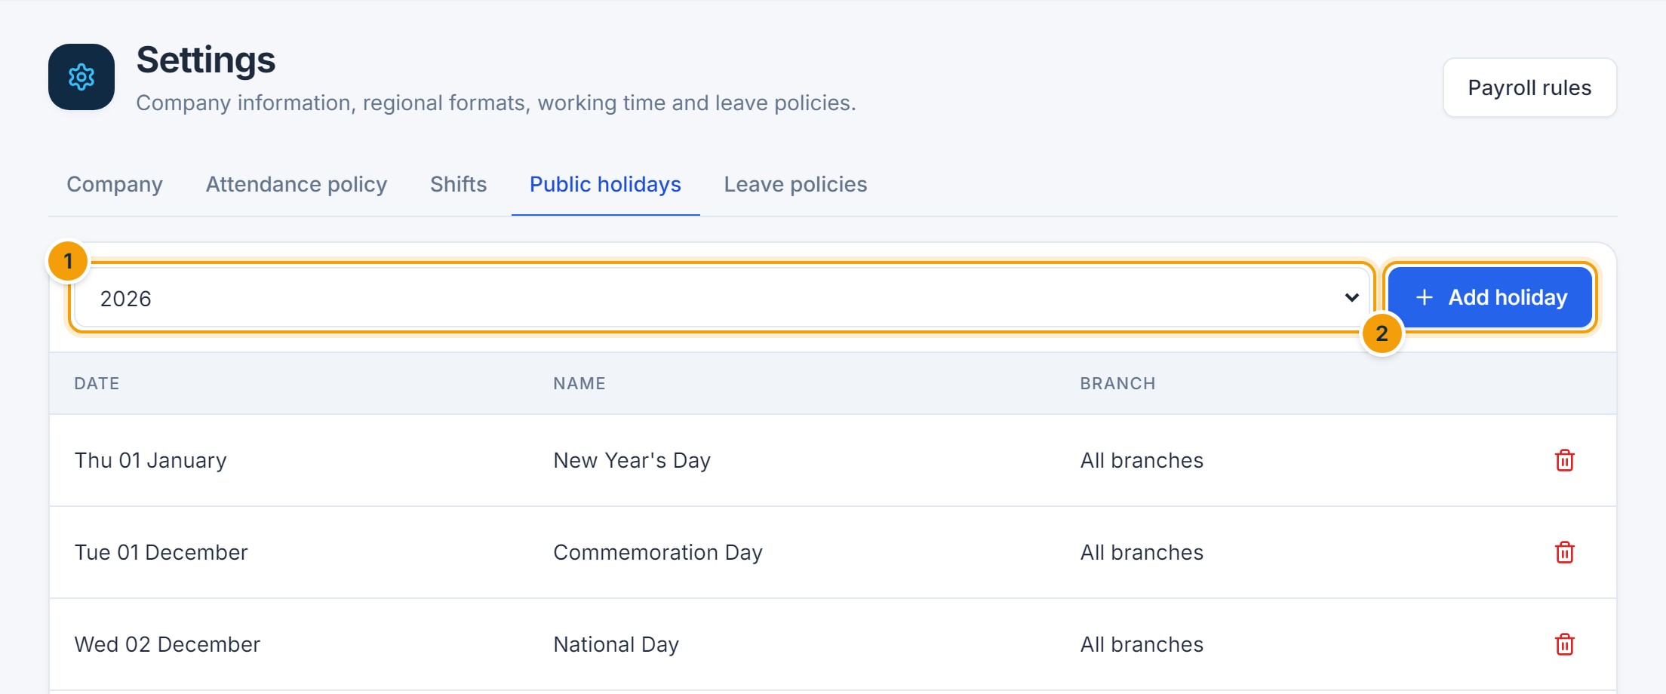
Figure 6.9 — Public holidays. (1) Year, (2) Add holiday — for all branches or one branch.
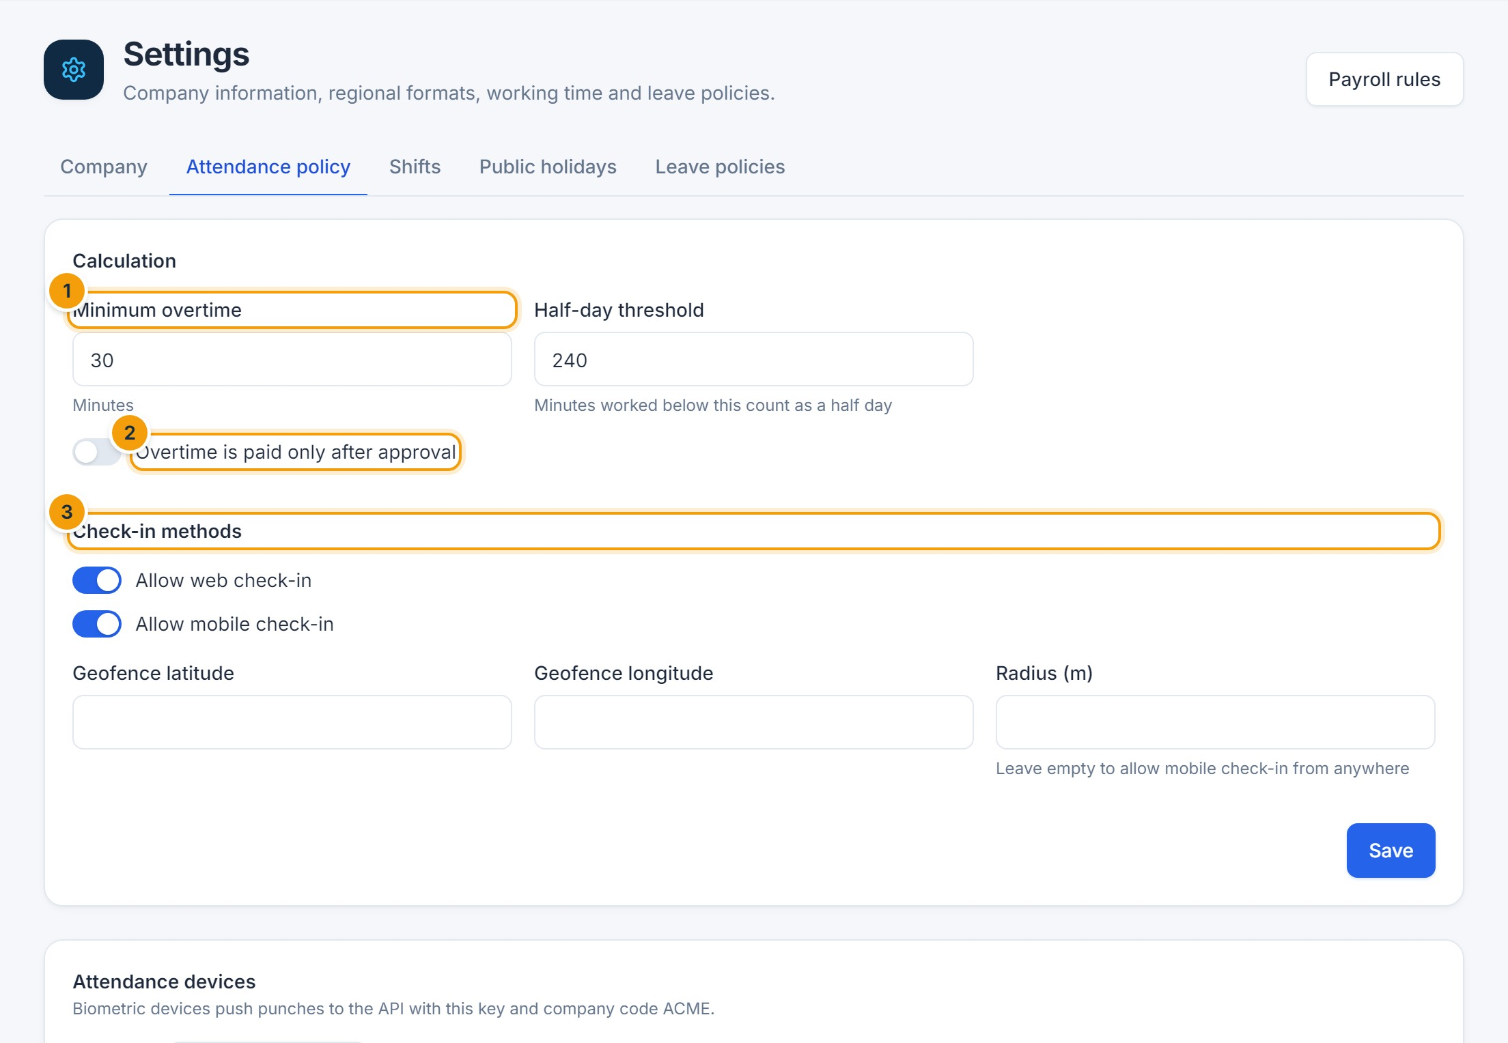
Figure 6.10 — Attendance policy. (1) Minimum overtime, (2) whether overtime needs approval before it is paid, (3) allowed check-in methods and optional geofence.

F. Common errors
Message | Cause and resolution
You have just checked in | A second punch within one minute is ignored.
You are … m from the permitted location | Mobile check-in is limited to the company geofence. Check in on site or ask HR.
A correction for this date is already pending | Wait for the existing request to be decided.
… belongs to the … payroll, which is approved and locked | The date is in an approved payroll period. Payroll must be reopened before it can change (Chapter 8).

G. Tips and best practices
- Check your records weekly and request corrections promptly.
- After a shift or holiday changes, ask HR to review the affected records; HR can correct individual records from Attendance → Records.
- Biometric devices can send punches automatically; ask your administrator.
CHAPTER 7

7. Leave Management

A. Purpose
Leave management handles leave balances and requests according to company policy: entitlement, monthly or yearly accrual, carry-forward, notice periods, half days, attachments and overlap rules. Requests go through the approval workflow and update balances and attendance automatically.

B. Accessing the module
Click Leave in the sidebar. Employees see My leave; HR and managers also see Requests and the Leave calendar.

Review your leave balances
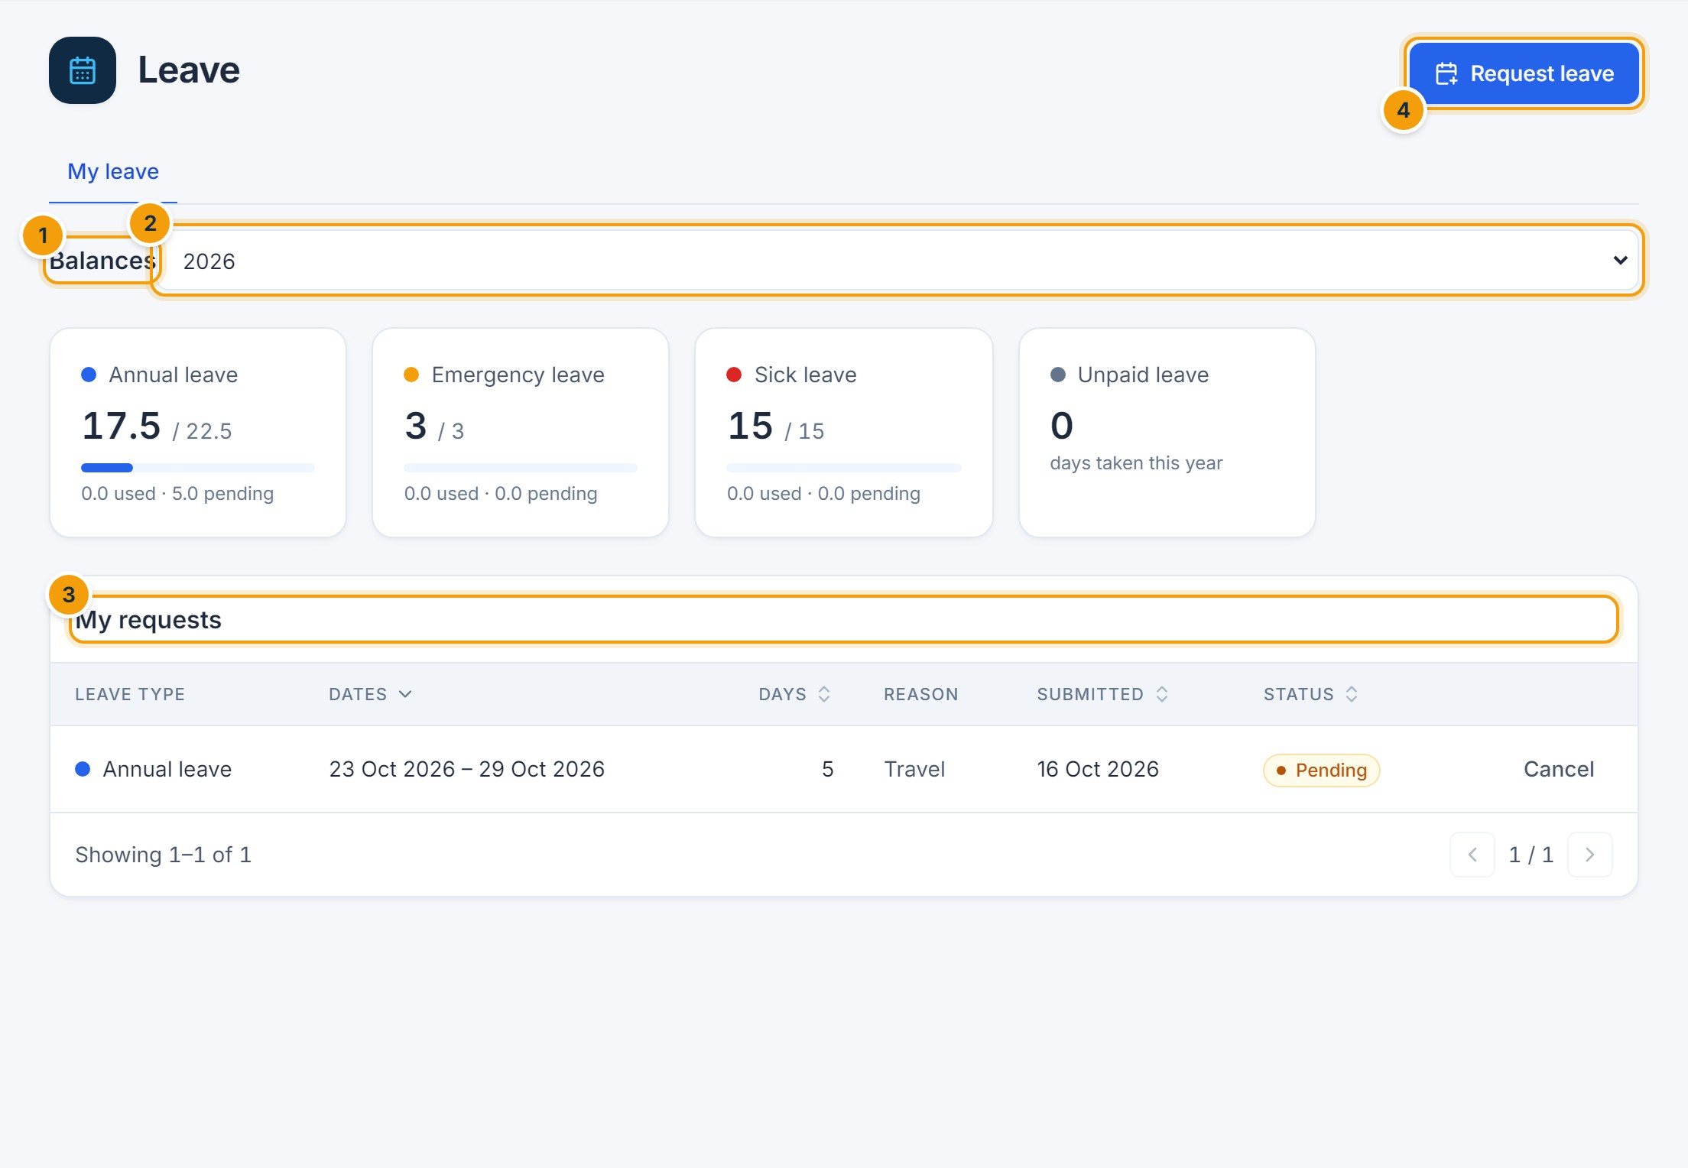
Figure 7.1 — My leave. (1) Balances for each leave type, (2) year, (3) your requests, (4) Request leave.
Each card shows the days available out of the total entitlement (including carried-over and adjusted days), with used and pending days underneath.

Submit a leave request
- Click Request leave.
- Choose the Leave type (1).
- Select the From and To dates (2). Tick Half day (3) for a half day on a single date.
- Check the green preview (4): it shows how many days will be counted (weekends and holidays are excluded where policy says so) and your remaining balance. A red message explains anything that breaks the policy.
- Add a reason, attach a document if the type requires one, and click Submit request (5).
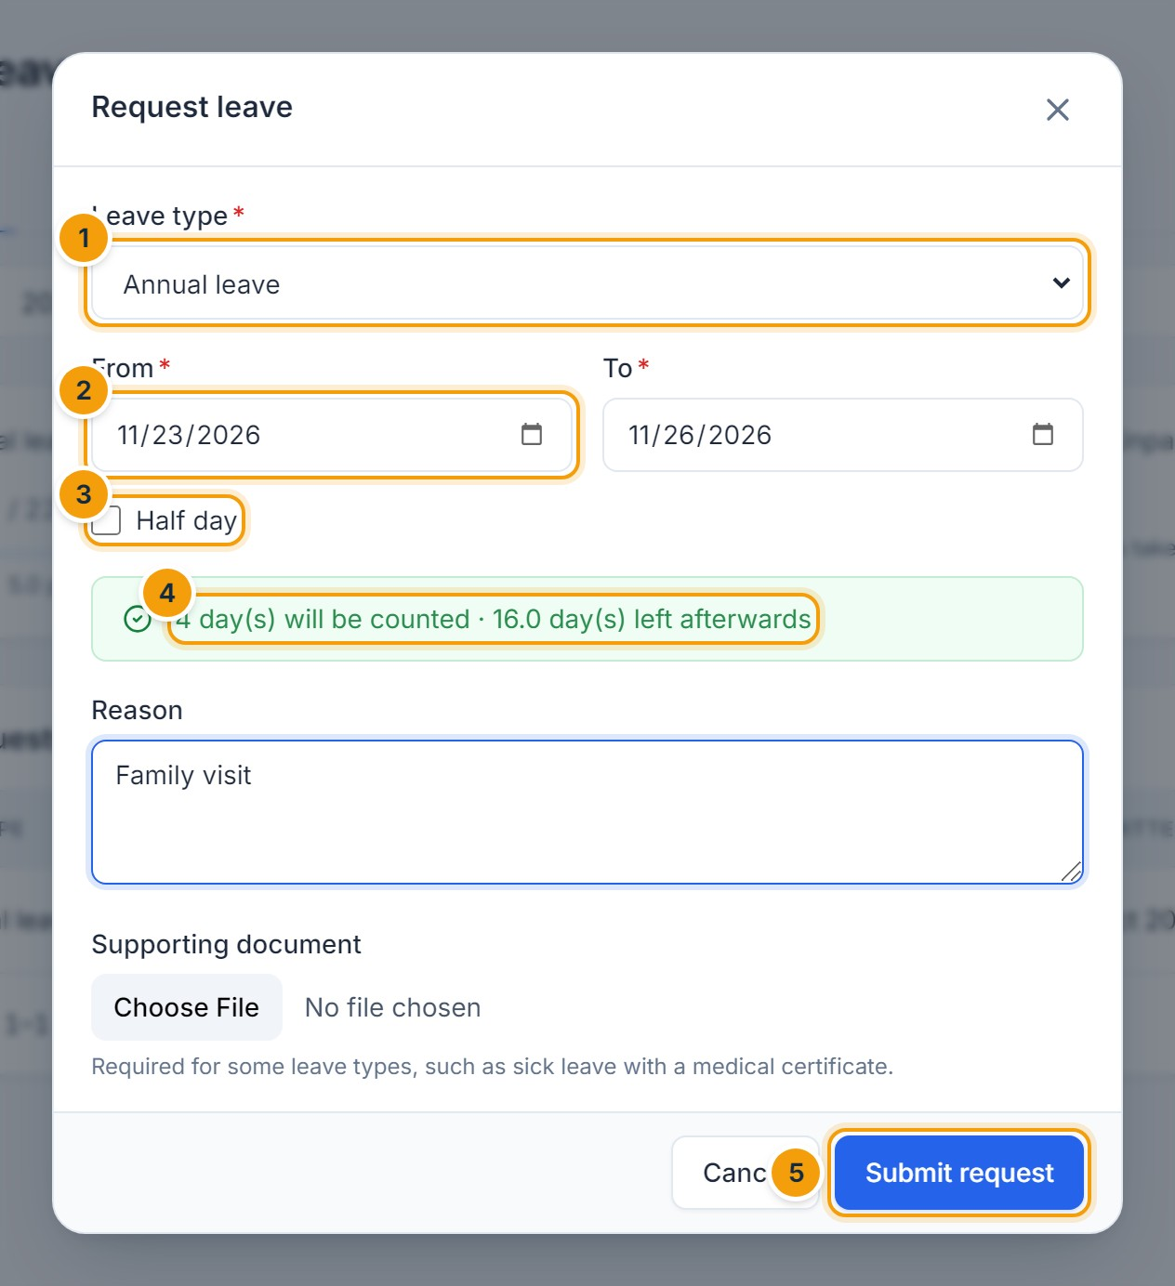
Figure 7.2 — Leave request form. (1) Leave type, (2) dates, (3) half day, (4) live preview of days counted and balance afterwards, (5) Submit request.
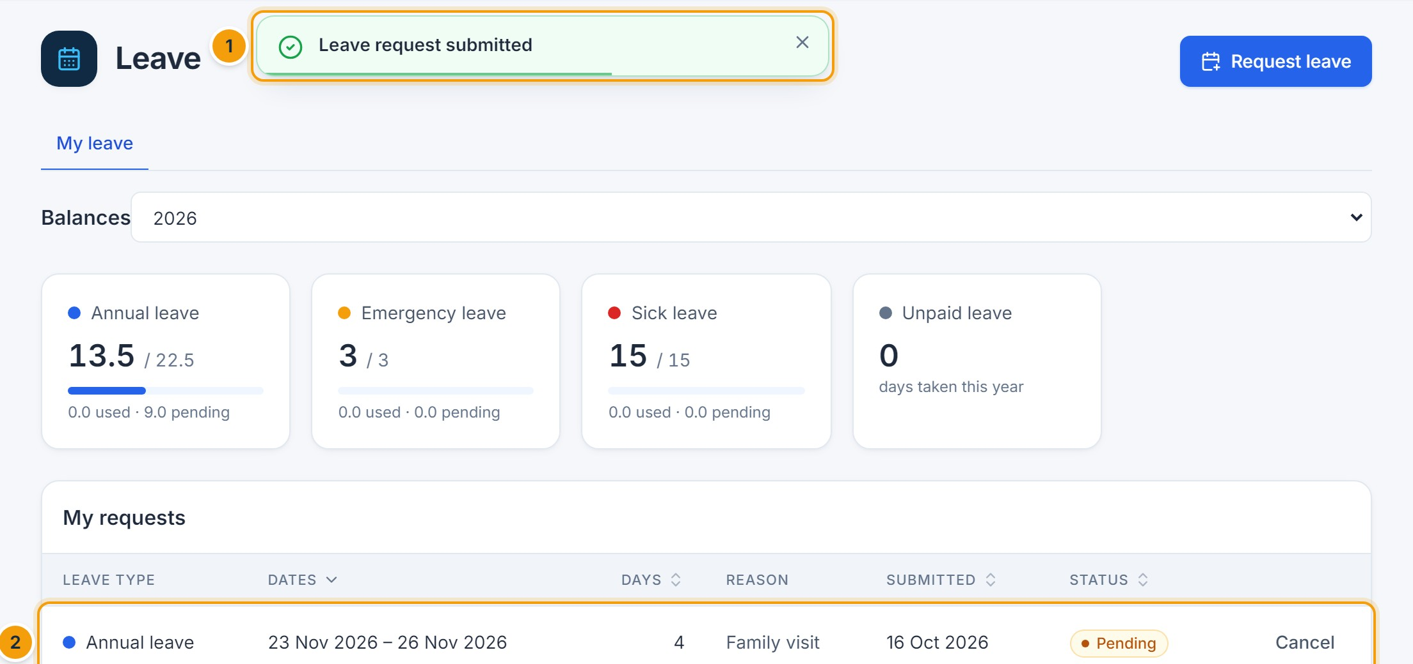
Figure 7.3 — Request submitted. (1) Confirmation message, (2) the new request with status Pending.

Track and cancel requests
- Your requests show Pending, Approved, Rejected or Cancelled.
- Click Cancel on a pending request, or on an approved request that has not started yet.
- Open Approvals → My requests to follow each approval step (Chapter 18).
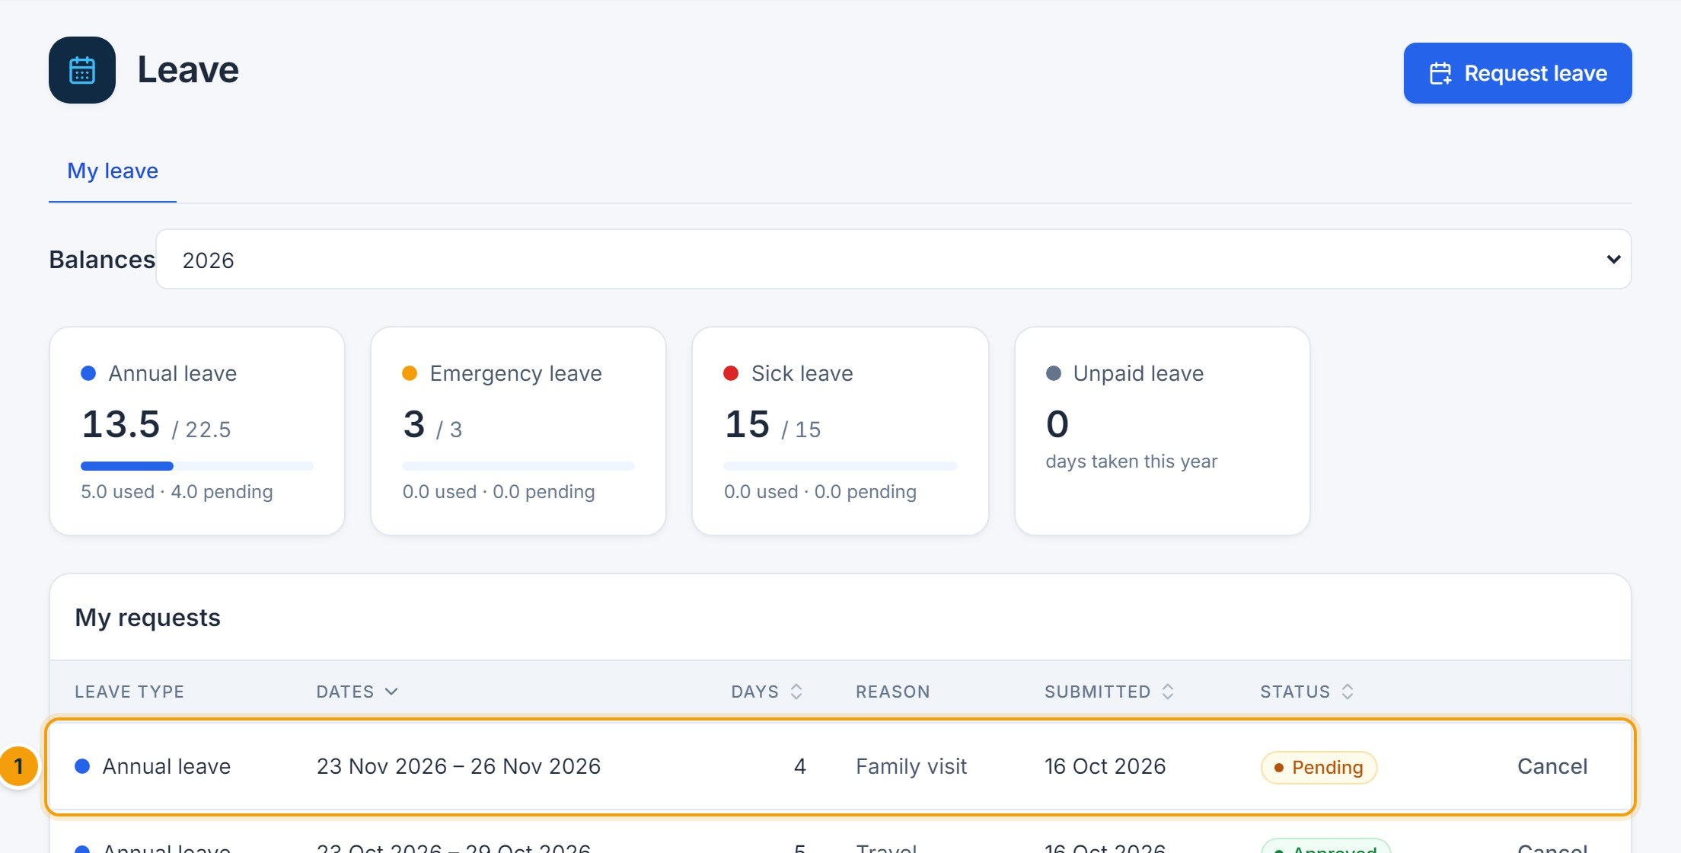
Figure 7.4 — Approved request. (1) After the manager’s approval the status changes to Approved and the days move from pending to used.

Approve or reject leave (managers)
Leave requests arrive in Approvals → Waiting for me. Open the request, review the dates, days and remaining balance, add a comment and click Approve or Reject (a comment is required to reject). See Chapter 18 for the full procedure.

Team requests, calendar and HR actions
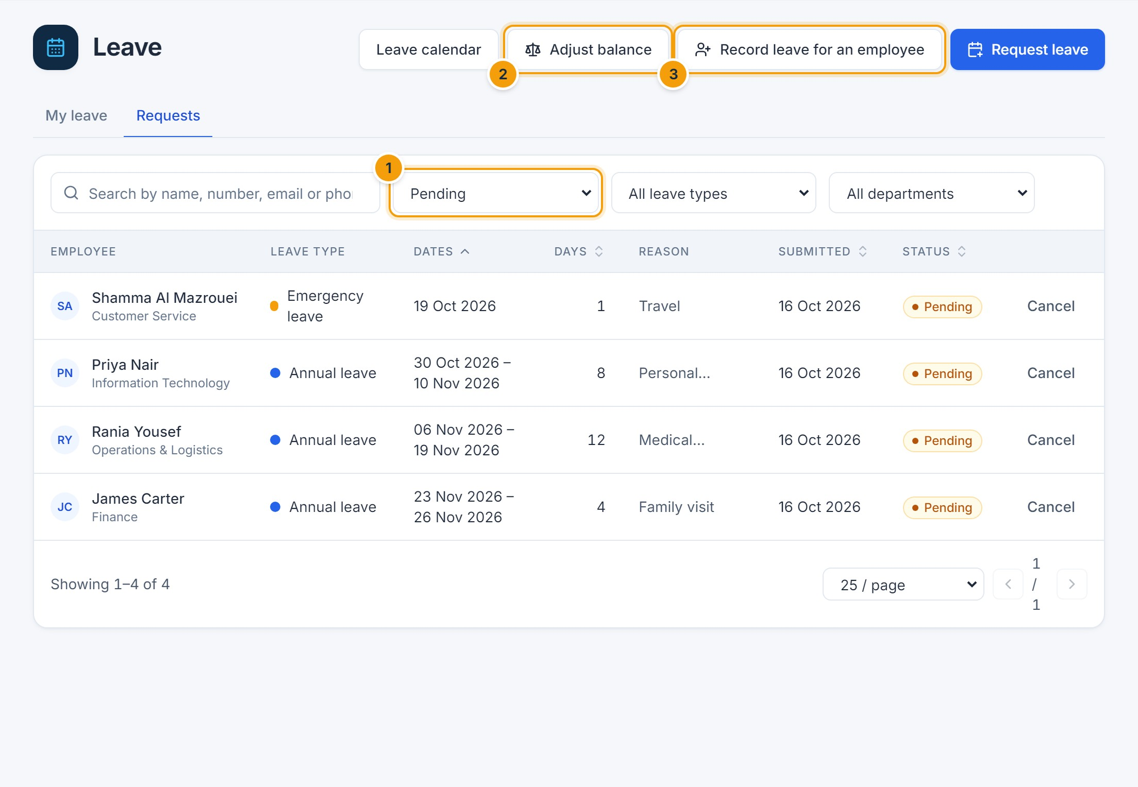
Figure 7.5 — Team leave requests. (1) Status, type and department filters, (2) Adjust balance, (3) Record leave for an employee.
- Record leave for an employee lets HR submit leave on someone’s behalf, optionally as already approved.
- Adjust balance adds or deducts days with a mandatory reason, recorded in the audit log.
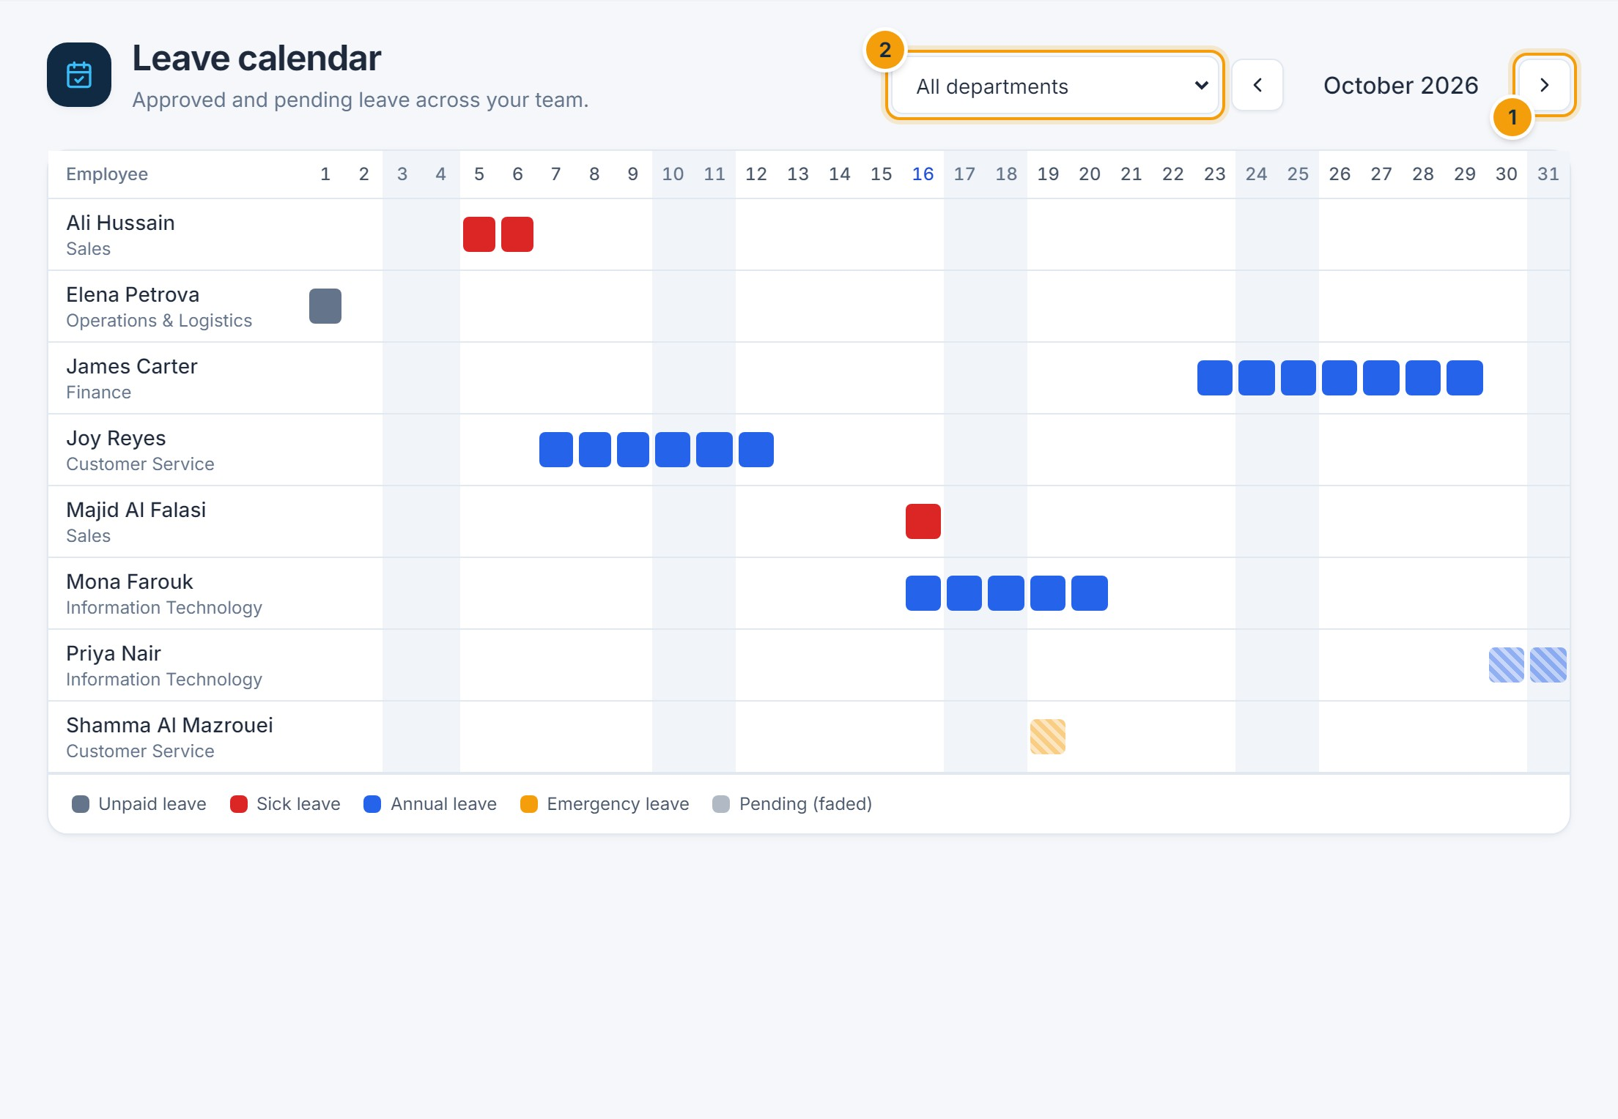
Figure 7.6 — Leave calendar. (1) Move between months, (2) filter by department. Pending requests appear faded.

Leave policies (administrators)
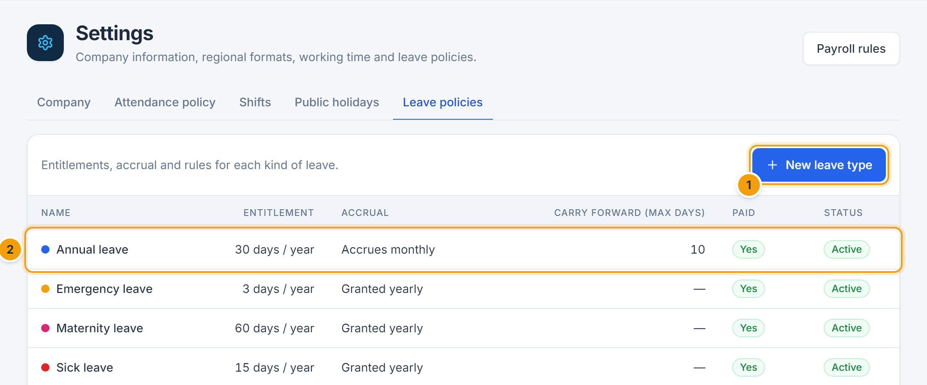
Figure 7.7 — Leave policies. (1) New leave type, (2) click a type to edit it.
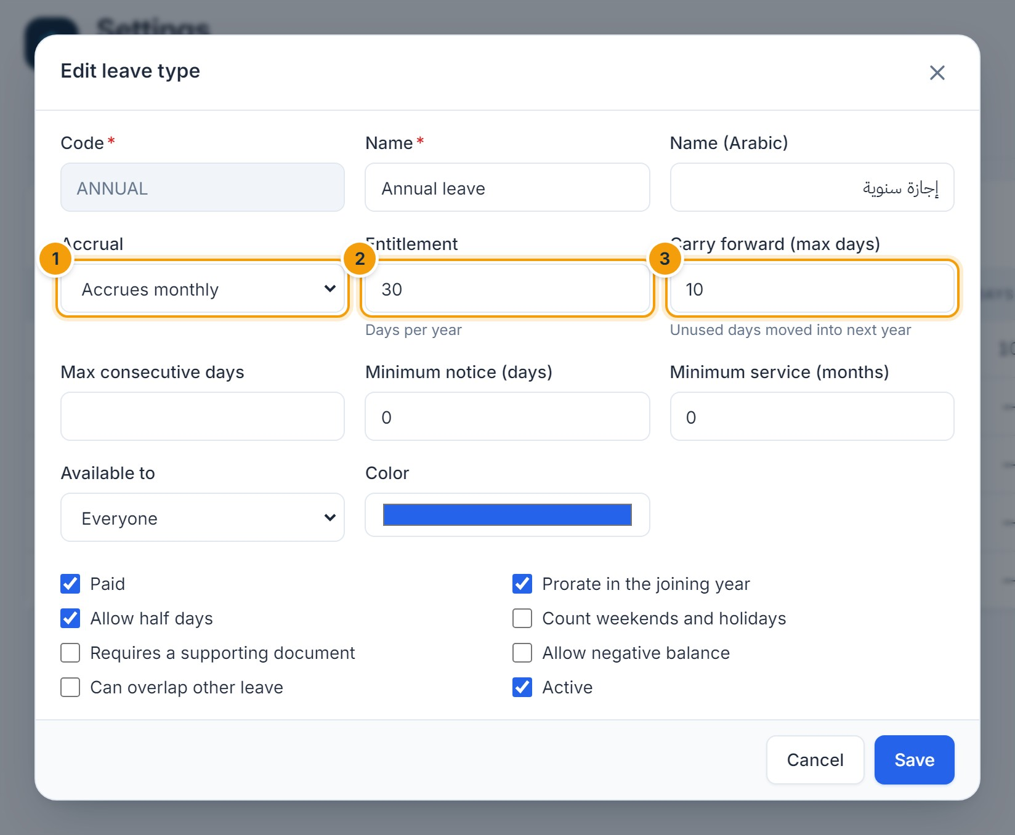
Figure 7.8 — Editing a leave type. (1) Accrual method, (2) yearly entitlement, (3) maximum carry-forward.

F. Common errors
Message | Cause and resolution
Insufficient … balance: X day(s) available | Choose fewer days or another leave type, or ask HR about an adjustment.
Overlaps an existing … request | You already have leave on those dates. Cancel or change the other request first.
… must be requested at least N day(s) in advance | The leave type has a notice period.
… requires a supporting document | Attach the file (for example a medical certificate).
A leave request cannot span two calendar years | Submit one request per year.
The selected dates contain no working days | The dates fall on weekends or holidays only.

G. Tips and best practices
- Look at the preview before submitting — it applies the same rules as the server.
- Plan long leave early: depending on your company’s workflow, longer requests may need a second approval (in the demo configuration, HR approves requests over 5 days).
CHAPTER 8

8. Payroll and Salary Management
IMPORTANT
Payroll processing must follow your company policy and applicable local labor and tax regulations. Aziz HRM does not contain built-in statutory rules: pension, social insurance, tax and similar items are configured by your organization as pay components. Have your configuration reviewed by your payroll or legal advisor.

A. Purpose
Payroll calculates monthly pay from each employee’s salary structure, approved attendance, overtime, unpaid leave and one-off adjustments; routes the result for approval; locks the period; and produces payslips, a payroll register and a bank transfer file.

B. Accessing the module
Who | Can do
Payroll Officer | Set salaries, configure components and rules, create and calculate runs, add adjustments, submit for approval.
Finance Officer | Approve payroll, download the bank file, mark as paid, reopen an approved (unpaid) run.
HR Manager, Auditor | View payroll runs and payslips.
Employees | View their own payslips after approval (My payslips).

Click Payroll in the sidebar. The tabs are Payroll runs, Salaries, Pay components, Calculation rules and Currencies.
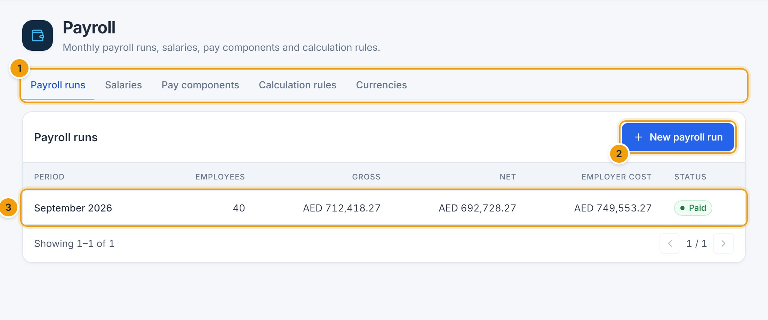
Figure 8.1 — Payroll runs. (1) Payroll tabs, (2) New payroll run, (3) an existing run.

Configure pay components and rules
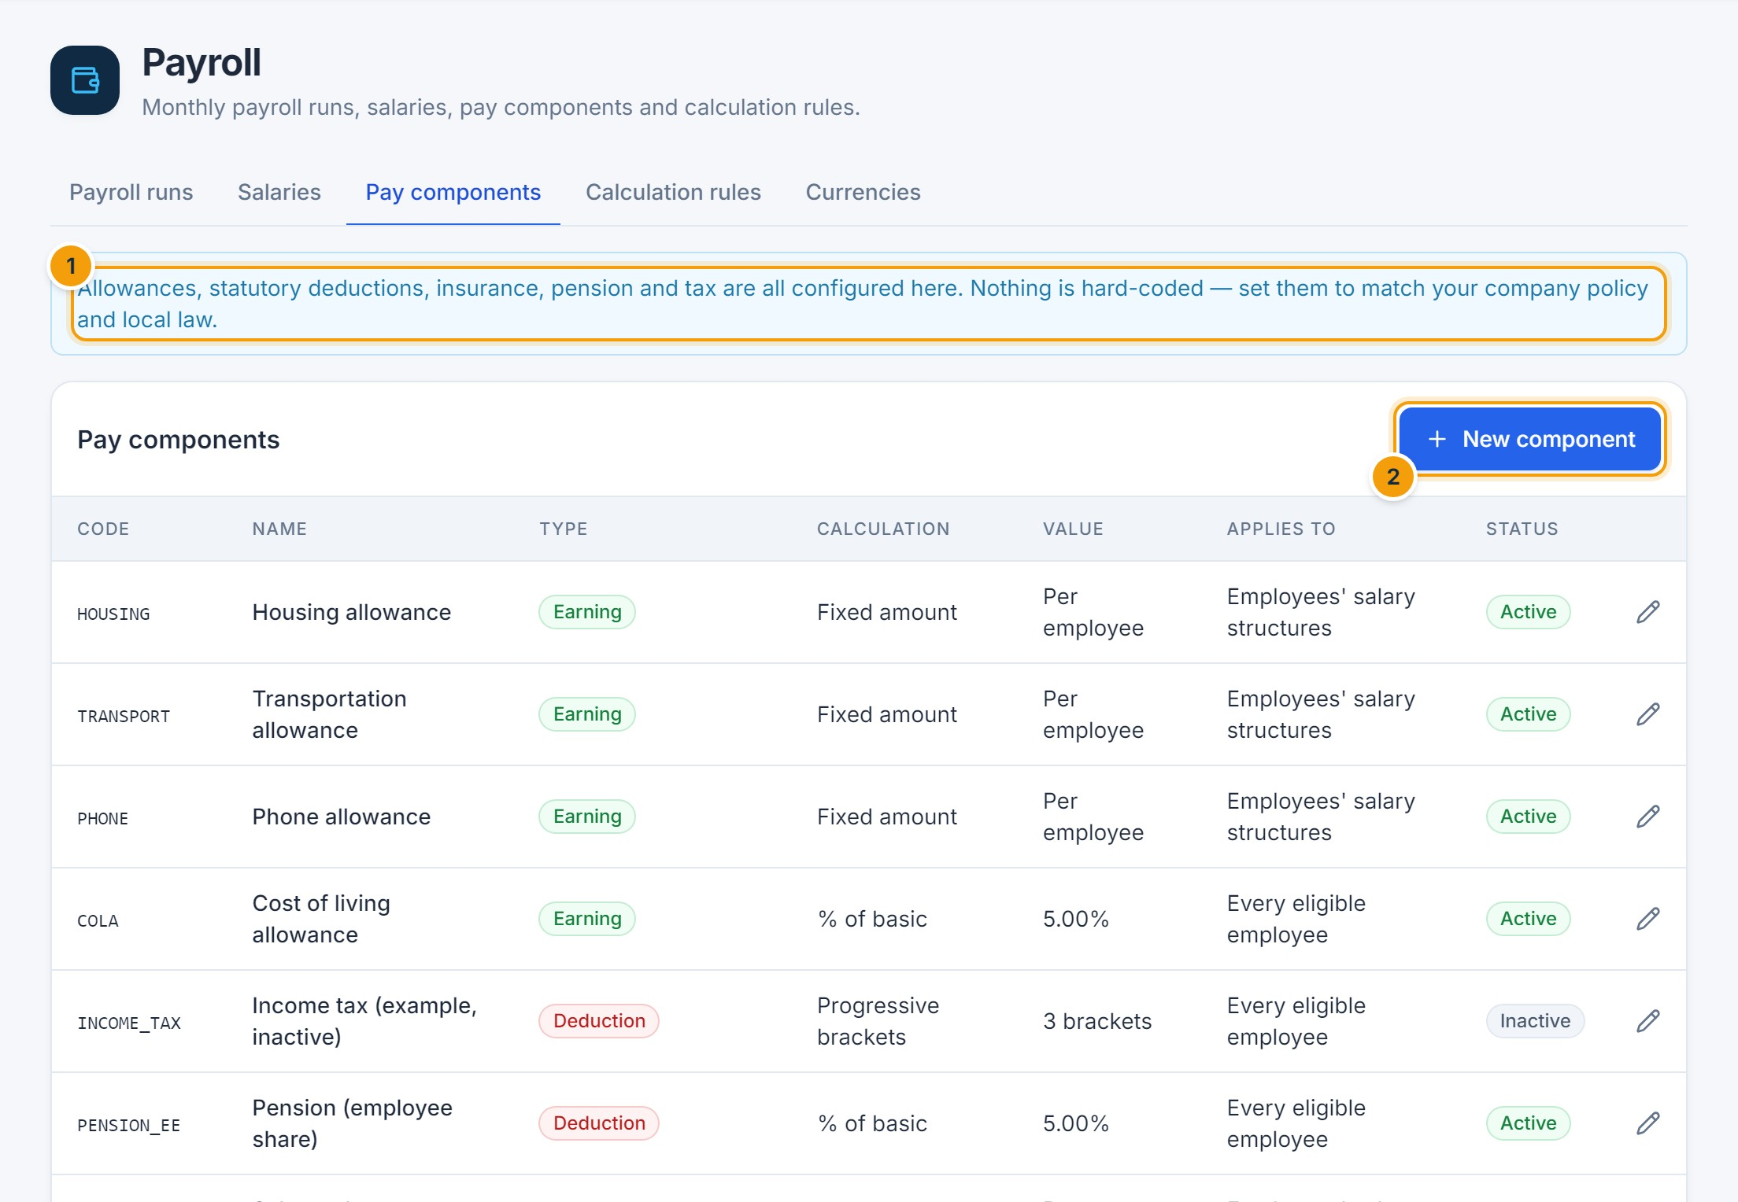
Figure 8.2 — Pay components. (1) Everything is configurable; nothing statutory is hard-coded, (2) New component.
A component is an Earning, Deduction or Employer contribution, calculated as a Fixed amount, % of basic, % of gross or Progressive brackets, with optional minimum/maximum amounts, a cap on the base, and eligibility by category, nationality or employment type. Components marked Apply automatically to every eligible employee (statutory items) do not need to be added to each salary.
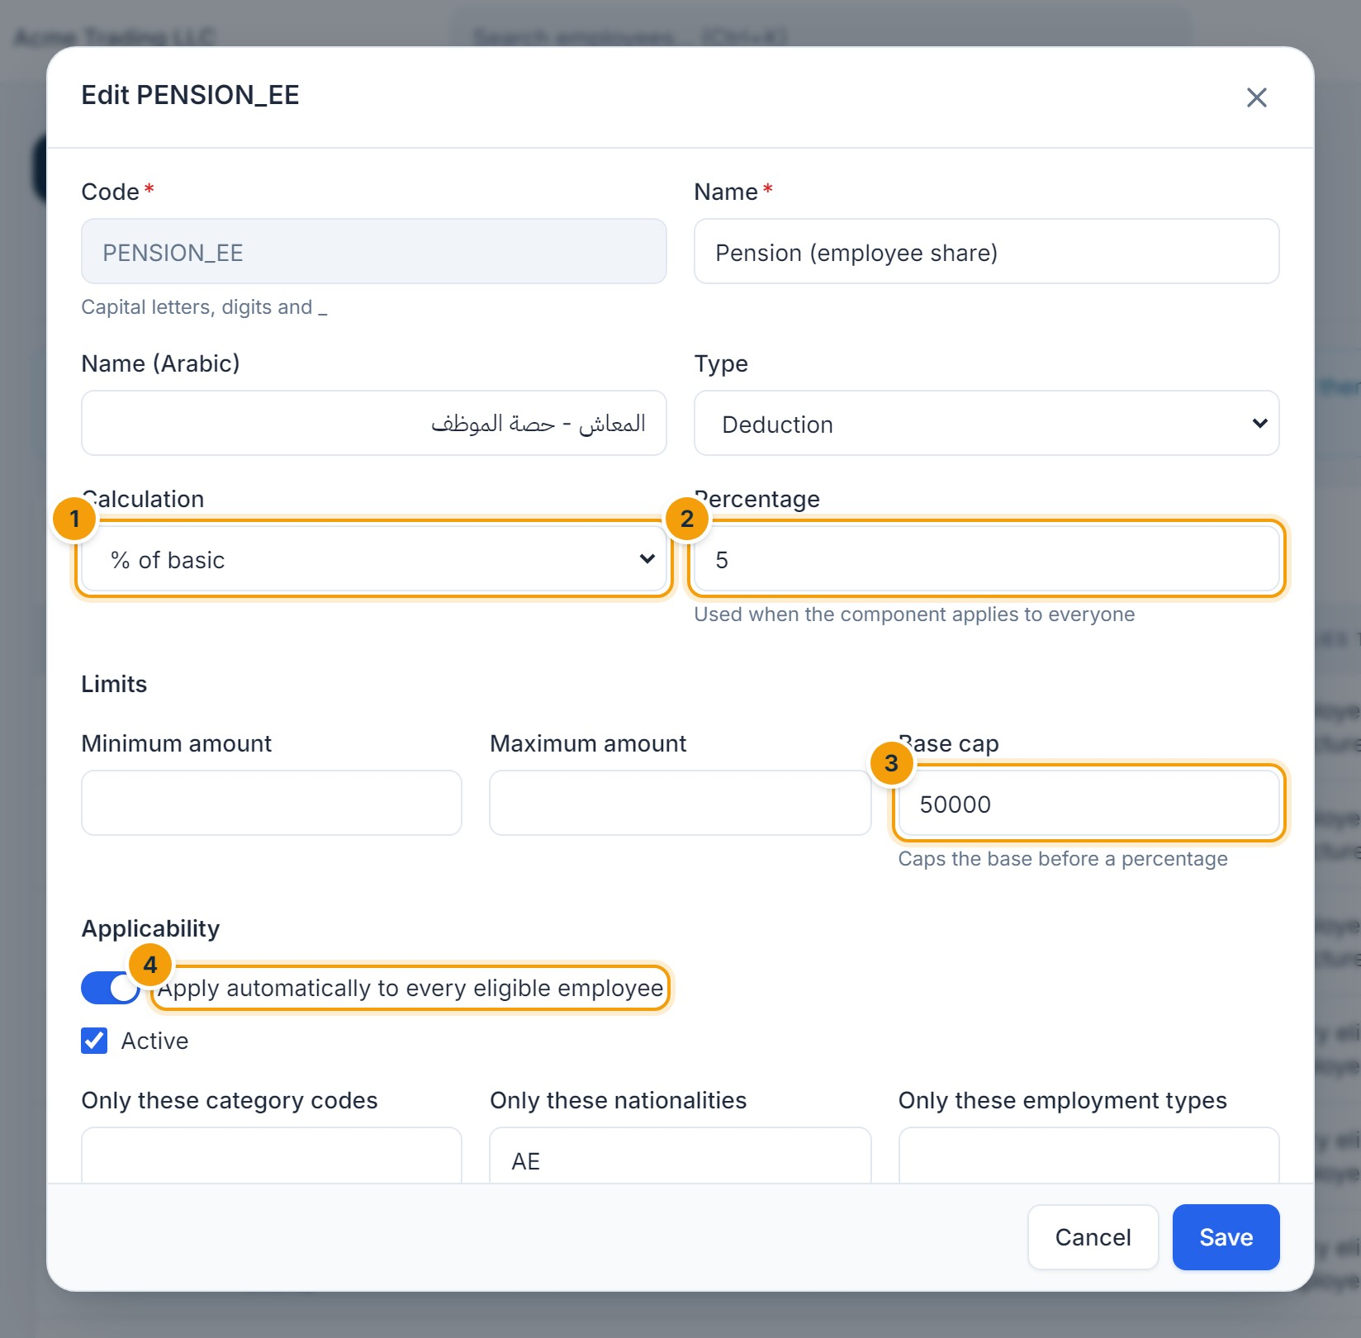
Figure 8.3 — Editing a pay component. (1) Calculation method, (2) percentage, (3) base cap, (4) apply automatically to every eligible employee.
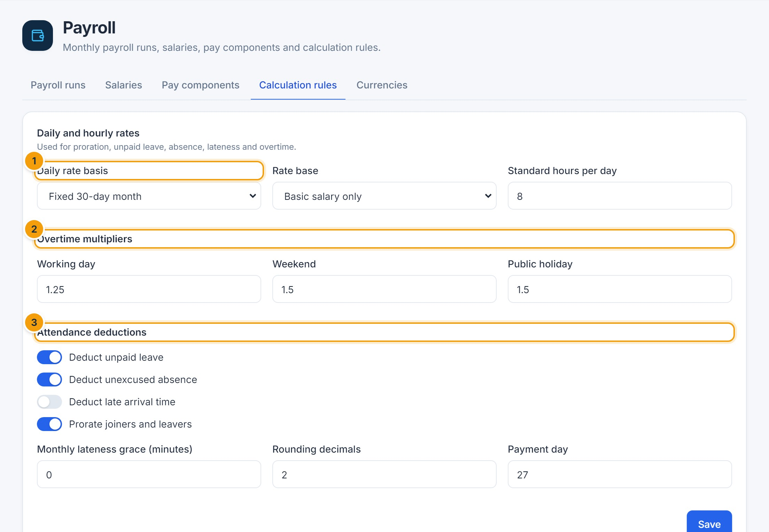
Figure 8.4 — Calculation rules. (1) Daily rate basis used for proration and deductions, (2) overtime multipliers, (3) attendance deductions.

Review and change salaries
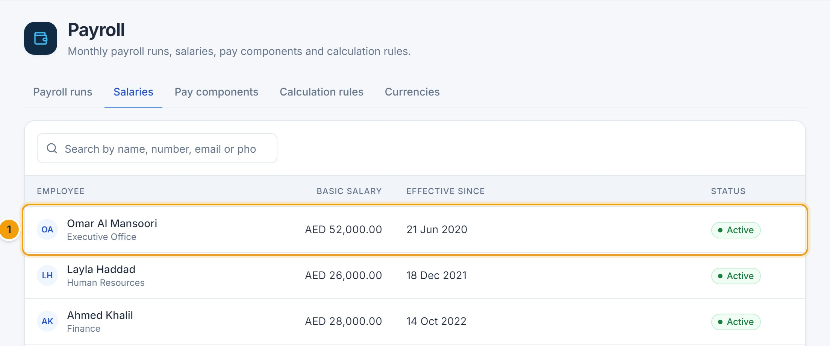
Figure 8.5 — Salaries. (1) Current basic salary of each employee; click a row to open the employee’s Salary tab.
- Open the employee’s Salary tab and click Change salary (or Set up salary for a new employee).
- Enter Effective from (1) and the new Basic salary (2); the percentage change is shown.
- Add or adjust allowances and deductions (3).
- Click Submit for approval (4). The change takes effect on the chosen date once the Salary change workflow approves it.
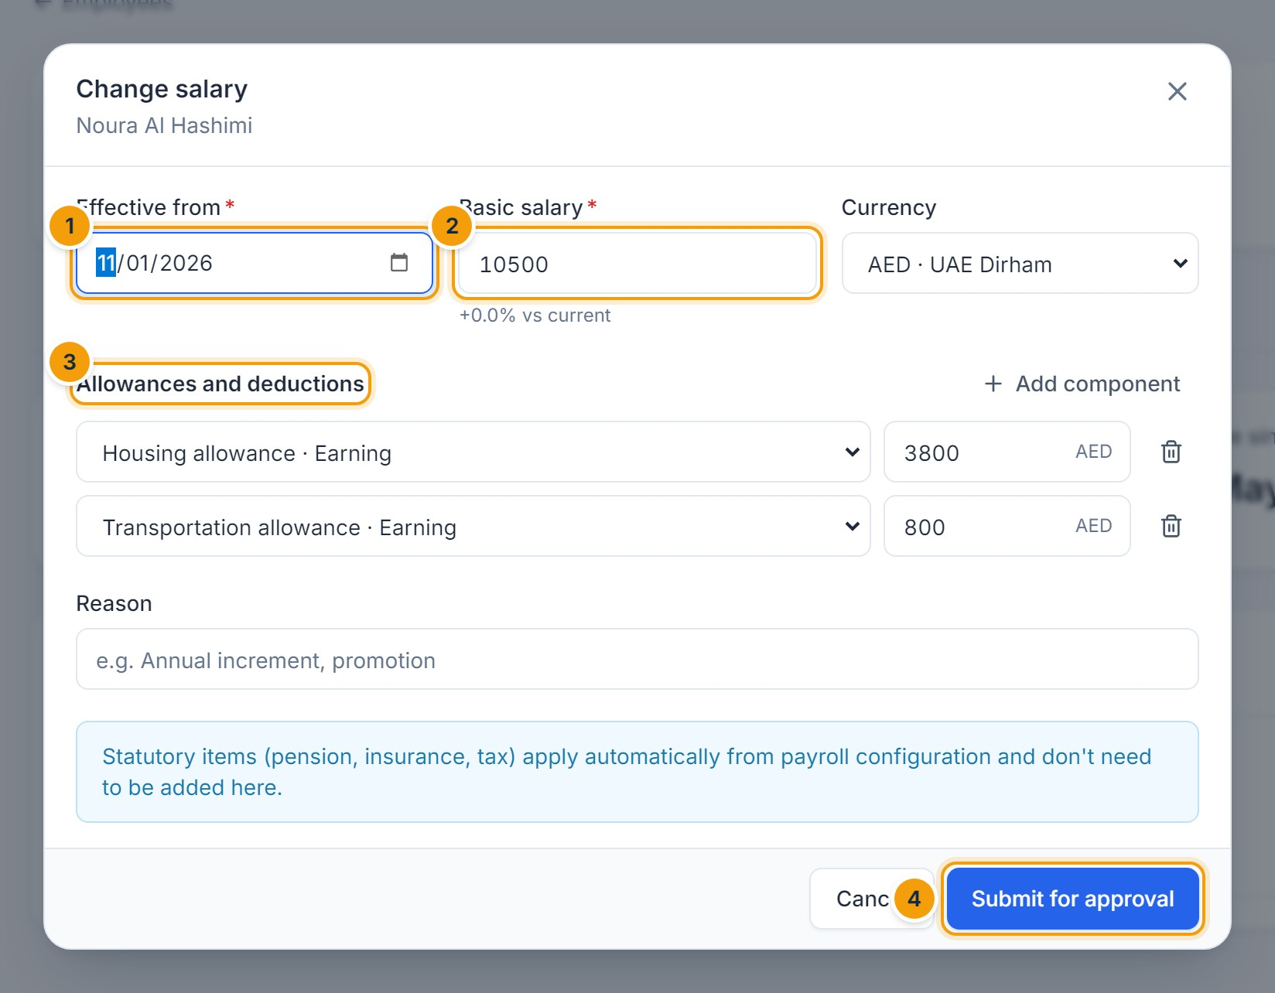
Figure 8.6 — Changing a salary. (1) Effective date, (2) basic salary, (3) allowances and deductions, (4) Submit for approval.

Run payroll
- Click New payroll run, choose the month and year (1) and optionally one branch (2), then Create (3).
- On the run page, click Calculate. Every eligible employee gets a payslip.
- Review the totals (1), the payslips (4) and the Calculation issues tab, which lists employees skipped (for example, no salary structure) and warnings (for example, negative net pay).
- Add one-off earnings or deductions on the Adjustments tab if needed, then click Recalculate.
- Open the Summary tab and confirm Totals reconcile.
- Click Submit for approval (3), add an optional comment, and confirm.
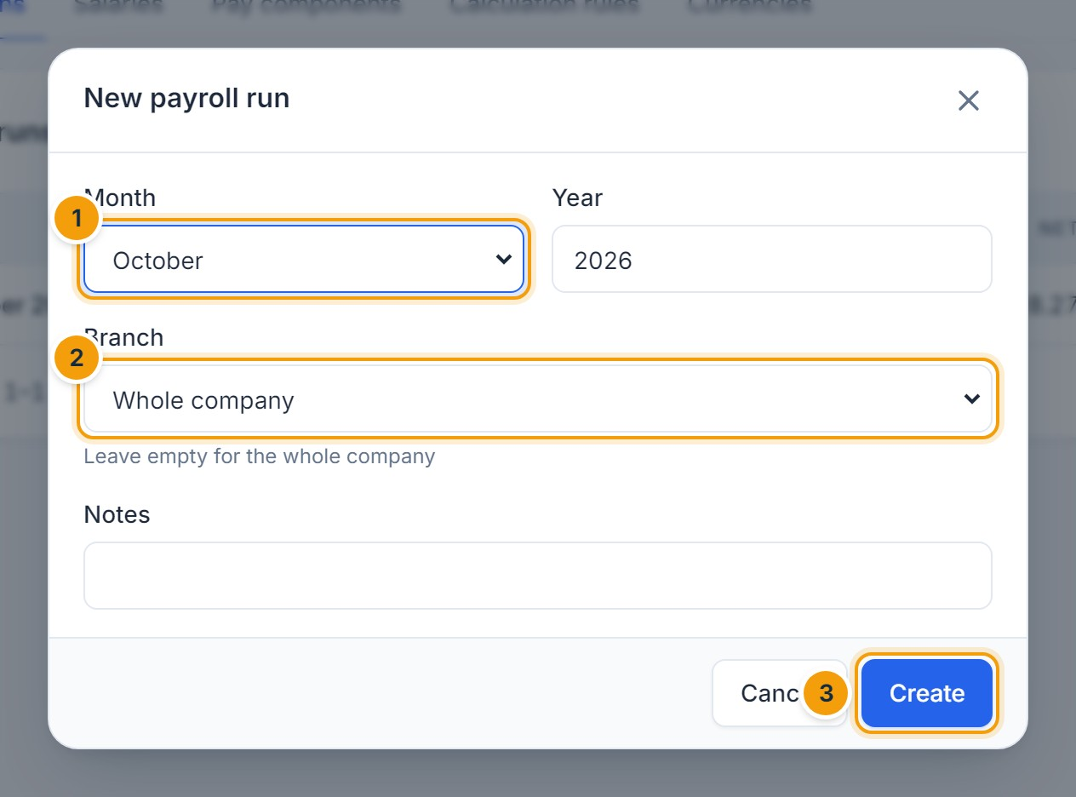
Figure 8.7 — Creating a payroll run. (1) Month, (2) branch (empty = whole company), (3) Create.
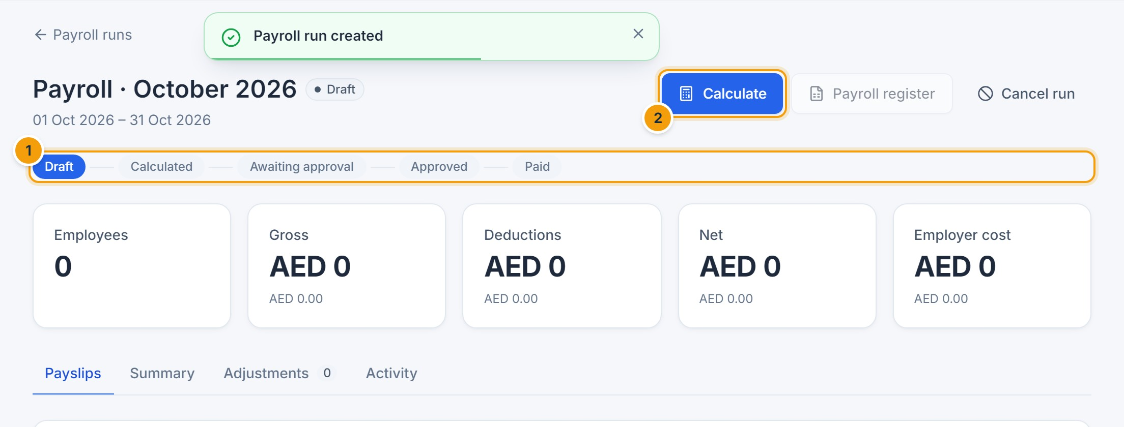
Figure 8.8 — A new run. (1) Progress: Draft → Calculated → Awaiting approval → Approved → Paid, (2) Calculate.
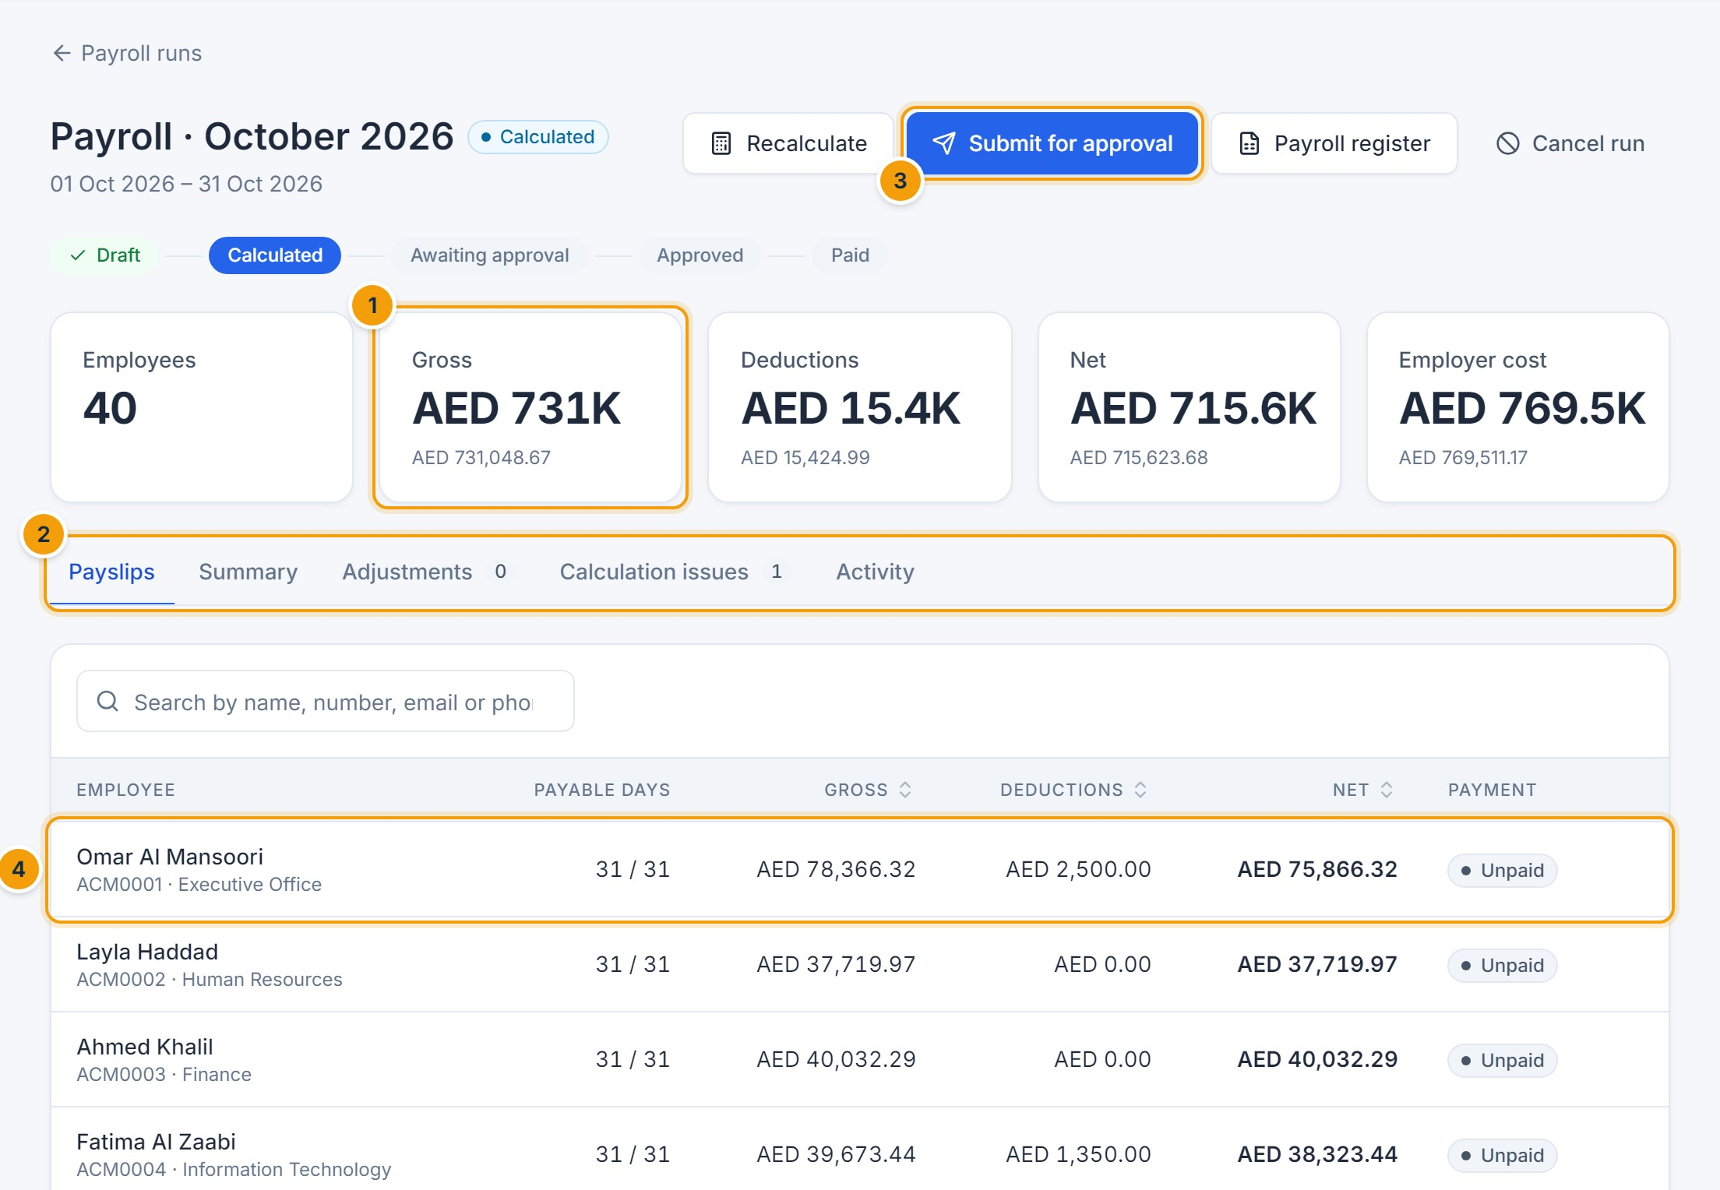
Figure 8.9 — Calculated payroll. (1) Totals, (2) tabs, (3) Submit for approval, (4) payslips — click one to see its lines.
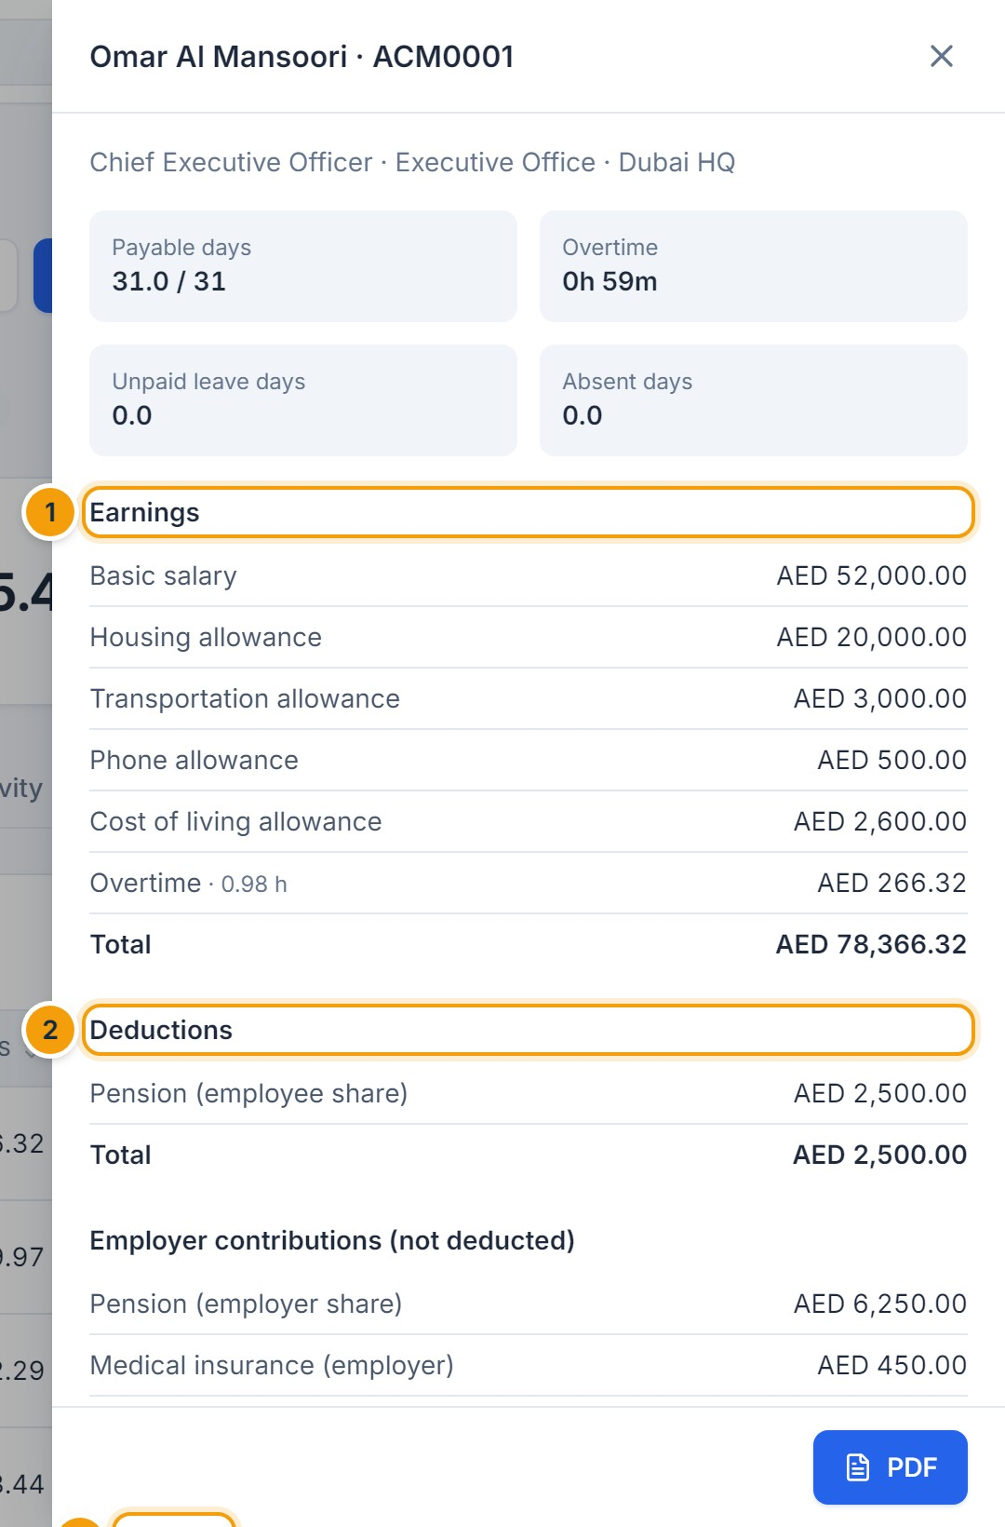
Figure 8.10 — Payslip details. (1) Earnings, (2) deductions, (3) net pay. Employer contributions are listed separately and are not deducted.
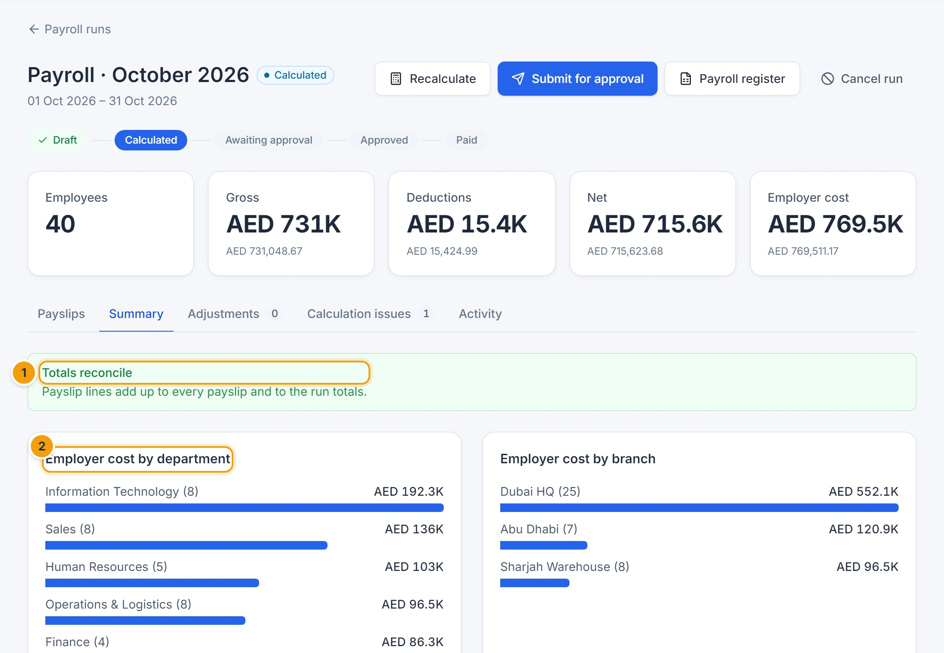
Figure 8.11 — Reconciliation and summary. (1) Payslip lines add up to every payslip and to the run totals, (2) employer cost by department.
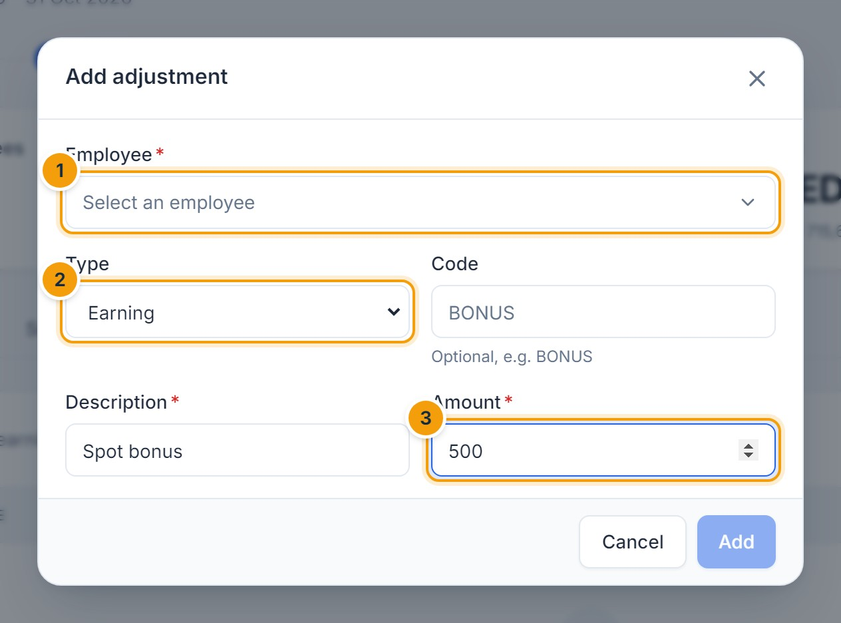
Figure 8.12 — Adding an adjustment. (1) Employee, (2) Earning or Deduction, (3) amount. Recalculate afterwards.
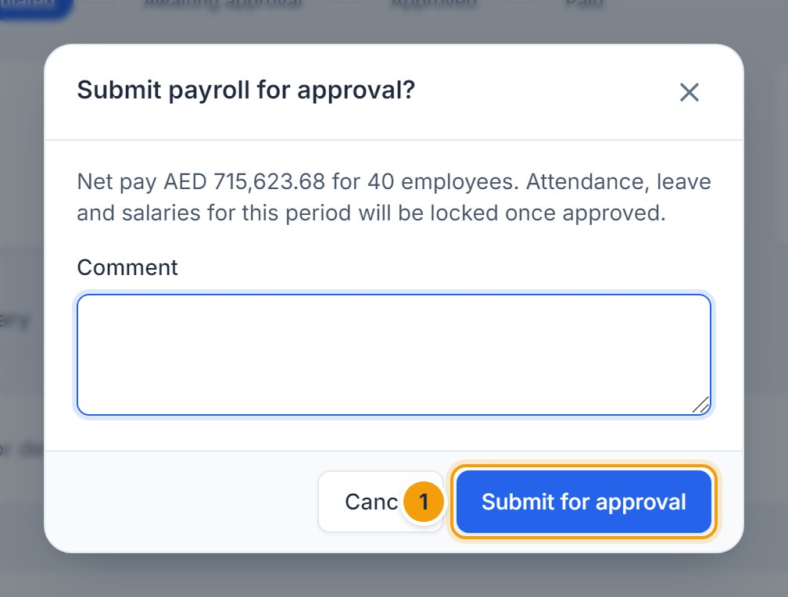
Figure 8.13 — Submitting for approval. (1) Confirm the submission.

Approve, pay and reopen (finance)
- The approver opens the request in Approvals, reviews the totals and clicks Approve. The person who submitted the payroll cannot approve it.
- Once approved, the run is Locked: attendance, leave and salary changes for that period are blocked.
- Click Bank file to download the transfer file. Employees without bank details are reported.
- After the transfer, click Mark as paid and enter the payment reference. Employees are notified that their payslips are available.
- If a mistake is found before payment, click Reopen, enter the reason, correct, recalculate and submit again. Paid payroll cannot be reopened.
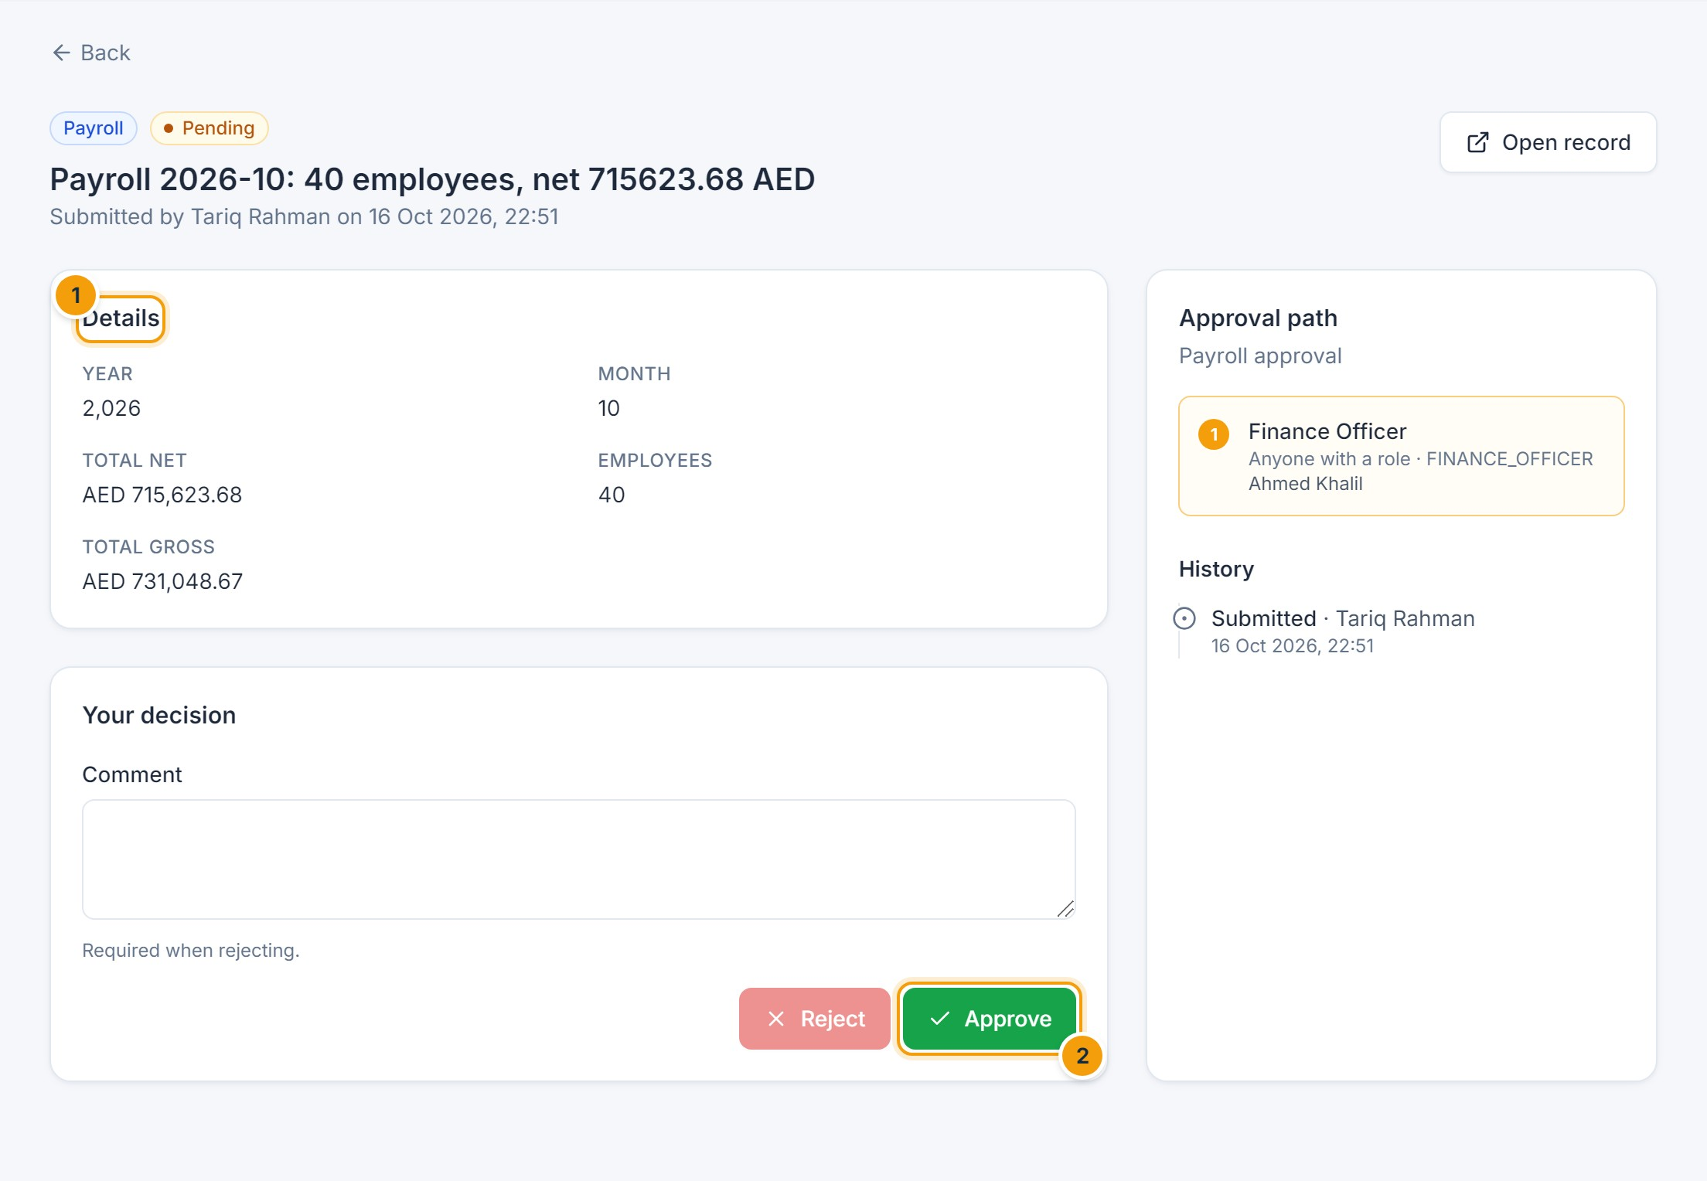
Figure 8.14 — Payroll approval request. (1) Totals under review, (2) Approve.
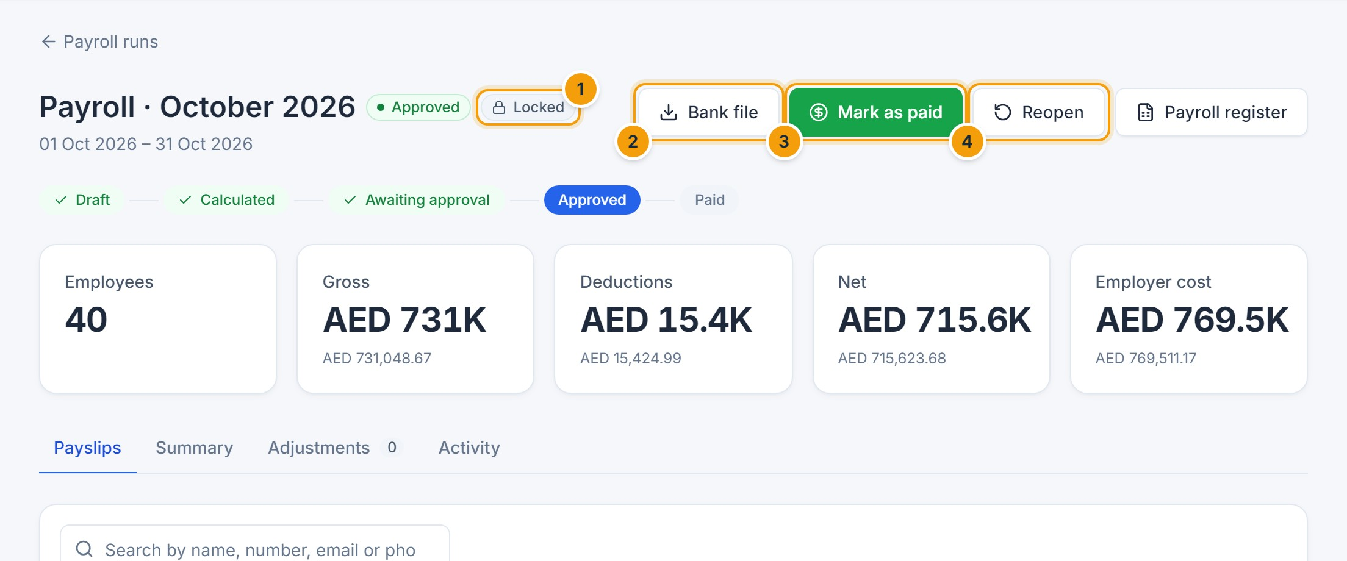
Figure 8.15 — Approved and locked payroll. (1) Locked, (2) Bank file, (3) Mark as paid, (4) Reopen.

Access salary slips
Employees open My payslips to see every approved payslip, click a row for the details, or click PDF to download it.
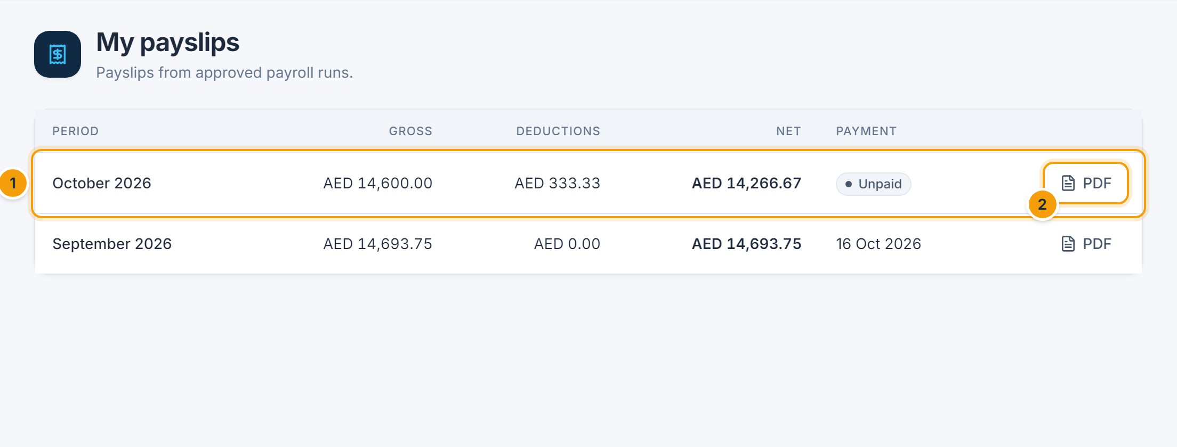
Figure 8.16 — My payslips. (1) A payslip, (2) PDF download.
The Payroll register button downloads all payslips of a run as an Excel workbook, one column per component.

F. Common errors
Message | Cause and resolution
A payroll run for … already exists | Only one active run per month and scope. Open the existing run.
Payroll does not reconcile; recalculate before submitting | Data changed after calculation. Click Recalculate.
Something changed since the last calculation | An adjustment was added or removed. Recalculate.
You are not an approver for the current step | Separation of duties: another authorized person must approve.
… is approved and locked. Reopen the payroll first. | The change affects a locked period.
No exchange rate from X to Y | Add the exchange rate under Payroll → Currencies.

G. Tips and best practices
- Run a calculation early in the month to catch missing salaries.
- Record attendance corrections and leave before calculating.
- Keep payroll preparation and approval with different people.
CHAPTER 9

9. Recruitment and Applicant Tracking
NOT AVAILABLE IN THIS VERSION
The recruitment and applicant tracking module is not available in this version of Aziz HRM. There are no screens for vacancies, candidates, CVs, interviews, feedback or job offers, so they are not documented here.

What you can use today
- Workforce planning (Chapter 16) shows budgeted seats, filled positions and vacancies per department and position.
- The dashboard card Open positions shows the total number of unfilled budgeted seats.
- When a candidate is hired, HR creates the employee record directly (Chapter 5). A Recruitment Officer role exists with permission to create employees.
NOTE
The approval engine already includes a Job offer request type for future use; no screen creates such requests yet.
CHAPTER 10

10. Employee Self-Service Portal

A. Purpose
Self-service lets every employee handle routine HR tasks without contacting HR: checking in, viewing attendance, requesting leave, viewing payslips, updating contact details and tracking approvals.

B. Accessing the module
Sign in; the Home page is your self-service starting point. Your account must be linked to your employee record (HR does this when creating your account).

D. Screenshot guide
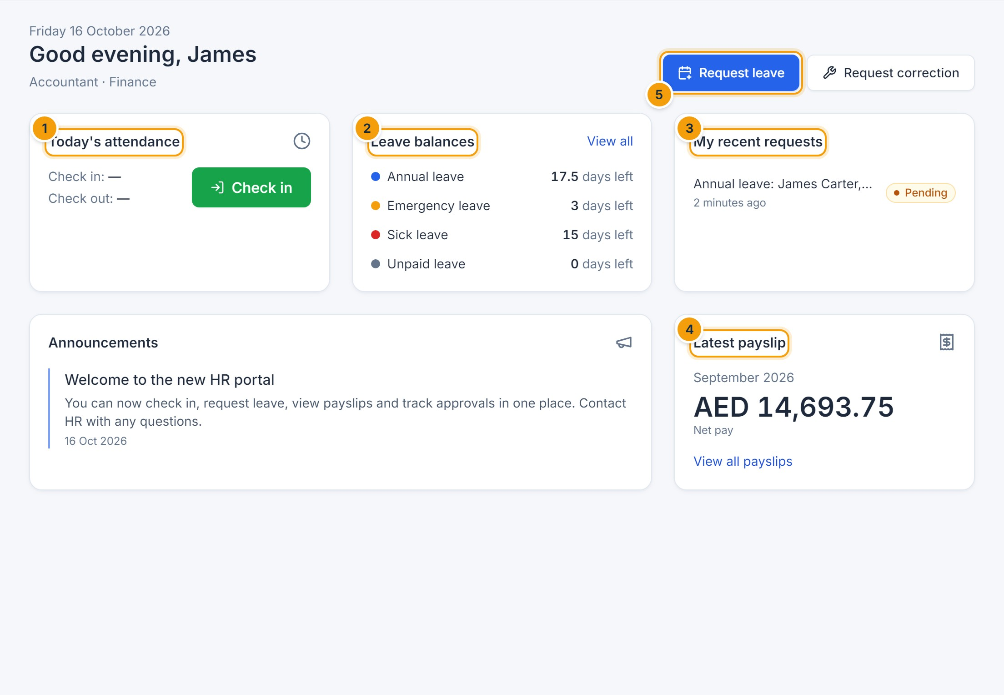
Figure 10.1 — Employee Home page. (1) Today’s attendance with Check in/Check out, (2) leave balances, (3) your recent requests and their status, (4) latest payslip, (5) Request leave.

C. Step-by-step instructions
Task | Where
Check in and out | Home → Today’s attendance (Chapter 6)
View attendance and request corrections or overtime | Attendance → My attendance (Chapter 6)
Request or cancel leave, view balances | Leave → My leave (Chapter 7)
View and download payslips | My payslips (Chapter 8)
Update contact details | Account menu → My profile → Update my details
Track requests | Approvals → My requests (Chapter 18)
Read announcements and notifications | Home, Announcements and the bell (Chapter 19)
Change password, language, theme, two-step verification | Account menu → Account settings (Chapter 23)

Update your personal information
- Open the account menu and click My profile.
- Click Update my details.
- Change your phone (1), personal email, address or emergency contact (2), and click Save.
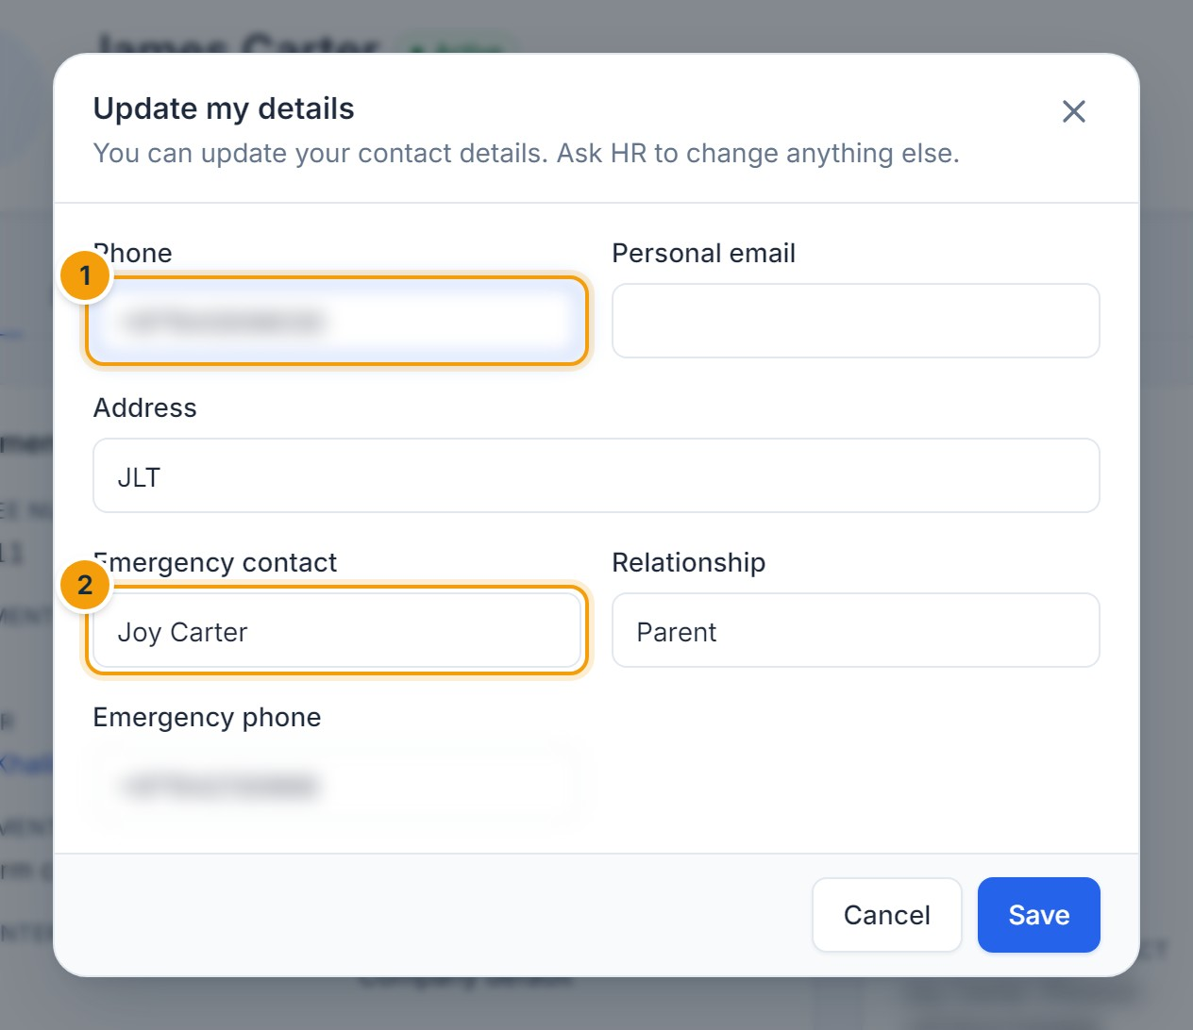
Figure 10.2 — Updating my details. (1) Phone, (2) emergency contact. Other details (job, bank, national ID) can only be changed by HR.
E. EXPECTED RESULT
Your profile is updated immediately and the change is recorded in the audit log.
NOT AVAILABLE IN THIS VERSION
HR inquiries / service requests and a company policy library are not available in this version. Contact HR directly for these.

G. Tips and best practices
- Check the bell regularly for decisions on your requests.
- Keep your emergency contact up to date.
CHAPTER 11

11. Performance Management
NOT AVAILABLE IN THIS VERSION
Performance management (goals, KPIs, review cycles, self-assessments and ratings) is not available in this version of Aziz HRM.
The system currently tracks probation end dates: the dashboard lists probations ending in the next 60 days, and HR and the manager receive a reminder 14 days before a probation ends. Confirming the employee is done by changing the status from Probation to Active when editing the employee (Chapter 5).
CHAPTER 12

12. Training and Development
NOT AVAILABLE IN THIS VERSION
Training programs, enrollment, course completion, certificates, training costs and skills records are not available in this version of Aziz HRM.
Certificates can be stored as employee documents with the type Certificate (Chapter 15).
CHAPTER 13

13. Benefits and Compensation
NOTE
Partly available. Compensation is managed through salary structures and pay components; a separate benefits administration module is not available.

Available
- Salary structures with effective dates, basic salary, allowances and deductions; changes go through the Salary change approval workflow and are recorded in the employee history (Chapter 8).
- Pay components for allowances (housing, transport, phone…), statutory deductions and employer contributions such as medical insurance or pension, with eligibility rules (Chapter 8).
- Job grades with minimum and maximum salaries; a warning appears when a proposed salary is outside the grade range (Chapter 16).
NOT AVAILABLE IN THIS VERSION
Benefit plans and enrolment, insurance policy tracking, and compensation review cycles are not available in this version.
CHAPTER 14

14. Expense and Reimbursement Management
NOT AVAILABLE IN THIS VERSION
Expense claims, receipts, categories, spending limits and reimbursement tracking are not available in this version of Aziz HRM. The approval engine lists an Expense request type for future use, but there is no screen to submit claims.
If your company policy allows it, the payroll officer can pay an approved reimbursement as a one-off Earning adjustment on a payroll run (Chapter 8). Approval of the claim itself must then happen outside the system.
CHAPTER 15

15. Employee Documents and Contracts
NOTE
Partly available: documents, expiry dates, reminders and contract dates are supported; generating letters and certificates from templates is not available in this version.

A. Purpose
Store employment contracts, IDs, passports, visas, certificates and letters on the employee record, track their expiry, and receive reminders before they expire.

B. Accessing the module
Open an employee and click the Documents tab. Viewing requires document access; uploading and deleting require document management rights (HR). Employees can see their own non-confidential documents.

C. Step-by-step instructions
- Click Upload document.
- Choose the file (1) — PDF, image, Word or Excel up to 15 MB.
- Select the Type (2), enter a title and number, and the issue and Expiry date (3).
- Tick Confidential (4) for sensitive files; only roles with confidential access can see them.
- Click Upload document.

D. Screenshot guide
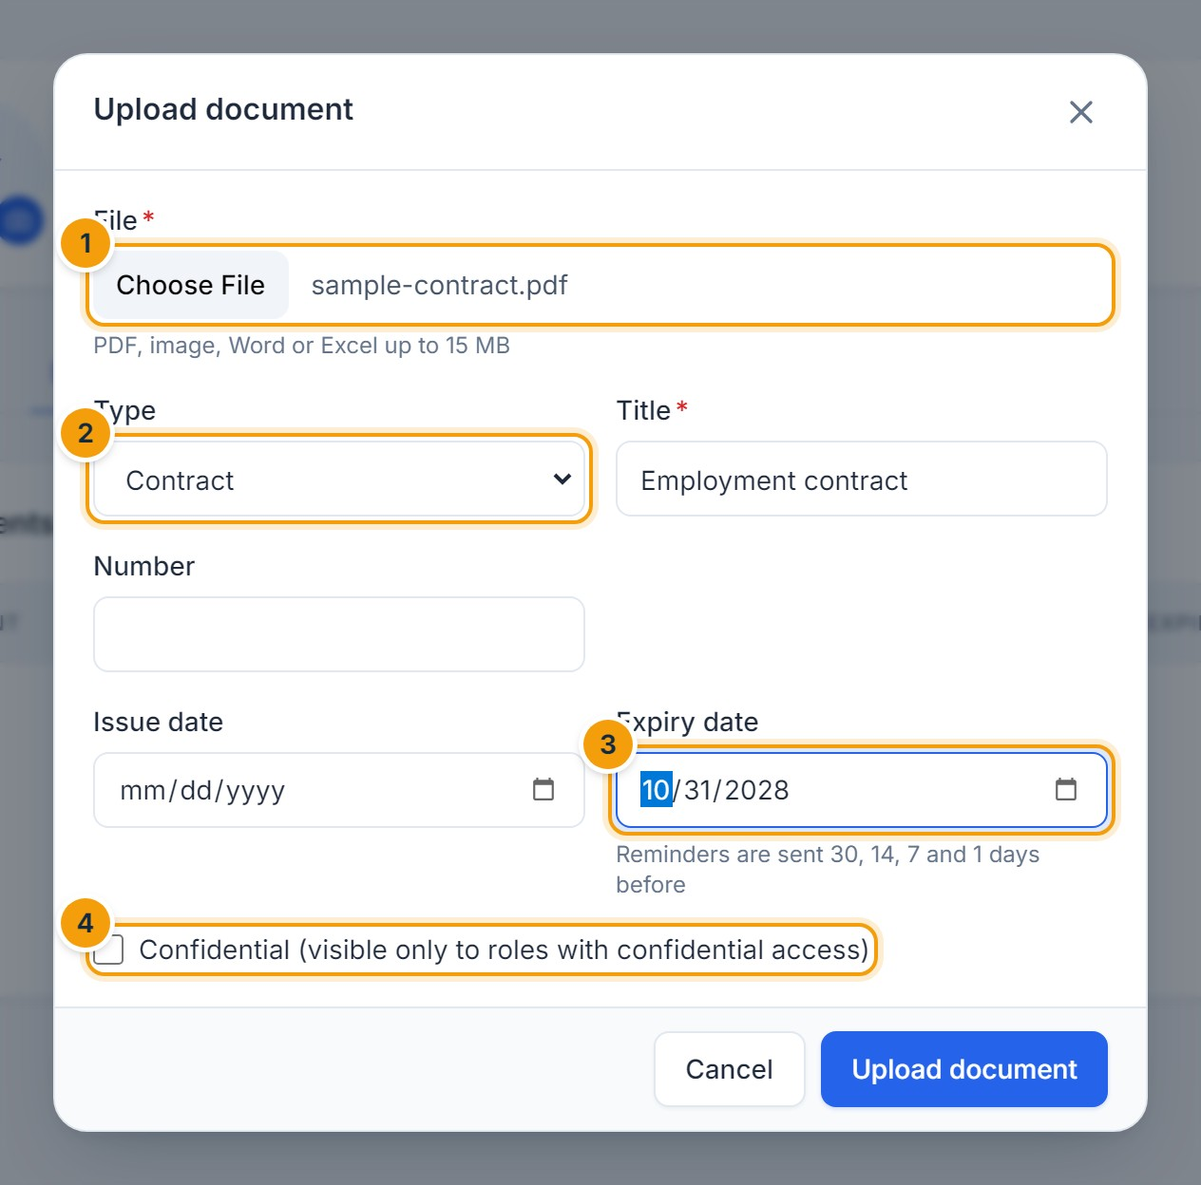
Figure 15.1 — Uploading a document. (1) File, (2) type, (3) expiry date, (4) confidential.
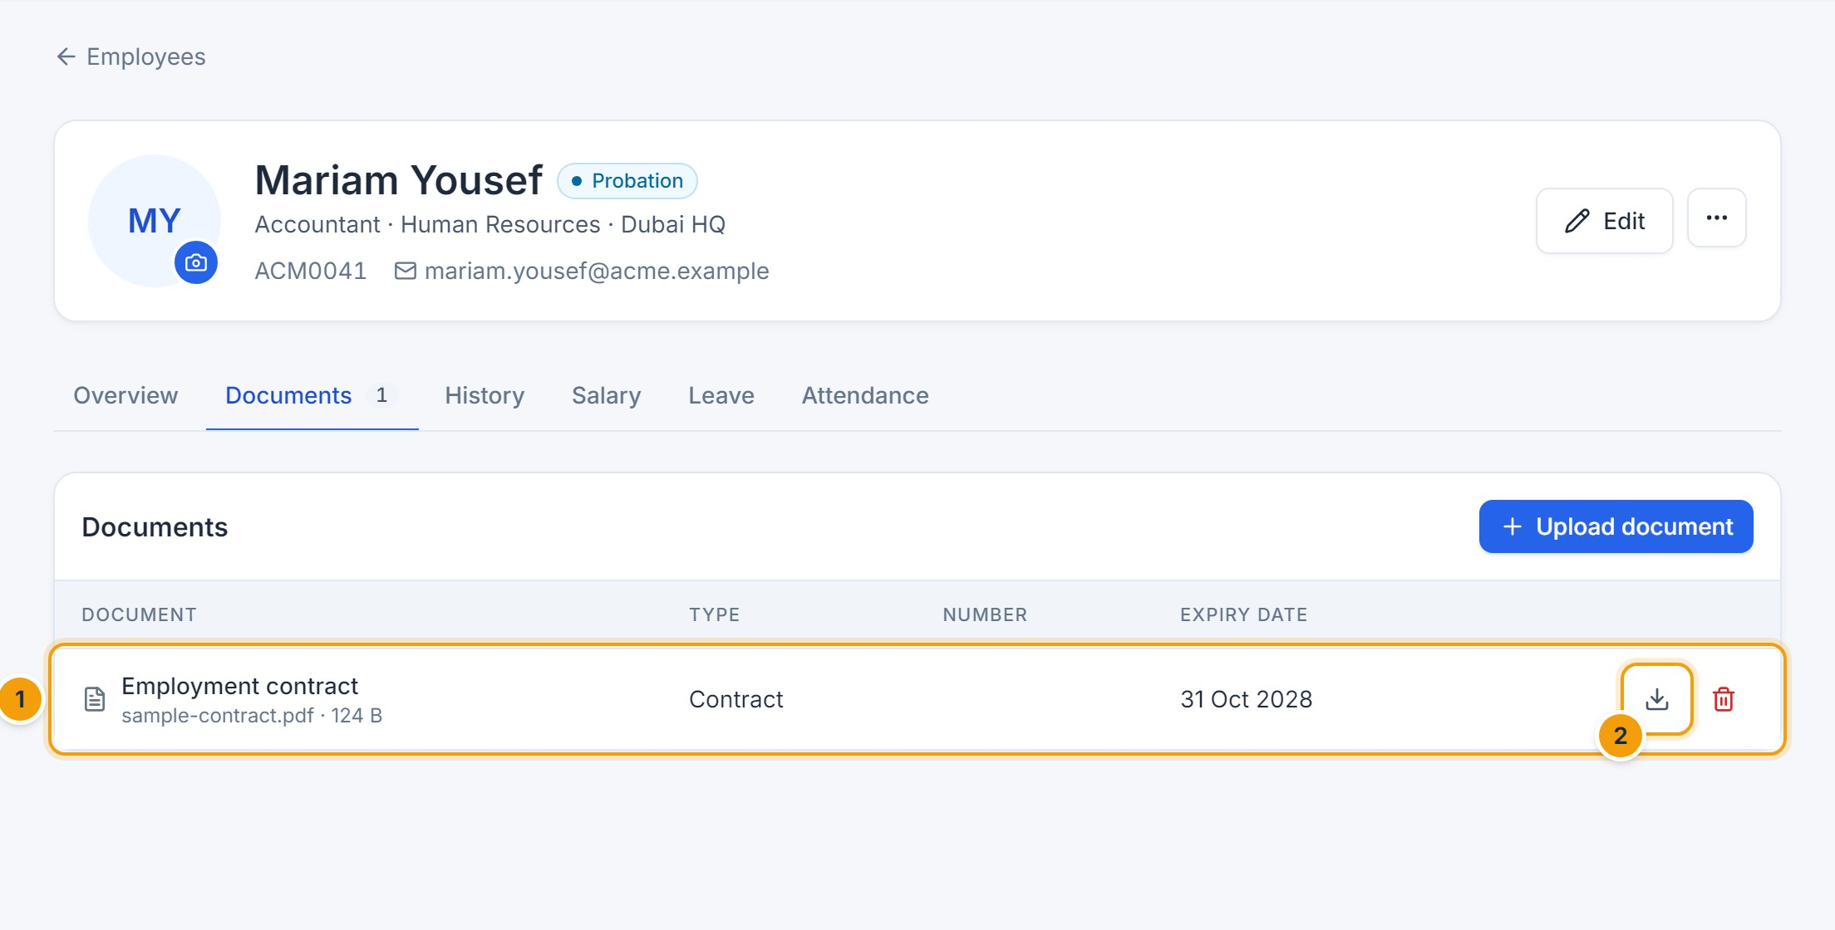
Figure 15.2 — Employee documents. (1) The uploaded document with its expiry date, (2) Download.

Contract dates and reminders
- Contract start and end dates and the probation end date are set when creating or editing the employee (Chapter 5).
- Reminders are sent to HR 30, 14, 7 and 1 days before a document expires (and to the employee for non-confidential documents), and 60, 30 and 7 days before a contract ends.
- The dashboard lists contracts and documents expiring within 60 days, and the Document expirations and Contract expirations reports list them in full (Chapter 20).

F. Common errors
- File type … is not allowed — upload PDF, PNG, JPEG, WebP, Word, Excel or CSV.
- Expiry date must be after issue date — correct the dates.

G. Tips and best practices
- Always enter expiry dates for IDs, passports and visas so reminders work.
- Deleting a document removes the file but keeps an audit entry.
CHAPTER 16

16. Organization Structure and Workforce Planning

A. Purpose
Define the company’s branches, departments (with sub-departments and managers), positions with budgeted headcount, job grades, cost centers, employee categories and employment types. These are used throughout the system, for example to decide who approves requests and which employees a manager can see.

B. Accessing the module
Click Organization in the sidebar (administrators with organization management rights). Everyone with employee access can open the Org chart.

D. Screenshot guide
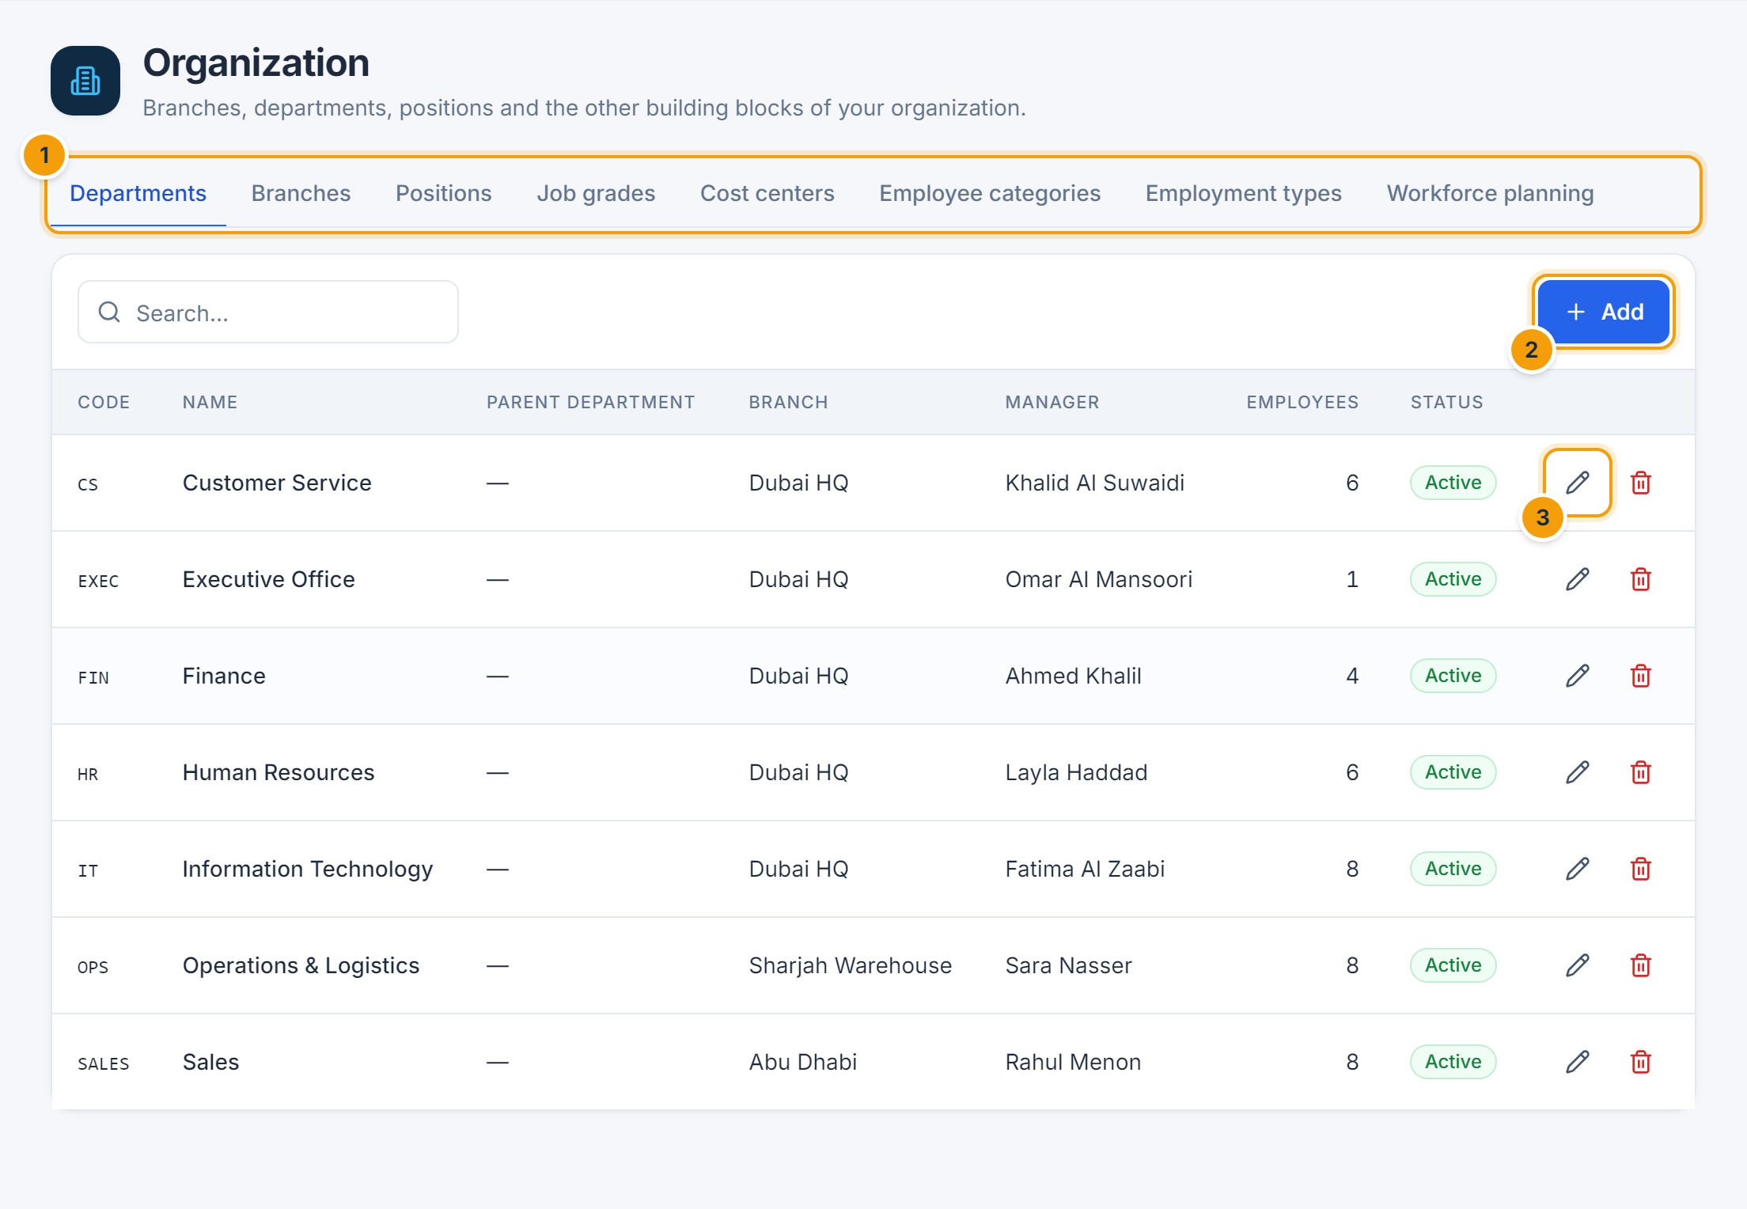
Figure 16.1 — Organization. (1) Tabs for departments, branches, positions, grades, cost centers, categories, employment types and workforce planning, (2) Add, (3) edit.

C. Step-by-step instructions
- Open the relevant tab and click Add (or the pencil icon to edit).
- Enter a unique Code (1) and Name (2) and the other details (for example parent department, branch and manager).
- Click Save (3).
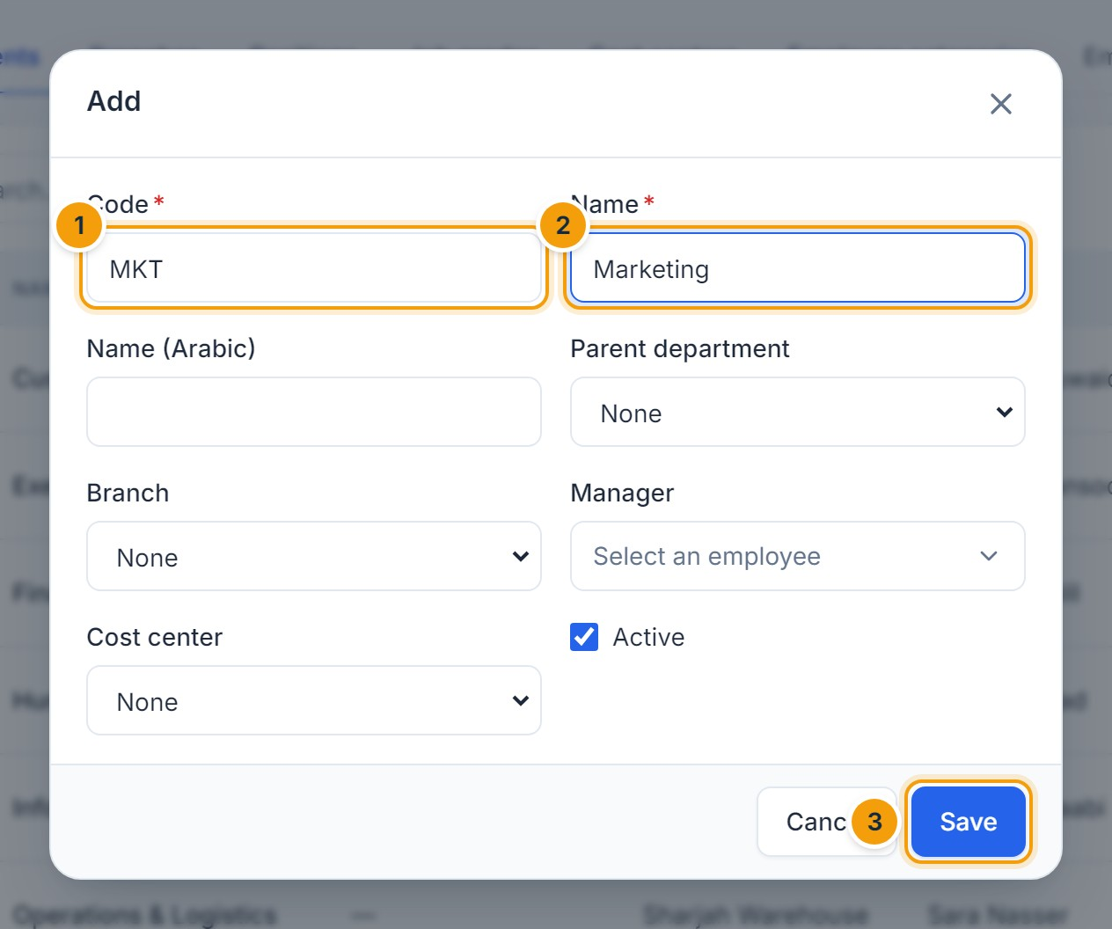
Figure 16.2 — Adding a department. (1) Code, (2) name, (3) Save.
E. EXPECTED RESULT
The item is saved and immediately available in employee forms and filters. A department’s manager approves requests that use the Department manager approval step.
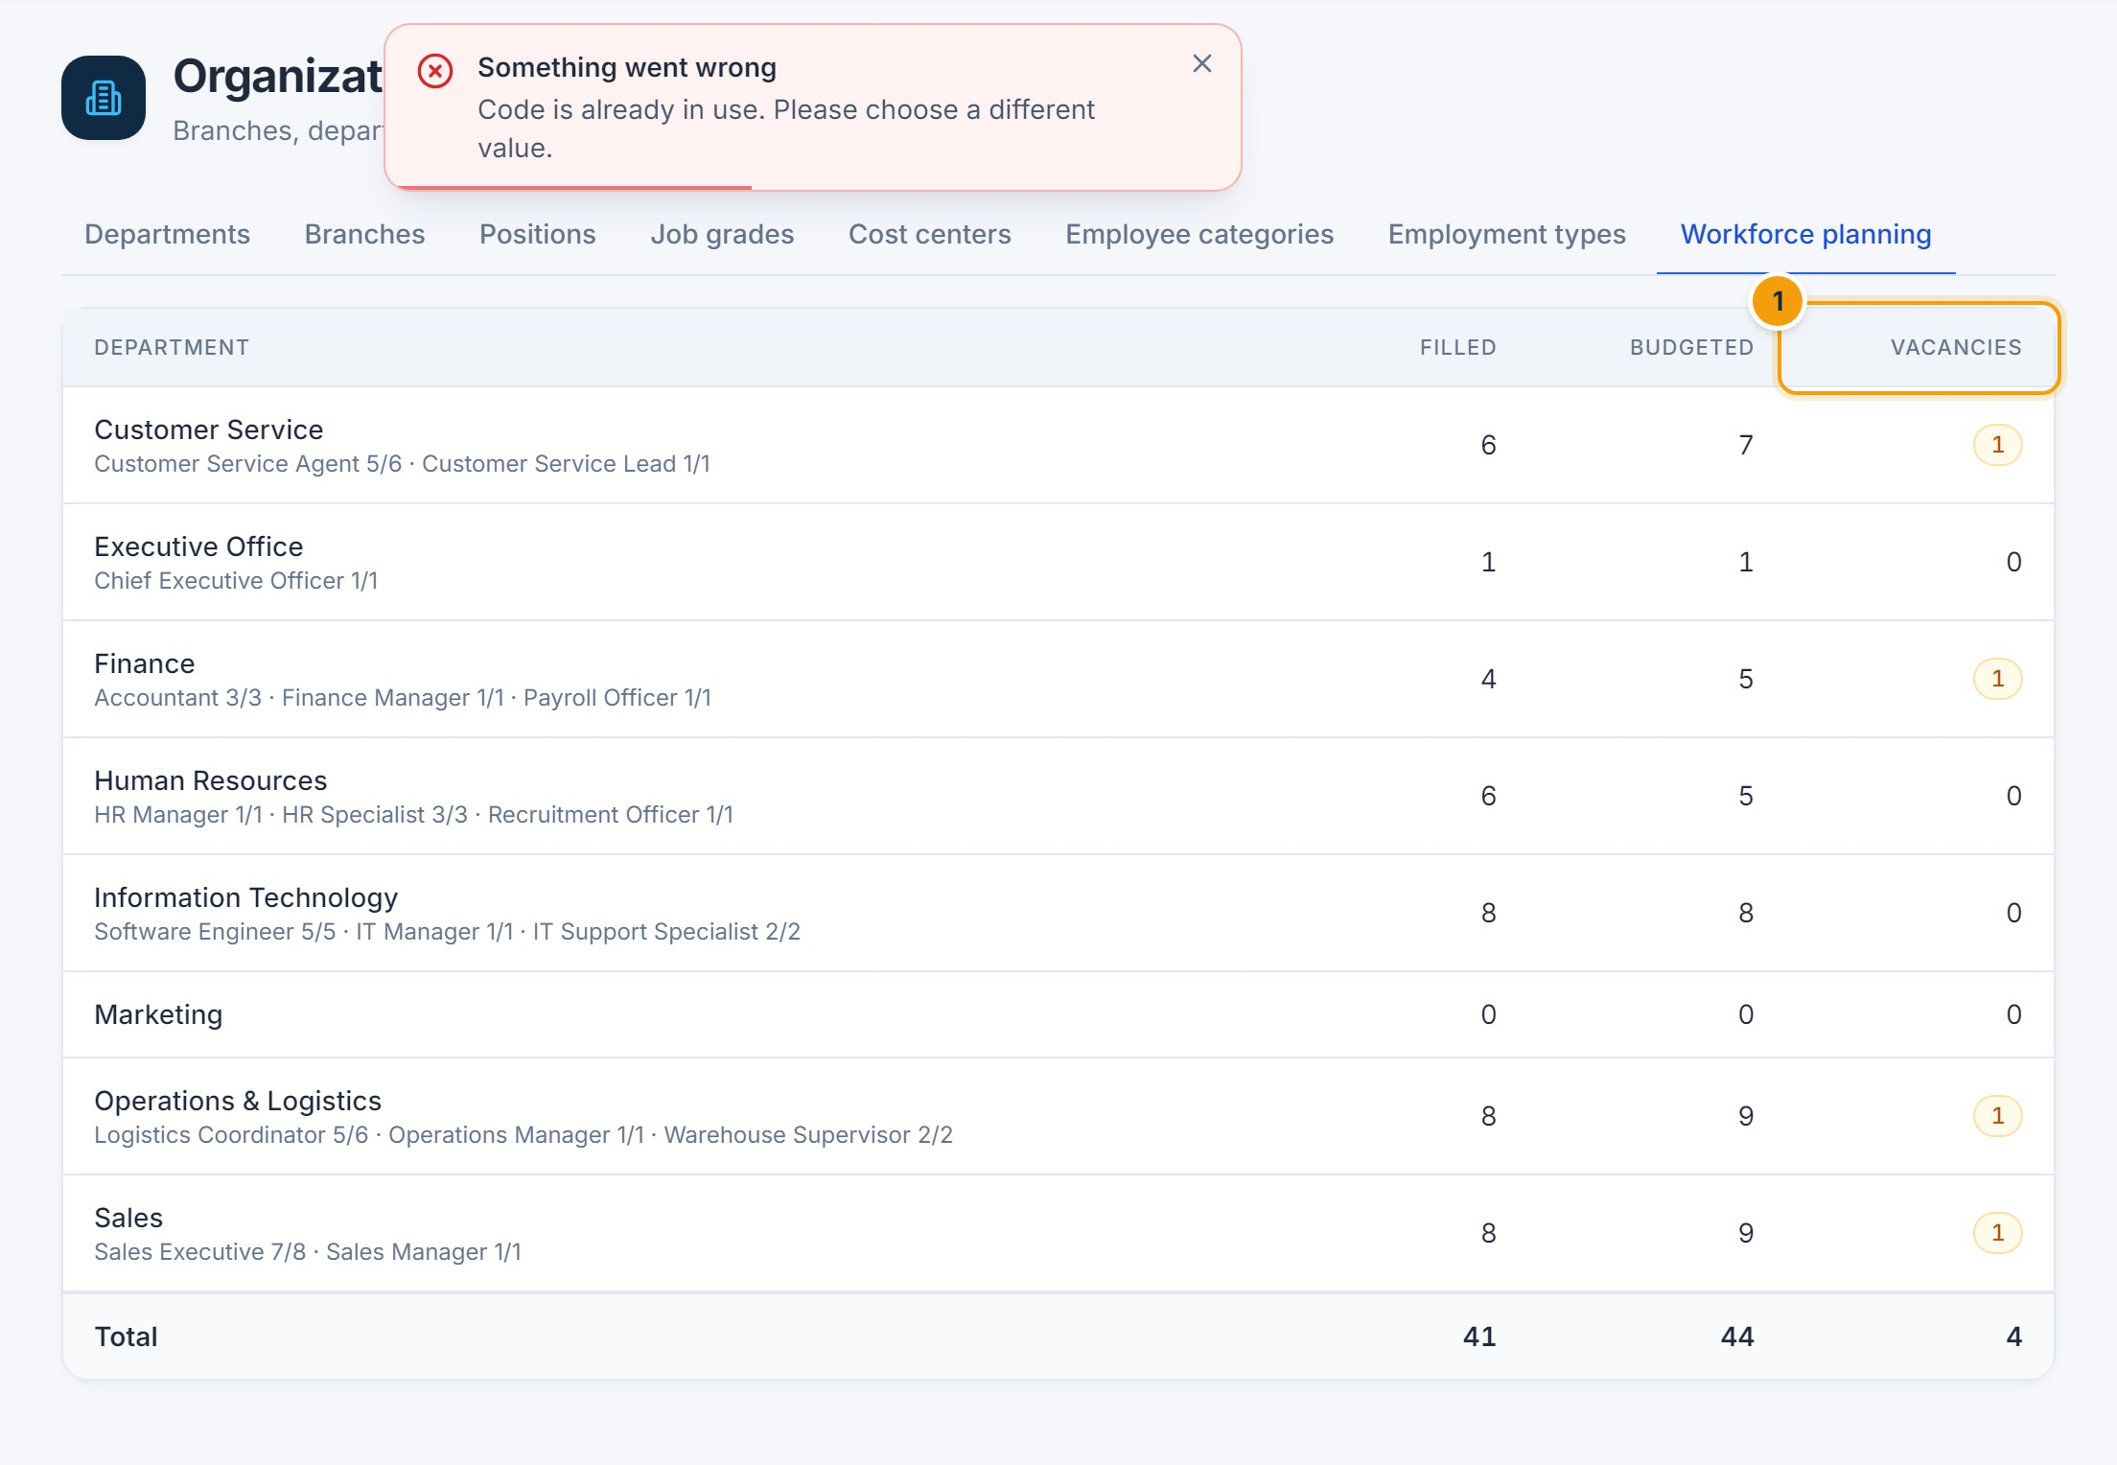
Figure 16.3 — Workforce planning. (1) Vacancies = budgeted seats on positions minus current holders.
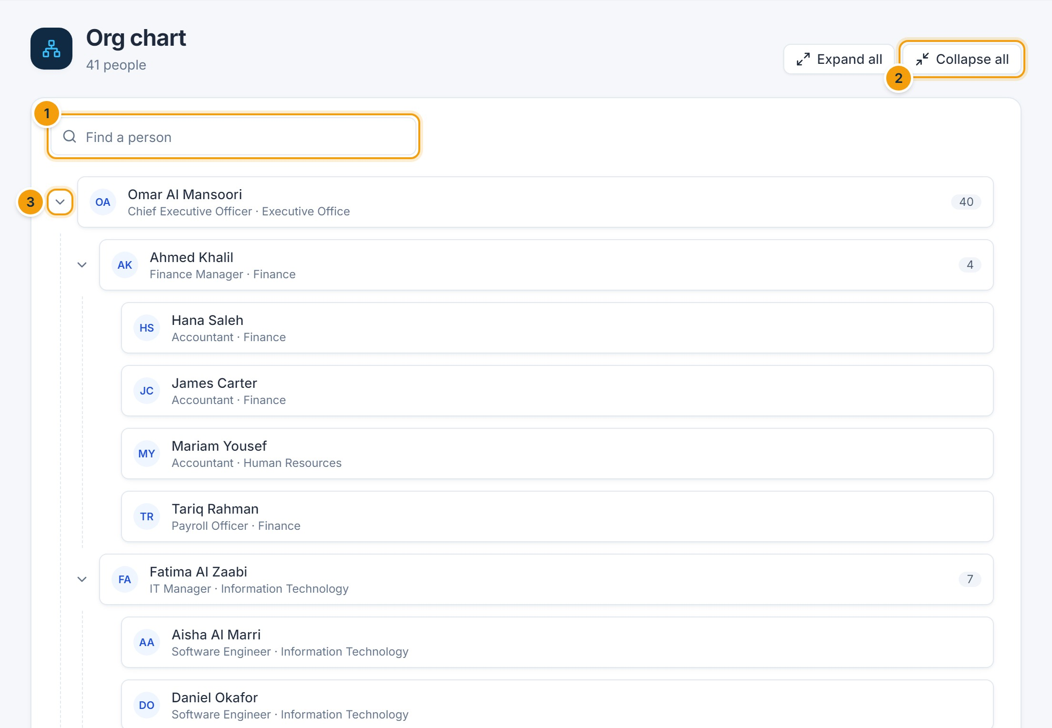
Figure 16.4 — Org chart. (1) Find a person, (2) expand or collapse all, (3) expand or collapse one team. The number shows the team size.

F. Common errors
- Code is already in use — codes must be unique within the company.
- This … is in use. Deactivate it instead of deleting it. — items referenced by employees cannot be deleted; edit them and untick Active.

G. Tips and best practices
- Assign a manager to every department and branch so approvals route correctly.
- Keep budgeted headcount on positions current for accurate vacancy figures.
CHAPTER 17

17. Employee Onboarding and Offboarding
NOTE
Partly available: creating employees, probation tracking and recording separations are supported. Onboarding and offboarding checklists, task assignment, exit interviews, asset handover, final settlement and notice-period tracking are not available in this version.

Onboarding — what you can do today
- Create the employee record and, if appropriate, their user account (Chapter 5).
- Set up their salary (Chapter 8) and upload contract and identity documents (Chapter 15).
- Track the probation end date on the dashboard; a reminder is sent 14 days before it ends.
- When probation is complete, edit the employee and change Status from Probation to Active.

Offboarding — what you can do today
- Open the employee profile and click ⋯ → Record separation.
- Choose Resigned, Terminated or Retired, set the last working day and the reason, and confirm (see Figure in Chapter 5).
E. EXPECTED RESULT
From the last working day the employee can no longer sign in, their direct reports move to their manager, and the record remains available for history, reports and payroll. Payroll prorates pay up to the separation date.
NOT AVAILABLE IN THIS VERSION
Resignation requests submitted by employees, exit interviews, checklists for IT/Finance/asset return and final settlement calculation are not available in this version.
CHAPTER 18

18. HR Requests and Approval Workflows

A. Purpose
The approval engine routes requests to the right people in the right order, records every decision with its comment and time, notifies everyone involved, and applies the result automatically (for example updating a leave balance).

Supported request types
Request | Created from | Result when approved
Leave | Leave → Request leave | Leave approved; balance and attendance updated
Attendance correction | Attendance → Request correction | Attendance record corrected and recalculated
Overtime | Attendance → Request overtime | Overtime counted for payroll
Salary change | Employee → Salary → Change salary | New salary takes effect on its date
Payroll | Payroll run → Submit for approval | Payroll approved and period locked

NOTE
Transfer, Resignation, Expense, Job offer and Document request types appear in the workflow configuration for future use, but no screens create these requests in this version.

1. Creating and submitting a request
Requests are created from the module concerned, as listed above. On submission the request enters the approval queue of the first step’s approvers, who are notified in the app and by email.

2. Reviewing the approval queue
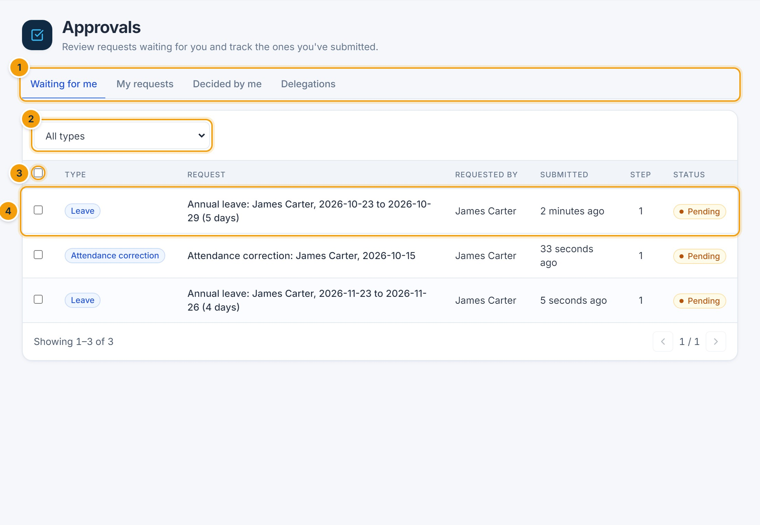
Figure 18.1 — Approvals — Waiting for me. (1) Tabs: Waiting for me, My requests, Decided by me, All requests (HR) and Delegations, (2) filter by type, (3) select several requests for bulk approval or rejection, (4) click a request to open it.

3–4. Approving or rejecting
- Open the request.
- Review the details (1) and the approval path (2), which shows every step and who is assigned.
- Enter a comment (3). A comment is required to reject.
- Click Reject (4) or Approve (5).
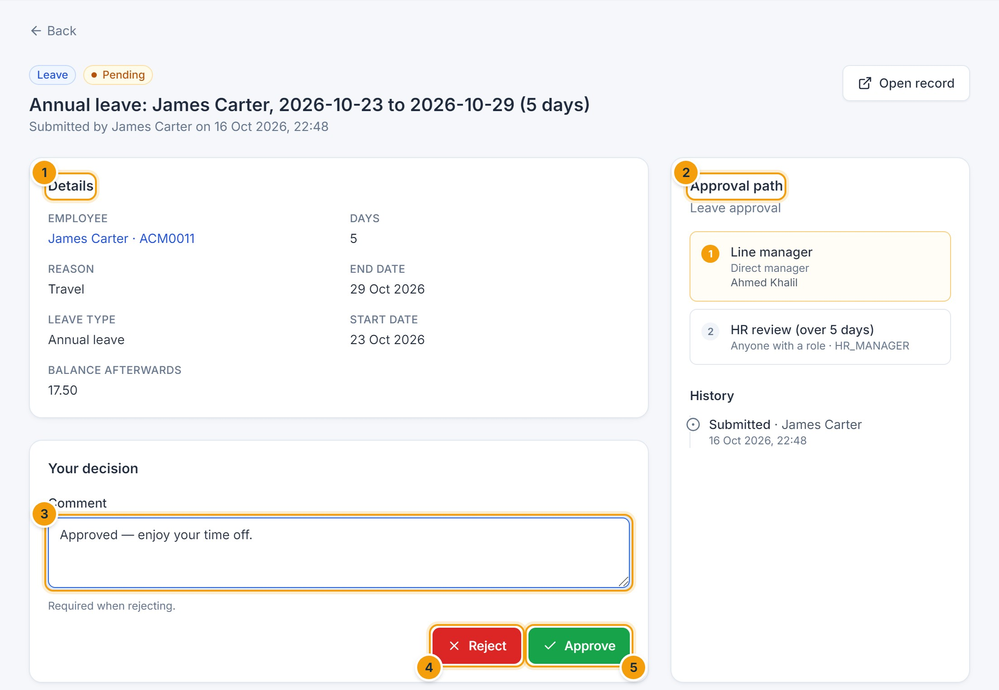
Figure 18.2 — Decision screen. (1) Request details, (2) approval path, (3) comment, (4) Reject, (5) Approve.
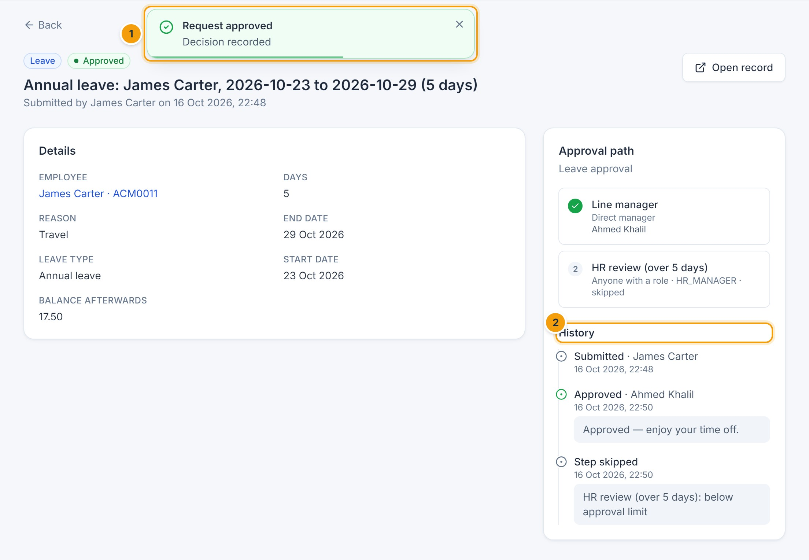
Figure 18.3 — After approval. (1) Confirmation, (2) history with each decision, the person, the time and the comment. Steps that do not apply (here, the HR step for leave under 5.5 days) are recorded as skipped.
NOTE
There is no separate “request clarification” action. To ask for more information, reject with a comment explaining what is needed, so the requester can submit a corrected request — or contact the requester directly.

5–6. Tracking the status
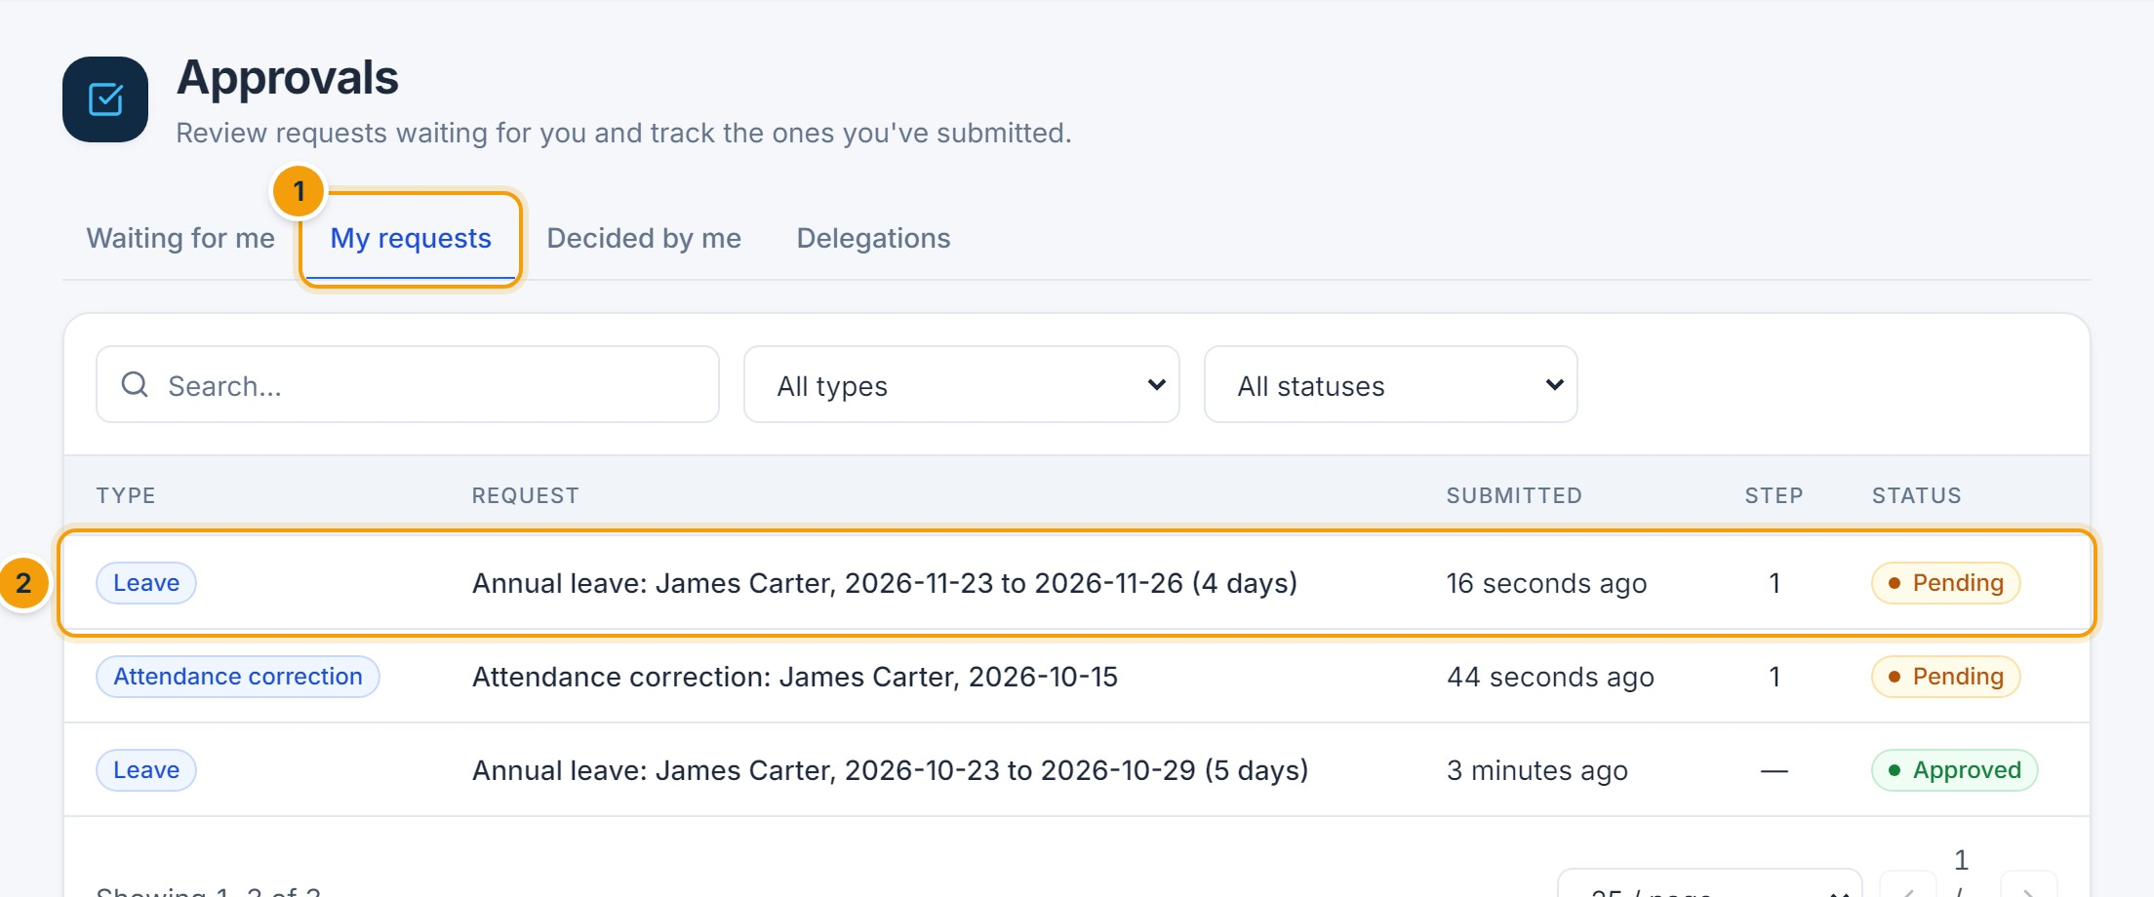
Figure 18.4 — My requests. (1) My requests tab, (2) each request with its current step and status. Open a request to see its full history.

7. Requests that remain pending
- On weekdays, approvers receive a reminder for requests waiting more than a day.
- Steps can escalate automatically after a set number of hours (configured in the workflow).
- If an approver is away, they can create a Delegation so a colleague receives their requests for a period.
- If no approver can be found for a step (for example, no manager), the request is routed to HR administrators.
- A requester can cancel their own pending leave request from the Leave page.
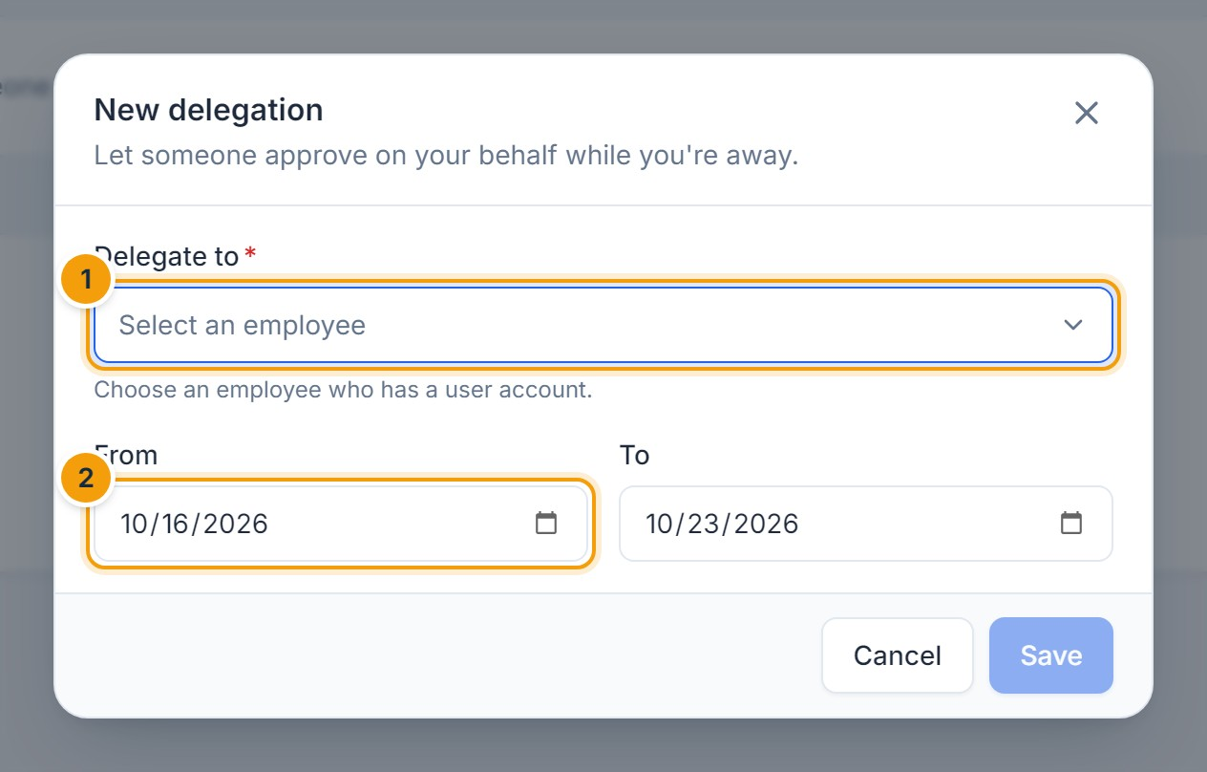
Figure 18.5 — Creating a delegation. (1) The colleague who will approve on your behalf, (2) the period.

Configuring workflows (administrators)
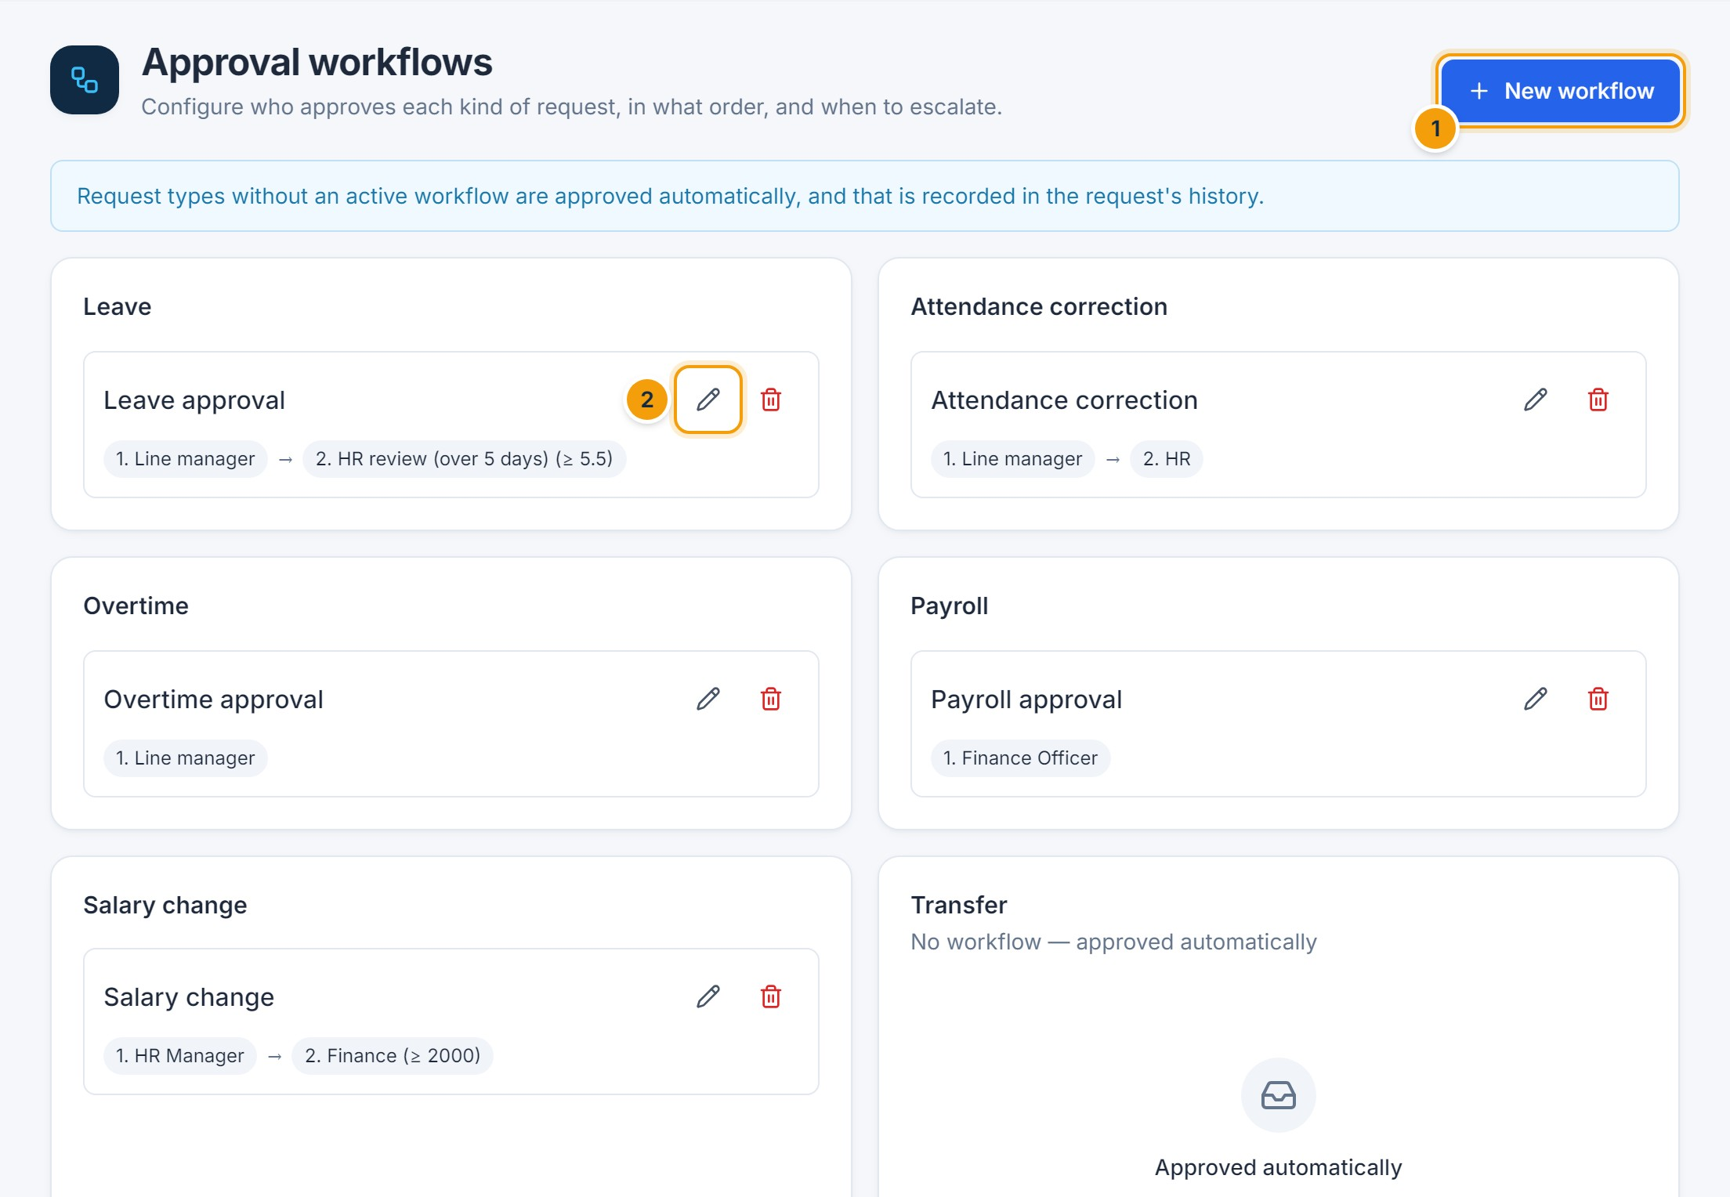
Figure 18.6 — Approval workflows. (1) New workflow, (2) edit a workflow. Request types without a workflow are approved automatically, which is recorded in the request history.
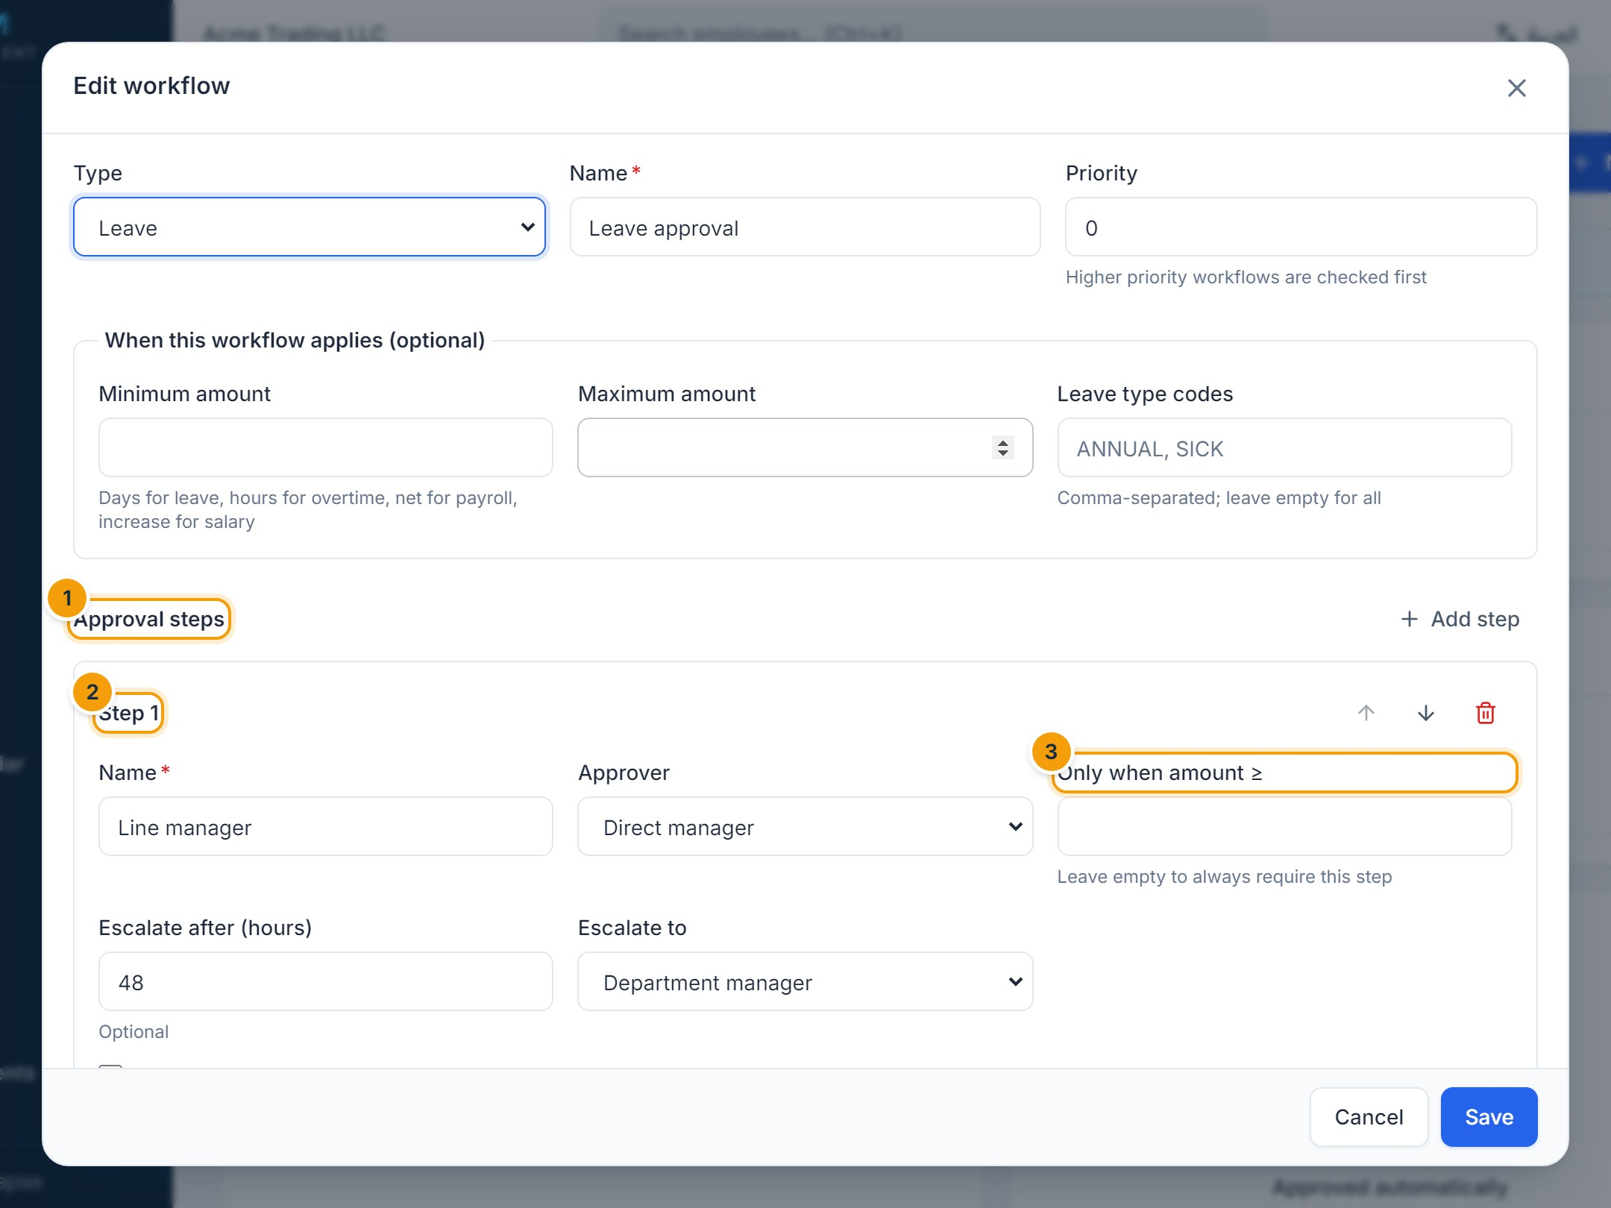
Figure 18.7 — Editing a workflow. (1) Approval steps, (2) a step with its approver (direct manager, department manager, branch manager, a role or a specific user), (3) an optional amount threshold so the step only applies above it.
TIP
The person who submits a request is never assigned as its approver unless the step explicitly allows it. This keeps payroll preparation and approval separate.
CHAPTER 19

19. Notifications and System Messages

On-screen messages
After every save, submission, approval or other action, a message appears at the top of the screen, just below the top bar. It slides down, disappears automatically after a few seconds (it pauses while your mouse is over it) and can be closed with ×. The same message is never shown twice at once.
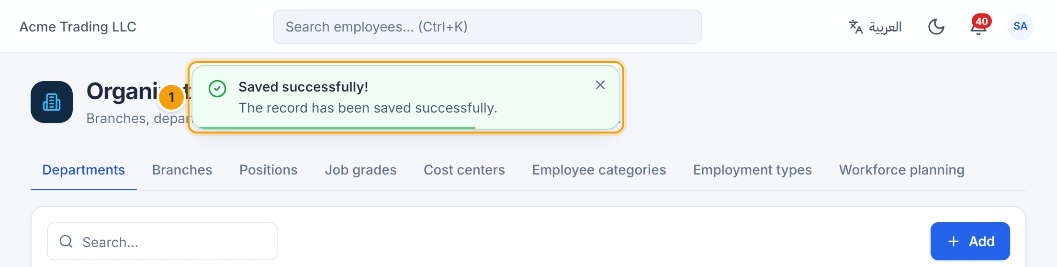
Figure 19.1 — Success message. (1) Green message with a check mark: the server confirmed the record was saved.
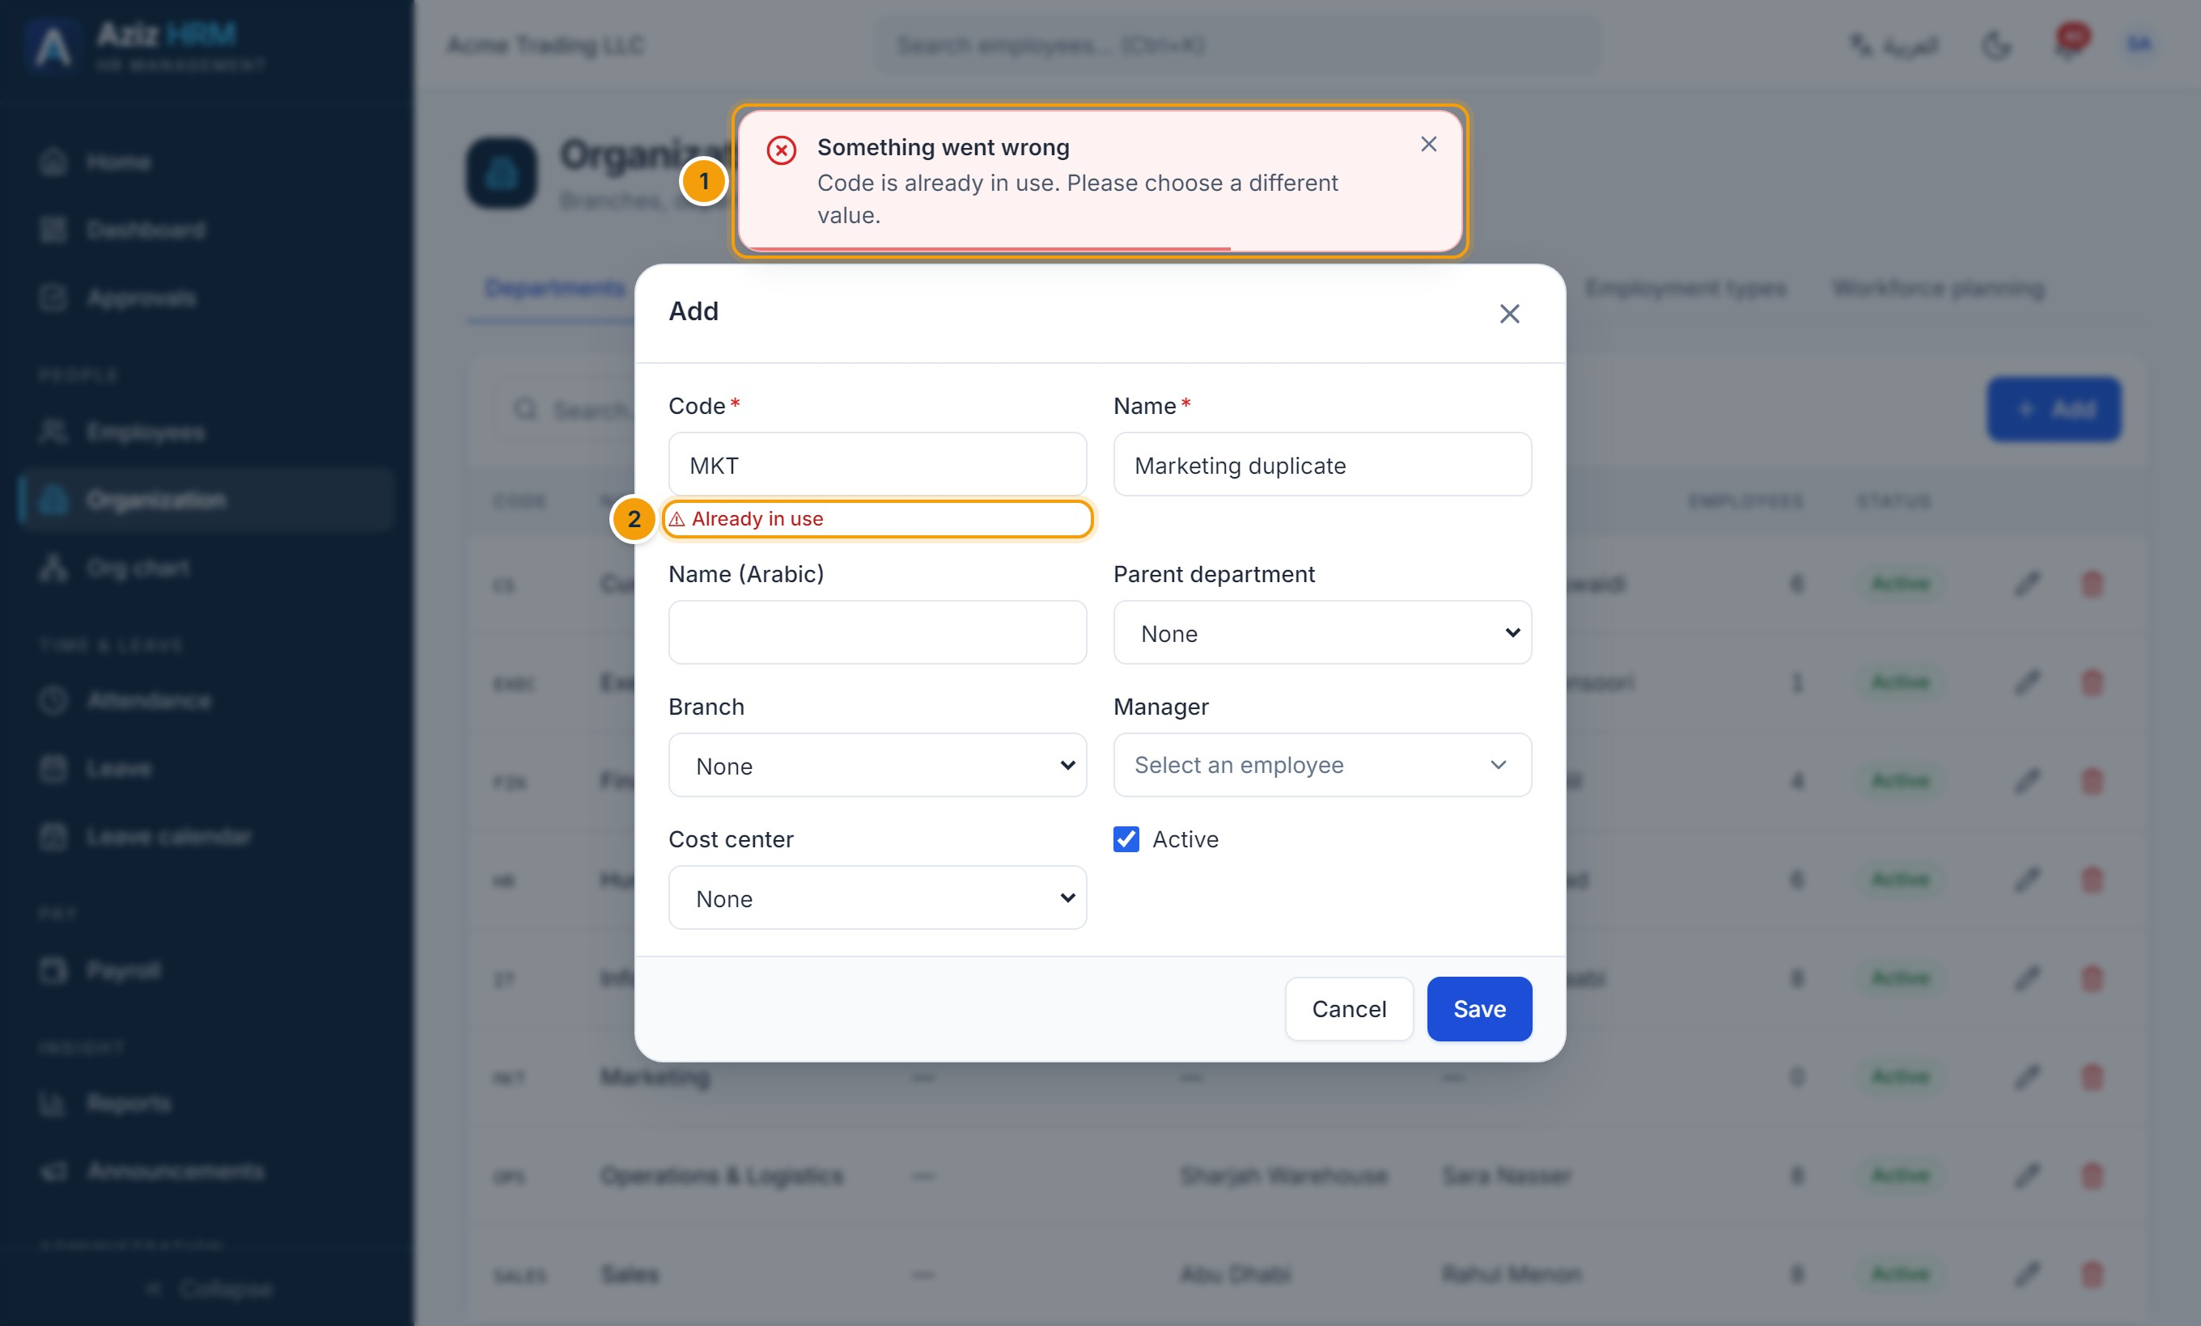
Figure 19.2 — Error message with field validation. (1) Red message explaining the problem, (2) the field concerned is marked beside it. Nothing was saved.
Message | Colour | Meaning | What to do
Saved successfully! / Employee updated | Green | The change was stored. | Nothing.
Leave request submitted / Correction submitted for approval | Green | The request is in the approval queue. | Track it in Approvals → My requests.
Request approved | Green | Your decision was recorded and applied. | Nothing.
Request rejected | Green | The rejection and your comment were recorded. | Nothing; the requester is notified.
Something went wrong — “… is already in use”, “Some fields are invalid: …” | Red | Validation error: the data was rejected. | Correct the fields shown and save again.
Something went wrong — other message | Red | The operation failed (for example a business rule or locked period). | Read the message; see Chapter 22.
Missing bank details for: … | Amber | Completed, with a warning. | Review the items listed.

IMPORTANT
A green message appears only after the server confirms the operation. If you see a red message, the operation did not complete and nothing was saved.

Access denied

Figure 19.3 — No access. (1) Shown when you open a page your role does not include. Contact your HR administrator if you need access.

Notification center
The bell in the top bar shows the number of unread notifications. Click it to see the latest; click one to open the related page. Mark all as read clears the counter, and View all notifications opens the full list.
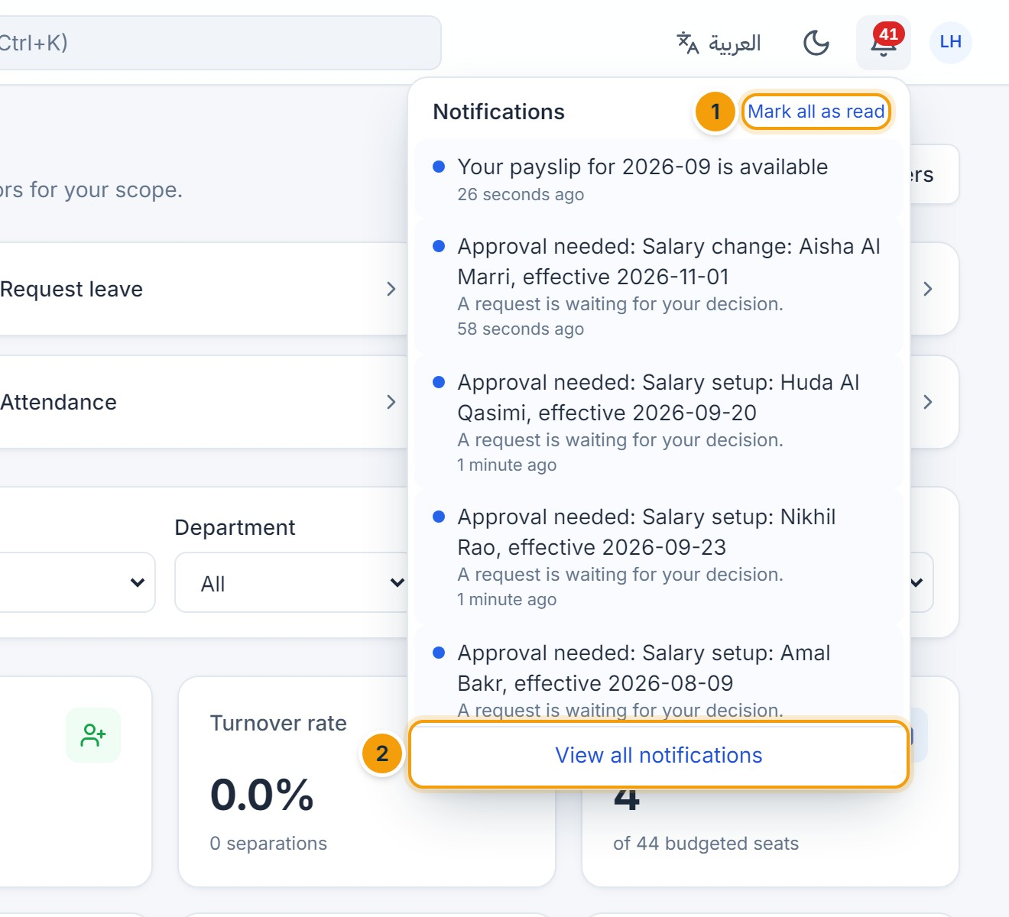
Figure 19.4 — Notification bell. (1) Mark all as read, (2) View all notifications.
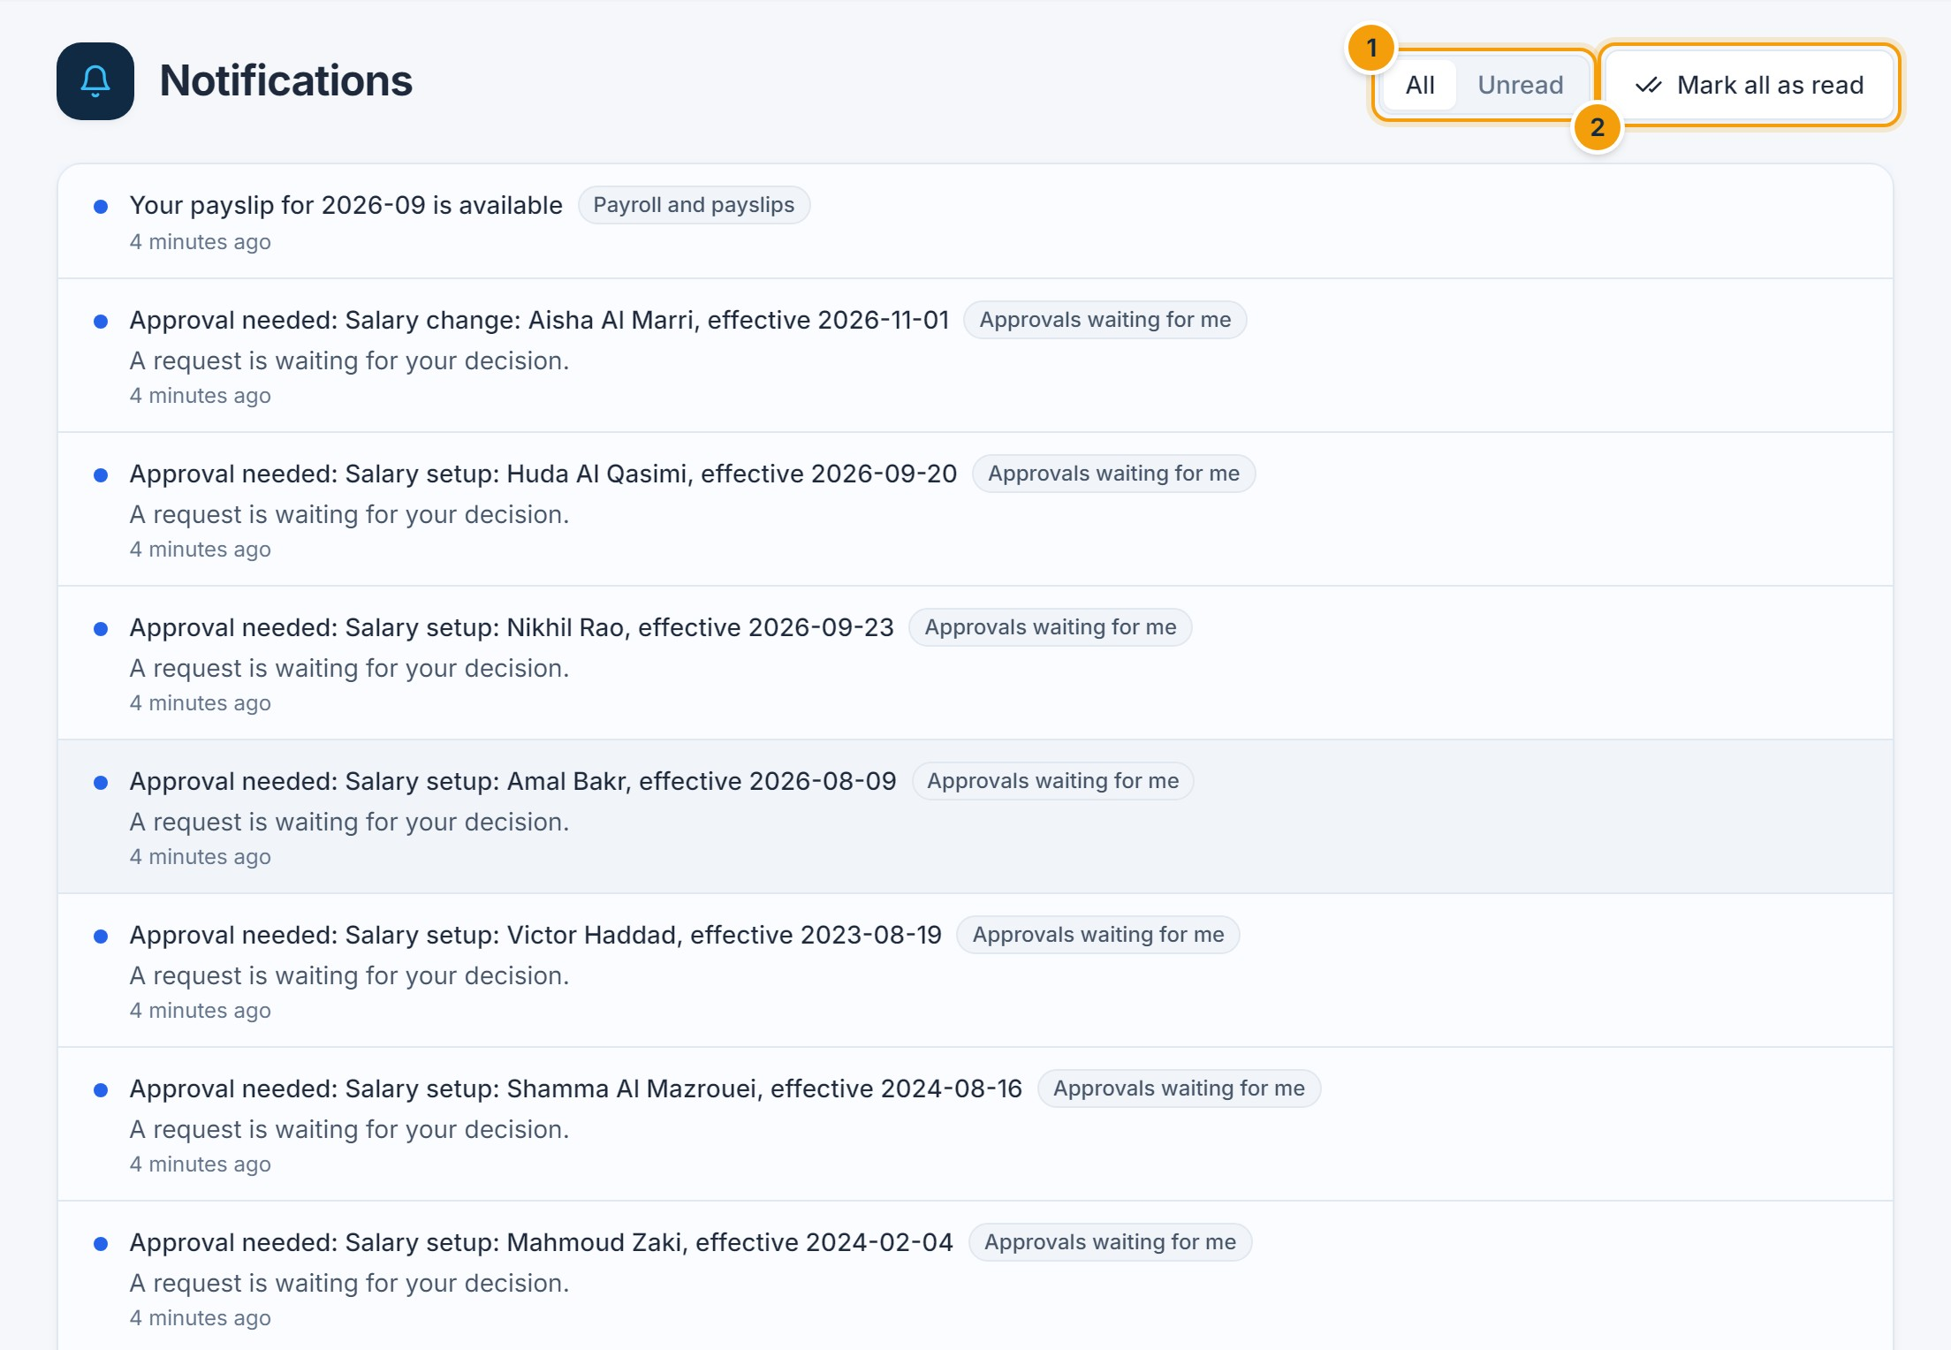
Figure 19.5 — All notifications. (1) Show all or unread only, (2) mark all as read.
You are notified when… | Who
A request needs your decision, is escalated to you, or is still waiting after a day | Approvers
Your request is approved, rejected or cancelled | Requester
A document is about to expire | HR and the employee
A contract or probation period is ending | HR and the manager
Payroll is approved / payslips are available | Payroll and finance / employees
An announcement is published | Employees in the audience

Choose which notifications you receive in the app and by email in Account settings → Notification preferences. Email is sent only if your organization has configured an email server.

Announcements
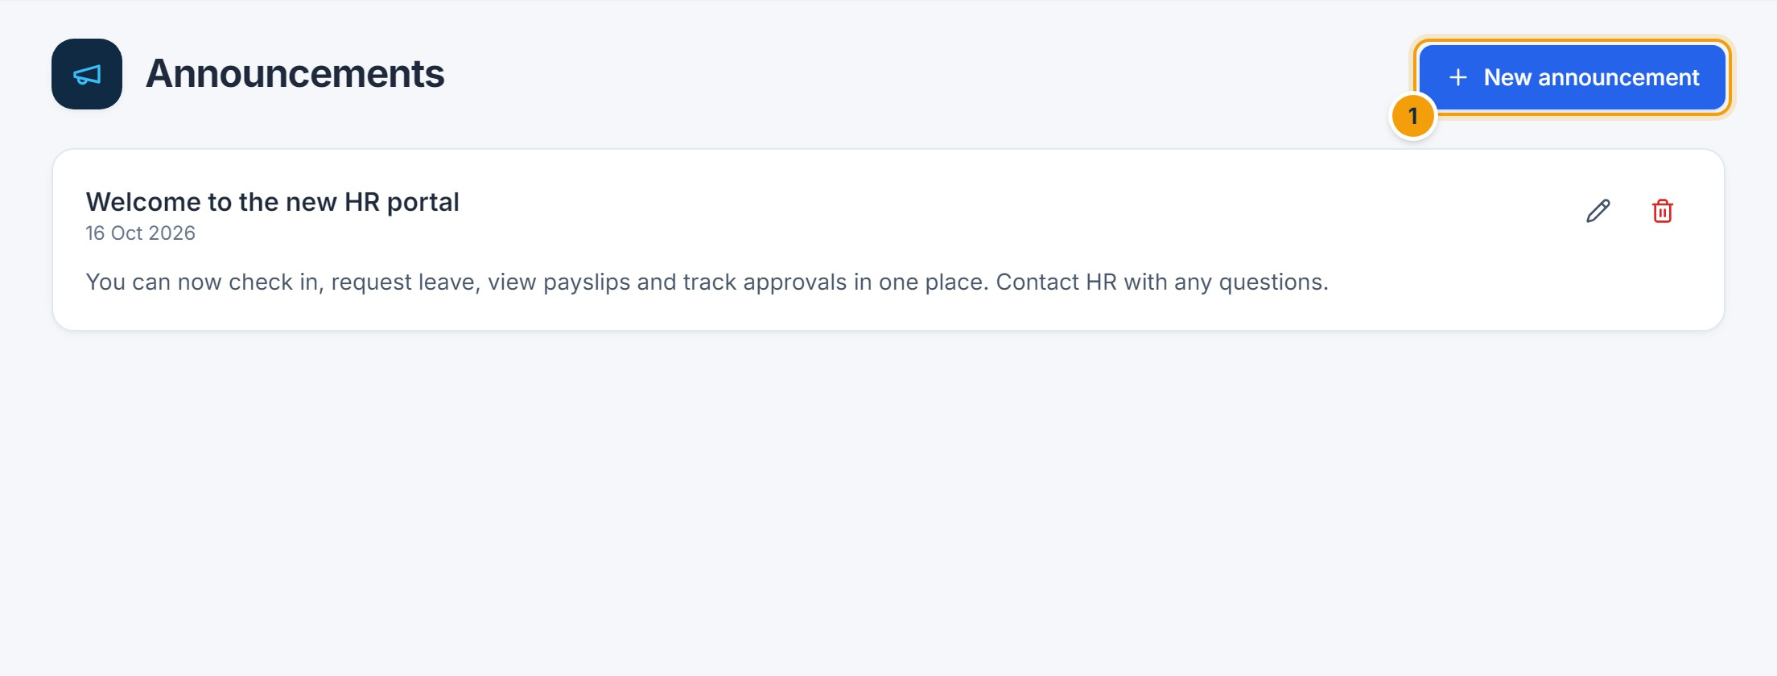
Figure 19.6 — Announcements. (1) HR can publish announcements to everyone or to selected branches and departments; employees see them on Home and receive a notification.
NOT AVAILABLE IN THIS VERSION
SMS and messaging-app notifications are not available in this version.
CHAPTER 20

20. Reports and Analytics

A. Purpose
Run ready-made reports on attendance, leave, workforce, payroll and compliance; view them as tables and charts; export them; and schedule them by email.

B. Accessing the module
Click Reports in the sidebar. Each report is listed only if your role has the underlying access (for example payroll reports require payroll access). Results are limited to your data scope.

C. Step-by-step instructions
- Choose a report in the list on the left (1).
- Set the filters (2) — date range, department, branch, year or month, depending on the report.
- Click Run report (3). The table and, where relevant, a chart appear below.
- Click Excel, CSV or PDF (4) to download.
- Click Save configuration (5) to keep the filters; optionally schedule email delivery.

D. Screenshot guide
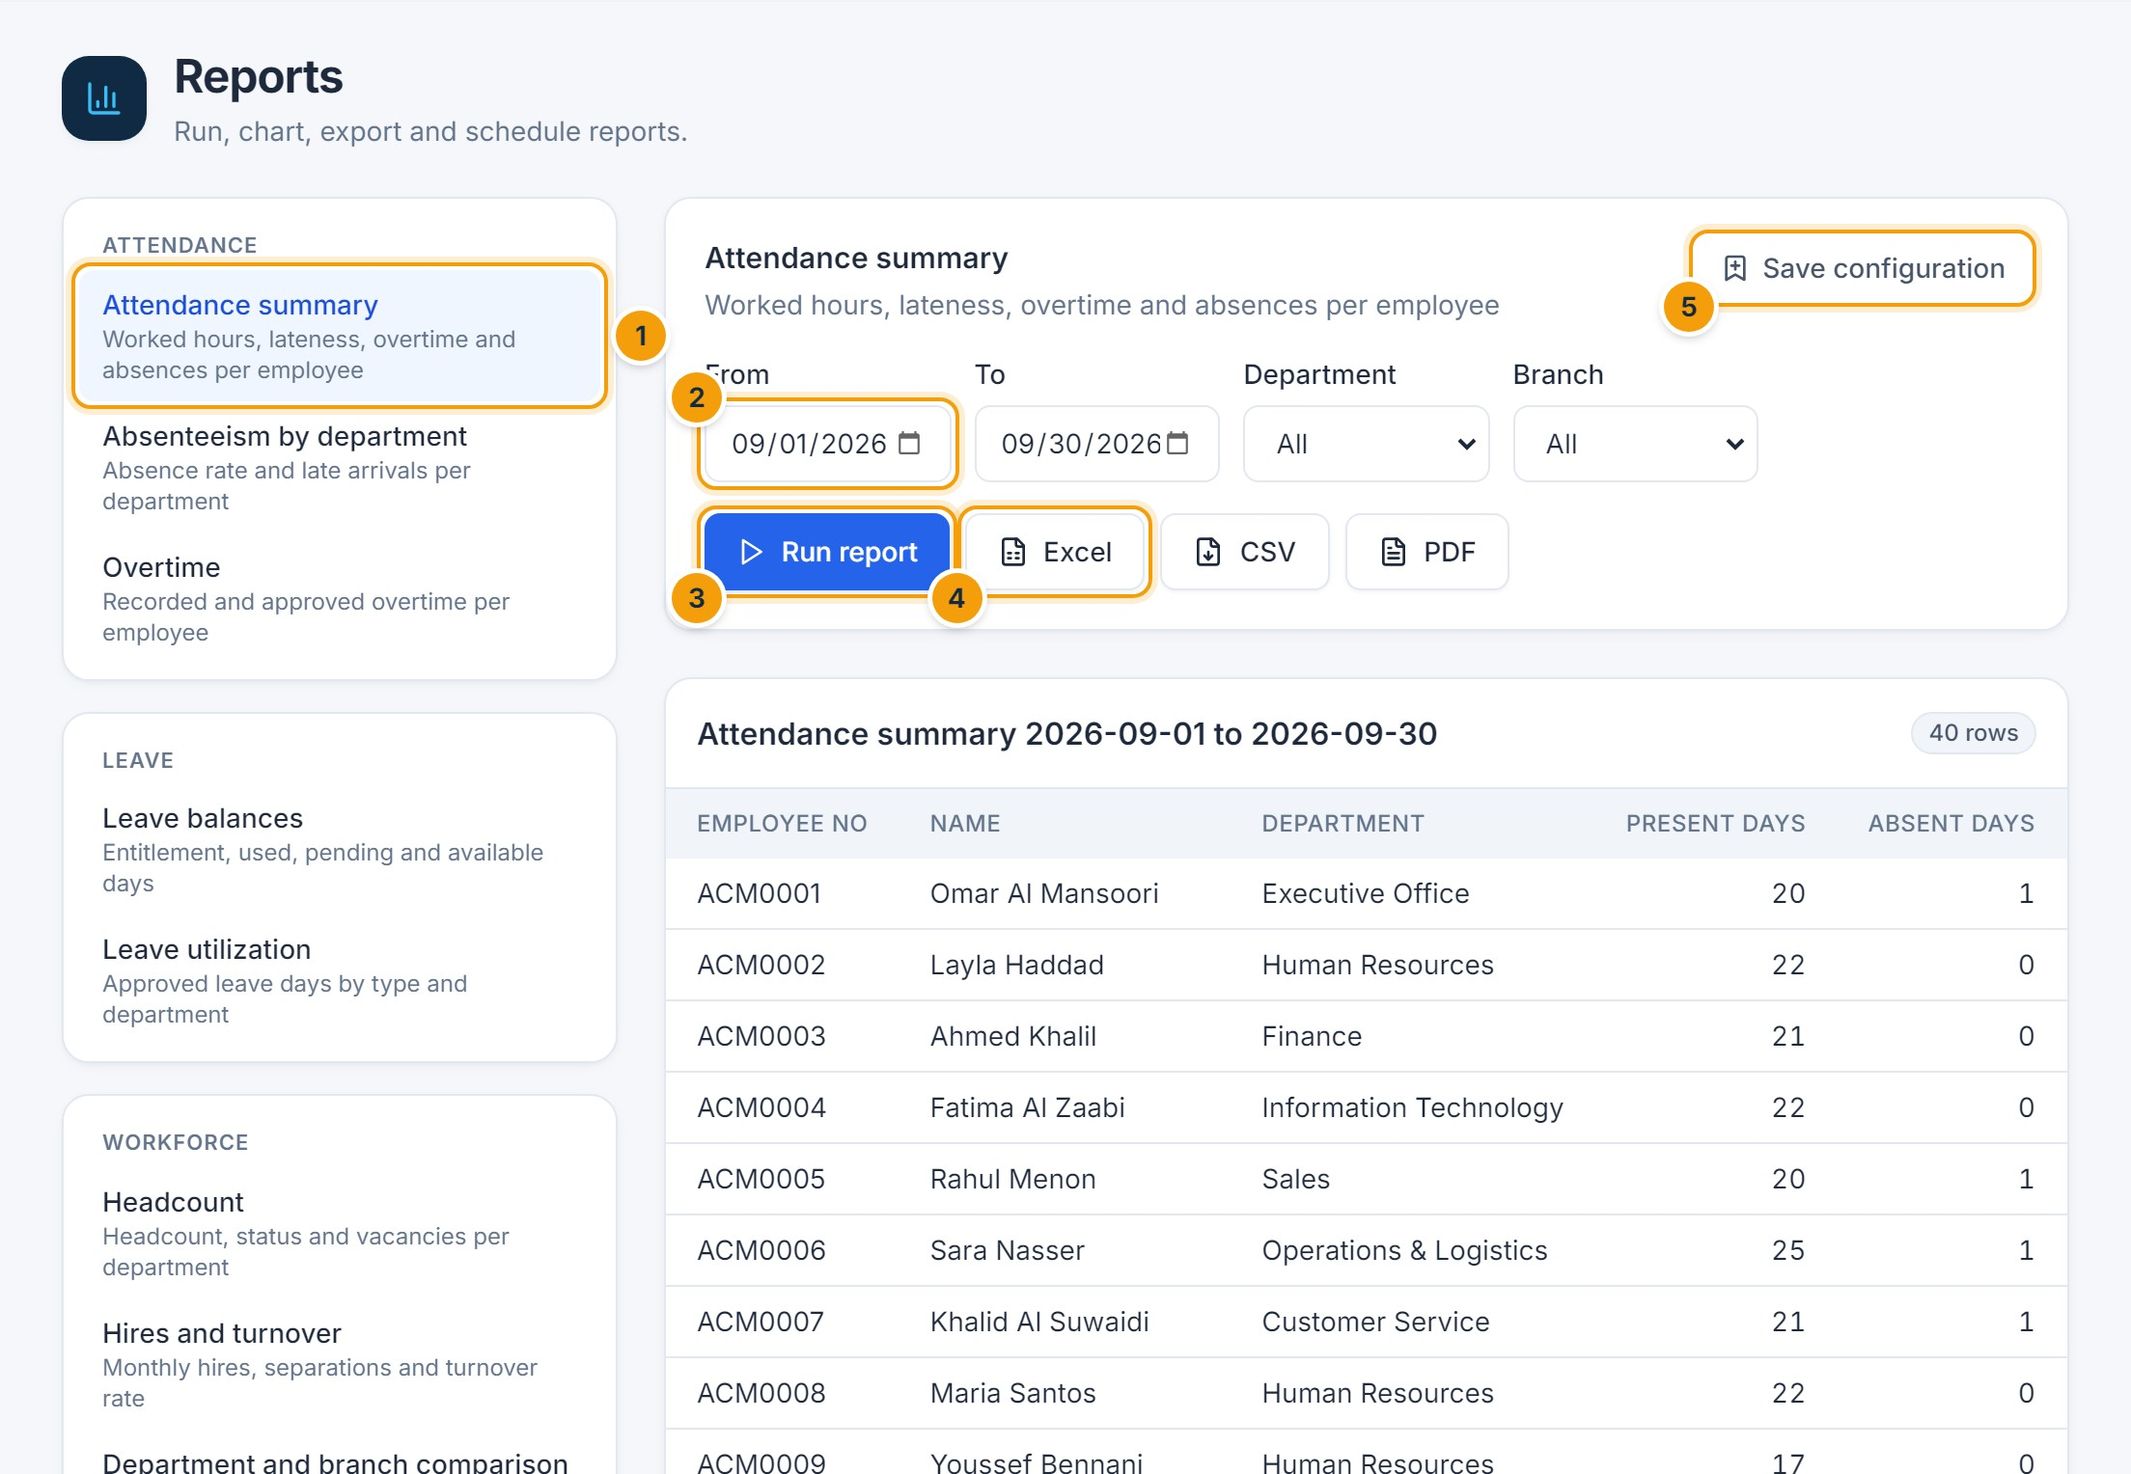
Figure 20.1 — Reports. (1) Report list, (2) filters, (3) Run report, (4) export, (5) save configuration.
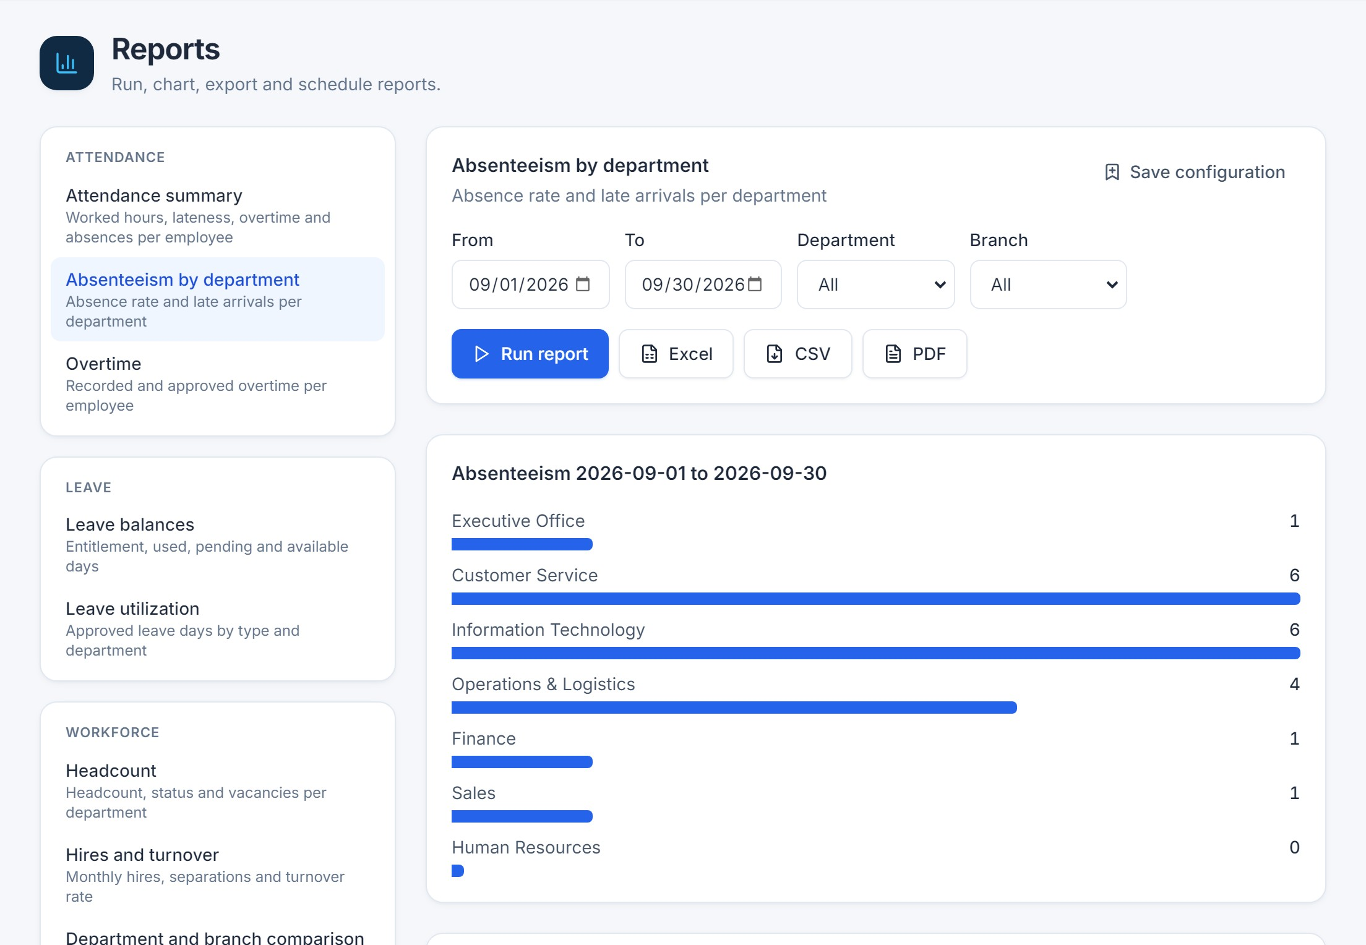
Figure 20.2 — Report with chart. (1) Switch the chart to a table view.
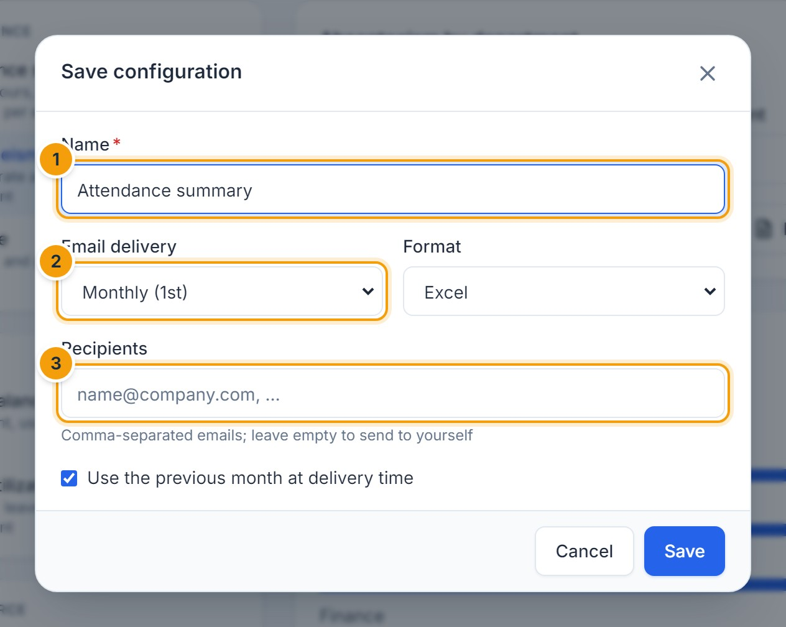
Figure 20.3 — Saving and scheduling a report. (1) Name, (2) delivery (daily, weekly on Mondays, monthly on the 1st), (3) recipients. Scheduled reports can use the previous month automatically.
Category | Reports
Attendance | Attendance summary · Absenteeism by department · Overtime
Leave | Leave balances · Leave utilization
Workforce | Headcount · Hires and turnover · Department and branch comparison
Payroll | Payroll summary · Payroll cost by department
Compliance | Contract expirations · Document expirations

F. Common errors
- Invalid report filters — check the dates (From must be before To).
- A report is missing from the list — your role does not include the required access.
- No rows for these filters — widen the date range or remove filters.

G. Tips and best practices
- Exports respect your data scope and permissions, like the screen.
- Every export is recorded in the audit log.
CHAPTER 21

21. System Settings and User Permissions

Company settings
Settings (administrators) contains the company information and regional settings, attendance policy, shifts, public holidays and leave policies. Payroll rules are under Payroll.
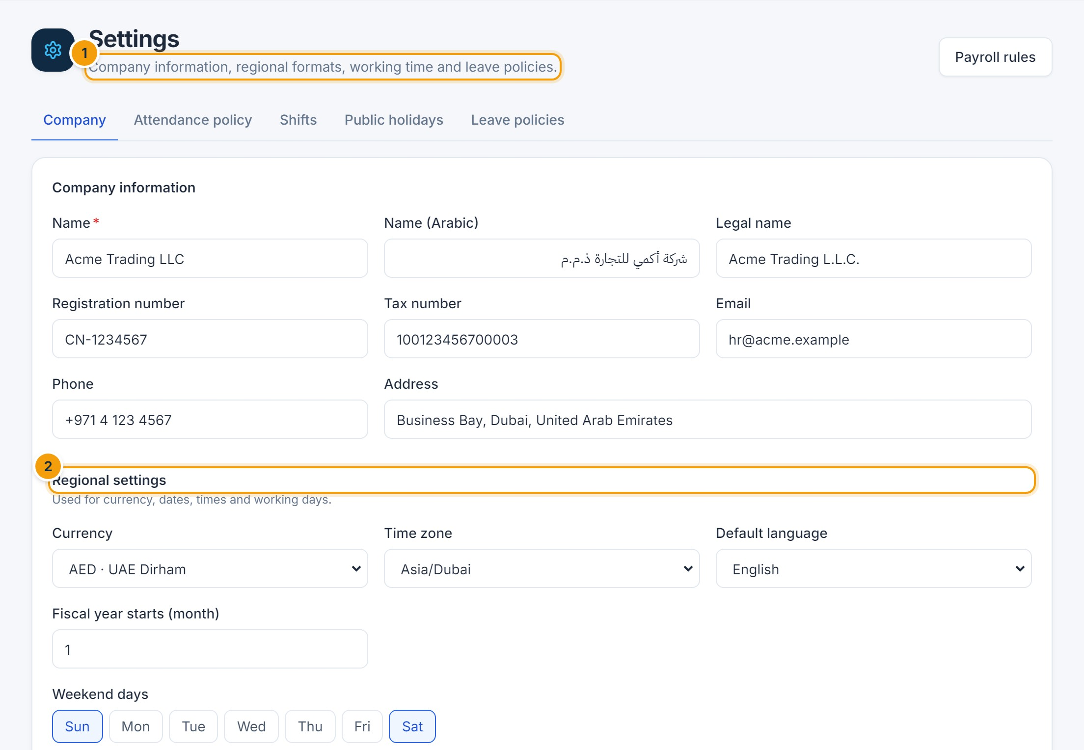
Figure 21.1 — Company settings. (1) Company information, (2) regional settings: currency, time zone, default language, fiscal year and weekend days.

Users
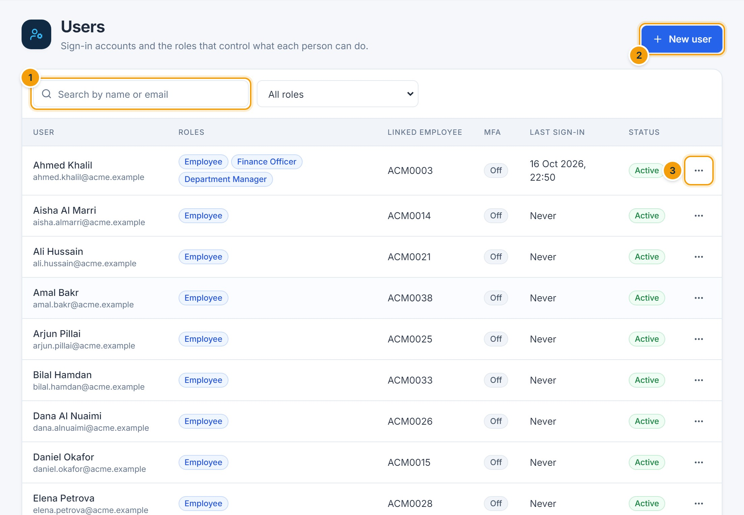
Figure 21.2 — Users. (1) Search, (2) New user, (3) actions: edit, reset password, unlock, remove two-step verification.
- Click New user, enter the email and display name, link the employee record if any, choose one or more roles, and save.
- Copy the temporary password shown once and give it to the user securely. They must change it at first sign-in.
- To revoke access, edit the user and untick Account is active; all their sessions end immediately.
IMPORTANT
Only a Super Administrator can grant or change the Super Administrator role.

Roles and permissions
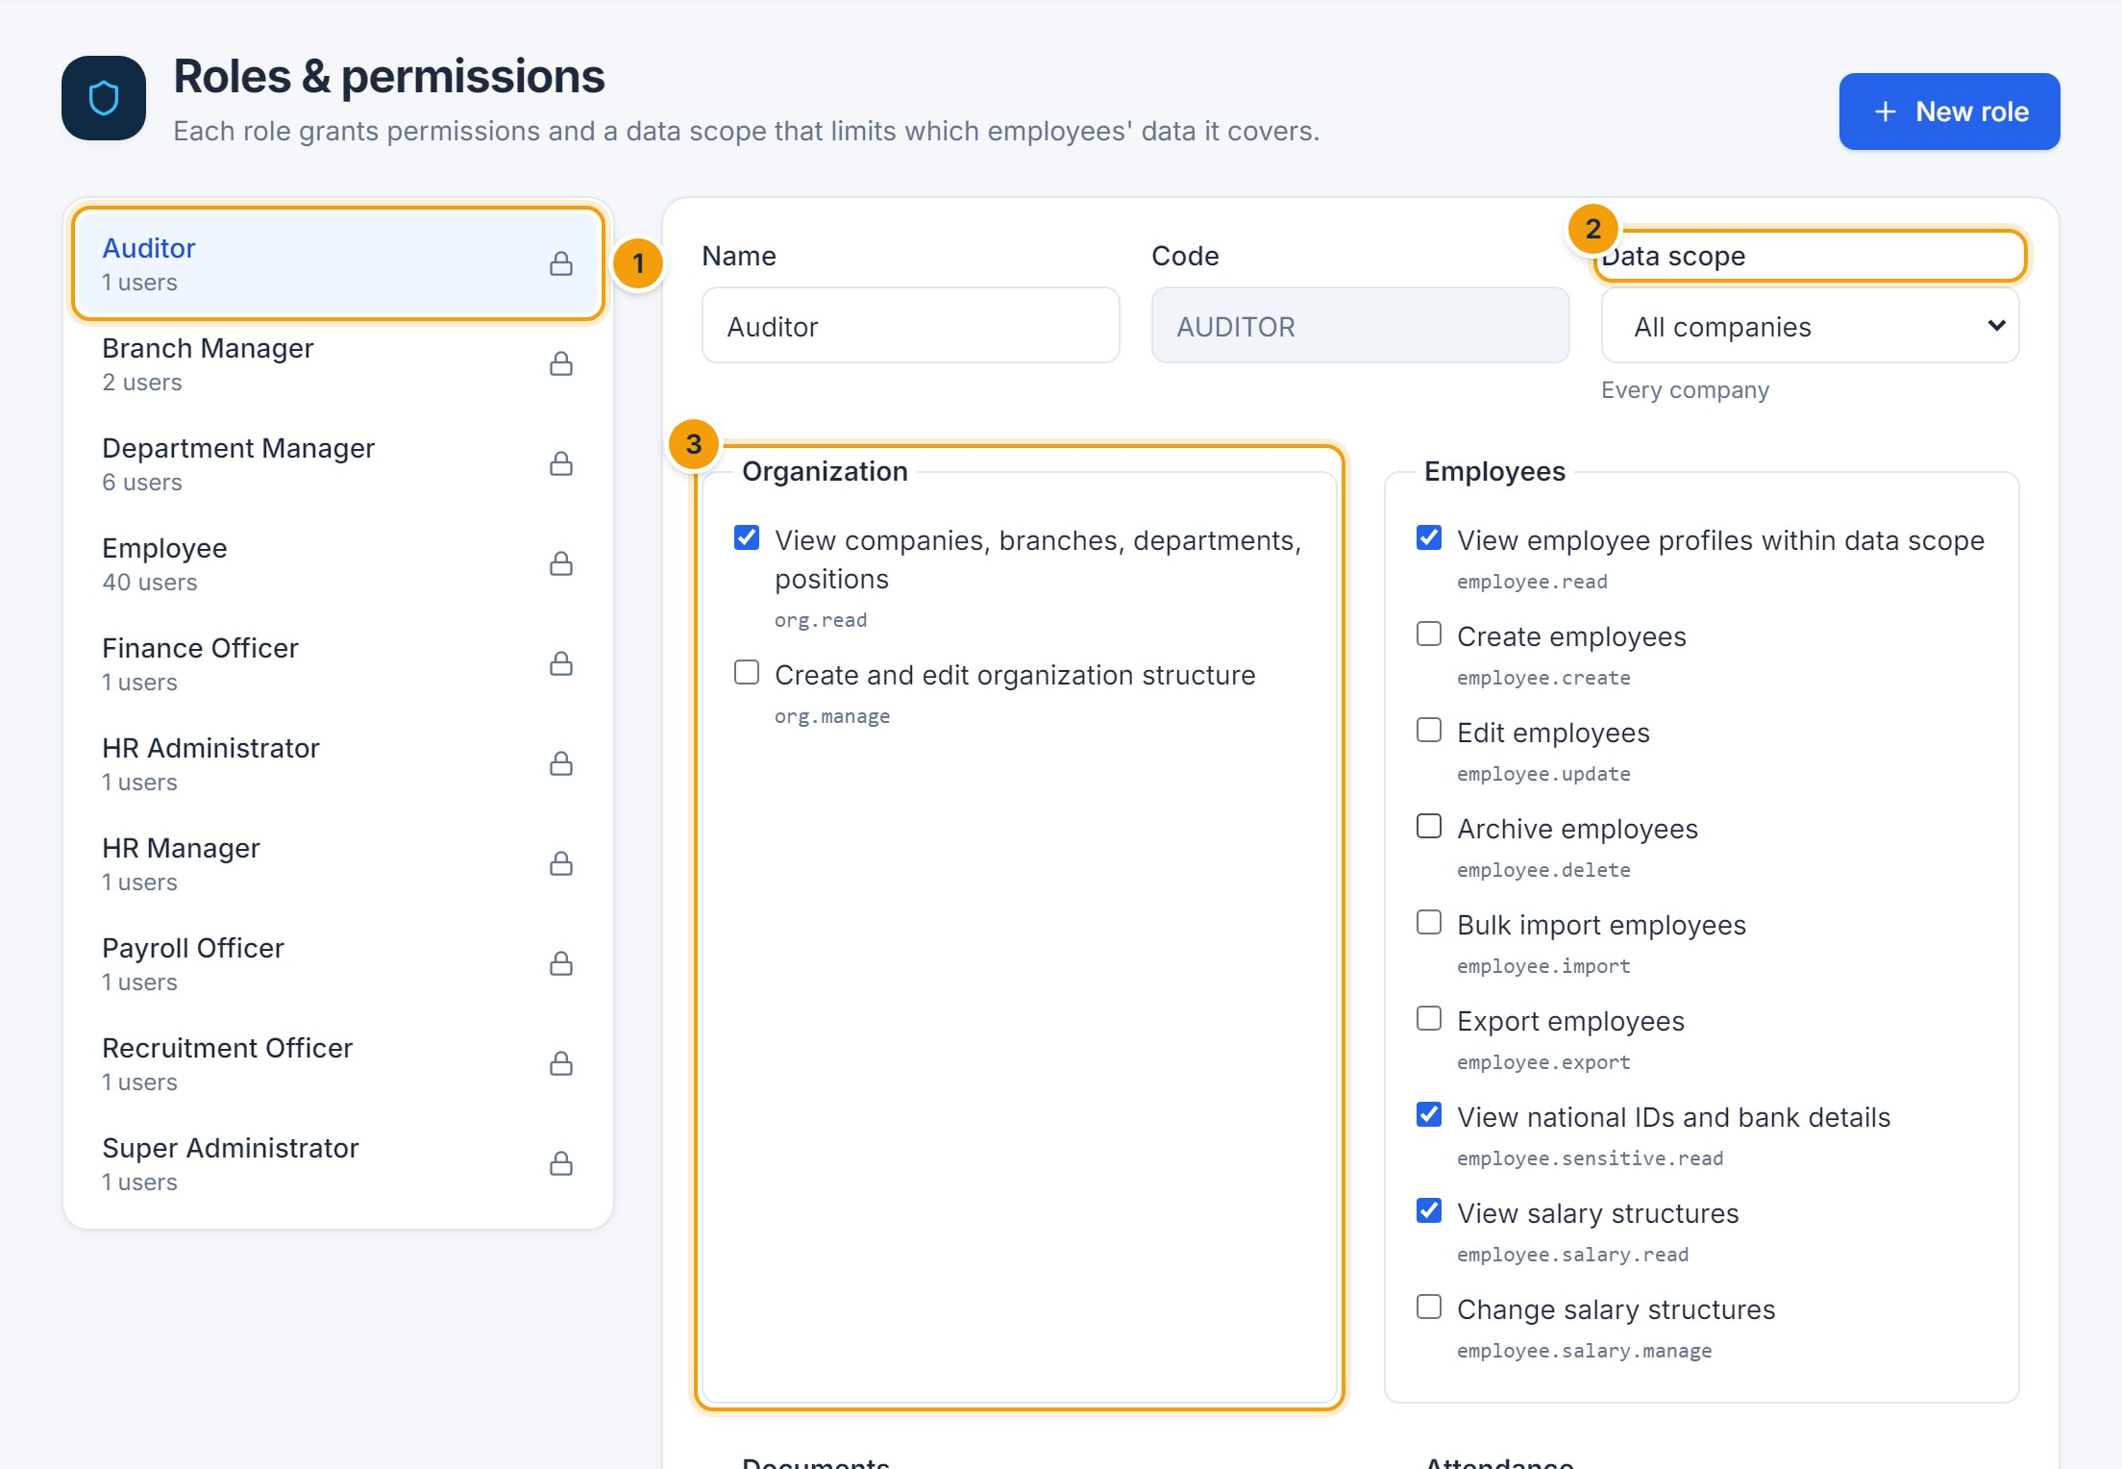
Figure 21.3 — Roles & permissions. (1) Roles, (2) data scope — which employees the role covers, (3) permissions grouped by module.
Each role combines a set of permissions with a data scope: own records only, own team, managed departments, managed branches, whole company, or all companies. Anyone with direct reports always sees their own team. The default roles are summarized below (✔ = included).
Role | Abbr. | Data scope | Responsibilities
Super Administrator | SA | All companies | Full access to every module and setting
HR Administrator | HRA | Whole company | Administers HR data, configuration and users
HR Manager | HRM | Whole company | Manages employees, attendance and leave; approves HR requests
Payroll Officer | PAY | Whole company | Prepares and calculates payroll
Recruitment Officer | REC | Whole company | Manages vacancies and converts hires into employees
Department Manager | DM | Managed departments | Manages the departments they lead
Branch Manager | BM | Managed branches | Manages the branches they lead
Finance Officer | FIN | Whole company | Reviews, approves and pays payroll
Employee | EMP | Own records | Self-service access to own records
Auditor | AUD | All companies | Read-only access to all records and audit logs
Permission matrix of the default roles (✔ = included). Administrators can change these defaults under Roles & permissions.
Permission | Type | SA | HRA | HRM | PAY | REC | DM | BM | FIN | EMP | AUD
Organization
View companies, branches, departments, positions | View | ✔ | ✔ | ✔ | ✔ | ✔ | ✔ | ✔ | ✔ | ✔ | ✔
Create and edit organization structure | Edit | ✔ | ✔
Employees
View employee profiles within data scope | View | ✔ | ✔ | ✔ | ✔ | ✔ | ✔ | ✔ | ✔ |  | ✔
Create employees | Create | ✔ | ✔ | ✔ |  | ✔
Edit employees | Edit | ✔ | ✔ | ✔
Archive employees | Delete | ✔ | ✔
Bulk import employees | Create | ✔ | ✔
Export employees | Export | ✔ | ✔ | ✔
View national IDs and bank details | View | ✔ | ✔ | ✔ | ✔ |  |  |  | ✔ |  | ✔
View salary structures | View | ✔ | ✔ | ✔ | ✔ |  |  |  | ✔ |  | ✔
Change salary structures | Edit | ✔ | ✔ |  | ✔
Documents
View employee documents | View | ✔ | ✔ | ✔ |  | ✔ |  |  |  |  | ✔
Upload and delete employee documents | Edit | ✔ | ✔ | ✔ |  | ✔
View confidential documents | View | ✔ | ✔ | ✔ |  |  |  |  |  |  | ✔
Attendance
View attendance within data scope | View | ✔ | ✔ | ✔ | ✔ |  | ✔ | ✔ |  |  | ✔
Create and edit attendance records | Edit | ✔ | ✔ | ✔
Check in/out and request corrections | Self-service | ✔ | ✔ | ✔ | ✔ | ✔ | ✔ | ✔ | ✔ | ✔
Manage shifts and assignments | Edit | ✔ | ✔ | ✔
Manage public holidays | Edit | ✔ | ✔ | ✔
Leave
View leave requests and balances within data scope | View | ✔ | ✔ | ✔ | ✔ |  | ✔ | ✔ |  |  | ✔
Submit own leave requests | Self-service | ✔ | ✔ | ✔ | ✔ | ✔ | ✔ | ✔ | ✔ | ✔
Adjust balances and apply leave on behalf of employees | Edit | ✔ | ✔ | ✔
Configure leave types and policies | Edit | ✔ | ✔ | ✔
Approvals
Act on approval tasks assigned to me | Approve | ✔ | ✔ | ✔ | ✔ | ✔ | ✔ | ✔ | ✔ | ✔
View all approval requests | View | ✔ | ✔ | ✔ |  |  |  |  |  |  | ✔
Configure approval workflows | Edit | ✔ | ✔
Payroll
View payroll runs and payslips | View | ✔ | ✔ | ✔ | ✔ |  |  |  | ✔ |  | ✔
Create, calculate and adjust payroll runs | Process | ✔ | ✔ |  | ✔
Approve payroll runs | Approve | ✔ |  |  |  |  |  |  | ✔
Mark payroll as paid and export bank files | Process | ✔ |  |  |  |  |  |  | ✔
Reopen approved payroll runs | Process | ✔ |  |  |  |  |  |  | ✔
Configure pay components and payroll rules | Edit | ✔ | ✔ |  | ✔
View own payslips | Self-service | ✔ | ✔ | ✔ | ✔ | ✔ | ✔ | ✔ | ✔ | ✔
Dashboards and reports
View the executive dashboard | View | ✔ | ✔ | ✔ | ✔ |  | ✔ | ✔ | ✔ |  | ✔
Run and export reports | View | ✔ | ✔ | ✔ | ✔ | ✔ | ✔ | ✔ | ✔ |  | ✔
Administration
Manage user accounts | Edit | ✔ | ✔
Manage roles and permissions | Edit | ✔
Manage company and system settings | Edit | ✔ | ✔
Publish announcements | Edit | ✔ | ✔ | ✔
View audit logs | View | ✔ | ✔ | ✔ |  |  |  |  |  |  | ✔

Audit log and system
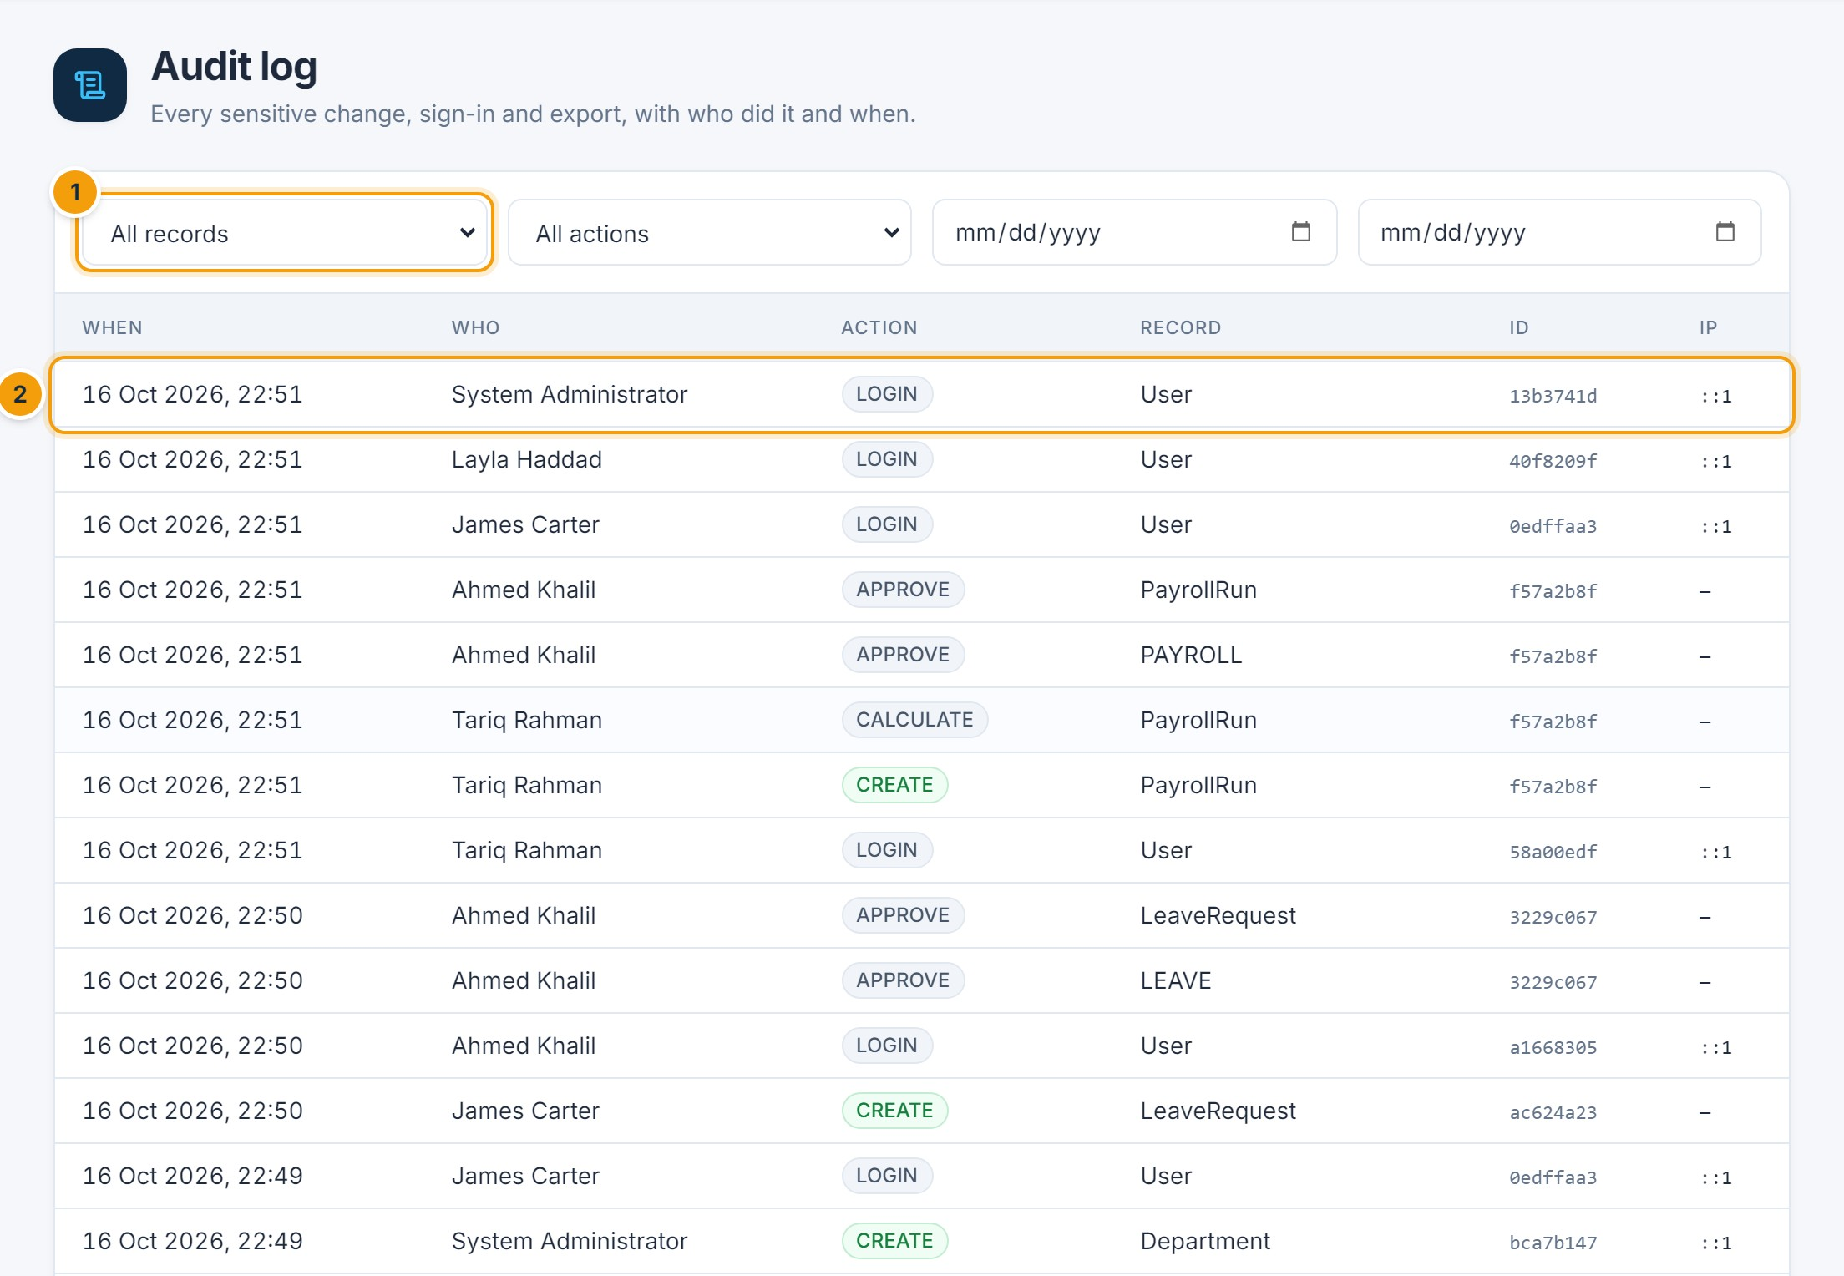
Figure 21.4 — Audit log. (1) Filter by record type, action and date, (2) click an entry to see the values before and after.
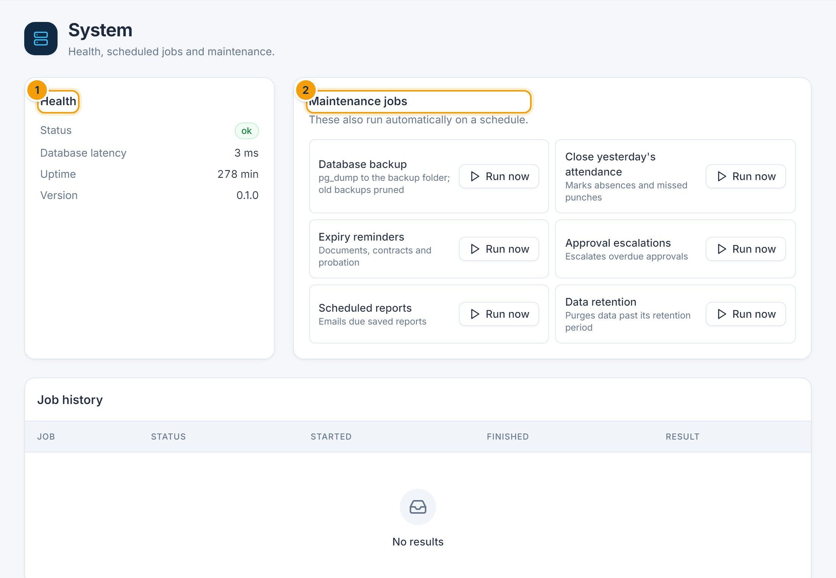
Figure 21.5 — System. (1) Health, (2) maintenance jobs such as backup, closing yesterday’s attendance and reminders, which also run automatically.
CHAPTER 22

22. Troubleshooting and Frequently Asked Questions
Use this table to resolve common issues. If the problem continues, contact the team shown, with the time, the page and the exact message.
Issue | Possible causes | What to try | Contact
Unable to sign in | Wrong email or password; account locked after 5 attempts; account inactive | Check Caps Lock; wait 15 minutes if locked | HR / system administrator (unlock or reactivate)
Forgotten password | — | There is no self-service reset | HR / system administrator (Reset password)
Lost the authenticator device | Two-step verification is on | — | System administrator (Remove two-step verification)
A menu or button is missing | Your role does not include it | Compare with Chapter 21 | HR administrator
An employee does not appear | Outside your data scope; separated (hidden by default); archived | Tick Include separated; clear filters | HR
“Some fields are invalid” or “… already in use” | Missing or invalid value, duplicate code or email | Correct the field marked in red | —
Attendance looks wrong | Missing punch, wrong shift, holiday not set | Request a correction; HR checks the shift and holidays | Line manager / HR
Leave request stays Pending | Approver away or not assigned | Check the approval path on the request | Approver, then HR
Payroll figures differ from expectations | Salary structure, unpaid leave, absences, overtime, or component settings | Open the payslip lines and the Calculation issues tab | Payroll officer
“… approved and locked” | The date is in an approved payroll period | Payroll must be reopened first | Finance officer
Not receiving emails | Email not configured, or turned off in preferences | Check Account settings → Notification preferences | System administrator
Report shows unexpected results | Filters, data scope, or period | Check dates and filters; compare with the dashboard | HR / report owner
A page does not load | Network, expired session, server unavailable | Refresh; sign in again | IT / system administrator
Save does not work | Validation error, missing permission, locked period | Read the red message at the top and under the fields | HR or the module owner

Frequently asked questions
Why can’t I approve my own request?
Approval steps never assign the requester, to keep duties separate.
Why did my leave count fewer days than the calendar shows?
Weekends and public holidays are excluded for most leave types.
Why is my payslip not visible yet?
Payslips appear only after the payroll for that month is approved.
Can I change my bank details?
No — ask HR. Bank details are restricted and encrypted.
Why does the screen show Arabic after I sign in?
Your language preference is saved to your account. Use the language switch to change it.
CHAPTER 23

23. Security and Best Practices

Your account
Figure 23.1 — Account settings. (1) Language and theme, (2) change password, (3) two-step verification, (4) active sessions.

Turn on two-step verification
- Open Account settings and click Set up two-step verification.
- Scan the QR code with an authenticator app (for example Google or Microsoft Authenticator).
- Enter the 6-digit code and click Verify and turn on.
- From now on, enter a code from the app after your password when signing in.

How the system protects data
- Role-based access: every page, action and record is checked against your role and data scope on the server.
- National IDs, bank details and two-step verification secrets are stored encrypted.
- Accounts lock for 15 minutes after five failed sign-ins.
- Approved payroll periods are locked against changes, also at database level.
- Every sensitive change, export, download and sign-in is recorded in the audit log.
- The database is backed up automatically every night.

Best practices
- Use a strong, unique password and never share it. HR will never ask for your password.
- Turn on two-step verification, especially for HR, payroll, finance and administrator accounts.
- Sign out on shared computers, and use Active sessions to sign out devices you no longer use.
- Grant users only the roles they need, and deactivate accounts promptly when people leave.
- Download exports only when necessary, store them securely and delete them when no longer needed.
- Report suspicious activity to your system administrator immediately.

