Hello, World!
Bookmark this page
Approximate topic time: 40 minutes
What is it?
Text steps.

What does it do?
Gives us the steps needed to create a simple app in Django.

Why do I need it?
These steps are mostly the same for any Django project.

Hello, World!
Topic objective: In these text-based steps, we will create a Django project and a Django app that will display simple HTML.
Follow the steps below to get up and running.
Create a new project or workspace using the appropriate template in your IDE.
TIP: If you are using our recommended IDE, ensure you use the standard template file to create your workspace.
- Creating your repo
1. Give your repo a unique descriptive name that is based on the project. I have used django-project.
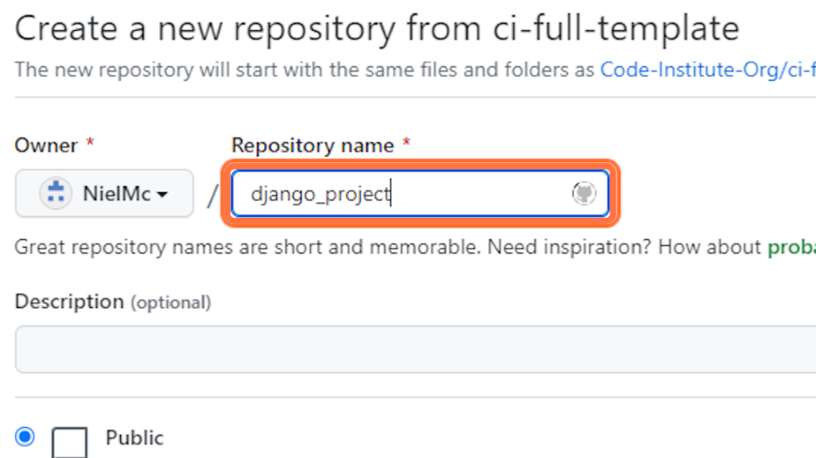

2. Click on Create repository from template.
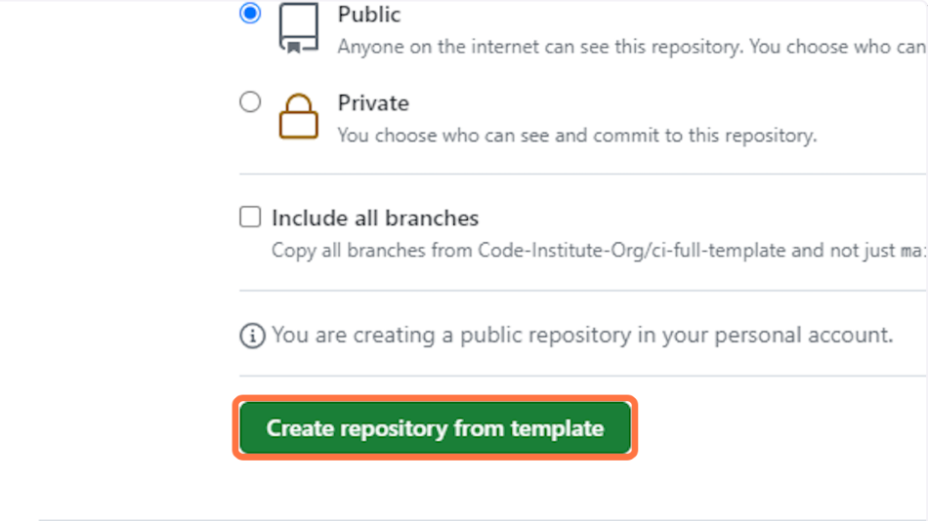

3. Open in your preferred IDE.
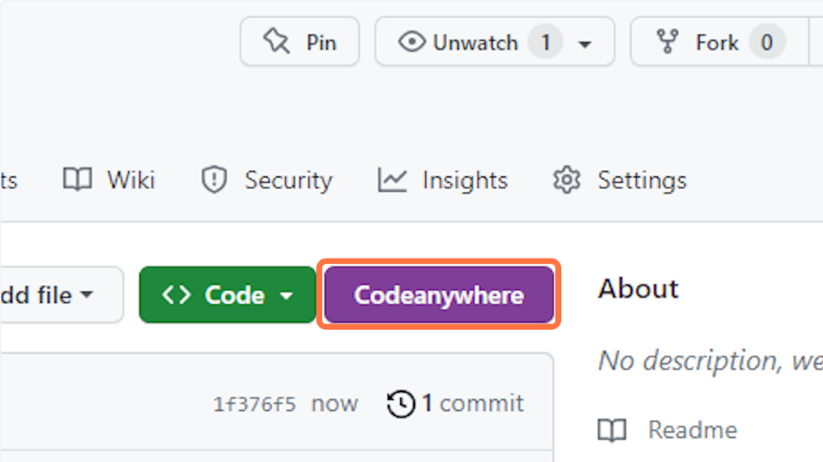

4. In the main menu, click on Terminal > New Terminal.
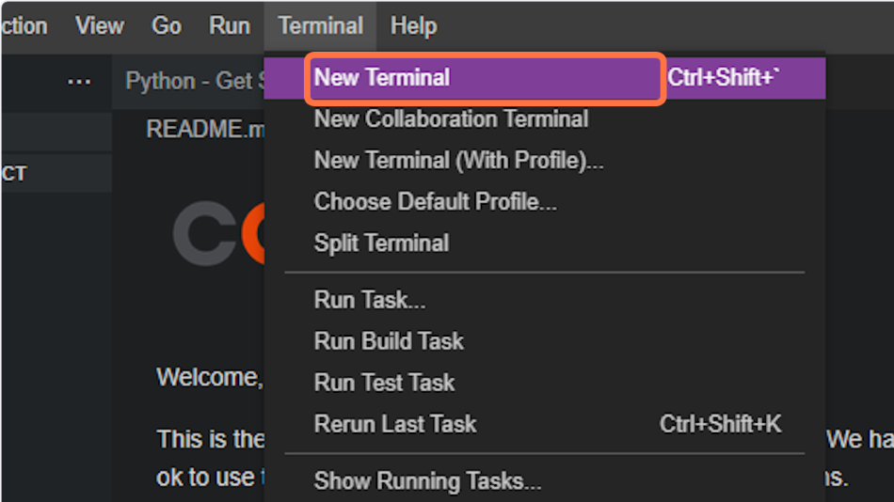

- Installing packages
5. Type the following command in the terminal to install the Django Python package:
pip3 install Django~=4.2.1
Note: ~=4.2.1 installs any package version greater than or equal to 4.2.1 but less than 4.3
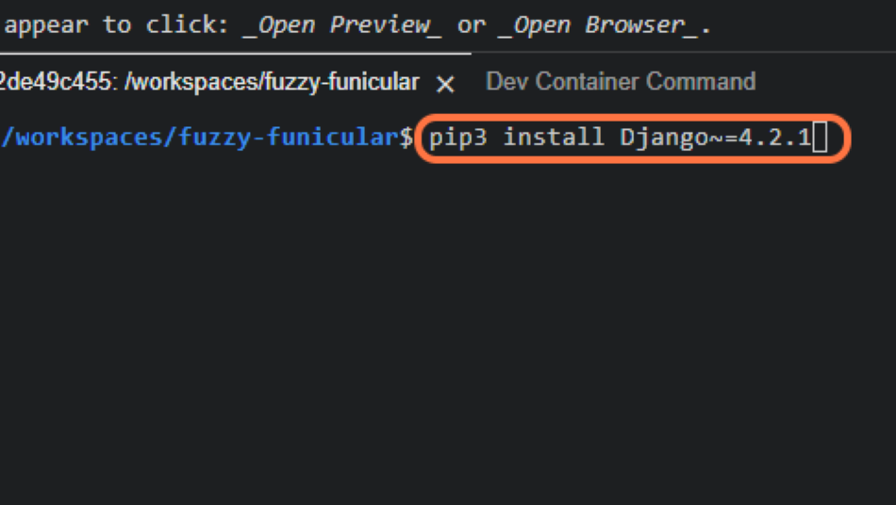

6. Once the package is installed, add it to the requirements.txt file with the following command:
pip3 freeze --local > requirements.txt
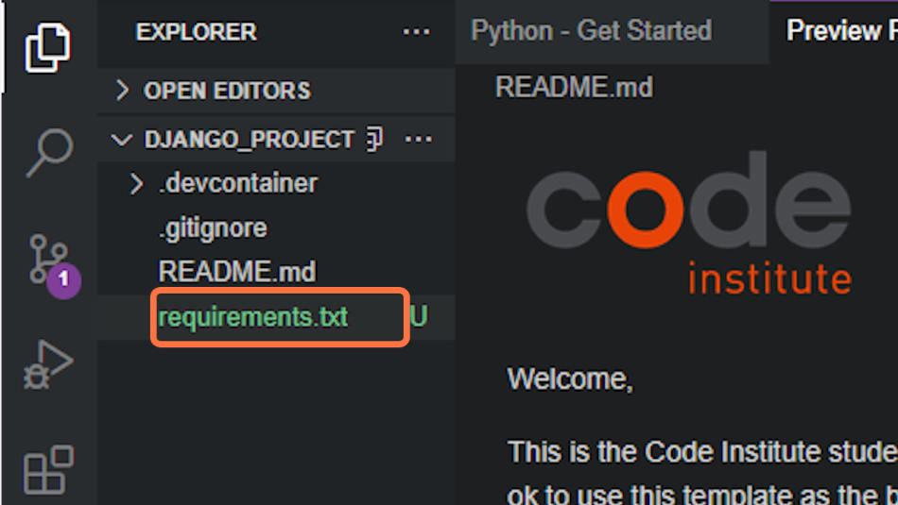

7. It's good practice to check what packages have been installed. When you look in the requirements file, you can see that three packages were installed.
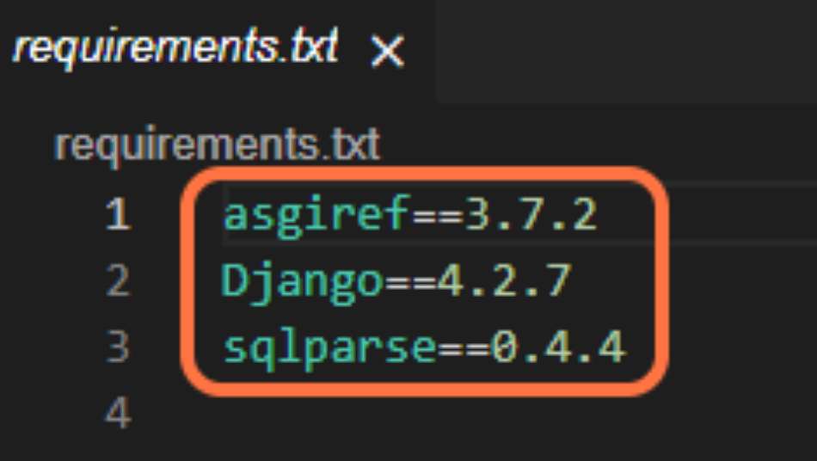

- Creating a Django project
8. Return to the terminal. In the terminal, create a Django project called my_project in the current directory.
Important: Remember that the shortcut to refer to the current directory is a single dot . at the end of the command.
django-admin startproject my_project .
Note: Check in the explorer tab to see that the my_project project structure has been created.
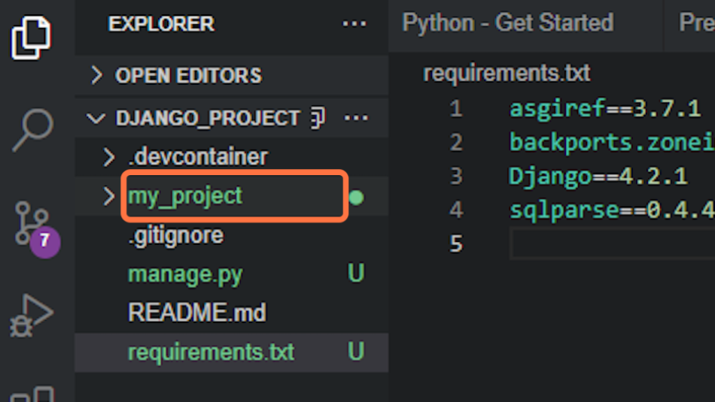

9. Return to the terminal and start the Django server with the following command:
python3 manage.py runserver
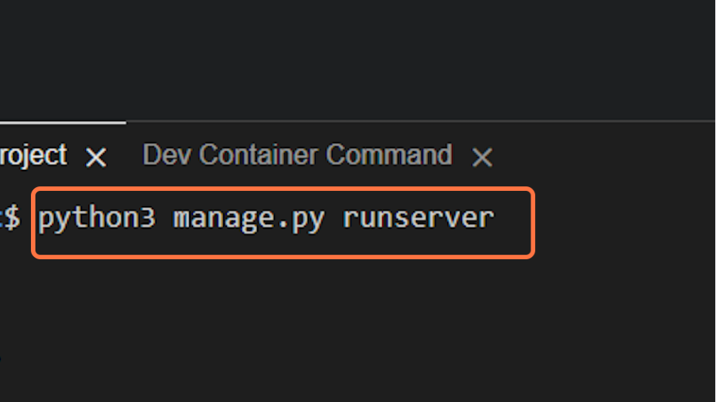

10. Click on Open Browser.
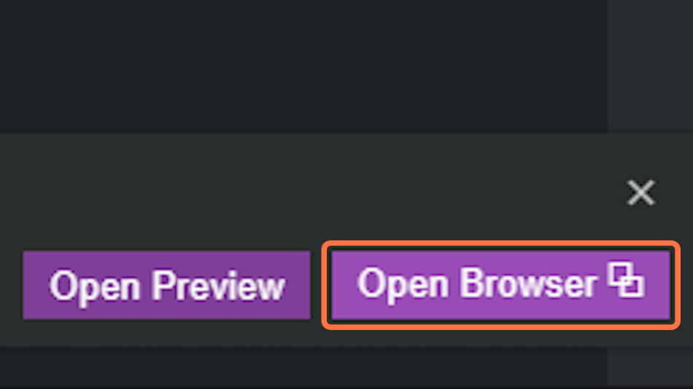

11. This opens a scary-looking yellow error screen, don't worry! Your server is running properly. This error is telling you that, for security reasons, Django doesn't recognise the hostname - the server name your project is running on.
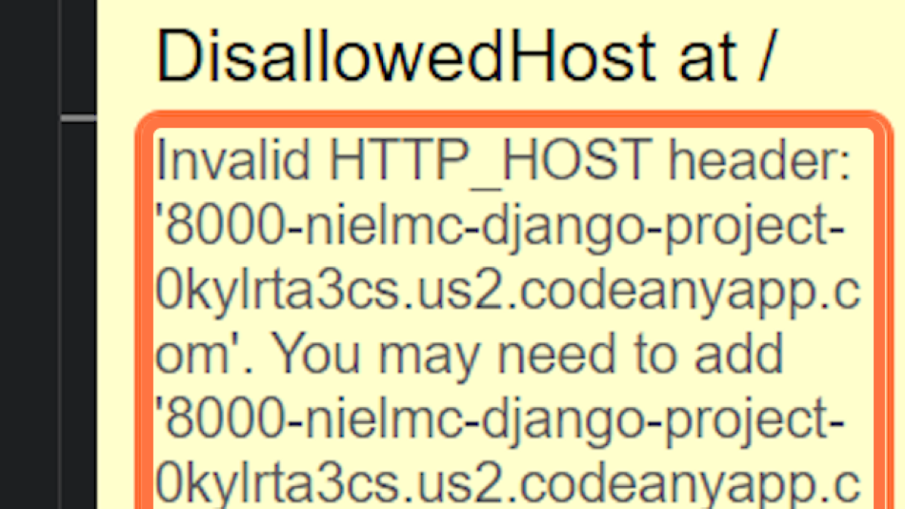

12. Select and copy the hostname after "Invalid HTTP_HOST header:". In this example, that is '8000-nielmc-django-project-0kylrta3cs.us2.codeanyapp.com' - you can include the quotes.
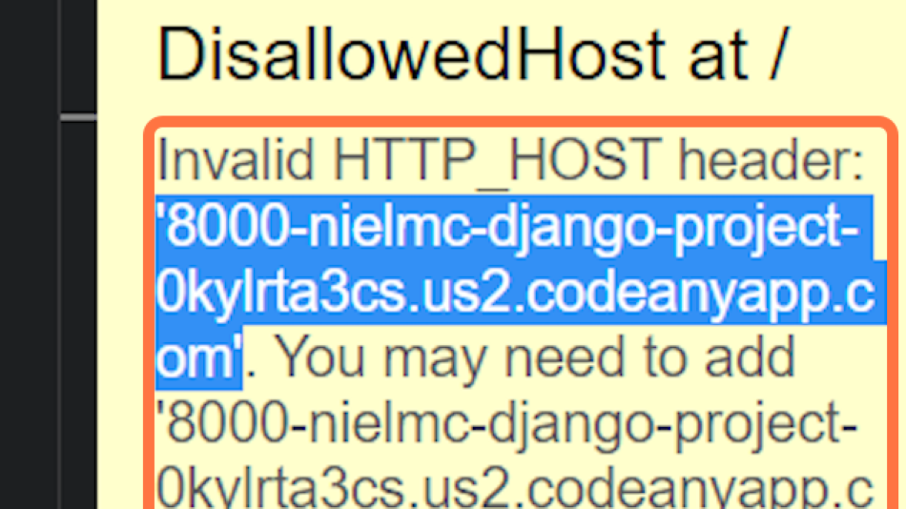

13. In the my_project/settings.py file, paste the hostname between the square brackets of ALLOWED_HOSTS and save. For the above example, this would look like:
ALLOWED_HOSTS = ['8000-nielmc-django-project-0kylrta3cs.us2.codeanyapp.com']
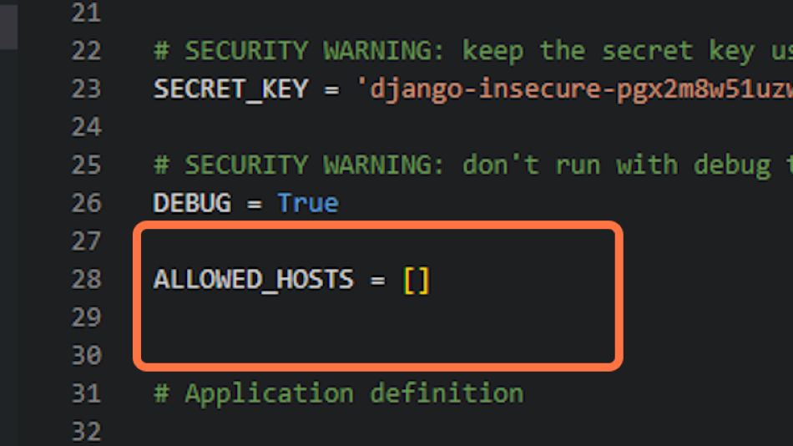

14. Now if you return to the browser tab and refresh you will see a bare-bones Django project.
Note: Return to the terminal and use ctrl-c to kill the server.
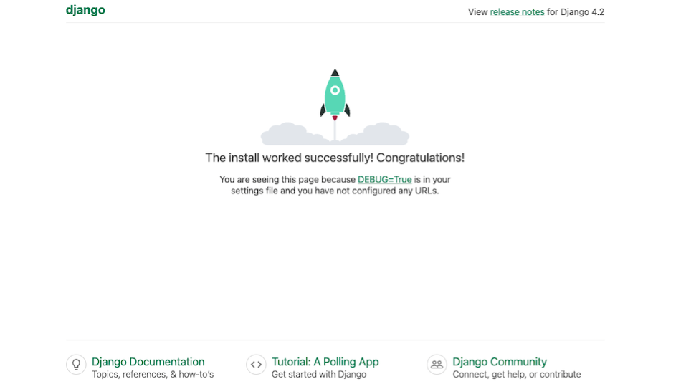

- Creating a Django app
15. Now we have a Django project created, we need to make an app. To do this, we use the manage.py file. In the terminal, type:
python3 manage.py startapp hello_world
Note: Check the explorer panel to see the new hello_world app directory has been created.
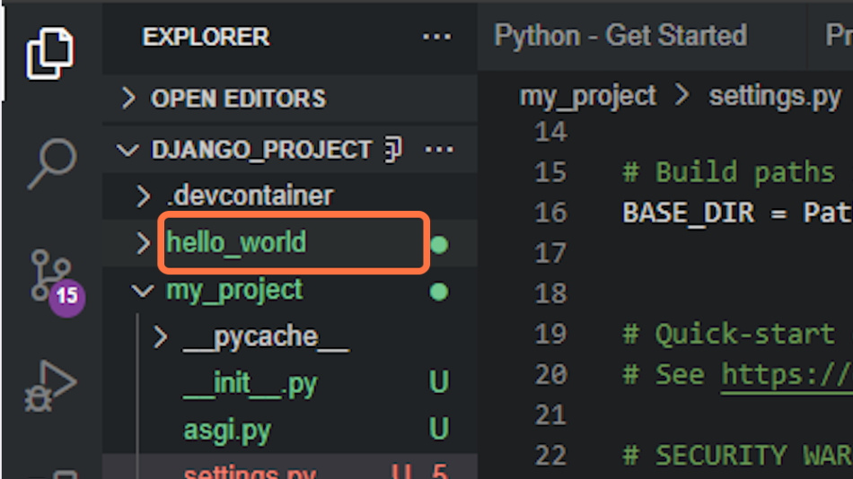

- Creating Views
16. In hello_world/views.py, below from django.shortcuts import render, type:
from django.http import HttpResponse
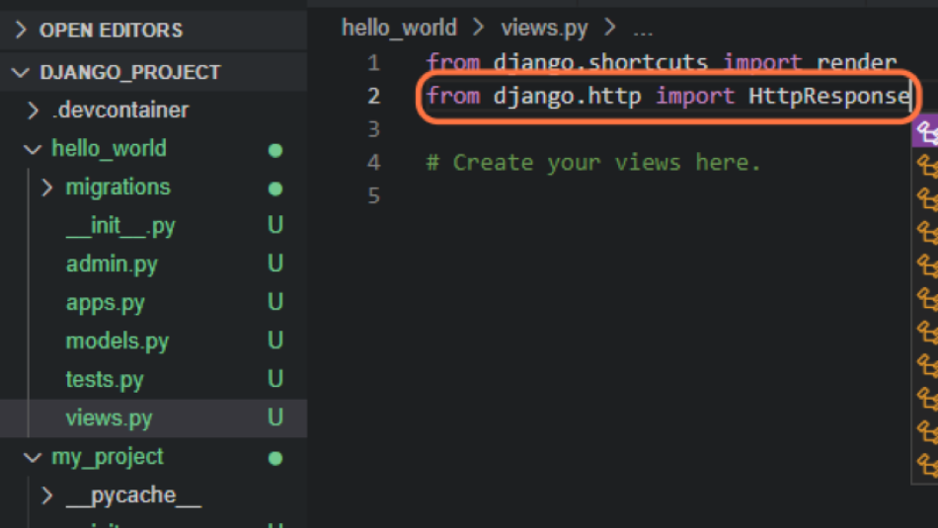

17. Below the # Create your views here. comment, create the following Python function named index. Inside the function, we are returning a simple HTTP response.
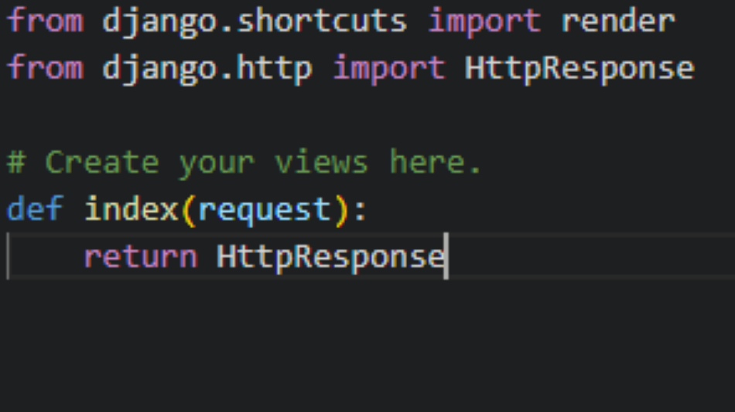

18. Within parentheses after HttpResponse add the string "Hello, world!"
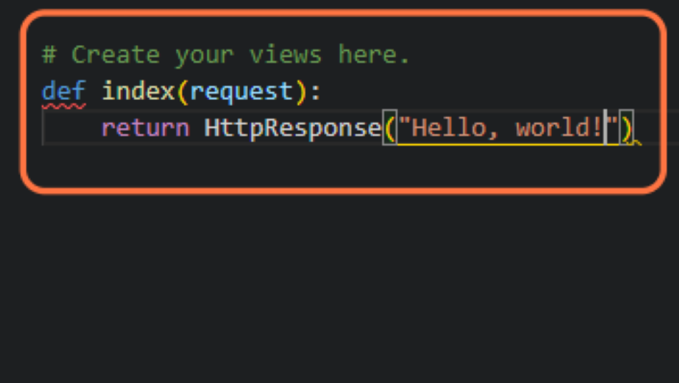

- Creating our URLs
19. In my_project/urls.py, You'll see that this urls.py file already has some content in it. That's fine, we will need that in future. Let's include the view we just created.
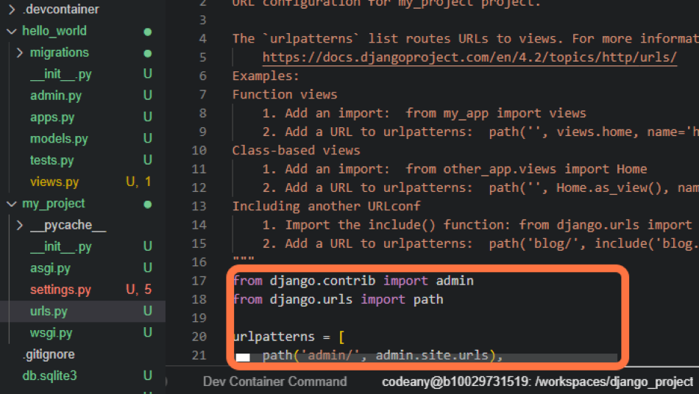

20. Import the include function by appending it after a comma to the existing django.urls import.
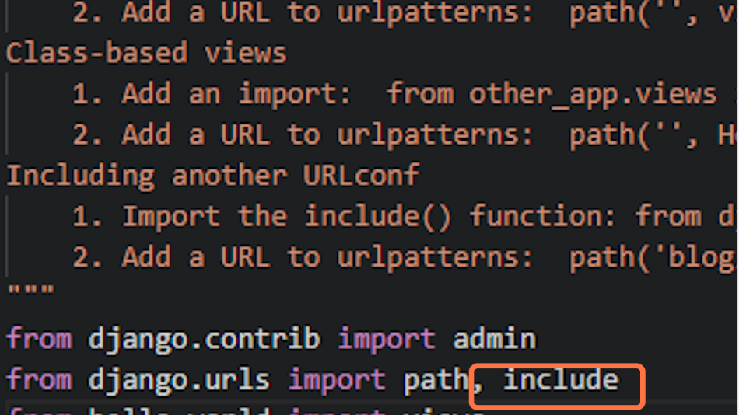

21. Below that, import the views from the hello_world app.
from hello_world import views as index_views
Here we are giving the hello_world/views.py file an alias of index_views. In a one-app project, this would not be strictly necessary. However, in a multiple-app project using descriptive alias names makes your urls.py file much easier to read and maintain.
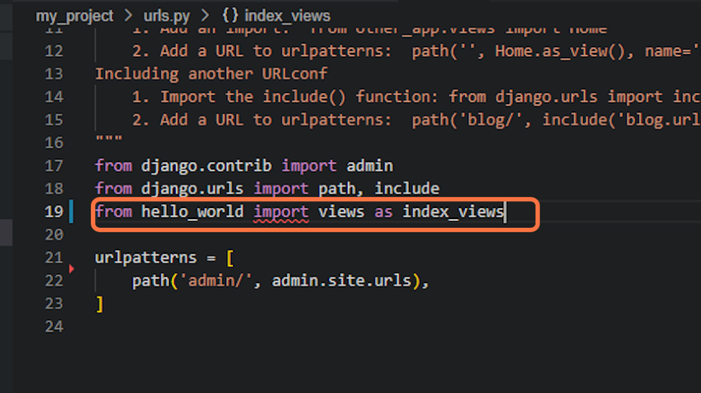

22. Above the admin pattern in urlpatterns add:
path('', index_views.index, name='index'),
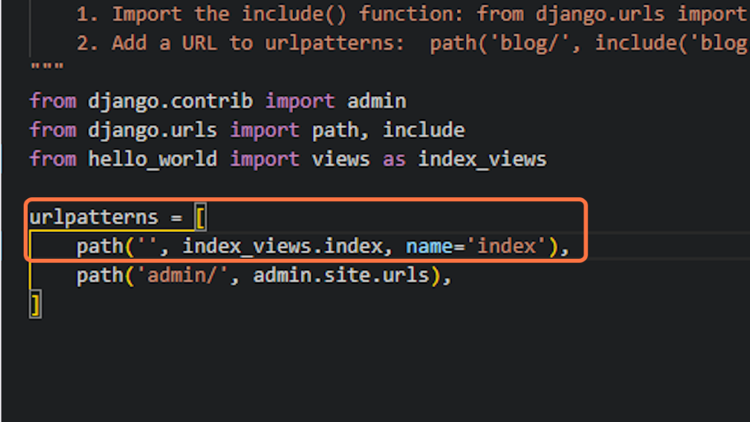

- settings.py
23. Finally, we just need to add our app to the settings.py file to connect the app to the project. For our simple app, this is not strictly necessary, but it's good practice and will be required later on when app models are connecting to databases.
To connect the app you will need to scroll down through the my_project/settings.py file to find the INSTALLED_APPS list.
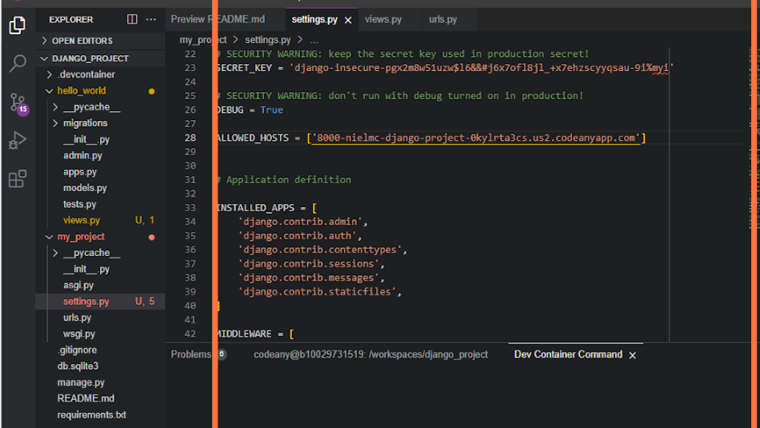

24. Append 'hello_world', to the end of the list of INSTALLED_APPS.
Note: Don't forget the comma at the end.
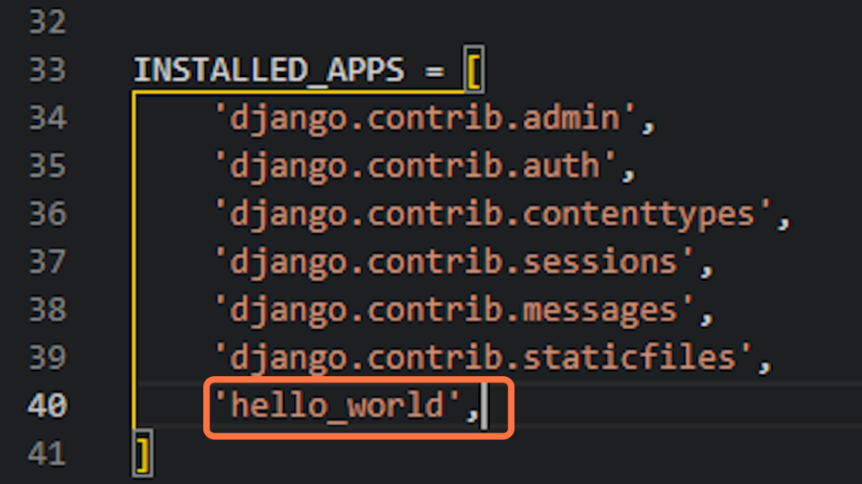

- Testing our app
25. Always make sure to always save all your files before running the project. You can also take this opportunity to git add, commit and push your work.
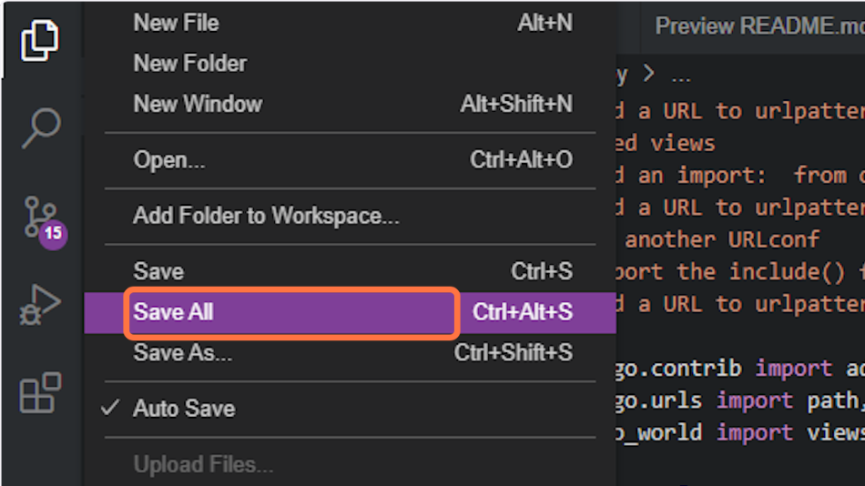

26. Open a browser window by returning to the terminal tab and running the Django server with the same command as you did previously, and now you can see the text Hello, world! In the browser.
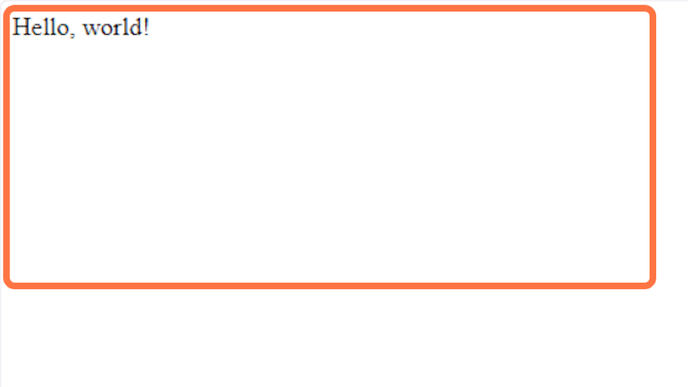
Deploying to Heroku
Bookmark this page
Approximate topic time: 40 minutes
What is it?
Text steps.

What does it do?
Gives us the steps needed to deploy a simple app in Django.

Why do I need it?
These steps are mostly the same for any Django deployment.

Deploying to Heroku
In these text-based steps, we will:
- Deploy our simple Hello, World Django project to Heroku.
Note: These text steps assume you have a verified Heroku account and an eco dynos plan subscription through your Student Developer Pack.
- Create the Heroku app
1. Navigate to your Heroku dashboard and create a new app with a unique name.
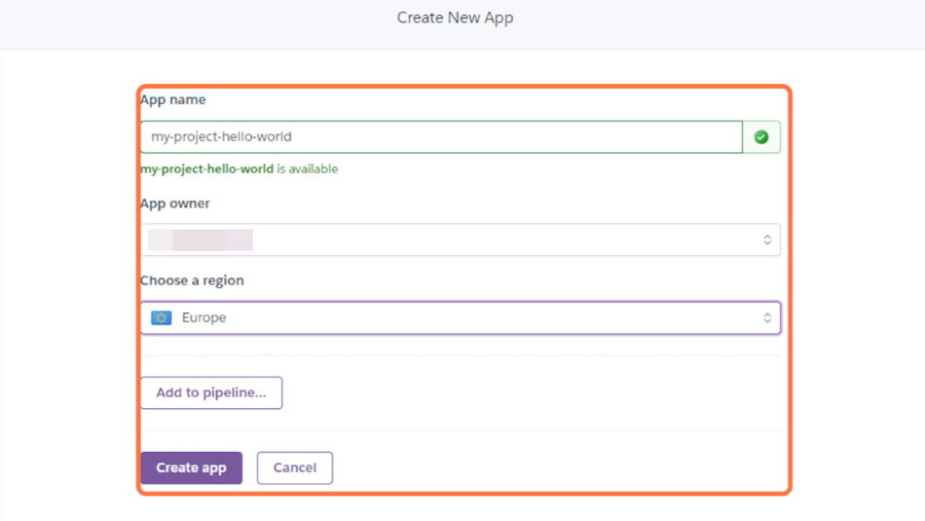

2. Click on the Settings tab and reveal the config vars. Add a key of DISABLE_COLLECTSTATIC and a value of 1 and click Add.
This step prevents Heroku from uploading static files, such as CSS and JS, during the build. We will explain this in more detail later when we have written some HTML for the project.
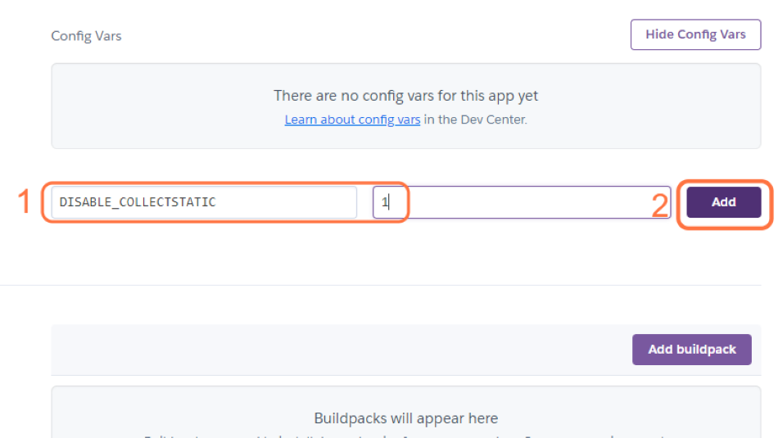

- Update your code for deployment
3. Install a production-ready webserver for Heroku.
pip3 install gunicorn~=20.1
Add gunicorn==20.1.0 to the requirements.txt file with:
pip3 freeze --local > requirements.txt
Note: gunicorn is a production equivalent of the manage.py runserver used in development but with speed and security optimisation.
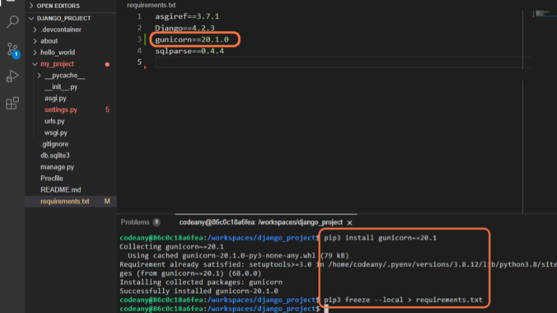

4. Create a file named Procfile at the root directory of the project (same directory as requirements.txt).
Note: The Procfile has no file extension.
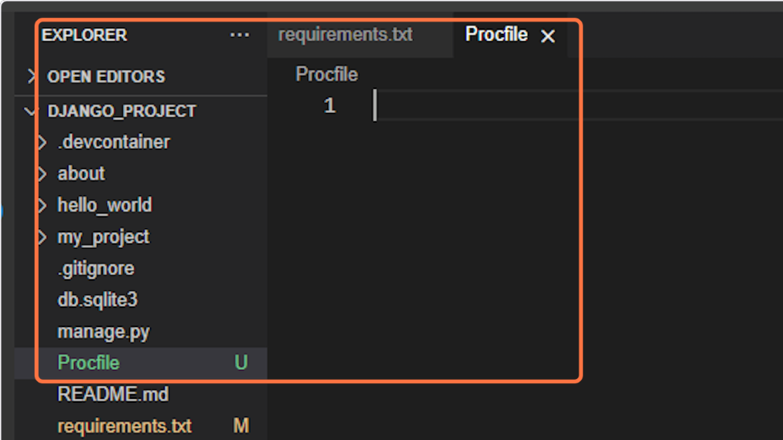

5. In the Procfile, declare this is a web process followed by the command to execute your Django project.
web: gunicorn my_project.wsgi
This assumes your project is named my_project.
Note the space after the colon.
Note: gunicorn my_project.wsgi is the command heroku will use to start the server. It works similarly to python3 manage.py runserver.
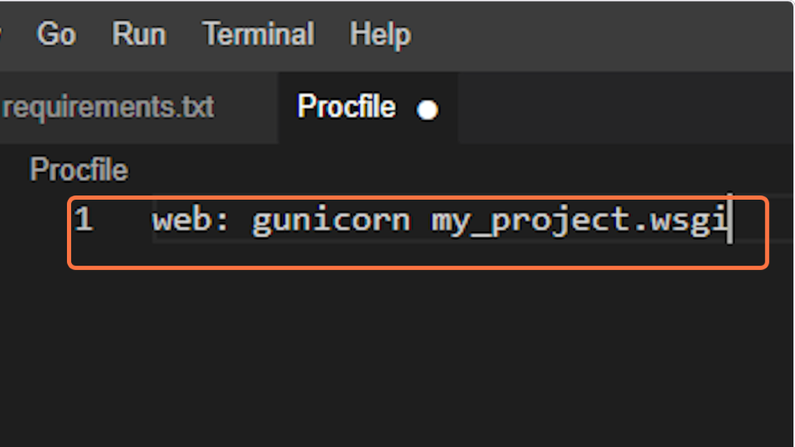

6. Open the my_project/settings.py file and replace DEBUG=True with DEBUG=False.
Note the comment regarding security in production.
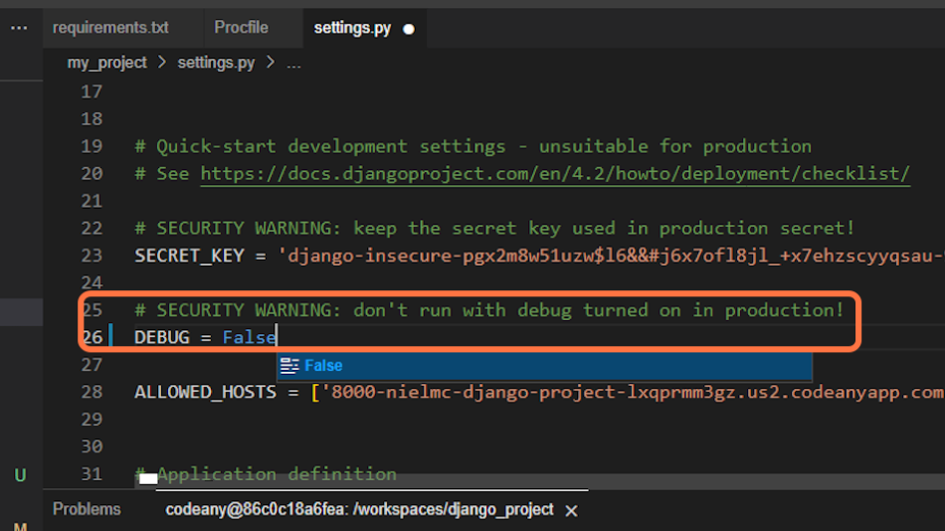

7. Also, in settings.py we need to append the Heroku hostname to the ALLOWED_HOSTS list, in addition to the local host we added in the last lesson.
,'.herokuapp.com'
Note: Remember the comma and the dot before herokuapp.
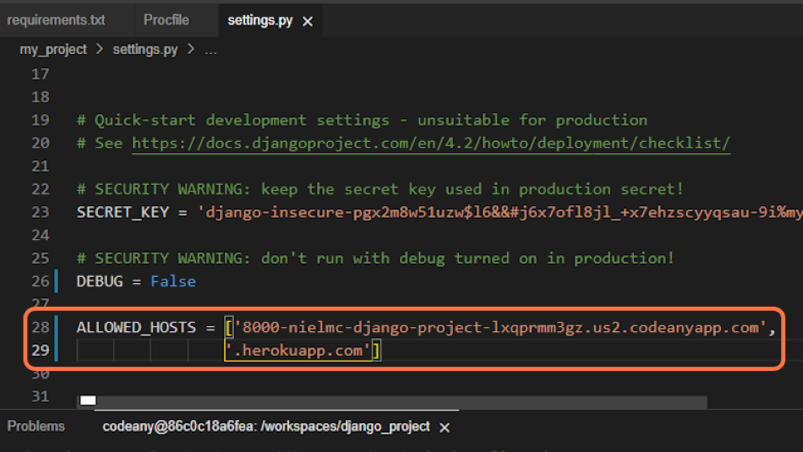

8. You can now git add the files you have modified, git commit them and push them to GitHub.
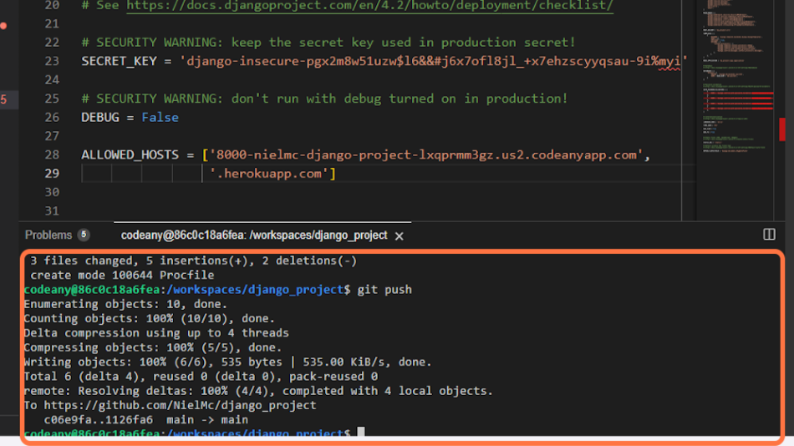

- Deploy on Heroku
9. Now, let's return to the Heroku dashboard, and in your app, click on the Deploy tab.
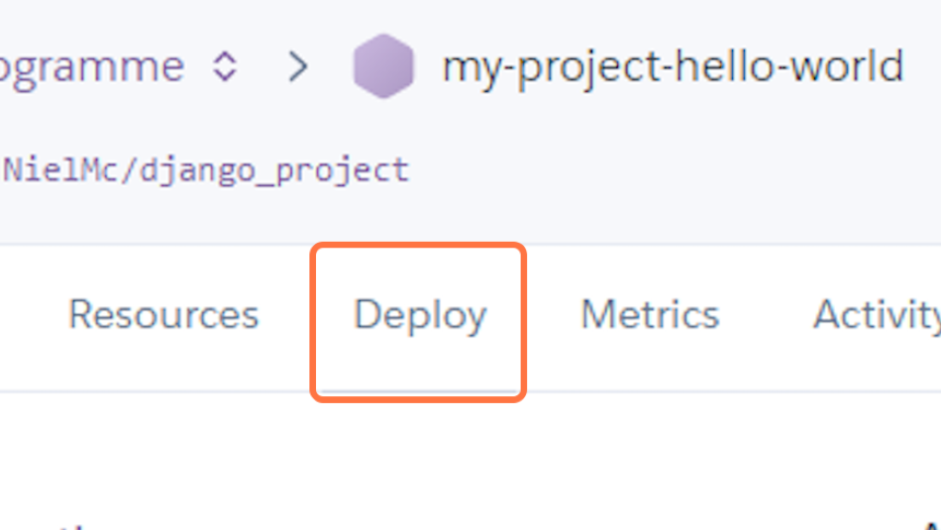

10. In the Deployment method section enable GitHub integration by clicking on Connect to GitHub.
If you have not deployed a project from GitHub before then, you will be asked to authenticate with GitHub.
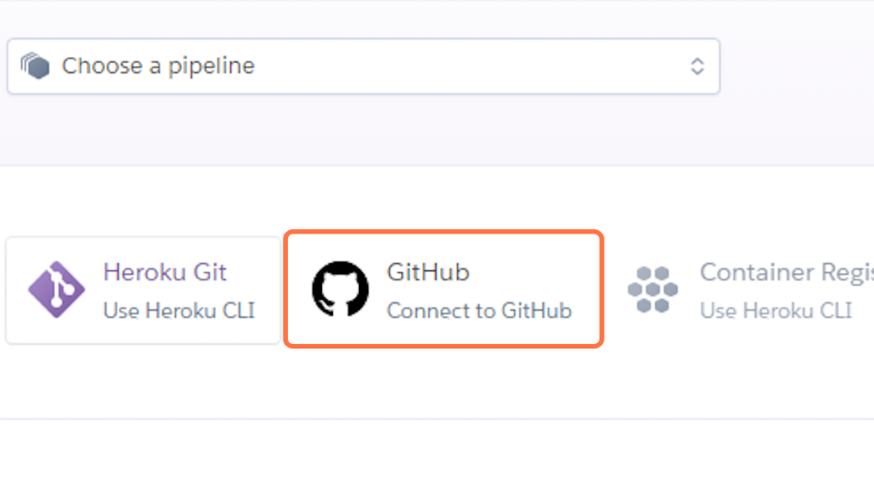

11. Start typing your project repo name into the search box and click Search. A list of repositories from your GitHub account should appear. Click on the GitHub repo you want to deploy from.
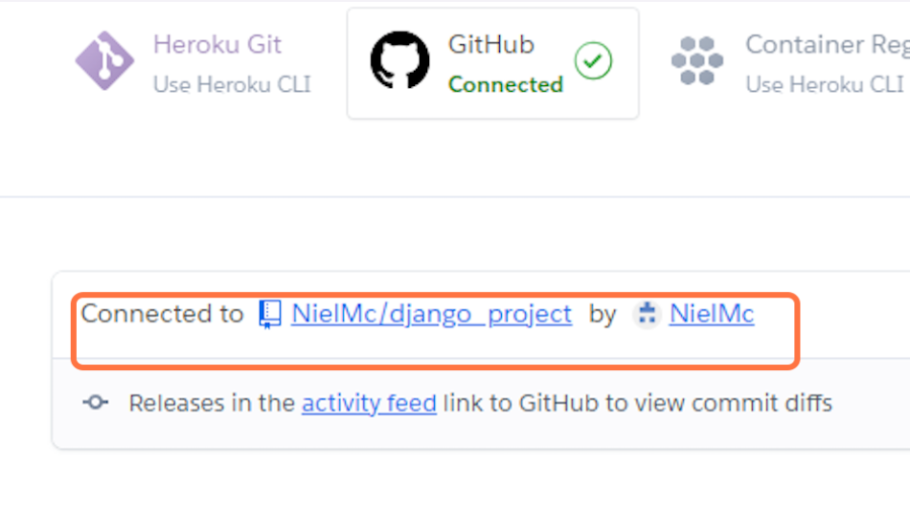

12. Scroll to the bottom of the page and click Deploy Branch to start a manual deployment of the main branch.
You can view the build output in the application's Activity tab in the dashboard.
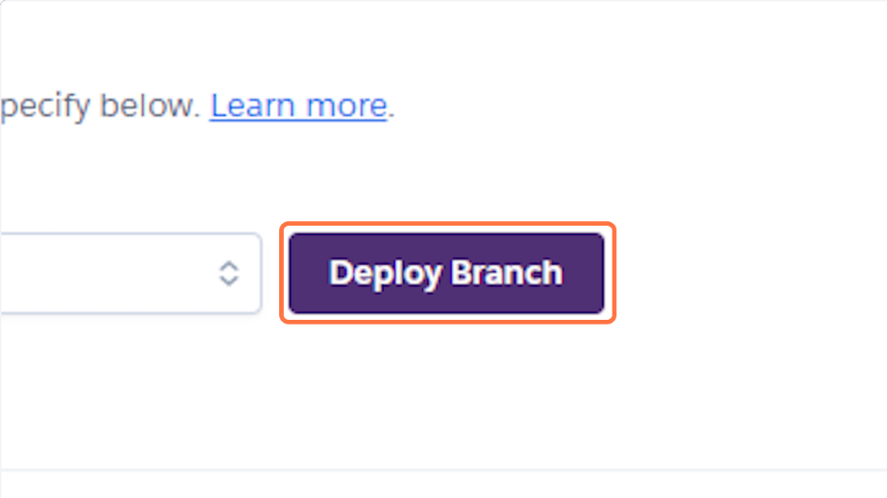

13. Click on Open app to view your deployed project.
Note: You will have to append /hello to the browser URL just as you did locally to see your view output.
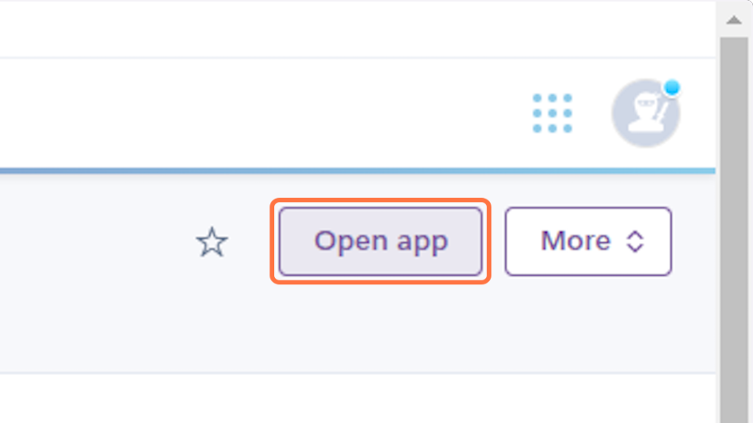

14. Open the Resources tab and choose an eco dyno. This dyno is a lightweight container to run your project.
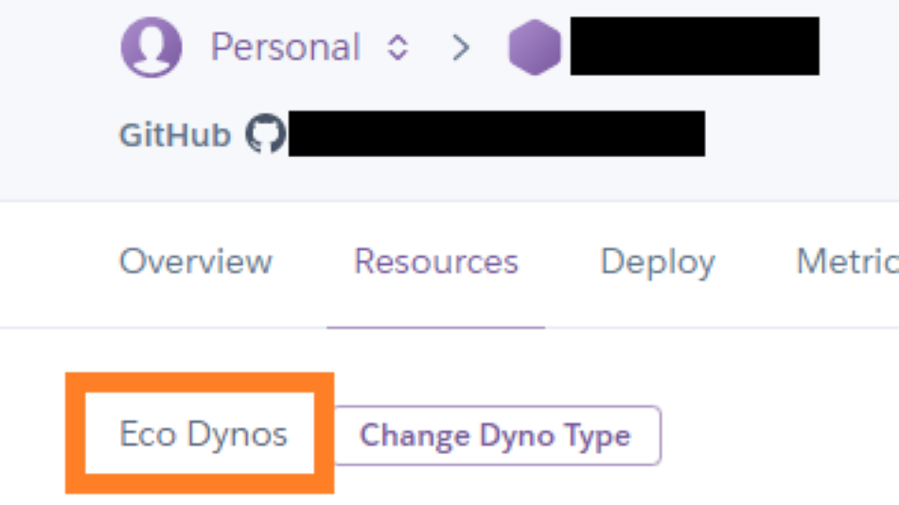

15. Open the Resources tab and verify there is no existing Postgres database add-on. If there is one you can destroy it. Hello, World does not use a database and if not destroyed can result in usage costs. If there is a database add-on select Delete Add-on to remove it.
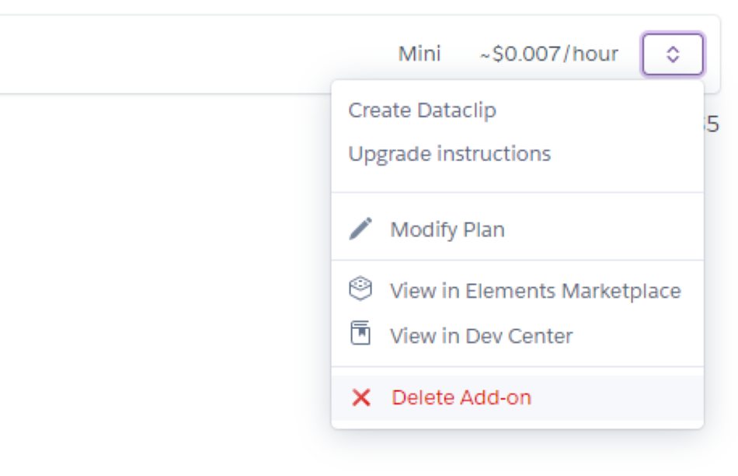

16. Click on Open app to view your deployed project.
Note: You will have to append /hello to the browser URL just as you did locally to see your view output.


- Using the cheat sheet
17. While you must take your own notes as you continue through this course, we also understand that there are a lot of different terminal commands to remember which are not captured by your finished code.
As a result, we've created a cheat sheet for easy reference. However, be sure only to use them once covered in the course material.
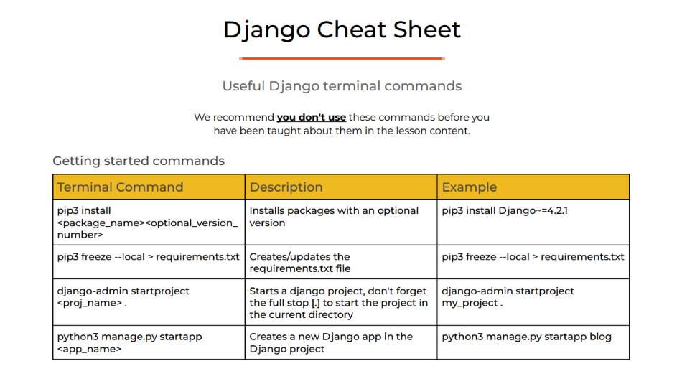

Creating the database
Bookmark this page
Approximate topic time: 40 minutes
What is it?
An organised collection of structured information.

What does it do?
Stores data electronically.

Why do I need it?
To store your user and blog data.

Creating the database
In these text-based steps, we will create an instance of a cloud-based PostgreSQL database and connect it to our project.
Follow the steps below to get up and running.
- Create PostgreSQL instance
1. Navigate to PostgreSQL from Code Institute.
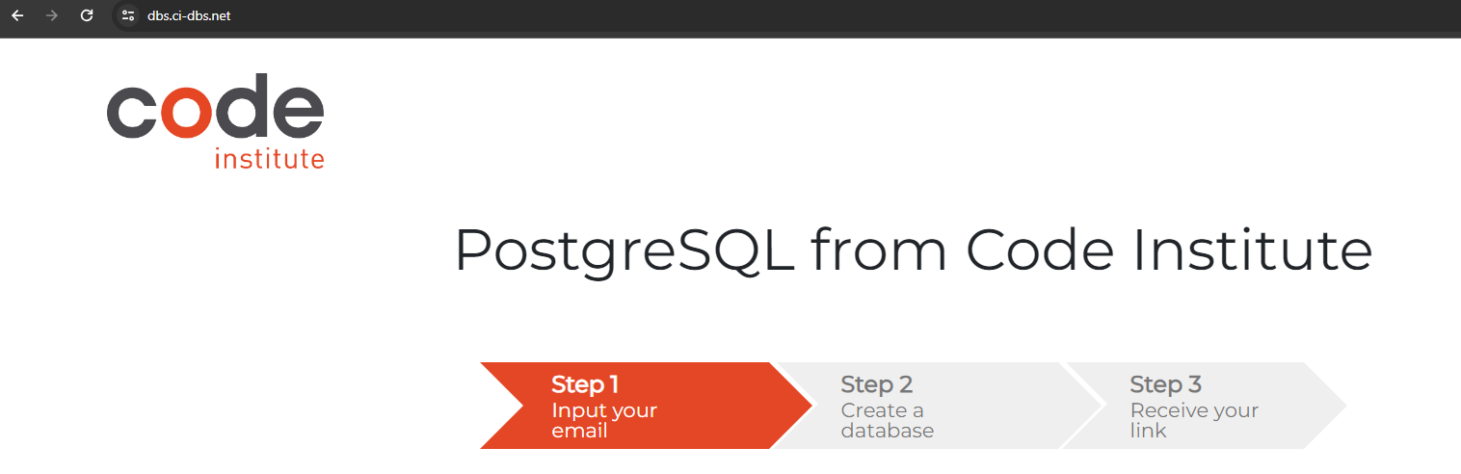

2. Enter your student email address in the input field provided.
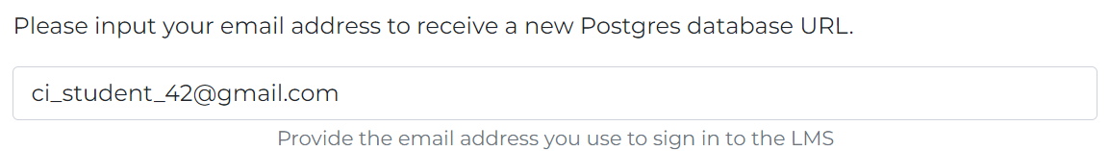

3. Click Submit.

4. Wait while the database is created.
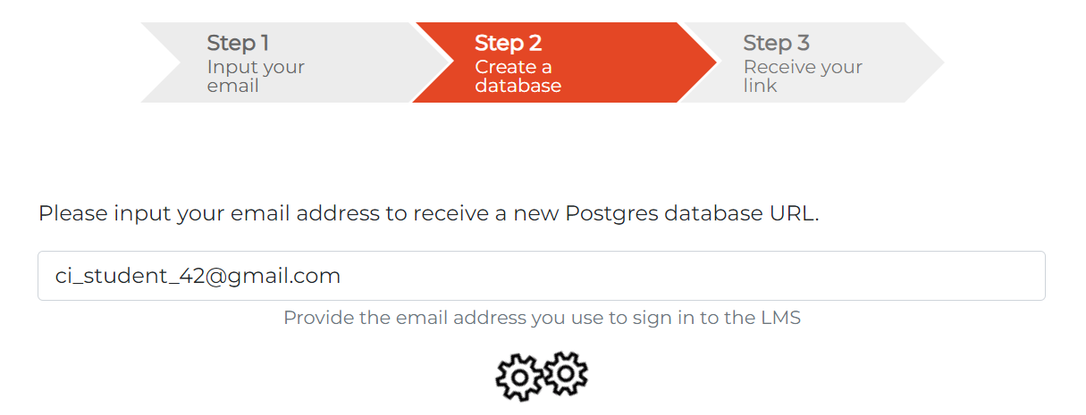

5. Your database is successfully created! Please review the email sent to your student email inbox.
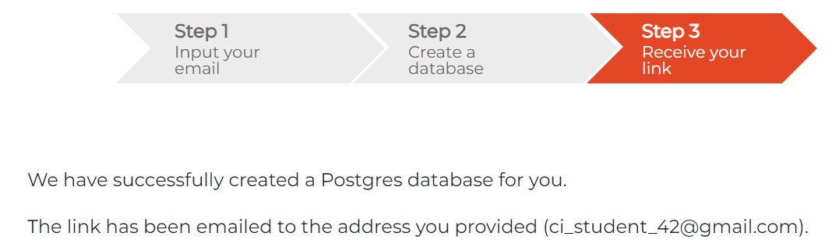

- Connect database to code
6. Return to your workspace and open the codestar/settings.py file. Change the value of DEBUG back to True as this will ensure that you get detailed errors to ease debugging during development.
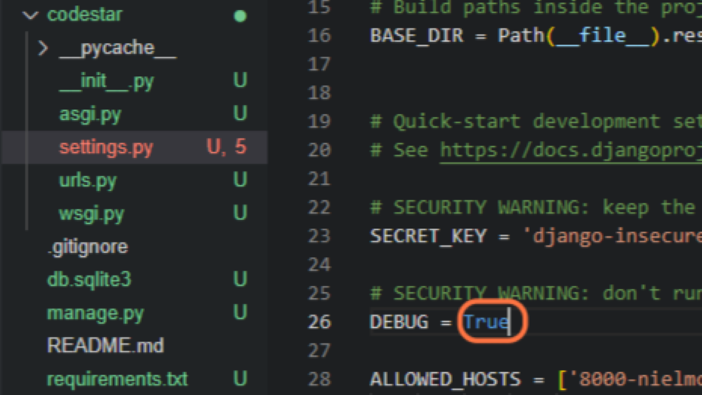

7. Create a file named env.py at the top level of the project. You can either create a new file in the file structure or use the terminal command as shown.
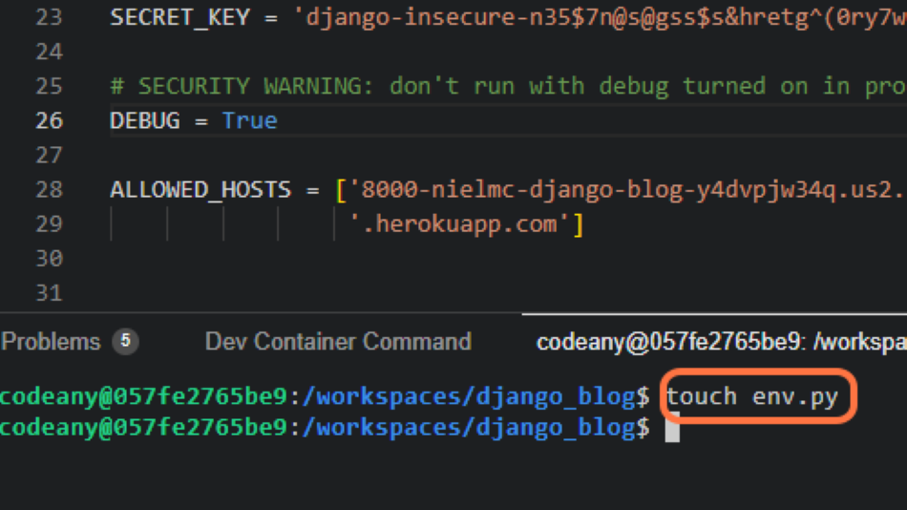

8. Open the .gitignore file and add env.py to prevent the secret data you will add to it from being pushed to GitHub.
Note: If you have used a codeinstitute template then it will be there already.
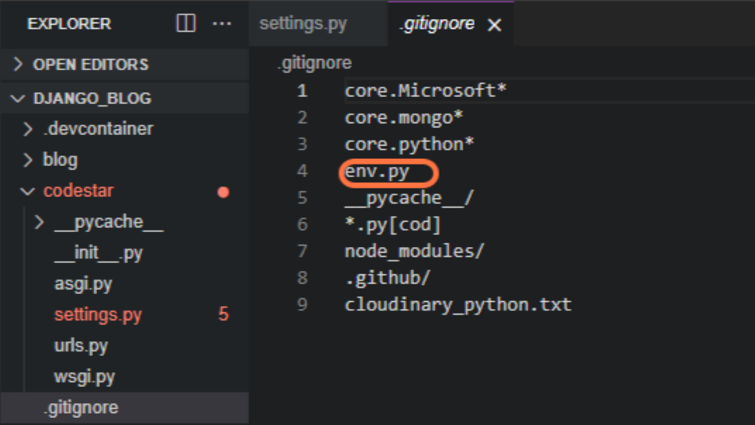

9. In your newly created env.py file, import Python's operating system module and use it to set the value of the DATABASE_URL constant to the URL in the email you received from PostgreSQL from Code Institute.
import os

os.environ.setdefault(
"DATABASE_URL", "<your-database-URL>")
Note: Remember the quotes around the constant and your URL as the setdefault() method expects string values as parameters.
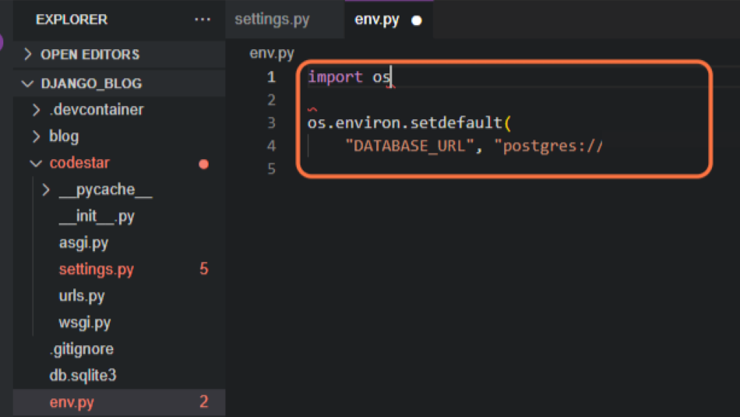

10. Pip install the two packages required to connect to your PostgreSQL database. Then add them to the requirements file:
pip3 install dj-database-url~=0.5 psycopg2~=2.9
pip3 freeze --local > requirements.txt
Note: psycopg2 is a driver for interacting with PostgreSQL databases using Python. The dj-database-url Python package is a utility to connect Django to a database using a URL.
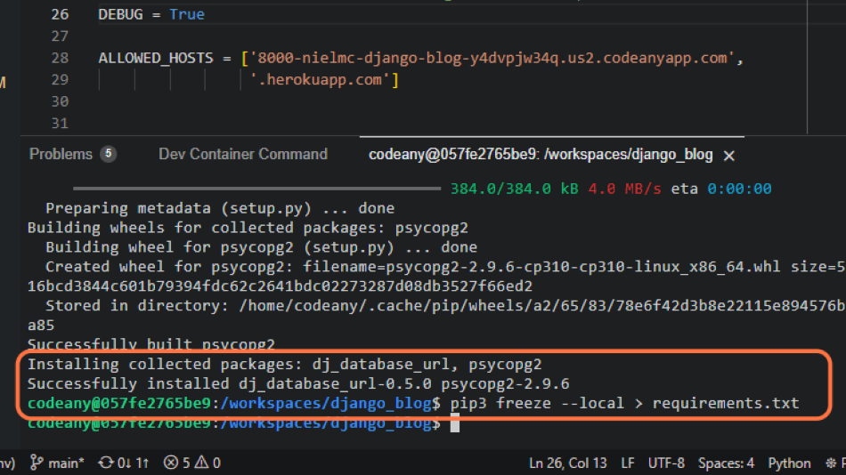

11. In codestar/settings.py, import the appropriate packages (Note: You will use dj_database_url in a later step). Now we connect the settings.py file to the env.py file:
import os
import dj_database_url
if os.path.isfile('env.py'):
import env
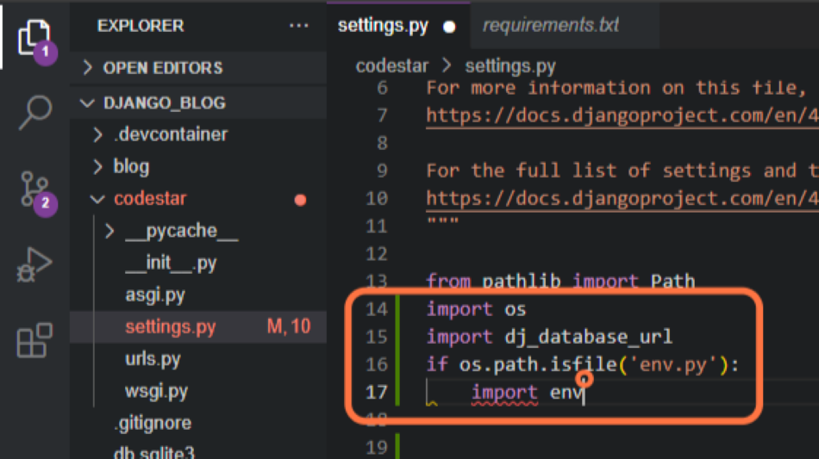

12. Next in the settings.py file, we need to comment out the local sqlite3 database connection.
Note: Django provides this local sqlite3 database by default for development, but we are going to go with a production-ready PostgreSQL cloud database instead.
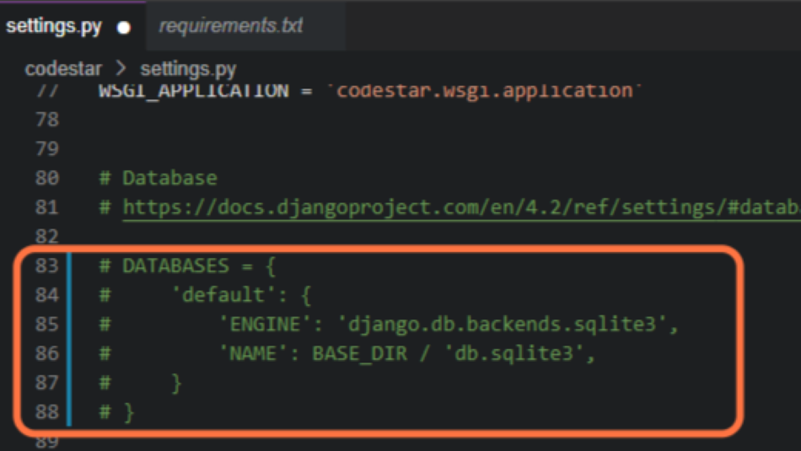

13. Then, in the settings.py file, connect to the environment variable DATABASE_URL you previously added to the env.py file:
DATABASES = {
'default': dj_database_url.parse(os.environ.get("DATABASE_URL"))
}
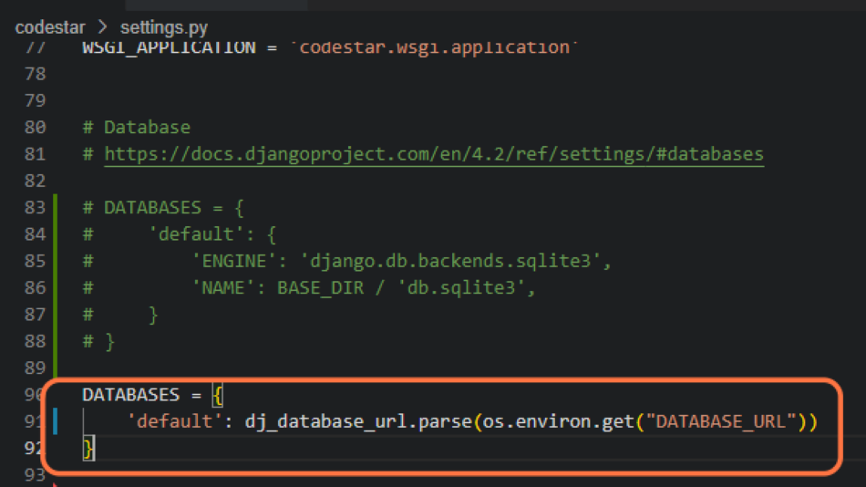

14. Now that your project is connected to the database, you can create database tables with Django's migrate command:
python3 manage.py migrate
Note: These tables are for data generated by the existing apps built into Django.
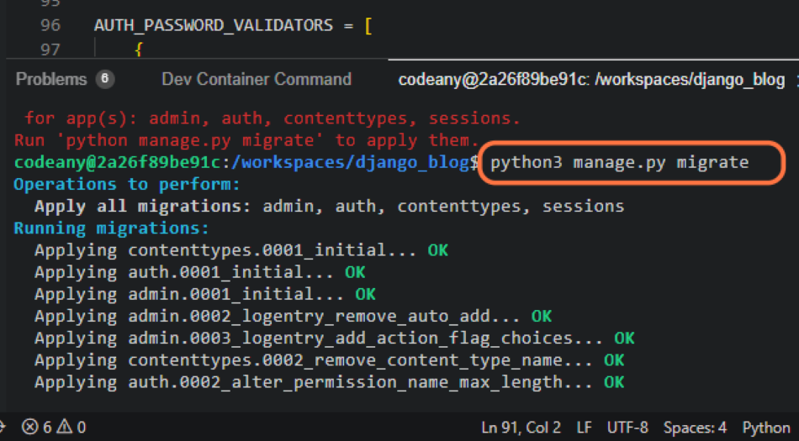

- Enter data into the database
15. Let's enter our first data into the database. As Django comes with built-in auth and admin apps we can create a superuser with admin access to our database:
python3 manage.py createsuperuser
Choose a memorable user name, use your email address and choose a secure password.
Note: Django will check your password security.
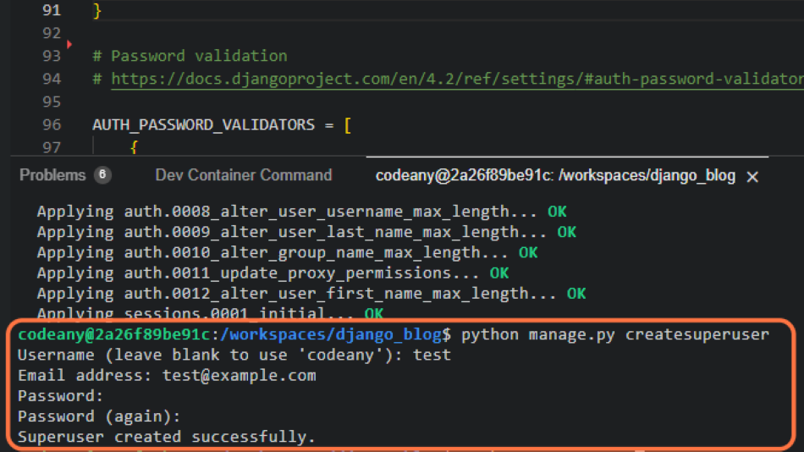

- Deploy the project
16. Return to your workspace and open the codestar/settings.py file. Change the value of DEBUG back to False as this will ensure the production deployed app is secure.


17. Git add, commit and push your updated code to GitHub.
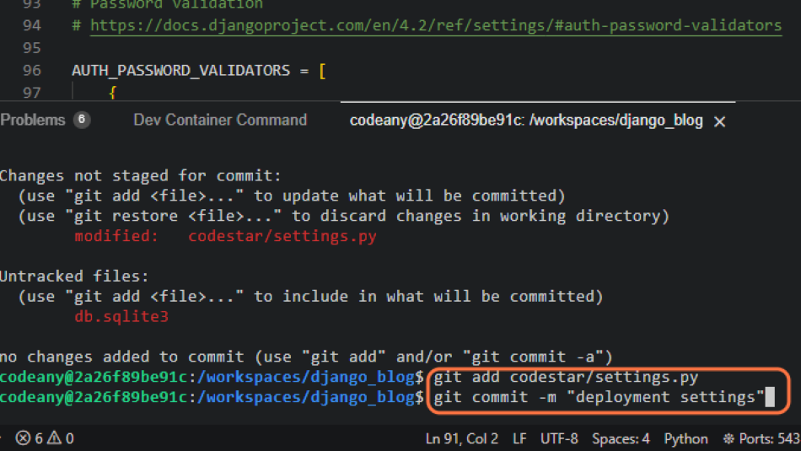

18. Return to your Heroku dashboard and go to your blog app. Click on the Deploy tab.
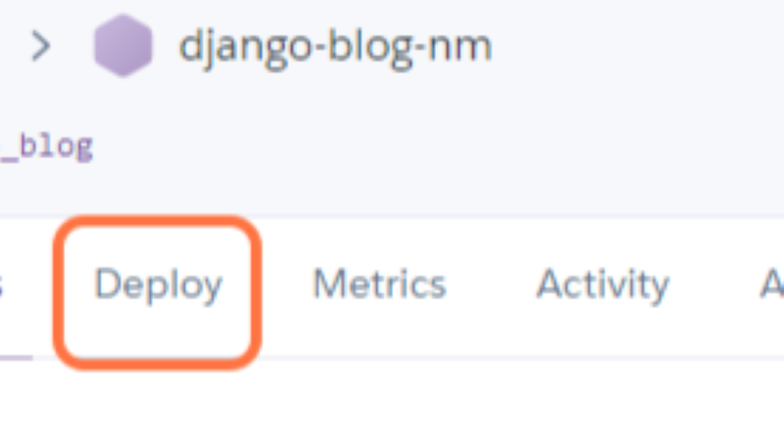

19. Do a manual deployment.


- Connect Heroku to the PostgreSQL database
20. Once the deployment is complete click on Reveal Config Vars in the Settings tab.
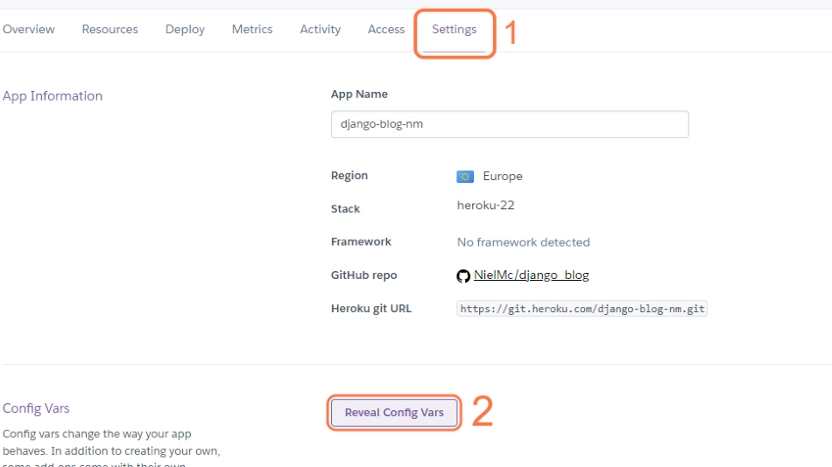

21. You may see that Heroku has automatically added its own PostgreSQL DATABASE_URL. If so, we want to remove the Postgres database Heroku created and replace it with the free PostgreSQL from Code Institute one as Heroku's PostgreSQL database offering has a monthly fee.
Note: If Heroku has not automatically provisioned a PostgreSQL database add-on, skip to step 25.
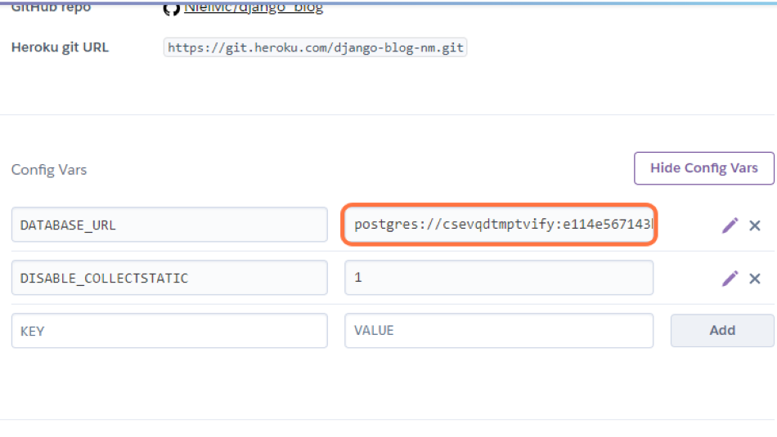

22. To remove the Heroku database, click on the Resources tab.
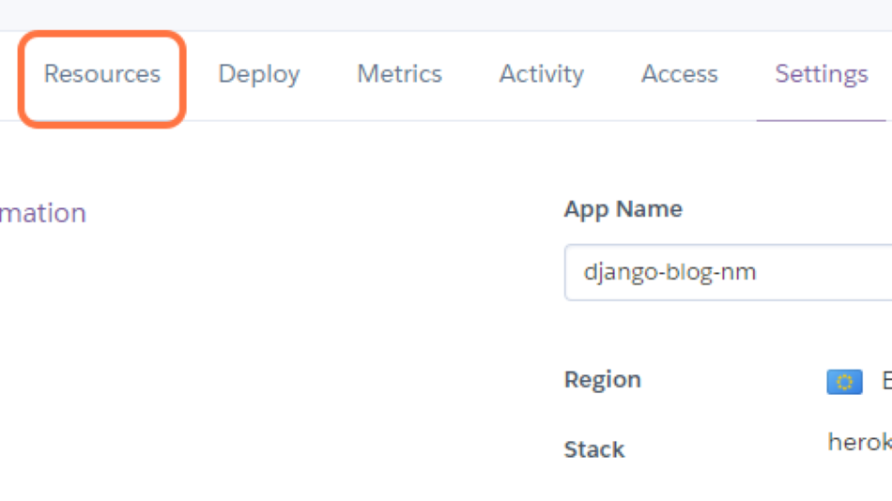

23. Click Delete Add-on from the drop-down menu to the right of the Heroku Postgres Add-on. Confirm the removal of the add-on by typing your app's name into a popup.
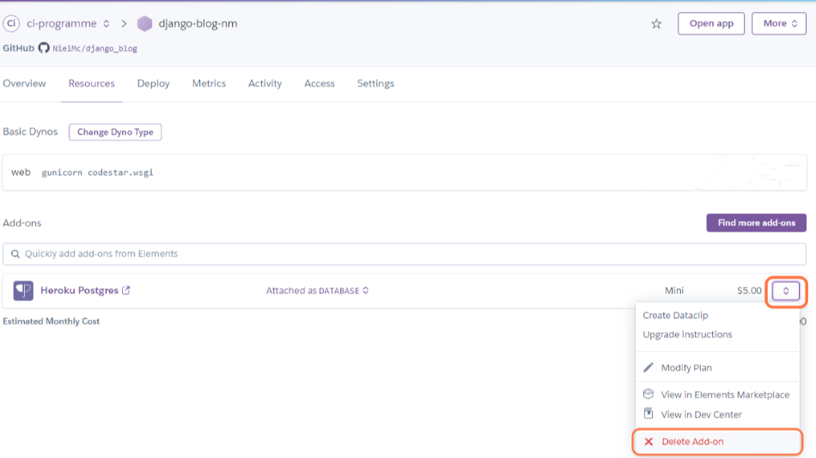

24. Now return to Settings and Reveal Config Vars.


25. Add a new config var with a key of DATABASE_URL and the value of the PostgreSQL from Code Institute URL.
Note: You can copy this from your env.py file (minus the quotes) or the email you received from PostgreSQL from Code Institute.
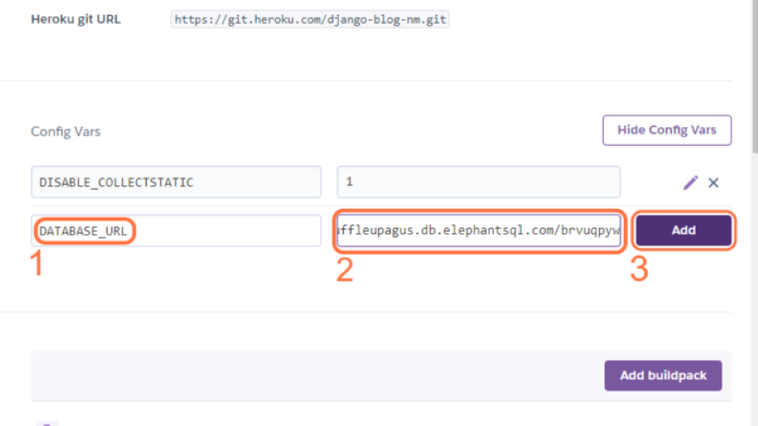

26. Now your deployed app is connected to your PostgreSQL cloud database.


- Overview of the Django Blog Project. Welcome to this walkthrough project.
My name is Niel McEwen, and I’m a senior content developer here at Code Institute. In the previous lesson, we covered deploying a simple Django project to Heroku. By the end of this blog walkthrough, you will know how to: Create a database-backed Django project and deploy it to Heroku. You'll learn how to host uploaded images on a Cloud provider. Create function-based views in a Django project. How to use Django generic views, Add authentication. Create custom models And add extra interactivity using JavaScript. The same principles and mechanics of Django design that you will learn, as you build the blog, can be used to build your projects. Before building our blog, let's first focus on getting our project set up. In this lesson, we will: Get an overview of the Blog Project. Create User Stories in GitHub Projects. Add all user stories and acceptance criteria to the Kanban board. Create the project and blog app.

Deploy the project.
- This application will be built using a Design Thinking approach.
- We’ll create User Stories in our next topic,
- which we’ll use to guide us as we add functionality.
- Now that we know what we’re building and how we'll do it, let’s get started on the blog.
- But, before we begin to write any user stories, let's lay some groundwork.
- We said we wanted to take a Design Thinking and Agile approach, so let's consider what
- we want from our blog before we start.
- With Design Thinking, we put ourselves in the user's position and we try to anticipate
- their needs.
- We also ask ourselves questions like, "Why would a user wish to visit our blog?"
- "What will make them return?"
- The best way to answer these questions is to think about what we would like when we
- visit a blog to drive our user story creation.
- So let's give that some thought now.
- What kind of features should a blog provide it's users?
- Jot down 3 or 4 features.
- Do some research by looking at some real life blogs.
- Pause the video for a few minutes to do that and come back when you're ready.
- Welcome back, here are my thoughts on the kinds of features a blog should provide:
- With any blog or journal site, the content is king.
- So we don't want to impede access to the blog post in any way.
- We like sign-up processes to be as easy and frictionless as possible, and we like to be
- able to engage with the blog in a meaningful way.
- This, then, forms our problem statement, namely: how do I develop a blog application that provides
- that functionality to a user?
- We can use this problem statement to populate our user stories.
- So, let's get started by first giving you an overview of the blog project you will create.
- We’re creating this full-featured blog project so that you can show off your skills as a
- software developer and share tips and tricks with other budding developers too.
- As well as reading posts, our blog will enable users to register for an account.
- The registration function allows users to sign up using a username and password with
- an optional e-mail address.
- When they're logged in, a user can view a post and then leave a comment.
- Additionally, they can edit or delete their existing comments.
- The project will also contain an About page app so that you can see how to create multiple
- apps in Django.
- As well as this, we have included a full-featured Admin's section where you can manage comments.
- Heroku will host the live application, and we’ll use the ElephantSQL database to store
- our blog posts and comments.
- Finally, we’re going to use a cloud-based provider called Cloudinary to store our blog’s images.
- In our next topic, we will set up a user story with acceptance criteria in GitHub projects
- using its Kanban Board.

