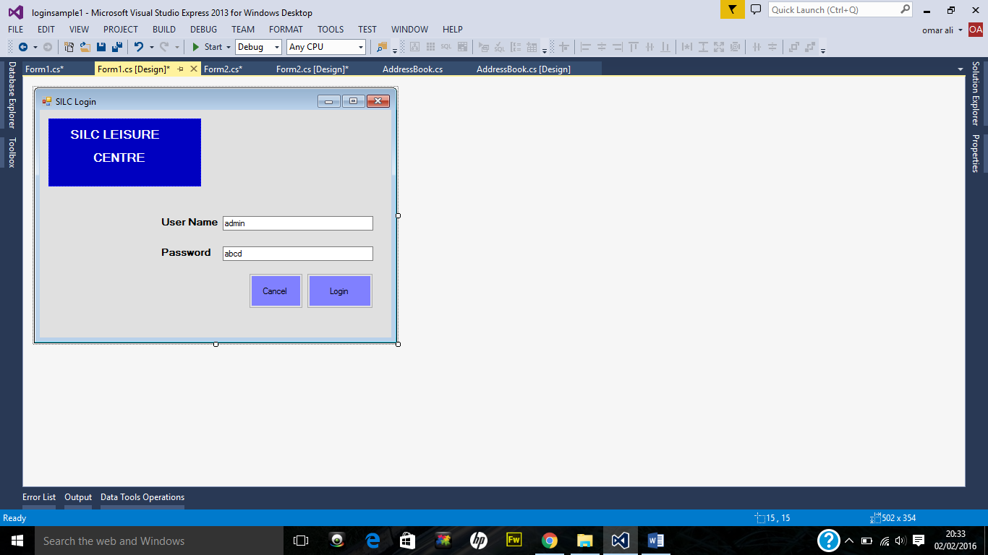

This txt field is for password

This txt field is for admin use name

The cancel button will stop the application

Login button will direct you to main form

In this field the name of member will appear when selected from the listview1

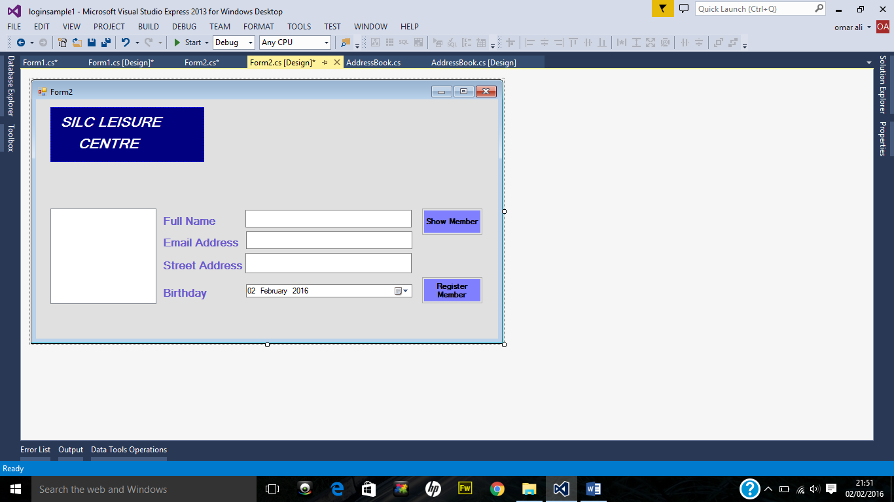

This form will direct you to the registration form

The street name of member will show here

The email will show here when name of member is selected from listview1

Show member button displays the name of member on listvikew1

This is listview1 this is where the name of member will show if show member is clicked

The date of birth will show here

This is listview1, only the name of all members will list up here

Email of selected member will show here

Name of selected member will show here

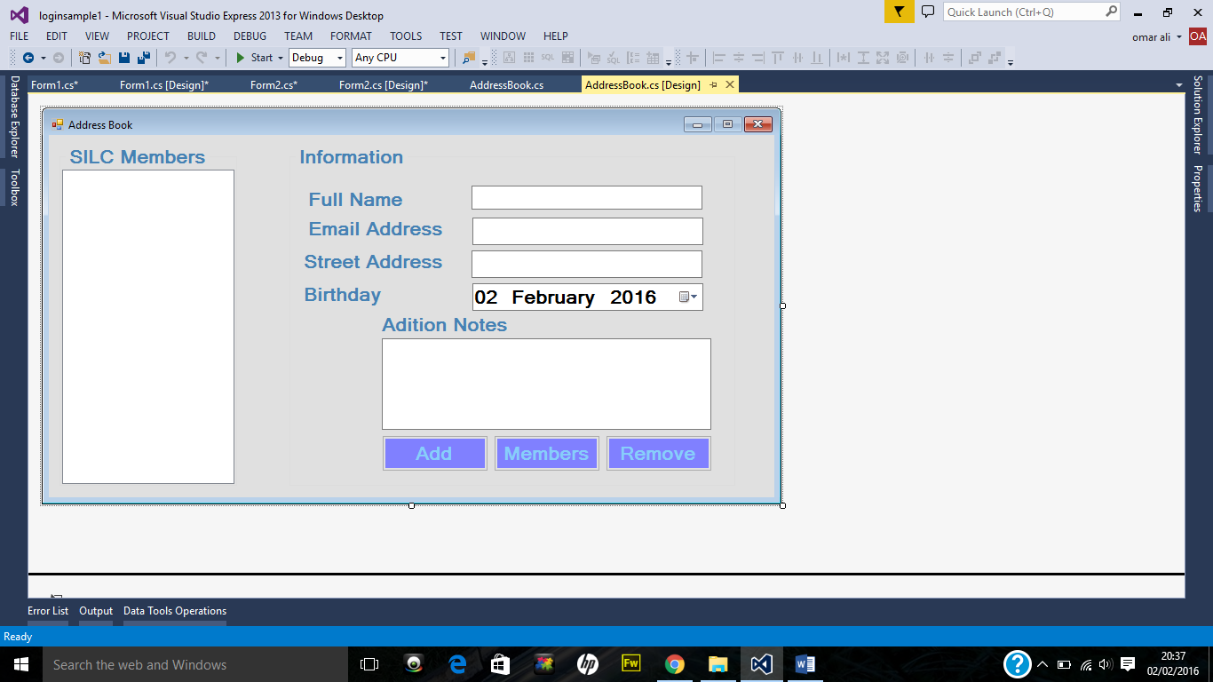

If there are notes saved for member they will appear here

Street address of selected member will appear here

The date of birth of selected member will show here

This button adds the created member on to the xml database

This button loads all members to the listview1

This button removes the selected member from the xml database