Omer Alrwais

IST380

1. Source code in GitHub repository

<https://github.com/omeralrwais/IST380Final>

1. Readme file in GitHub repository with the following content:
   1. Overview of the project

Emergency rooms are congested with patients all the time. And this is a nationwide phenomenon. There isn’t a system yet to dispense the patients over adjacent ERs. While that can be understood for severe cases (if you feel very ill, then go to the nearest ER to you regardless of waiting time) there is no reason not to have that for less severe cases. This will smooth patient’s arrival time over neighboring ERs. In this project, I present a solution to this problem by providing a mobile application able to (1) detect nearby ERs (2) list them ordered by distance and show a map populated with the hospitals (3) provide average waiting time in the ER for hospitals all over the USA (4) display a map showing the hospitals and calculating the time it will take the patient to arrive at the ER from his\her location as well as the driving directions.

* 1. Required Android Permissions and why the app needs them

To insure the device has google play installed which is required by Google maps Api v2 ---> <uses-feature android:glEsVersion=*"0x00020000"* android:required=*"true"*/>

Use the internet to connect to CGU’s Arcgis server to get the list of nearby ER ---> <uses-permission android:name=*"android.permission.INTERNET"*></uses-permission>

Permissions required and preferred to use the GPS and Google maps APi v2 --->

<uses-permission android:name=*"cgu.edu.ist380.er.permission.MAPS_RECEIVE"*/>

<uses-permission android:name=*"android.permission.ACCESS_FINE_LOCATION"* />

<uses-permission android:name=*"android.permission.ACCESS_NETWORK_STATE"*/>

<uses-permission android:name=*"android.permission.WRITE_EXTERNAL_STORAGE"*/>

<uses-permission android:name=*"com.google.android.providers.gsf.permission.READ_GSERVICES"*/>

The following two permissions are not required to use

Google Maps Android API v2, but are recommended --->

<uses-permission android:name=*"android.permission.ACCESS_COARSE_LOCATION"*/>

<uses-permission android:name=*"android.permission.ACCESS_FINE_LOCATION"*/>

Google maps Api v2 Key to use the api --->

<meta-data android:name=*"com.google.android.maps.v2.API_KEY"*

android:value=*"KEY"*/>

* 1. Required Web Services, e.g., GIS, Google, etc., and why the app needs them
* CGU ArcGIS REST Web Service: to query the DB of hospitals and get the hospital information based on the coordinates of the mobile phone
* Google Maps Android API v2: To display the hospitals by a special icon on the map and zoom the view to fit all the list dynamically and more faster than directing to maps.google.com
* Google maps: To get the driving directions.
* <https://maps.googleapis.com/maps/api/directions/json>: To get the actual distance, driving times and routes to draw a path from the devices location to the designated hospital on Google Maps Android API v2.
  1. Required, built-in, features/devices: GPS, Camera, Gallery, Contacts, SMS, etc.
* Google Play (market): to use Google maps and it requires the device to be linked with a Gmail account
* GPS: to get the devices location, query nearby hospitals based on the location and draw the marker on the maps.
* Internet connection: to call Cgu’s server and google maps
* The minimum SDK version supported by the app is “10” which is the Android 2.3.3 OS and the app wouldn’t run on an older version
  1. Testing procedures (emulators, device tests, unit tests, etc.)

Google Maps Android API v2 required a running Google play to be installed on the emulator and I wasn’t able to do that so I was able to test it only on a physical device. Thanks to Mr Yousef Abed who lend me an android device (HTC Thunderbolt) which I used to test the app.

* 1. Screenshots

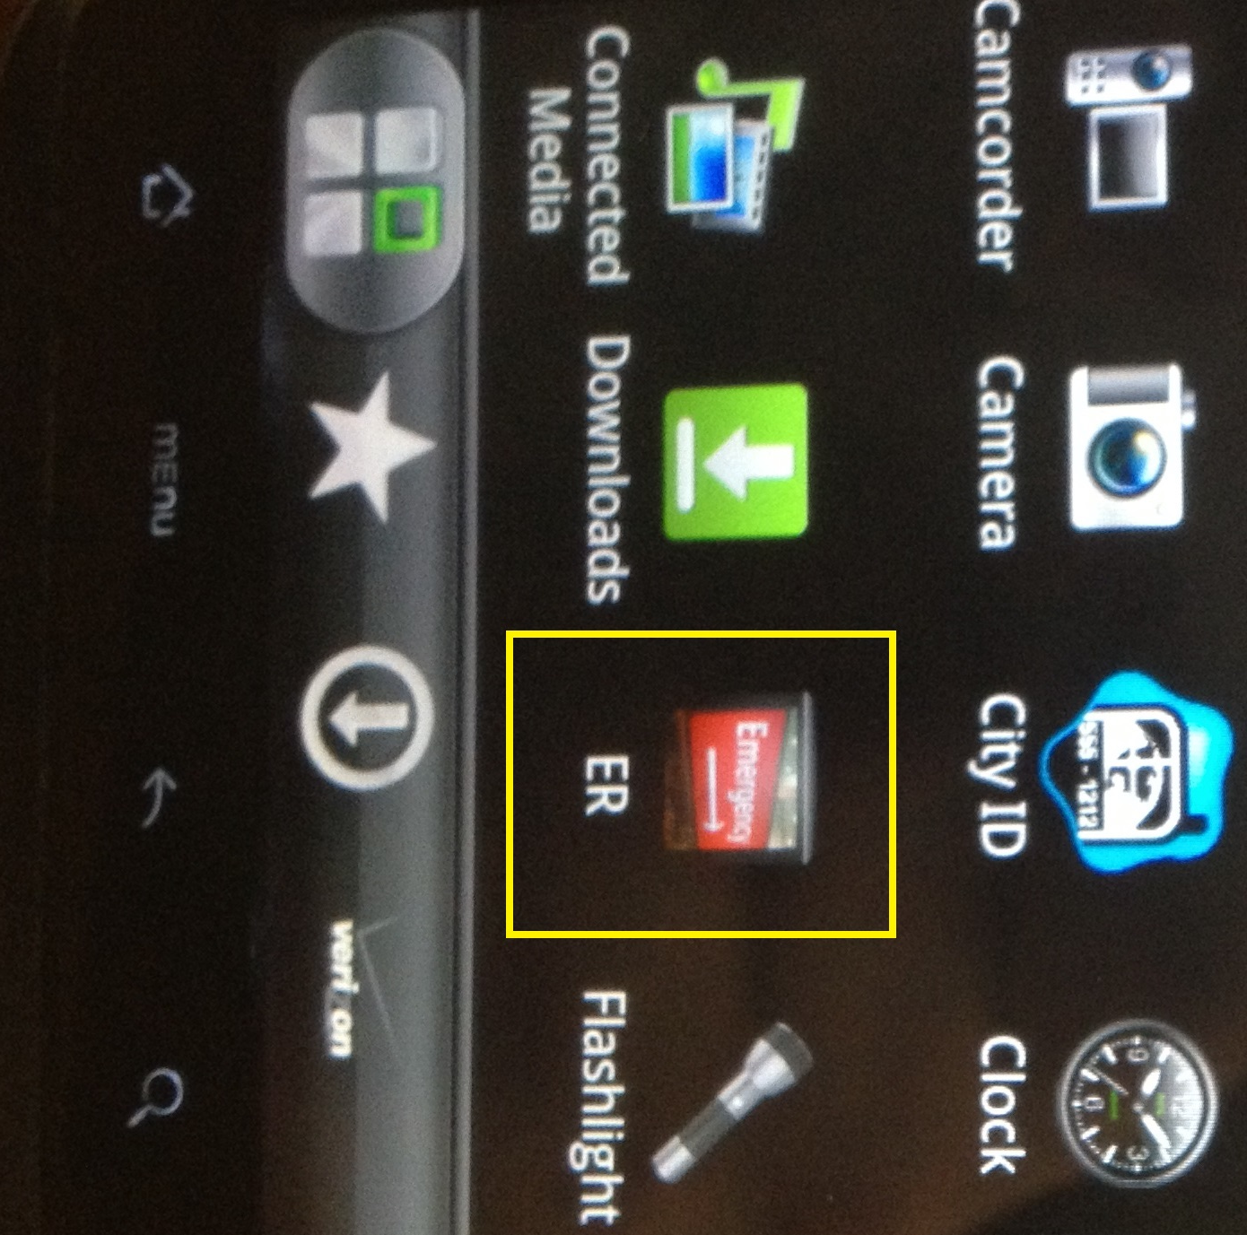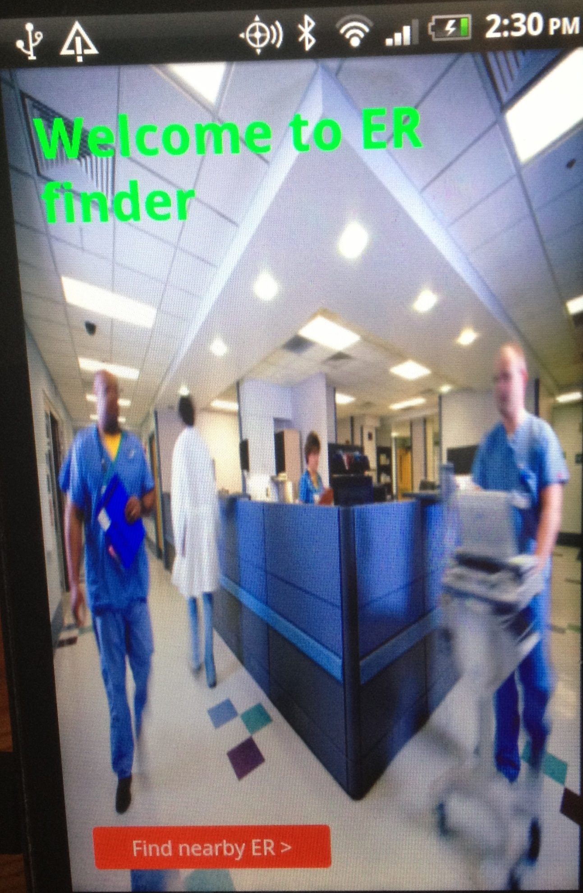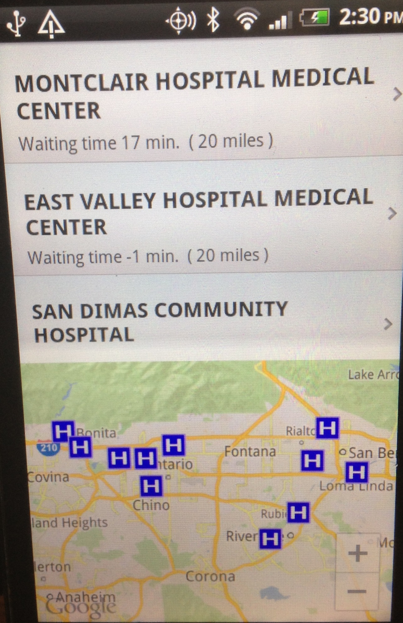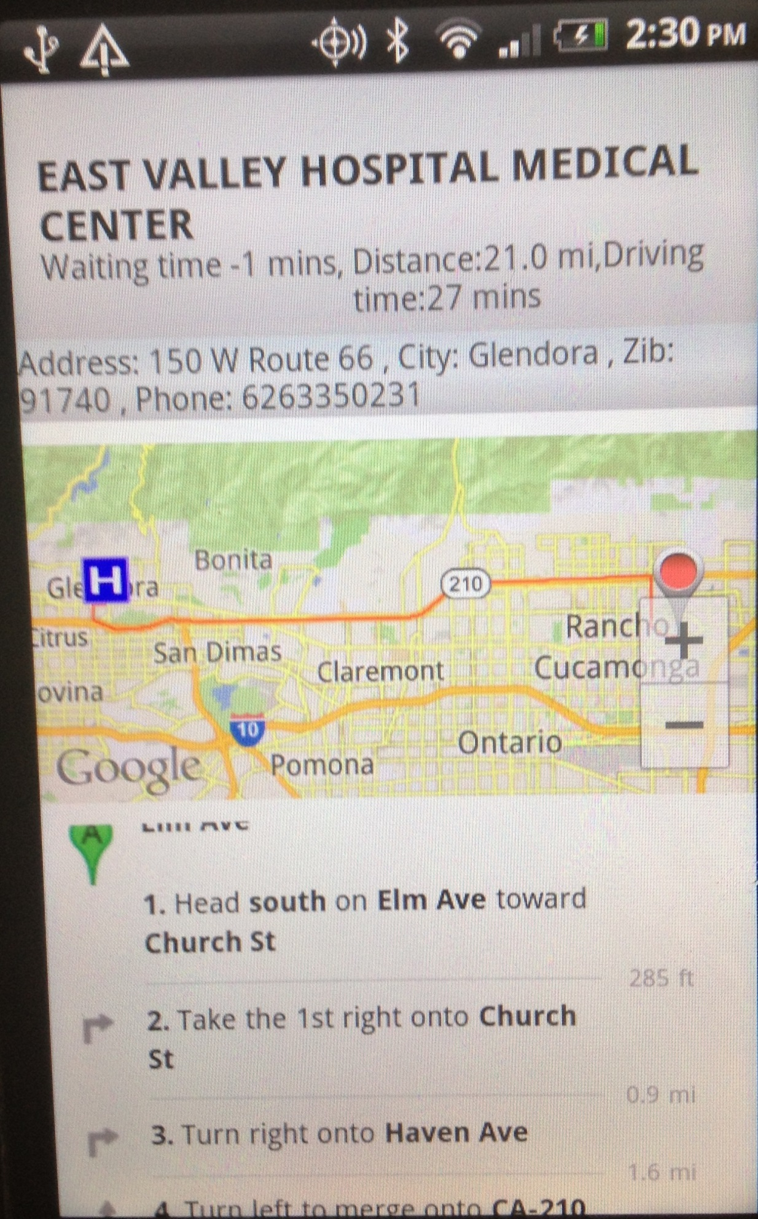

* 1. Known bugs, limitations, and problems

If there are no hospitals within 31 miles the app sometimes crashes.

* 1. Set of features to be implemented or next steps
* Diagnosing (performing the Triage process)
* Pre check-in at the chosen ER
* Getting the actual waiting time from each hospital hour by hour
  1. License and contributors

This work wouldn’t have possible if it wasn’t for Allah (God) then the Help of Dr. [Brian Hilton](https://canvas.instructure.com/courses/795869/users/3441465), Mr Yousef Abed and Abdullah Murad. Thank you All.