**Air and Noise Pollution Monitoring System**

**A Report Submitted to the**

**Dokuz Eylül University, Department of Computer Engineering**

**CME 4436 Basics of Internet Of Things**

**by**

**Mehmet UYĞUT**

**2015510064**

**Ömer Selim ATİLA  
2015510010**

**January, 2021**

**İZMİR**

**1. INTRODUCTION**

The main objective of IOT Air and Sound Monitoring System is that the Air and sound pollution is a growing issue these days. It is necessary to monitor air quality and sound level and keep it under control for a better future and healthy living for all. Project uses gas sensors to sense presence of harmful gases in the air and constantly transmit this data. Also, it keeps measuring sound level and reports it via e-mail.

**1.1 Scales for Air and Noise Pollution**

For the noise pollution, According to the World Health Organization, sound levels less than 70 dB are not damaging to living organisms, regardless of how long or consistent the exposure is. Exposure for more than 8 hours to constant noise beyond 85 dB may be hazardous. You can see the chart below for noise levels.

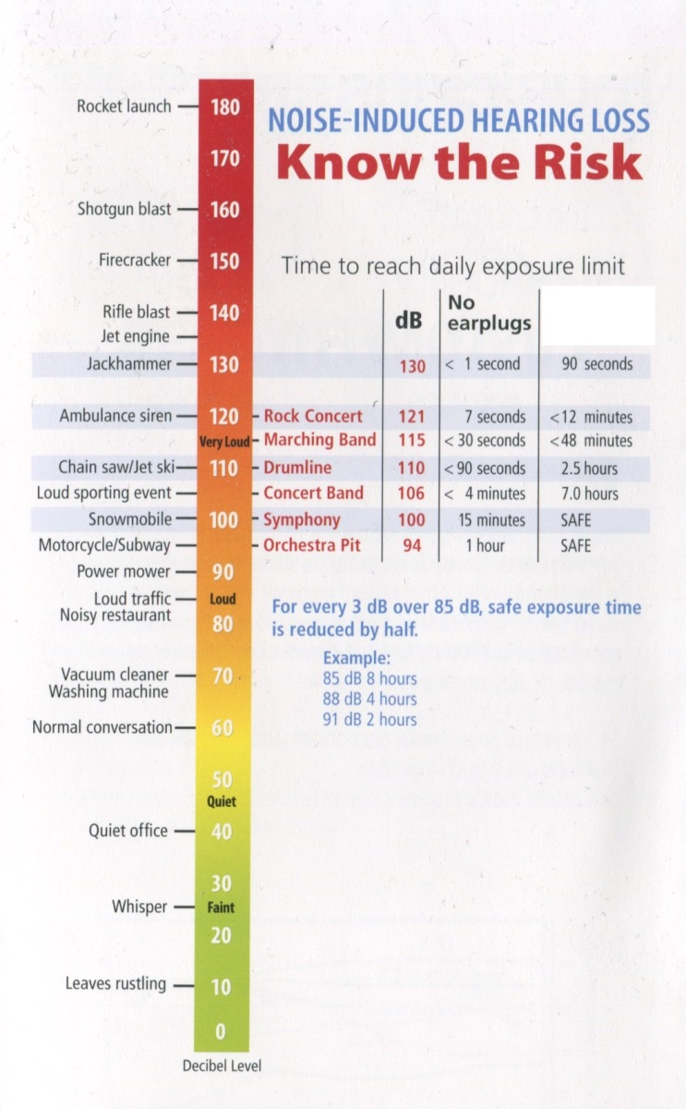

There are some limits for certain types of gas in air pollution. Below you can see the table on harmful gases and their limits.

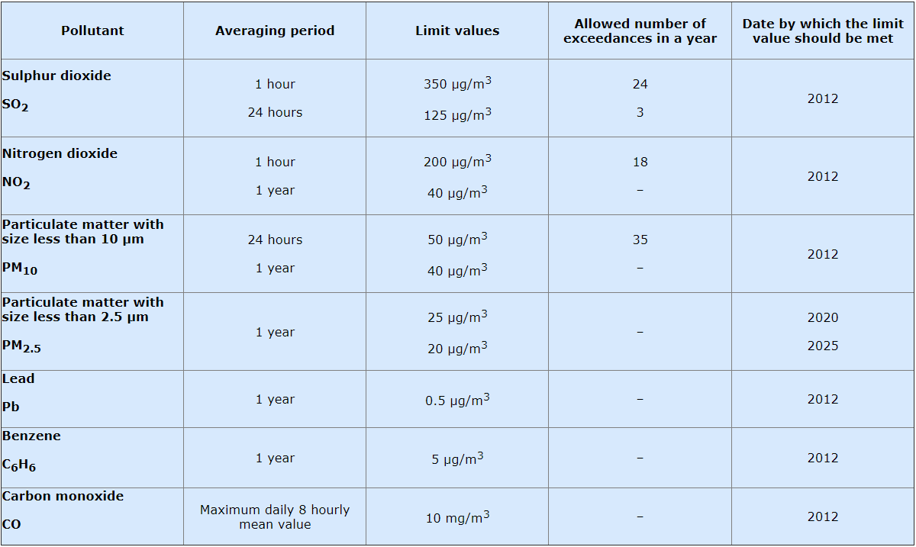

**2. METHODOLOGY/TOOLS**

The tools we will use to prepare the project are MQ-135 air quality sensor, KY-038 sound detection sensor and ESP-32 Microcontroller. In this project Information collected by sensors will be transferred to thingspeak application via ESP-32 wi-fi and air and sound pollution will be monitored instantly. If there is a dangerous stuation for the air or sound quality ESP-32 will send mail to the users with its mail client library. For the software part Arduino IDE’s will be used.

Information for tools is below;

**MQ-135 Air Quality Sensor**

This sensor used for detecting a wide range of gases, including NH3, NOx, alcohol, benzene, smoke and CO2. ideal for use in office or factory. MQ135 gas sensor has high sensitivity to Ammonia, Sulfide and Benzene steam, also sensitive to smoke and other harmful gases.

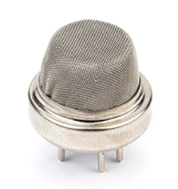

**MQ-135 Air Quality Sensor**

**KY-038 Sound detection Sensor**

KY-038 sensor can measure how many decibels the outside sound is by acting as a microphone.

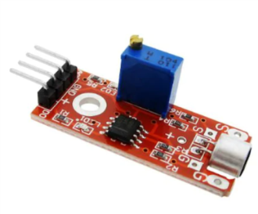

**KY-038 Sound Detection Sensor**

**NodeMCU ESP32**

NodeMCU is an open-source Lua based firmware and development board specially targeted for IoT based Applications. It includes firmware that runs on the ESP32 Wi-Fi SoC from Espressif Systems, and hardware which is based on the ESP-32 module. NodeMCU ESP32 can used with Arduino IDE’s.

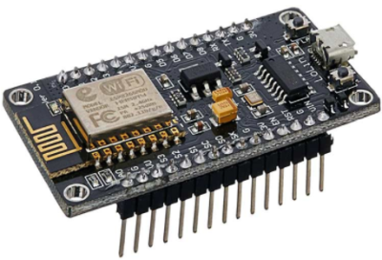

**ESP32 Microcontroller**

**3. RESULTS**

As a result, the project has been carried out successfully. The data we received with the sensors were transmitted to thingspeak with the ESP-32 Wifi module and visualized. Then, when the values ​​reached dangerous levels, an e-mail was sent to the user through the ESP-32 mail client library.

Below you can see some screenshots of our project.

**3.1 Screenshots**

**3.1.1 Data Displayed in Thingspeak**

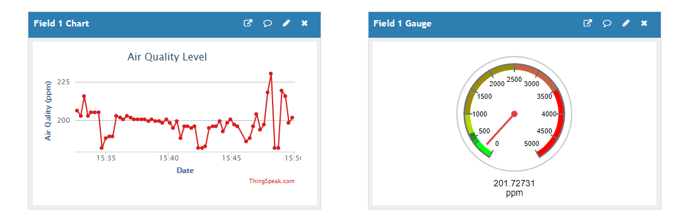

**Gas level**

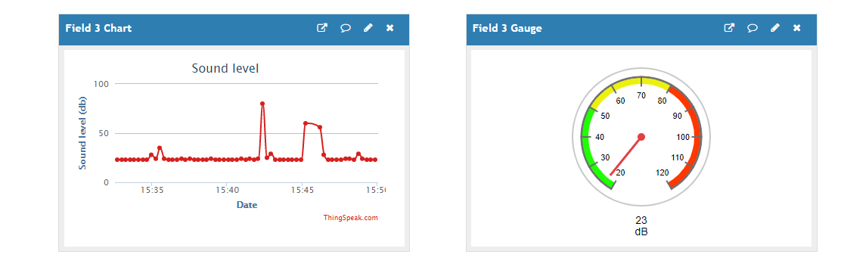

**Noise level**

**3.1.2 E-mail sended to User**

