**Student Name: Dileep kumar reddy Thathireddy**

**Student ID: 20003992**

B9MG119

Small and medium scale Company: CoinBurp

**Cloud Strategy and Sample Deployment**

**Cloud Technology for Business**

Table of Contents

1 Introduction 2

2 Enterprise background 3

3 Current IT Setup 4

4 Deployment Procedure 5

5 Recommendations 9

5.1 Cloud vs non-cloud solutions 9

5.2 Appropriate deployment types and service level 10

5.3 Justification for Recommendation 10

6 Conclusion 12

7 References 13

# Introduction

The study looks at cloud computing as a possible solution for medium-sized and small enterprises. Microsoft Azure, Docker, as well as GitHub are each of the main solutions that utilize cloud systems. The suggestion and procedure are mirrored in this set of instructions. On all of those platforms, we pushed the web application's programming in a collection of pictures that we created as part of the Networking Coinburp organization.

# Enterprise background

With the help of its bitcoin trading system, CoinBurp, anyone is able to purchase and sell digital assets in a straightforward, secure, and convenient manner. The business has an intuitive user interface and supports a number of cryptocurrencies, such Bitcoin (BTC), Ethereum (ETH), and others.Crunchbase data indicates that CoinBurp has raised money in a number of different rounds. As early September 2021, a Seed round that raised £5.5 million ($7.5 million) in February 2021 became the industry's most recent investment round (crunchbase 2022).

A marketplace for buying, selling, and storing bitcoins is provided by CoinBurp. On the app, consumers can transact in digital goods directly, and they can safely manage their money by connecting external wallets. The site seeks to offer both seasoned and inexperienced bitcoin traders an effortless trading experience.

# Current IT Setup

The company uses a number of different computer systems, with its official website being one of the most important. Additionally, the company uses digital marketing to promote its products and services. Since usage of the internet is expanding quickly, the company may be able to reach a wider range of clients with the help of digital marketing methods. The data is used as the company engages with additional clientele. The data could be utilized for a number of purposes, particularly for the organization's successful strategy. Data research may help businesses identify their strong and weak points, which is helpful for identifying clients of interest. Java script is used by the company to create the backside of the internet presence.

The company may connect the program to cutting-edge technologies to provide a range of API options. Several APIs are currently associated with the company. Using the addition of Django or Flask, every aspect of functionality can be completed alongside a single line of code (Campbell 2023). As the source code length decreases, the website's effectiveness and lifespan rise.

# Deployment Procedure

Application directory architecture: The root directory structure must be configured in line with the picture provided, which includes the code for the application, all required files, along with the Docker configuration file used to create and encapsulate the image itself.

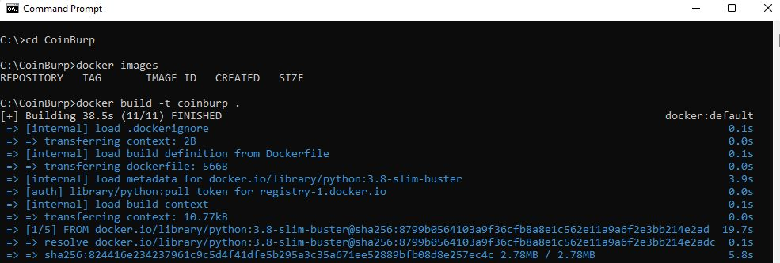

It is necessary to create a Docker image in so that you can encapsulate the application. The graphic below shows the commands for Docker (Niero 2023).

The local pictures can be examined after the photograph has been made.

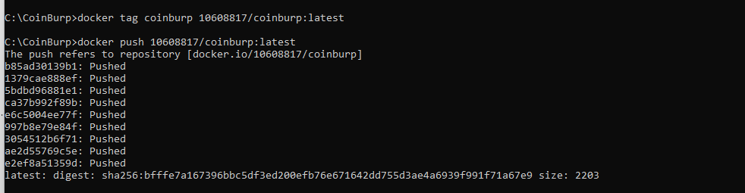

The image is additionally posted to Docker Hub so that it may be utilized for launching the web-based app from the Docker desktop.

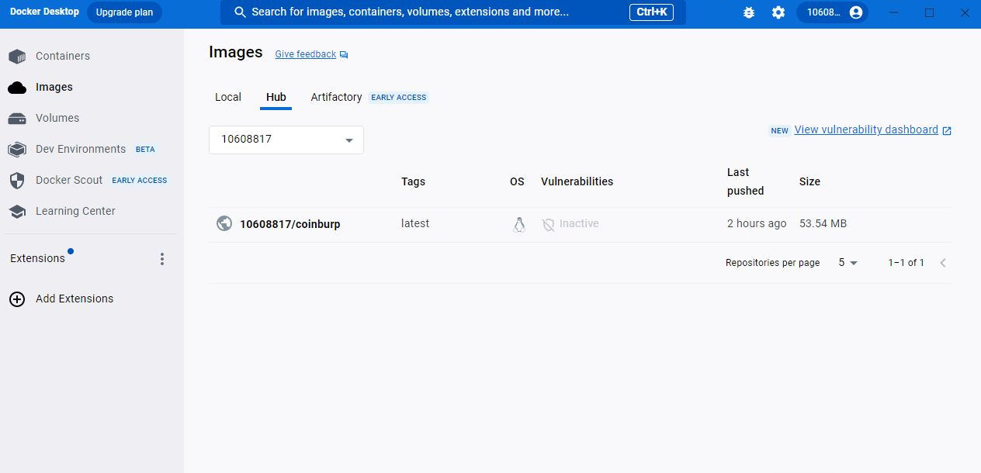

**Uploading a container to Azure:**

The image is posted to Azure in the following manner:

Creating the Azure containers registry using the resource group.

• Add an annotation to the Docker images in the Azure Containers Registry.

• Go and sign in to the Azure Container Registry.

• Post the picture to the Azure container registry.

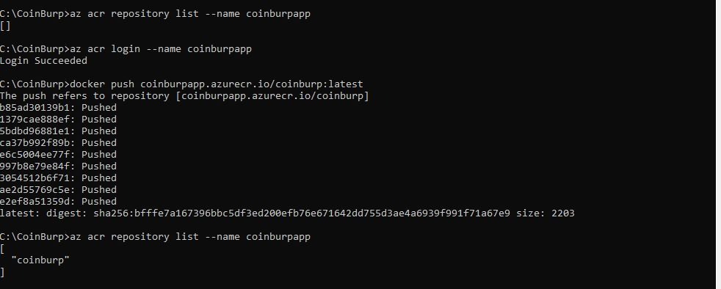

Applying these steps, the created Docker image is now posted to the GitHub registry:

• The docker picture should be given a GitHub registry tag.

• Upload the Docker image to GitHub, as you can see in the picture below.

• To verify the picture that has been uploaded into GitHub, make use of the GitHub interface.

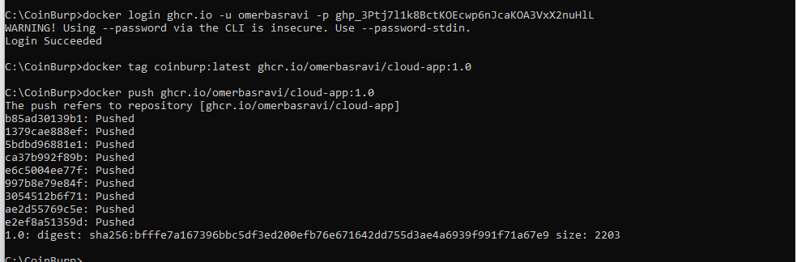

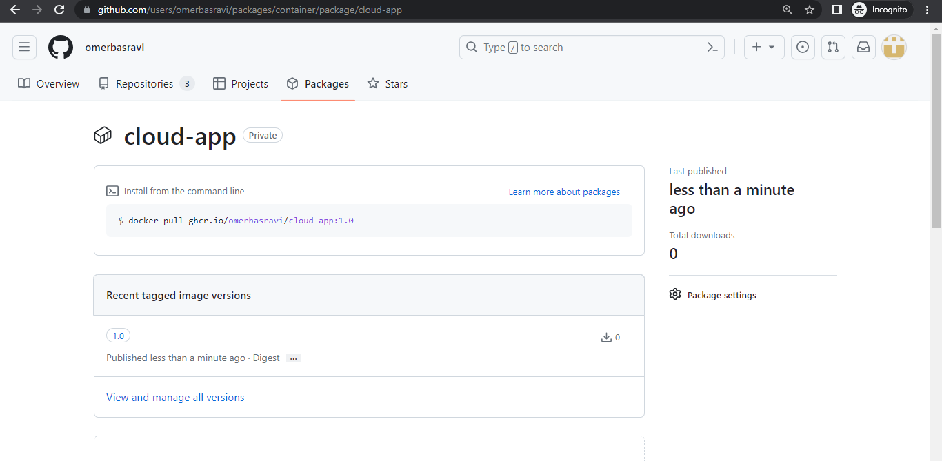

**Run/test the program:**

Use an on-premise or docker image, an Azure or GitHub-pulled image, etc. to run the program on the server itself.

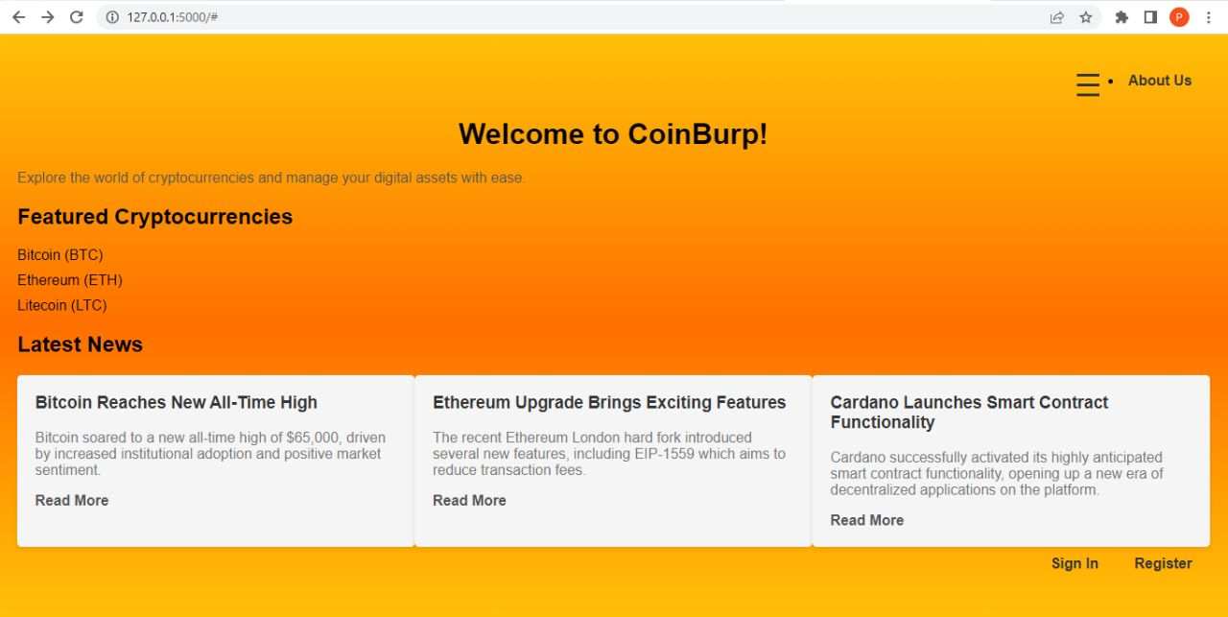

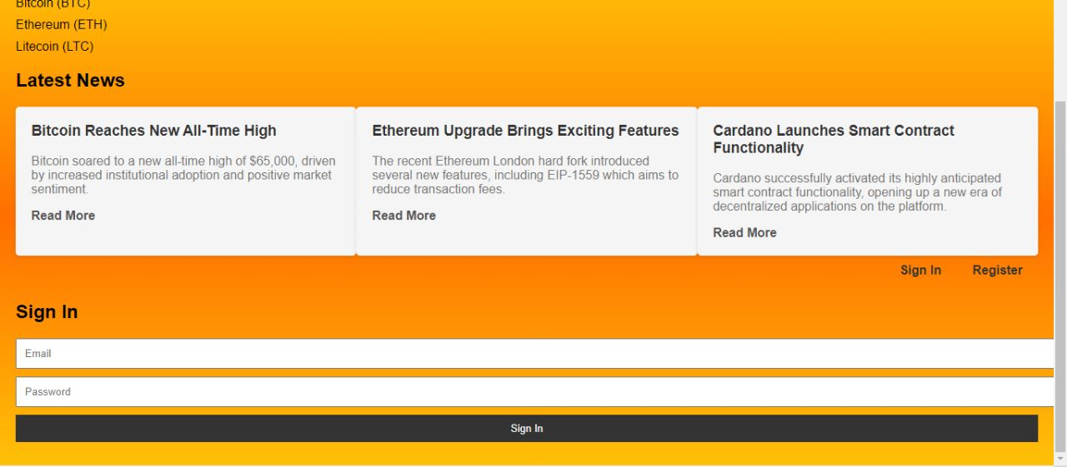

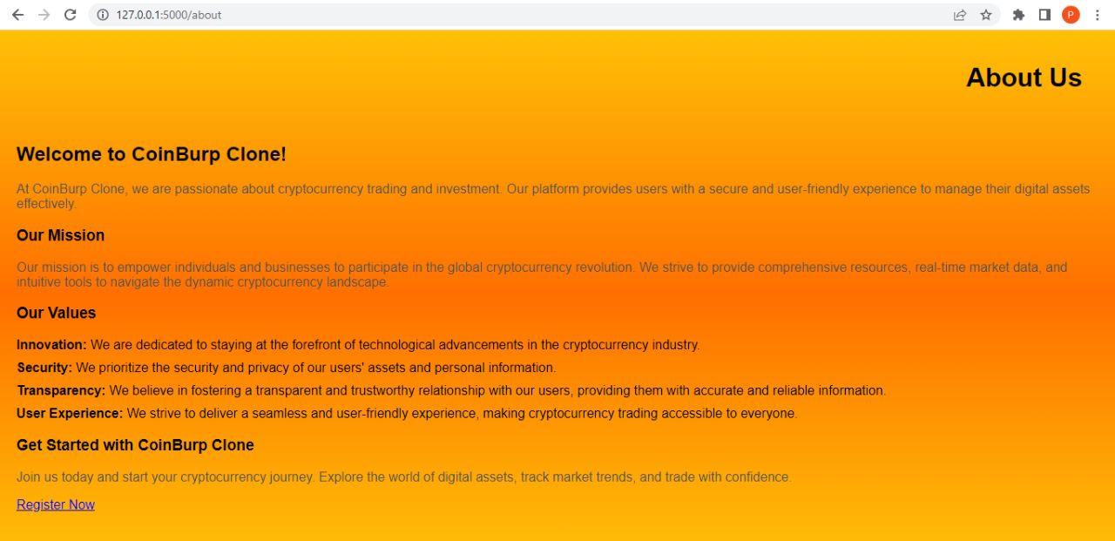

# Recommendations

## Cloud vs non-cloud solutions

Since cloud services make it easier to install programs on an external computer, host the applications there, or maintain information in a remote database, it is advisable that the firm implement them (Kumar 2022).

* In order to reduce expenses and preserve speed, we can scale either upward or downward apps through the aid of the cloud.
* The cloud allows anyone to access the server that is remote, decreasing the need for on-premise equipment.
* Pay-as-you-go systems for cloud computing simply charge consumers for the features or assets we actively use, as well as for the period we spend on them. We are not charged for the cost of putting up the facilities.
* Utilizing cloud services necessitates regular software maintenance and patching for both the foundational software and apps. The burden on IT personnel is reduced as a result.
* Cloud solutions remain current with infrastructure requirements, such as hardware enhancements, security updates, and fault tolerance.
* Companies' speed to market is slashed by the rapid installation and application activation offered by cloud-based applications.

## Appropriate deployment types and service level

To set up the cloud assets or services that we required.

GitHub Container Registry

Docker instance

Docker Container

Application containerization and application update.

Services/Resources needed by Multi-Container Apps:

GitHub Registry; Azure Active Registry

Python, HTML, CSS, and JS with Docker Desktop

## Justification for Recommendation

Traditional in-house infrastructure, often known as non-Cloud solutions, primarily comprises the installation and running of programs on the on-premise infrastructure. Since demand fluctuates, we've been unable to adapt our capacity. Users are not permitted to access the servers from a distance. The infrastructure's initial setup expenses are also very high. The deployment of resources and services takes longer than usual despite being partially automated (Kumar 2022).

Given all of these aspects, a company that requires scalability, cheaper costs for infrastructure, as well as remote utilization of resources must switch from a physical premises to an online cloud-based one. In order to do this, the on-premise system must be moved to cloud resources, and the application must be hosted either on an external server utilising containerization that occurred or on a server located in the cloud utilising a virtual machine instead.

# Conclusion

The Coinburp Web application, that's helpful for a number of things including improved data storage, security of data, and effective code processing, was successfully implemented, as is covered in the report. Additionally, it offers suggestions for both cloud-based and non-cloud solutions.

# References

Niero, P. (2023) HW accelerated gui apps on Docker, Medium. Available at: https://medium.com/@pigiuz/hw-accelerated-gui-apps-on-docker-7fd424fe813e (Accessed: 17 July 2023).

Campbell, S. (2023) Flask vs django – difference between them, Guru99. Available at: https://www.guru99.com/flask-vs-django.html#:~:text=Flask%20does%20not%20support%20dynamic,offers%20a%20Monolithic%20working%20style. (Accessed: 17 July 2023).

Kumar, V. (2022) An introduction to microsoft azure global infrastructure, Live Training, Prepare for Interviews, and Get Hired. Available at: https://www.dotnettricks.com/learn/azure/microsoft-azure-global-infrastructure (Accessed: 17 July 2023).

COINBURP - Crunchbase Company Profile &amp; Funding (2022) Crunchbase. Available at: https://www.crunchbase.com/organization/coinburp (Accessed: 17 July 2023).