

Logic Circuits & Design

Homework - 2



ÖMER FARUK BİTİKÇİOĞLU

161044010

**Question 1**

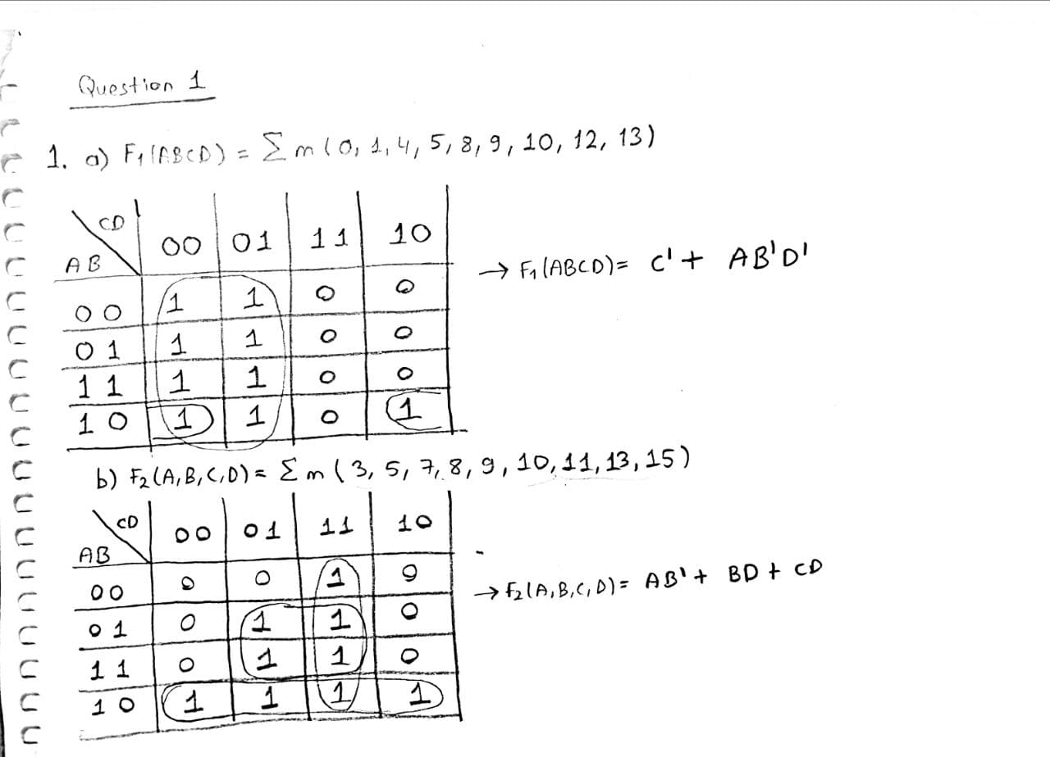

1. **F1:**

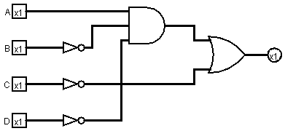

**F2:**

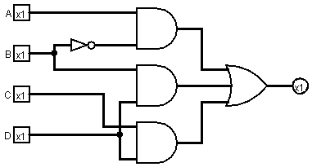

1. **F1 by NAND gates:**

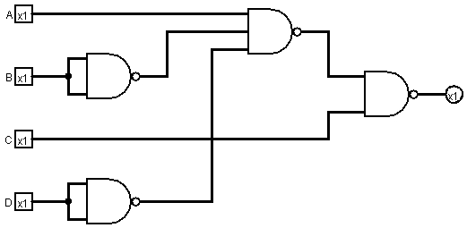

**F2 by NAND gates:**

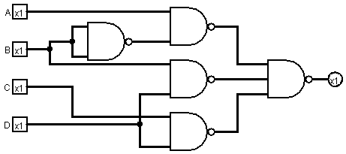

**Question 2**

**1 -)**

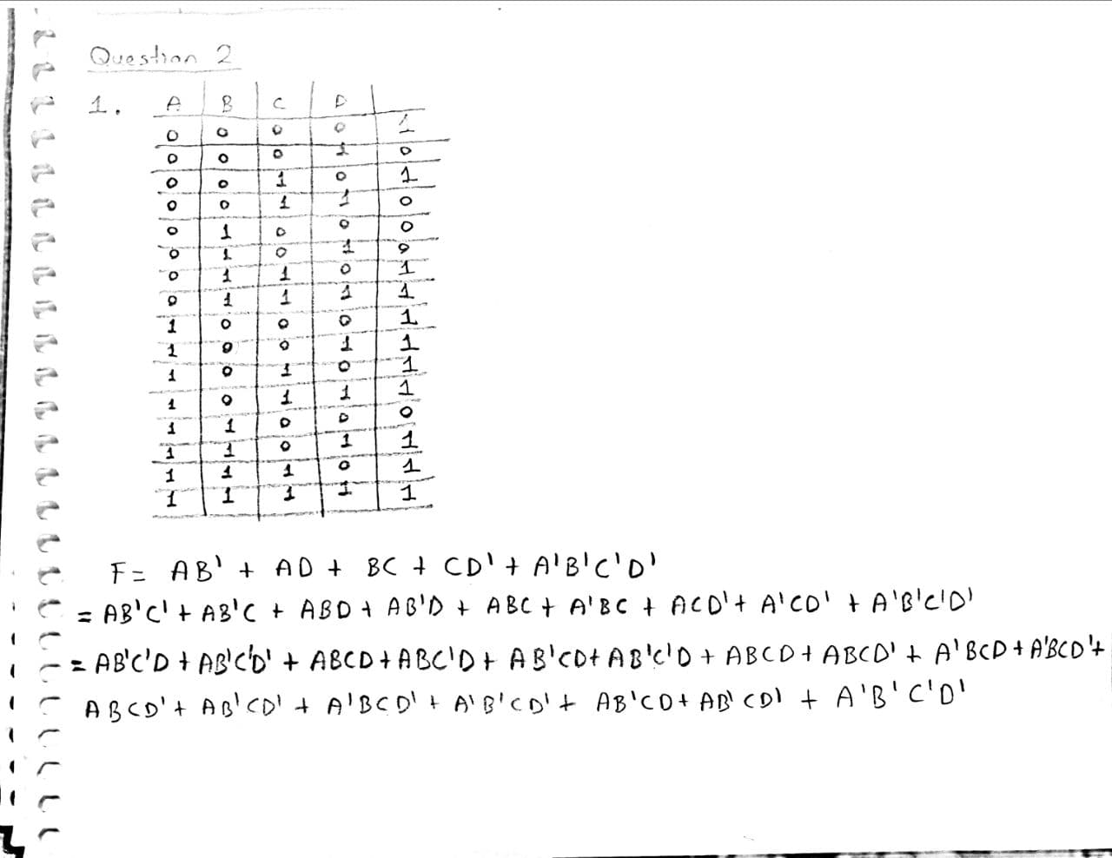

**2, 3, 4 -)**

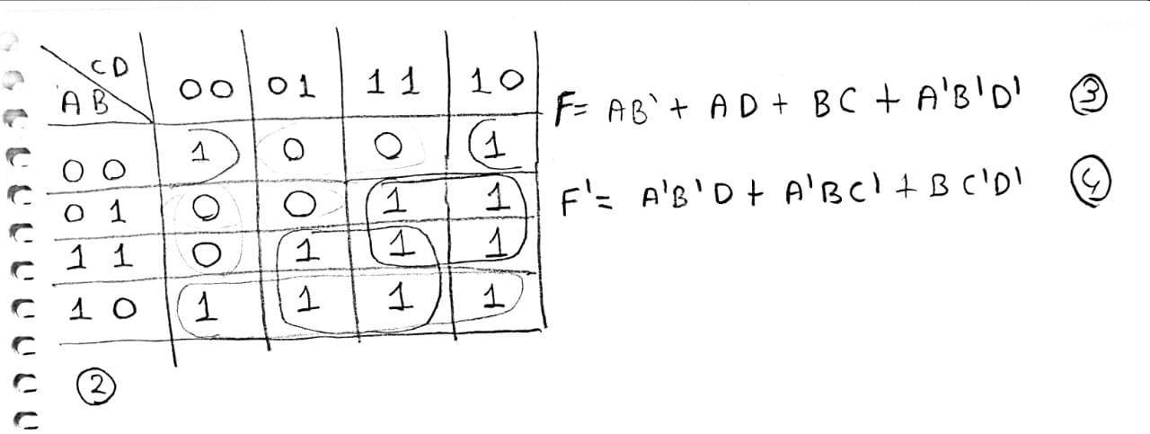

**5 -) F by NAND gates:**

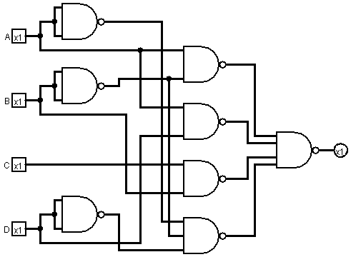

**F’ by NAND gates:**

