The Economic Costs of Crime in Brazil
Carlos Góes, Lucas Siqueira Simões, Giulia Spiess and Bruna Santos
Inter-American Dialogue — Brazil Program
Complete first draft for substantive review
2026

Contents
Contents 2
1. Executive summary 3
2. Introduction 4
3. Homicide and crime in Brazil 6
3.1 Brazil in the international context 6
3.2 Recent crime trends 7
3.3 Strong territorial heterogeneity in violence 11
4. Estimating the economic costs of crime in Brazil 15
4.1 Public and private security 15
4.2 Incarceration 17
4.3 Insurance and material losses 19
4.4 Productive-capacity losses 20
4.5 Judicial costs 22
4.6 Medical and therapeutic services 23
4.7 Total economic costs of crime 24
5. Regional heterogeneity in the economic costs of crime 26
5.1 Distribution of state-level costs 26
5.2 How the economic burden changed over time 27
6. Conclusion 30

Status: complete first draft for substantive review. State-level results for 2025 remain preliminary and must be updated before publication.

1. Executive summary
This report updates the accounting of the economic costs of crime in Brazil and expands its national and regional coverage. Its main findings are:
- R$439.5 billion in 2025, or 3.5% of GDP. This is the total measured economic cost of crime in the final year of the series. The account combines public security, private security, incarceration and the incarceration benefit, insurance and material losses, productive-capacity losses from homicide, judicial costs, and medical and therapeutic services.
- Lethal violence declined, but Brazil remained high in the international distribution. The UNODC rate fell from 30.1 intentional homicides per 100,000 inhabitants in 2016 to 18.7 in 2024. In the common sample of 87 countries or territories, Brazil moved from the 91.9th to the 86.0th percentile.
- National police records also indicate a decline in lethal crime. Between 2016 and 2025, the rate of intentional homicide recorded by Sinesp fell from 25.1 to 14.8 victims per 100,000 inhabitants. Robbery followed by death and several property crimes also declined. Reported rape of a vulnerable person and femicide increased, although changes in reporting and classification may also affect these series.
- The national average conceals substantial territorial heterogeneity. In 2024, the median homicide rate across 558 microregions was 18.1 per 100,000 inhabitants. The mean in the bottom quartile was 6.9, compared with 39.1 in the top quartile. Forty-seven microregions had rates of at least 40 homicides per 100,000 inhabitants.
- The homicide decline was geographically widespread and larger where initial rates were higher. Between 2016 and 2024, 70.3% of microregions recorded a decline. In a population-weighted descriptive regression, each additional homicide per 100,000 inhabitants in the 2016 rate was associated with a 0.50-point more negative change through 2024. The pattern is consistent with convergence, but the relationship is not causal and mechanically includes the initial rate in the change calculation.
- The real cost nearly doubled but declined relative to national income. In December 2025 reais, the aggregate rose from R$220.6 billion in 1996 to R$439.5 billion in 2025. Over the same period, it fell from 4.7% to 3.5% of GDP. The sum of annual values from 1996 through 2025 was approximately R$10.0 trillion.
- The costs extend far beyond police budgets. In 2025, public security accounted for 37.1% of the total; insurance and material losses for 21.9%; judicial costs for 16.8%; and private security for 14.5%. Productive-capacity losses accounted for 6.6%; incarceration and the incarceration benefit for 3.0%; and medical and therapeutic services for 0.03%.
- The burden also varies sharply across states. In the preliminary 2025 results, the median state recorded costs equivalent to 4.9% of state GDP, and half of the states lay between 3.2% and 6.4%. From 2016 to 2025, real GDP per capita increased in every state; the measured crime burden fell in 19 states and rose in eight.
- The total is a broad accounting measure, not a causal welfare estimate. It combines public and private expenditures, a social-security transfer, insurance payments, material losses, and future income estimated by a model. Its purpose is to measure the channels through which crime mobilizes resources and destroys economic value while preserving the conceptual differences among components.

2. Introduction
Opinion surveys indicate that most Brazilians regard violence as the country’s most serious problem. The concern is well founded. In an international comparison, Brazil’s homicide rate places the country among the 15% of reporting units with the highest incidence of homicide, according to United Nations data.
This report presents an accounting of the economic costs of crime in Brazil for 1996–2025. It updates the report The Economic Costs of Crime in Brazil, published by the Office of the President in 2018 and covering 1995–2015. The new edition extends the earlier estimates, refines the methodology, and expands the geographic and temporal coverage of the economic costs of crime.
Crime affects the economy through several accounting channels. The federal government, states, and municipalities finance public security; families and firms purchase surveillance and insurance; the judicial system devotes resources to criminal cases; and prisons require funding. The effects extend beyond these expenditures: assaults lead to hospital admissions, crime creates material losses, and homicide interrupts working lives and future income. Combining these channels requires preserving their distinct economic meanings. Some components, such as courts and police, are preventive or institutional expenditures with fixed costs that would not disappear even at very low levels of violence. Others, including material and productive-capacity losses, vary more directly with the incidence of crime.
The measured costs are substantial. In 2025, they reached R$439.5 billion, or 3.5% of GDP. Public security accounted for 37.1% of the total, followed by insurance and material losses at 21.9%, judicial costs at 16.8%, and private security at 14.5%. This burden tends to be larger in lower-income states and approaches 10% of state GDP in some cases. In real terms, the measured cost nearly doubled, from R$220.6 billion in 1996 to R$439.5 billion in 2025, while falling from 4.7% to 3.5% of GDP.
The recent cost trajectory coincided with an improvement in several indicators of violence. Between 2015 and 2021, costs fell in real terms and declined by more than 0.5 percentage point of GDP. Over the longer period, the economic cost of crime as a share of Brazilian GDP trended downward. The peak was in 2001, when the burden exceeded 5% of GDP. The subsequent decline first coincided with economic growth in the 2000s and, more recently, with lower measures of violence over the past decade.
The recorded intentional-homicide rate fell from 25.1 to 14.8 victims per 100,000 inhabitants between 2016 and 2025. Robbery followed by death, vehicle theft and robbery, cargo robbery, and robbery of financial institutions also declined. Approximately 70.3% of microregions experienced a reduction in homicide rates between 2016 and 2024. Other offenses did not follow the same path: recorded sexual and gender-based violence increased, subject to the limitations of reporting and legal classification.
Brazil therefore combines improvement in lethal-violence indicators with persistently high and geographically unequal levels of violence. In 2024, the median microregion had a homicide rate of 18.1, while dozens of areas exceeded 40 homicides per 100,000 inhabitants. State-level economic costs also vary substantially: the median burden was 4.9% of state GDP, and 19 of 27 states recorded a decline in this ratio between 2016 and 2025 even though all experienced growth in real GDP per capita.
These values form a broad accounting measure. They are not a causal estimate of how much GDP would increase in the absence of crime, nor a complete welfare calculation. The total combines expenditures, a social-security transfer, insurance payments, material losses, and modeled income losses. Its contribution is to make the scale, trajectory, and channels of the economic burden associated with crime explicit under verifiable definitions and transparent limitations.
Section 3 places Brazil in the international context and examines national and territorial crime trends. Section 4 presents the methodology for each component and consolidates the measured economic costs. Section 5 examines variation in the level, composition, and trajectory of the burden across states. Section 6 summarizes the report’s central implications.

3. Homicide and crime in Brazil

3.1 Brazil in the international context
Intentional homicide is an especially useful starting point for international comparisons of violence. Because of its severity, it is generally less dependent on a victim’s decision to report an offense than many property crimes. Comparisons still require caution: recording systems, investigative capacity, and cause-of-death classifications differ across countries.
Figure 1 compares Brazil’s position in 2016 and 2024 using the official intentional-homicide rate from the United Nations Office on Drugs and Crime (UNODC) and a harmonized sample of 87 countries or territories observed in both years. In 2016, Brazil recorded 30.1 homicides per 100,000 inhabitants and stood at the 91.9th percentile. By 2024, the rate had declined to 18.7 and the country had moved to the 86.0th percentile. This was a meaningful improvement: Brazil moved out of the highest decile. It nevertheless remained in the top fifth of the distribution—four out of every five reporting units had lower rates.
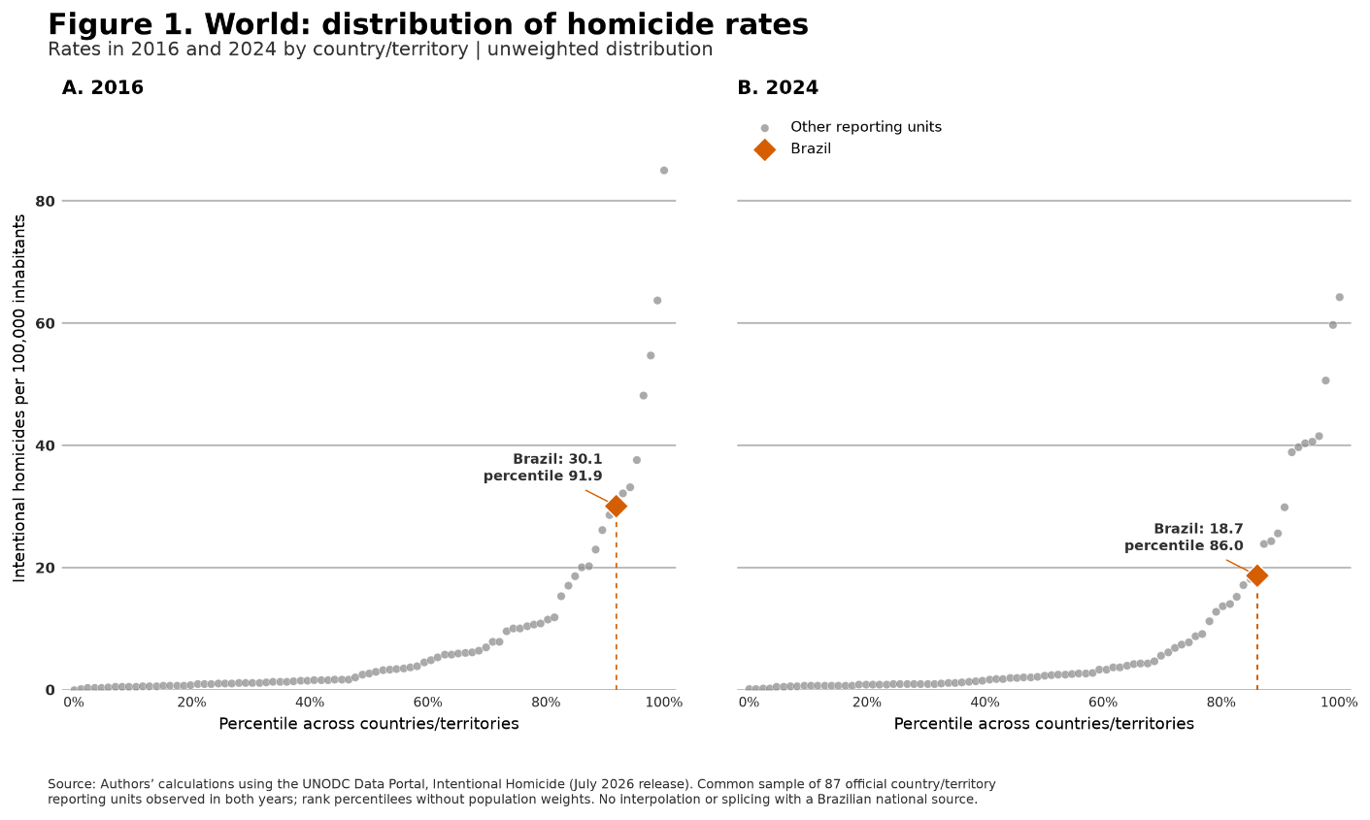

3.2 Recent crime trends
The launch of Brazil’s Unified Public Security System (SUSP) in 2018 strengthened efforts to integrate state-level public-security information systems. Today, all states share data on the most serious offenses through the National System of Public Security, Prison, Firearm and Ammunition Traceability, Genetic Material, Fingerprint, and Drug Information (Sinesp). Managed by the Ministry of Justice and Public Security, Sinesp supports operational and investigative use and provides public access to selected data. The harmonized records indicate declines in the violent offenses with the most complete coverage, with the exception of rape of a vulnerable person and femicide. They also indicate substantial reductions in property crimes such as vehicle theft.
Sinesp data show a pronounced decline in recorded lethal violence. The intentional-homicide rate fell from 25.1 to 14.8 victims per 100,000 inhabitants between 2016 and 2025, while the number of victims declined by 38%. Brazil recorded 51,200 intentional-homicide victims in 2016 and 31,500 in 2025. Over the same period, victims of robbery followed by death fell from 2,400 to 800, a reduction of 67%. Attempted homicide also ended the period below its initial level, declining by 24.6%, from 45,000 to 33,900. The decline was not uniform: intentional homicide reached its highest value at the beginning of the window, increased again in 2020, and then resumed its downward path.
Recorded sexual and gender-based violence followed a different trajectory. Victims classified as rape of a vulnerable person increased by 144%, and femicide by 93%. The series cannot distinguish changes in incidence from changes in reporting, recording, and the consolidation of legal classifications. Femicide is a relatively recent category whose administrative application may have become more consistent over time. The orders of magnitude also differ: the decline in intentional homicide exceeded the increase in femicide by a wide margin. Intentional homicides fell by 19,700 victims, while femicides increased by 800.
Figures 2A and 2B track six indicators with complete coverage of all 27 states and all twelve months of every year. Each measures victims rather than incidents.
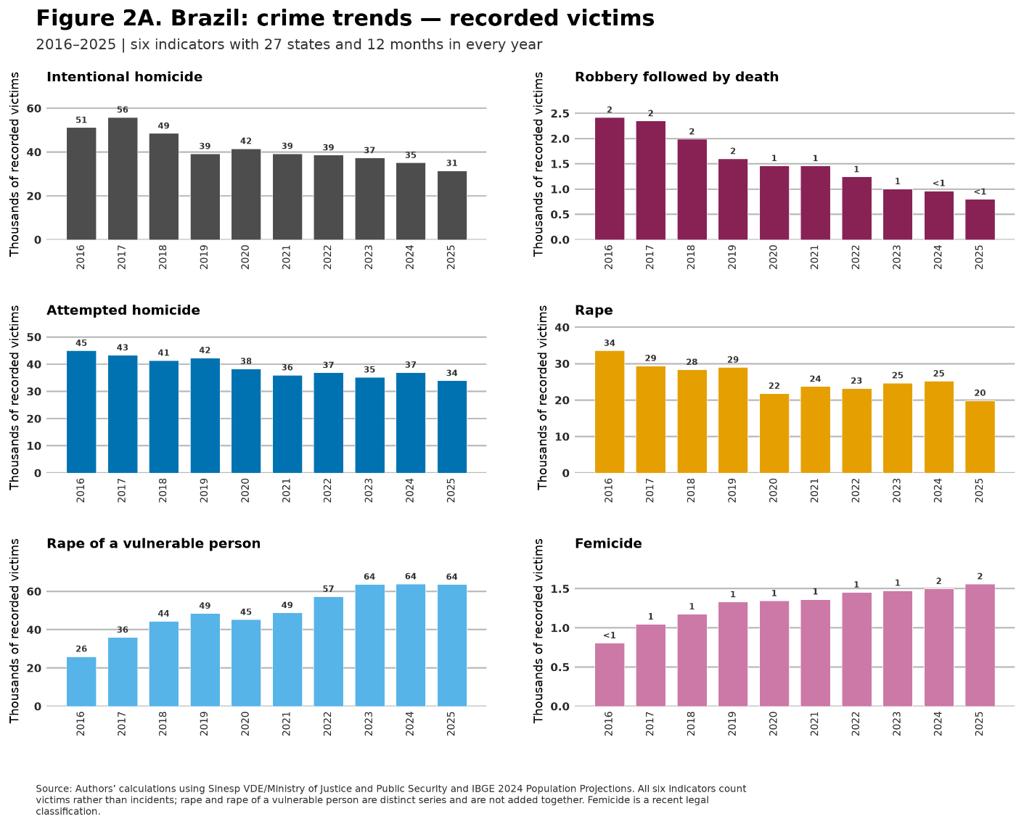
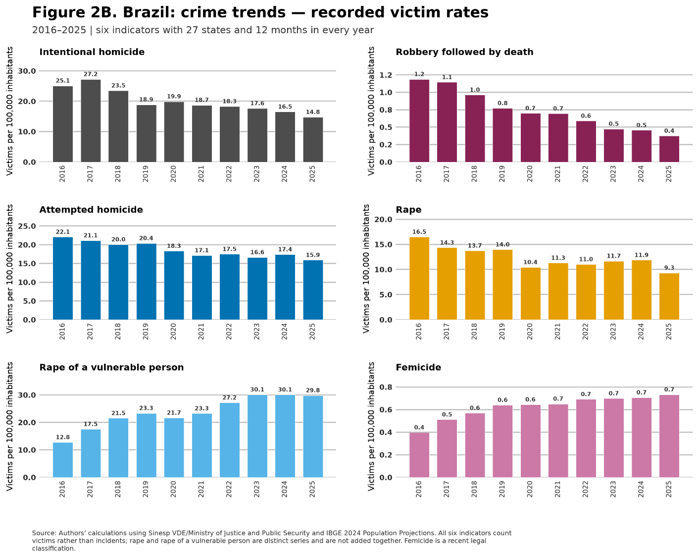
Some criminal categories are not yet reported uniformly to Sinesp. Coverage is broad but varies by indicator. The two vehicle indicators cover 22 states and 87.8% of Brazil’s population in 2025. Cargo robbery and robbery of financial institutions cover 20 states and, respectively, 85.3% and 86.0% of the population. These indicators do not measure every occurrence in the country, but they remain informative about trends within stable reporting panels.
Over the period, the rates of vehicle robbery and cargo robbery fell by 61.7% and 64.4%, respectively. Vehicle theft declined less and rose after reaching a low in 2020, while robbery of financial institutions became rare. In broad terms, these trends resemble those of the best-covered offenses, with substantial declines in violent and property crime over the past decade.
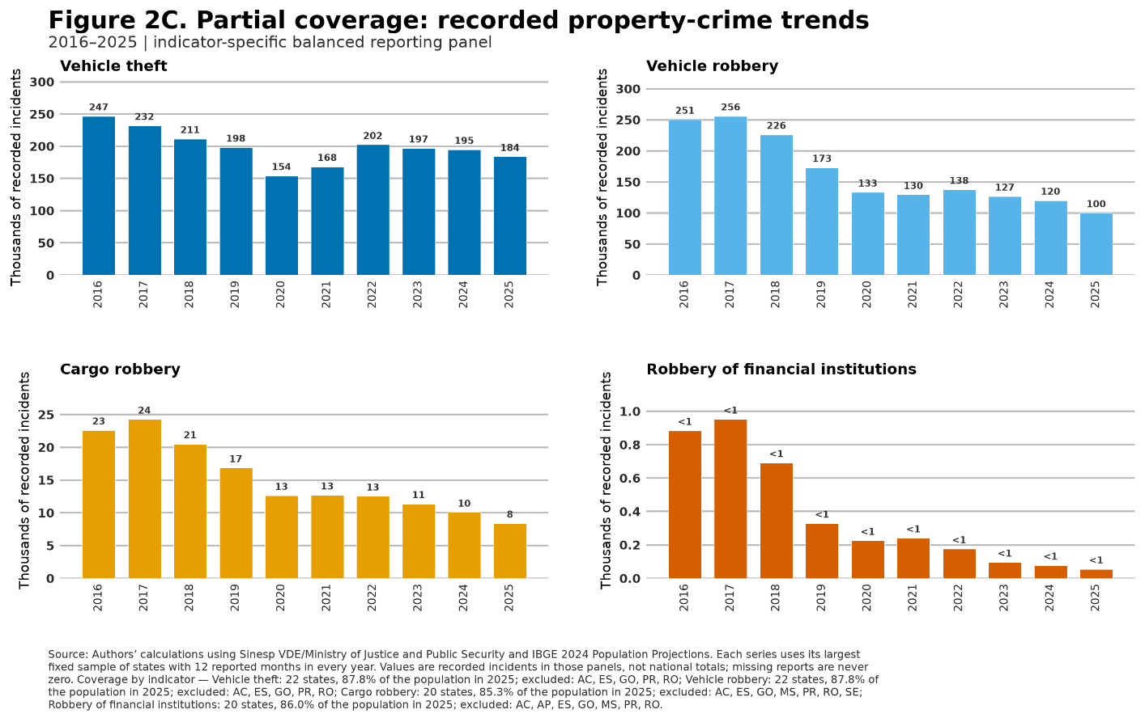
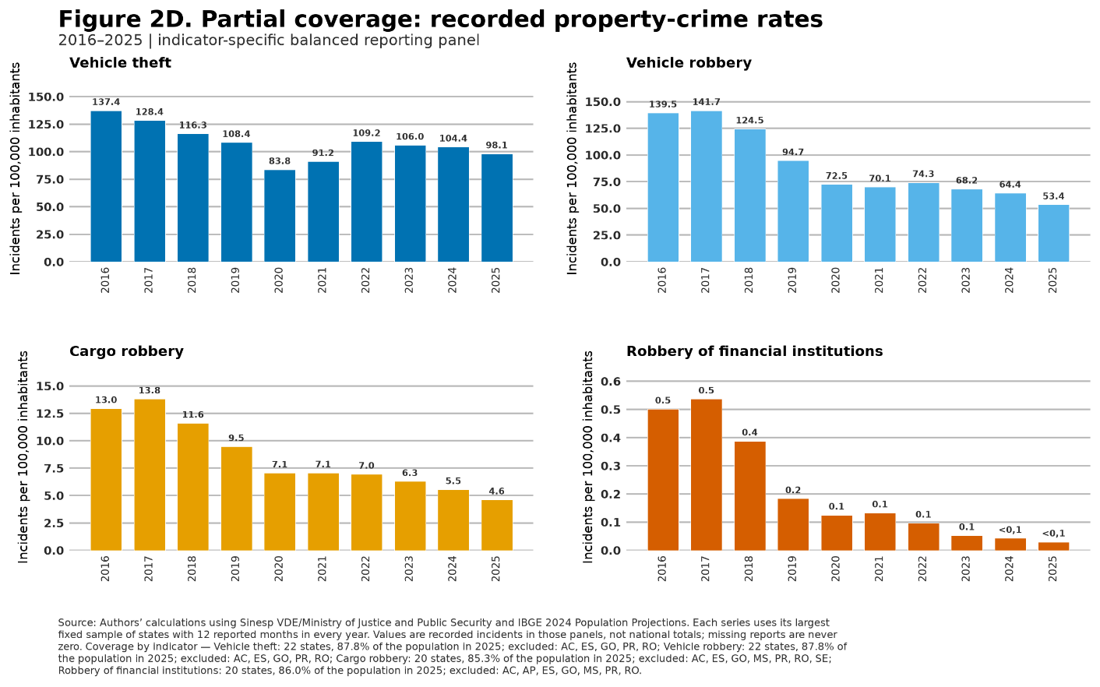

3.3 Strong territorial heterogeneity in violence
The national decline conceals important regional differences. Figure 3 plots the 558 microregions by their 2024 homicide rate, the latest year with final data from the Mortality Information System (SIM). Bubble area is proportional to population, while horizontal position depends only on the microregion’s rank in the homicide-rate distribution, with higher-rate areas to the right.
Regional differences are substantial. Microregions in the bottom quartile recorded an average of 6.9 homicides per 100,000 inhabitants, an order of magnitude close to the United States. In the top quartile, the average reached 39.1, close to Haiti. Forty-seven microregions had rates of at least 40 homicides per 100,000 inhabitants. The upper tail therefore contains dozens of labor markets and urban areas exposed to extremely high levels of lethal violence.
Microregions containing major capitals illustrate the range. São Paulo recorded 3.1 homicides per 100,000 inhabitants; Brasília 10.3; São Luís 18.3; and Rio de Janeiro 19.3. At the other end among the highlighted metropolitan areas, Fortaleza reached 33.0, Recife 41.6, and Salvador 52.8. Large metropolitan areas are therefore spread widely across the distribution.
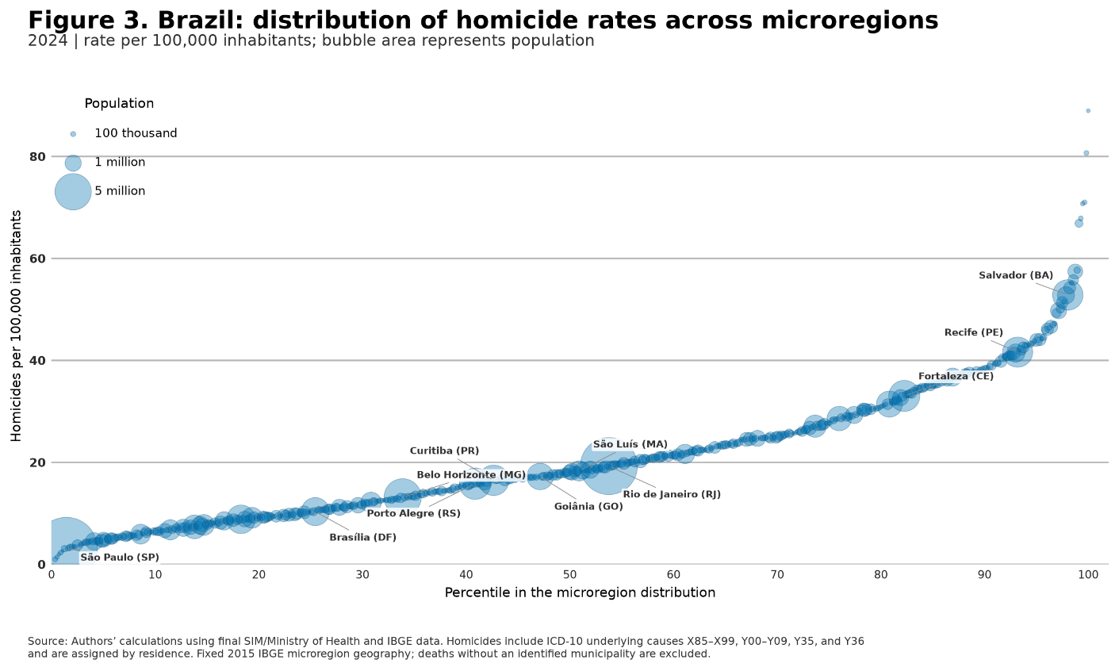
Figure 4 maps the absolute change in each microregion’s homicide rate between 2016 and 2024. Rates declined in 70.3% of microregions, and the median change was −4.1 homicides per 100,000 inhabitants. This contrasts with the preceding decade. From 2006 to 2015, regional rates had declined in the Center-West, South, and Southeast while increasing in the North and Northeast. In the most recent decade, the decline was not limited to the South and Southeast: in every major region, most microregions had a lower rate at the endpoint.
The map also reveals pockets of increase and local movements against the national pattern. These are concentrated in parts of the North and Northeast but are not confined to a single region. The combination of a widespread decline and localized increases shows that local conditions still diverge from the national trend and may help explain differences between individual perceptions and aggregate indicators.
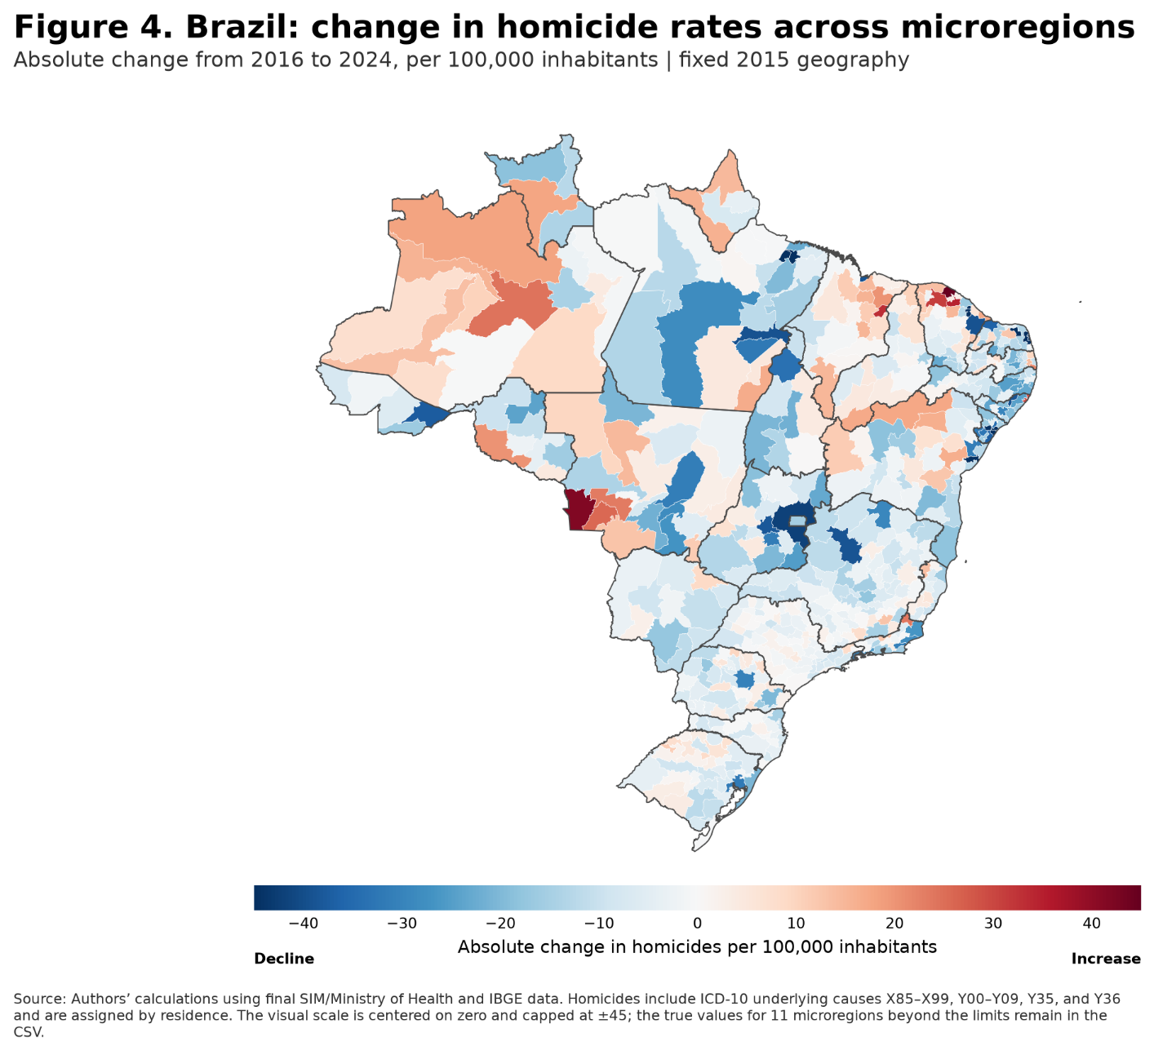
Figure 5 indicates that declines were larger in microregions with higher homicide rates in 2016. In the population-weighted descriptive regression, each additional homicide per 100,000 inhabitants in the initial rate was associated with a 0.50-point more negative change from 2016 to 2024. The pattern is consistent with convergence in homicide rates across microregions. The relationship is not causal and must be interpreted cautiously because the initial rate also enters mechanically into the change variable.
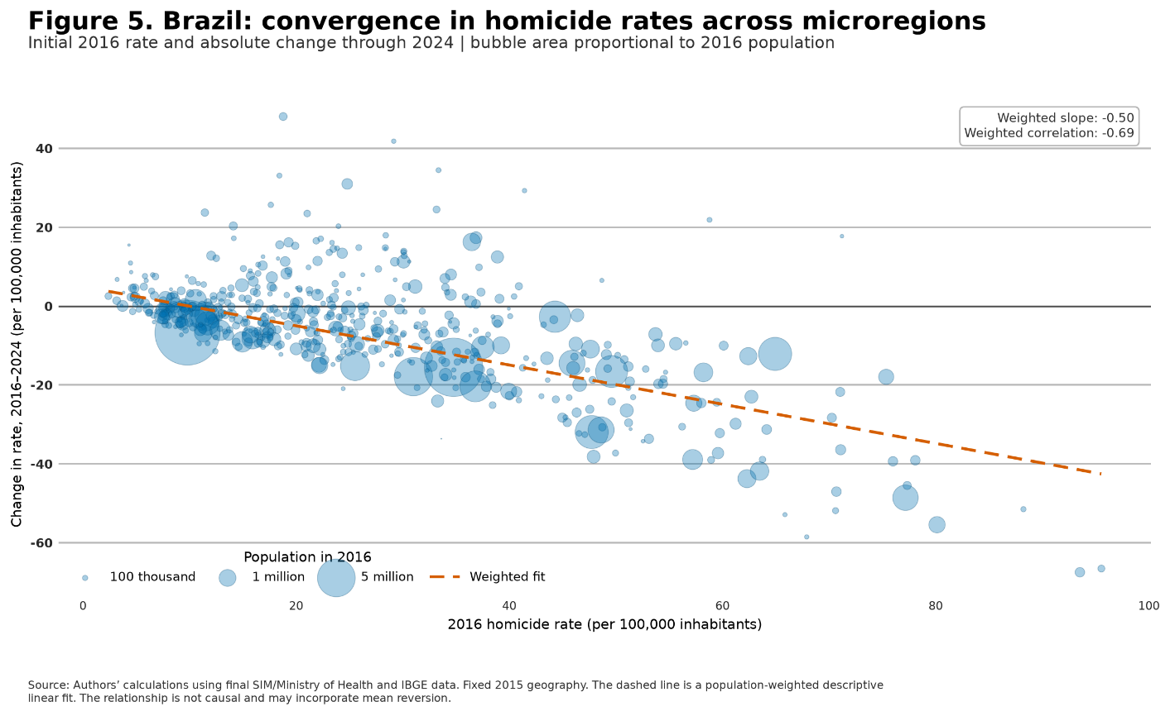

4. Estimating the economic costs of crime in Brazil
This section describes the components of the economic costs of crime in Brazil. The accounting framework comprises seven components: public security, private security, incarceration and the incarceration benefit, insurance and material losses, productive-capacity losses from homicide, judicial costs, and medical and therapeutic services. Unless otherwise stated, monetary values are expressed in December 2025 reais and adjusted by the IPCA consumer price index. GDP shares use the denominator for the corresponding year.

4.1 Public and private security
Public-security spending comprises expenditures classified under this budget function by the federal government, states, the Federal District, and municipalities. The series combines a historical reconstruction by the Institute for Applied Economic Research (Ipea) based on National Treasury records, consolidated public accounts, and the Brazilian Public Security Yearbooks. It covers policing, civil defense, information and intelligence, and other subfunctions recorded as public security.
Figure 6 shows that real spending increased from R$61.4 billion in 1996 to R$163.1 billion in 2025. As a share of GDP, however, it remained close to 1.3% at both endpoints. Although real spending increased by 165.8%, the economy and the budget allocated to the function grew at similar rates over the full period. In 2025, states and the Federal District accounted for 80.5% of the total, compared with 11.1% for the federal government and 8.4% for municipalities. This concentration reflects the federal organization of police forces and most operational security activities.
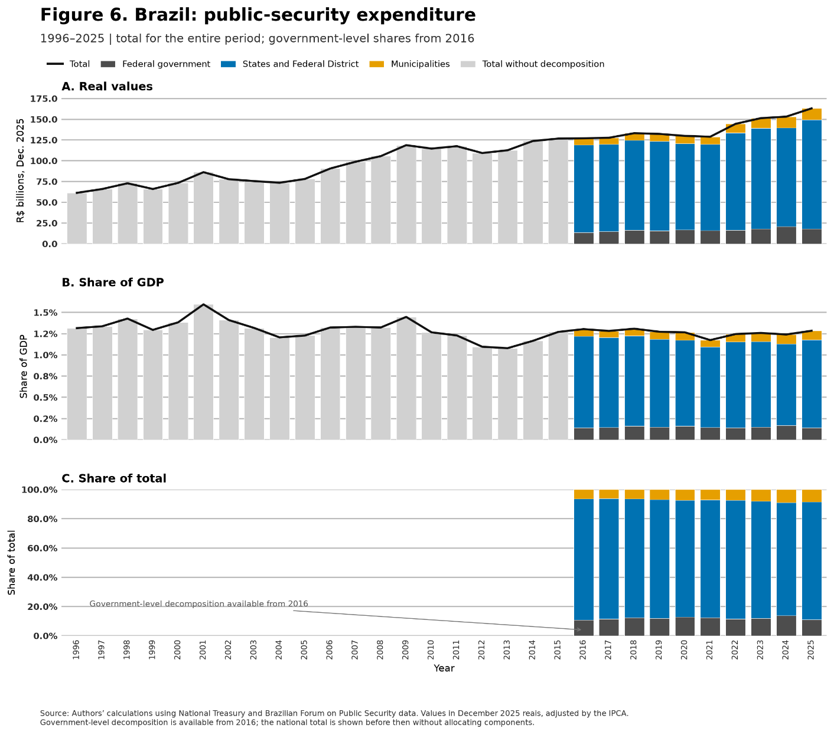
Private-security spending is estimated through the annual cost of labor in surveillance, guard, and protection occupations. The underlying survey is the annual National Household Sample Survey (PNAD) for 1996–2011 and the Continuous PNAD for 2012–2025. Formal-sector earnings are multiplied by 1.86 to incorporate payroll charges and employer-paid benefits. Informal provision enters through the earnings mass estimated directly from household surveys, without employment benefits. Equipment, electronic systems, and insurance not observed as labor costs remain outside this component.
Figure 7 shows that the estimated cost of private security rose from R$40.4 billion in 1996 to R$63.8 billion in 2025, after peaking at R$66.7 billion in 2014 in December 2025 reais. Its GDP share fell from 0.9% to 0.5%. Approximately one million formal workers and 300,000 informal workers held security-related occupations. Formal provision dominated the series and represented 90.1% of the total in 2025. Public and private security therefore both increased in real terms over the long run but followed different relative trajectories: public spending maintained approximately its share of GDP and ended the period far above private security, while private-security spending declined relative to national income after the middle of the last decade.
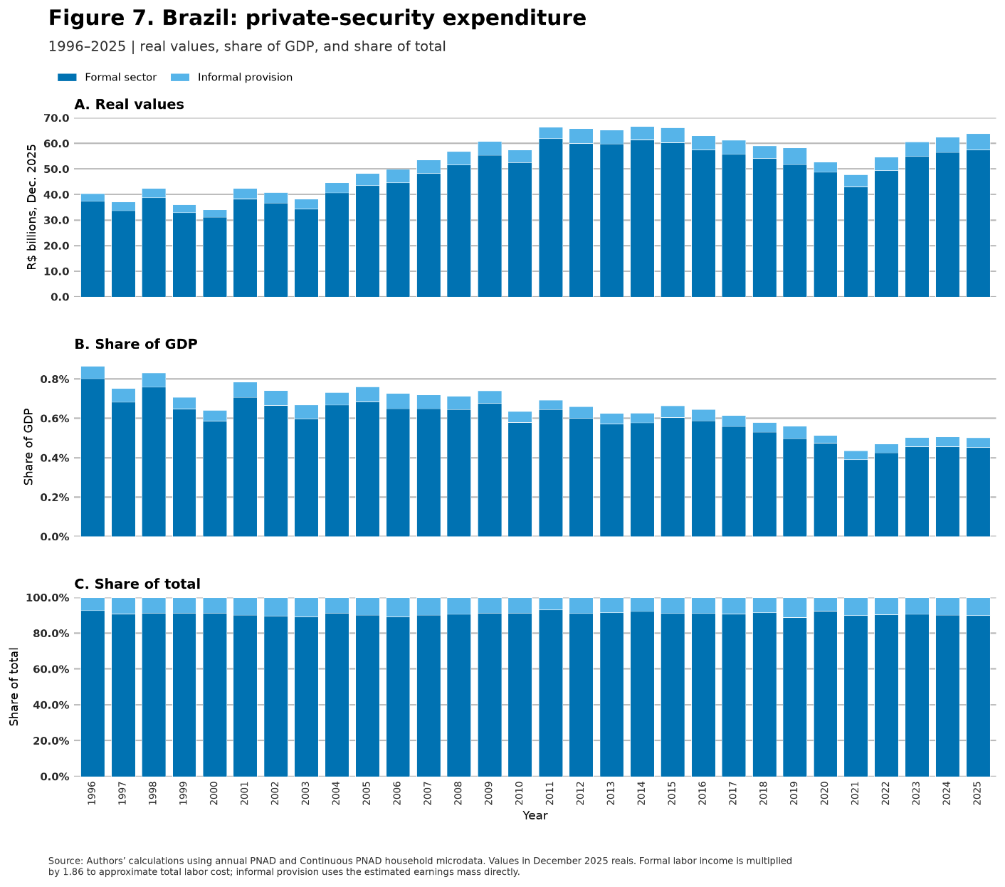
Both components measure resources devoted to preventing, controlling, and responding to crime. This does not make the spending unproductive by definition. Policing, surveillance, and protection may generate substantial social benefits. Their inclusion indicates that crime and insecurity alter the allocation of public and private resources, not that every expenditure should be eliminated or treated as waste.

4.2 Incarceration
Historical incarceration expenditure is difficult to estimate because state budget data are not consistently available. For more recent years, partial information comes from the Accounting Data Collection System for Subnational Governments (SISTN) and the Brazilian Public Sector Accounting and Fiscal Information System (Siconfi), maintained respectively by Caixa Econômica Federal and the National Treasury. These systems identify state expenditure committed under the subfunction “Custody and Social Reintegration.” To reduce double counting, identifiable federal transfers to states are subtracted from the federal component. When historical records are unavailable, the series uses explicit backcasts based on the prison population and civil-service compensation; in recent years it combines data from SIGA Brasil, the National Treasury, and Siconfi.
The account also includes payments of the incarceration benefit (auxílio-reclusão). This is a social-security transfer to the families of eligible insured workers, not a direct use of resources by the prison system. It represents a small share of the component: in 2025, custody and reintegration accounted for 98%, and the benefit for 2%.
Figure 8 shows that the component increased from R$1.4 billion in 1996 to R$13.3 billion in 2025, while its GDP share rose from approximately 0.03% to 0.10%. The growth is substantial, although the component remains small relative to public security, insurance and material losses, and judicial costs. Discontinuities in particular years also reflect data availability, accounting-conversion rules, and documented imputations. The long-run trend is therefore more informative than isolated annual movements.
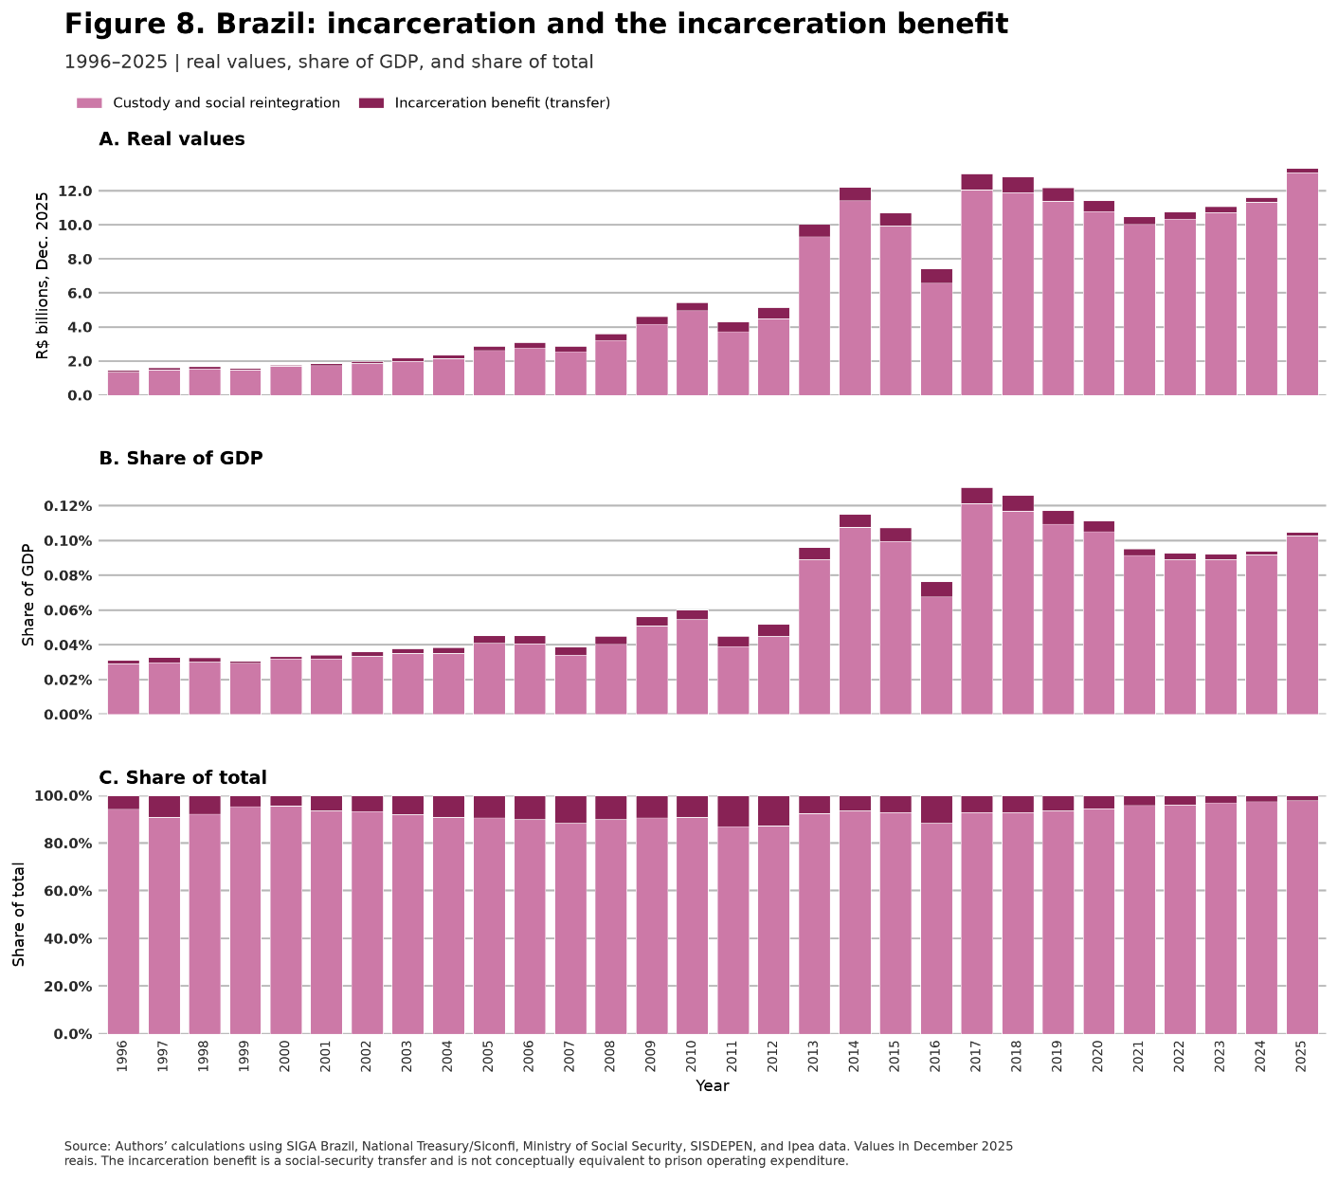

4.3 Insurance and material losses
This component combines two distinct flows. Direct premiums paid for automobile, property, transport, and cargo insurance purchase protection and risk transfer. Material losses capture property and cargo claims as well as an estimate of the value of stolen vehicles that were not recovered. Premiums and claims come from the Statistical System of the Superintendence of Private Insurance (Susep); vehicle losses combine incidents reported in the Brazilian Public Security Yearbook, reference prices, and a fixed recovery assumption.
Figure 9 shows that the combined value increased from R$57.9 billion in 1996 to R$96.2 billion in 2025, while falling from 1.2% to 0.8% of GDP. In 2025, automobile premiums represented 39% of this category and property premiums 32%. Vehicle losses, which accounted for a much larger share at the beginning of the series, fell to 10%; property, transport, and cargo losses completed the account. The changing composition reflects expansion of the insurance market, the recent decline in vehicle robbery, and revisions to the inputs used to value assets.
An insurance premium is not the same as a destroyed asset: it also pays for administration, intermediation, and risk transfer. The broad accounting scenario also preserves possible overlap among premiums, claims, and material losses. The sum is useful for measuring purchased protection and recognized damages, but it should not be interpreted as a net welfare loss.
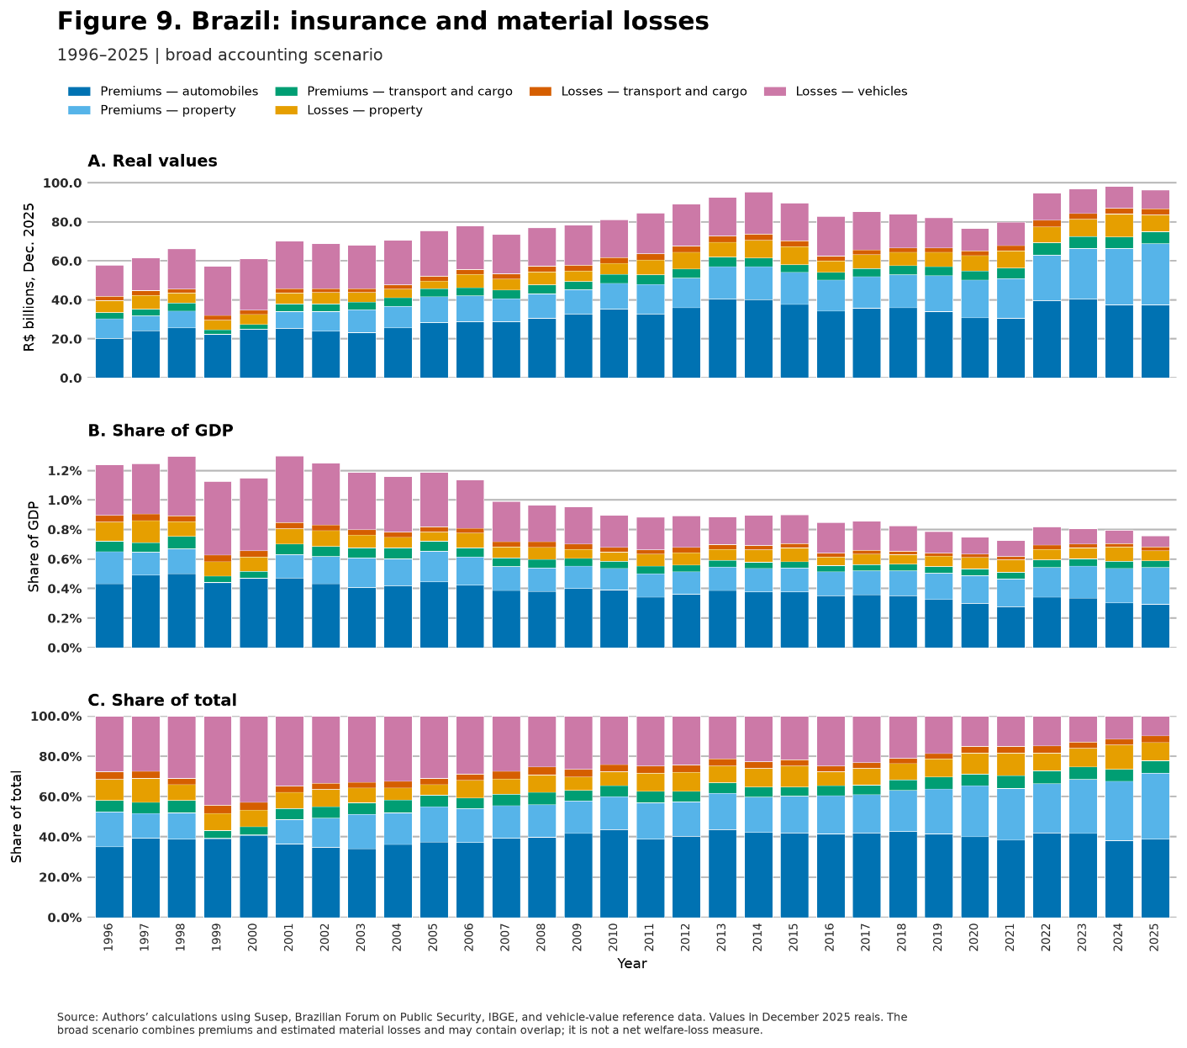

4.4 Productive-capacity losses
Productive-capacity losses estimate the present value of labor income that would otherwise have been generated by homicide victims. For each victim, the methodology combines expected income and employment probabilities by age and major region, survival profiles, and the remaining working-life horizon. It uses the 2025 Continuous PNAD, IBGE’s 2024 Life Table, real income growth of 2% per year, a 3% discount rate, and a horizon through age 90. The homicide distribution comes from SIM and uses the same set of causes as the territorial analysis.
The estimate captures expected labor production, not the full value of human life. Nonmonetary dimensions—including pain, suffering, quality of life, and other intangible losses—are not valued. The measure summarizes the present value of income no longer generated because a person exits the labor force. Results depend on average income and employment profiles, survival, and the selected growth and discount rates, so the order of magnitude and trajectory are more informative than an appearance of exact precision.
In 2025, the estimated average loss was R$715,400 per homicide. The amount varies with a victim’s age and region: earlier deaths interrupt a longer stream of expected earnings and therefore tend to generate larger productive losses. The concentration of homicide among young people raises the economic importance of this channel, although the estimate remains limited to expected labor income and does not assign a monetary value to intangible losses.
Figure 10 shows an estimated loss of R$35.5 billion in 1996, a peak of R$50.3 billion in 2017, and a decline to R$29.2 billion in 2025. Its GDP share fell from 0.8% to 0.2%. The trajectory reflects both homicide incidence and the victims’ age and regional distribution. For 2025, the national estimate applies an aggregate of 40,775 homicides to the estimated average cost per homicide in 2024 because complete age-level microdata for the new year were not yet available.
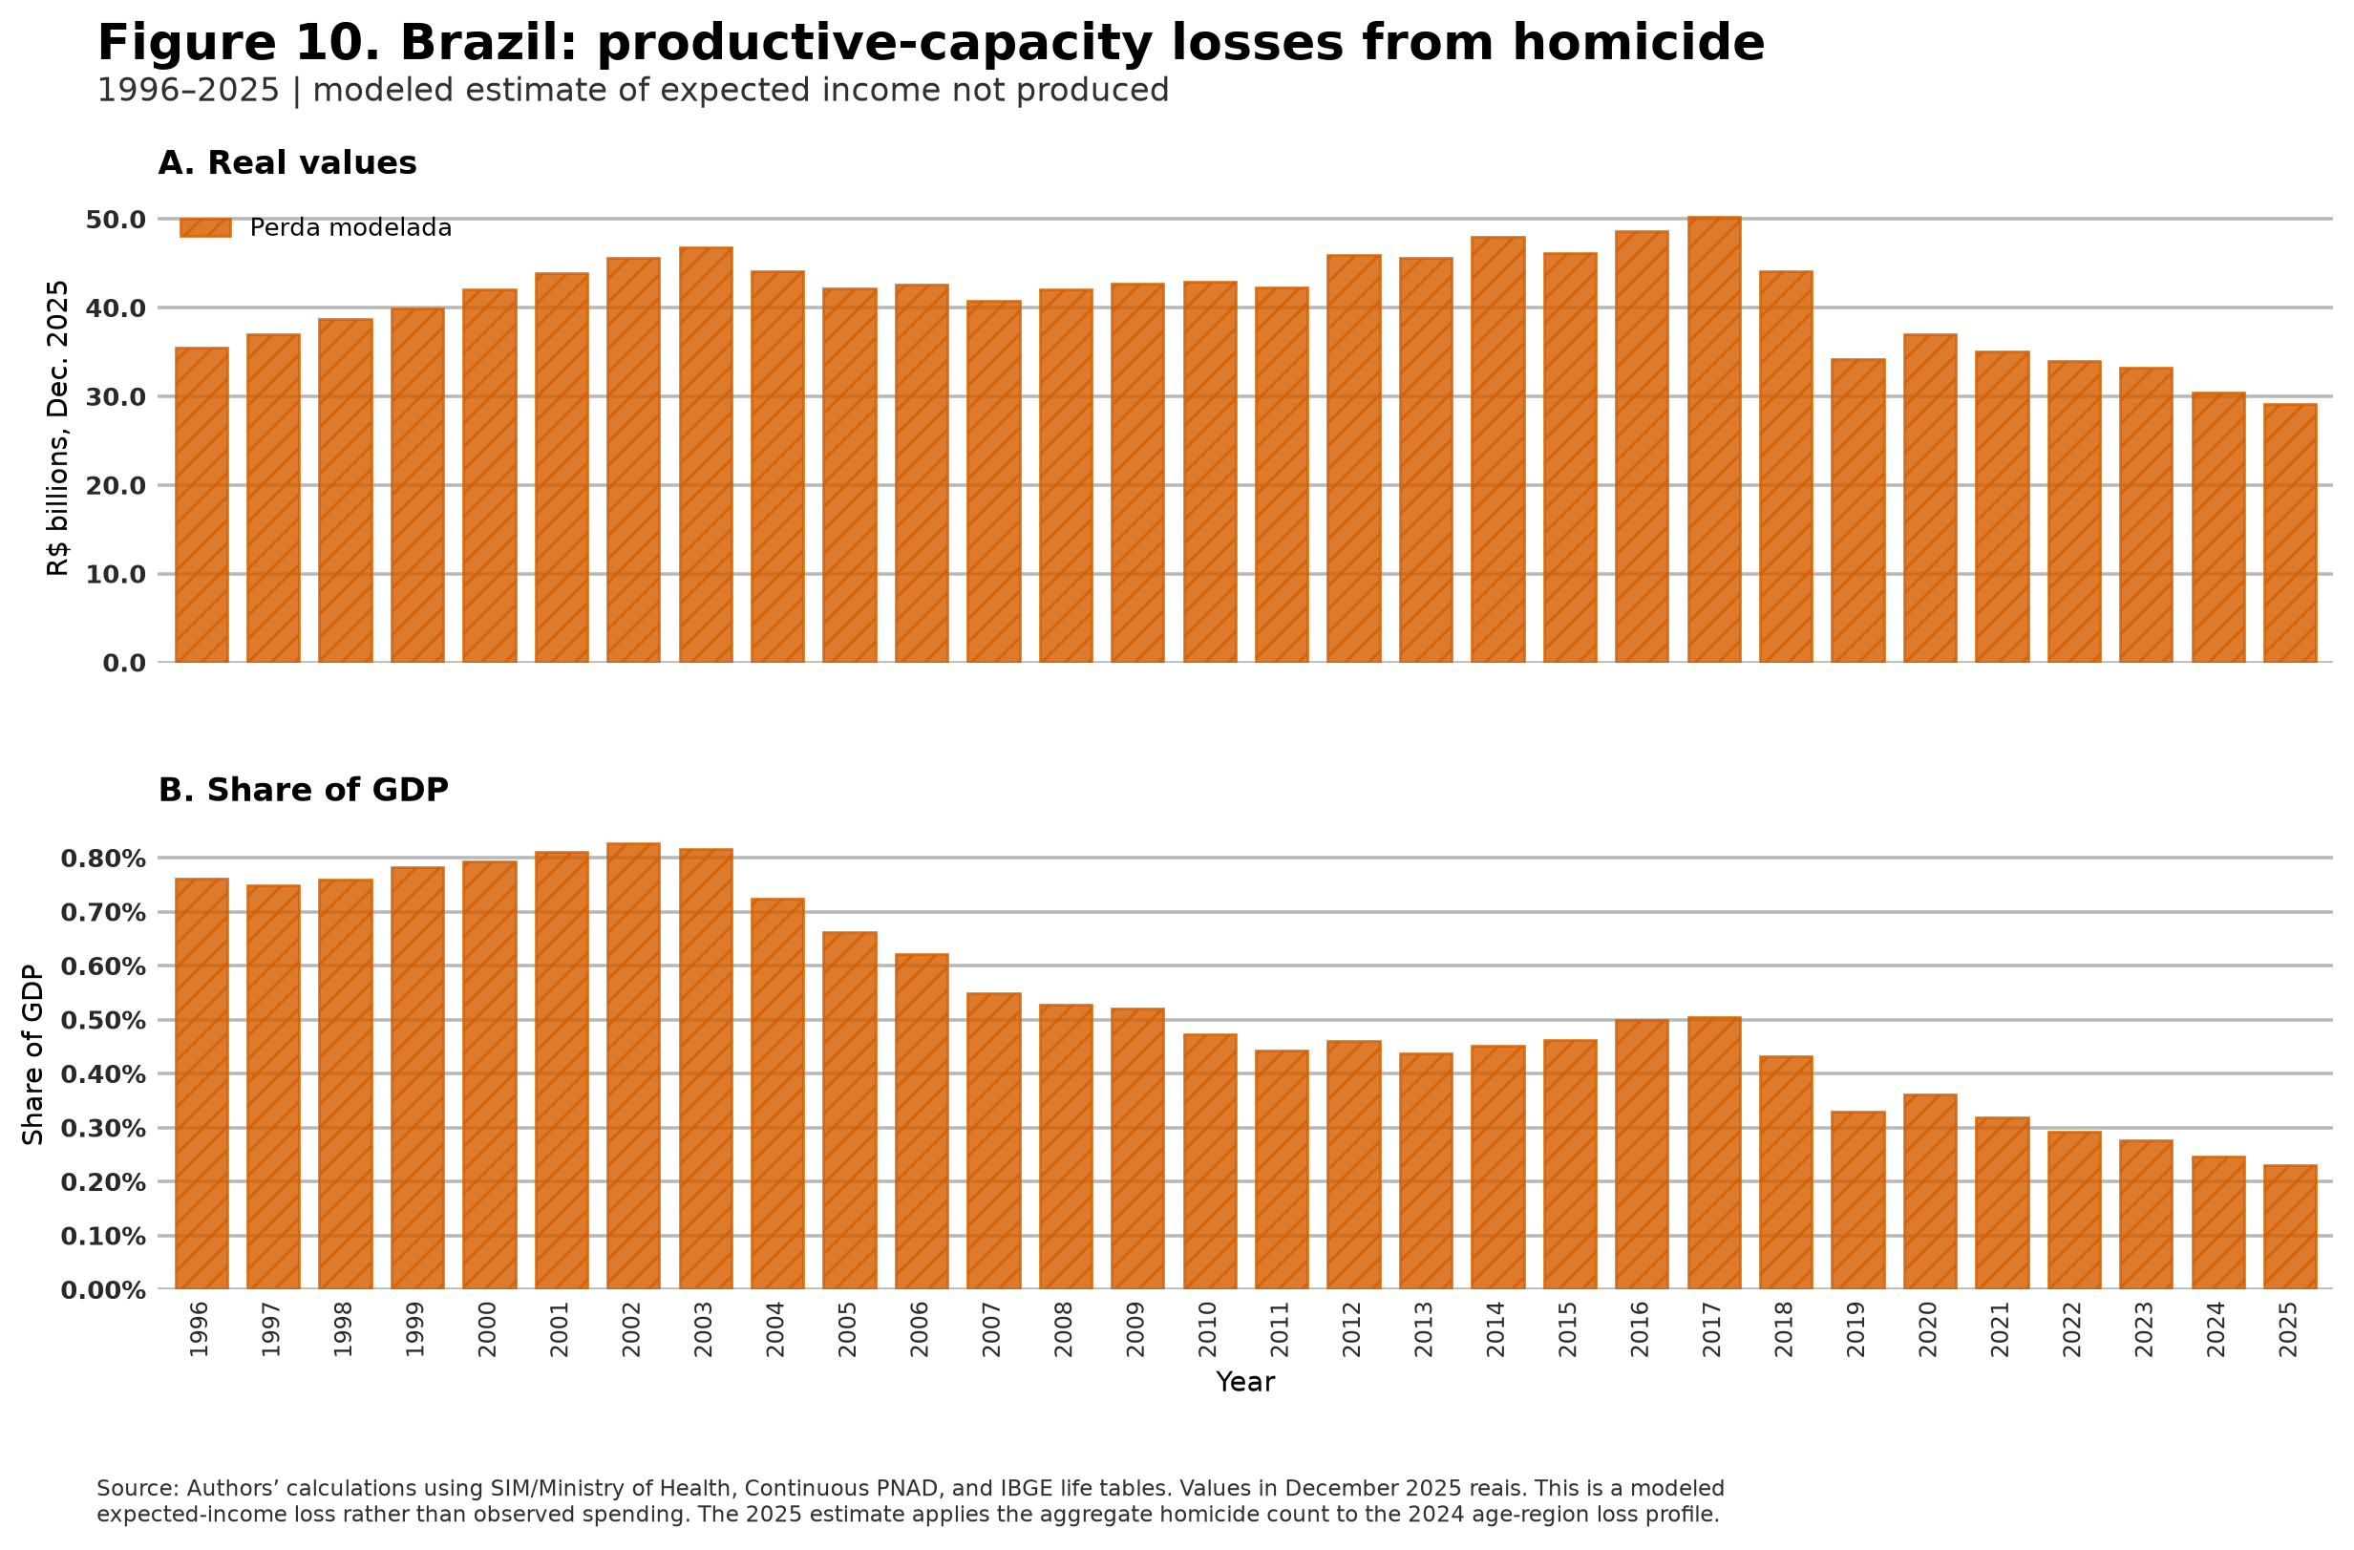

4.5 Judicial costs
Crime-related judicial costs include the criminal share of state-court expenditures, the criminal share of expenditures by state and Federal District public prosecutors, and a reference value for defense services in first-instance criminal proceedings and Special Criminal Courts. Court and public-prosecutor expenditures are attributed to criminal matters using information on decisions, institutional activity, and processing time. Defense is valued by multiplying new cases by reference fees from the Brazilian Bar Association. To keep the exercise tractable, the calculation focuses on defense, prosecution, and state courts, where a disproportionate share of criminal cases is concentrated. Federal courts, the federal prosecution service, higher courts, and federal defense services remain outside the calculation.
Figure 11 shows that the real total rose from R$23.9 billion in 1996 to R$73.7 billion in 2025, while its GDP share increased from 0.5% to 0.6%. In 2025, criminal-defense services represented 52% of the component, public prosecutors 31%, and state courts 17%. The real expansion reflects both institutional expenditure growth and the valuation of caseloads; historical extrapolations and imputations for missing cells limit precise year-to-year comparisons.
This component measures resources required to operate institutions that process and resolve criminal matters. It does not imply that every judicial expenditure is a social loss: the justice system provides public services and legal guarantees. Nonetheless, part of these resources is directed toward criminal cases rather than other matters. Under this report’s accounting convention, the value records the scale of institutional resources mobilized in response to crime.
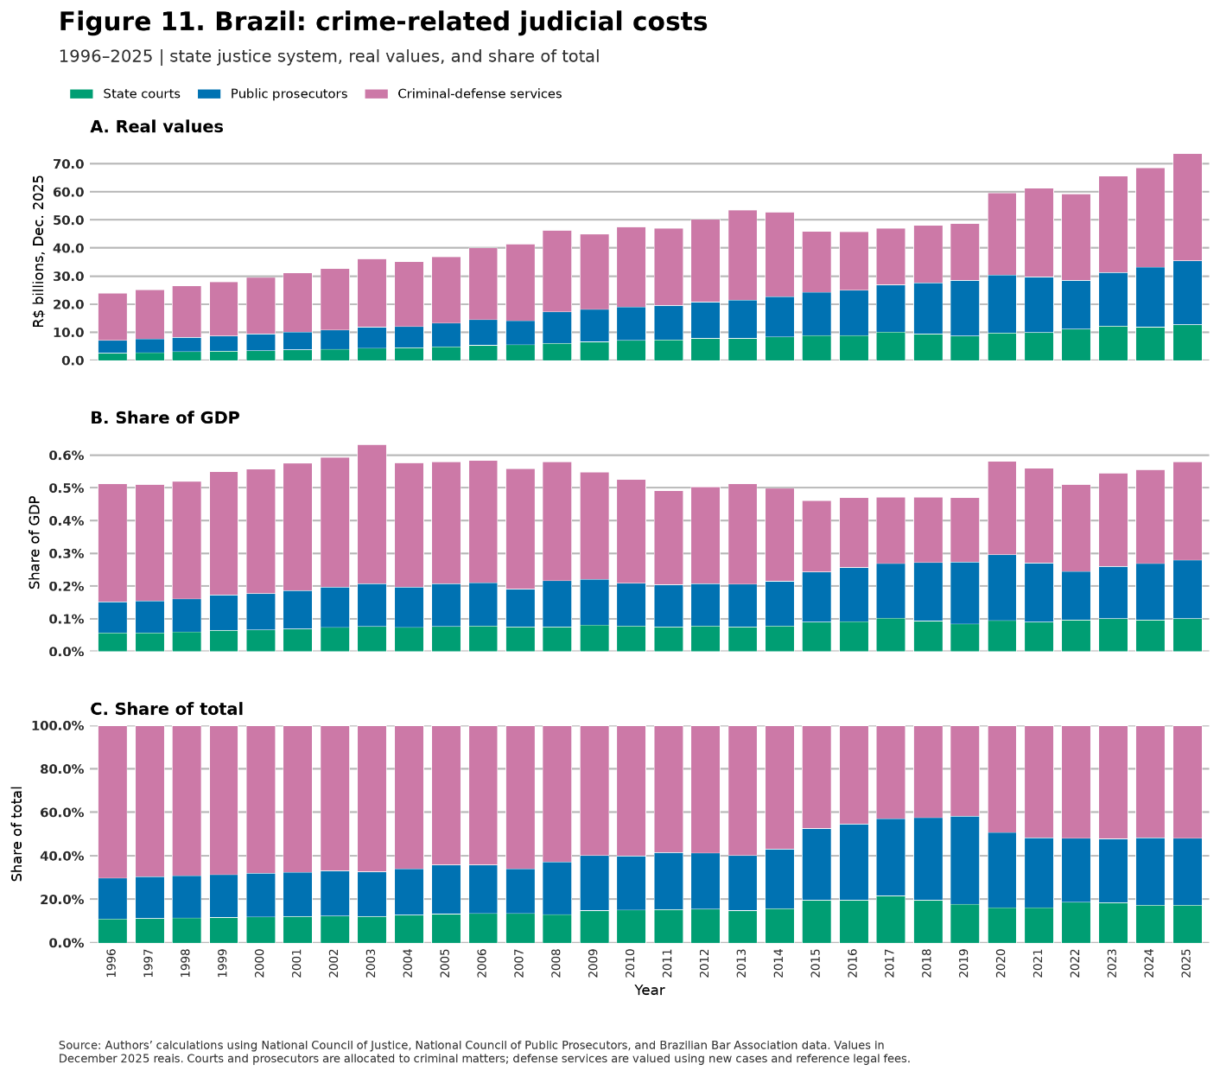

4.6 Medical and therapeutic services
The medical component combines payments by Brazil’s Unified Health System (SUS) for hospital admissions due to assault with the expected income not produced during the hospital stay of nonfatal victims. Records come from Hospital Admission Authorizations in SIH/SUS; temporary productive losses use actual hospitalization days and income and employment profiles from the Continuous PNAD. Hospital deaths do not receive the temporary-loss component, avoiding overlap with the long-run productive-capacity loss from homicide. The measure excludes outpatient care, emergency care without admission, private health care, medication, rehabilitation, and time away from work after discharge.
National cells do not report the number of assault-related admissions for 1996 and 1997. The series records 42,500 admissions in 1998, 57,500 in 2015, and 52,800 in 2025. In addition to hospital expenditure, the measure includes temporary productive-capacity loss during the hospitalization of nonfatal victims. Figure 12 shows that in 2025 medical and temporary productive costs totaled R$120 million, or approximately 0.001% of GDP. This is by far the smallest component, representing only 0.03% of measured economic costs. Its small value partly reflects the conservative scope of SIH rather than the absence of broader health consequences from violence.
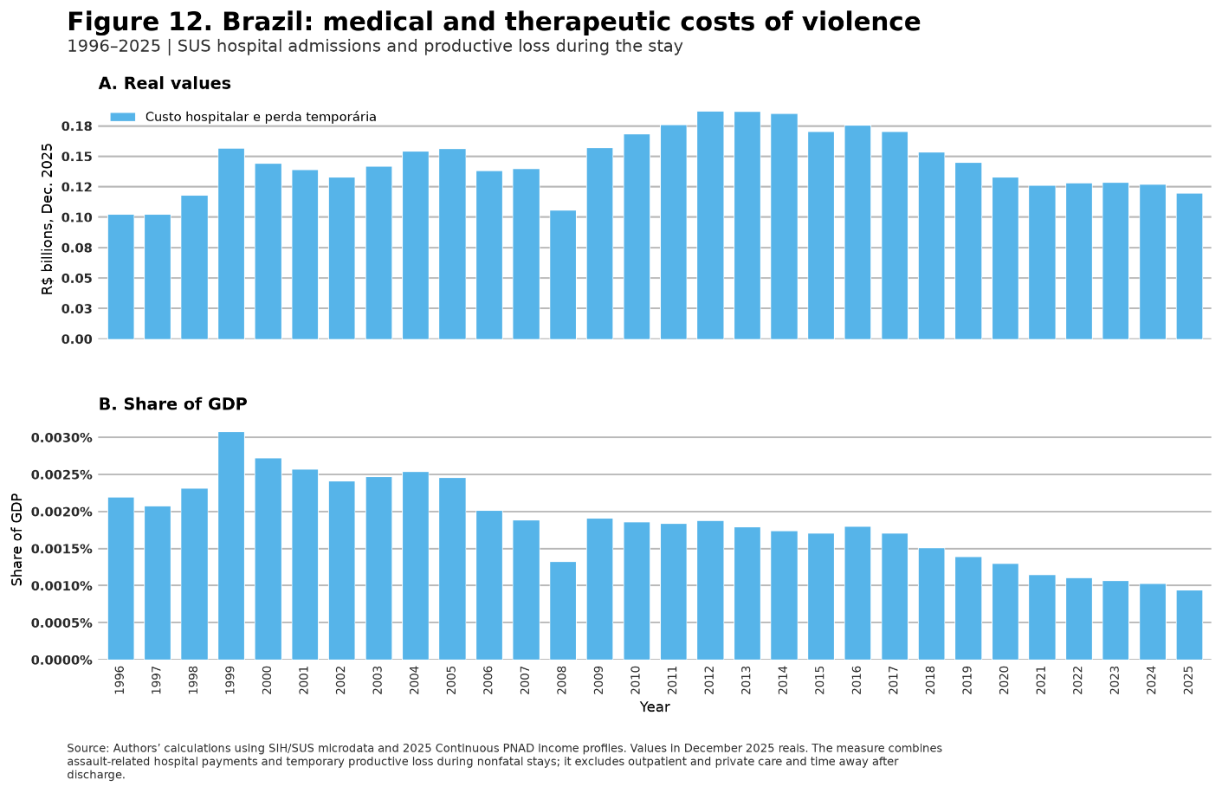

4.7 Total economic costs of crime
In 2025, the seven components totaled R$439.5 billion, equivalent to 3.5% of GDP. In December 2025 reais, the total was R$220.6 billion in 1996 and R$385.9 billion in 2015. The sum of annual values over the thirty years was approximately R$10.0 trillion. The real value nearly doubled from the beginning to the end of the series, but its relative burden fell: from 4.7% of GDP in 1996 to 3.9% in 2015 and 3.5% in 2025. Economic growth therefore exceeded the increase in the accounting aggregate over the full horizon.
The distinction between level and GDP share is central to Figure 13. The real cost increased through the middle of the last decade, fell from 2017 to 2021, and then resumed growth, reaching its highest level in 2025. Relative to GDP, the long-run trend was downward, albeit with fluctuations: the burden had already declined in the 2000s and reached its minimum in 2021 before partially recovering. Brazil now mobilizes more real resources and records larger losses in reais than at the beginning of the series, but the sum represents a smaller share of national income.
Public security was the largest component in 2025, at 37% of the total. Insurance and material losses accounted for 22%, judicial costs for 17%, and private security for 14%. Productive-capacity losses represented 7%; incarceration and the incarceration benefit 3%; and medical and therapeutic services a negligible share. The composition shifted toward greater weight for public security and judicial costs and less for productive-capacity losses and private security. This shift coincided with lower homicide and property-crime indicators, but the exercise does not identify its causes.
The total should be interpreted as a broad accounting aggregate. It combines observed expenditures, valued legal services, a social-security transfer, insurance premiums, material losses, and modeled future income. The insurance and material-loss component may contain overlap, and the components are not equivalent in welfare terms. Even so, the sum measures the order of magnitude of observable resources and economic losses associated with crime under a transparent and replicable convention.
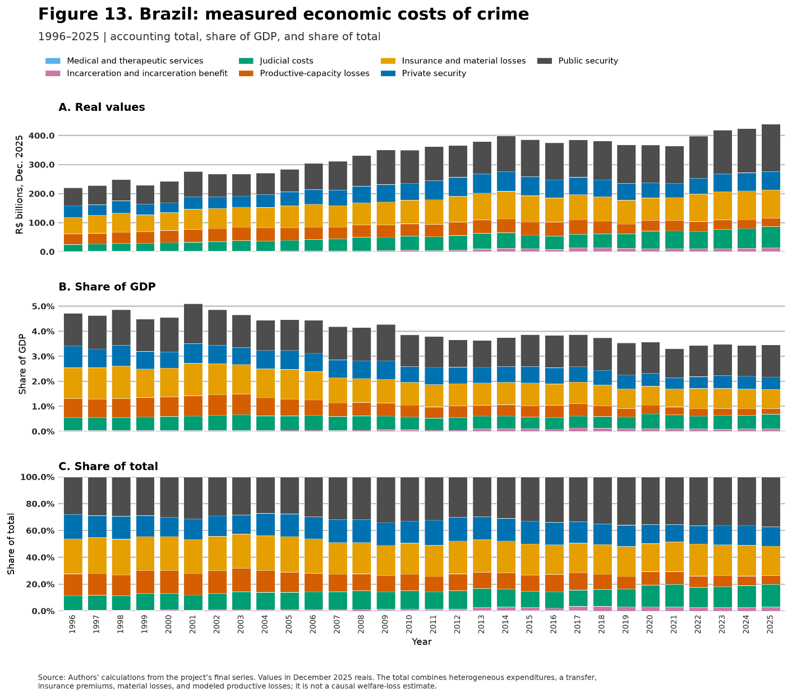

5. Regional heterogeneity in the economic costs of crime
The national aggregate conceals substantial heterogeneity across Brazil’s 27 states and does not show where the burden is concentrated or which components produce it in each territory. Differences in income, crime incidence, prices, institutional structure, and expenditure choices lead to very different burdens and compositions. This section presents harmonized state-level estimates for 2016 and 2025.

5.1 Distribution of state-level costs
Panel A of Figure 14 relates measured economic costs as a share of state GDP to real GDP per capita in 2025. The median state recorded a burden of 4.9% of GDP; half of the observations lay between 3.2% and 6.4%. The range is large: Amapá and Acre are at the top, at approximately 10% and 9%, respectively, while Santa Catarina and the Federal District are close to 2%.
The association between income and burden is negative. The simple correlation between the natural logarithm of GDP per capita and costs as a share of GDP was −0.78. Lower-income states tend, in this cross section, to devote or lose a larger share of output through the measured components. Several features affect this calculation. Judicial and public-security costs have fixed components that do not vary proportionately with state size and may therefore represent high GDP shares in smaller states. A high burden can reflect both larger losses and greater mobilization of resources in response to crime.
Panel B shows that there is no single composition behind the highest totals. Public security displays the greatest cross-state dispersion in GDP points, followed by insurance and material losses and judicial costs. In Amapá, judicial costs and public security occupy much of the bar; in Acre, public security carries particularly high weight; in Piauí and Pernambuco, insurance and material losses are more prominent. Total heterogeneity therefore cannot be attributed solely to homicide rates or a single expenditure policy.
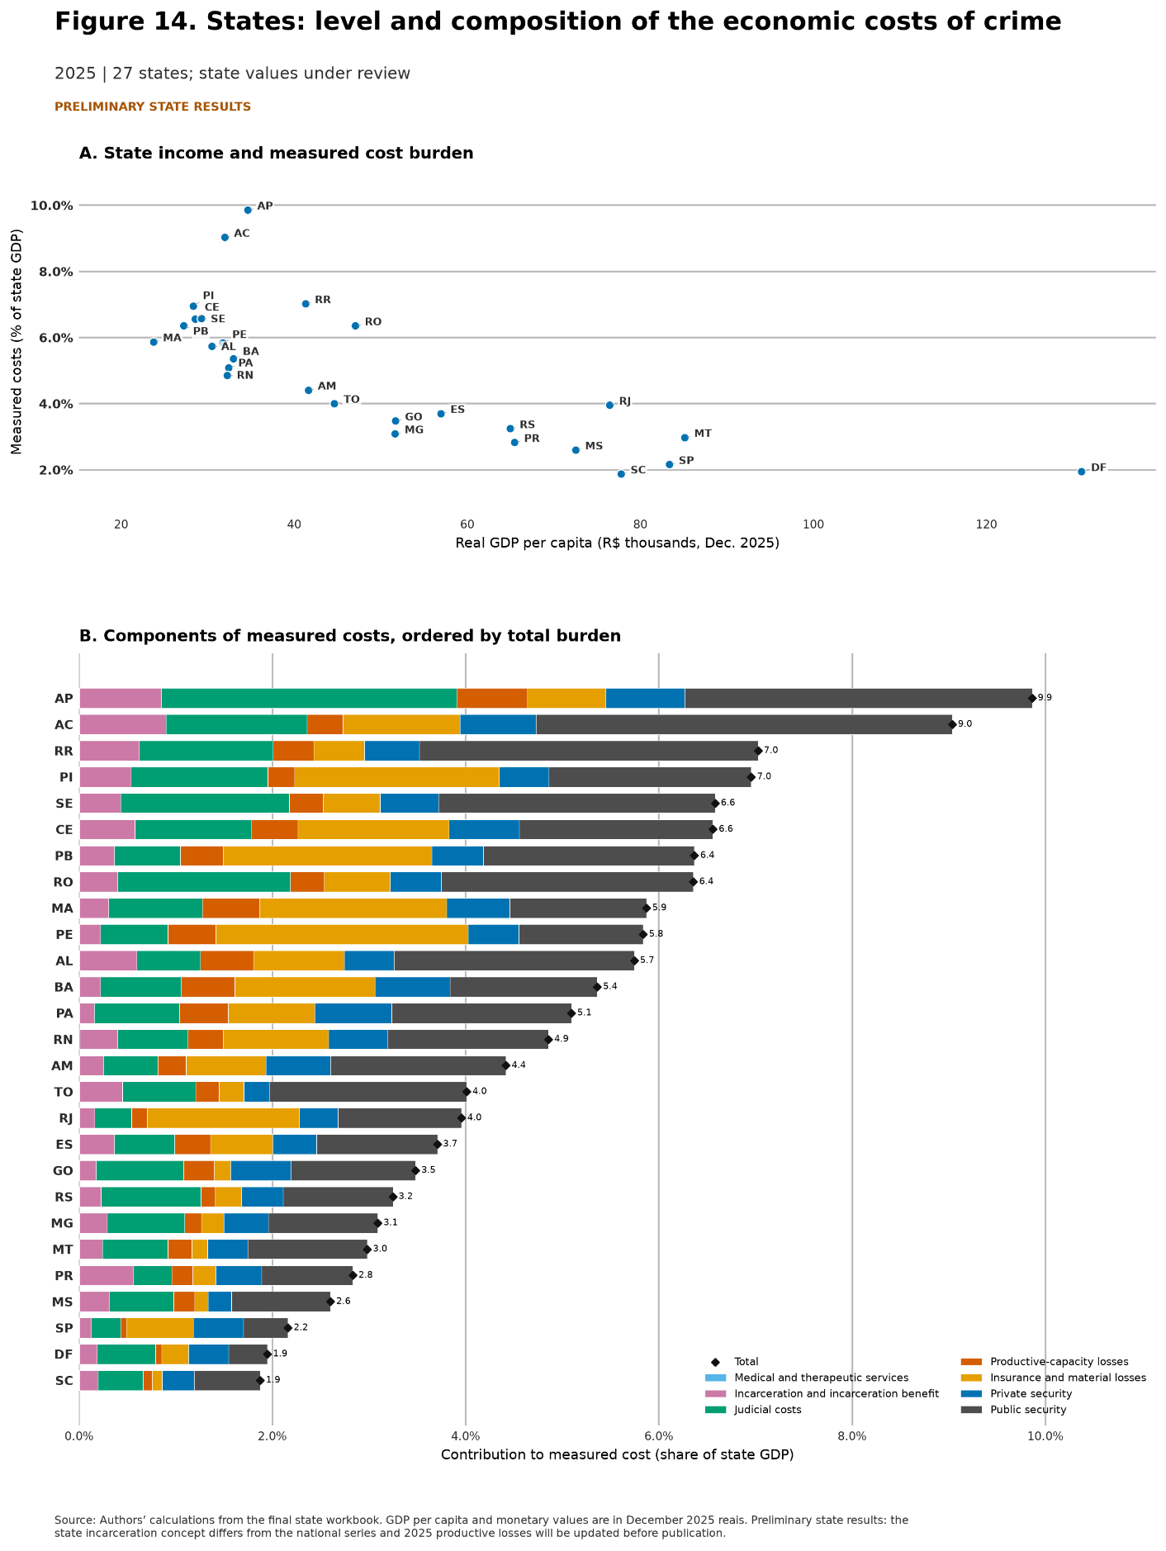

5.2 How the economic burden changed over time
Figure 15 tracks each state between two combinations of income and cost: the initial point in 2016 and the endpoint in 2025. Every state moved to the right, indicating higher real GDP per capita; median growth was 24.4%. Vertical movement was less uniform. Income increased and the crime burden declined in 19 states; both increased in the other eight. The median change was a reduction of 0.4 percentage point of GDP.
The largest declines occurred in Goiás, Tocantins, and Rio Grande do Norte. Acre, Amazonas, Bahia, Ceará, Paraíba, Pernambuco, Piauí, and Roraima moved against the dominant pattern, with a higher measured burden despite growth in income per capita. Part of the ratio’s decline may result from GDP growing faster than the numerator; part may reflect lower losses, expenditure changes, or a different component composition.
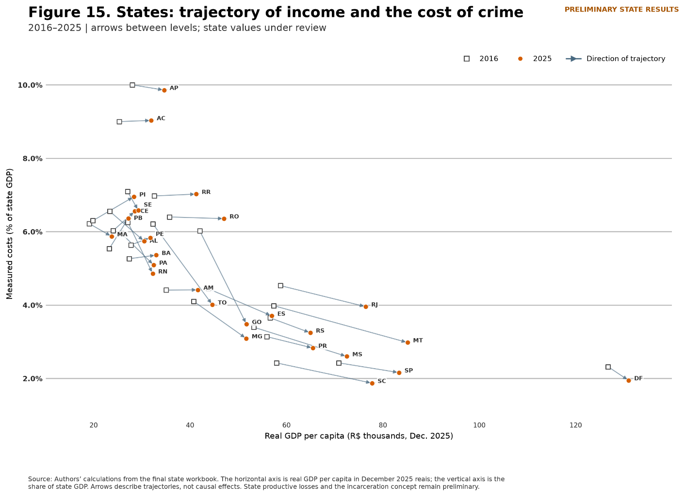
The regional evidence reinforces two conclusions. First, the national aggregate conceals differences of several GDP points across states. Second, states with similar burdens may reach them through very different combinations of public spending, private protection, institutional operation, and economic losses. Updating the state data may change individual positions, but the dispersion in levels, composition, and trajectories already shows that the territorial dimension is essential to interpreting the economic costs of crime.

6. Conclusion
In 2025, the measured economic costs of crime reached R$439.5 billion, equivalent to 3.5% of GDP. This order of magnitude summarizes the report’s central result: even after recent improvements in lethal-violence indicators, crime remained associated with hundreds of billions of reais in public and private expenditures, institutional services, material losses, and production that did not take place.
The long-run trajectory combines a real increase with a relative decline. In December 2025 reais, the total rose from R$220.6 billion in 1996 to R$439.5 billion in 2025, while falling from 4.7% to 3.5% of GDP. The aggregate increased through the middle of the last decade, declined from 2017 to 2021, and then resumed growth. Resources and losses are therefore larger in real terms but increased less than national income.
The composition shows why the economic burden of crime extends beyond police budgets. Public security accounted for 37.1% of the total in 2025, followed by insurance and material losses at 21.9%, judicial costs at 16.8%, and private security at 14.5%. Productive-capacity losses, incarceration and the incarceration benefit, and medical and therapeutic services completed the account. Governments, families, firms, and institutions mobilize resources in response to insecurity, while property damage and premature death remove value from the economy.
Crime indicators improved, but the remaining burden is severe and unequal. Brazil’s intentional-homicide rate fell between 2016 and 2024, yet the country still occupied the 86.0th percentile of the international distribution analyzed here. Within Brazil, 70.3% of microregions experienced a decline over the same period. The reduction was greater where initial rates were higher, a pattern consistent with descriptive convergence. Nevertheless, dozens of microregions still had very high rates in 2024, and several indicators of sexual and gender-based violence moved in the opposite direction from homicide.
The national aggregate also conceals substantial state-level differences. In the preliminary 2025 results, half of the states had burdens between 3.2% and 6.4% of state GDP. From 2016 to 2025, this ratio declined in 19 states and increased in eight even though real GDP per capita rose in all of them. States also differ in the composition of public and private security, judicial costs, incarceration, insurance and material losses, and productive-capacity losses. Updating the state-level series may alter individual positions but will not remove the importance of the territorial dimension.
The total must be interpreted within the limits of the exercise. It is a broad accounting of resources and losses associated with crime, not a causal estimate of crime’s effect on GDP, a structural welfare calculation, or a claim that all components are equivalent. Public and private security are resources deployed in response to insecurity and may generate benefits; the incarceration benefit is a transfer; insurance premiums are not destroyed assets; and productive-capacity losses depend on assumptions about income, employment, survival, growth, and discounting. The value of the aggregate lies in making orders of magnitude visible without erasing these distinctions.
This perspective broadens the relevant criterion for public-policy analysis. Evaluating an intervention should consider not only its direct budget cost but also the expenditures and losses it may avert, while respecting the limits of evidence on its effects. State heterogeneity indicates that diagnoses and evaluations must also consider which channel dominates in each territory. The report does not identify which policies produce the highest return. It provides an accounting basis for future evaluations to compare costs with fiscal, private, material, medical, and productive benefits more completely.

Ipsos, “Crime e violência se mantêm no topo das preocupações dos brasileiros” (https://www.ipsos.com/pt-br/crime-e-violencia-se-mantem-no-topo-das-preocupacoes-dos-brasileiros), accessed August 30, 2026.
Other studies accounting for the economic costs of crime in Brazil include: CERQUEIRA, Daniel; SOARES, Rodrigo. “The welfare cost of homicides in Brazil: accounting for heterogeneity in the willingness to pay for mortality reductions.” Health Economics, vol. 25, pp. 259–276, 2016; CERQUEIRA, Daniel; CARVALHO, Alexandre; LOBÃO, Waldir; RODRIGUES, Rute. “Análise dos custos e consequências da violência no Brasil.” Texto para Discussão do Ipea, no. 1284, 2007; and PEREZ-VINCENT, Santiago M. et al. Los costos del crimen y la violencia: ampliación y actualización de las estimaciones para América Latina y el Caribe. Washington, DC: IDB, 2024.
The measure includes ICD-10 underlying causes X85–X99, Y00–Y09, Y35, and Y36, covers all ages, and assigns each death to the municipality of residence.
The comparison uses 2023, the latest year in which both countries appear in the retained UNODC panel: 5.8 homicides per 100,000 inhabitants in the United States and 41.2 in Haiti.
As a diagnostic, the change between endpoint years was compared with the difference between the 2015–2017 and 2022–2024 averages. The correlation between the two measures is 0.89, and the direction of change agrees in 81.5% of microregions. The broad spatial interpretation is therefore robust.
The transition from the annual PNAD to the Continuous PNAD creates a potential break between 2011 and 2012. Occupational classifications were harmonized; after the adjustment, real spending in both years is close to R$65 billion, supporting level comparability at the transition.
There is no descriptive evidence that initially richer states experienced systematically larger declines: the correlation between 2016 GDP per capita and the subsequent change in the burden was −0.15.

