Introduction

This blog is for everyone that like to cook and like gastronomy. If you want to add recipe and This blog site is for anyone who likes to cook. You can comment on other users' meals and review their recipes.

Purpose
We create a website that you can search and find the various recipes of the meals which other people added. You can also create an account with e-mail address and add your own recipes and photos to the website.

Intended Audience
The people that want to search recipes.

Definitions and acronyms

Definitions

Keyword | Definitions
Front-end Development | Front-end web development is the practice of converting data to a graphical interface, through the use of HTML, CSS, and JavaScript, so that users can view and interact with that data.
Back-end Development | Back-end web development connects the web to a database, manages user connections, and powers the web application itself.

References

https://en.wikipedia.org/
https://learntocodewith.me/

Used Technology
We used language that is Python with Django framework and HTML-CSS. Front-end web development is the practice of converting data to a graphical interface, usage of HTML, CSS, and JavaScript, so that users can view and interact with that data.

- Python

Python is an interpreted, object-oriented, high-level programming language with dynamic semantics. Its high-level built in data structures, combined with dynamic typing and dynamic binding, make it very attractive for Rapid Application Development, as well as for use as a scripting or glue language to connect existing components together. Python's simple, easy to learn syntax emphasizes readability and therefore reduces the cost of program maintenance. Python supports modules and packages, which encourages program modularity and code reuse. The Python interpreter and the extensive standard library are available in source or binary form without charge for all major platforms and can be freely distributed.

Often, programmers fall in love with Python because of the increased productivity it provides. Since there is no compilation step, the edit-test-debug cycle is incredibly fast. Debugging Python programs is easy: a bug or bad input will never cause a segmentation fault. Instead, when the interpreter discovers an error, it raises an exception. When the program doesn't catch the exception, the interpreter prints a stack trace. A source level debugger allows inspection of local and global variables, evaluation of arbitrary expressions, setting breakpoints, stepping through the code a line at a time, and so on. The debugger is written in Python itself, testifying to Python's introspective power. On the other hand, often the quickest way to debug a program is to add a few print statements to the source: the fast edit-test-debug cycle makes this simple approach very effective.

- HTML

HTML is a computer language devised to allow website creation. These websites can then be viewed by anyone else connected to the Internet. It is relatively easy to learn, with the basics being accessible to most people in one sitting; and quite powerful in what it allows you to create. It is constantly undergoing revision and evolution to meet the demands and requirements of the growing Internet audience under the direction, the organization charged with designing and maintaining the language.

The definition of HTML is Hyper Text Markup Language.

- Hyper Text is the method by which you move around on the web — by clicking on special text called hyperlinks which bring you to the next page. The fact that it is hyper just means it is not linear — i.e. you can go to any place on the Internet whenever you want by clicking on links — there is no set order to do things in.
- Markup is what HTML tags do to the text inside them. They mark it as a certain type of text (italicized text, for example).
- HTML is a Language, as it has code-words and syntax like any other language.
- CSS

CSS stands for Cascading Style Sheets with an emphasis placed on “Style.” While HTML is used to structure a web document (defining things like headlines and paragraphs, and allowing you to embed images, video, and other media), CSS comes through and specifies your document’s style—page layouts, colors, and fonts are all determined with CSS. Think of HTML as the foundation (every house has one), and CSS as the aesthetic choices (there’s a big difference between a Victorian mansion and a mid-century modern home).

- JavaScript

JavaScript is a scripting or programming language that allows you to implement complex features on web pages — every time a web page does more than just sit there and display static information for you to look at — displaying timely content updates, interactive maps, animated 2D/3D graphics, scrolling video jukeboxes, etc. — you can bet that JavaScript is probably involved. It is the third layer of the layer cake of standard web technologies, two of which (HTML and CSS) we have covered in much more detail in other parts of the Learning Area.

- DJANGO

Django is a free and open source web application framework written in Python. A framework is nothing more than a collection of modules that make development easier. They are grouped together and allow you to create applications or websites from an existing source, instead of from scratch.

This is how websites - even simple ones designed by a single person - can still include advanced functionality like authentication support, management and admin panels, contact forms, comment boxes, file upload support, and more. In other words, if you were creating a website from scratch you would need to develop these components yourself. By using a framework instead, these components are already built, you just need to configure them properly to match your site.

The official project site describes Django as "a high-level Python Web framework that encourages rapid development and clean, pragmatic design. Built by experienced developers, it takes care of much of the hassle of Web development, so you can focus on writing your app without needing to reinvent the wheel. It’s free and open source."

Django offers a big collection of modules which you can use in your own projects. Primarily, frameworks exist to save developers a lot of wasted time and headaches and Django is no different.

You might also be interested in learning that Django was created with front-end developers in mind. "Django’s template language is designed to feel comfortable and easy-to-learn to those used to working with HTML, like designers and front-end developers. But it is also flexible and highly extensible, allowing developers to augment the template language as needed."

If you're going to be working with Python, especially for web applications or web design, you'll want to remember the Django framework. It will certainly come in handy.

CherryPy is another Python-based framework that is great to work with, although it is designed with the absolute minimalist in mind. It's a framework you'll want to explore after you already have some experience working with Python.

Requirements

- Functional requirement

- Buttons must be active and functional
- Recipegram must be redirect index
- User must search for any recipes with button in recipes page
- User must go to the details page with title or read more button
- User must go to profile and add recipes.
- If User want to sign in profile, User must enter correctly
- If the user enters the password incorrectly, the system will prompt you to re-enter the password.
- User cannot comment without registering

- Diagrams

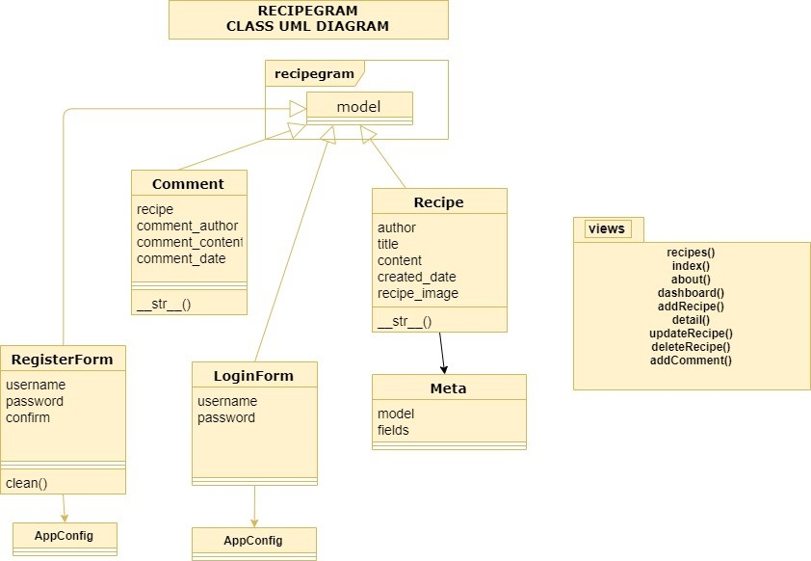

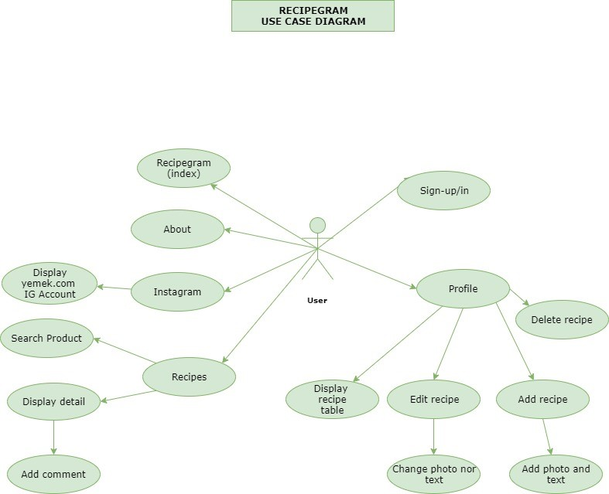

Project Experiences

Positive Experiences
The experience we learned from this project is to build a web page. Using bootstrap and various design tool such as JavaScript are learned.

Improvement Possibilities
We have experience that if we had organized our time according to requirements then we can make project more successful.

