IN3062 Introduction to Artificial Intelligence
Group Report

Credit Risk Classification Using Applicant and Credit History Data

Authors: Hassan Mirza, Omer Chaudhry, Abdullah Sarkar

Link to GitHub: https://github.com/omercha/in3062-coursework

1. Introduction
Data source: https://www.kaggle.com/datasets/rikdifos/credit-card-approval-prediction

We chose to study this dataset because credit scoring is a realistic scenario and application of machine learning in the financial sector. In banking, determining whether a customer can be approved for a credit card is often a manual and time-consuming process that can involve a substantial amount of human bias. By using this dataset, we aim to investigate the classification of "good" versus "bad" clients using historical personal and financial data. We frame this as a binary classification task to predict high-risk clients from their attributes. This study allows us to explore the challenges of working with real world data and demonstrates how predictive modelling can reduce financial risk for banks while ensuring a fairer application process for consumers.

2. Methods

To prepare our data we used a common split across all models: 15% validation, 15% test (implemented as 15% test first, then 15% of the remaining set used for validation) so that we could evaluate our models on unseen data and ensure the high risk cases balanced adequately across groups. All of our models use the same split to ensure fair comparison between models. For our numeric variables, the preprocessing pipeline included, median imputation as well as standardising numeric features only for the SVM models since SVM optimisation is scale-sensitive. (scikit-learn, 2025) For our categorical variables, we imputed any missing values with a constant named “Missing” then one-hot encoded them. Our tree-based models used the same imputation + one-hot steps but do not require the scaling.
We defined high_risk = 1 if an applicant haid either of these 3 things: (i) >= 2 delinquent months OR (ii) max delinquency status >= 3 OR (iii) delinquency fraction > 0.2, otherwise high_risk = 0.

For our models, we selected hyperparameters by using validation F1 for the positive class. For SVM we explored linear vs RBF kernels and tuned C, plus class weighting to address the imbalance. For Random Forest, we tested class_weight, tuned n_estimators, then max_features.

Our baseline shows, a model can achieve 99% accuracy while failing to identify a single high risk applicant, hence our decision to focus on recall and the F1 score ensures our models provide value by flagging up the potentially risky borrowers.

The Decision Tree model was chosen because it represents one of the simplest but very powerful nonlinear classification methods, especially suitable for tabular data such as credit records. Unlike linear models, Decision Trees can grasp correlations between demographic and credit history without the necessity of complex feature engineering. The usage of class weighting allows a to improvise the strong class imbalance in the dataset by giving higher importance to correctly identify high-risk applicants. The degree of reasoning of Decision Trees through precise decision rules and feature splits makes this model optimal int the scenario of the project.

We also chose to use Support Vector Machines (SVMs), since they are a standard supervised learning method for our binary classification problem. They try to find a decision boundary that separates two classes. This is suitable for our task of predicting high_risk applicants with our mix of numerical and categorical input variables. They also help with improving the models despite the challenges faced with our dataset. Given the extreme imbalance in the high_risk label, class weighting allows the model to penalise mistakes on the minority class. To add to this, we can tune C (regularisation) to try and avoid overfitting by setting a sort of ‘strictness’ level for how the model treats mistakes. (Helmy, 2025) Finally, we also explore kernel functions like RBF, to see how a non-linear decision boundary performs. Later, you will see how we created ‘iterations’ of the SVM model by exploring how each iteration affects performance under imbalanced binary classification.

Finally, we decided on the Random Forest Classifier. It builds on the decision tree model as it combines multiple decision trees and predicts using a sort of majority vote across trees. We used it because it will be well-suited to tabular data like ours. Compared to a single decision tree, the ensemble method should reduce overfitting and generalises better. It allows for class weighting (class_weight = “balanced”) to help with the imbalanced high_risk target. (Leo Breiman, 2004) There are also opportunities for tuning n_estimators to find the optimised number of trees and tuning max_features to improve performance and stability. Therefore, we decided on using Random Forest and evaluated how class weighting and hyperparameter tuning affected the high_risk’s performance.

3. Results

Exploratory analysis and data pre-processing:

We created a merged dataset by using two raw tables: application_record (applicant demographic/financial attributes) and credit_record (monthly credit status history). After aggregating the credit history per applicant and merging on the ID column, the merged dataset contained 36,457 rows and 30 columns.

From the aggregated credit status information, we derived a binary named high_risk. After merging, the class distribution became extremely imbalanced. 36,074 low-risk (0) vs only 383 high-risk (1) - ~ 1.05%.

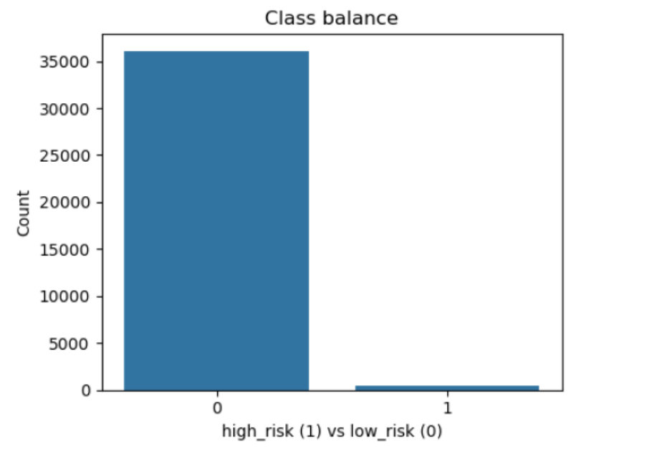
Figure 1 - Bar chart showing the extreme class imbalance
As seen by the imbalance in Figure 1, there were some problems we had to look out for. First, we understood accuracy becomes useless since it can show the model achieving 99% accuracy by only predicting all cases as low risk. Second, we had to focus our models on precision, recall and F1-score for the high-risk class.

Our dataset did contain several missing values, specifically, in the OCCUPATION_TYPE column. 11,323 (around 31%) missing values. Despite the substantial missingness, it was not dropped but instead treated as a categorical feature with its missing values being handled during preprocessing.

DAYS_BIRTH and DAYS_EMPLOYED are two numeric fields which are stored as negative day counts, for interpretability in the EDA, they were converted into AGE_YEARS and EMPLOYED_YEARS. The EDA also revealed a placeholder value (365243) in the DAYS_EMPLOYED field which appeared in 6,135 rows and this value was treated as “unknown” and set to missing for the analysis. We use boxplots of some of the key numeric features to look for any outliers and compare how these variables differ between high)risk classes.
In terms of the categorical features, we compared average high-risk rates across categories (and checked group counts) to see whether some groups had higher observed risk. These findings helped us to justify keeping them in the feature set and one-hot encoding them for the models to use them.
For the sake of consistency across models, we used the same train/validation/test split strategy. 15% was used for test, then 15% of the remaining amount was used for validation. We used a small amount of numeric and categorical columns that are available for all applicants. These were numeric variables such as income and day-based things, and the categorical fields included occupation, gender, education and more. Preprocessing was done using scikit-learn pipeline, with numeric variables being imputed with the median. Categorical columns were imputed with a constant value of “Missing” and were one-hot encoded, that way these steps are only learned in the training set.

Models fitting:
Perceptron Baseline
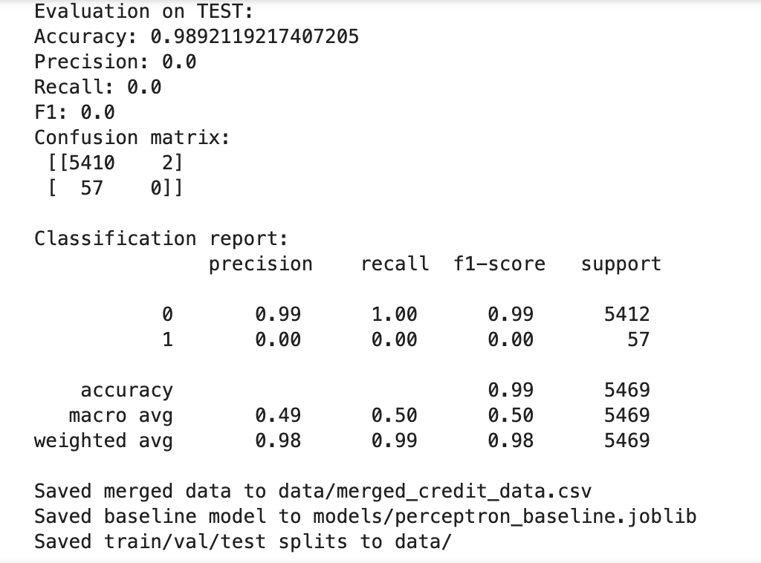
Figure 2 - showing the baseline results on Test set

The Perceptron managed to keep its accuracy at around 98.9% throughout the training, validation and test sets. Nevertheless, a detailed observation of the confusion matrices and class-specific performance metrics indicated that this figure is not true. The model considered all the applicants as low risk and therefore it did not have true positive predictions for the high-risk class. As a result, the precision, recall, and F1-score for high-risk applicants were zero for every data split. This failure highlights the inadequacy of accuracy as a singular metric for evaluation in cases of classification with high class imbalance. Besides, it shows that a simple model can look like it is working well while it is failing at the task of interest.

The results of the experiments indicate that the Perceptron only manages to figure out a dominant decision boundary that facilitates the majority class, but it does not have enough power of expression to uncover non-linear patterns of rare high-risk behaviour. Therefore, the Perceptron is a perfect dummy baseline to illustrate the minimum level of performance which can be improved by using more sophisticated models. The fact that it did not detect a single high-risk applicant indicates the need for deploying more powerful models such as decision trees, support vector machines, and ensemble methods that can deal with complex relationships and heavy class imbalance in credit risk prediction.

Decision Tree Model

A decision tree model, which was deliberately constrained for model complexity and biased towards the minority class through hyperparameter tuning, was trained to beat a linear Perceptron baseline in terms of performance. To perform the hyperparameter optimization, GridSearchCV with three-fold cross-validation was used, where the F1-score was chosen as the scoring metric to give priority to the minority high-risk class performance. The grid search varied the values for the maximum tree depth (max_depth), the minimum number of samples required to split a node (min_samples_split), and the minimum number of samples required at a leaf node (min_samples_leaf). Moreover, the class imbalance issue was explicitly addressed by the Decision Tree classifier through setting the class_weight="balanced".

Figure 3 - showing the best parameters for the decision tree model
The best model, as per cross-validation results, did not impose any limitation on the depth of the tree (max_depth=None), having min_samples_split=2 and min_samples_leaf=1. Such a setting implies that the model is most capable of capturing non-linearities in the data when the tree is fully grown. The parameter-tuned Decision Tree effectively identified the high-risk applicants far better than the Perceptron baseline, thus obtaining non-zero recall and F1-scores for the training, validation, and test sets. Even though the overall accuracy slightly dropped in comparison with the baseline model, the minority class performance was significantly elevated. The decrease of F1-score from training to validation and test sets indicates overfitting to some extent, however, the model still manages to substantially raise the high-risk case detection rate, hence underscoring the significance of hyperparameter tuning and correct evaluation metrics in imbalanced classification ​‍​‌‍​‍‌​‍​‌‍​‍‌tasks.
Support Vector Machine (SVM) Models:
SVM classifiers were trained on the fixed train/validation/test split and we evaluated performance by primarily focusing on precision, recall and F1-score for the high-risk class due to the imbalanced nature of the target. To show iterative improvements, we tested a sequence of configurations as seen below.

First, we created a baseline linear SVM without class weighting. It achieved a very high accuracy of ~99% but F1 was 0 on the test set. The reason being, it predicted only the majority class, the confusion matrix shows this as no positives were predicted, hence demonstrating why accuracy is misleading under our extreme class imbalance.

Secondly, we addressed the imbalance by setting class_weight = “balanced”. By doing this, recall for the minority class drastically increased to about 0.68 meaning the model was now detecting many more high-risk applicants. However, precision was exceptionally low at ~0.009. The reason for this is the model predicted a large number of false positives (4187) meaning the F1-score on the test set was only 0.018. This highlights that class weighting makes the model more wary of the minority class, but it then predicts too many high-risk cases.

Next, we tried to tune the parameter C, we did this by obtaining the ‘best’ C based on validation F1-score. This improved the overall balance compared to the second iteration as precision increased to about 0.016 (still low), recall dropped a little to 0.56, while F1-score increased to 0.031. Although, it was very slight improvement, it shows that tuning C reduced the unnecessarily high number of false positives being detected.

Finally, we tested a non-linear boundary using an RBF kernel while tuning parameters using validation F1. This achieved the best SVM performance as F1 sat at 0.053 and recall was at 0.54. Compared to linear SVM variants, this iteration reduced the number of false positives substantially (1091 vs 4187 in iteration 2), while still catching 31 out of 57 high-risk cases.

Overall, the SVM performance improved across iterations, however, even the best SVM model has a low F1-score due to the difficulty of separating the minority class with the imbalance.

Random Forest (RF) Models:
Random Forest is great for our scenario due to it being well-suited for tabular data. (Płoński, 2019) We trained three iterations of RF models using the same fixed train/validation/test split. Performance was mainly evaluated using precision, recall and F1 due to the class imbalance.

The first iteration had no class weights; it proved to have our strongest overall F1 score among our different iterations. In the test set, F1 = 0.33, recall = 0.25 and precision = 0.52. The confusion matrix shows that the model correctly identified only 14 out of the 57 high risk cases, but it did produce relatively low false positives (13). From this, we gathered that this variant is quite reserved since it predicts fewer positives, which keeps the number of ‘false alarms’ low, resulting in higher precision.

The second iteration used class_weight = “balanced” to improve sensitivity to the minority class. Recall increased to ~0.40, meaning the model detected more high-risk cases, but precision dropped to ~0.21 due to the increase in the number of false positives (87). In Figure 4, we see the model correctly identifies 23 out of the 57 high-risk applicants, hence reflecting our priority in detecting risky clients. As a result of this, test F1 was ~0.28. This shows the same trade-off seen in the SVM model due to the imbalance, as we see more applicants being flagged as high-risk.
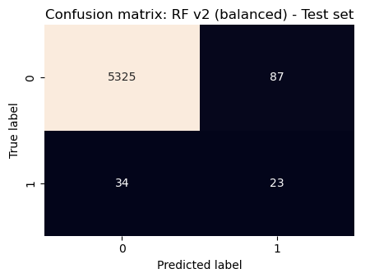
Figure 4 - showing a confusion matrix of the Random Forest v2 classifier

We attempted to tune n_estimators (number of trees). By plotting validation F1 against the number of trees, we noticed F1 changes noticeably at very small forests but plateaus after around 200 trees. We decided to settle with using 300 trees, that way run-time stays low and we have a stable choice. As seen by figure 5 below, using 300 trees gives stability as well as keeping down run-time.

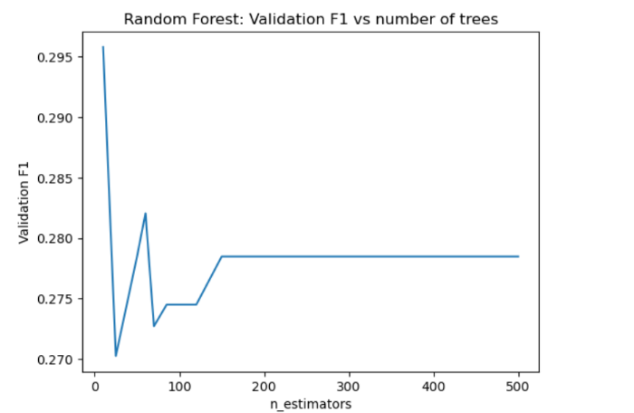
Figure 5 - showing how validation F1 changes as you increase the number of trees
Finally, we tuned max_features. The best setting chosen was sqrt, and the model achieved test recall of 0.42, but precision was only 0.19 meaning test F1 was 0.26. This variant slightly increased recall compared to the second iteration but did not improve overall F1. Overall, this shows that the main performance driver here is the imbalance.

Models’ performance and comparison:

On the test set, the Perceptron baseline achieved high accuracy but failed to detect any high-risk applicants (recall and F1 of 0 for class 1), showing that a simple linear baseline does not handle this task. The tuned SVM models improved when using class weighting and a non-linear kernel (RBF), but performance remained limited with incredibly low precision; the best SVM model (RBF) achieved recall of 0.54 but precision was only 0.028.

The tree-based models showed to be the better performers overall. The decision tree model achieved a higher F1-score for the minority class (0.27) and recall being 0.44, showing a better balance between identifying high-risk cases and controlling false positives. The unweighted Random Forest model was reserved as it had higher precision but lower recall meaning it struggled to find truly positive cases. However, the class-weighted Random Forest (RF v2 balanced) increased recall to 0.4035 (TP=23 out of 57) with precision being 0.2091 and F1 being 0.2754 on the minority class. Since our priority is detecting risky clients, the class-weighted Random Forest is an appropriate final choice since it captures more true positives than the first iteration while maintaining a similar overall F1 score to the Decision Tree as seen below in Figure 6.
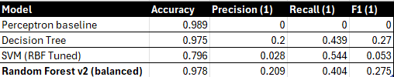
Figure 6 - showing how each model compares to each other based on metrics of the higher risk class

Model Interpretation (Feature importance)

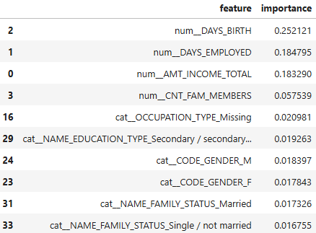
Figure 7 - showing a list of the top 10 most important features to the Random Forest v2 model (balanced class weight)
As seen by Figure 7, we extracted feature importances from the Random Forest v2 classifier. These values summarise how much each feature contributed to the trees splitting decisions. The strongest predictors in the model are the applicants age, employment length, and their total income. This suggests the model relies on core financial indicators when differentiating the higher-risk from the lower-risk applicants. A number of categorical indicators such as education level, gender and missing occupation information show some contribution. OCCUPATION_TYPE_Missing may indicate that the lack of information may carry some weight in this dataset such as high risk applicants may not have reported their occupation which justifies our decision to keep this column and treat missing values as a category. These importances are model-based and show usefulness in prediction.

4. Discussion
Our results show clear differences between linear, kernel-based and tree-based approaches on this classification task. The baseline Perceptron achieved high overall accuracy but did not detect any high-risk applicants. It confirmed that this dataset could not handle being a simple linear baseline. The SVM models improved across iterations, especially when moving from a linear boundary to non-linear RBF kernel. Despite this, even the best SVM flagged many low-risk applicants as high-risk. This suggests that the minority class is not cleanly separable and that increasing flexibility will increase false positives.

Our models might not be improving a lot due to two main reasons. First is how we created the target label, and secondly what information we have in the features. The high_risk label was engineered by us based on credit history status of clients. In hindsight, this was not the perfect way of creating the label as a client could be labelled as high-risk on limited evidence and the rules could miss details such as whether the missed payments happened recently or whether the client’s situation worsened over time. To add to this, the application data (income, age, education, etc) may not have been enough to explain why someone becomes delinquent. Therefore, the models can only learn so much and hit a ceiling, this helps explain why tuning improvements were quite small, especially for the SVM models.

Limitations and Potential Improvements:
The main limitation of this work is the extreme imbalance of the derived target. As seen by our results, our models are prone to either predict almost no positives (leading to poor recall) or it over predicts positives (leading to poor precision) due to the lack of high-risk examples. Class weighting did partially tackle this, but it did not solve the issue of little to no representation of the high_risk = 1 class. In the future, we could have explored the use of oversampling the minority class so that the models can learn more. This could eventually lead to overfitting, but this also could have been solved through stronger regularisation.

Another limitation is that our target label is based on a simple summary of a client’s credit record over time. We potentially lost out on useful information by turning the credit_record data into basic totals and rules. In the future, we would recommend looking into when the client had a delinquency, for example, was it recent or a long time ago. Also, whether their status is getting worse over time or even if they had a streak of missed payments. Features such as “delinquency_streak” or “months_since_delinquency” could have been created and the models may have learned clearer patterns. Perhaps, this would have made the predictions more accurate and reduced the number of false positives.

A final limitation was the depth of how much we tuned our hyperparameters. For example, we were only able to try a limited set of values, with time we could have assessed a wider range of settings especially with the RBF SVM model since C and gamma work together and could have changed our results some more. Even with the Random Forest models, we could have tuned more things such as the maximum depth of trees or minimum samples per leaf.

Conclusion:
Overall, by applying supervised learning techniques to a binary classification task, we were able to predict applicant risk. The Perceptron showed us the limitations of extreme class imbalance, our SVM models did show improvement throughout their iterations but they were very weak in comparison to our tree-based models. These tree-based models worked much better on our tabular dataset and given our objective of catching more risky clients, we select the class-weighted Random Forest (RF v2 balanced) as our ‘best’ model. It achieves a test recall of 0.4035 (23/57 high-risk cases detected) with an F1-score of 0.2754 on the minority class. Overall, the results show that in heavily imbalanced risk problems, choosing a point that prioritises recall is the most appropriate decision since the increased number of false positives can be handled with the suggested changes above (creating additional features so we do not lose out on important information, as well as further tuning some of the key hyperparameters).

References
Anon., 2020. Machine learning techniques for credit risk evaluation: A systematic literature review- journal of banking and financial technology. [Online]
Available at: https://link.springer.com/article/10.1007/s42786-020-00020-3?fromPaywallRec=false
[Accessed December 2025].
Chang, V., 2024. Credit risk prediction using machine learning and Deep Learning: A study on credit card customers, s.l.: s.n.
Helmy, B. E.-D., 2025. The C Parameter in Support Vector Machines. [Online]
Available at: https://www.baeldung.com/cs/ml-svm-c-parameter
[Accessed December 2025].
Leo Breiman, A. L. C. C., 2004. Using Random Forest to Learn Imbalanced Data, s.l.: Dept of Statistics, UC Berkeley.
Płoński, P., 2019. Random Forest vs Neural Network (classification, tabular data). [Online]
Available at: https://mljar.com/blog/random-forest-vs-neural-network-classification/
[Accessed December 2025].
scikit-learn, 2025. Importance of Feature Scaling. [Online]
Available at: https://scikit-learn.org/stable/auto_examples/preprocessing/plot_scaling_importance.html
[Accessed December 2025].
scikit-learn, 2025. Support Vector Machines. [Online]
Available at: https://scikit-learn.org/stable/modules/svm.html
[Accessed December 2025].
Wang, Y., 2020. A Comparative Assessment of Credit Risk Model Based on Machine Learning - a case study of bank loan data. [Online]
Available at: Https://www.sciencedirect.com/science/article/abs/pii/S1047847720300046?via=ihub

