purpose:

on a pc: a.out

on cluster: srun -n8 a.out (run on 8 nodes)

slurm allocates resources:

nodes identified by IP

sockets

memory

switch

GPUs

license

architechture

70 plugins for authentication, MPIs, databases, etc

slurmd - daemon running on each node

slurmctld - daemin running on the management node

user commands: sacct, salloc, sattach, sbatch, sbcast, scancel, scontrol, sinfo, smap, squeue, srun, strigger and sview

node - the compute resourse

partition - group nodes into logical sets. can be considered as job queue, with a set of limitations like time limit, permitted users, etc.

job step - task within the job

הפקודות

sinfo - מצב המערכת

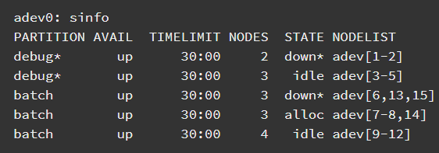

squeue - סטטוס הג'ובים במערכת:

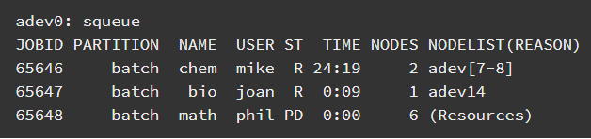

scontrol - מידע על partitions, jobs, job steps, and configuration. גם היישום המשמש לביצוע שינויים.