Slurm setup on NCNR-R9nano.campus.nist.gov

Purpose:

Install and run slurm controller and compute node on NCNR-R9nano, using ubuntu 16.04.

preparations

create slurm user, and add it to sudo group.

slurm is run by a user called slurm. it needs write access to some of the files.

This is achieved by changing the owners of the following to be root:sudo (user root and sudo group).

/etc/slurm

/var/log

/var/spool

/var/run ≡ /run. Note that /var/run is soft-linked to /run.

Source: https://github.com/mknoxnv/ubuntu-slurm

Differences

slurm.conf

|  |  |  |  |
| --- | --- | --- | --- |
| item | original | modified | notes |
| ControlMachine | slurm-ctrl | NCNR-R9nano | NCNR-R9nano.campus.nist.gov didn't work |
| NodeName | linux1 | NCNR-R9nano |  |

Note that the files

cgroup.conf and cgroup_allowed_devices_file.conf should also be present.

at ths point in time when this doc is written, srun still doesn't work.

Hardware data is obtained by running lshw command. It should be run under sudo, even though it can run without it, but with less accurate results[1]. This utility can produce an html results, as follows:

sudo lshw -html > a.html

Other commands:

lscpu:

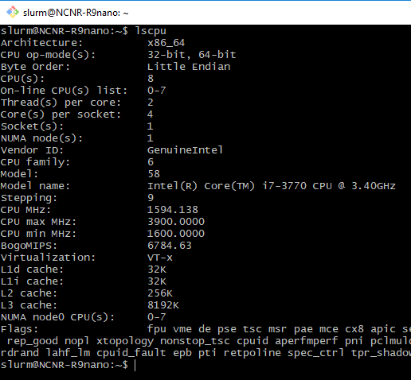

After starting the daemons (slumctld, slurmd), they were in drain state.

scontrol show node display the status and the reason:

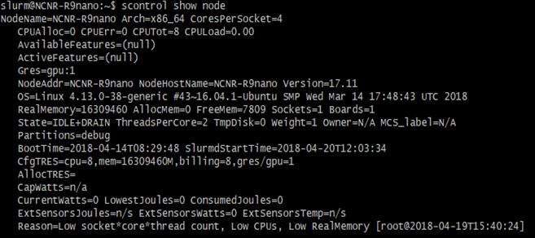

I've tried restarting several times, but that didn't help, and the node remained drained with low resources:

systemctl stop slurmd

systemctl restart slurmctld

systemctl start slurmd

The correct thing to do was to restart using scontrol:

scontrol update nodename=NCNR-R9nano state=resume

1. Not sure what inaccurate means about hardware. Probably memory usage.