BumpsFlask
Web interface for running bumps on a parallel machine
Development by Raúl Negrón.
Documented by Omer Eisenberg
Checked by Paul Kienzle
Abstract
This document describes web interface for bumps, developed by Raul Negron during the summer of 2017. The interface has been developed using Flask framework. The document describes how BumpsFlask operates and includes recommendations for future development.

Keywords: bumps; web development;
March, 2018

Table of content
Purpose 4
Current Implementation 4
Technology 4
User Interface 4
Database 4
Source & Directories 4
Running Bumps 4
Defining the problem 6
Under the hood 7
Background 7
Flask 7
Tokens 7
Connecting - Getting the Token 7
Jobs Results 9
User Interface 9
How is works 9
Results Display 11
User Interface 11
How it works 11
Submitting a new job 12
Executing the job 14
Results Files 14
Deleting Job 15
Logging Out 17
Environment 17
How it works 19
Summary 19
Suggestions 21

Table of Figures
Figure 1: Login page with token 8
Figure 2: Login page withput token 8
Figure 3: tokenizer with token 8
Figure 4: Acquiring a token 9
Figure 5: Display example for alphanumeric results 11
Figure 6: Job submission 14
Figure 7: bumps command line example 14
Figure 8: Delete button in dashboard.html 15
Figure 9: Job delete HTML form 15
Figure 10: Job delete HTML form with Jinja template 15
Figure 11: Splitting the path to arguments for get method 17

Purpose
The described system, unformal named BumpsFlask, is a GUI for running bumps, curve fitting and uncertainty estimation, on HPC (High Performance Computer).

Current Implementation
The current implementation was developed as a proof of concept. That is, most of the building blocks have been implemented.

Technology

User Interface
The user interface is based on Flask and Flask Forms - python based web development framework. Flask itself uses Jinja - a template engine for python. It also uses Flask-JWT (Jason Web Token) for authentication.

Database
Redis serves as the database backend. This is a key-value database, that doesn't use SQL.
Each value is stored with a unique key. If that key already exists, the value is overwritten.
Slurm was selected as workload management and distribution. However, it is not yet implemented.
Bumps, BumpsFlask (the user interface) and Redis, run on Ubuntu, Linux based operating system. Bumps and BumpsFlask runs on one Docker container, while Redis runs on another Docker container.

Source & Directories
The system source files are in
bumps / extra / bumps_flask
They can be found online at Raul's github repository: https://github.com/rnegron/bumps

Running Bumps
Bumps runs in the following steps.
- Connecting - getting a token
- Defining the problem in a python file.
- Setting up job details
- Submitting the job
- Displaying results
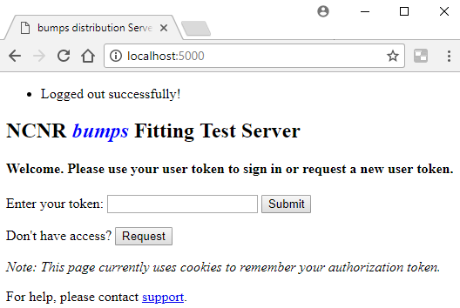 | click  Request | 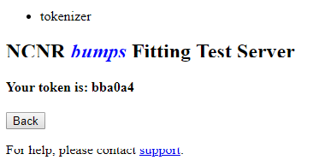
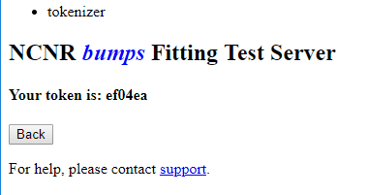 | click Back | 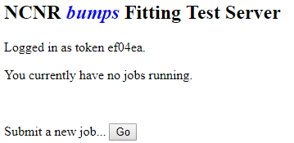
 | click Go | 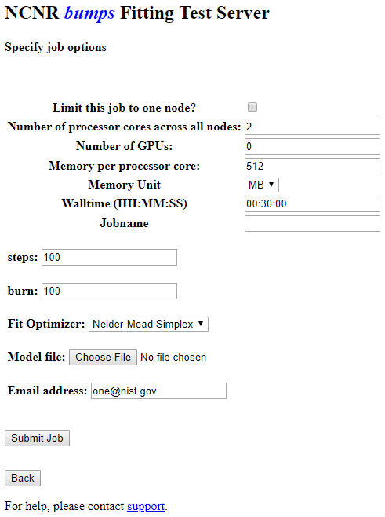
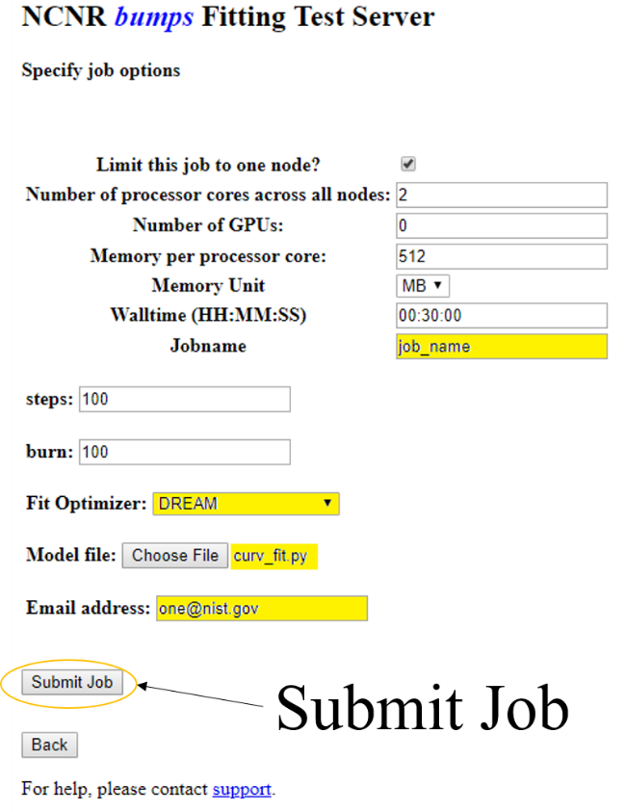 | Fill the necessary fields, click Submit Job.  Refresh the browser until results are displayed | 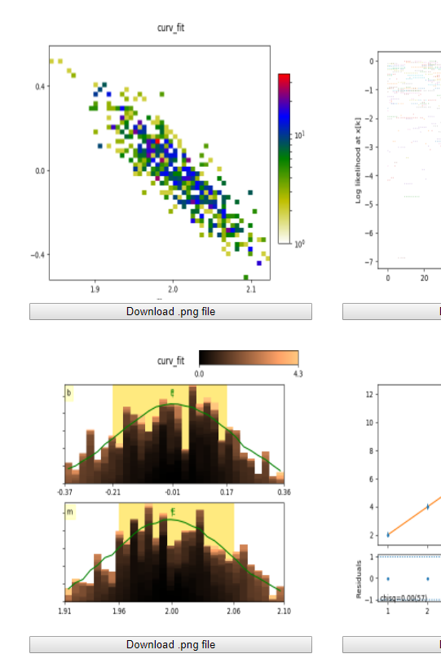

Defining the problem
The following is an example for curve fitting problem in python

from bumps.names import *

x = [1, 2, 3, 4, 5, 6]
y = [2.1, 4.0, 6.3, 8.03, 9.6, 11.9]
dy = [0.05, 0.05, 0.2, 0.05, 0.2, 0.2]

def line(x, m, b=0):
return m * x + b

M = Curve(line, x, y, dy, m=2, b=2)
M.m.range(0, 4)
M.b.range(-5, 5)

problem = FitProblem(M)

Under the hood

Background

Flask
Flask, which is the basis for BumpsFlask, operates so that the UI is in html files, while processing is done in python. Clicking on a link or a button, on an html file, usually invokes a python function. That function performs its tasks and returns control, or redirects, to an html file

Tokens
Tokens are created by the server and saved by the client. When a user requests access to a resource server (e.g. BumpsFlask), the token is used to authenticate the server.
BumpsFlask uses two tokens types: access and refresh. Access tokens are needed to access the data itself. Refresh tokens are needed, along with used id, to generate new access token.
The idea is that if an Access token is compromised, the bad guys have little time to cause damage.
Refresh tokens, on the other hand, are long lived. If compromised, it cannot be used to generate access token without the user id.
Good source about protocols and security can be found here:
https://iam.harvard.edu/resources/behind-login-screen
Source for refresh token:
https://auth0.com/blog/refresh-tokens-what-are-they-and-when-to-use-them/
Discussion about the need for both refresh and access tokens:
https://stackoverflow.com/questions/3487991/why-does-oauth-v2-have-both-access-and-refresh-tokens

Connecting - Getting the Token
When starting the BumpsFlask, at http://localhost:5000, flask invokes index() function in views.py. The current token is retrieved from get_jwt_identity() to jwt_id (JSON Web Token). The index.html file is displayed. This file accepts an access token, in a variable called jwt_id. If the token exists, dashboard.html is displayed with the user token, as shown in Figure 1.
Otherwise, i.e. jwt_id = NULL, the page on Figure 2 is displayed, suggesting the user to request a token.
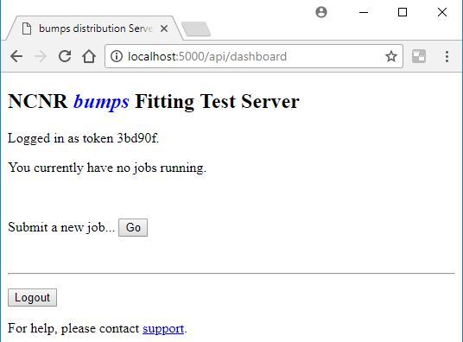 | 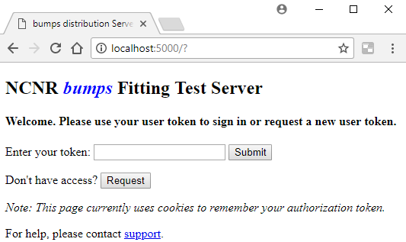
Figure 1: Login page with token | Figure 2: Login page withput token
The HTML forms in Figure 2 is created in the function index() (in views.py), by instantiating a TokenForm object. That form is passed to index.html as an argument, named form.
Clicking the Request button invokes tokenizer function (views.py). First, a unique user ID is generated by calling a function from the uuid family (in user_token, in api.py). That ID is used to create both access and refresh tokens, in register_token (api.py), where they are saved to Redis database. Note that the refresh token is save to Redis in register_token, while the access token is saved to Redis in create_auth_token (api.py), itself called from register_token. The tokens are also encoded and saved to cookies in index (views.py).
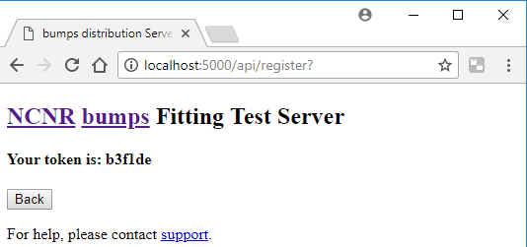
Figure 3: tokenizer with token
If a token does exist, tokenizer.html is displayed, with the user ID (user_token variable) passed as argument for display (b3flde in the example).
When the user selects Back, index function is called. This time the token does exists, and the control is redirected to dashboard function, by calling:
return redirect(url_for('dashboard'))

Figure 4: Acquiring a token

Jobs Results
BumpsFlask operates in jobs. A job is the framework of submitting, processing, storing and displaying the results. A user access token is required before submitting a job. That token is used later as an access key to the results.

User Interface
Once the user obtains an access token through request, tokenizer.html is displayed. That page both enables submitting a new job, and displays current results associated with the current user (token, actually). The mechanism of results display is discussed later.

How is works
After obtaining a token (described in Connecting - Getting the Token, pg. 7), index function (view.py) is called that redirects to dashboard function (view.py).
Called from tokenizer (views.py), with the user token as argument, as shown in Figure 3. Clicking Back invokes the index function (in views.py). That function reads the user ID from the cookie, by calling get_jwt_identity. Since this time a user ID exists, control is redirected to dashboard function (views.py).
The dashboard function:
- Retrieves the current user ID from the cookie.
- Use the ID to retrieve the jobs from Redis database.
Note: Redis stores data as key-value pairs. In our case, the stored data is a python tuple, and the key is the current ID. Examples for such a tuple is displayed in Table 1.
Table 1: Example for job tuple saved in Redis database
key | data
origin: | 172.17.0.1,
status: | COMPLETED
filebase: | curv_fit
completed: | Mon Feb 26 13:59:59 2018
submitted: | Mon Feb 26 13:59:53 2018
user: | 3451a0
directory: | /tmp/bumps_flask/fit_problems/3451a0/job1
_id: | 1
- Loops over all the jobs. For each job, the results files names are saved in a set, called files. The files themselves are zipped, to a file called job_results.zip. That zip file is stored in the following directory:
/tmp/bumps_flask/fit_problems/user_ID/job1/results/
- Finally, control is passed to dashboad.html, with the user ID, jobs, and files names are passed as arguments.
At the end of dashboard.html, a small HTML form enables the user to submit a new job, by linking an HTML button to fit_job python function (views.py).

Results Display
Since all bumps results are stored in files,

User Interface

Results are displayed in dashboard.html.
All the jobs' results are displayed in a single page.
Graphic results, such as PNG files, are display as HTML image inputs, e.g. <input type="image" src="file_name">.
Other results are displayed with the file name and a "download button, as shown in Figure 5.
Downloading
Each file A button enables downloading all the zipped results. Clicking the download button opens a "Save As" dialog box, that lets the user choose the result file name, and if selected, download the zipped file.
Deleting
Another button enables deleting the jobs results. Clicking that button deletes both the job from the Redis database and the files from the results directory.
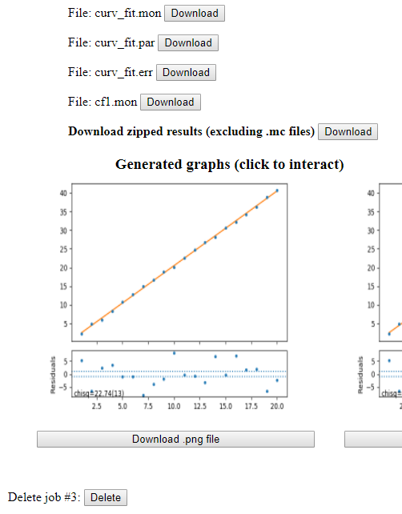
Figure 5: Display example for alphanumeric results

Go button redirects to a new job entry form.
Logout button deletes the current user ID and redirects to the login page (Figure 2, page 8).

How it works
After loading the user ID (user_token), jobs (user_jobs), and results files (files), dashboard function redirects to dashboard.html page. That page contains the following sections:
Header, job results, new job submission, and logout.
The following pseudo code summarize the page.
Dashboard (user_ID, jobs, files)
Write header
if (user_ID is None) return
Write user ID (user_id)
for (job in jobs)
for file in files[jobs] # data files loop
if file is not PNG
Display file name and download button
for file in files[jobs] # graphic (png) files loop
if file is PNG
Display image file and download button
Display job submission form
display logout form
Header is the extension of base.html that shows the site header, and current token.
Data files display includes the file name followed by a download button. The is done with a Jinja template that generates an HTML form for each result file. The following is an example for the Jinja format:
{% if result_file.split('.')[-1] != 'png' %} # The file is not an image file
<form action="file_directory/file_name" method="GET">
<p…> File: {{ file_name }}
<input type="submit" value="Download"/></p> # Download button
</form>
{% endif %}
Graphic files display the image file itself and a download button, with two forms as in the following Jinja template.
<form action="file_directory/file_name" method="GET">
<input class="thumbnail" type="image" src="file_directory/file_name" alt="View" />
</form>
<div class='graph_btn'>
<form action="file_directory/file_name">
<input name="graph_btn" type="submit" value="Download .png file"/>
</form>
</div>
At most, 3 images are displayed in each line.

Submitting a new job
New job is submitted from service.html. That page shows an HTML form, that is based on WTForms, a forms validation library. The page data is generated in and called from fit_job function (views.py).
Pseudocode describing fit_job is presented in the following figure
- fit_job()
- form ← FitForm () // instantiate a FTForm derived class
- If form_data valid:
- form_data ← parse data into command lines
- job_id ← # of jobs per current user ID // Number of 1st job will be 1, 2nd is and so on
- _dir ← join_path (temporary_dir, 'fit_problem', user_id, job#)
- payload_default ← dictionary {user id, job id, origin URL, results directory, status=PENDING, submitted date & time}
- bumps_payload ← process_request_form - returns dictionary (payload_defaults, HTML form data, problem script file)
- SaveToRedis (bumps_payload)
- flash ("job submitted") // show test on html page
- redirect_to ('dashboard')
- else
- render_template (service.html) // return to the calling page to show the problem
Notes
Line # | Comment
6 | The following is an example of the results directory
temporary_dir | 'fit_problem' | user_id | job#
/tmp/bump_flask/ | fit_problem/ | fbf919/ | 3

7, 8 | The payload variables are python dictionaries that are used to create the command line activating bumps. Some defaults are set up in fit_job (line #7). Others in process_request_form (api.py).
Note: form_data is a python dictionary that includes a list of missing keys, and 2 dictionaries with command line, one for slurm and another for bumps (cli). For example
{
'missing_keys': ['n_gpus', 'limit_node'],
'slurm': {'job-name': u'f', '--mem-per-cpu': 512, '--mail-user': u'one@nist.gov', '--time': '00:30:00', 'mem_unit': u'M', '--ntasks': 2},
'cli': {'burn': 100, 'steps': 100, 'fit': u'newton'}
}
If the form is valid, the function redirects to dashboard function.

Executing the job
Users submit jobs by clicking the Submit Job button in service.html. That invokes fit_job function (views.py), that builds the slurm and bumps command line, by calling setup_files. The setup_files function calls build_slurm_script (run_job.py), that take the command line as argument, and calls Popen with the command line argument to execute the job in the background.
The process is described in Figure 6 (p. 14).
Figure 6: Job submission

Results Files
Bumps saves results in files. The directory, where those files are saved, is passed to bumps in the command line --store argument. E.g.,
bumps /tmp/bumps_flask/fit_problems/fc4356/job1/cf1.py --batch --stepmon --burn=100 --steps=100
--store=/tmp/bumps_flask/fit_problems/fc4356/job1/results
--fit=newton
Figure 7: bumps command line example
The underlined parts in the directory path are user (fc4356) and job (job1) dependent.

Deleting Job

Users can delete job by clicking the Delete button on dashboard.html, as shown in Figure 8. This will cause the job's results file to be deleted. Also, job parameters are deleted from Redis database.
The Delete button is part of the following HTML form, defined in dashboard.html, shown in Figure 9:
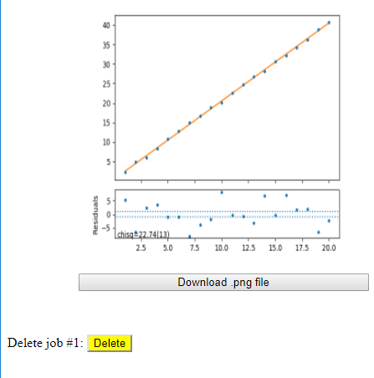
Figure 8: Delete button in dashboard.html
The button's yellow background does not appear in the actual screen

<form action="/api/jobs/fc4356/job1/delete.html" method="GET">
Delete job #1:
<input style="display:inline;" type="submit" value="Delete">
</form>
Figure 9: Job delete HTML form
The purpose of this form is to invoke a python procedure that will delete the proper job, which is get method in Jobs class. The job is identified by user and job IDs. Those IDs are part of the form's action path:
"/api/jobs/fc4356/job1/delete.html"
The path is created in dashbopard.html, with the following Jinja template:
<form action="/api/jobs/{{ id }}/job{{ job['_id'] }}/delete.html" method="GET">
Delete job #{{ job['_id'] }}:
<input style="display:inline;" type="submit" value="Delete"/>
</form>
Figure 10: Job delete HTML form with Jinja template
This HTML code shown here is the result of the Jinja template in Figure 9.

That code invokes a python get function, part of Jobs class in api.py, with the following arguments:

Bumps_flask uses Flask-RESTful to call get, with the arguments extracted from the path's parts. The following python code is used to link between the path and the python Jobs class, and the parameters in the path
api.add_resource(
Jobs,
'/api/jobs',
'/api/jobs/<string:user_id><string:_format>',
'/api/jobs/<string:user_id>/job<int:job_id><string:_format>',
'/api/jobs/<string:user_id>/job<int:job_id>/<string:action>.<string:_format>',
'/api/jobs<string:_format>')
The process is illustrated in Figure 11.

Figure 11: Splitting the path to arguments for get method
In get function, once invoked, first the arguments validity is checked. Next, the job's record is deleted from Redis database, by calling hdel. The next step is to delete the job's result files, by calling clean_job_files. That function (file_handler.py) takes the user ID and the job ID as arguments and deletes the entire result directory.

Logging Out
The user interface for logging out is implemented in dashboard as a button at the bottom of the page.

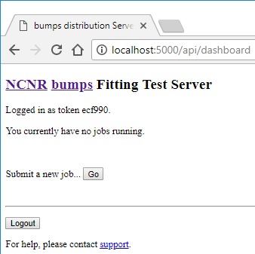
Users disconnect from the system by clicking Logout button in dashboard.html page. That brings up the index display, with "Logged out successfully!" written at the top of the page.
When invoked, the JTI (JSON Token ID) is obtained from JWT. Redis record is set to note an expired authentication token, the token is deleted from the cookie, and the function returns a response to index.html.

Environment
BumpsFlask uses several libraries and external tools. Those are listed below:
bumps curve fitting and uncertainty analysis routines set, developed mainly by Paul Kienzle.
Flask web development microframework for python.
WTForms Validation and rendering library for python.
RESTful Flask API extension that helps, among other, connecting links and passing arguments, to python functions
Jinja HTML template engine for python.
Docker Containers platform
Redis NoSQL database
Slurm Cluster management and jobs scheduling
BumpsFlask first authenticate the user. Next, it takes both problem definition and running parameters. Those parameters are then used to execute bumps from a command line, with the problem parameters. Slurm results are saved in files, that their location is one of the command line arguments.
Slurm was also planned to run, but is currently not implemented.
BumpsFlask displays the job's status as either pending, or the results, when bumps completes.
Access permission is controlled by JWT - JSON Web Token - also saved in the Redis database. Identifying users by private data is limited by US privacy laws. (note: one may argue that the data is not private, and therefore doesn't fall under the privacy laws).
The user then can download all the results files or one by one, submit another job, or logout. That process is illustrated in the following figure.

How it works

Bumps and BumpsFlask run on Ubuntu in a single Docker container. Redis database runs in a different container.
BumpsFlask uses Flask, Jinja, WTForms, and RESTful to generate web-based GUI to bumps. The BumpsFlask application, as well as bumps itself, runs on an Ubuntu system that itself runs in a Docker container.
It is not clear to the author where slurm is planned to run.

Summary
BumpsFlask system was developed in a remarkably short time, especially considering the variety of technologies involved.
However, some modifications and topics completion needed. Those are summed in the following.
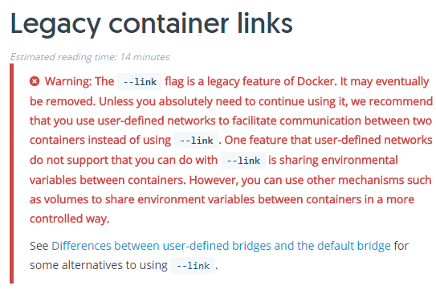
Topic | Description
Slurm | Slurm script is written but not implemented.
Redis --link | Redis runs in a different container (good thing), and linked to bumps through --link.
That option might be removed from Docker.
Software Engineering | Several things are making the code is hard to change, for example:
The calls to external procedures, e.g. the database, are part of the code. | Moving those call to a dedicated class will ease future change. Note that there is a database class, but in some places Redis is accessed directly.
Inputs | Building forms with Flask Form, WTForms, makes it harder to develope a friendly application. Tab order and cells alignment are just two examples.
Results | bumps stores results in files. While image files are shown, data files are not.
Results | Users must save tokens in order to watch existing results.
Results | Missing housekeeping tool for results files.

Suggestions
Users Survey users to learn and document their expectations and needs.
Result Display alphanumeric data files
User Interface Update job status automatically, without the user refreshing the browser.
Development
The are two main directions to proceed
1. Fix whatever needed and complete required features using the current code.
From there, adding multiprocessing interface seems to have the highest priority. AWS and/or Eucalyptus might be a good place to start.
2. Research develpment frameworks that will provide friendly user interface and easy maintenance.

From Negron and Kienzle, A web-based service for distributing curve fitting algorithms onto remote server clusters for improved performance, p. 8
The link between the button and the python function is stored in the html file.
By calling set_access_cookies() and set_refresh_cookies()
Note that the user ID is stored in a variable called user_token, which is somewhat confusing.
Which reads the user ID from a cookie
http://flask.pocoo.org/docs/0.12/patterns/wtforms/
In a nutshell, WTForm provides a convenient way to generate form fields with validators.
The python version of fit_job takes one argument but never uses it.
The function can also accept an output format. At this point it has a default value if "JSON", and it's not a part of the action path.
https://docs.docker.com/network/links/

