**EXPLANATİONS ABOUT THE PROGRAM**

* First,grade data of 104 students was randomly generated and students’ numbers are created.After that student number and exam data were saved as a matrix in a text called Exams_table.txt.So if we run the code, data matrix created and save in the Exams_table.txt. If we want to use this data ,the text we have saved can be easily used.(Part-1)
* Program ask the user what type of information you want.
* If the user input is a valid information type,the program runs successfully.
* If the user enters an invalid input,the program warns the user and asks for input again and again until the user enter valid input.
* If the user selects to see overall grade distribution program provides the necessary information.(Shown in more detail in Part-2)
* If the user selects to see grade information for an individual,the program ask the user for their number.If the user enters a student ID that is on the list,user can access their information.(Shown in more detail in Part-3)
* If the user enters a student ID that is not on the list.Program warn the user and asks for input again and again until the user enter a student ID that is on the list.
* If the user want to quit the program,entering -1 will be enough.

**Part-1**

Inside a text file you are required to create a data set for 100+N1 people, where N1 is the last digit of your student number.

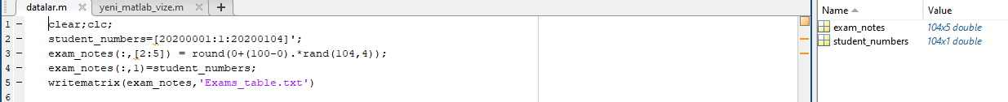

The program would ask the user what type of information is asked for. The program should ask the user whether the user wants to see overall grade distribution or grade information for an individual.

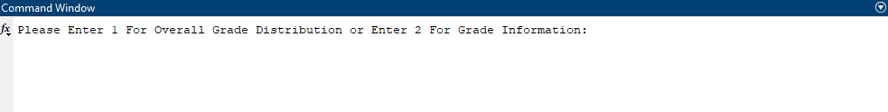

Here your program should watch for invalid input. If the user enters an invalid input, the program should warn the user and ask for the input again until the user enters a valid input. In this phase the program should NOT stop until the user enters a valid input.

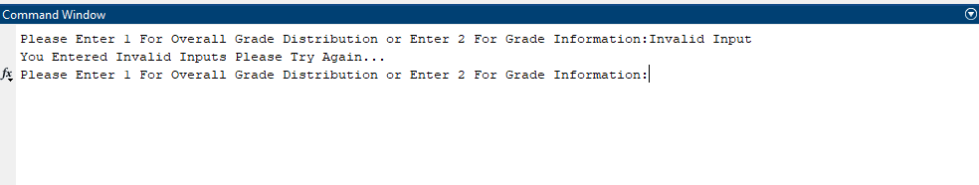

**Part-2**

If the user selects to see overall grade distribution your program should write in a text file; the number of people who received AA, the number of people who received BA, etc… for all grades. The program should also write the number of people who passed and the number of people who failed into the text file. You should design the format of the output such that it should be neatly written and explanatory. Your program should also produce three figures. 1) A pie chart for letter grade distribution, 2) a histogram of letter grades, 3) a bar chart for total grades of each student long with a horizontal line showing the mean of the class calculated in step 3 above. The name of the text file should be “class_info” with the extension of txt or dat.

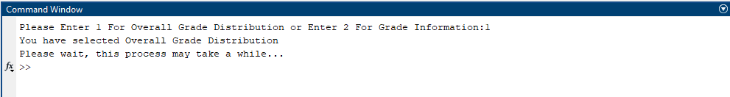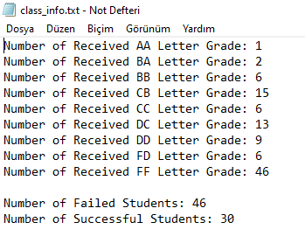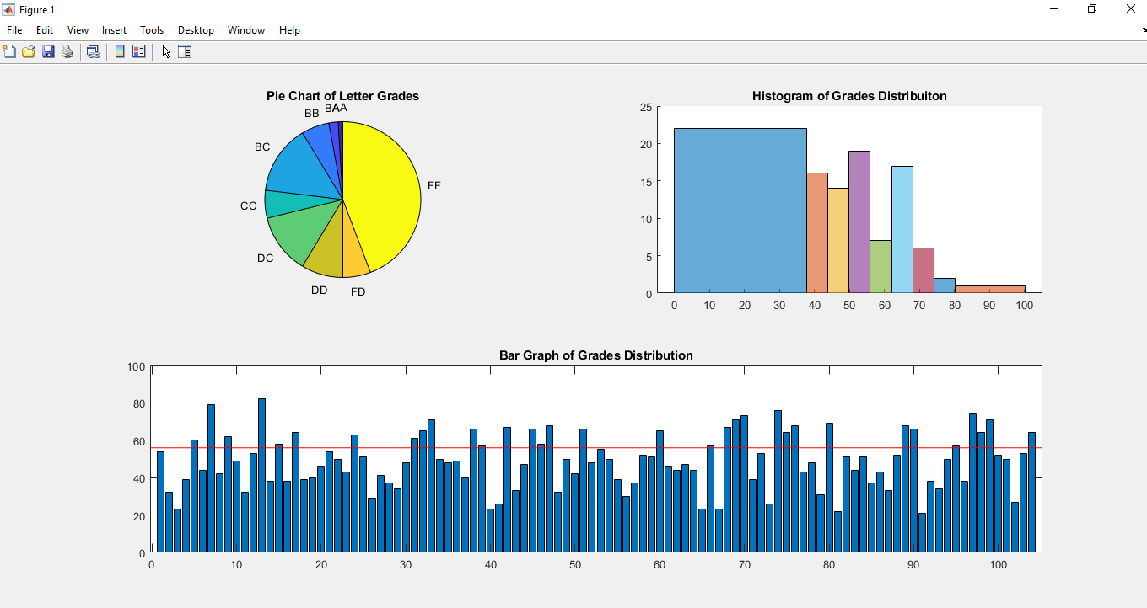

**Part-3**

If the user selects to see grade info for an individual, your program should ask for the ID number of the person.

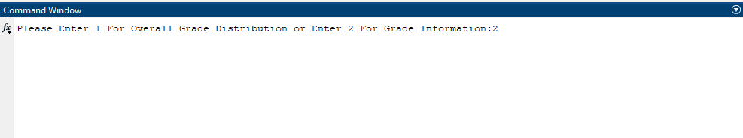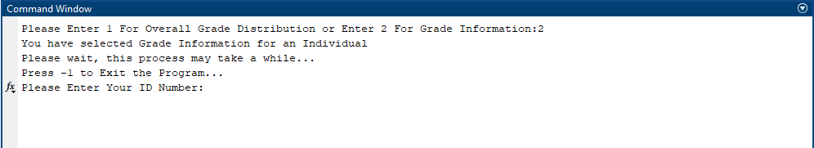

If the user enters an ID number which is not in the list, then the program should warn the user and ask to enter the ID number again. The program should continue to warn the user until the user enters correct Id number.

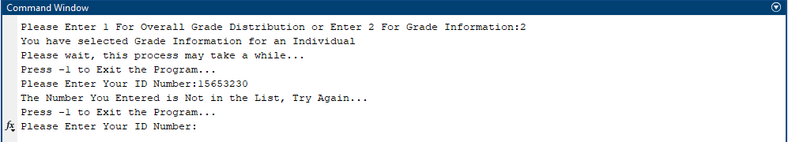

When the user enters a valid ID number the program should give the grade information. For grade information your program should write the exam grades (exam 1, exam 2, lab, final exam, total grade, letter grade) of the student in a text file as a table along with the class average calculated in step 3 above. You should design the format of the output such that it should be neatly written and explanatory. The name of the text file should be the ID number of the student with the extension of txt or dat. After the information is given the program should ask the user to enter the ID number of another student to receive the information for that person. This process should continue until the user enters -1

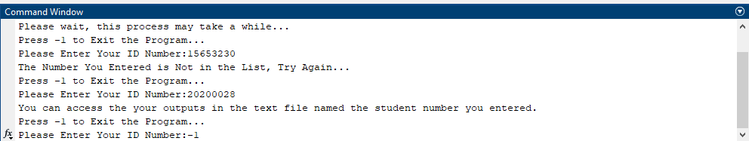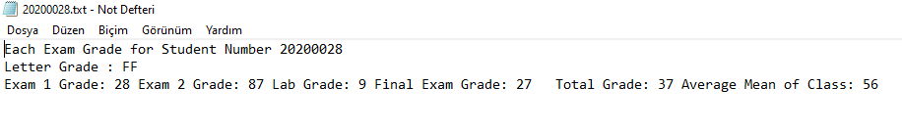

This process should continue until the user enters -1.

