**Assignment 1**

**EECS 3461 B**

**User Interfaces**

**Group Members:**

Arjun Kaura 216379620

Antonio Cedrone 217798000

Melvin Gagarao 216469637

Omer Faruk Celik 218383224

# PART 1: Problem Statement/Design Brief

Identify one of the main struggles or barriers of:

**international** or **first-generation students** transitioning back to campus and eventually find a solution that can help with the daily lives of them in some shape or form.

## 2.1.1 Method: Make observations

### **Probe:**

#### **“Map of York” Activity:**

Show a map of York University, and ask the subject to highlight sections they are familiar with. Specifically ask them whether they know about specific services offered across campus, like: do they know where they can get food (**yellow**), where to ask for student assistance/counselling (**blue**), where to get transportation (**black**), where they sit to work (**green**) – tell them to mark these locations by circling them in the corresponding colour.

### Survey:

The survey used to acquire data and represent it in a quantitative way. The subject is asked for information such as their name, gender, and certain other details:

<https://docs.google.com/forms/d/e/1FAIpQLSesA-UAdKLaCwajeQdpuynYZixBnlwU5Fh6uMOnKJiEKvqiQw/viewform?usp=sf_link>

### Contextual Inquiry:

#### **Questions to ask during the interview:**

Some example questions under each category:

***Note****: you can ask additional questions as well for each category, the below is the main baseline. If a question does not apply to someone then try asking another question. Follow up with their response.*

***Note:*** *some questions only apply to people that are international students, and some only apply to people who are only first-generation students, then those types of questions will probably have to be skipped.*

* How difficult was the transition from online to in-person learning?
* How is your mental health?
  + Better or worse since being in-person?
* Have you had any trouble commuting to campus?
  + If yes, please explain:
* Describe some of these difficulties. For example, difficulty navigating the public transportation system, and issues related to the time it takes to commute.
* Have you had any health and safety concerns with the return to in-person learning?
* Is covid 19 one such concern?
  + If yes, please explain:
  + If applicable, is this due to different laws or regulations in your home country regarding public spaces and vaccination? Or does this not matter at all?
* Since returning to in-person learning have you had any issues with time management?
* If you are a first-generation student, do you come from a low-income family where you must work to pay tuition?
* Has the need to be physically present on campus at certain times of the day and commute while working affected your ability to manage time?
* Do you have any concerns regarding food and diet coming for in-person studies?
* If you have arrived in Canada for this in-person semester, how similar are the common foods in Toronto to your home country?
* Does this dissimilarity cause any issues like finding it more difficult to acquire certain foods for traditional dishes?
  + Are they more expensive?
* Are the foods on campus more expensive?
* Have you had to adapt to a different kind of diet and how has that affected your health if at all?
* Does the campus have restaurants that sell food you would normally eat before coming to Canada?

### Collection of Data Observed:

*The following is a google drive link to some of the transcripts from interviews done.*

**Transcripts:**

<https://drive.google.com/drive/folders/1zCy816WQK505D7MtKp8sTa_z0ZrvdKbC?usp=sharing>

*Below are some of the results from the activity involving the Probe done with the subjects:*

#### **Subject A (Krish):**

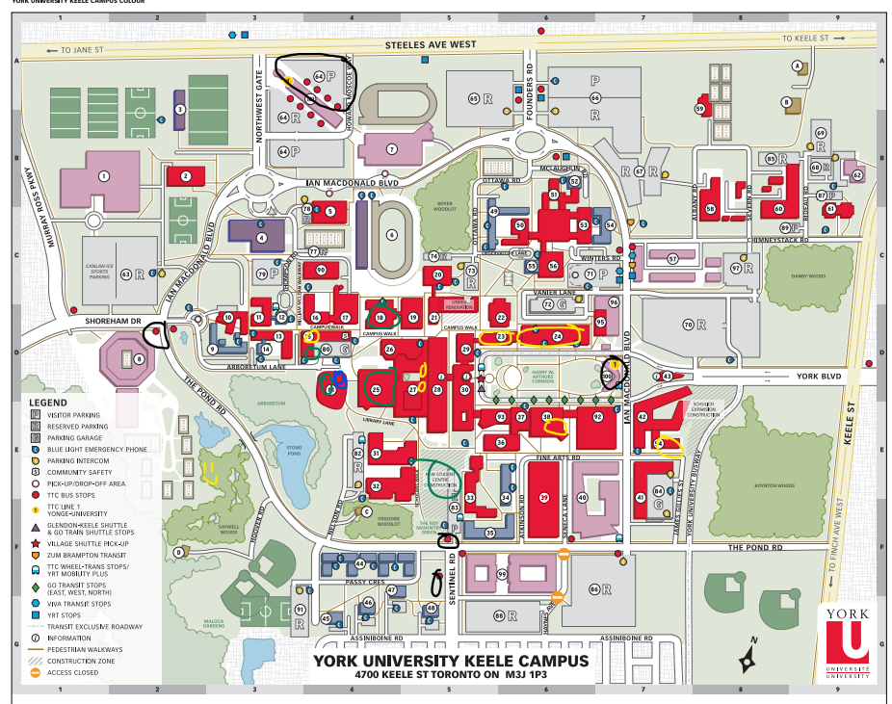

#### **Main Notes/ Observations from Interview:**

– First Generation Student

–Takes public transportation, does not live too far from campus

– Sometimes purchases food from campus but very familiar with the food spots

– Mental health improved when in-person because they are meeting with people and hanging out with friends

#### **Subject B (Lester):**

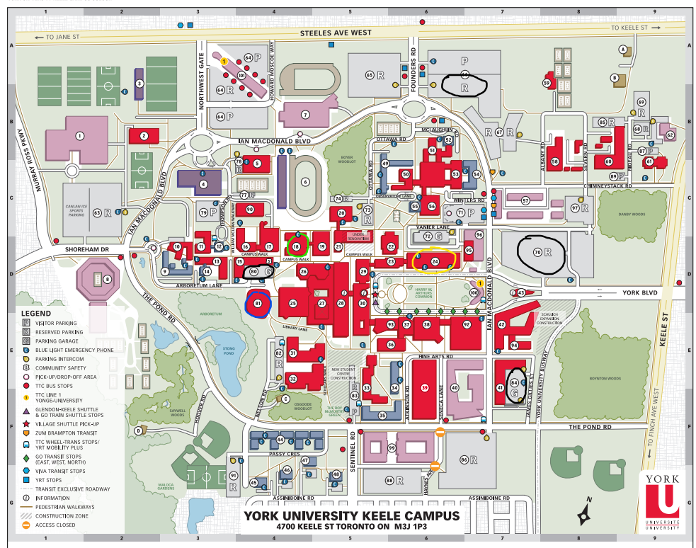

#### **Main Notes/ Observations from Interview:**

– International student

– usually uses a car (if they do: the cost of parking is a problem), does live very far

– some fear of health due to COVID, but not anything debilitating or abnormal

– less familiar with food spots, and prefer to eat at home usually – more easy that way and healthier for them (health matters to them)

#### **Subject C (David):**

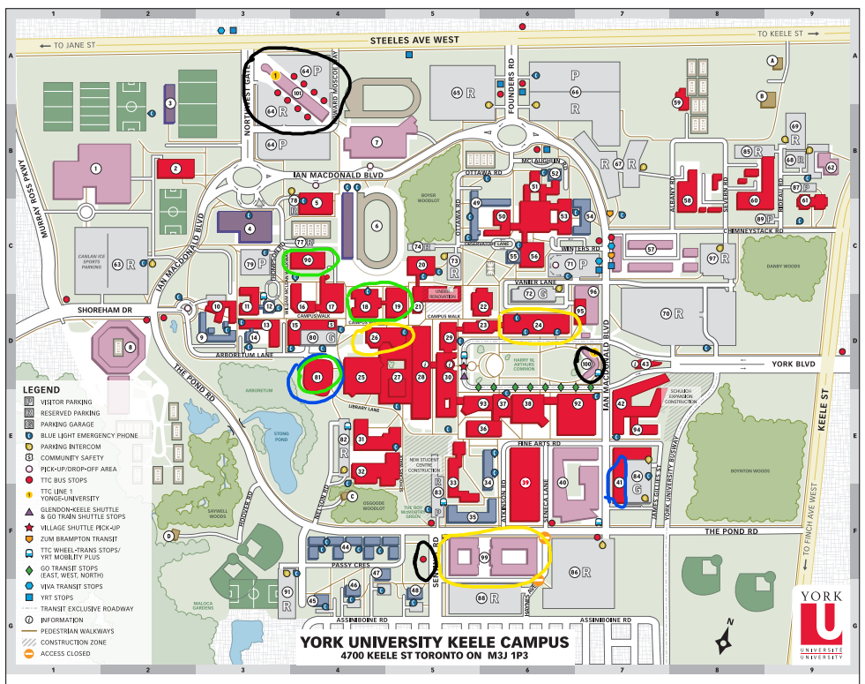

#### **Main Notes/ Observations from Interview:**

– First Generation Student

– Healthy food not really taken into consideration

– Less fear of COVID than most people

– Mental health better when in-person

### Survey Results:

Below are some of the results from the survey:

***Note****: last 5 columns are for numeric values 0 to 5 – 0 meaning the subject is least concerned about, and 5 being something the subject is most concerned about.*

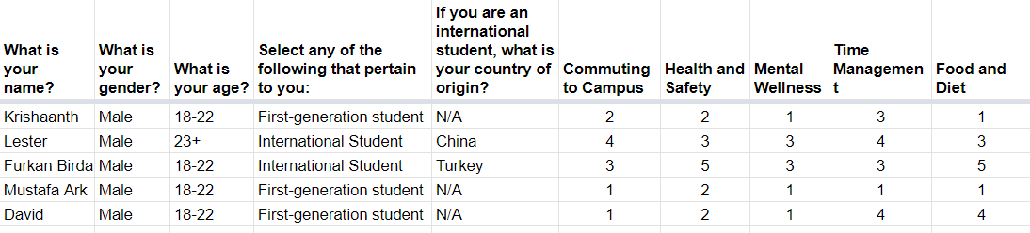

### Commonalities in Data

From the data (the interviews, probe activity, and survey) we could determine some conclusions and commonalities in the data. The two types of people interviewed were first-gen students and international students.

We noticed that first-generation students are more aware of certain parts of the campus and its functions than other people we interviewed. International students are less familiar with aspects of it, but the problems both groups face are mostly common. First-gen students, as well as international students, have a common goal of saving money, and value time management (especially true for first-gen students). There is an opportunity to design a solution for this problem and to create a system to help save time and money for them. We can address the problem of finding ways to save time in the users daily activities, perhaps shorten times in lines by finding less cluttered places.

Many of the subjects have a general idea of their surroundings and the campus. But we can improve this and enhance the ability for students to become more familiar with aspects of the campus – this would help with the problem international students face. Similarly, we can enhance the type of food they can find, since this is another need common among the subjects.

One difference between first-gen students and international students is that international students are more concerned with health and safety, especially in terms of the pandemic going on. This is a need that cannot easily be solved in one way since the regulations for health and safety have more to do with the campus rules or laws in the area, but there could be other ways to potentially solve it.

## 2.1.2 User Profiles:

The collection of characteristics for a typical user is called a user profile. Any one product may have several different user profiles.

### Profile 1:

### 

**Age:** 18-22

**Gender:** Male

**Commute style:** Public transport

**Traits:** Calm, emotional

**Most concerned with:** Time Management, Food Pricing, Food wait times, Mental

Wellness (being with friends)

### Profile 2:

### 

**Age:** 23+

**Gender:** Male

**Commute style:** Car

**Traits:** Nervous, logical

**Most concerned with:** Health and Safety (concerns with Covid and pandemic),

Food (Little bit of pricing, mostly health)

## 2.1.2 Personas

### Primary Persona

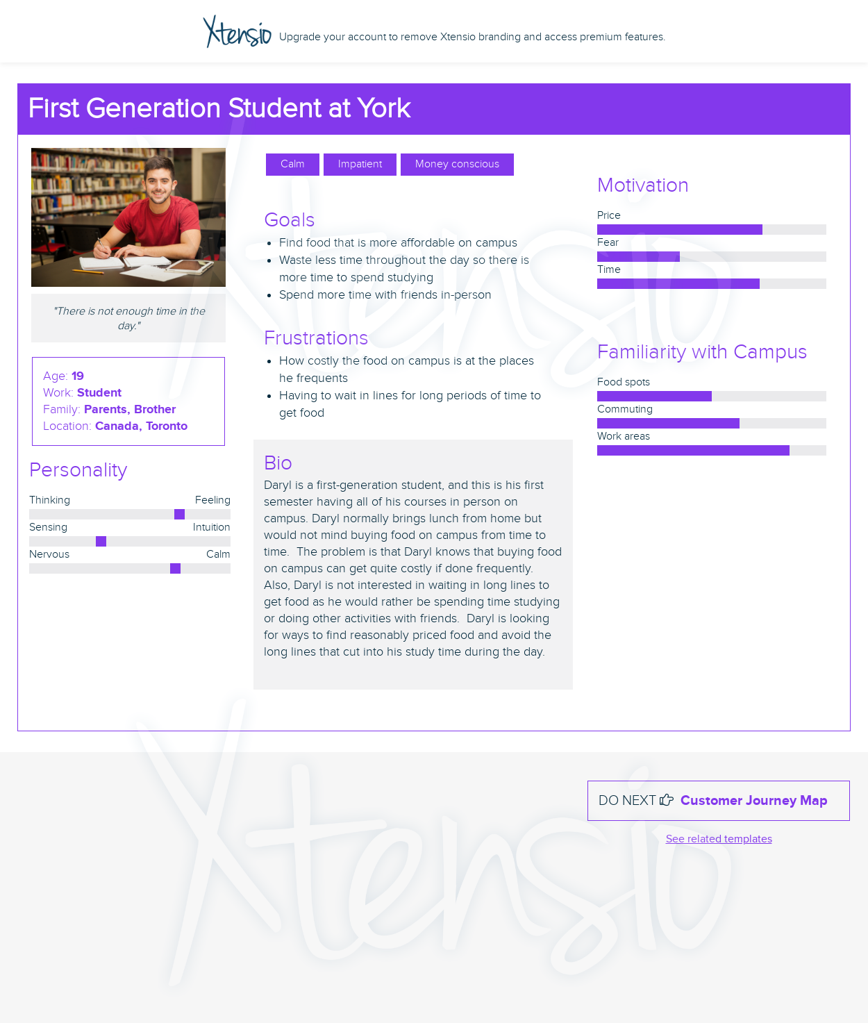

### **Secondary Persona**

### Scenario 1 - for Persona 1:

Daryl is home and needs to get ready for classes. He has a very early class and it takes a large part of his morning to commute to campus, but he lives close enough so it takes half an hour. He also finds the early class to be difficult to adapt to so it's important for him to keep track of these schedules and times – he uses his calendar app to do just this. When reaching campus, he wants some breakfast so he uses an app to see food spots on campus. He knows many of the locations listed but he wants one with the best affordability and where the wait for food is not too long. Finally, Daryl finds a good option and gets his food.

He needs a spot to sit and eat and work so he uses his map on his phone to find the best spot – he wants the spot closest and which is not too busy so that he does not feel so suffocated.

He uses his calendar app to keep track of how much time he has to study before he has to leave to go to the lecture. While doing his work, he wants to talk with his friends– he wants to remain social because that is something he missed in online classes. He uses his contact list to keep track of all these people and their names and some of their information.

### Scenario 2 - for Persona 2:

Lee is coming to the university from a long way. He drives to school and requires a close parking spot and needs to spend on parking every day. It takes him one whole hour to drive to campus. He didn’t have a chance to prepare his coffee, so he wants to get a morning coffee before his class starts. Also, he isn’t too familiar with the cafeterias around the campus, so he needs to use his app to find these places. In addition, he doesn’t know how crowded cafeterias are and if it's near to his class building. He doesn’t like crowded areas because he doesn’t feel safe due to the recent pandemic. He opens the app on his smartphone and enters the keyword “coffee”, he sets the current location which is his class building.

A map of places that sell coffee is displayed with an indicator showing how crowded they are. The app shows the suggested place for him. However, he wants to know how expensive the place is. He checks the cost indicator of the place which in the app shows above average. So, he asks for an alternative place that has an average cost indicator, which the app displays. He checks the app to see the estimated arrival and service time then he sets off, following the route from the app.

## 2.1.3 Establishing requirements:

Functional Requirements

| **ID** | **Description** | **Rationale** | **Fit Criterion** | **Example** |
| --- | --- | --- | --- | --- |
| 9a.1 | The product shall show food spots all around the campus | To be able to show all food spots that are on the campus to the users. | The product shall show the updated food spots within the campus displaying new locations and not displaying closed locations | The students can see all the cafeterias around the campus in the application. |
| 9a.2 | It shall allow the user to search for food they are looking to eat and provide recommendations nearby | Users should be able to enter a type of food they are looking for and get recommendations around campus that fit their requirements so that they can narrow down where to go to eat. | The product must be able to match keywords that the user provided with those found in the description of the restaurant. | The product should be able to take any type of food like fried chicken and determine from restaurant descriptions or menu information provided whether a restaurant sells fried chicken so that the establishment can be shown to the user. |
| 9a.3 | It shall allow users to give reviews of the restaurant that are visible to other users | Users can see the reviews of the food spots and decide whether to go or not. | The product shall take reviews from the users which have visited the restaurant. | The food spots will be having reviews from the visited users where other users can see this information. |
| 9a.4 | Allow users to give live updates as to how busy establishments are | To keep users updated, the product will show the live busyness of a food spot | The product needs to collect live data and update accordingly. | The students will be able to see the busyness of a restaurant and will be notified if the situation changes |
| 9a.5 | It shall request the user’s current location | The product needs the user's location to give recommendations that are close to the user. | The location data collected must be accurate and should be close enough coordinates to the users' location (within a certain tolerance). | Data is collected from wifi or cell phone data or the user is manually inputting address |
| 9a.6 | It shall suggest general nearby food spots using location data | Will give the user an overview of options available that will be more easily viewed since there will be fewer |  | If the user is on the South side of campus, then food spots near the South side of Campus will be shown |
| 9a.7 | It shall provide directions on a map where it would show estimated arrival and service time | Will allow users to reach the location on time and help users who are more unfamiliar with the area | The user needs to select the food spots that are within the campus. | The students manage their time as they will be seeing the estimated arrival and service time which can improve their time management. |
| 9a.8 | It shall show the cost range of each restaurant | This allows users to consider their budget while deciding where to get food on campus. | The collected cost information from the owners and the users | The students will be able to see the cost range for different food spots and decide accordingly. |
| 9a.9 | It shall authenticate restaurant owners | This is important so that people who are not the restaurant owner cannot impersonate them or provide incorrect information maliciously. | The product administrators will be needing proofs from the owners that shows the credibility of the establishment | The owner can upload restaurant certifications which will be reviewed by the application administrator |
| 9a.10 | It shall allow authenticated restaurant owners to view and respond to reviews | This allows users to get another side to reviews and see the restaurant’s response to what could be potentially negative reviews that patrons have left on the product. | The restaurants shall be verified by the application administrator where the owners will be needing to provide proofs. | The establishment owner can use the feedback from the users to have better outcomes. |
| 9a.11 | It shall allow restaurant owners to update restaurant information | This allows for new restaurants to show in the system and existing ones to have their information updated | The product allows for a store/restaurant owner to update their store’s data | Change data in a restaurant such as updating the menu, or a new owner can add their store into the system |
| 9a.12 | It shall show a description and any menu information available about a selected restaurant | Allow users to make the best decision in terms of the food they want to eat by providing important information allowing them to make informed decisions | The product shows the most current data that has been inputted in the system and reviewed to describe the restaurant. | Show information on the type of food (healthy food, cheap food, taste) |
| 9a.13 | It shall allow for the adding and removing of restaurants from the system | This allows the system to keep track of the new restaurants and the shutdown ones. This can allow users to know if a restaurant is shut down or if there is a new one. | The product must not contain incorrect information about whether a location exists or not after that information has been entered into the system. | If a restaurant opens or closes, the system will be able to be adjusted by those with the necessary requirements to reflect this. |

Non Functional Requirements

| **ID** | **Nonfunctional Type** | **Description** | **Rationale** | **Fit Criterion** | **Example** |
| --- | --- | --- | --- | --- | --- |
| 10a | Appearance Requirements | -Text and objects must be colours of sharp contrast  - Must be professional looking to be used on campus | Users are going to all be students and the students need it to be something professional for class use, also users need to save time – so UI must look clean | If the user feels comfortable to open the app on campus, so the participants who use the app are mostly all on campus (90% of concurrent users are on campus) | - Attractive to post-secondary students, design must fit professional college setting |
| 10b | Style Requirements | - style must be recognizable  - look is familiar to other apps of similar nature  - style must be simplistic | -if look is similar to other apps user uses, then it will feel more safer to use for users who feel their safety and data is important  -if style is simplistic, it will be easier to recognize and remember for user | - After substantial use and visibility of product, 80% of users must feel they can trust the product | - Looks similar to something like eClass in terms of how data is displayed |
| 11a | Ease of Use Requirements | - Must be quick to use  - Must be easy to remember  - Error rate should be few but some error is allowable  - Feedback: must responds | - Students want to save time so design must be quick and responsive  - They want app to provide multiple possible solutions so some error is ok since those will be least desirable solution present (bottom of list) | If User is able to find the solution they need in a quick time (within a minute of opening the software) | - Product is easy to use for young adults  - Product should not require training  - Product should be easy to remember |
| b | Personalization and Internationalization Requirements | - Language change ability  - Currency must be consistent  - Personalization not necessary (N/A) | - Users are international students and first gen students  - Currency is of one kind because it is meant for one Campus | N/A | - Product has language options like Korean, Spanish, Chinese, etc  - Currency is CAD |
| c | Learning Requirements | - Must be quick to learn  - No training necessary  - Easy to comprehend | - Time must be saved for the user, so less to learn will be better  - People from different backgrounds using it, so greater accessibility is important | When user views the design, they instantly can see what different parts of design mean | - Use of symbols over text |
| d | Understandability and Politeness Requirements | - Some data must be already entered for user  - User must see immediately what product can do for them | - Autofill of information and auto-inputting of it is very useful for time – it also avoids repetition which is important for our user base | N/A | - Info like gps data and name and student info does not need to be entered again, already should be saved  - Autofill of info previously entered |
| e | Accessibility Requirements | - Multiple languages  - Visually must be easy to understand  - Audio is minimal value | - People from multiple backgrounds are using the system  - Fewer text and more symbolic representation will allow for greater accessibility by multiple types of users  - Audio is minimal because the service would depend on text and visuals mainly | N/A | -There are multiple options for language  -Symbolic/graphic representation on buttons and functions |
| 12a | Speed and Latency Requirements | - The product shall be quick to respond to the users commands without interruptions.  - It shall give updates of the location's information within a 0.5-second to 3-second timeframe. | - The students might need this product in quick situations.  - The updates of information about the food spots will have a positive impact which will allow students to save time. | - The product’s ideal response time shall be less than 1.5 seconds for 90 percent of the user’s commands. No response shall take longer than 3 seconds. | - The product’s interface between a user and the system shall have a maximum response time of 3 seconds  - The product shall update the location's crowdedness automatically every 5 minutes.  - The response shall be fast enough to avoid interrupting the user’s flow of thought. |
| b | Safety-Critical Requirements | - The product shall be safe to use.  - It must comply with university safety rules and regulations. | - The students would like to have a safe environment while using the application.  - The application should be ready for possible cyber-attacks.  - To maintain the trust between the user and the application | - Comply with university and province safety rules and regulations.  - The product shall be certified to comply with data privacy and collection requirements. | - The product shall not share private user data.  - The product shall have high wall security to protect data from hackers and other possible threats. |
| c | Precision or Accuracy Requirements | - The product shall be as accurate as possible with the information to the users  - To maintain the accuracy of the information in the product, it shall be updated. | - The students would like to have accurate information to assist them in having proper time management.  - To have successful outcomes, the application should be accurate and ready to get customer feedback upon failure. | N/A | - The given food spots' busyness information to the users should be accurate and updated.  - Accuracy of food spots shall be within the campus area. |
| d | Reliability and Availability Requirements | - The product should be always available for use.  - The product's failure rate should be as low as possible. | - The application would be ready to use for the students whenever they want because sometimes students might be on campus early in the morning or late at night.  - The students should be able to use it error-free and in case of any bugs, they should be able to send the bug information which can be resolved. | N/A | - The product shall be available to use 24 hours and 7 days.  - The product shall achieve 99.9% uptime. |
| e | Robustness or Fault-Tolerance Requirements | - The product shall continue to function under unexpected situations  - It should have a recovery system in abnormal situations.  - The user should be aware of the unexpected situation and also be aware that the product is continuing to function. | - The students will be using the application constantly on campus which can lead to unexpected situations that might disable some parts of the application. To be able to recover from this situation will maintain the good relationship with users. | N/A | - The product shall continue to operate in offline mode whenever it loses its link to the internet. It can display nearby food spots and its average busyness report in offline mode by looking at the daily activity of the store and taking an average of it. |
| f | Capacity Requirements | - The product should be able to handle a high volume of users at the same time. | - To avoid crashes the product should be able to handle a maximum number of students logging in at the same time. | - The university's total students need to be checked by taking into account that the product should be able to handle the maximum number of students on the campus. | - The product should be able to handle 50,000 users when they are using it at the same time. |
| g | Scalability or Extensibility Requirements | - The product is expected to grow within 3 years  - The desired goal for it would be to increase capacity and extend the use of it in the next 3 years. | - The application will be used by the university’s students which means it will be open to growth and expansion. | N/A | - The product is expected to have a boosted growth with the start of usage in different universities.  - The product shall be capable of processing the existing nearly 50,000 students. This number is expected to grow to 200,000 students within three years. |
| h | Longevity Requirements | - The product will be able to be used for a long period of time. | - Students should be able to use the application even when they graduate from their studies as well. | N/A | - The product can be used on Campus, while the user studies, and also used even after they graduate to help them find restaurants near their workplace, for example |
| 13a | Expected Physical Environment | The product shall be used by students both inside and outside while they are walking around campus. It shall also be usable in all reasonable outdoor conditions. Finally it shall be used in both noisy and quiet environments. | A student should be able to use the application anywhere they are on campus with internet access whether that be in a building or outside so they can determine where they want to go next.. | N/A | - The product shall be usable in lecture halls where it is loud as people are leaving the room or outside in the rain. |
| b | Requirements for Interfacing with Adjacent Systems | Our product must interface with applications that allow for the production of directions from a current location to another location. | The product not only needs to recommend places for the users to purchase food but must also provide the user with this restaurant's location and tell the user how to get there from their current position. | The data content will be the map and directions created for the user to follow. The medium that carries the interface will be a page in the application that is associated with the restaurant. The frequency will be quite often, whenever the user decides to go to a recommended restaurant. The trigger will be the user plotting a path to the restaurant after they have decided to go. | The product must interface with an application such as google maps. |
| c | Productization Requirements | The product must be formatted such that it shall be available for installation by an untrained user on major app downloading services. | The product needs to be available for a user with basic technological skills who can install this application the same way they would install any game or app on their device. | N/A | The product must conform to the standard format necessary to allow it to be downloaded from marketplaces like the google play store |
| d | Release Requirements | The maintenance releases shall be offered frequently. Each release shall not cause previous features to become unusable. | The product should be bug-free and when a bug is reported it should be dealt with quickly so that the user can use the application as intended. As well these fixes should not cause other things to break. The application must always maintain its usability after all bug fixes so that the user does not experience frustration with cascading issues after every bug fix. | Maintenance may include fixing unexpected issues like recommendation issues or other issues making core features unusable. The effort budgeted for this endeavor will be high as the core functionality provided in the releases must work as expected. | Maintenance releases shall be offered every 2 months, or when a sizable number of bug fixes have been completed. These releases will not do things like destroy previously provided user data on things like how busy and crowded a restaurant is nor will they make it impossible to use other functionalities like getting directions to recommended restaurants. |
| 14a | Maintenance Requirements | - Scheduled updates should be convenient  - Unexpected failures should be dealt with quickly  - Maintenance should be short and frequent rather than long and infrequent | - Time management is a key problem for some users so short maintenance is desirable  - When and how long maintenance is will greatly impact users if the it interrupts during usage | N/A | - The product shall have updates every 2 weeks  - The product shall need no more than 24 hours to resolve unexpected downtime  - The product’s planned maintenance time shall not exceed 1 hour |
| b | Supportability Requirements | - Support should be easy to contact  - Support should be convenient for the user to access  - Support should be available as often as possible | - Quick and understandable support will improve the experience of a user facing difficulty and prevents them from finding other solutions  - Multiple levels of support allows the product to be more accessible to a wider array of users | N/A | - The product shall have 9AM - 5PM call support  - The product shall have FAQ available |
| c | Adaptability Requirements | - The product should be portable to platforms students typically use  - The product should be flexible in the format that it can operate under | - The more portable the product is, the more likely users will make use of it  - Allowing for multiple platforms emphasizes the simplicity of the product | - The product should take no longer than 3 months to migrate to new platforms | - The product shall be compatible with PC and mobile  - The product shall be available on iOS and Android |
| 15a | Access Requirements | - Private data should be accessible to few trusted individuals  - Users should have access to public information  - Unique data belonging to certain users should be kept safely | - Limited access to certain data allows development and maintenance to be easier to handle  - Defining who can use the product helps define the usage of the product and reveals possible refinements that can be made | - Admins with correct credentials should have read and write access | - The product shall allow admin to access data  - The product shall request user logins to access unique data to them  - User shall have access to all data except source files and other private user data |
| b | Integrity Requirements | - Incorrect data should be detected and prevented when possible  - The malicious insertion of incorrect data should be protected against | - Faulty information will inconvenience users and lower their perceptions of the products usability  - Users are particularly looking for corrected information to ease their student-life balance | N/A | - The product shall verify stored data before insertion  - The product will check the validity of data every week  - The product shall time-out users detected inputting incorrect data |
| c | Privacy Requirements | - Private data should follow relevant laws  - The protection of private user data should be robust | - The presence of identifiable data puts users at risk if not handled correctly  - Users should not feel as though they are taking a personal risk in using the product  - Strong security reflects on the positive perception of the product | N/A | - The product will follow provincial privacy laws  - The product shall follow federal privacy laws  - The product shall inform users of the privacy policies that are adhered to |
| d | Audit Requirements | - Auditing data should be stored for the product’s usage  - Auditing data should be detailed and informative | - Planning ahead for auditing eases required checks in the future  - Audit records can assist with problem identification and usage tendencies  - Audit policies can have legal implications on product usage and performance | N/A | - The product shall have time stamps of user activity  - The product shall record all instances of maintenance  - The product shall record all financial transactions |
| e | Immunity Requirements | The product must include standard defence against attacks that would take down the information available on the application. It must also not allow users to run anything they wish directly into any part of the application that is getting information to be displayed. | The product must be protected from users with malicious intent that would attempt to force the application to not run. Also, user input must be controlled and what is done with that input must be controlled so that users do not have unrestricted access to change or view what should otherwise be unavailable information. | N/A | The product shall have basic protections in place for standard attacks that affect applications of its kind. Also, the product should not directly insert any user inputted data into queries of any kind without the contents being reviewed so as to ensure that the user is not putting something that could damage the system somewhere where simple information like a preference is expected. |
| 16a | Cultural Requirements | The product shall not be offensive in its recommendations or descriptions of restaurants and the food or drinks served there. The product shall not include any language or symbols that could be interpreted by those of other religions or ethnic groups as offensive. | The product will be used by international students among other groups of a variety of different ethnicities and thus care must be taken to ensure that none of the material in the product could be considered offensive and that no one will feel attacked in any way by anything found in the application. | N/A | The product shall not include things like offensive descriptions of dishes that involve derogatory mentions of culture. As well, the product will not include symbols like those on maps, representing different styles of establishments or features of the establishment that could be considered offensive to users. |
| 17a | Compliance Requirements | - The product should be compliant with legal requirements inside and outside of the campus. | - To maintain trust with the students and the authority the application should comply with the legal requirements. | - The application needs to take a lawyers’ opinion to make sure the product does not break any laws. | - Personal information shall be implemented so as to comply with the Data Protection Act. |
| b | Standards Requirements | - Product should follow common design standards  - Product should comply with the rule that everything can be understood by all people  - Product should follow security safety code | - To have the application running smoothly, it needs to have internal standards which will maintain discipline and issueless results. | - If all standards are adhered to then criterion is met  - If Standards in Materials Guideline are met, then criterion is met | - Materials Guidelines is one example of a design rulebook that can be used across all of the product  - Data safety can be akin to eclass, another app used by students |

## 2.1.4 Use Cases:

The diagram below shows the three Use Cases of our system which correspond to three roles, the User, the Administrator and the Restaurant Owner.

