**Assignment 2**

**EECS 3461 B**

**User Interfaces**

**Group Members:**

Arjun Kaura 216379620

Antonio Cedrone 217798000

Melvin Gagarao 216469637

Omer Faruk Celik 218383224

**PART 2: Assignment 2**

# Mood Board:

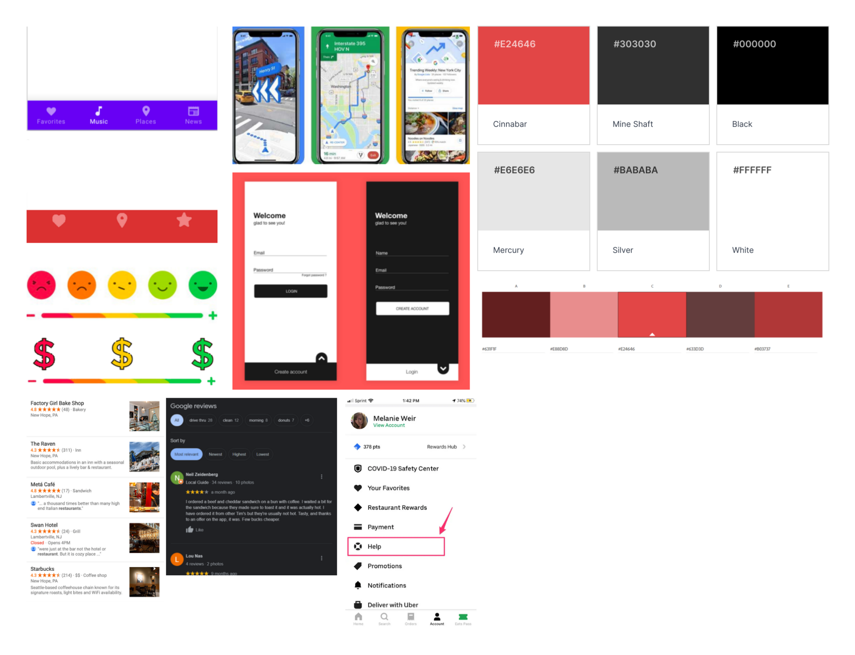

# Low-Fidelity Prototype:

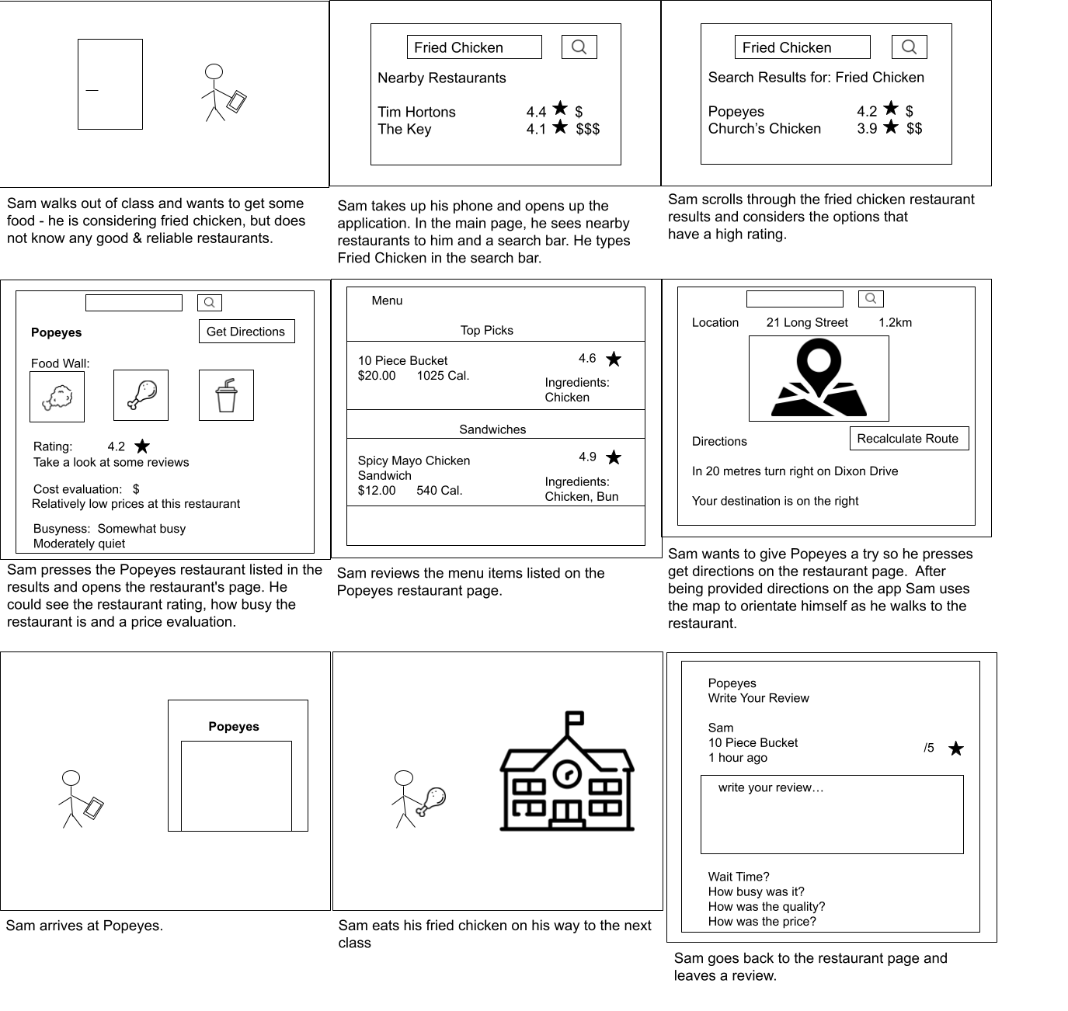

# Wireframes:

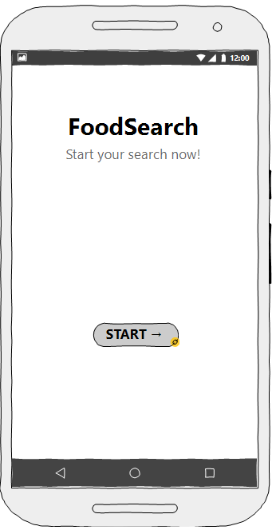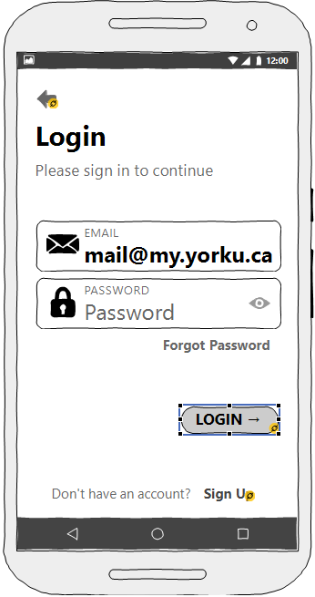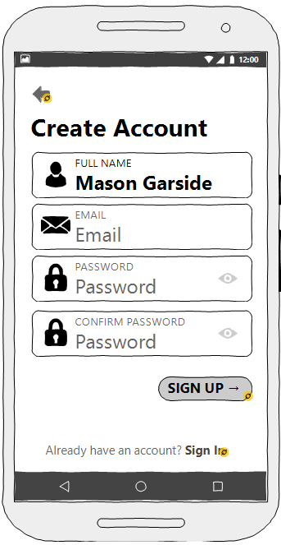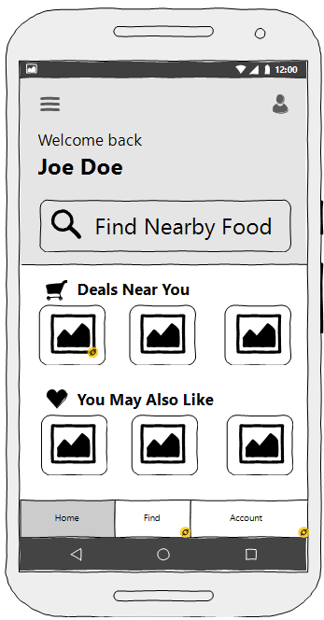

**Figure 1**: Initial page of the app.

**Figure 2**: Login page where the user can type in his/her email and password.

**Figure 3**: Create an account page where users can register for the app.

**Figure 4**: The first look of the app which displays nearby and favourite food areas.

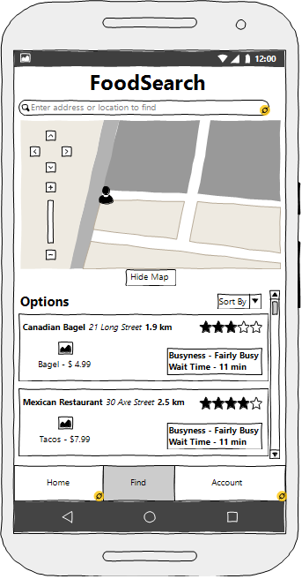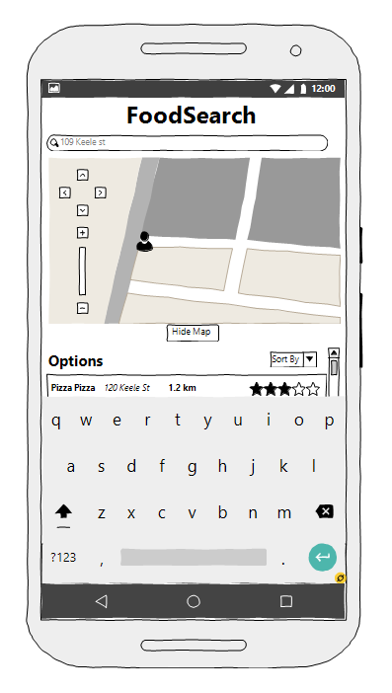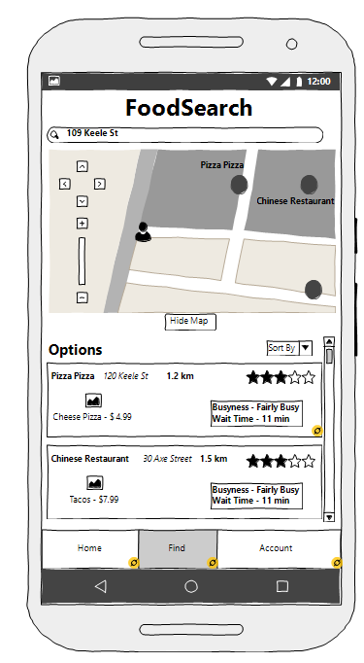

**Figure 5**: Initial find page with a search bar, map, and suggested food options.

**Figure 6**: Find page with the search bar enabled via keyboard input.

**Figure 7**: Find page with store locations on the map and nearby options based on a

given address.

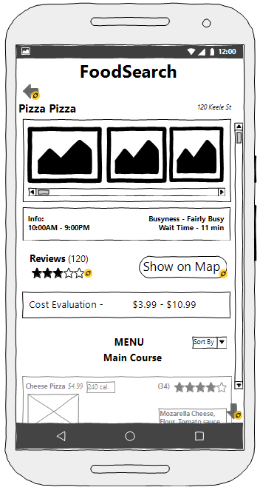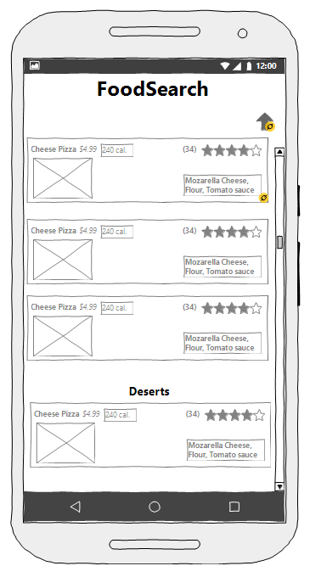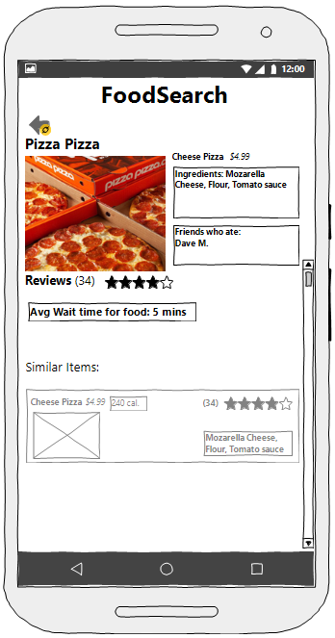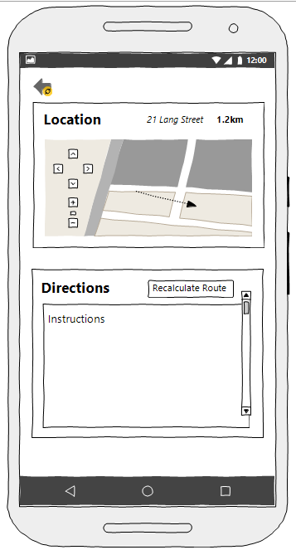

**Figure 8**: Restaurant page with food item images, information about the restaurant

(hours, busyness, wait time), a review score, and a cost evaluation.

**Figure 9**: Bottom of the restaurant page showing the menu of the restaurant.

**Figure 10**: Product page for an individual product sold by the restaurant with information

about ingredients, product reviews, waiting time as well as names of friends who have ordered it and similar items.

**Figure 11**: Directions page accessed through pressing show on map that provides a map

with a path from the user's current location to the restaurant as well as generated directions.

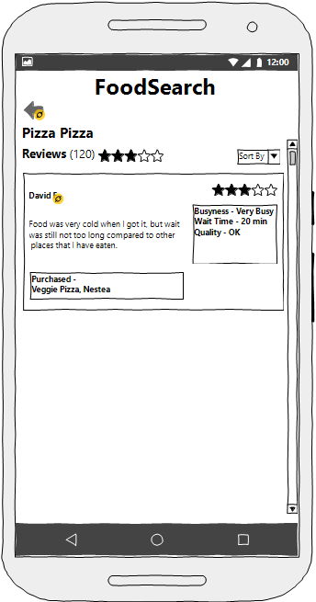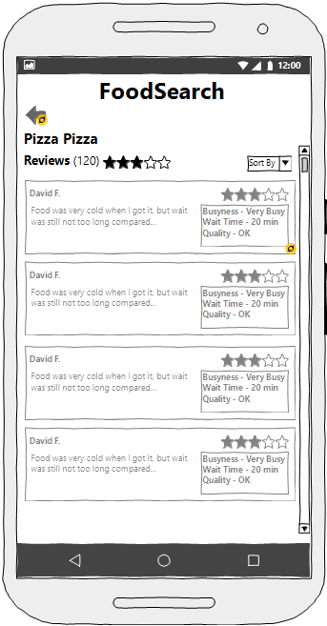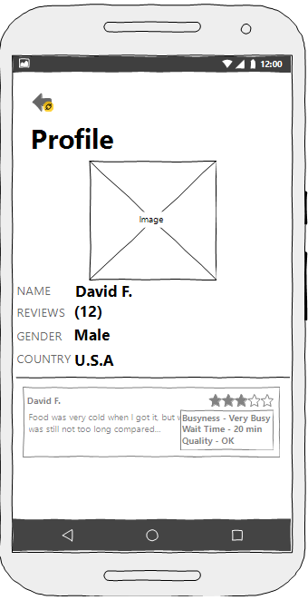

**Figure 12**: Initial look of the Reviews page of the selected restaurant.

**Figure 13**: When a user clicks on a review, they can see more about the review.

**Figure 14**: The user can check the Profile page of the reviewer.

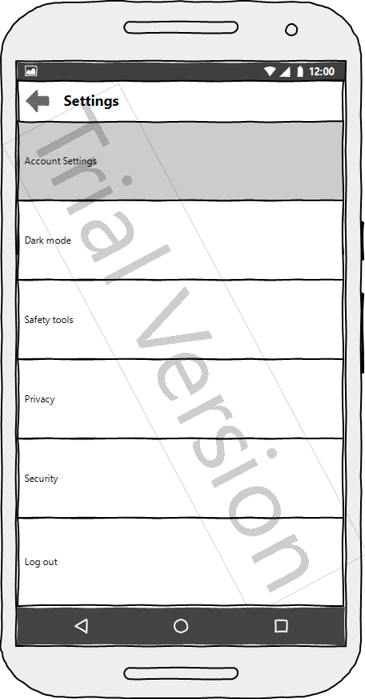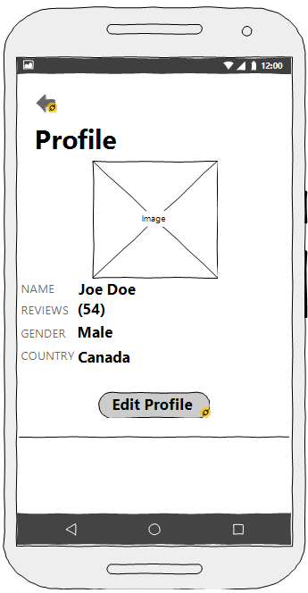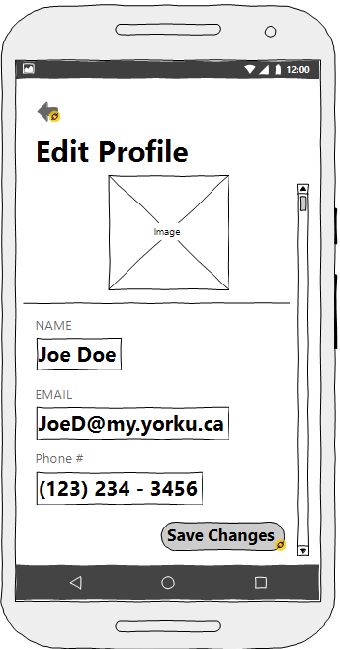

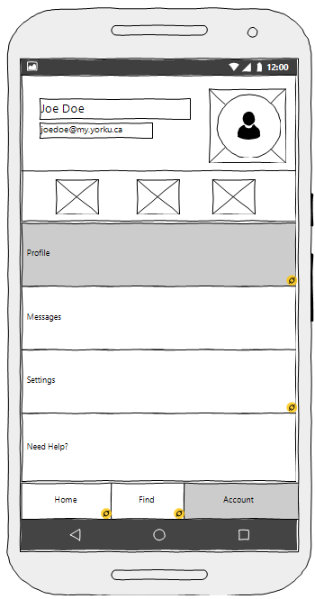

**Figure 15**: Settings page where settings such as: account settings, dark mode, safety

tools, privacy, security, and logout can be selected.

**Figure 16**: Profile page where the user can check their account information

**Figure 17**: Edit profile page where the user’s info can be edited.

**Figure 18**: Account page allows the user to view basic info and select options like profile,

message, settings, and help.

# Interactive Prototype

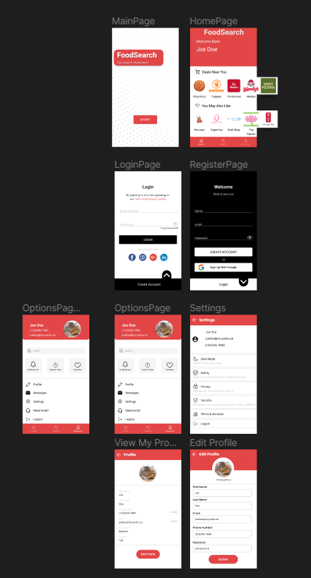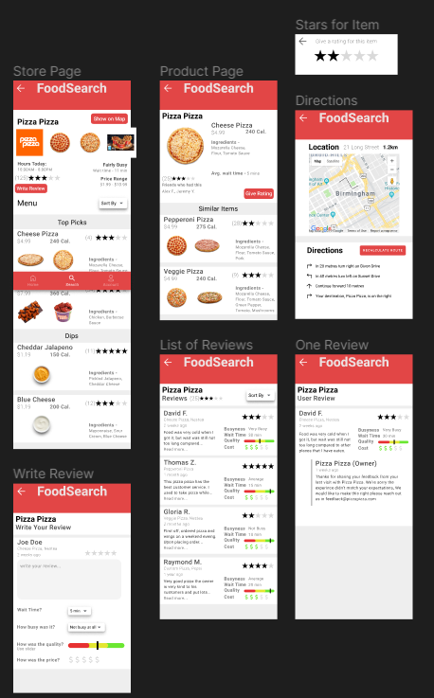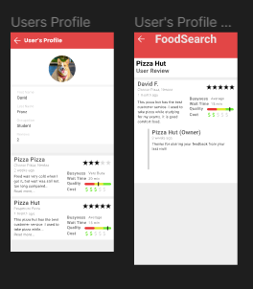

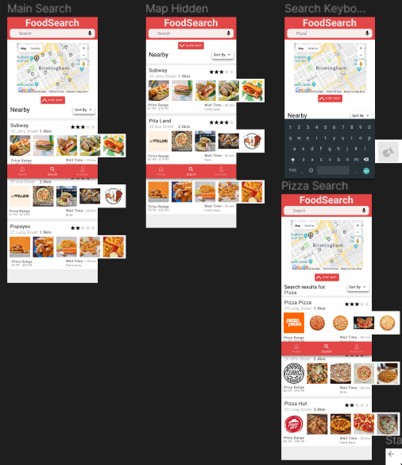

**MainPage**: Initial page of the app.

**LoginPage & RegisterPage**: The users will be able to login with their login credentials if

they don’t have an account, they will be able to create one from RegisterPage.

**HomePage**: Main page of the application accessed after successfully logging in.

**OptionsPage:** From the account bar users will be able to see administrative options for the app.

**Settings:** Settings page where settings such as: dark mode, safety, privacy, security, terms and services, and logout can be selected.

**ViewMyProfilePage & EditProfilePage:** In ViewMyProfilePage, the profile of user where user can view their profile picture, first name, last name, phone number, email address, occupation and number of the written reviews. In addition, in EditProfilePage the users will be able to edit their information in the profile.

**Main Search & Map Hidden**: Users will be able to view nearby food on a map with related ratings, reviews, and pictures below.

**Search Keyboard:** Search page after search bar has been pressed and keyboard comes up for users to input their search request.

**Pizza Search:** An example of a user searching for pizza using the search bar alongside mapped locations and relevant reviews.

**Store Page:** A page dedicated to a selected store providing images for the restaurant and their food offerings. It also has information about busyness, price, hours, and the menu.

**Product Page:** A page for a specific product sold by a restaurant tells users its name, price, calories, ingredients, waiting time, review score as well as providing similar items.

**Directions:** A page of directions and google mapping to guide the user to their desired food location.

**List of Review Page:** The users will be able to see the other users' reviews about the selected restaurant.

**One Review Page:** A page where users can see more details about the review that the selected user has written, and the responses to the review.

**Write Review Page:** A page where users can create a review and show their personal wait time, expenses, and experience.

**User’s Profile:** Profile of a user who’s name in a review was clicked on. This page allows a user to see another user’s information as well as all of their reviews that they have posted.

**User’s Profile > Open One Review:** An individual review from another user accessed through their profile page.

## Link To Interactive Prototype

<https://www.figma.com/file/MnF5bGLDIDILtpmaBjrMLJ/FoodSearchv2?node-id=0%3A1&t=3R3lp48hig8C3HOu-1>

# Alternative Solutions

Some alternative solutions that our group came up with for our problem involve various ideas for user products. One idea was to focus on transit – mainly trying to save time for the user on arrival time at their destinations and to provide choices available on the user’s campus.

When looking at other concerns that were present amongst our subjects in Assignment 1, there was a need for social interaction. This idea was to focus on social circles online within our app, and there was an importance on seeing other people's opinions. This social aspect was reduced in our final idea.

Our current product focuses on finding food and saving time in doing so. One idea we had was to provide the ability to place an order on the food and to purchase it from the app, but we realized the focus should be on providing the best options for findingrestaurants and not necessarily provide an alternative for purchasing products from them.

# Final Solution and Design Brief

Our final solution was a food app for finding restaurants and the best options for users. By using this food app the users will be able to see how busy the establishment is and will be able to minimize the wait times in the restaurants around the campus.

From our personas, we could see that the main concern was related to time management and finding food on campus and everything that entails – affordable food, shorter lines, and healthier food. With these concerns in mind, and taking into account some of the other concerns of our personas, we chose the idea of an app for finding the best options for food that provide details about pricing and time (wait time for food and busyness).

There was also the fact that many international students (which is one of our personas) had trouble being familiar with all of the campus, so there is the ability to find the stores using a map and directions. Also, there is a social aspect because users are able to manage their own profile and view others’ via reviews. Another concern from our personas were that they liked being more social since the pandemic did not provide much of that.

# Explaining App design

The app has a design that is intuitive and minimalist. This allows for it to be easy to learn and remember. There is consistency across many screens of our app – this in turn helps with memorability. There is plenty of use of symbols and commonly identifiable icons so that there is not too much confusion with overuse of words for different options. Also this can help overcome language barriers.

The most important information is shown straight up – the wait time, the distance the store is away, and details of the price range for the restaurant are shown. Further information can be seen through buttons and easy to access options – this prevents an overload of information being shown all on one page.

**Link to Video:**

<https://www.youtube.com/watch?v=DKUr9_s4w-0>