CSE 344
HW4
REPORT

Ömer Faruk SAYAR
171044038

OverAll Design

In this project I used the structure of single-server , multiple-client application:

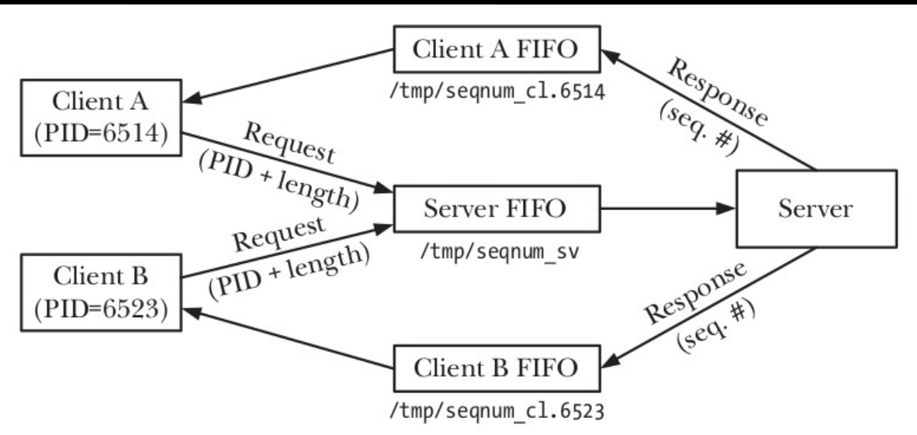
There is a one server FIFO with named server.PID that accepts the connection requests.
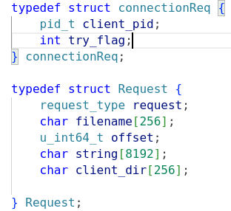

My connection requests are consist of client_pid (needed to open client FIFO which is named client.PID) and try_flag for the determine if the request is tryConnect or connect.
After the connection established. Program uses Request structure to send its requests.

When the server wake up, it generates a thread pool with the given size. Each thread in the pool starts to wait until a connection request comes to request queue in a condition wait. In the main thread server reads its FIFO in a while-true loop. If there are clients their number is less than max_number then server accepts the connection, otherwise adds request to queue if it is try_flag is 0, else rejects the request.

Server Side:
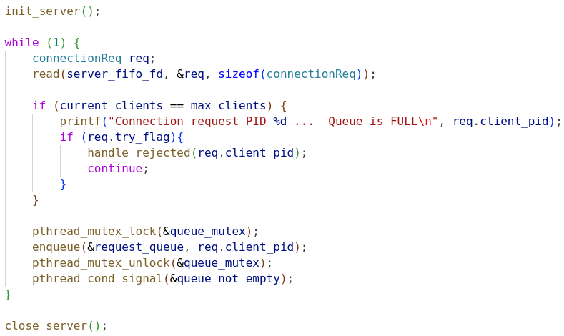
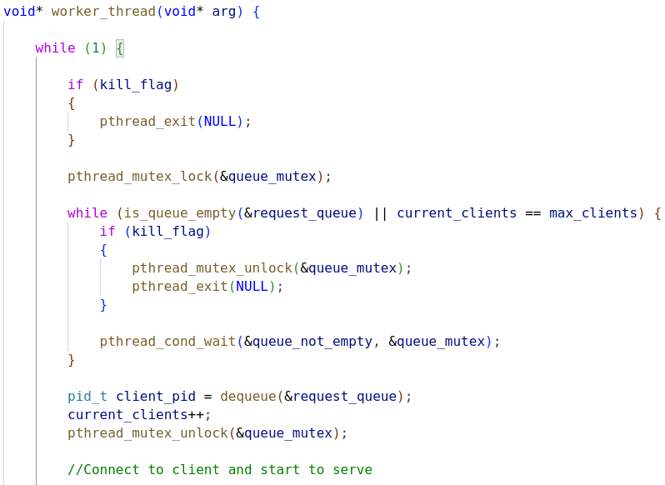

To able to provide synchronization between threads when using sharing data (request_queue), server program uses pthread_mutex to access data and pthread_cond variable to check if the data is ready or not in the queue.

Client Side:
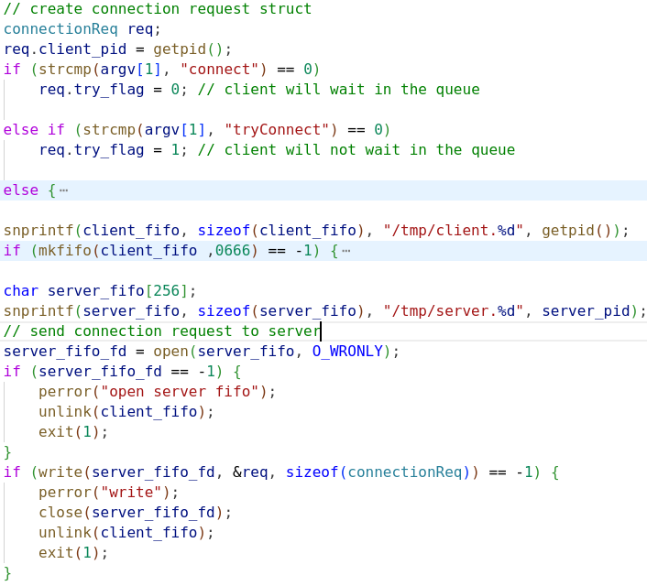

To be able to keep any number of requests, queue was implemented as linked-list. Queue only keeps client pid as data.
There is also a log file for the server that logs the client requests. To provide any data corruption on the log file I used unnamed semaphore as mutex and server initialize the mutex with pshared arguments as 0 to be able to use between threads.
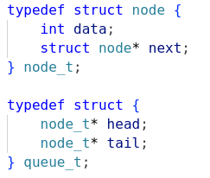
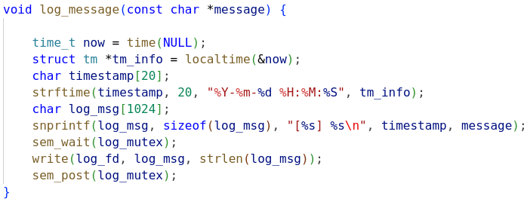

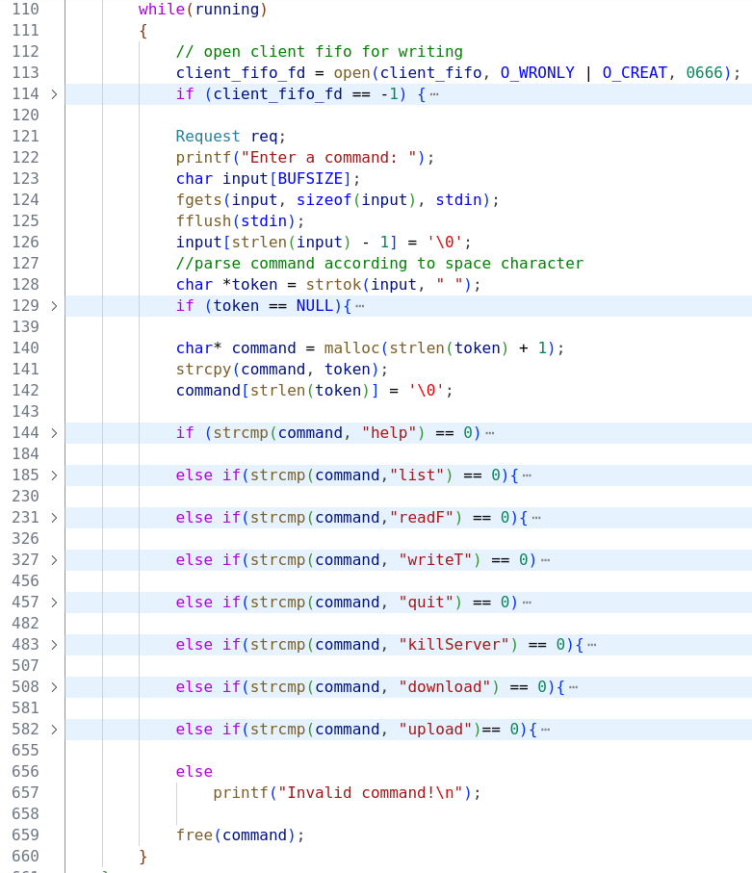

After the connection established, client and server threads use the client FIFO respectively. First one side opens the FIFO for writing other side opens for reading then, writing side closes and opens for reading, reading side closes and opens for writing. Before client sends any commands to server it waits the user input.

To provide synchronization between the server’s threads when access to files on the server directory, named semaphores was used to avoid any race condition and data corruption.

Semaphores are named with file names on the server to be able to sure correct semaphore(mutex) is locked and opened. Before the termination of the server program unlink them using the files names on the server.

To be able to cleanup threads when client sends killServer commands to server or any SIGINT, SIGTERM, SIGQUIT signal arrives the server, Program keeps the array of the client file descriptors and closes them after cancel the threads in the pool.

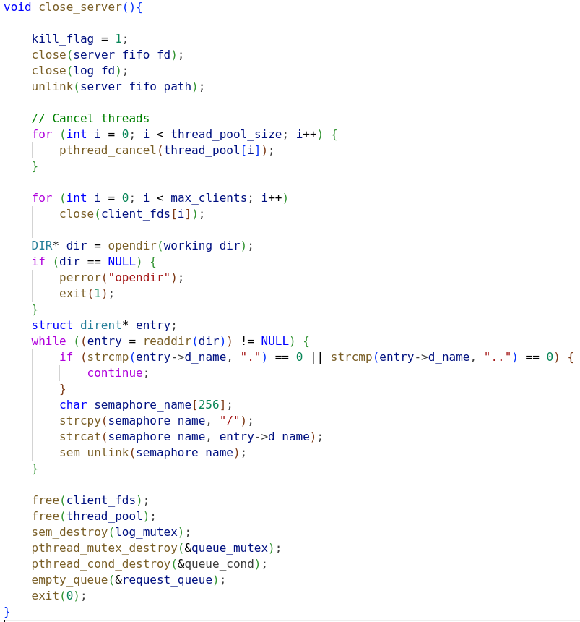

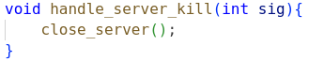

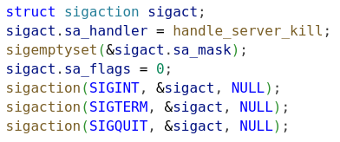

TEST CASES:

1- Open server for existing directory, shows all commands are working.

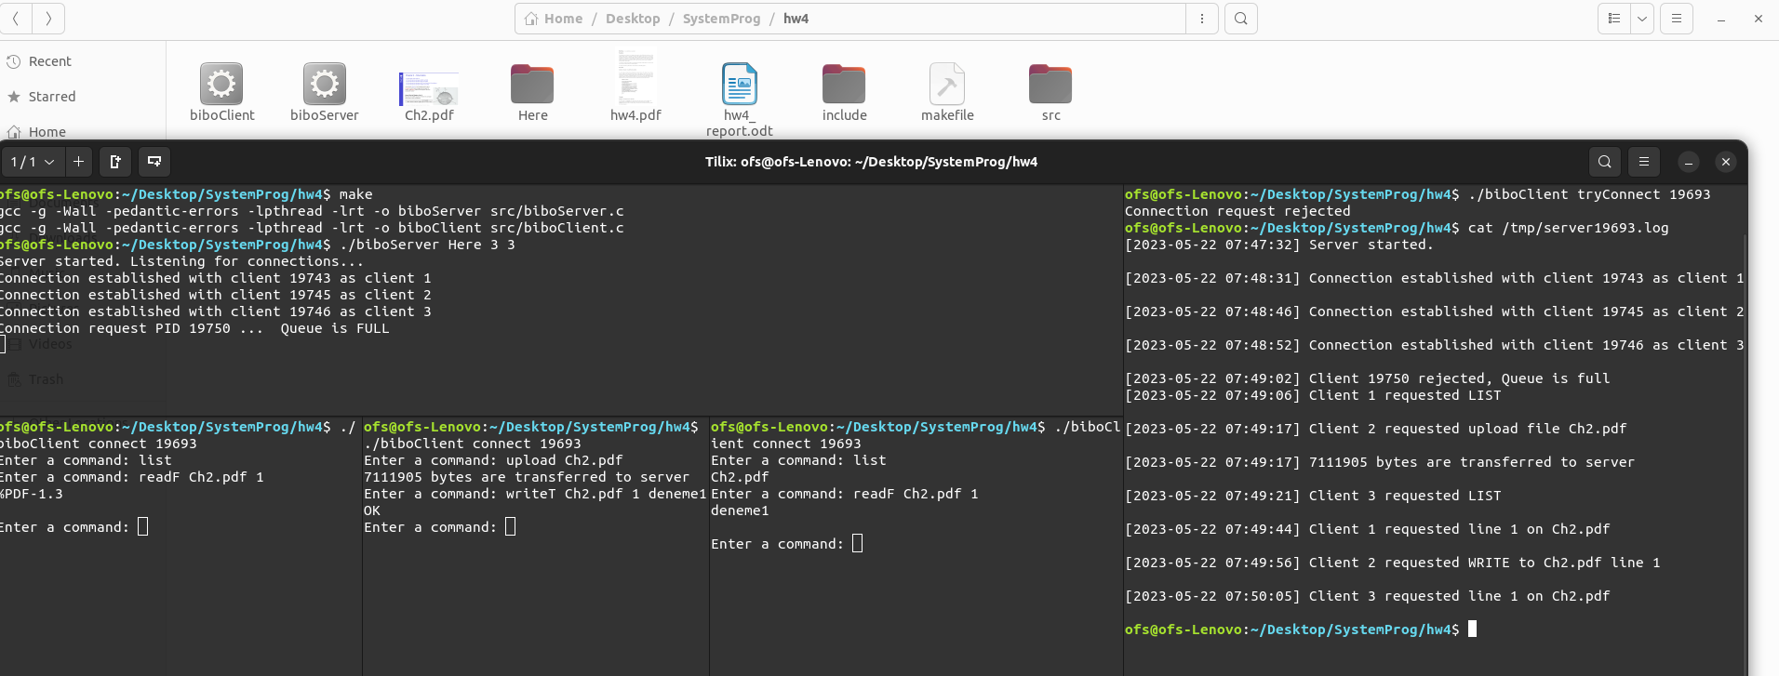
Now adding deneme.txt to Here directory manually to test download option.

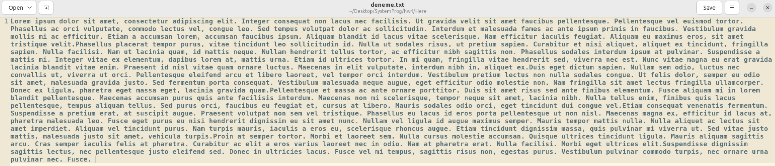
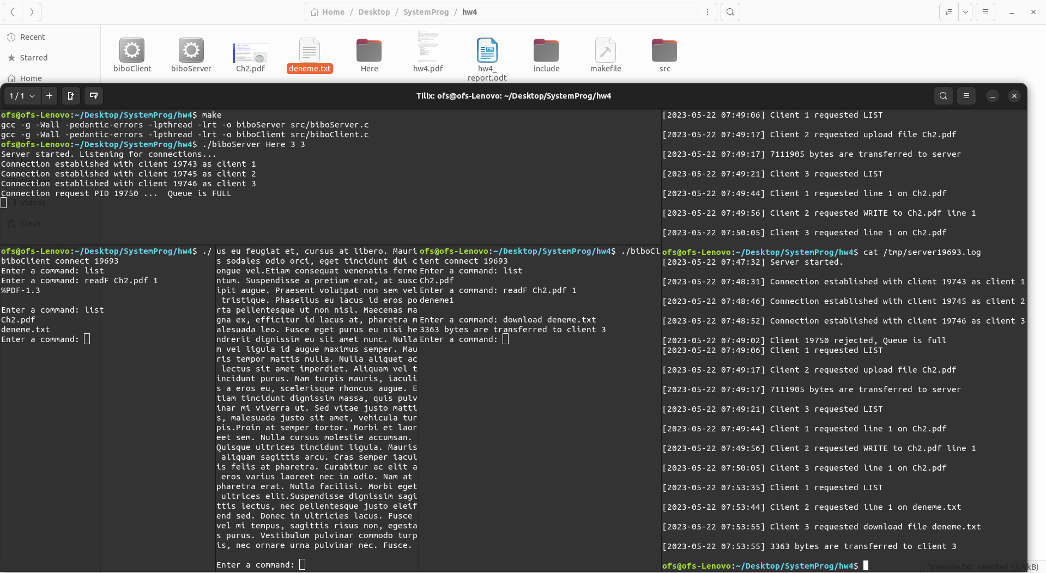

2- Sending 50 connect requests and test if they are in the queue

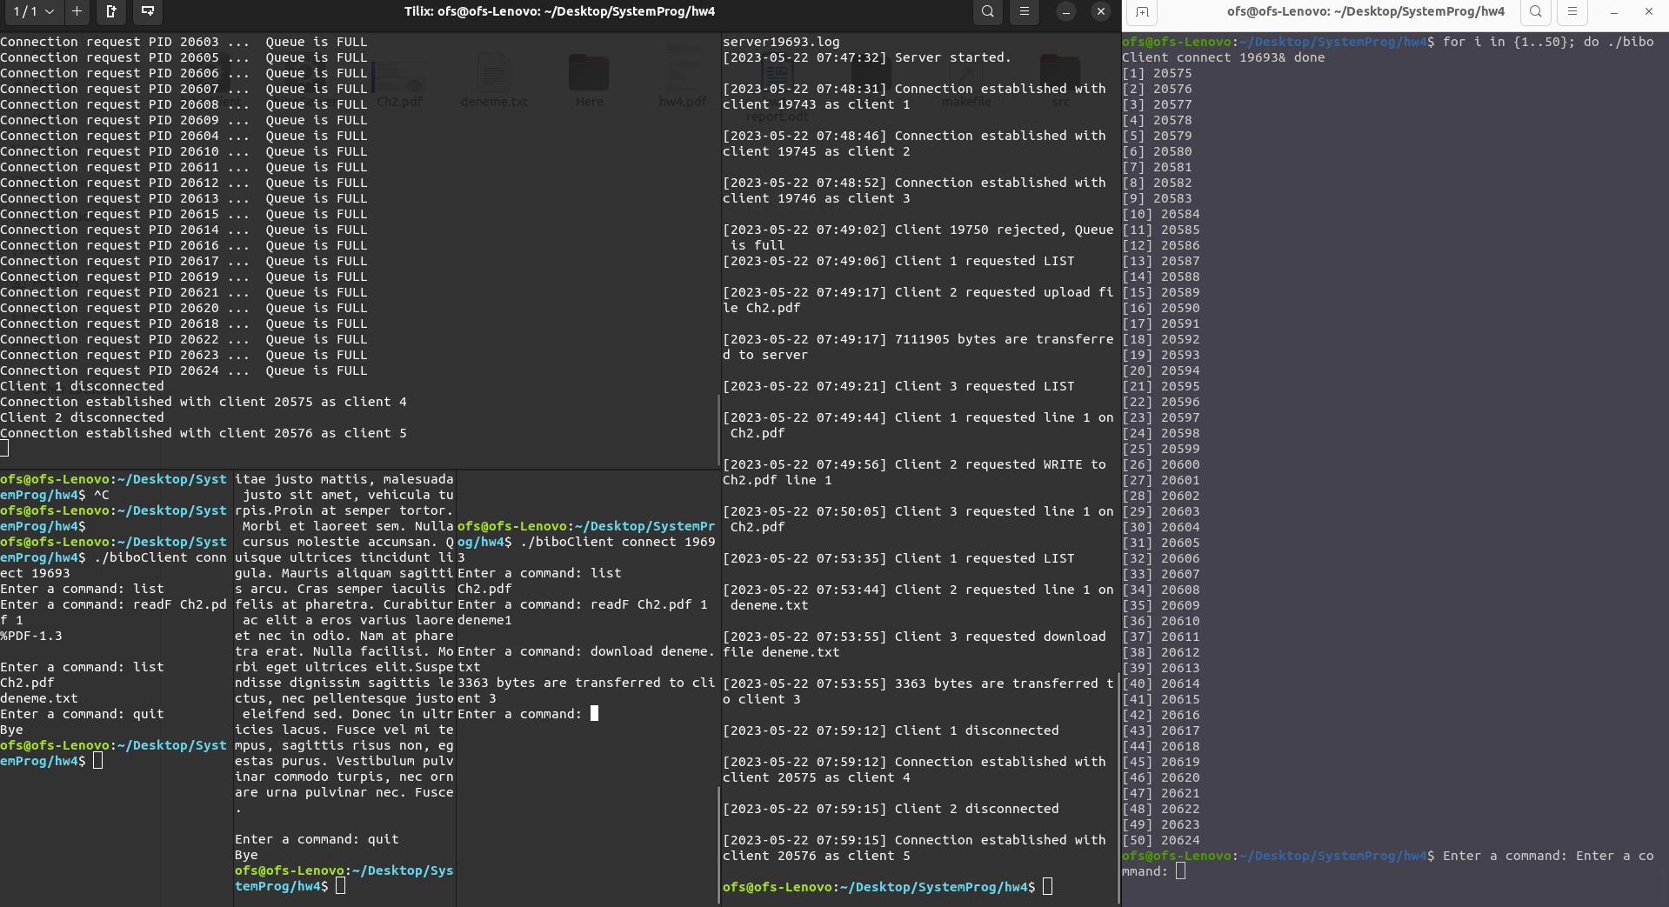
3-Sending killServer request

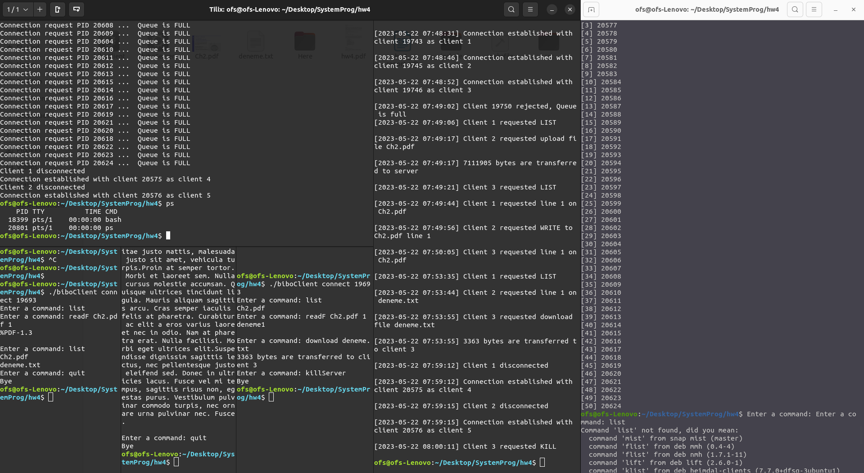

4- Invalid file name

