CSE 344
MIDTERM
REPORT

Ömer Faruk SAYAR
171044038

OverAll Design

In this project I used the structure of single-server , multiple-client application:

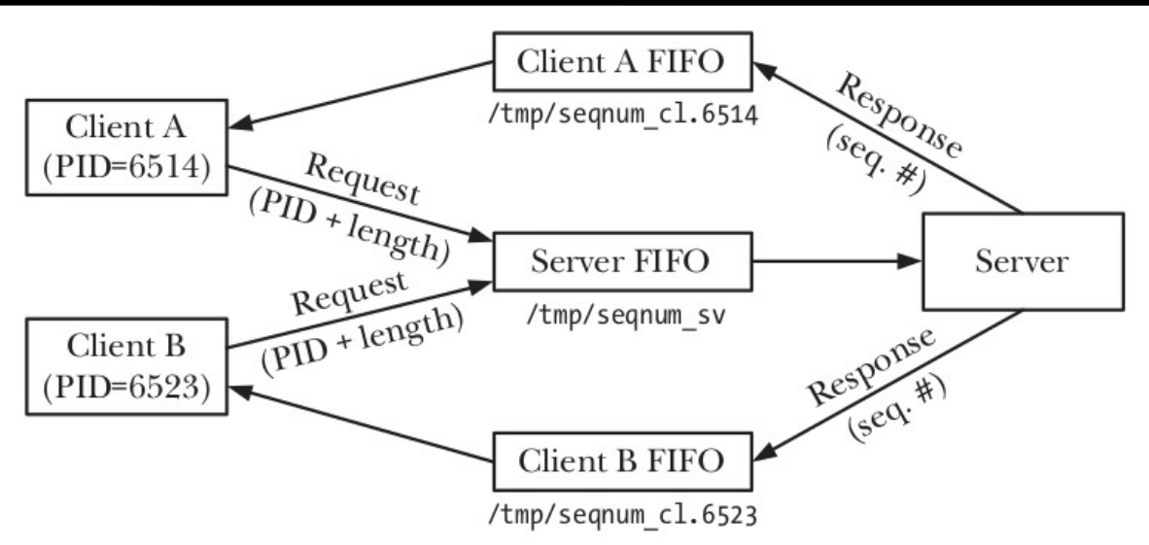
There is a one server FIFO with named server.PID that accepts the connection requests.

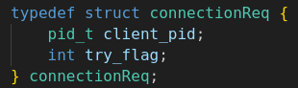
My connection requests are consist of client_pid (needed to open client FIFO which is named client.PID) and try_flag for the determine if the request is tryConnect or connect.

Server continuously reads the incoming requests in a while-true loop, and if there are clients their number is less than max_number then server accepts the connection, otherwise adds request to queue if it is try_flag is 0, else rejects the request.

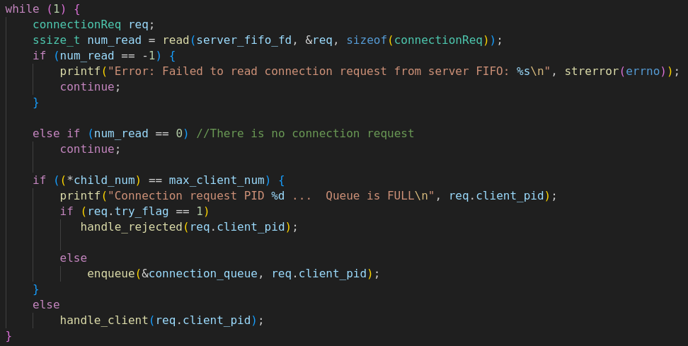
Server Side:
Client Side:
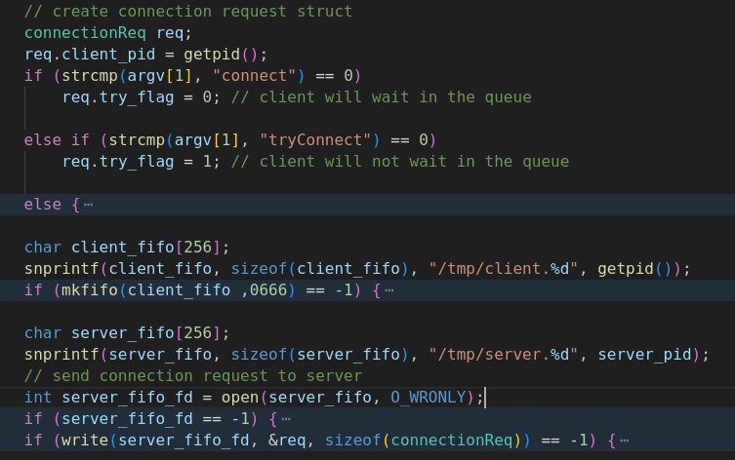

To be able to keep any number of requests, queue was implemented as linked-list.
There is also a log file for the server that logs the client requests. To provide any data corruption on the log file I used unnamed semaphore as mutex and kept it on the shared memory.
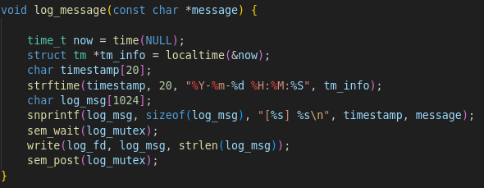

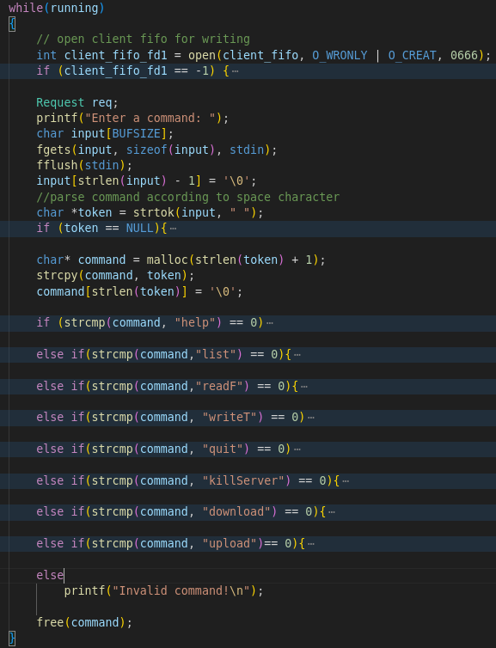

After the connection established, client and child-server use the client FIFO respectively. First one side opens the FIFO for writing other side opens for reading then, writing side closes and opens for reading, reading side closes and opens for writing.
Before client sends any commands to server it waits the user input.

For synchronization between the server’s child processes I used named semaphores to avoid any race condition and data corruption.
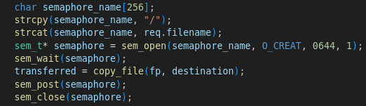

I named the semaphores using file names on the server to be able to sure correct semaphore(mutex) is locked and opened. Before the termination of the server program unlink them using the files names on the server.

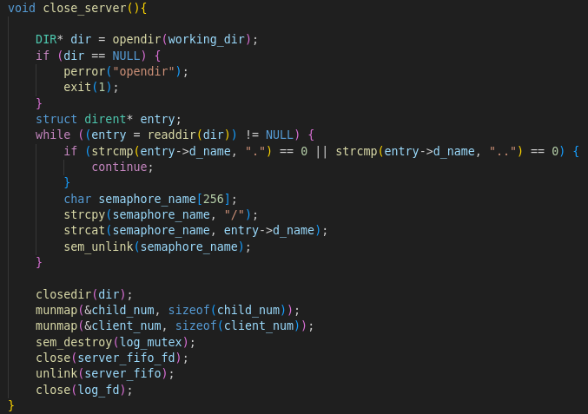

I also used shared memory to keep client number and currently running child number.
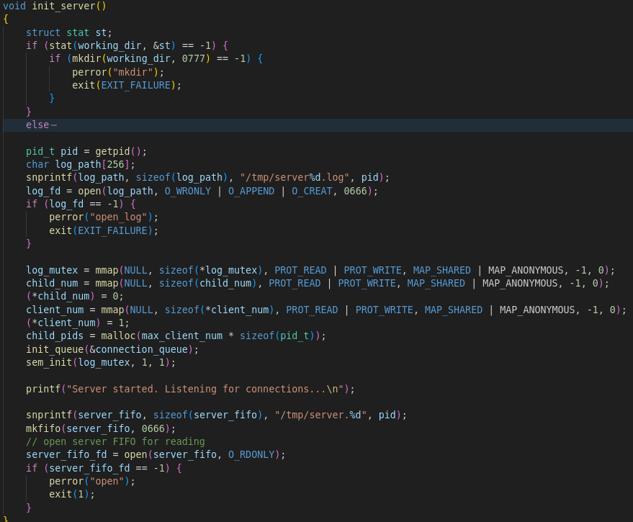

To be able to cleanup child processes when client sends killServer commands to server or any SIGINT, SIGTERM etc. signals arrives the server, Program keeps the array of currently working child pids in an array.

When a child server terminates, program checks the queue if there is any request using SIGCHLD signal handler.

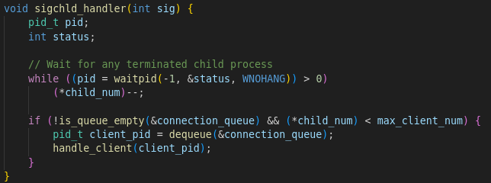

TEST CASES:



