CSE 344
HOMEWORK1
REPORT

Ömer Faruk SAYAR
171044038

Part1: AppendMeMore

In the program for the first part of the homework, I wrote a function, called writeToFile, that takes three parameters;

path : Path of the file that will be appended.
numBytes: Number of the bytes that will be appended.
IsSupplied: If the third argument, [x], is given the program it is 1 otherwise 0.
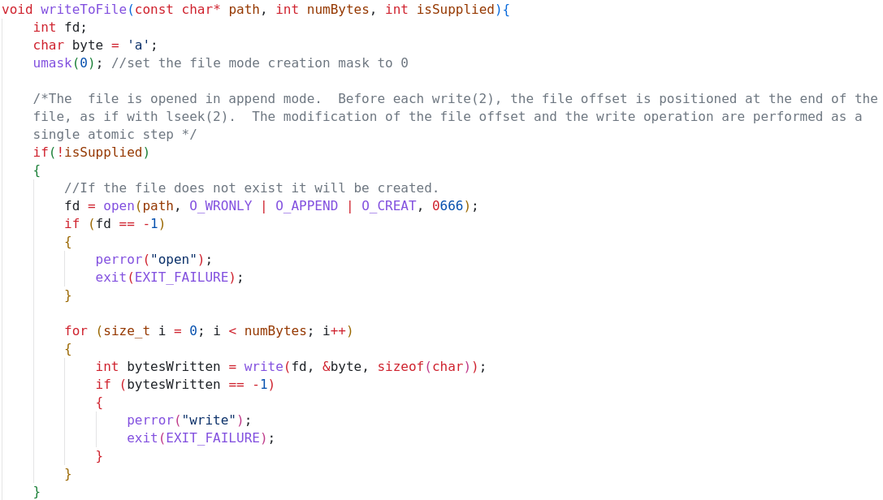
In the if block (If the third argument, [x], is not given), File is opened using open syscall with the supplied path, O_WRONLY (Only write operations are allowed) | O_APPEND ( The file is opened in append mode) | O_CREAT (If pathname does not exist, create it as a regular file) flags and modes (read-write permissions for user, group and other).
If the open syscall return successfully, In a number of numBytes loop, character ‘a’ is written to the file (1 byte at a time).
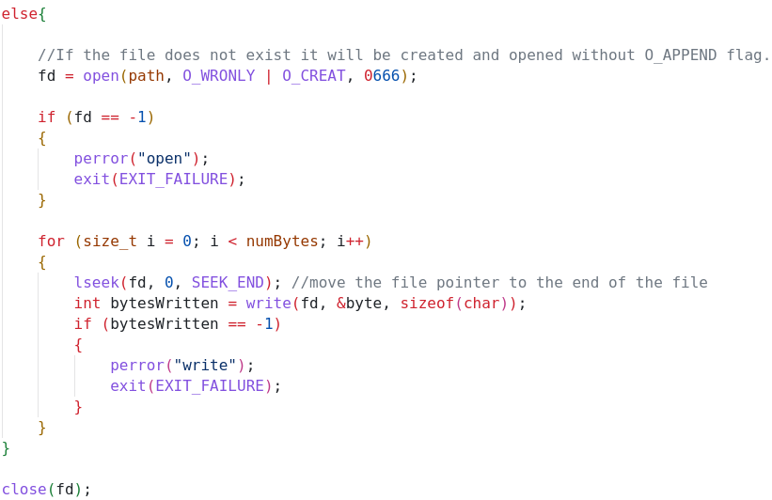

In the else block (If the third argument, [x], is given), File is opened using open syscall without the O_APPEND flag. In the each iteration of the loop, file pointer is moved to end of the file using lseek(fd, 0, SEEK_END) call before the write operation.

And the main function of the program:
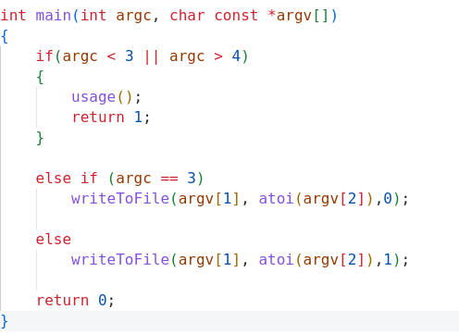

If the number of argument given to the program is wrong then it prints usage and terminates.
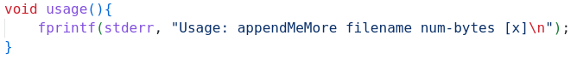
Running Results:

$ appendMeMore f1 1000000 & appendMeMore f1 1000000 :

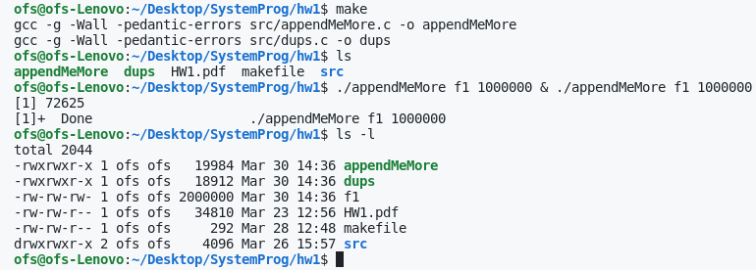
$ appendMeMore f2 1000000 x & appendMeMore f2 1000000 x :
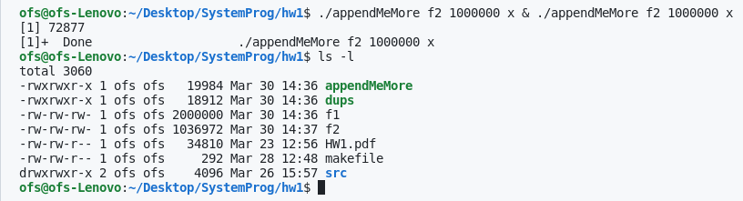
The difference between the size of the files is due to the O_APPEND flag. In the first situation,
Before each write operation, thanks to this flag, the file offset is positioned at the end of the file and the modification of the file offset and the write operation is performed as a single atomic step. This way in each loop we are sure that each byte is appended to one after another.

In the second situation, when we open the file without the O_APPEND flag and change the position of the offset using lseek() before each write, some bytes are written to the same position. Since we run two instances of the program concurrently some situations occur where one program instance sets the file offset to the end of the file and before it writes one byte, the other instance also sets the file offset to the end of the file thus these instances write to the same position of the file.

Part2: Dups

My dup() function implementation:
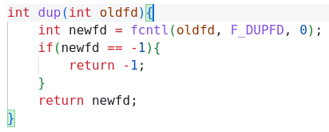

It uses fcntl with the F_DUPFD command and 0 as argument. This command duplicates the file descriptor fd using the lowest-numbered available file descriptor greater than or equal to argument (0 in this case).

My dup2() function implementation:
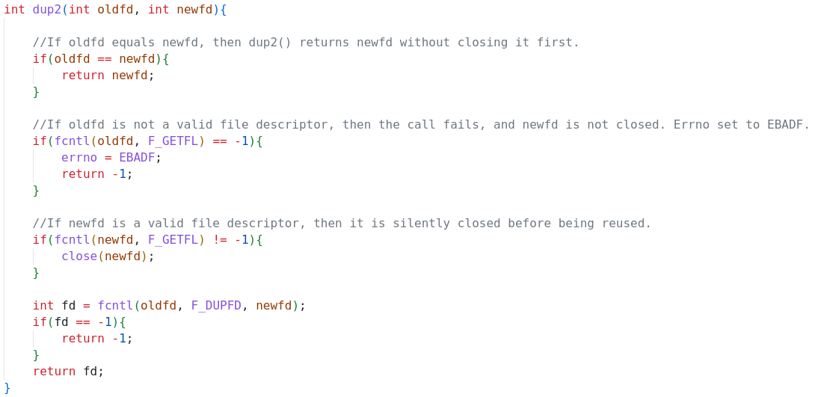
Firstly I checked if the two fd are equals or not. If they are equal, function returns the newfd without doing anything. If they are not equal, I first checked oldfd is a valid file descriptor or not.
If it is not a valid descriptor then function sets errno to EBADF and return -1.
If it is a valid descriptor then it checks the newfd if it is a valid or not. Again if it is a valid descriptor, function close it and duplicates the oldfd to newfd using fcntl.
Part3: Test program for part2
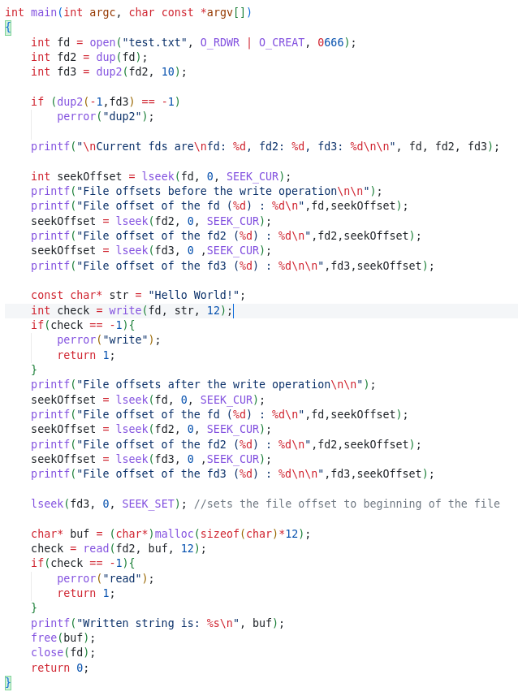

I wrote this part in the main function of the dups.c where the dup and dup2 functions are implemented.

Firstly program creates a file called test.txt with the read-write permissions. After duplicates the fd to fd2 using dup function and fd2 to fd3 using dup2 fuction also try to duplicate -1 to fd3 to show errno set. Then prints the fds and file offsets. After writes a string (Hello World!) to fd and gets the current file offsets of fd2 and fd3 to show their offsets also changed. After sets the file offset of the fd3 to beginning of the file then read 12 bytes from fd2 and prints read bytes to stdout to show fds are points to same file.

Running Result:

