CSE 344
HOMEWORK2
REPORT

Ömer Faruk SAYAR
171044038

Flow of the program

In a loop:

Get Input (Parent) => Parse Commands (Parent) => Create Child Processes (Parent) => Connect pipes to stdin and stdout (Child) => Check and set redirection from stdin/stdout to file (Child) => Execv bin/sh command given from user (Child) => Wait until all child processes to finish (Parent) => Write the log file => Cleanup for the next command.

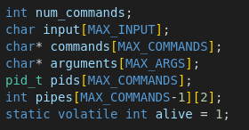
There are 6 global variable to handle input, commands, pipes and pids.
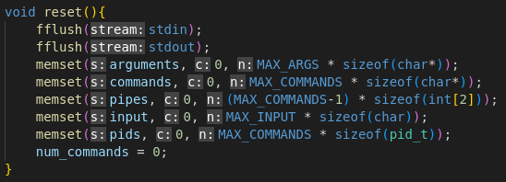
After getting an input from the user, program resets them using reset function.

After an input getting from the user program checks if it is a proper input or not. Also checks if it is a quit command. Then calls pars_commands function to separate commands according to pipe (|) operator.

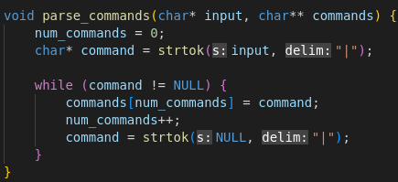

Then creates pipes according to the number of command .

After that, in a for loop that runs number of command times, program parse the arguments of a command according to whitespace (“ ”) .
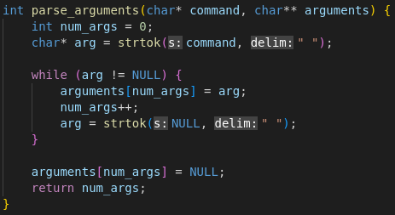

After arguments are set, program creates a child process using fork().
In the child process, connects stdin to read end of the pipe and stdout to write end of the pipe using dup2() and closes pipe file descriptors.

Then checks if any redirection operator in the arguments and if there is any, program handles properly by redirecting stdin or stdout to appropriate file descriptor using dup2 again.
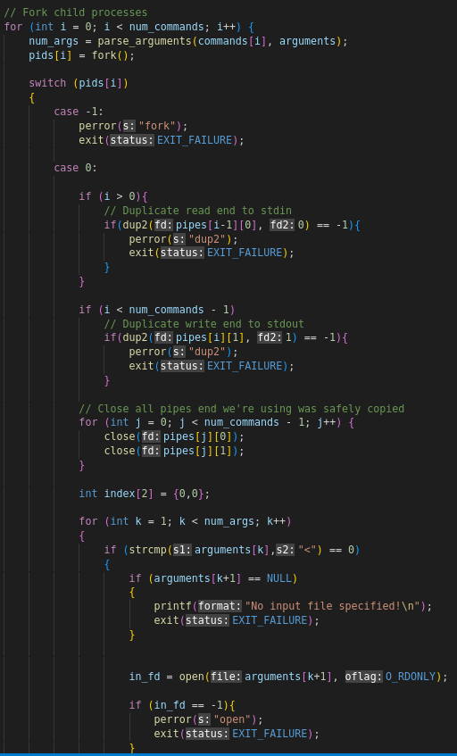

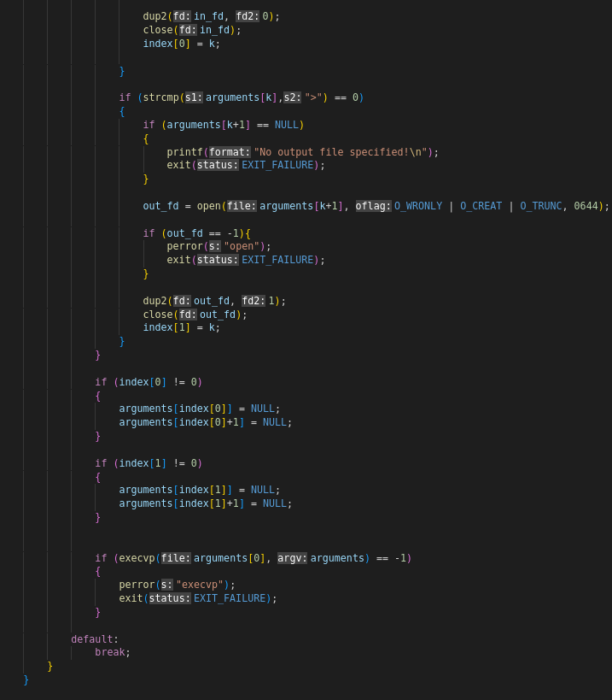
After the pipe and redirection operators handled, program calls execvp (I did not use execl because it was needed to use execl with bin/sh command and it creates a shell process then creates a child process of the shell to execute the command, Instractor gave permission to use execvp) to run given bin/sh command with the arguments.

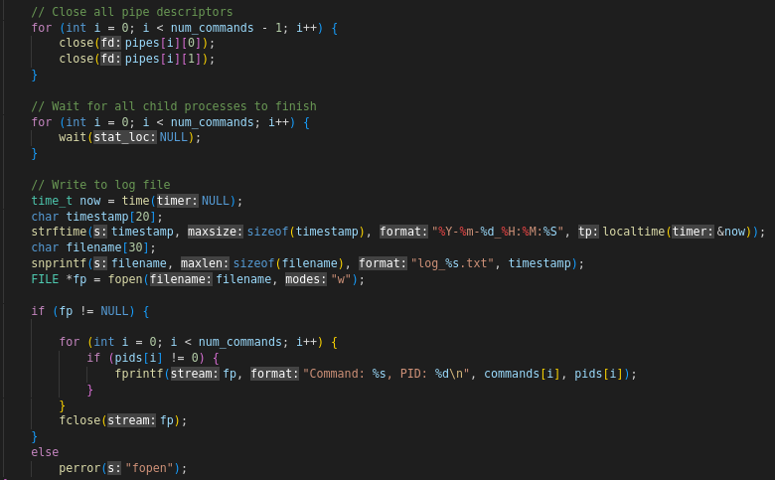
Meanwhile, after closing it’s pipe fds, parent process wait for all child process to finish then pids of child processes with their corresponding commands logged in a file named current timestamp.

Program have also two signal handler for four different signals. When a SIGTERM or SIGTSTP or SIGINT signal comes, handler kills all child then program return to prompt. When a SIGQUIT signal comes, program kills all child then terminates the program properly.
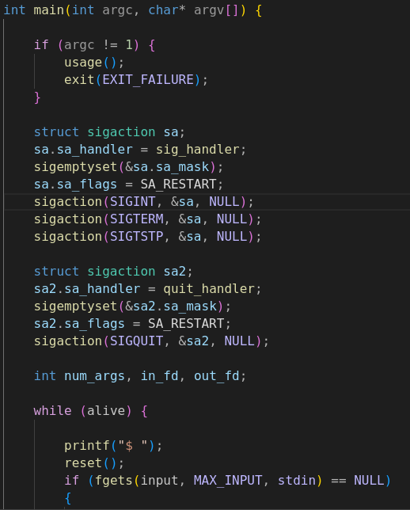

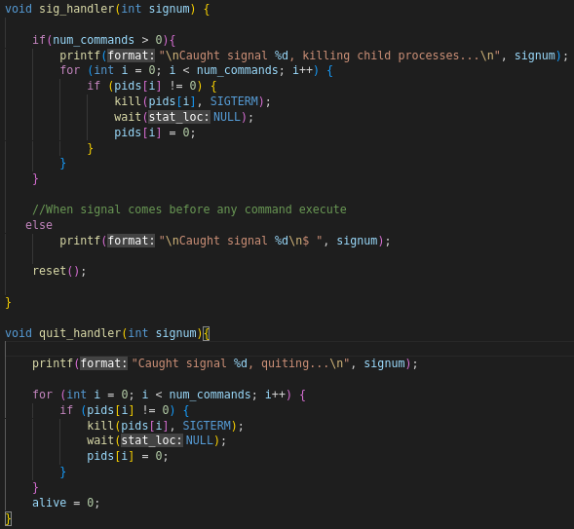

Valgrind Output :
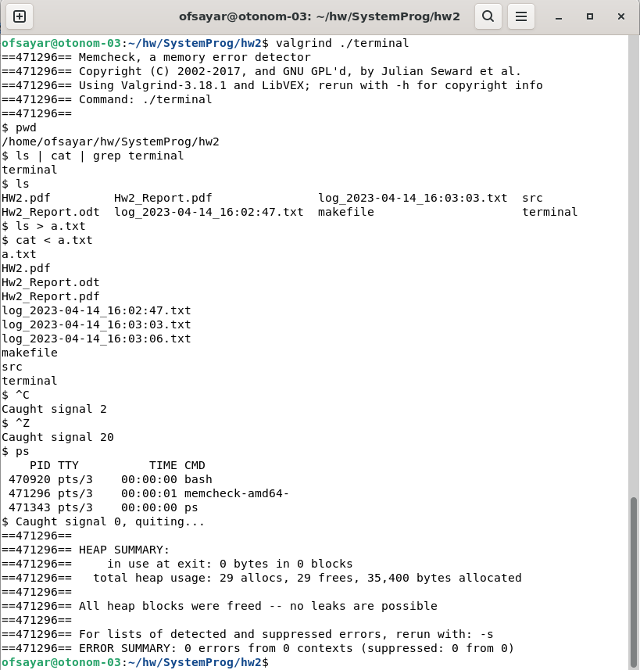
Test Cases:
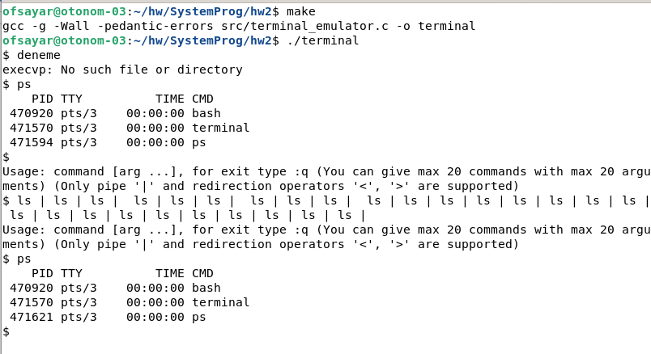
1) Giving a non existing command – empty command – more than 20 command:
2) Redirection - Redirection to nowhere
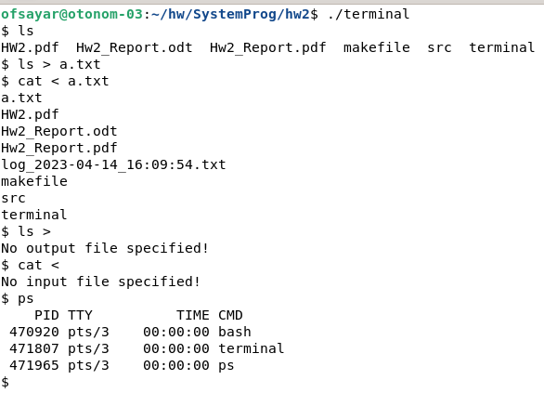

3) Signal handling – Zombie process check

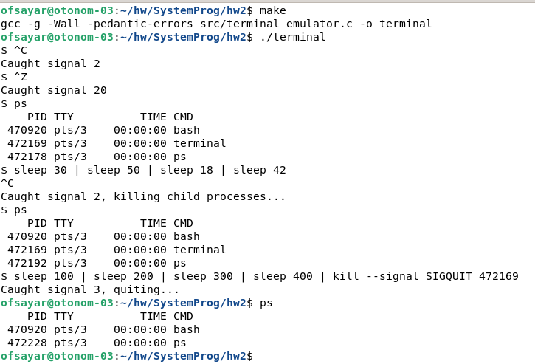

4 ) Multiple child – log – quit

