CSE 344
HW5
REPORT

Ömer Faruk SAYAR
171044038

Global Variables:

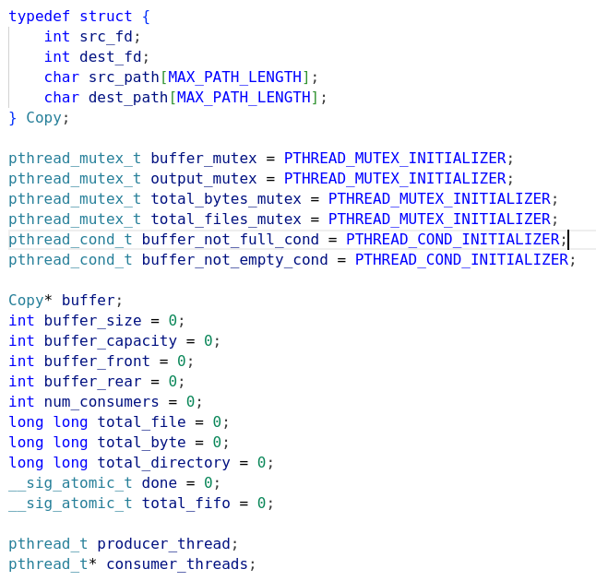
To provide synchronization between producer thread and consumer threads I used mutex and condition variables.

Since our buffer is the critical section, producer locks the buffer and wait until buffer_not_full signal comes using pthread_cond_wait before enqueue the Copy struct. After the enqueue operation it signals to buffer_not_emtpy condition variable.

Consumers also lock the buffer using mutex and wait until buffer_not_empty signal comes using pthread_cond_wait. After the dequeue operation consumer send signal to buffer_not_full variable.

Producer: Consumer:
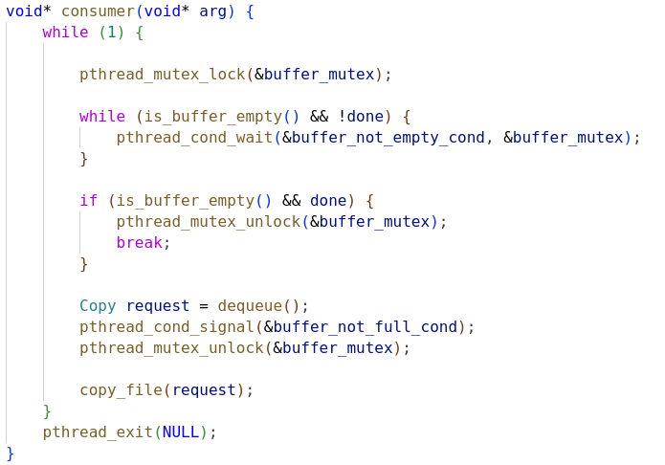
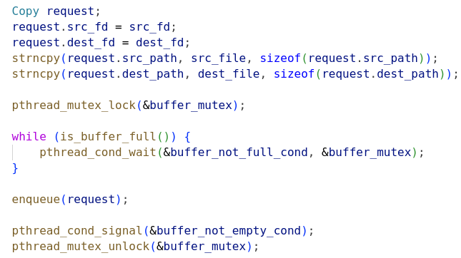

I also used a mutex for writing to stdout and another mutex to sum total byte copied and total regular file number copied. I used sig_atomic_t type for counting number of FIFO files copied.
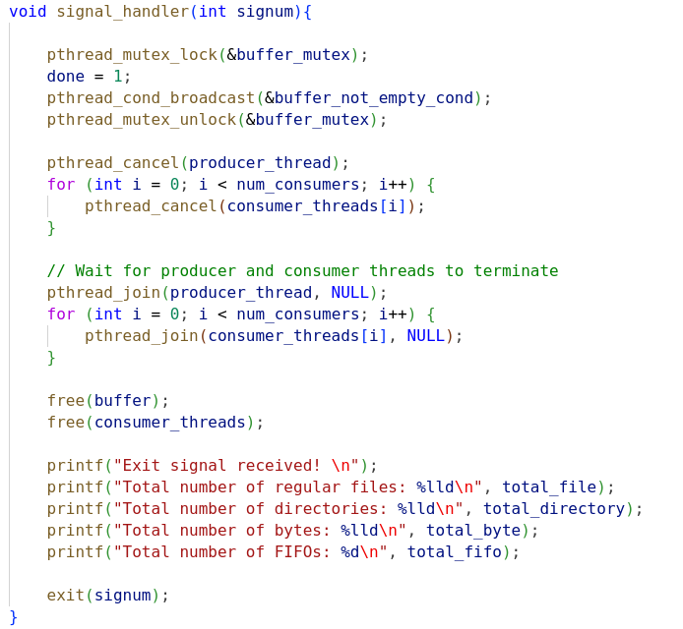
There is a signal handler for SIGINT, SIGTERM and SIGQUIT signals. This handler makes done flag 1 and broadcasts buffer_not_empty signal then cancels producer thread and consumer threads. After wait until all threads terminates. Then frees all resources that allocated and prints the results.

I implemented buffer as a circular array queue with fixed size for better performance.
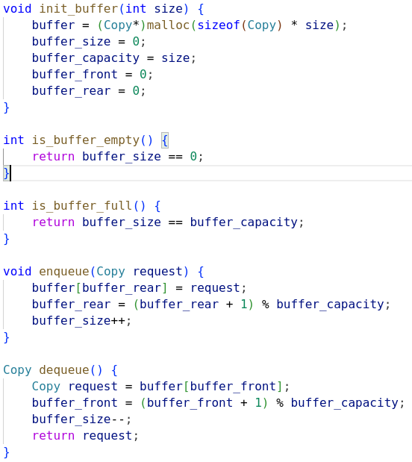

TEST RESULTS

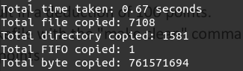
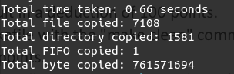
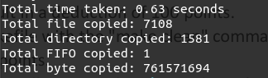
Buffer Size vs. Performance:

Buffer size: 10
Consumer: 2

Buffer size: 50
Consumer: 2

Buffer size: 100
Consumer: 2

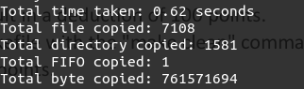
Buffer size: 500
Consumer: 2
Observations: From the results, increasing the buffer size from 10 to 500 generally leads to a decrease in the total time taken, indicating improved performance. However, after a certain threshold (around 500), the performance gain becomes marginal. Therefore, a buffer size of around 100-500 seems to provide a good balance between performance and memory usage.

Number of Consumer Threads vs. Performance:

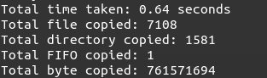
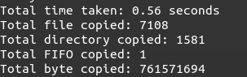
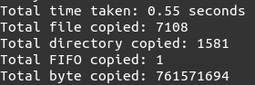
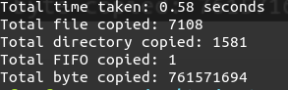
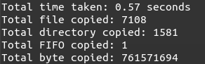
Buffer Size: 500
Number of Consumers: 2

Buffer Size: 500
Number of Consumers: 4

Buffer Size: 500
Number of Consumers: 8

Buffer Size: 500
Number of Consumers: 16

Buffer Size: 500
Number of Consumers :32

Observations: Increasing the number of consumer threads from 2 to 4 leads to a significant improvement in performance, reducing the total time taken. However, further increasing the number of consumer threads beyond 4 does not result in a significant improvement. In fact, in some cases, it may slightly degrade performance due to increased thread coordination overhead. Therefore, a number of consumer threads between 4 and 8 seems to provide the best performance.

Conclusion: Based on the conducted experiments, the following combinations of buffer size and number of consumer threads produce the best results for my code:
- Buffer Size: 500
- Number of Consumer Threads: 8

