Ömer Faruk Tuna

**README**

The code is written and tested using Python 3.7. Programs take a couple of minutes to run. Pleae wait untill it finishes and shows the output.

There are 2 python file:

main_d.py

main_e.py

The structure of the folder is as below below. That is: dataset folder should be in the same directory with main_e.py and main_d.py files.

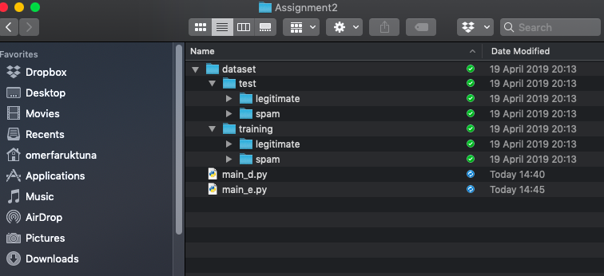

For section “e” of Assignment 2, you should run main_e.py. It uses Laplace smoothing with alpha equals 1 and calculates all the perforance values for Naive Bayes based spam mail classifier.

For section “d” of Assignment 2, you should run main_d.py. It calculates the performance values without using smoothing.

The python files creates 3 files during the execution. Those files are written to the same directory.

legitimate_features.txt

spam_features.txt

common_features.txt