RESULTS

Djibouti:

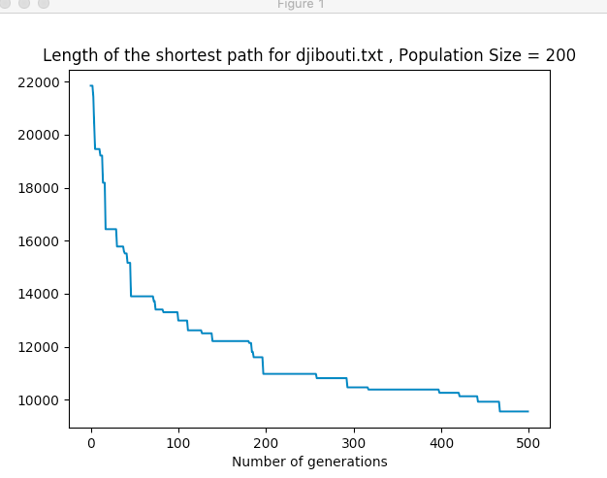

Western Sahara:

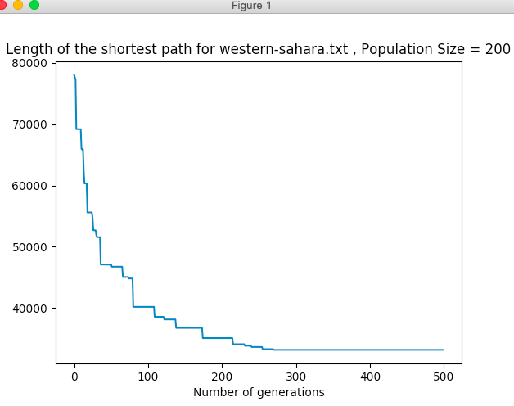

US States:

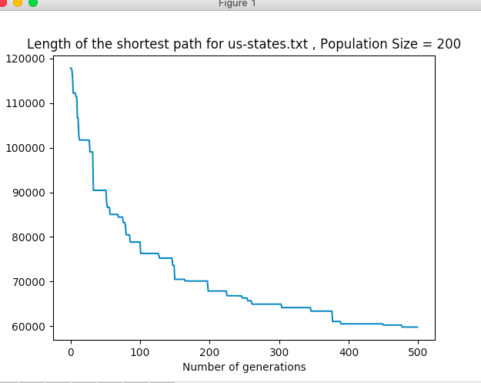

Qatar

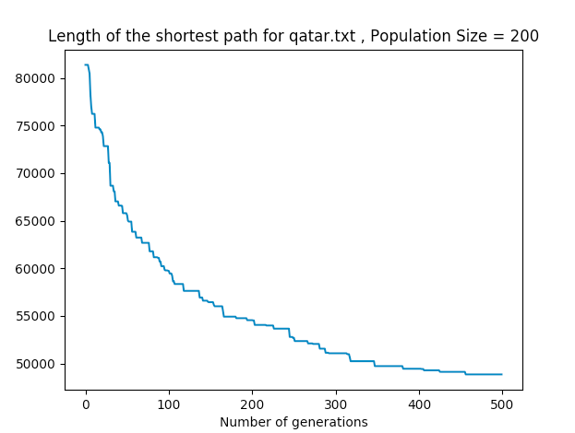

Uruguay:

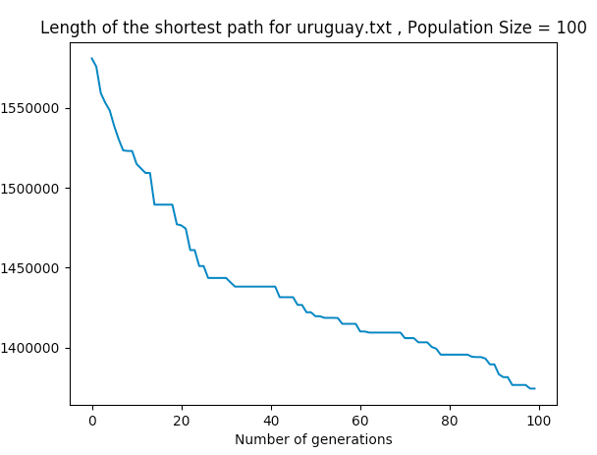

Uruguay takes too much time for execution. So I chosed number of generation as 100 and population size as 100. If the program keeps execution, distance would be less as the iteration number increases.