Sample Course Name

Sample Course Module Name

Author: Omer Faruk DOGAN

## Sample Course Name

### Week-1 (Sample Course Note)

#### Spring Semester, 2021-2022

Download [DOC](week-1.en.md_doc.pdf), [SLIDE](week-1.en.md_slide.pdf), [PPTX](week-1.en.md_slide.pptx)

### Outline

* Using Google

## **How can google be used?**

### Sample Topic

* ****What is Google?****  It has been referred to as the “most powerful company in the world. and one of the world’s [most valuable brands](https://en.wikipedia.org/wiki/List_of_most_valuable_brands) due to its market dominance, data collection, and technological advantages in the area of artificial intelligence.Its parent company [Alphabet](https://en.wikipedia.org/wiki/Alphabet_Inc.) is considered one of the [Big Five](https://en.wikipedia.org/wiki/Big_Tech) American [information technology](https://en.wikipedia.org/wiki/Information_technology) companies, alongside [Amazon](https://en.wikipedia.org/wiki/Amazon_(company)), [Apple](https://en.wikipedia.org/wiki/Apple_Inc.), [Meta](https://en.wikipedia.org/wiki/Meta_Platforms), and [Microsoft](https://en.wikipedia.org/wiki/Microsoft).

### Sample Images-1

* ****What is Google?****
* Google was founded on September 4, 1998, by [Larry Page](https://en.wikipedia.org/wiki/Larry_Page) and [Sergey Brin](https://en.wikipedia.org/wiki/Sergey_Brin) while they were [PhD](https://en.wikipedia.org/wiki/Doctor_of_Philosophy) students at [Stanford University](https://en.wikipedia.org/wiki/Stanford_University) in [California](https://en.wikipedia.org/wiki/California). Together they own about 14% of its publicly listed shares and control 56% of the stockholder voting power through [super-voting stock](https://en.wikipedia.org/wiki/Super-voting_stock). The company went [public](https://en.wikipedia.org/wiki/Public_company) via an [initial public offering](https://en.wikipedia.org/wiki/Initial_public_offering) (IPO) in 2004.
* 
* Android Apps by Google LLC on Google Play

### Sample Images-2

* ****What is Google?**** In 2015, Google was reorganized as a wholly owned subsidiary of Alphabet Inc. Google is Alphabet’s largest subsidiary and is a [holding company](https://en.wikipedia.org/wiki/Holding_company) for Alphabet’s Internet properties and interests. [Sundar Pichai](https://en.wikipedia.org/wiki/Sundar_Pichai) was appointed CEO of Google on October 24, 2015, replacing Larry Page, who became the CEO of Alphabet. On December 3, 2019, Pichai also became the CEO of Alphabet.
* 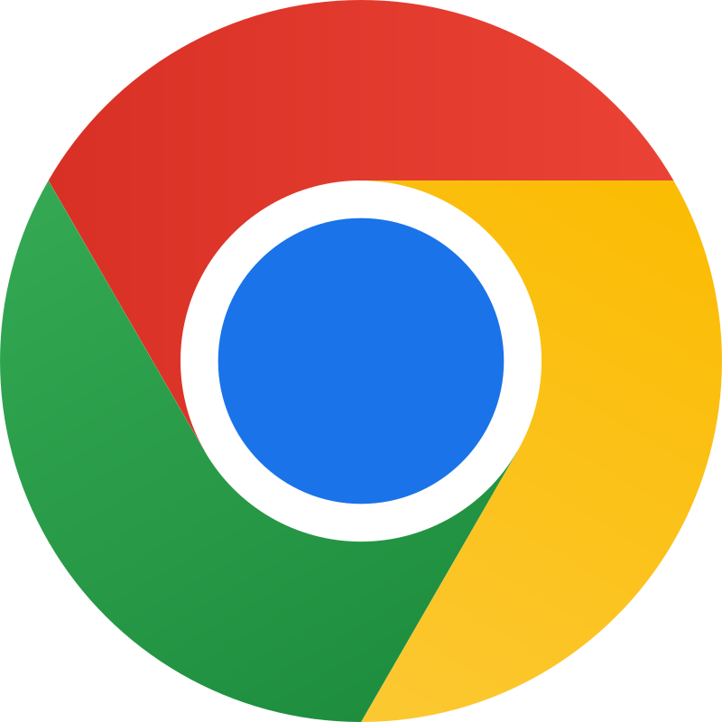
* Google Chrome - Vikipedi

### Sample Images-3

* ****What is Google?**** Google Chrome is one of the most popular web browsers because of its fast performance, stability, efficiency, and top-notch security. And if you use Gmail, Chrome makes the transition from checking your email to surfing the web seamless.
* 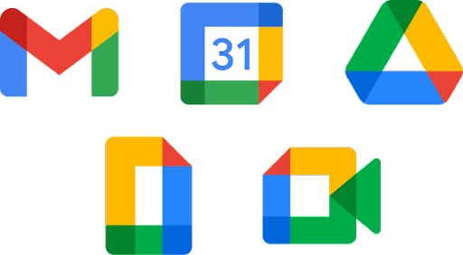
* Browse All of Google’s Products & Services - Google

### Sample Images-4

* **How is download Google ?**
* Go to Google Chrome internet. You can use any internet browser to download Google Chrome. If you haven’t installed a browser, you can use the operating system’s pre-installed internet browser (Internet Explorer for Windows and Safari for Mac OS X).

### Latex Sample-1

$$\begin{matrix}\begin{matrix}\text{compute }m\left[i,i+1\right] \\ \underset{\left(n−1\right)\text{ values}}{\underset{⏟}{\{m\left[1,2\right],m\left[2,3\right],…,m\left[n−1,n\right]\}}}\end{matrix} & \left\{\begin{matrix} & ℓ=2 \\ & \text{for }i=1\text{ to }n−1\text{ do } \\ & m\left[i,i+1\right]=∞ \\ & \text{for }k=i\text{ to }i\text{ do } \\ & ⋮\end{matrix}\right. \\ \begin{matrix}\text{compute }m\left[i,i+2\right] \\ \underset{\left(n−2\right)\text{ values}}{\underset{⏟}{\{m\left[1,3\right],m\left[2,4\right],…,m\left[n−2,n\right]\}}}\end{matrix} & \left\{\begin{matrix} & ℓ=3 \\ & \text{for }i=1\text{ to }n−2\text{ do } \\ & m\left[i,i+2\right]=∞ \\ & \text{for }k=i\text{ to }i+1\text{ do } \\ & ⋮\end{matrix}\right. \\ \begin{matrix}\text{compute }m\left[i,i+3\right] \\ \underset{\left(n−3\right)\text{ values}}{\underset{⏟}{\{m\left[1,4\right],m\left[2,5\right],…,m\left[n−3,n\right]\}}}\end{matrix} & \left\{\begin{matrix} & ℓ=4 \\ & \text{for }i=1\text{ to }n−3\text{ do } \\ & m\left[i,i+3\right]=∞ \\ & \text{for }k=i\text{ to }i+2\text{ do } \\ & ⋮\end{matrix}\right.\end{matrix}$$

### Latex Sample-2

$$\begin{matrix} & \text{OPTIMAL-BST-COST}\left(p,n\right) \\ & \text{for} i←1 \text{to} n \text{do} \\ & c\left[i,i−1\right]←0 \\ & c\left[i,i\right]←p\left[i\right] \\ & R\left[i,j\right]←i \\ & PS\left[1\right]←p\left[1\right]⇐PS\left[i\right]→\text{ prefix-sum }\left(i\right):\text{Sum of all} p\left[j\right] \text{values for} j≤i \\ & \text{for} i←2 \text{to} n \text{do} \\ & PS\left[i\right]←p\left[i\right]+PS\left[i−1\right]⇐\text{compute the prefix sum} \\ & \text{for} d←1 \text{to} n−1 \text{do}⇐\text{BSTs with} d+1 \text{consecutive keys} \\ & \text{for} i←1 \text{to} n–d \text{do} \\ & j←i+d \\ & c\left[i,j\right]←∞ \\ & \text{for} r←i \text{to} j \text{do} \\ & q←min\{c\left[i,r−1\right]+c\left[r+1,j\right]\}+PS\left[j\right]–PS\left[i−1\right]\} \\ & \text{if} q<c\left[i,j\right] \text{then} \\ & c\left[i,j\right]←q \\ & R\left[i,j\right]←r \\ & \text{return} c\left[1,n\right],R\end{matrix}$$

**TODO** UPDATE CONTENT FOR YOUR COURSE NOTES

## References

* https://www.wikihow.com/images/thumb/3/31/Download-and-Install-Google-Chrome-Step-2-Version-3.jpg/v4-728px-Download-and-Install-Google-Chrome-Step-2-Version-3.jpg
* [Google - Wikipedia](https://en.wikipedia.org/wiki/Google)
* https://lh3.googleusercontent.com/O53jgarLMMs6WBjROWgvDFWD1SrzVxc3yLfpI8Lk7_2zUwmgzDi4T-y3QxFTABRkzXKG385ZSkknvOcbL0dt0S5XiAAqEzUO06gy6koJDSCxLERtlJw
* https://storage.googleapis.com/gweb-uniblog-publish-prod/images/Chrome__logo.max-500x500.png
* https://i.bigpara.com/resize/650x365/i/55big/google_650.jpg

$End−Of−Week−1−Module$