

İÇİNDEKİLER

1. GİRİŞ 1

2. SORUN İÇERİĞİ 2

3. MARKETECTURE 3

MOBILE APPLICATION 3

4. UTILITY TREE 5

5. APPROACHES ANALYSIS 6

5.1. FIRST APPROACH 6

DESCRIPTION 6

SWOT MATRIX 6

5.2. SECOND APPROACH 7

DESCRIPTION 7

SWOT MATRIX 7

6. TASARIM KARARLARI ...7

6.1. SECİLEN TEKNOLOJ İ YE GORE TASARIM KARARLARI ...7

6.2. KARAR MATRİSİ 9

7. MİMARİ GÖRÜNÜMLER 10

7.1. KULLANIM ALANLARI 10

7.1.1. KULLANIM DURUM ŞEMASI:CUSTOMER 10

7.1.2. KULLANIM DURUM ŞEMASI : EMPLOYEE 16

7.1.2. KULLANIM DURUM ŞEMASI : OWNER 21

7.1.6. USE CASE 3 DESCRIPTION: 23

7.2. LOGICAL VIEW 27

7.2.1. SEQUENCE DIAGRAM: Customer to register 27

7.2.3. SEQUENCE DIAGRAM: Customer to search 28

7.2.4. SEQUENCE DIAGRAM: Customer to purchase 29

7.2.5. SEQUENCE DIAGRAM : Customer to payment 30
7.2.5. SEQUENCE DIAGRAM : Employee 31
7.3. PROCESS VIEW 32
7.3.1 ACTIVITY DIAGRAM : OWNER 32
7.3.2 ACTIVITY DIAGRAM : CUSTOMER 33
7.3.3ACTIVITY DIAGRAM : PAYMENT 34
7.4. IMPLEMENTATION VIEW 35
1. GİRİŞ

Bu belgenin amacı, tatil fonu yazılım sistemi üzerinde çalışacak yazilim geliştiricilerine sistemin programlanmasinda veya güncellenmesinde yardımcı olmaktır. Bu belge projeye, mimarisine genel bir bakış ve alınan kararı açıklar. Bu belgede, yazılımın problematiğini, pazar izlemesini ve sistemin nasıl çalıştığını gösteriyoruz. Daha sonra, projenin fayda ağacını sunacağız; Bu şema, projelerin değişme noktalarını ve ilgilendikleri paydaşı sunmaktadır. Daha sonra varlıkları ve bunların karşılaştırılmasını ve tasarım öğelerini çözmek için çözümler sunan bir yaklaşım analizi sunacağız.

2. SORUN İÇERİĞİ

Türkiye Cumhuriyeti vatandaşlarının her biri için kendi fikrimizle başlatılmış, hükümet için uygun bir projedir.

Günümüzde ülkemiz insanlarının büyük çoğunluğu orta ve alt gelir grubunda olup, insanlarımızın en çok ilgi ve istek duydukları alanların başında da Tatil gelmektedir. Hemen her insan tatil yapmayı, farklı bölgeleri gezmeyi ve o coğrafyanın kültürlerini tanımayı, çeşitli etkinliklere katılmayı, dilediği şekilde dinlenmeyi ve iyi vakit geçirmeyi hayallerinden biri olarak saymaktadır. Ancak mevcut ekonomik koşullarda bu her zaman herkes için mümkün olmamaktadır. Tatil Fonu Sistemi, bunu herkes için mümkün kılabilecek fırsatlarla dolu dinamik ve etkin bir yapıdır.

Tatil Fonu Sistemi; halihazırdaki 4-5 aylık turizm faaliyetini bütün bir yıla ve tüm Türkiye’ye yayarak, sürdürülebilir turizm ilkesini kredi ve kredi kartı gibi yabancı kaynak kullanmadan gerçekleştirmek ve iç turizmi hareketlendirerek, ekonomik canlanmayı sağlama ve bunu sürdürülebilir kılma hedefine dayanmaktadır.

Tatil Fonu Sistemi, faiz ve borçlanmaya dayanmayan, kredi ve kredi kartı gibi enstrümanların kullanımını özendirmeyen bir yapılanma olup, “önce kazan, sonra harca” temelinde oluşturulan ve insanları birikim yapmaya teşvik edecek bir vizyon projesidir. Tasarruf eğiliminin oldukça düşük olduğu ülkemizde, kredi ve borçlanmada yaşanan yükseliş endişe verici boyutlardadır. Sözkonusu borçlanmadaki trend sürekli artış göstermekle birlikle, ekonomik yapıyı tehdit edecek noktalara ulaşmaktadır. Oysa ki bizler, harcamayı değil, tasarrufu özendirmeliyiz.

“Tatil” denince insanlarımızda “Deniz-Kum-Güneş” algısı veya “Memlekete gitme” fikri belirginlik kazanmaktadır. Tatil Fonu Sistemi, her iki alandaki tercihleri mümkün kılmakla birlikte, insanlara ülkemizin tarihi, doğal ve kültürel tüm güzelliklerini görme, tanıma ve tatil sürecini en iyi şekilde değerlendirme imkanı da sağlayacaktır.
Tam anlamıyla, ciddi ve detaylı bir şekilde incelenip uygulandığında, “kaybedeni olmayan” sistem adını verdiğimiz Tatil Fonu Sistemi, bünyesindeki dinamikler ve fırsatlar itibariyle alanında “ilk ve tek” olma özelliğine sahip sosyo-ekonomik sistemler bütünüdür.

3. MARKETECTURE

This is a software design specification for a shopping system that will be built around the QR Code technology.

The system includes a mobile application that will be used to manage the NFC interactions and desktop applications that will mainly be used to manage product inventory and for shopping Bill generation corresponding to the items in the customer’s cart on the mobile application.

This system is meant to help the end users by saving them a lot of time at the cash counters and making payment. It consists of following three faces:

MOBILE APPLICATION

The customer will be able to scanning QR codes for each product that he/she wants to buy and that product will be added to the cart in application. The customer will also be able to:

- Add Item

- Delete item

- Specify quantity

This cart will also be maintained simultaneously on the server database so that when the customer is done shopping, the cart is already available at the cashier’s system after the customer ID is read off from server.

The app will also contain a recommendation engine that will provide the customer with appropriate offers and products that are relevant to the customers purchase history and the season. and give cashier number according to product quantities

ADMIN APPLICATION

This is where the product inventory will be managed. Each new product to be added will be assigned a unique QR code and the quantity stated QR codes. The real-time communication between the mobile app and the server database will allow employees to view the status of the payment This is where the product inventory will be managed. Each new product to be added will be assigned a unique QR code and the quantity stated QR codes.

The real-time communication between the mobile app and the server database will allow employees to view the status of the payment and give cashier's number to customers according to product quantity in cart to reduce waiting time in queues and saving customers a lot of time at the cash counters and making payment.

APPLICATION ON CASHIER’S SYSTEM

This application will only fetch the cart from the server corresponding to the customer ID and generate the final bill.

To conclude, with an increasingly consumerist society, the crowds and queues at the markets and stores using the conventional shopping processes, are inevitable, our aim is to change that by making the shopping at a store by application and customer receive bill while products are packaging.

Cashier is going to check the product(s) which is/are in the list of products in system while packaging the cart items and giving the bill to the customer.
4. UTILITY TREE

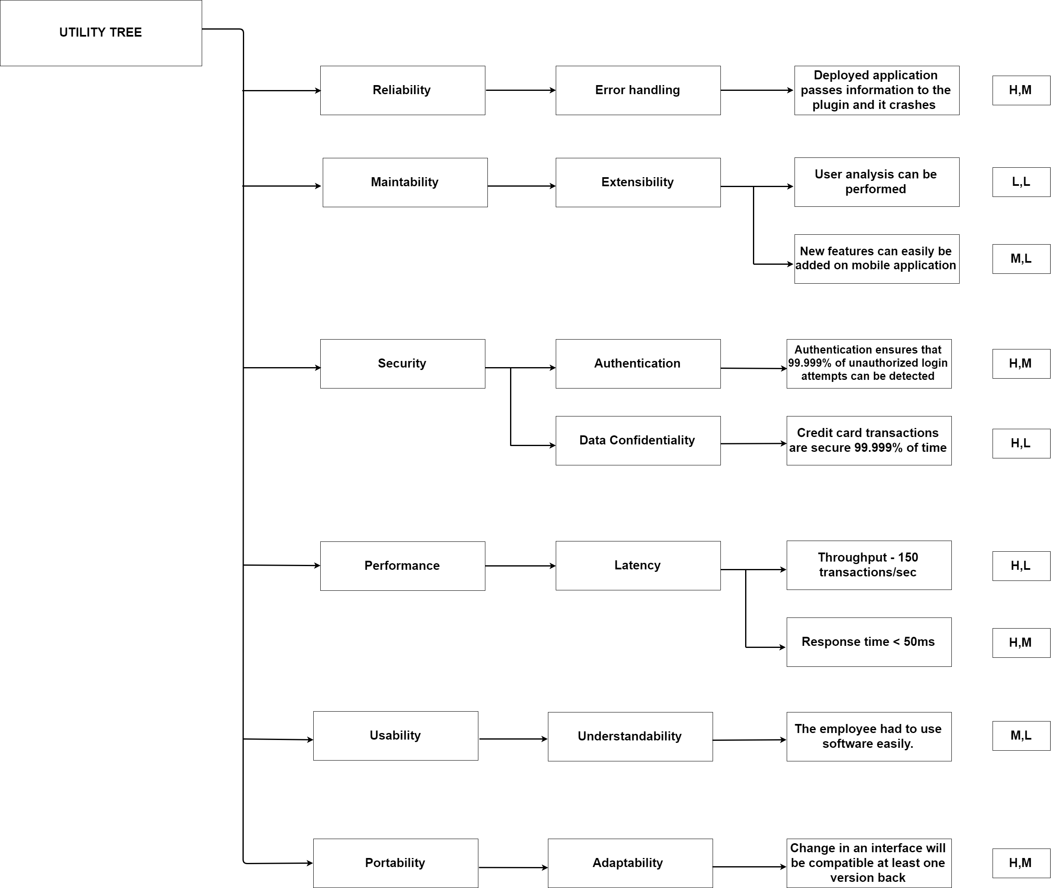

Figure 1 : Utility Tree

5. APPROACHES ANALYSIS

5.1. FIRST APPROACH

The system includes a mobile application that will be used to manage product inventory for shopping. Bill generation corresponding to the items in the customer’s cart on the mobile application. Users will have mobile phones in which they will have an application where they can buy products. The customer will be able to: Add Item, Remove item and Specify quantity.

 | Helpful | Harmful
Internal Origin | Strengths  - Helps customers to save a lot of time at the cash counters and making payment  - Easy in usage  - Free mobile application | Weaknesses  - Application is required highly amounted advertising plan  - Hard to manage how people will behave against the application
External Origin | Opportunities  - Facilitate process of buying and selling | Threats  - Budget planning is required some stakeholders.  - People may not want to resign "old school" form of buying products.  - Everybody has not smart phones to use
Table 1 : First Approach by SWOT Analysis
5.2. SECOND APPROACH

This approach is made for people who don't have smartphones. New technology tablets or devices with the application will be put in some places in Commercial Center. Users will be able to use this device to buy products. The customer will be able to use their accounts by logging in the application.

 | Helpful | Harmful
Internal Origin | Strengths  - Helps customers to save a lot of time at the cash counters and making payment  - Easy in usage  - Free device service in Commercial center  - Free mobile application | Weaknesses  - Application is required highly amounted advertising plan  - Hard to manage how people will behave against the application
External Origin | Opportunities  - Facilitate process of buying and selling | Threats  - Budget planning is required some stakeholders.  - People may not want to resign "old school" form of buying products.  - Devices may not be enough to customer who does not use smart phones
Table 2 : Second Approach by SWOT Analysis
6. DESIGN DECISIONS

6.1. DESIGN DECISIONS FOLLOWED BY CHOSEN TECHNOLOGIES

- Identifier: D1

- Name: easy in use

- Description: application should be easy in usage for Customer

- Source: To Try

- Rationale: Customer shouldn't have any problems with using application. If the user had problems he wouldn't use this application.

- Identifier: D2

- Name: free

- Description: application should be available without paying for it

- Source: Made

- Rationale: Customer wouldn't like to pay for the application. He would prefer to do “old school” payment rather than paying for application.

- Identifier: D3

- Name: available

- Description: application should be available for all smartphones

- Source: Idea
- Rationale: All customers would like to use the application. Not only the customers who are in use of smart phones.
6.2. DECISION MATRIX

Skill Levels | 1 | 2 | 3 | 4 | 5 | 6 | 7 | 8 | 9 | 10
Software / Hardware Installation |  |  |  |  |  |  |  | X
Software / Hardware Maintanance |  |  |  |  |  |  |  | X
HTML |  |  |  |  |  |  |  |  |  | X
PHP |  |  |  |  |  |  |  |  |  | X
OOP Concepts and Programming |  |  |  |  |  |  |  |  |  | X
Android Development Kit |  |  |  |  |  |  |  |  | X
Mobile Developer |  |  |  |  |  |  |  |  | X
Table 3 : Decision Matrix

7. ARCHITECTURAL VIEWS

7.1. USE CASES

7.1.1. USE CASE DIAGRAM: COSTUMER

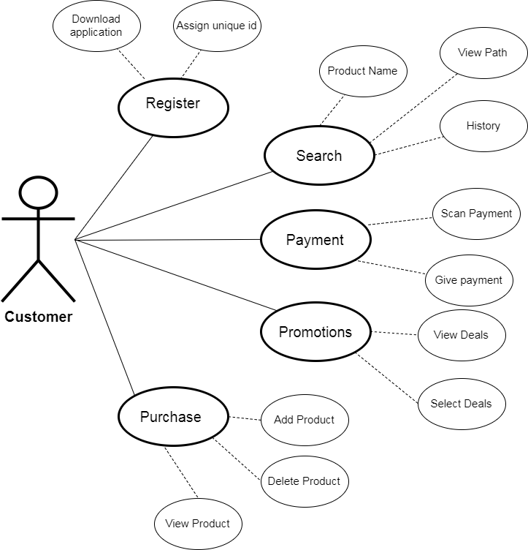

Figure 2 : Customer Use Case Diagram

7.1.1.1 USE CASE DESCRIPTION: Customer to Register



 |  | <Use Case 1.1: Register>
Use case Id: |  | 1
Actors: |  | Customers
Feature: |  | Customers that come for shopping will register themselves
Pre-condition: |  | Customer must have a working camera on smart phone
Scenarios
Step | Action |  | Software Reaction
#
1. | Scan QR code to download app |  | App start downloading into the device
2. | Install the application |  | Unique ID is assigned to the customer

Alternate Scenarios: Write additional, optional, branching or iterative steps. Refer to specific action number to ensure understandability.

1a:

Device is not near proximately to scan QR code, so the app does not install.

1b:

Bring the mobile device close enough and scan QR code again

Post Conditions

Step Description

#

Customer have an app on its phone

Customer have unique id

Customer can now purchase items

Use Case Cross | 1
referenced

Table 4 : Customer to Register Use Case Description

7.1.1.2 USE CASE DESCRIPTION: Customer to Purchase

 |  | <Use Case 1.2: purchase>
Use case Id: |  | 2
Actors: |  | Customers
Feature: |  | Customers can add, delete or view items
Pre-condition: |  | Customer should have register him/herself
Scenarios
Step# | Action |  |  | Software Reaction
1. | Scan the QR code on product |  |  | Product appear on screen to add/view
2. | Click on add button |  |  | Product added into the cart
3 | View cart |  |  | List of purchased items will display

Alternate Scenarios:

1a:

Device is not near proximately to scan the QR code , so the product will not be able to view in application
1b:

Bring the mobile device close enough and scan QR code again

Post Conditions

Step# Description

Customer can now see its total items and bill

Use Case Cross referenced 1

Table 5 : Customer to Purchase Use Case Description

7.1.1.3 USE CASE DESCRIPTION: Customer to Search

 |  |  | <Use Case 1.3: search>
Use case Id: |  |  | 3
Actors: |  |  |  |  | Customers
Feature: |  |  | Customers can find the item shelf where the is place
Pre-condition: |  |  |  | Customer should have register him/her self
Scenarios
Step# | Action |  |  |  | Software Reaction
1. | Enter the name of the item |  |  |  | Display list of related items
2. | Click on desired item |  |  |  | Display product in map with shelf no


Alternate Scenarios:

1a:

Product name is not entered correctly

1b:

Re-enter the name of the product

1c:

Item is not available

Post Conditions

Step# Description

 Customer can go to the desired shelf and scan the product Use Case Cross referenced 1
Table 6 : Customer to Search Use Case Description

7.1.1.4 USE CASE DESCRIPTION: Customer to Promotions

 |  | <Use Case 1.4: promotions >
Use case Id: |  | 4
Actors: |  |  | _{Customers}
Feature: |  | People/customers can see the general deals and product
related offers
Pre-condition: |  | Customer should have register him/her self
Scenarios
Step# | Action |  | Software Reaction
1. | Click on Promotions |  | List of promotions displayed
2. | Select the desire promotions |  | Promotion activates

Alternate Scenarios:

Post Conditions

Step# Description

 Customer can now get discount on the bases of selected promtion Use Case Cross referenced 1 , 2

Table 7 : Customer to Promotions Use Case Description

7.1.1.5 USE CASE DESCRIPTION: Customer to Payment
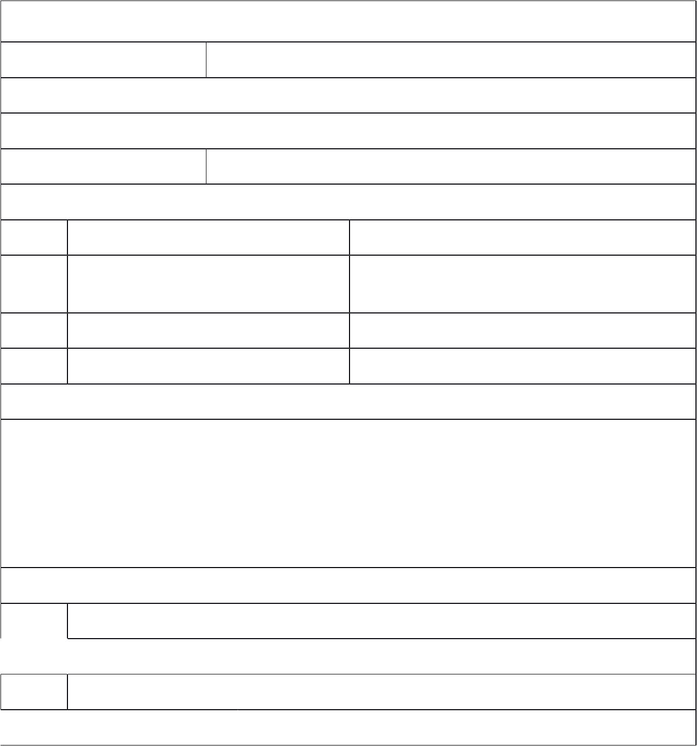 |  | <Use Case 1.5 payment>
Use case Id: |  | 5
Actors: |  |  | Customers, cashier
Feature: |  | Customers can pay the amount
Pre-condition: |  | Customer should have purchased products
Scenarios
Step# | Action |  | Software Reaction
1. | Complete payment - in app |  | Generate Invoice and complete shopping
2. | Move to the cashier to package |  | Update data base inventory

Alternate Scenarios:

1a:

Cashier can scan items to add customer's cart in application so customer can use application to complete payment instead of using credit card or cash money
Post Conditions

Step# Description

 Inventory is updated

Use Case Cross referenced 1 ,2

Table 8 : Customer to Payment Use Case Description

7.1.2. USE CASE DIAGRAM: EMPLOYEE

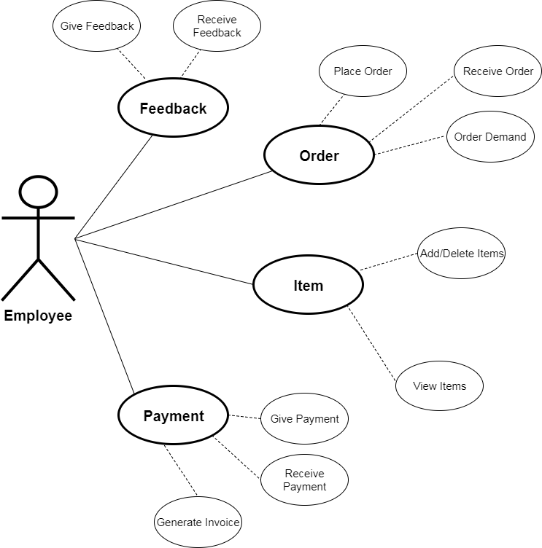

Figure 3 : Employee Use Case

7.1.2.1 USE CASE DESCRIPTION: Employee to Order


 |  | <Use Case 2.1: order>
Use case Id: |  | 6
Actors: |  |  | Customers , Employee
Feature: |  | Employee can place and receive order
Pre-condition: |  | Employee must be logged in
Scenarios
Step# | Action |  | Software Reaction
1. | Order to the supplier |  | Send notification to supplier
2. | Receive order from customer |  | Customer's cart is on purchased list

Alternate Scenarios:

1a:

Did not receive the Acknowledgment

1b:

Resend the order

Post Conditions

Step# Description

 Supplier can provide items according to the order
Cashier perform action with respect to the owner’s order

Use Case Cross referenced 1 ,2, 5

Table 9 : Employee to Order Use Case Description


7.1.2.2 USE CASE DESCRIPTION: Employee to Feedback

 |  | <Use Case 2.2: feedback>
Use case Id: |  | 7
Actors: |  | Employee, Owner
Feature: |  | Employee can send and receive the feedback
Pre-condition: |  | Employee must be logged in
Scenarios
Step# | Action |  | Software Reaction
1. | Cashier send the feedback to the |  | Sent to the owner
 | owner by going to the feedback
 | portion
2. | Receive feedback from owner |  | acknowledgment

Alternate Scenarios:

1a:

Did not receive the Acknowledgment

1b:

Resend the feedback

Post Conditions

Step# Description

Perform actions according to feedback

Use Case Cross referenced 1 ,2, 5

Table 10 : Employee to feedback Use Case Description


7.1.2.3 USE CASE DESCRIPTION: Employee to Payment

<Use Case 2.3: payment>

Use case Id: 8
Actors: Customers , Employee

Feature: Employee can give and receive payments

Pre-condition: Employee must be logged in and customer have purchased

items

Scenarios
Step# | Action | Software Reaction
1. | Customer can scan QR code | Total bill displayed in front of cashier
 | that employee generated
2. | Receive amount | Generate invoice

Alternate Scenarios:

1a:

Device is not near proximately to scan QR code , so the payment will not complete
1b:

Bring the mobile device close enough and scan QR code again

Post Conditions

Step# Description

Inventory must be update

Use Case Cross referenced 1 ,2, 5

Table 11 : Employee to payment Use Case Description


7.1.2.4 USE CASE DESCRIPTION: Employee to Item
 |  | <Use Case 2.4: item>
Use case Id: |  | 9
Actors: |  | Employee
Feature: |  | Employee can add ,delete and view items
Pre-condition: |  | Employee must be logged in
Scenarios
Step# | Action |  | Software Reaction
1. | Employee enter the customer ID |  | Products list displayed
2. | Select the item and press delete |  | Item will delete and total bill upgrade
3. | Employee can add the item |  | Item will add and total bill upgrade
Alternate Scenarios:
1a:
Customer ID did not found
1b:
Display error
1c:
Re enter iD
Post Conditions
Step# | Description
 | Invoice generate and update the inventory

Use Case Cross referenced 1 ,2, 5 ,8

Table 12 : Employee to Item Use Case Description

7.1.3 USE CASE DIAGRAM: Owner

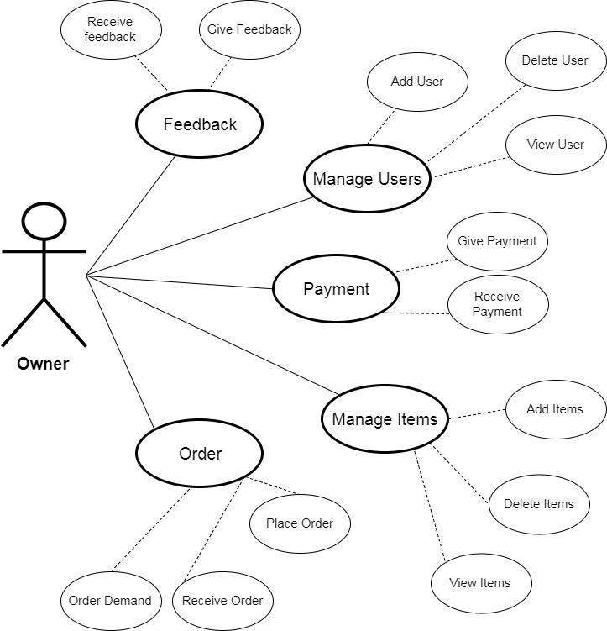

Figure 4 : Owner Use Case Diagram

7.1.3.1 USE CASE DESCRIPTION: Owner to Manage Users


<Use Case 3.1: manage users>

Use case Id: 11

Actors: owner

Feature: owner can add ,delete and view the employees

Pre-condition: owner must be logged in

Scenarios

Step# Action

- Click on the add employee
- Enter the details of the employee
- Click on view employees

- Select the employee and click on delete

Software Reaction

Employee portal open

Details are saved

Employees list displayed

Sytem will remove the employee and its information

Alternate Scenarios:

1a: Log in ID did not found

1b: Display error

1c: Re enter iD

2a: In adding an employee if employee of same name is already present then display error

Post Conditions

Step# Description

Assign task to the employee

Use Case Cross referenced

Table 13 : Owner to Manage Users Use Case Description


7.1.3.2 USE CASE DESCRIPTION: Owner to Manage Items
 |  | <Use Case 3.2: manage items>
Use case Id: |  | 12
Actors: |  | Employee
Feature: |  | owner can add, delete and view items
Pre-condition: |  | owner must be logged in
Scenarios
Step# | Action |  | Software Reaction
1. | Owner click on display items |  | Products list displayed
 | button
2. | Select the item and press delete |  | Item will delete the item from inventory
3. | owner can add the item |  | Item will add into inventory
Alternate Scenarios:
1a:
Supplier don't have the desired items
1b:
Find another supplier
Post Conditions
Step# | Description
 | update the inventory

Use Case Cross referenced 1 ,2, 5 ,8

Table 14 : Owner to Manage Items Use Case Description

7.1.3.3 USE CASE DESCRIPTION: Owner to Feedback
 | <Use case 3.3: feedback>
Use case Id: |  | 13
Actors: |  | owner
Feature: |  | owner can send and receive the feedback
Pre-condition: |  | owner must be logged in
Scenarios
Step# | Action |  | Software Reaction
1. | owner send the feedback to the |  | Sent to the employee
 | owner by going to the feedback
 | portion
2. | Receive feedback |  | acknowledgment

Alternate Scenarios:

1a:

Did not receive the Acknowledgment

1b:

Resend the feedback

Post Conditions

Step# Description

Perform actions according to feedback

Use Case Cross referenced 1 ,2, 5

Table 15 : Owner to Feedback Use Case Description


7.1.3.4 USE CASE DESCRIPTION: Owner to Payment
 |  | <Use Case 3.4: payment>
Use case Id: |  | 14
Actors: |  |  | owner
Feature: |  | owner can give and receive payments
Pre-condition: |  | Owner must be logged in and customer have purchased items
Scenarios
Step# | Action |  | Software Reaction
1. | Customer scan the QR code |  | Total bill displayed in front of cashier
 | that generated by employee
2. | Receive amount |  | Generate invoice

Alternate Scenarios:

1a:

Mobile is not near proximately to read the tag, so the invoice will not generate 1b:

Bring the mobile close enough and read the tag again

Post Conditions

Step# Description

Inventory must be update
Use Case Cross referenced 1 ,2, 5

Table 16 : Owner to Payment Use Case Description

7.1.3.5 USE CASE DESCRIPTION: Owner to Order


 |  | <Use case 3.5: order>
Use case Id: |  | 15
Actors: |  |  | owner
Feature: |  | owner can place and receive order
Pre-condition: |  | owner must be logged in
Scenarios
Step# | Action |  | Software Reaction
1. | Order to the supplier |  | Send notification to supplier
2. | Receive order from Employee |  | acknowledgment

Alternate Scenarios:

1a:

Did not receive the Acknowledgment

1b:

Resend the order

Post Conditions

Step# Description

Supplier can provide items according to the order
Cashier perform action with respect to the owners order

Use Case Cross referenced 1 ,2, 5

Table 17 : Owner to Order Use Case Description
7.2. LOGICAL VIEW

7.2.1. SEQUENCE DIAGRAM: Customer to register

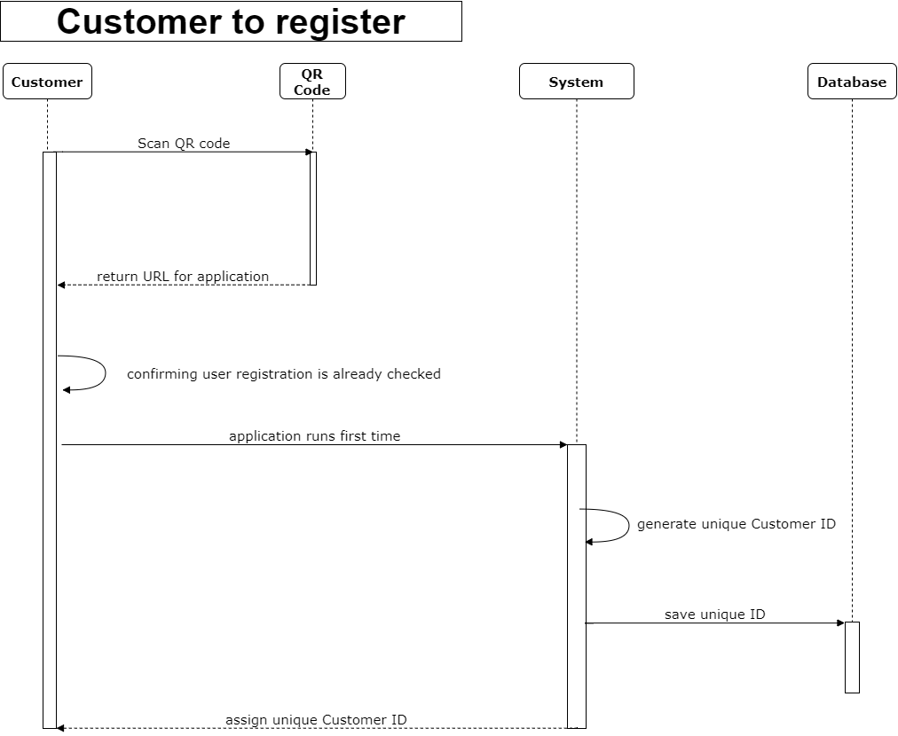

Figure 5 : Customer to Register Sequence Diagram
7.2.2. SEQUENCE DIAGRAM: Customer to search

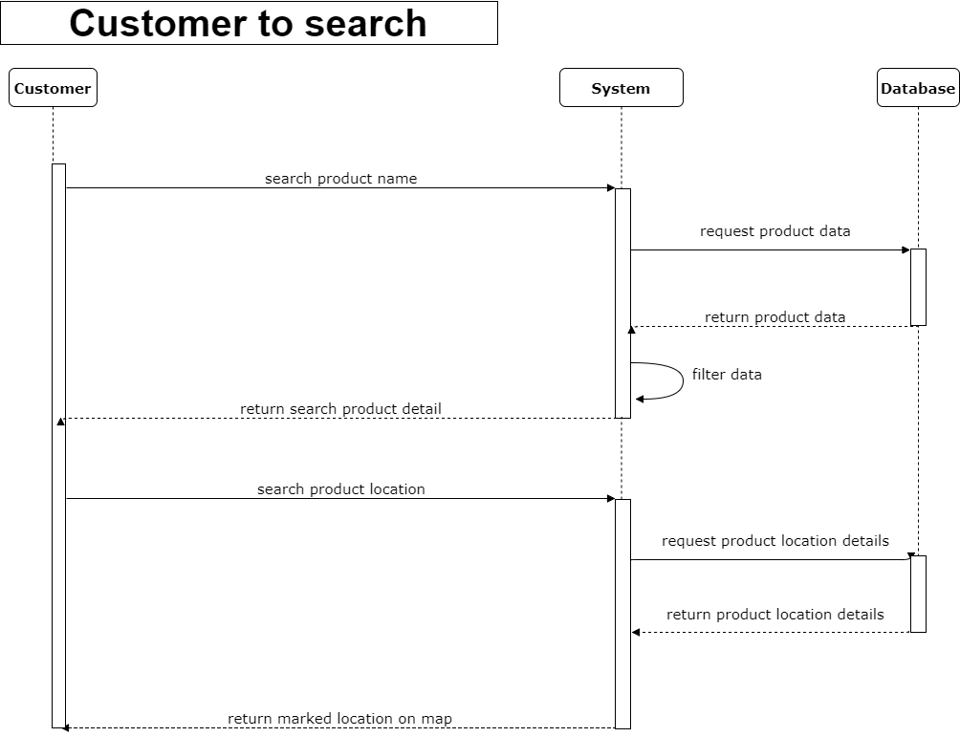

Figure 6 : Customer to Search Sequence Diagram

7.2.3. SEQUENCE DIAGRAM: Customer to purchase

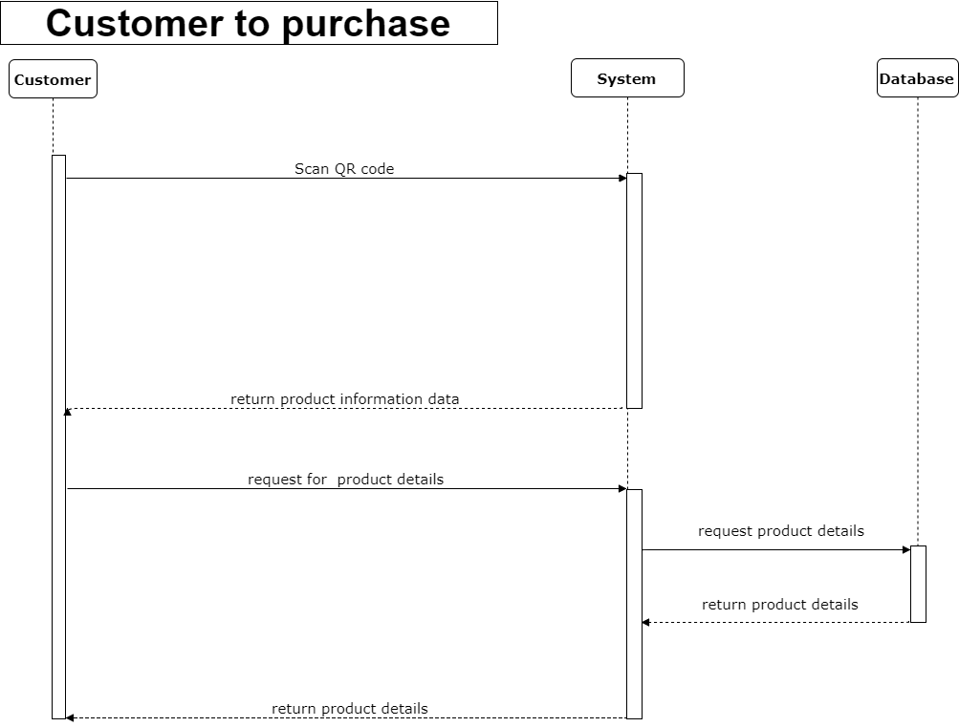
Figure 7 : Customer to Purchase Sequence Diagram
7.2.4. SEQUENCE DIAGRAM: Customer to payment

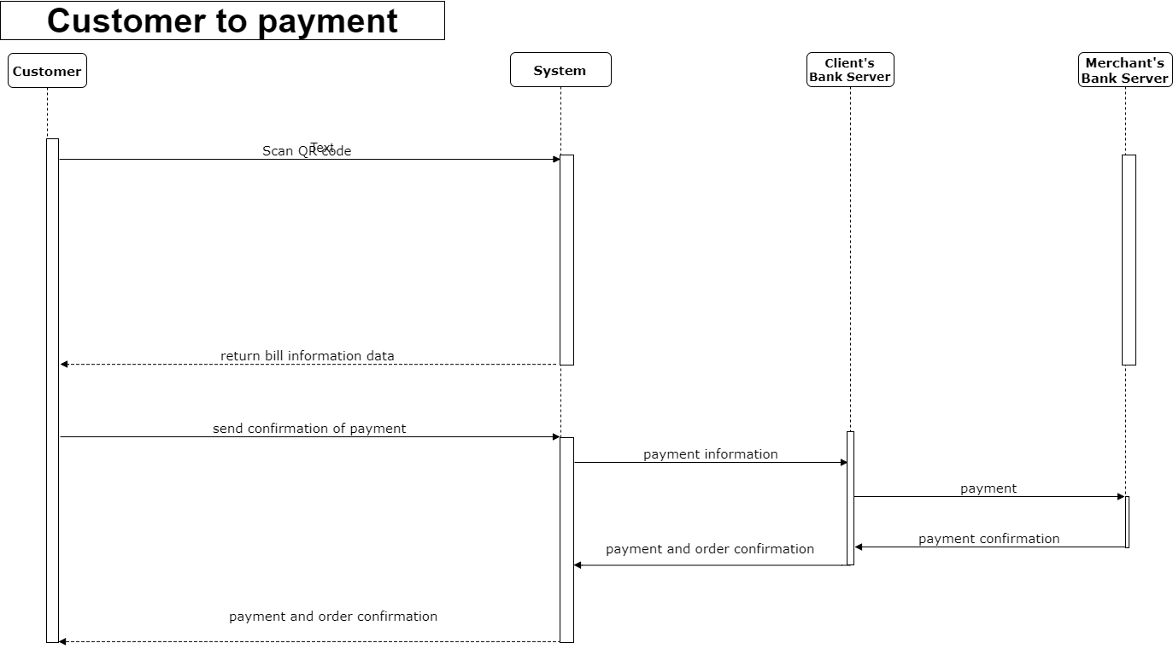

Figure 8 : Customer to Payment Sequence Diagram
7.2.5 SEQUENCE DIAGRAM: Employee

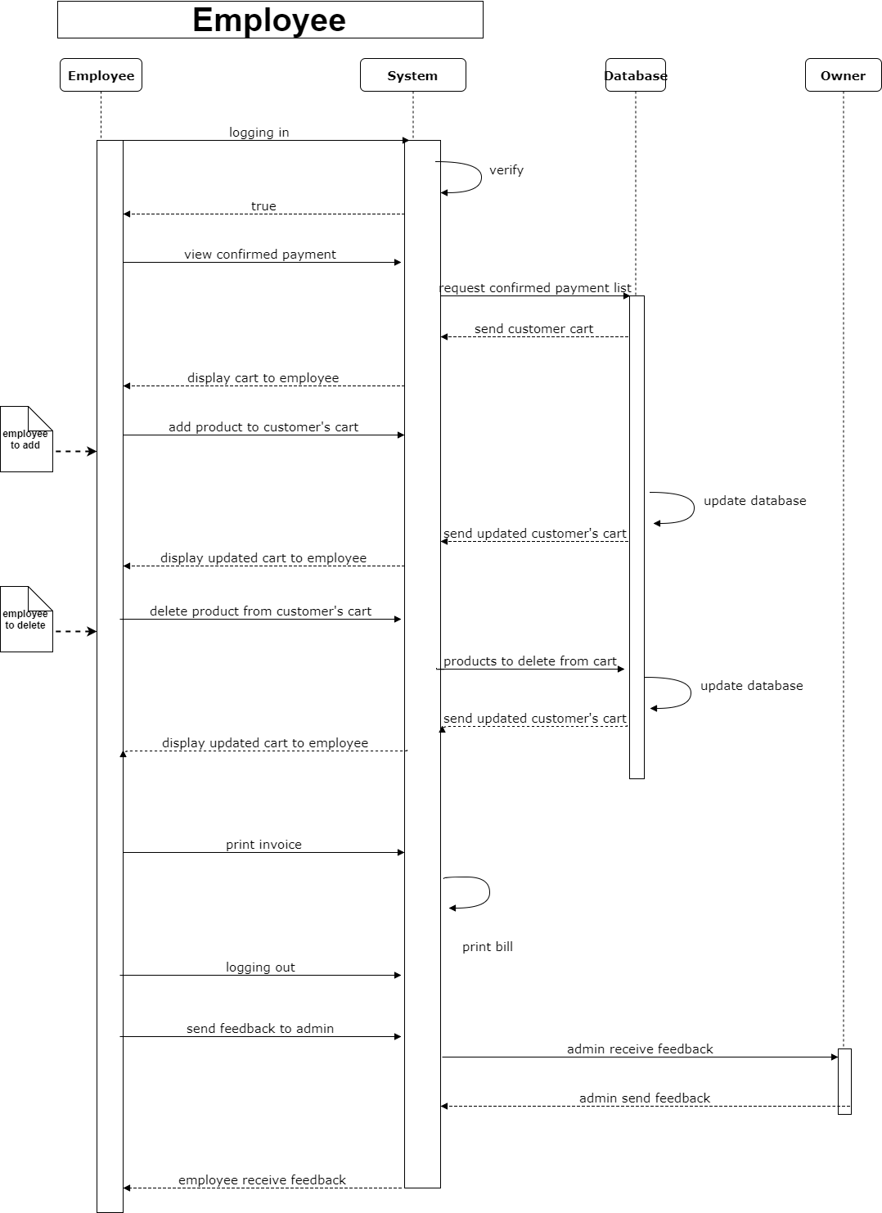
Figure 9 : Employee Sequence Diagram

7.3. PROCESS VIEWS

7.3.1. ACTIVITY DIAGRAM: OWNER

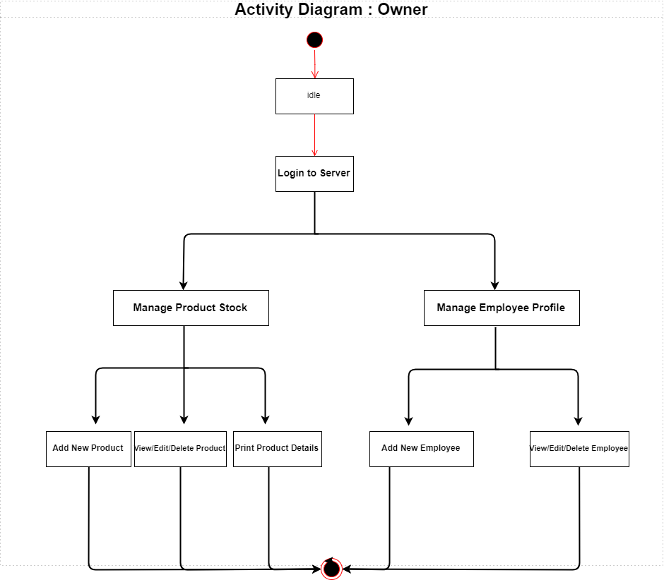

Figure 10 : Owner Activity Diagram

7.3.2. ACTIVITY DIAGRAM: COSTUMER

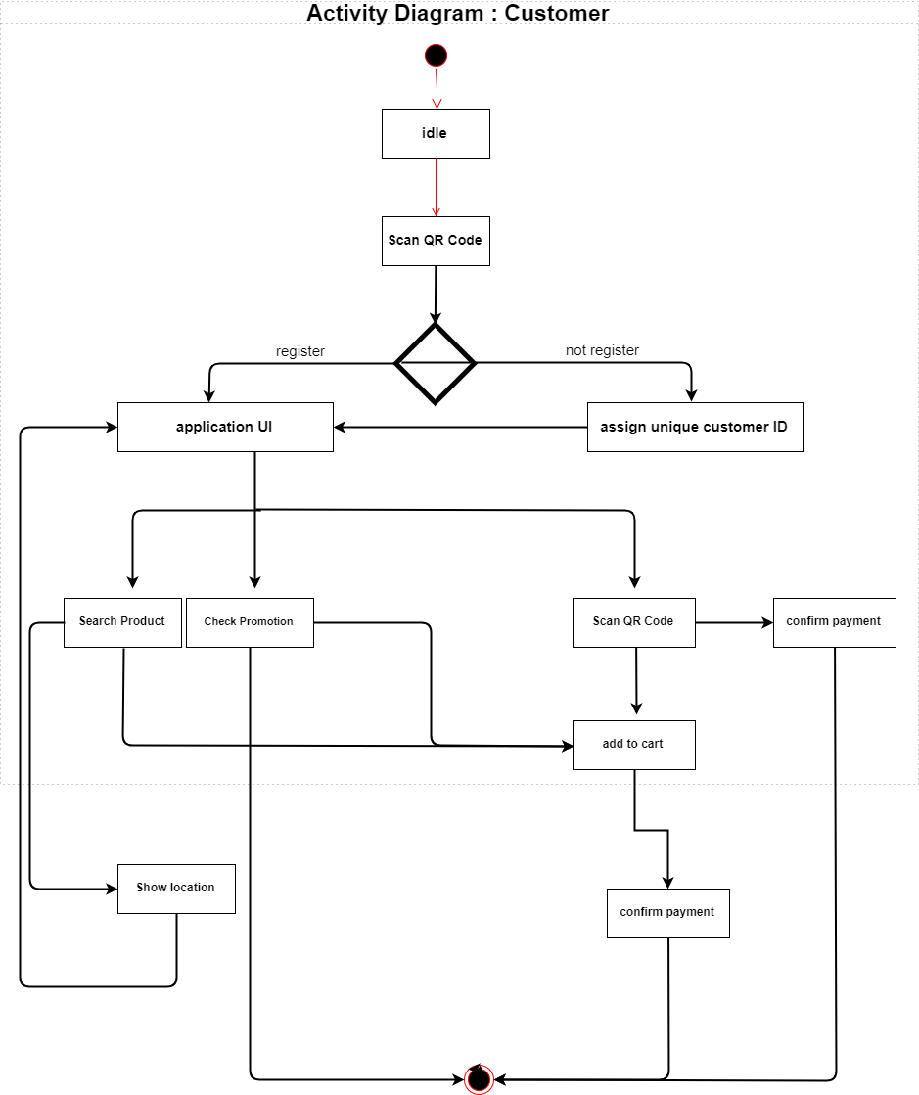

Figure 11 : Customer Activity Diagram

7.3.3. ACTIVITY DIAGRAM: PAYMENT

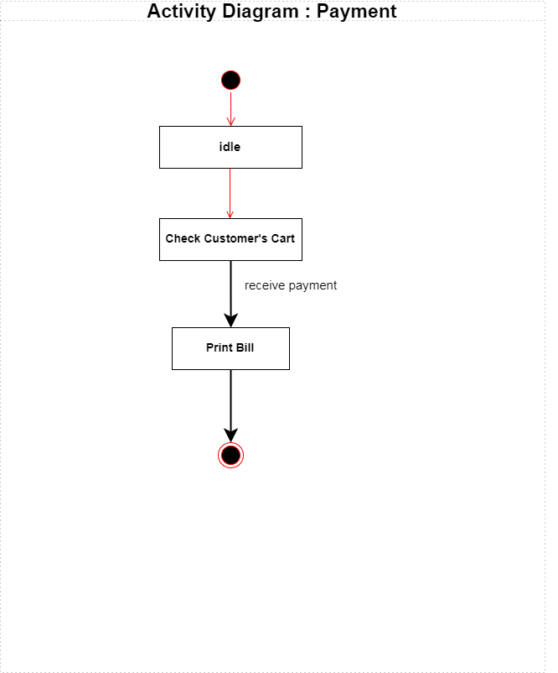
Figure 12 : Payment Activity Diagram

7.4. IMPLEMENTATION VIEW
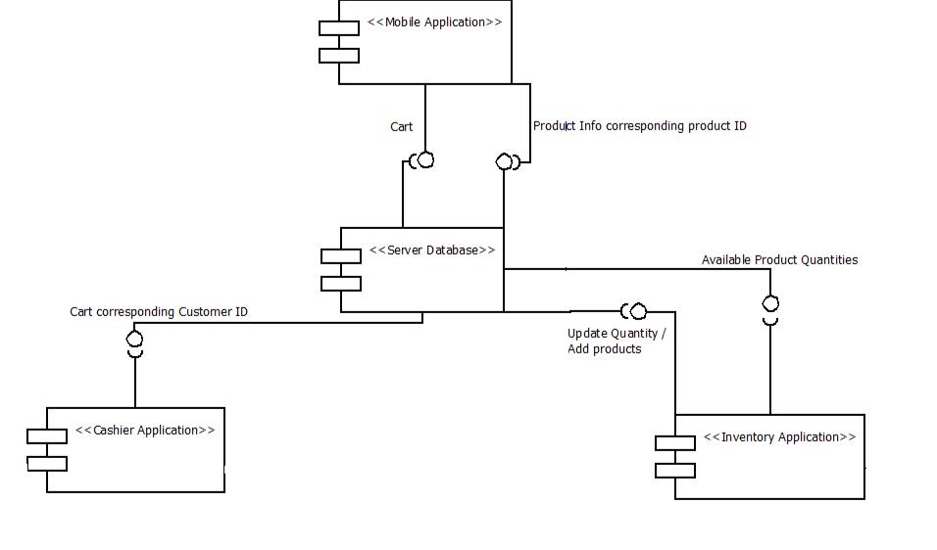

Figure 13 : Implementation View

