

**T.C. Maltepe University**

**Faculty of Engineering & Natural Sciences**

**Software Engineering Department**

**SE 401 CAPSTONE PROJECT REPORT**

**MOBILE LIBRARY**

**Project Team:**

**Ömer GÖKDERE 110706008**

**ACKNOWLEDGMENTS**

We would like to thank our project advisor who is Yrd.Doç. Dr. Mehmet Ali Aksoy TÜYSÜZ for his all contributions on this project. He supported and helped us during whole project process.

Additionally, our friends and families for helping us during preparing this document.

**ABSTRACT**

Mobile library is application that search books on android devices.

Mobile library application helps you to search books by choosing the searching criterion which are author , category, title , publisher, keyword and isbn of books.

It is necessary to use system with an internet connection, because application requires connection to take data from server and google server.

**TABLE OF CONTENTS**

ACKNOWLEDGMENT......................................................................................................................ii

ABSTRACT....................................... ..................................................................................................iii

TABLE OF CONTENTS................................................................................................................ ...iv

LIST OF FIGURES..............................................................................................................................vi

LIST OF TABLES..............................................................................................................................vii

1. INTRODUCTION.............................................................................................................................1

2. PROJECT REQUIREMENTS.........................................................................................................2

2.1 Customer Meetings ....................................................................................................................2

2.2 Literature Research ....................................................................................................................2

2.2.1 LibAnywhere...................................................................................................................2

2.3 Requirements ..............................................................................................................................4

2.3.1 Functional Requirements ...............................................................................................4

2.3.2 Non-Functional Requirements ......................................................................................5

3. PROJECT ANALYSIS.....................................................................................................................6

3.1 Data Dictionary...............................................................................................,............................6

3.2 Use-Case Model...........................................................................................................................6

3.2.1 Use-Cases and Actors.....................................................................................................6

3.2.2 Brief Descriptions of the Use-Cases.............................................................................7

3.2.2.1 Author Criterion Use-Case.....................................................................................7

3.2.2.2 Title Criterion Use-Case.........................................................................................7

3.2.2.3 Publisher Criterion Use-Case.................................................................................8

3.2.2.4 Category Criterion Use-Case..................................................................................8

3.2.2.5 Google Search Criterion Use-Case.......................................................................9

3.2.3 Use-Case Diagram..........................................................................................................9

3.2.4 Use-Case Scenarios and Collaboration Diagrams....................................................10

3.2.4.1 Author Criterion Use-Case...................................................................................10

3.2.4.2 Title Criterion Use-Case.......................................................................................11

3.2.4.3 Publisher Criterion Use-Case...............................................................................12

3.2.4.4 Category Criterion Use-Case................................................................................13

3.2.4.5 Google Search Criterion Use-Case......................................................................13

3.3 Software Project Management Plan........................................................................................14

3.3.1 Gantt Chart.....................................................................................................................14

3.3.2 Project Risk Matrix.......................................................................................................15

3.3.3 Technological Infrastructure and Development Environment............................... 17

3.3.4 System Requirements...................................................................................................18

4. PROJECT DESIGN .................................................................................. ....................................19

4.1 Architectural Design.................................................................................................................19

4.1.1 System Architecture......................................................................................................19

4.1.2 Database Architecture...................................................................................................20

4.1.2.1 Enhanced ER Diagram..........................................................................................21

4.1.2.1.1 Crow's Foot Notation.....................................................................................21

4.1.2.1.2 Chen Notation.................................................................................................22

4.1.2.2 Database Data Dictionary.....................................................................................23

4.1.2.2.1 Author Table...................................................................................................23

4.1.2.2.2 Category Table...............................................................................................23

4.1.2.2.3 Publisher Table...............................................................................................23

4.1.2.2.4 Book Table......................................................................................................23

4.2 Detailed Design.........................................................................................................................24

4.2.1 Class Design..................................................................................................................24

5. USER GUIDE .................................................................................................................................25

5.1 Landing Page……....................................................................................................................25

5.2 Main Page ………....................................................................................................................26

5.2.1 Database Search…........................................................................................................27

5.2.2 Google Search…….......................................................................................................29

5.2.3 About................................................................................................................................31

5.2.4 Exit..................................................................................................................................31

6. CONCLUSION................................................................................................................................32

REFERENCES......................................................................................................................................33

APPENDIX...........................................................................................................................................34

APPENDIX A. Version History...................................................................................................34

**LIST OF FIGURES**

**Figure 1** LibAnywhere App...............................................................................................................3

**Figure 2** LibAnywhere App...............................................................................................................3

**Figure 3** Use - Case Diagram ...........................................................................................................9

**Figure 4** Author Criterion Use - Case Collaboration Diagram.................................................10

**Figure 5** Title Criterion Use - Case Collaboration Diagram.......................................................11

**Figure 6** Publisher Criterion Use - Case Collaboration Diagram..............................................12

**Figure 7** Category Criterion Use - Case Collaboration Diagram...............................................13

**Figure 8** Google Search Criterion Use - Case Collaboration Diagram.....................................13

**Figure 9** Gantt Chart - 1.................................. .......................... .....................................................14

**Figure 10** Gantt Chart - 2............................................................ .......................................................14

**Figure 11** System Architectural of Mobile Library. .....................................................................19

**Figure 12** Database Architectural of Mobile Library....................................................................20

**Figure 13** Crow's Foot Notation of Mobile Library.....................................................................21

**Figure 14** Chen Notation of Mobile Library.................................................................................22

**Figure 16** Icon of brand ................................................................ ....................................................25

**Figure 17** Main Page........................................ç..................................................................................26

**Figure 18** Database Book Search…………...................................................................................27

**Figure 19** Database Book Search Error ….....................................................................................27

**Figure 20** Database Book Search Result …...................................................................................28

**Figure 21** Database Book Search Detail …...................................................................................28

**Figure 22** Database Book Search Connection Error.....................................................................28

**Figure 23** Google Book Search……...……...................................................................................29

**Figure 24** Google Book Search Error …........................................................................................29

**Figure 25** Google Book Search Result …......................................................................................30

**Figure 26** Google Book Search Detail …......................................................................................30

**Figure 27** Google Book Search Error........................ ....................................................................30

**Figure 27** About Page.. .................. .................. ...............................................................................31

**LIST OF TABLES**

**Table 1** Data Dictionary.......................................................................................................................6

**Table 2** User search books by author criterion and see the details of book ........................................7

**Table 3** User search books by title criterion and see the details of book ............................................7

**Table 4** User search books by publisher criterion and see the details of book ...................................8

**Table 5** User search books by category criterion and see the details of book .....................................8

**Table 6** User search books by google search criterion and see the details of book .............................8

**Table 7** Author criterion Use - Case Scenario...................................................................................10

**Table 8** Title criterion Use - Case Scenario.......................................................................................11

**Table 9** Publisher criterion Use - Case Scenario................................................................................12

**Table 10** Category criterion Use - Case Scenario ...............................................................................13

**Table 11** Google Search criterion Use - Case Scenario ......................................................................13

**Table 12** Risk Matrix - 1.....................................................................................................................15

**Table 13** Risk Matrix - 2.....................................................................................................................15

**Table 14** Risk Matrix - 3.....................................................................................................................15

**Table 15** Risk Matrix - 4........................................... ........................ ........................ ........................16

**Table 16** Risk Matrix - 5.................................................................... .................................................16

**Table 17** Risk Matrix - 6.................. ........................ ........................ ........................ ........................16

**Table 18** Risk Matrix - 7........................................... ........................ .................................................16

**Table 19** Author Table Data Dictionary................... ................................................. ........................23

**Table 20** Category Table Data Dictionary........................ ................ ........................ ........................23

**Table 21** Publisher Table Data Dictionary........................ ............... ........................ ........................23

**Table 22** Book Table Data Dictionary........................ ...................... ........................ ........................23

**Table 23** Apendix Table......................................................................................................................34

**1. INTRODUCTION**

* Mobile Library Application will be used as book search engine.
* It will be available for everyone who wants to use it.
* It will be commonly used by students for book searching.
* Users can search book by selecting the criterion of searching method.
* Users can not check the database tables.
* Application can be accessible from Android operating system.
* It is necessary to use system with an internet connection, because application requires connection to take actual data from server and google server.

**2. PROJECT REQUIREMENTS**

**2.1 CUSTOMER MEETINGS**

According to customer meetings ; client need an application for everyone commonly students which search books in any place with an internet connection. The application get data from the database or google server and application returns the result of searching with a list in android device.

**2.2 LITERATURE RESEARCH**

In this section , the project which has been deployed before and has some similar functions with our project has been researched. Project documentations as set light to our project process for having ideas for initiation process and the technologies can be used to improve our project.

**2.2.1 LibAnywhere**

Middle East Technical University has developed an application which is LibAnywhere. LibAnywhere is a project for students of METU to search books on their university library also allows students to check their own library that created by themselves.

**LibAnywhere** for iPhone (and all iOS products) and Android phones. **Mobile web** for iPhone, Android, and universal version that works on any phone with web-browsing capabilities.

**Custom Branded Apps:** Upgrade to get the power of Library Anywhere along with custom colors and branded apps, downloadable under your library's name in the app stores.

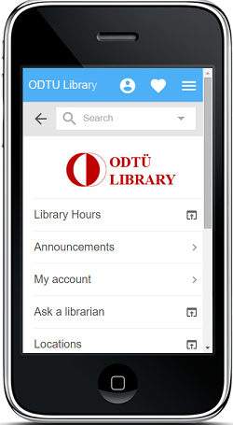 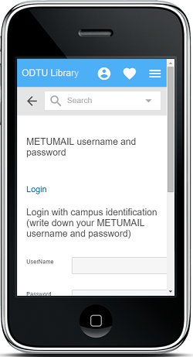

Figure 1: LibAnywhere App Figure 2: LibAnywhere App

Search the catalog, place holds, see checkouts, renew items. It does what the regular catalog does.

Flexibile and customizable homepages. Library Anywhere is your entire mobile solution, not just the catalog. Showcase hours, branches, events, ask a librarian pages, and more.

New items are added the moment they enter your regular catalog—no uploads or reindexing necessary.

Integrates seamlessly with OverDrive.

Use your phone's camera to scan barcodes on books to see if the library has a copy.

"Universal Version" is fully compliant with Section 508 and other accessibility standards.

LibraryThing for Libraries customers also get integrated tags, recommendations, information about other editions, and access to over 100,000 reviews.

**2.3 REQUIREMENTS**

Requirements derived from customer are divided into two; functional and non functional requirements.

**2.3.1 Functional Requirements**

Functional requirements of the software to be developed are listed here.

* Main page of application allows users to choose search options which are google search or database search.
* Inner pages of application allows users to search books by entering criterion of searching.
* Another inner page of application lists detail of the selected book.
* The data will be sorted easily from largest to smallest and vice-versa when the corresponding column titles is clicked / touched which are in page of an application
* Application will allow users to see books in library by selecting the criterion of searching method.
* User can search which authors have books in the library by selecting author criterion.
* User can search which publishers have books in the library by selecting publisher criterion.
* User can search books category to category in the library with selecting category criterion.
* User can search which books in the library by selecting title criterion.
* Importing logs will be stored by the system.

**2.3.2 Non-Functional Requirements**

Non-functional requirements of the software to be developed are listed here.

* The system will run on android environment.
* The response time of the system must be less than 4 seconds when there are 1000 concurrent users.
* When the users enter erroneous input the system will be monitored some error messages to directing user.
* Application has user friendly design who wants to use this application easily.
* The system to be developed should provide ease of use which are the current mobile devices already provide users such as multi-touch , slide properties and the visual elements with the professional level.
* Background and text colors selected carefully not to reduce the readability.
* Ease of uses and the general habbits of usage Home / Back buttons on the device will be protected

**3. PROJECT ANALYSIS**

This chapter presents the details of the requirements analysis using the preferred analysis methodology.

**3.1 DATA DICTIONARY**

In this section, a data dictionary which contains the technical terms and their descriptions related to the problem and application domain.

|  |  |
| --- | --- |
| **DATA** | **DESCRIPTION** |
| **Author** | Author of the book also a criterion of book searching method |
| **Publisher** | Publisher of the book also a criterion of book searching method |
| **Description** | Physical description of books such as the length of book or page count |
| **ISBN** | International Standard Book Number |
| **Publication Date** | The date of the book has been published |

Table 1:Data Dictionary

**3.2 USE-CASE MODEL**

**3.2.1 Use-Cases and Actors**

Mobile library application consist of an actor who is "user".

User is a person who can search books .

1. User search books by author criterion and see the details of book

2. User search books by title criterion and see the details of book

3. User search books by publisher criterion and see the details of book

4. User search books by category criterion and see the details of book

5.User search books by google searching criterion and see the details of book

**3.2.2 Brief Descriptions of the Use-Cases**

**3.2.2.1 Author Criterion Use-Case**

|  |
| --- |
| BRIEF DESCRIPTION  **User search books by author criterion and see the details of book**  User search books by author criterion on database book search page and see the details book on inner page. |
| STEP BY STEP DESCRIPTION    1- User select author search criterion on the upper left panel  2- User enter the name of author  3- User click search button on the upper right panel  4- Books of author will be shown on database book search page as list  5- User click on any book to see detail of book  6- Details will shown on inner page |

Table 2: User search books by author criterion and see the details of book Brief Description

**3.2.2.2 Title Criterion Use-Case**

|  |
| --- |
| BRIEF DESCRIPTION  **User search books by title criterion and see the details of book**  User search books by title criterion on database book search page and see the details book on inner page. |
| STEP BY STEP DESCRIPTION    1- User select title search criterion on the upper left panel  2- User enter the title  3- User click search button on the upper right panel  4- Books with entered title will be shown on database book search page as list  5- User click on any book to see detail of book  6- Details will shown on inner page |

Table 3: User search books by title criterion and see the details of book Brief Description

**3.2.2.3 Publisher Criterion Use-Case**

|  |
| --- |
| BRIEF DESCRIPTION  **User search books by publisher criterion and see the details of book**  User search books by publisher criterion on database book search page and see the details book on inner page. |
| STEP BY STEP DESCRIPTION    1- User select publisher search criterion on the upper left panel  2- User enter the name of publisher  3- User click search button on the upper right panel  4- Books of publisher will be shown on database book search page as list  5- User click on any book to see detail of book  6- Details will shown on inner page |

Table 4: User search books by publisher criterion and see the details of book Brief Description

**3.2.2.4 Category Criterion Use-Case**

|  |
| --- |
| BRIEF DESCRIPTION  **User search books by category criterion and see the details of book**  User search books by category criterion on database book search page and see the details book on inner page. |
| STEP BY STEP DESCRIPTION    1- User select category search criterion on the upper left panel  2- User enter the name of category  3- User click search button on the upper right panel  4- Books of entered category will be shown on database book search page as list  5- User click on any book to see detail of book  6- Details will shown on inner page |

Table 5: User search books by category criterion and see the details of book Brief Description

**3.2.2.5 Google Search Criterion Use-Case**

|  |
| --- |
| BRIEF DESCRIPTION  **User search books by google search criterion and see the details of book**  User search books by google search criterion on google book search page and see the details book on inner page. |
| STEP BY STEP DESCRIPTION    1- User select google search option on landing page then google book search page open  2- User enter input to any criterion on the google book search page  3- User click search button on the bottom of page  4- Books of entered input will be shown on inner page as list  5- User click on any book to see detail of book  6- Details will shown on another inner page |

Table 6: User search books by google search criterion and see the details of book Brief Description

**3.2.3 Use-Case Diagram**

use-case moblib.png

Figure 3: Use -Case Diagram

**3.2.4 Use-Case Scenarios and Collaboration Diagrams**

**3.2.4.1 Author Criterion Use-Case**

|  |
| --- |
| **Scenario**  1- User select author search criterion on the upper left panel  2- User enter the name of author  3- User click search button on the upper right panel  4- Books of author will be shown on landing page as list  5- User click on any book to see detail of book  6- Details will shown on inner page |

Table 7: Author criterion Use - Case Scenario

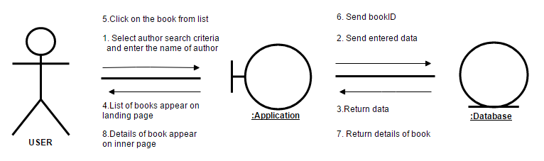

Figure 4: Author Criterion Use - Case Collaboration Diagram

**3.2.4.2 Title Criterion Use-Case**

|  |
| --- |
| **Scenario**  1- User select title search criterion on the upper left panel  2- User enter the title  3- User click search button on the upper right panel  4- Books with entered title will be shown on landing page as list  5- User click on any book to see detail of book  6- Details will shown on inner page |

Table 8: Title criterion Use - Case Scenario

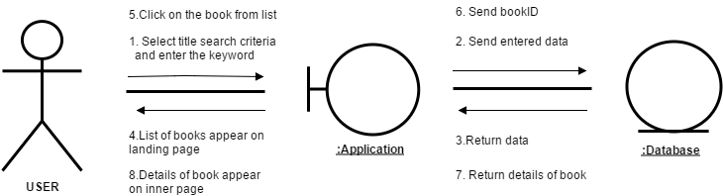

Figure 5: Title Criterion Use - Case Collaboration Diagram

**3.2.4.3 Publisher Criterion Use-Case**

|  |
| --- |
| **Scenario**  1- User select publisher search criterion on the upper left panel  2- User enter the name of publisher  3- User click search button on the upper right panel  4- Books of publisher will be shown on landing page as list  5- User click on any book to see detail of book  6- Details will shown on inner page |

Table 9: Publisher criterion Use - Case Scenario

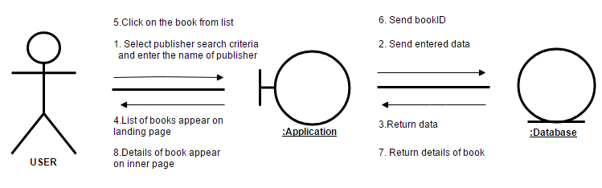

Figure 6: Publisher Criterion Use - Case Collaboration Diagram

**3.2.4.4 Category Criterion Use-Case**

|  |
| --- |
| **Scenario**  1- User select category search criterion on the upper left panel  2- User enter the name of category  3- User click search button on the upper right panel  4- Books of entered category will be shown on landing page as list  5- User click on any book to see detail of book  6- Details will shown on inner page |

Table 10: Category criterion Use - Case Scenario

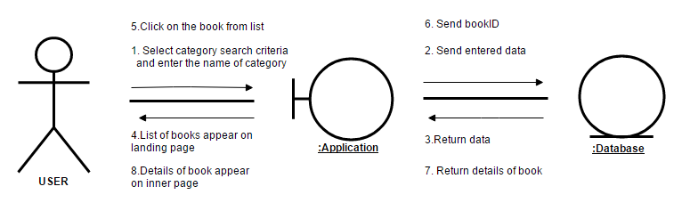

Figure 7: Category Criterion Use - Case Collaboration Diagram

**3.2.4.5 Google Search Criterion Use-Case**

|  |
| --- |
| **Scenario**  1- User select google search option on landing page then google book search page  2- User enter input to any criterion on the google book search page  3- User click search button on the bottom of page  4- Books of entered input will be shown on inner page as list  5- User click on any book to see detail of book  6- Details will shown on another inner page |

Table 11: Google Search criterion Use - Case Scenario

**Google Search Collaboration Diagram.png**

Figure 8: Google Search Criterion Use - Case Collaboration Diagram

**3.3 SOFTWARE PROJECT MANAGEMENT PLAN**

**3.3.1 Gantt Chart**

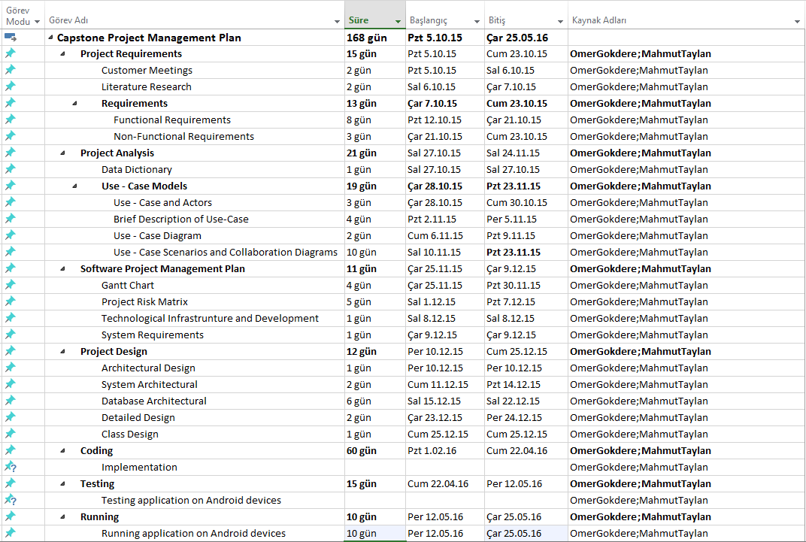

Figure 9: Gantt Chart - 1

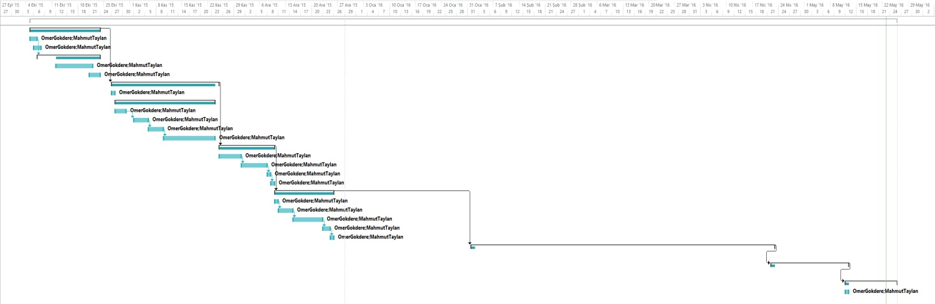

Figure 10: Gantt Chart - 2

**3.3.2 Project Risk Matrix**

|  |  |
| --- | --- |
| Risk | Failure to accurately determine the requirements |
| Description | There may be missing or uncorrect parts in the project. |
| Importance Level | High |
| Probability | Medium |
| Alternative | Requirements must be prepared again from the beginning. |
| Result of Risk | Project result may be different then the expected. |

Table 12: Risk Matrix -1

|  |  |
| --- | --- |
| Risk | Disfavor of user interfaces |
| Description | Interfaces may not be user-friendly or not satisfy user needs. |
| Importance Level | High |
| Probability | Medium |
| Alternative | - |
| Result of Risk | Interfaces must be re-designed. It cause waste of time, therefore project will be delayed. |

Table 13: Risk Matrix -2

|  |  |
| --- | --- |
| Risk | Software is failed tests. |
| Description | Software may fail during test process |
| Importance Level | High |
| Probability | Low |
| Alternative | All cases must be re-design and test by software developers |
| Result of Risk | Project will be delayed because it should successfully pass through tests. |

Table 14: Risk Matrix -3

|  |  |
| --- | --- |
| Risk | Change of requirements |
| Description | Requests of customers may be changed. |
| Importance Level | High |
| Probability | Medium |
| Alternative | Latter request must be postponed to the next version of application. |
| Result of Risk | Project will be delayed because of estimates changed. |

Table 15: Risk Matrix -4

|  |  |
| --- | --- |
| Risk | Software developers cannot be full concentrate on project because of lessons.  Software developers cannot be full concentrate  on project because of lessons and other projects. |
| Description | There may be several project study and exams of other courses. |
| Importance Level | High |
| Probability | High |
| Alternative | - |
| Result of Risk | It causes delay of project because there is no enough time. Also it causes stress on team members. |

Table 16: Risk Matrix -5

|  |  |
| --- | --- |
| Risk | Disagreement problems between team members |
| Description | There may be some disagrements between team members especially about interfaces. |
| Importance Level | Medium |
| Probability | High |
| Alternative | Get advice from someone else |
| Result of Risk | It may take a bit longer time to find an agreed decision about interfaces. |

Table 17: Risk Matrix -6

|  |  |
| --- | --- |
| Risk | Change of programming languages / tools |
| Description | Recognising insufficiency of language or tool that previously decided. |
| Importance Level | High |
| Probability | Low |
| Alternative | Preffered language/or tool must be compatible with the old one to provide re- writing of the problematic part in the projects. |
| Result of Risk | It may cause delay of project because some parts of the application will be re- write from the beginning. |

Table 18: Risk Matrix -7

**3.3.3 Technological Infrastructure and Development Environment**

The Project will be implemented in Android platform. Android provides a rich application framework that allows you to build innovative applications and games for mobile devices in a Java language environment.

There will be a database which is used for transferring data from web server to mobile application which will show the result of searching books. This database will be implemented by using My SQL Server.

Technological tools, which will be used during developing process, are listed below:

* Android Studio
* MySQL Server
* MySQL Workbench
* Source Monitor
* Android Studio Genymotion Plugin
* MS Project
* MS Visio Professional 2013
* IntelliJ IDEA Community Edition 15

We have tested our application on :

* Samsung Galaxy Note V (Android 5.0)
* Asus MemoPad HD7 (Android 5.0)

**3.3.4 System Requirements**

The minimum system requirements are listed below;

* Hard Disk : 20 GB
* Memory : 768 MB
* CPU : 1xCore 1Ghz
* Android 4.2
* Operating system : Ubuntu 15.04 (GNU/Linux 3.19.0-21-generic x86_64)
* Wi-Fi 802.11 b/g/n, hotspot
* VPS (Virtual Private Server)
* MySql server : 5.6.27

**4. PROJECT DESIGN**

**4.1 ARCHITECTURAL DESIGN**

**4.1.1 System Architectural**

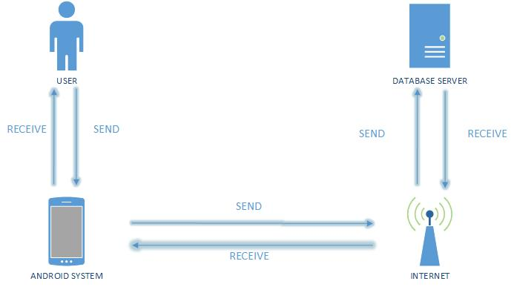

Figure 11: System Architecture of Mobile Library

**4.1.2 Database Architectural**

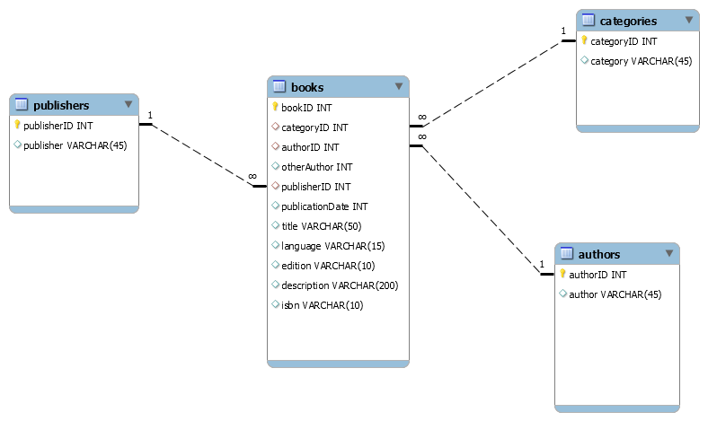

Figure 12: Database Architecture of Mobile Library

**4.1.2.1 Enhanced ER Diagrams**

**4.1.2.1.1 Crow's Foot Notation**

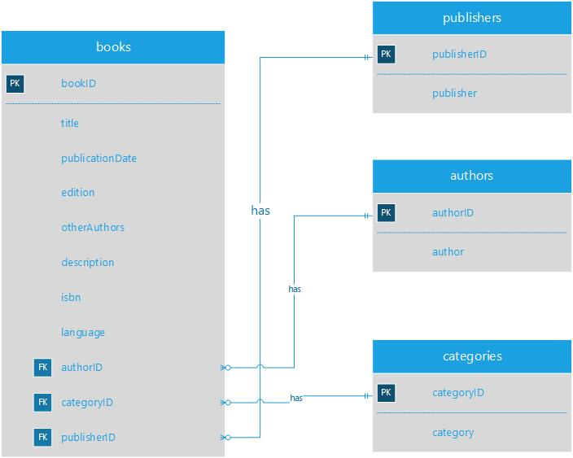

Figure 13: Crow’s Foot Notation of Mobile Library

**4.1.2.1.2 Chen Notation**

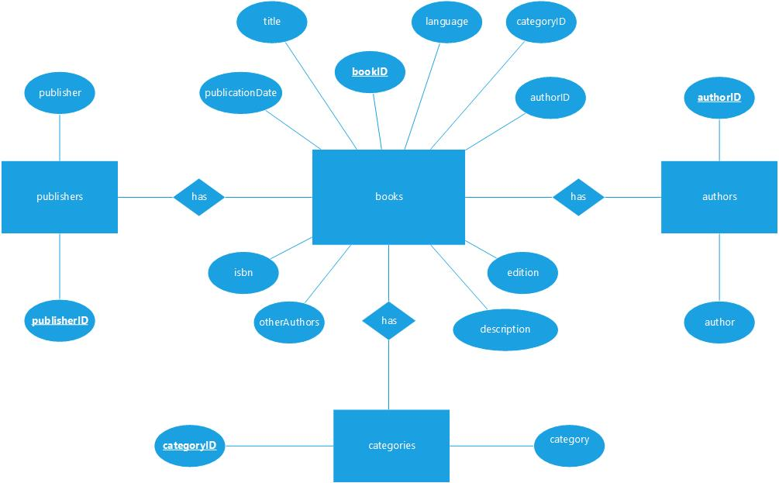

Figure 14: Chen Notation of Mobile Library

**4.1.2.2 Database Data Dictionary**

**4.1.2.2.1 AUTHOR TABLE :**

|  |  |  |
| --- | --- | --- |
| **COLUMN NAME** | **DATA TYPE** | **CONSTRAINTS** |
| authorID | INT | AI,PK |
| author | VARCHAR(45) |  |

Table 19: Author Table Data Dictionary

**4.1.2.2.2 CATEGORY TABLE :**

|  |  |  |
| --- | --- | --- |
| **COLUMN NAME** | **DATA TYPE** | **CONSTRAINTS** |
| categoryID | INT | AI,PK |
| category | VARCHAR(45) |  |

Table 20: Category Table Data Dictionary

**4.1.2.2.3 PUBLISHER TABLE :**

|  |  |  |
| --- | --- | --- |
| **COLUMN NAME** | **DATA TYPE** | **CONSTRAINTS** |
| publisherID | INT | AI,PK |
| publisher | VARCHAR(45) |  |

Table 21: Publisher Table Data Dictionary

**4.1.2.2.4 BOOK TABLE :**

|  |  |  |
| --- | --- | --- |
| **COLUMN NAME** | **DATA TYPE** | **CONSTRAINTS** |
| bookID | INT | AI,PK |
| categoryID | INT | FK |
| authorID | INT | FK |
| publisherID | INT | FK |
| otherAuthor | VARCHAR(45) |  |
| publicationDate | INT |  |
| title | VARCHAR(50) |  |
| language | VARCHAR(15) |  |
| edition | VARCHAR(10) |  |
| description | VARCHAR(200) |  |
| isbn | VARCHAR(10) |  |

Table 22: Book Table Data Dictionary

**4.2 DETAILED DESIGN**

**4.2.1 Class Design**

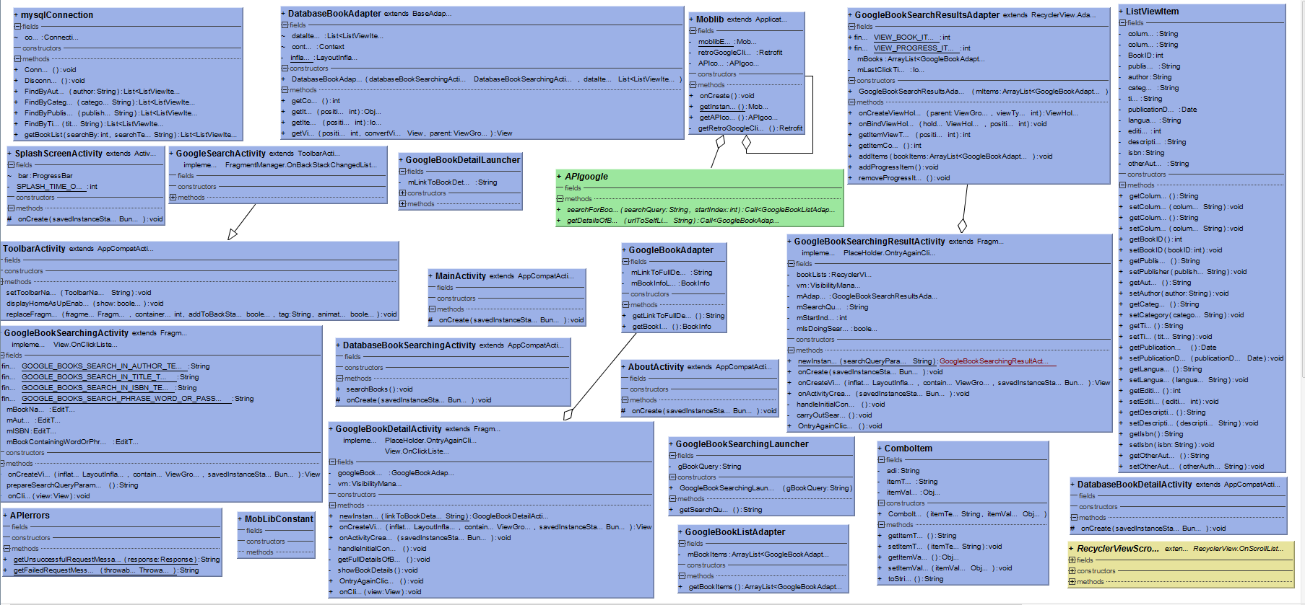

Figure 15: Class Diagram of Mobile Library

**5. USER GUIDE**

The application is implemented for only Android operating system. Firstly , all you need to do it just open Google Play and download the application.

**5.1 LANDING PAGE**

When you open the application loading screen will automatically shown for next 3 second. You can consider this is the landing page of our application. Image that appears on screen also the icon of our brand and application.

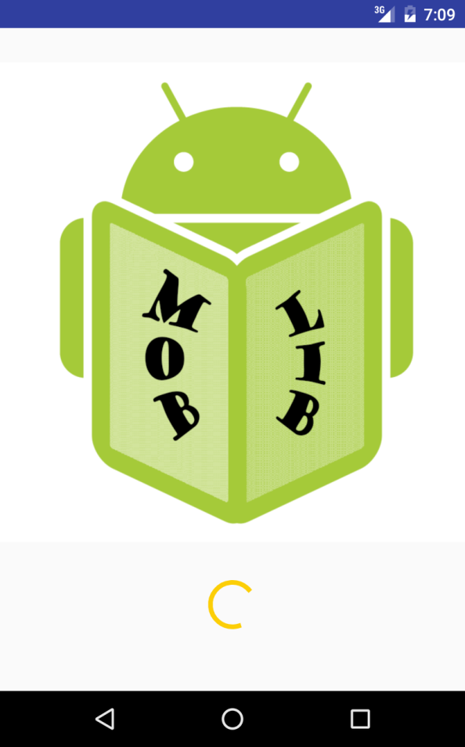

Figure 16: Icon of brand

**5.2 MAIN PAGE**

After landing page main page will be shown. You can consider that this page is menu of our application.User start using application from this page.Main page contains 4 selection which are Database Search , Google Search , About and Exit.

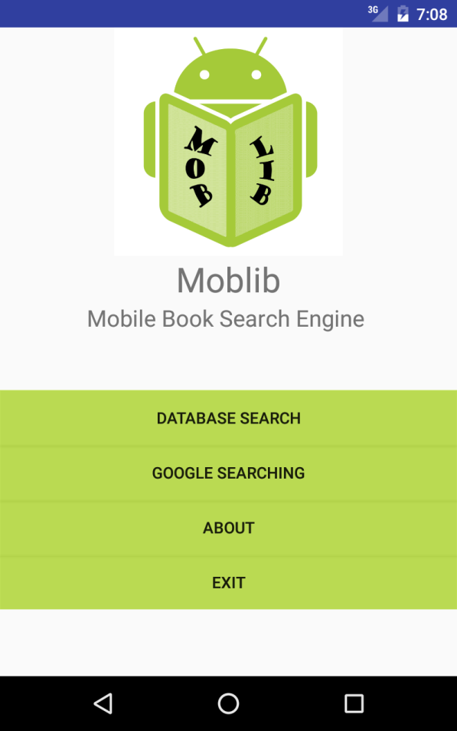

Figure 17: Main page (main menu)

**5.2.1 Database Search**

When user select Database Search this Figure( ) will be shown on screen . This search selection allows user to search books which are already defined in our custom database server. User has to choose atleast one searching criterion to search books on our database server.Otherwise there will be error message which is shown in Figure.After selecting a searching criterion , user can enter input to specify searching or list all books .After successfully searched , books will be listed.When user click on any listed book , detail page will be appear and list all the detail of book (Figure ). If there is no internet connection there will be error message shown in screen .(Figure )

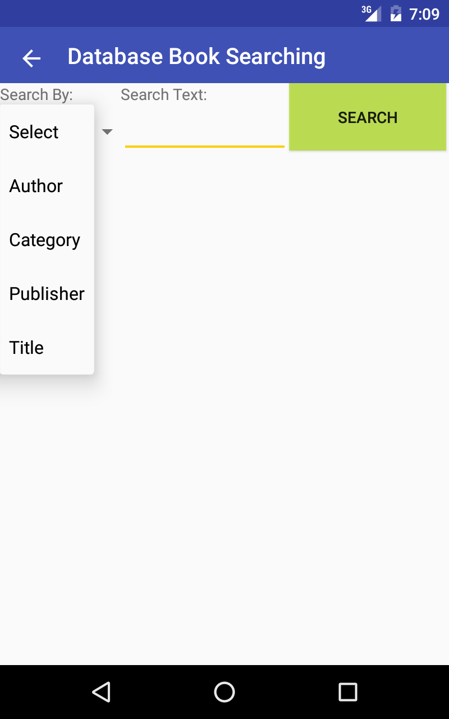 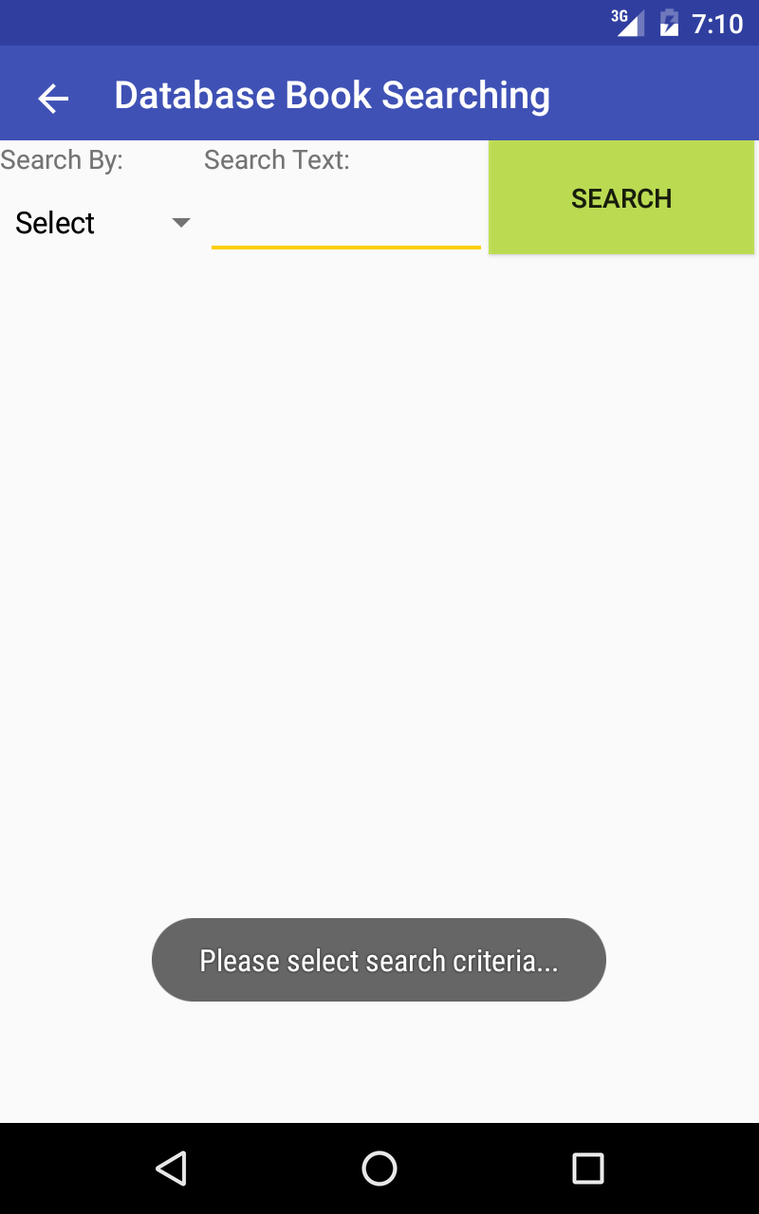

Figure 18: Database Book Search Figure 19: Database Book Search Error

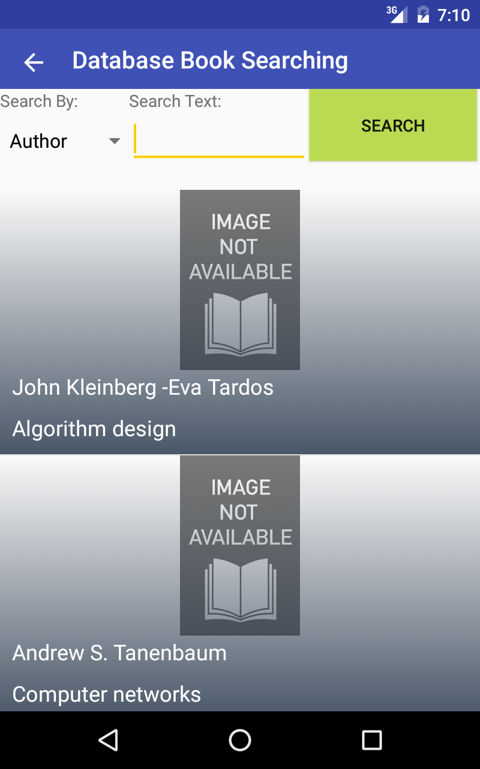 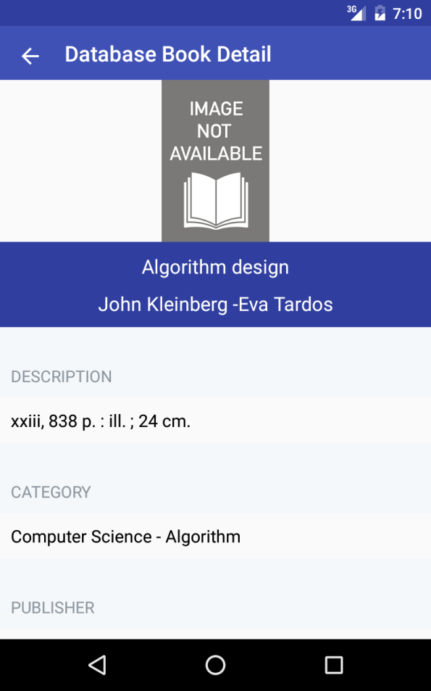

Figure 20: Database Book Search Result Figure 21: Database Book Detail

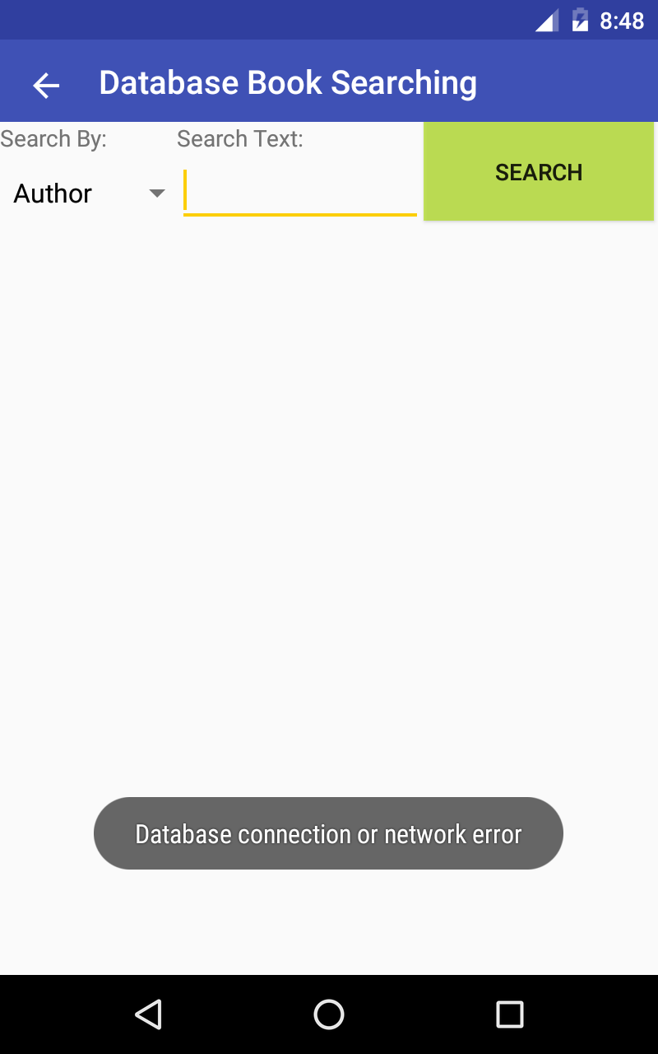

Figure 22: Database Book Search Connection Error

**5.2.2 Google Search**

When user select Google Search this Figure( ) will be shown on screen . This search selection allows user to search books which are already defined in Google database server which means user can reach any book from this selection. In this search selection compared to Database Search selection user has not to choose atleast one searching criterion to search books , user has to enter atleast one input because we cannot list all the books which are published in the world.Otherwise there will be error message which is shown in Figure .After successfully searched , books will be listed.When user click on any listed book , detail page will be appear and list all the detail of book (Figure ). If there is no internet connection there will be error message shown in screen .(Figure )

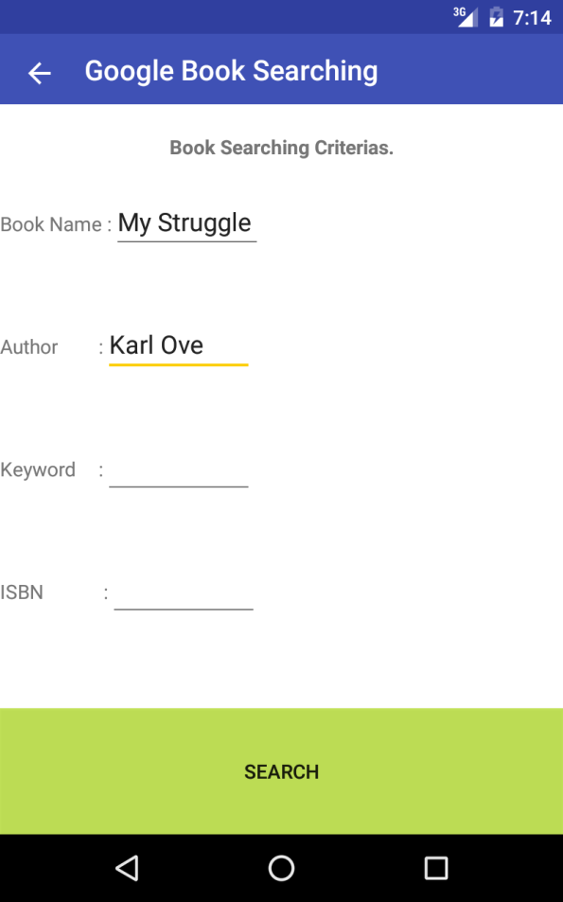 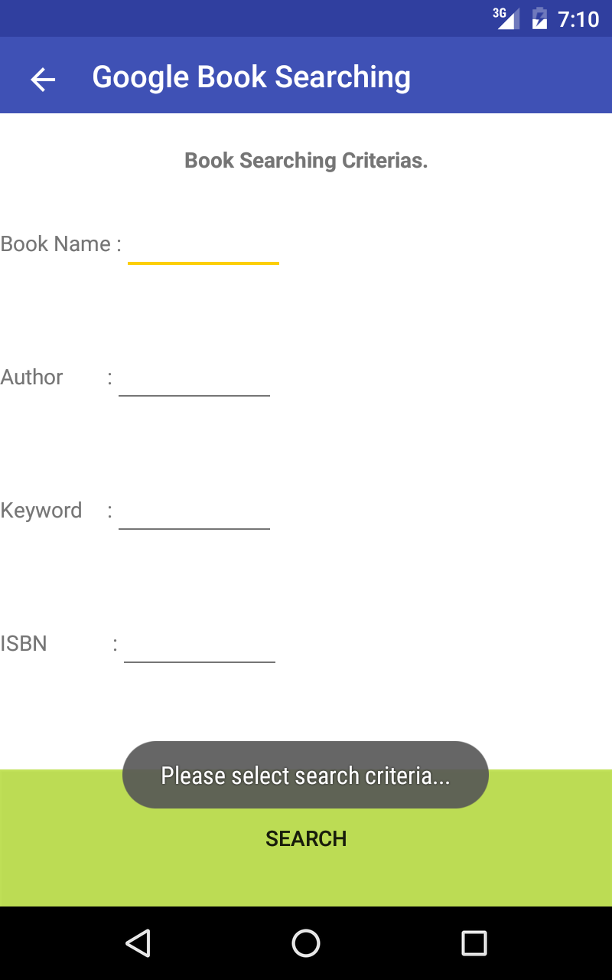

Figure 23: Google Book Search Figure 24: Google Book Search Error

 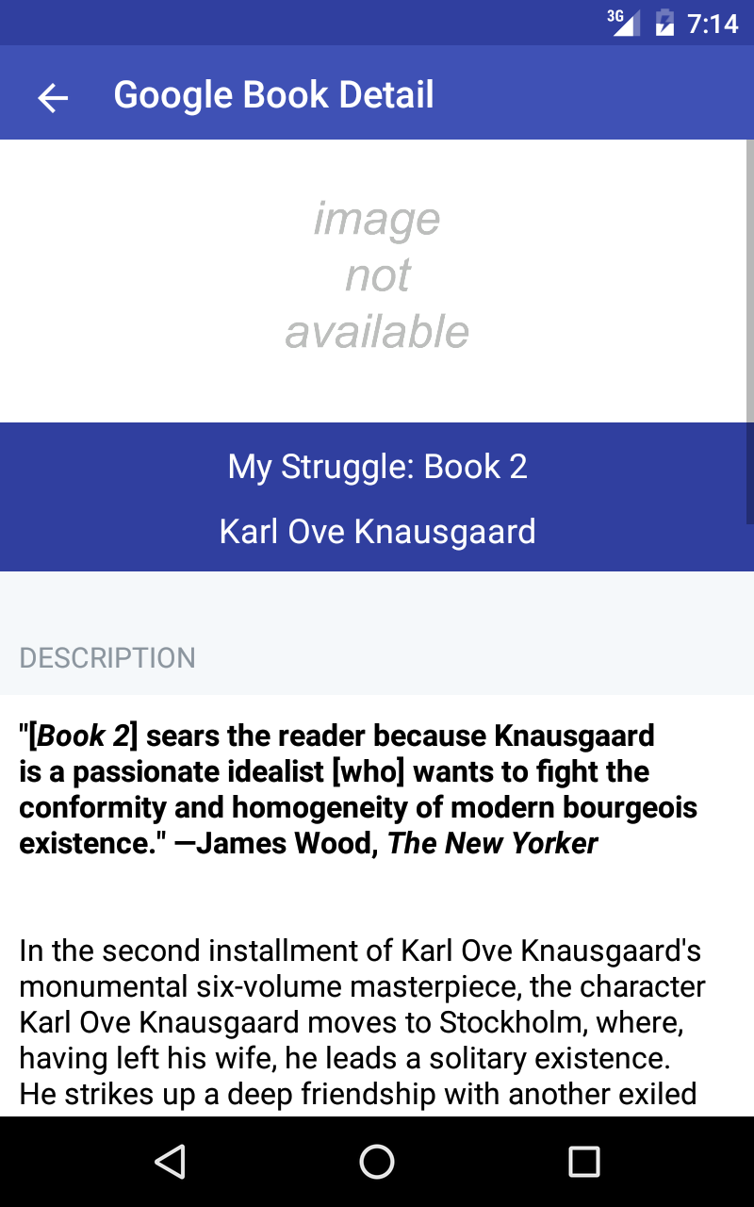

Figure 25: Google Book Search Result Figure 26: Google Book Detail

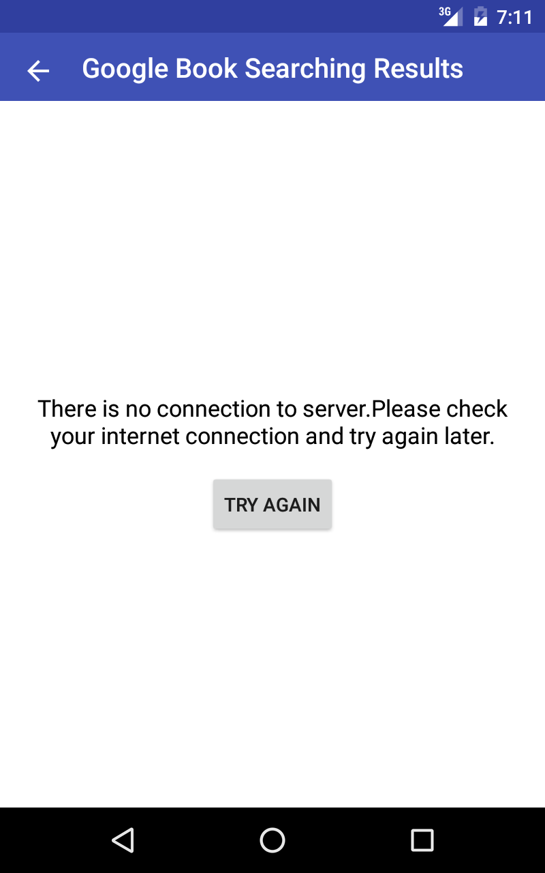

Figure 27: Google Book Search Connection Error

**5.2.3 About**

When user select “About” in main page this about page will be shown on screen(Figure ) .This page gives an information about the graduation project.

Figure 28: About page

**5.2.4 Exit**

When user select “Exit” in main page application stops running in device and it closes.

**6. CONCLUSION**

In the first section of the capstone project report , we introduce our project and describe it briefly.

In the second section of the capstone project report , we clarify the customer meetings , literature research and requirements of the project.Literature research has set light to our project process for having ideas.Requirement section has been completed after customer define the needs during customer meetings.

In the third section of the capstone project report , we clarify the analysis of our project .We organize use - cases scenarios and use - case collaboration diagrams.We also describe project management plan during this section.

In the last section of the capsone project report , we clarify design of project which is system and database architectures , database and class diagrams. At the same time we start implementing our project on android system.

Finally , we have completed our implementation and testing phase. Application is available to use for everyone.

**REFERENCES**

1- www.genmymodel.com is used for drawing use case models

2- https://www.draw.io is used for drawing collaboration diagrams

3- http://stackoverflow.com/questions/5792159/setting-id-for-spinner-items is used by setting text and id of spinner items

4- http://dev.mysql.com/downloads/file/?id=460363 is used for JDBC MySQL Connector

5- https://www.caveofprogramming.com/guest-posts/custom-listview-with-imageview-and-textview-in-android.html is used for setting custom listview

6- http://stackoverflow.com/questions/17183411/network-on-mainthread-exception-one-app-is-working-other-one-throwing-exceptio is used for solving on mainthread problem

7- MS Visio 2013 is used for database diagrams

8- MS Project 2013 is used for software project management plan

9- MySQL Server is used for database

10- IntelliJ IDEA Community Edition 15 is used for drawing uml class diagram

**APPENDIX**

**APENDIX A. Version History**

|  |  |  |
| --- | --- | --- |
| **Version** | **Date** | **Short Description** |
| 1.0 | 11.01.2016 | Initial version. |
| 2.0 | 23.05.2016 | Final version. |

Table 23: Apendix Table