Name: Mohammad Omer ERP No:35749
Personalization block: R = 49 , V = 1, B = 110001 , n = 6

Question 1:
Task A:
Task A:
To check if a binary integer read from left to right is divisible by 4, the Turing machine tracks the running remainder modulo 4 using its internal state set. Starting at remainder 0 in state q₀, as the tape head moves right across each bit, reading a 0 doubles the current remainder (rem ← (2 × rem) mod 4), while reading a 1 doubles it and adds 1 (rem ← (2 × rem + 1) mod 4). States q₀, q₁, q₂, and q₃ represent remainders 0, 1, 2, and 3, respectively. The head scans left-to-right without modifying any input symbols until it reads the trailing blank symbol ␣. Upon encountering ␣, if the machine is in state q₀ (rem = 0), it transitions to qaccept; otherwise, it transitions to qreject.

TASK b: 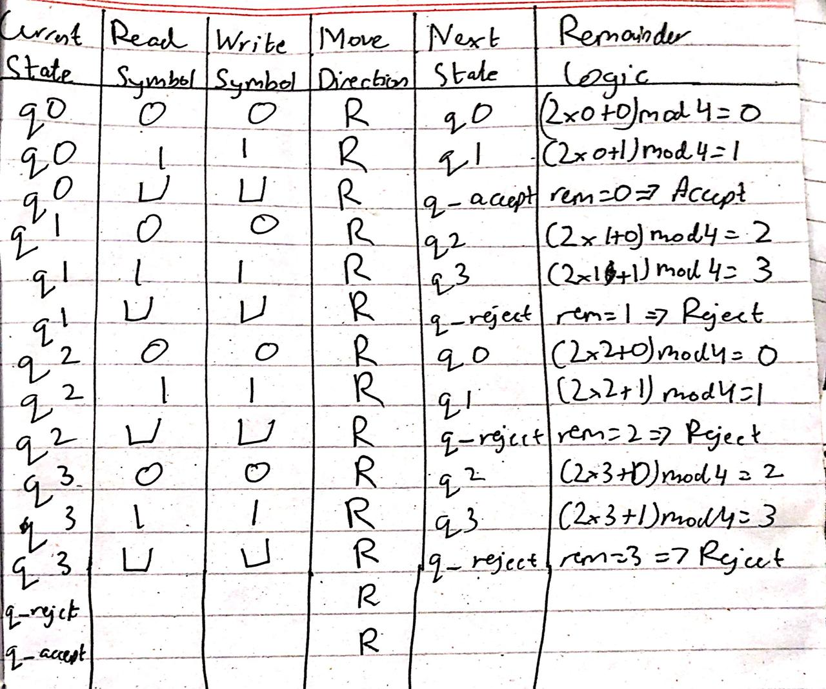

Task C:
RUN
Input: 110001: https://www.automataverse.com/m/uvK2ReUy
Json file: q1_first_input (json file)
Screenshot file name: q1_first_input (png file)
Rejected, correct since 49 is not divisible by 4 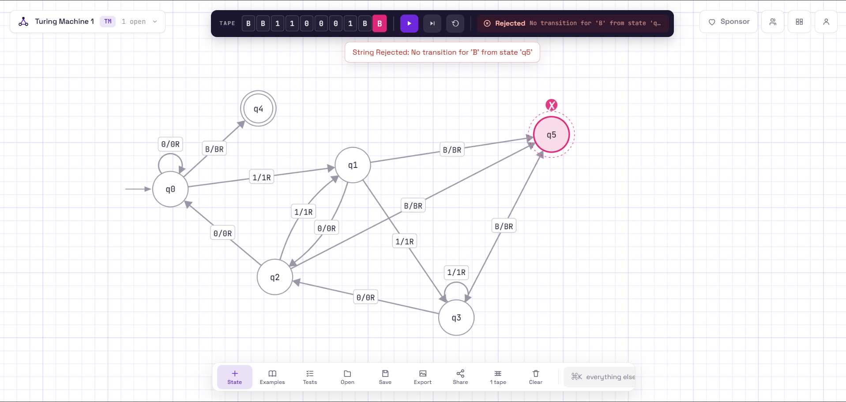
Input: 1100: https://www.automataverse.com/m/QFUN7o5U

Json file: q1_second_input (json file)
Screenshot file name: q1_second_input (png file)
Accepted, correct
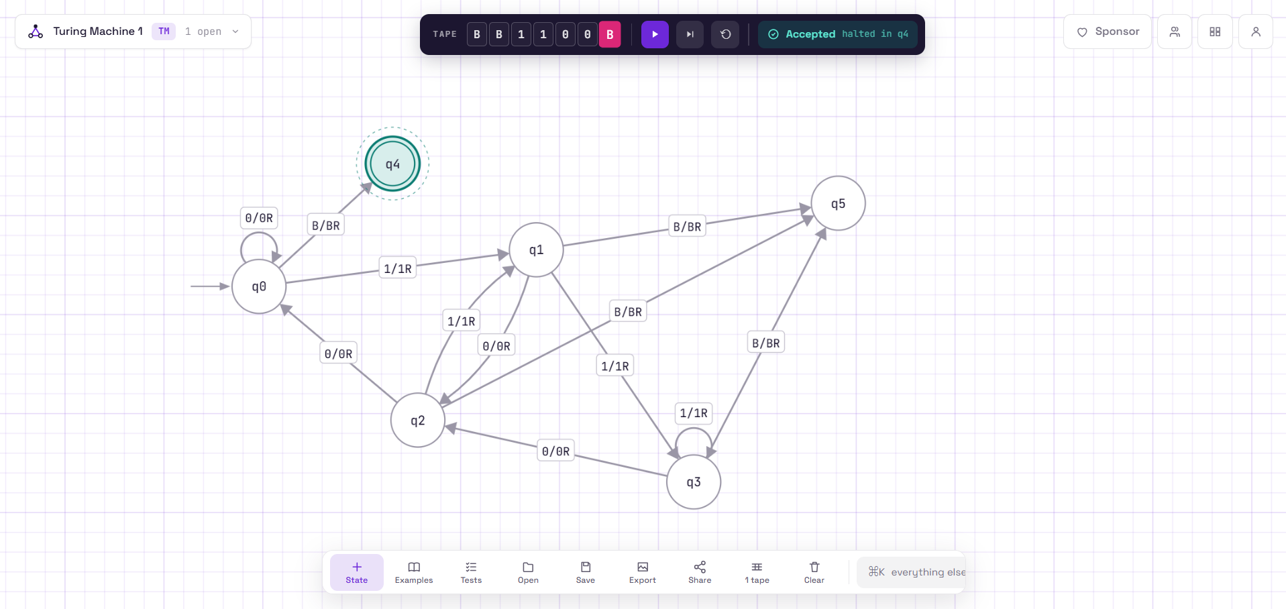

Input: 111 : https://www.automataverse.com/m/3GYECnyZ
Rejected, correct
Json file: q1_third_input (json file)
Screenshot file name: q1_third_input (png file)
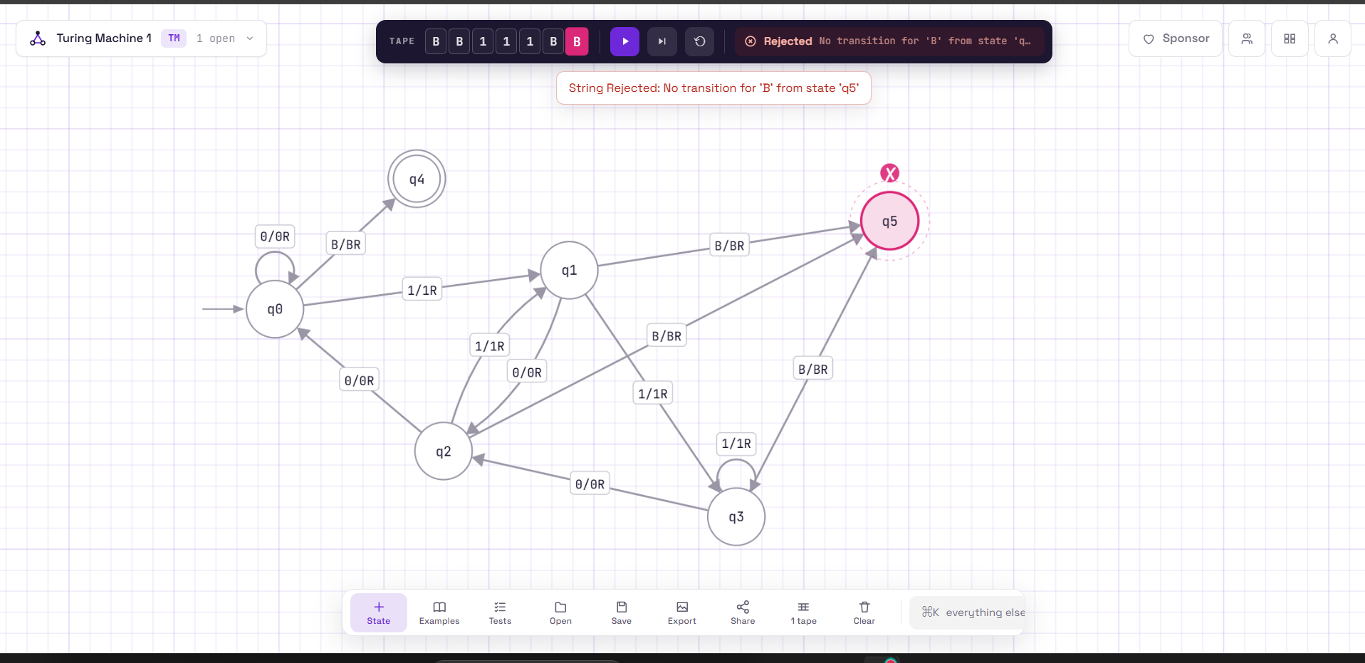

Task D: In my machine, the states q0 to q3 each stand for a remainder mod 4, so the number of states and every transition come directly from M = 4. For example, q3 reading a 1 loops back to q3 because (2·3 + 1) mod 4 = 3, but for M = 5 the same situation would have to lead to remainder 2, so the arrow would point somewhere else. A different M would also need a different number of remainder states (five for M = 5, six for M = 6) with all of their 0 and 1 transitions recomputed. Only the general structure (scan right, accept from the remainder-0 state at the blank) carries over, so my machine can't be reused unmodified and would basically become a new machine.

Question 2:
Task A
My machine works in passes. Each pass finds the leftmost unmarked a, overwrites it with X, then sweeps right past the remaining as and already-marked Ys to the first unmarked b and overwrites it with Y. It then marks the next b the same way, and the head sweeps all the way back left to the blank at the start of the tape to begin the next pass. So each a is paired off with exactly two bs. When no unmarked a is left, the machine walks right over the Ys and accepts only if it reaches the blank without seeing any leftover a or b. If a b is missing, a b is left over, or the symbols are out of order, there is no matching transition and the machine rejects.

Task b:
(below page)
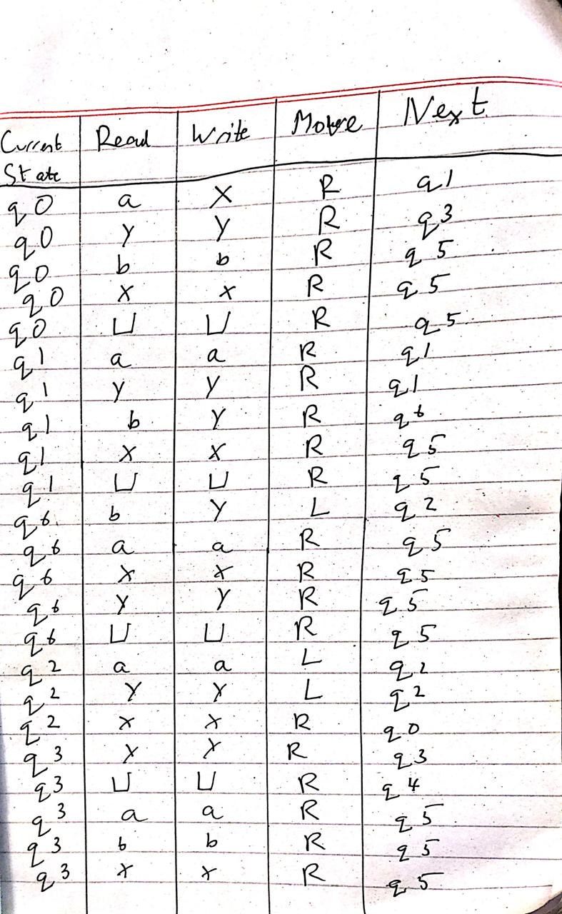
Task C:
RUN
Input: aaaaaabbbbbbbbbbbb : https://www.automataverse.com/m/9EWNQfaa
Json file: q2_first_input
Screenshot: q2_first_input (png)
This was supposed to be accepted, and it did get accepted
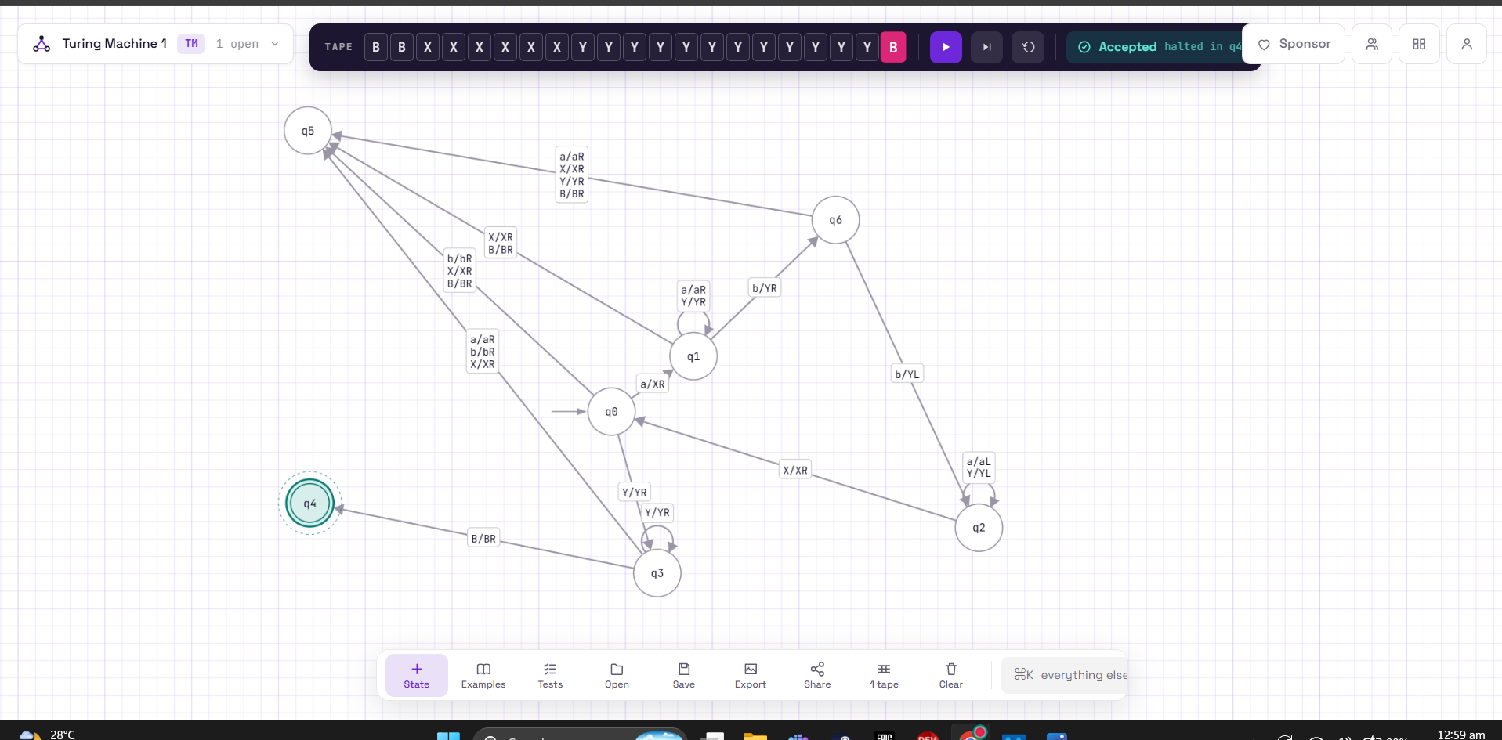

Input: aabbb: https://www.automataverse.com/m/eAPNy7Jd

Json file: q2_second_input
Screenshot: q2_second_input (png)
This was supposed to be rejected, and it did get rejected
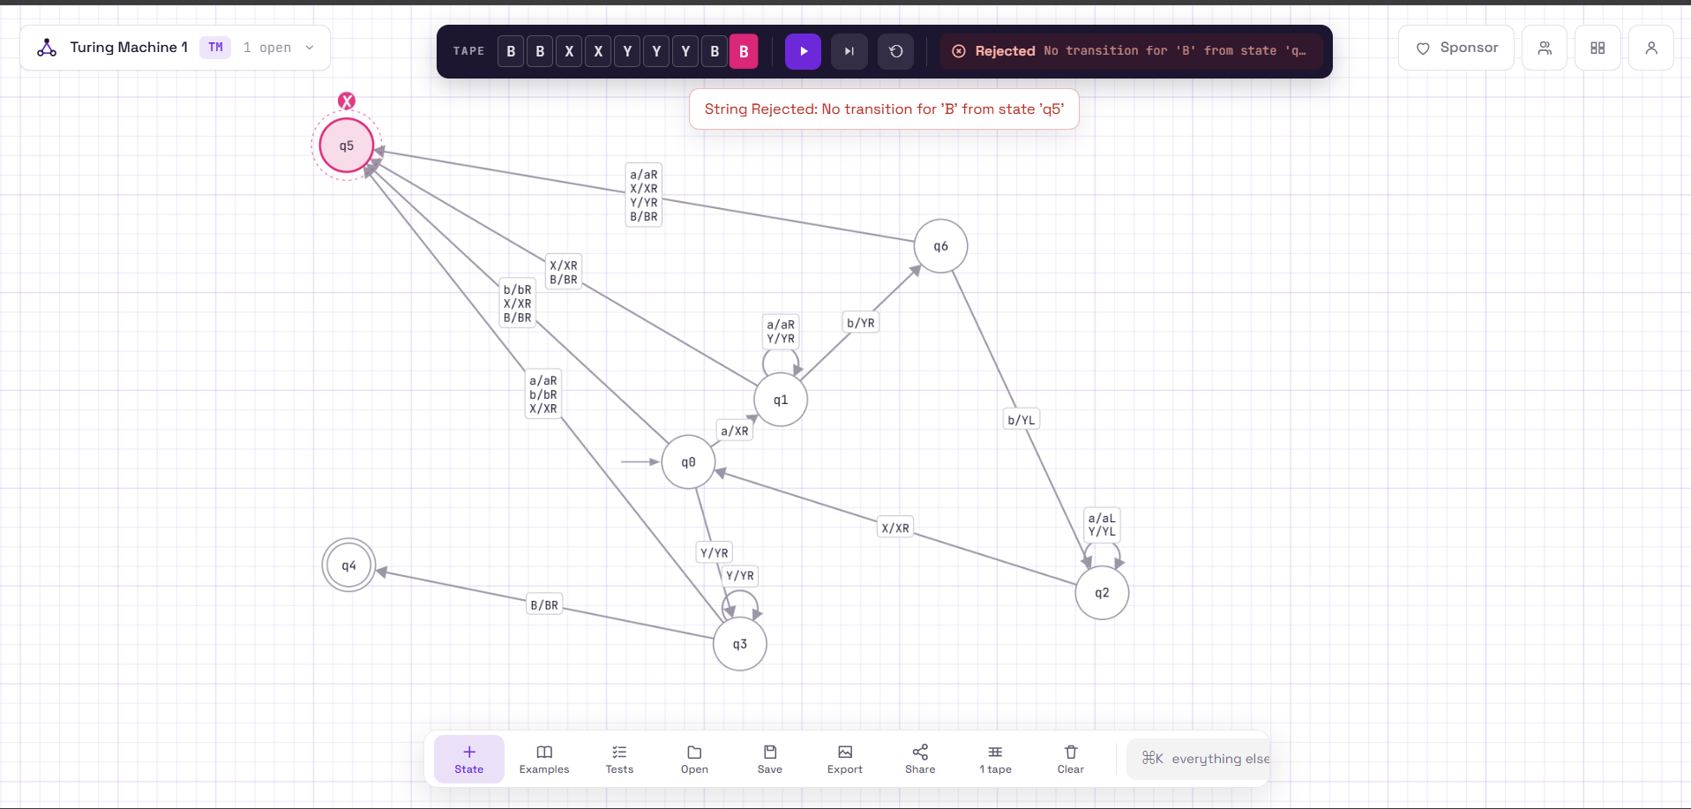
Input: abb: https://www.automataverse.com/m/kufJAPUZ

Json file: q2_third_input
Screenshot: q2_third_input (png)
This was supposed to be accepted, and it did get accepted
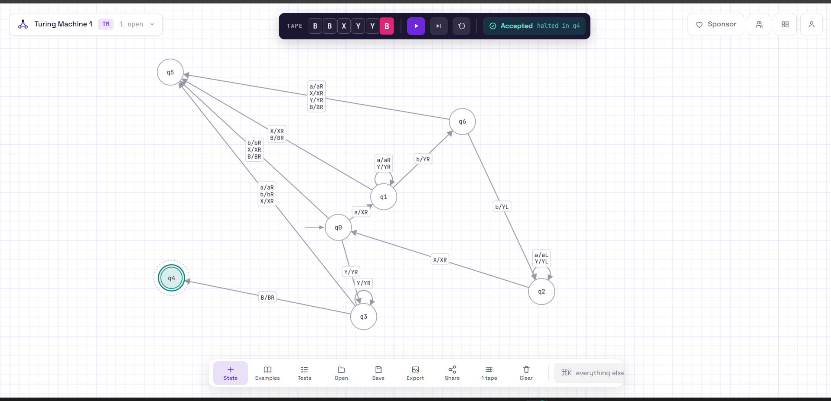

Task d:
The off-by-one error is most likely to occur in the "two b's per a" step, where my machine moves from q1 to q6. State q1 marks the first b as Y and moves right, and q6 marks the second b and only then moves left into q2 to rewind. If q1 went straight to q2 after a single b, the machine would recognize aⁿbⁿ instead of aⁿb²ⁿ, because each a would be paired with only one b. The other risky spot is the final check in q3, where a leftover b could slip through if the transitions were wrong. To convince myself the machine is correct, I first ran n = 6 with exactly 12 b's, which was accepted. I then ran aabbb, which has one b too few for its two a's, and it was rejected: in the second pass q1 marked the only remaining b, and q6 then reached the blank without finding a second b, so the machine went to the reject state. Finally I ran abb, the smallest string in the language, which was accepted, showing that exactly two b's are marked for each a.

Question 3
Task A: My machine decrements a binary number the way you subtract 1 on paper, by borrowing from the right. First it scans right to the blank after the last bit, then steps back onto the last bit. Moving left, every 0 it meets is overwritten with 1 (the borrow), until it reaches the first 1, which is overwritten with 0, and the borrowing stops. The head then walks left to the start of the number and checks the leftmost bit. If it is still 1, the answer is already correct. If it is 0, the original number was a 1 followed only by zeros, so the result is a string of all ones with a stray leading 0. In that case the machine either leaves the single 0 (for the input 1) or erases the last cell and turns the leading 0 into 1, which shortens the number by one without shifting anything. It then halts in the accept state. If the input is all zeros, there is nothing to borrow from, so the machine rejects.

Task B:
(below
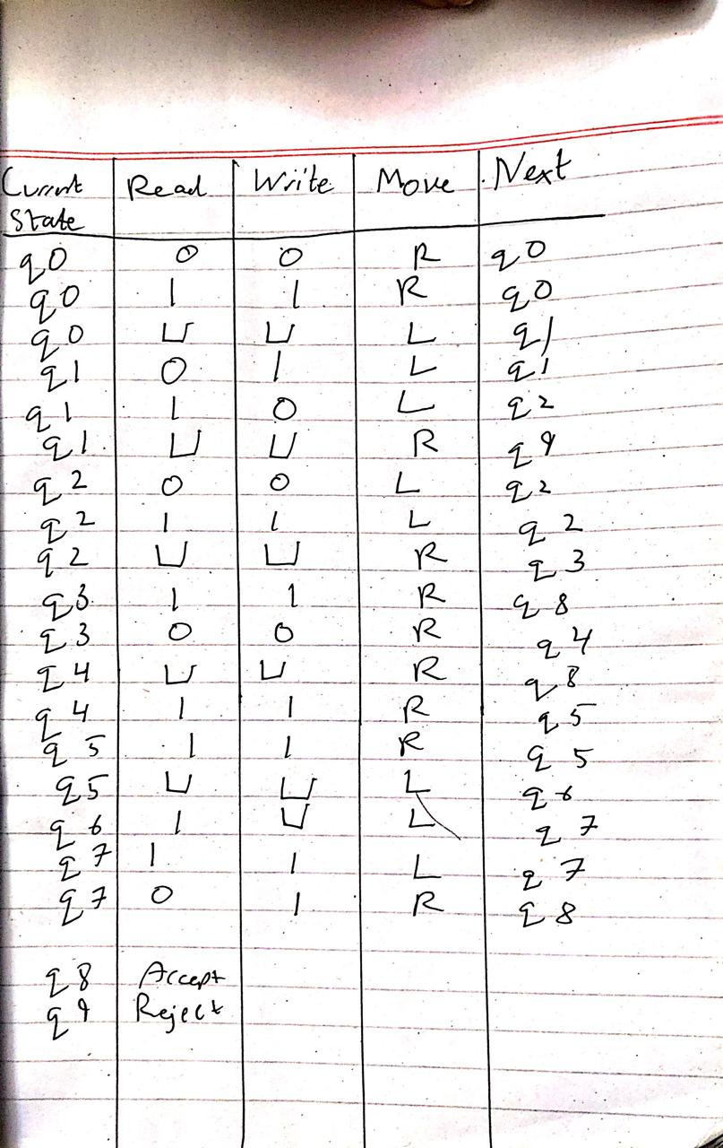
Task C:
Json file: q3 after
https://www.automataverse.com/m/8nmKsdiR
RUN
Decimal value b: 49, the operation should produce 48, yes it does match
Before screenshot: file name: q3_run1_B_before (png)
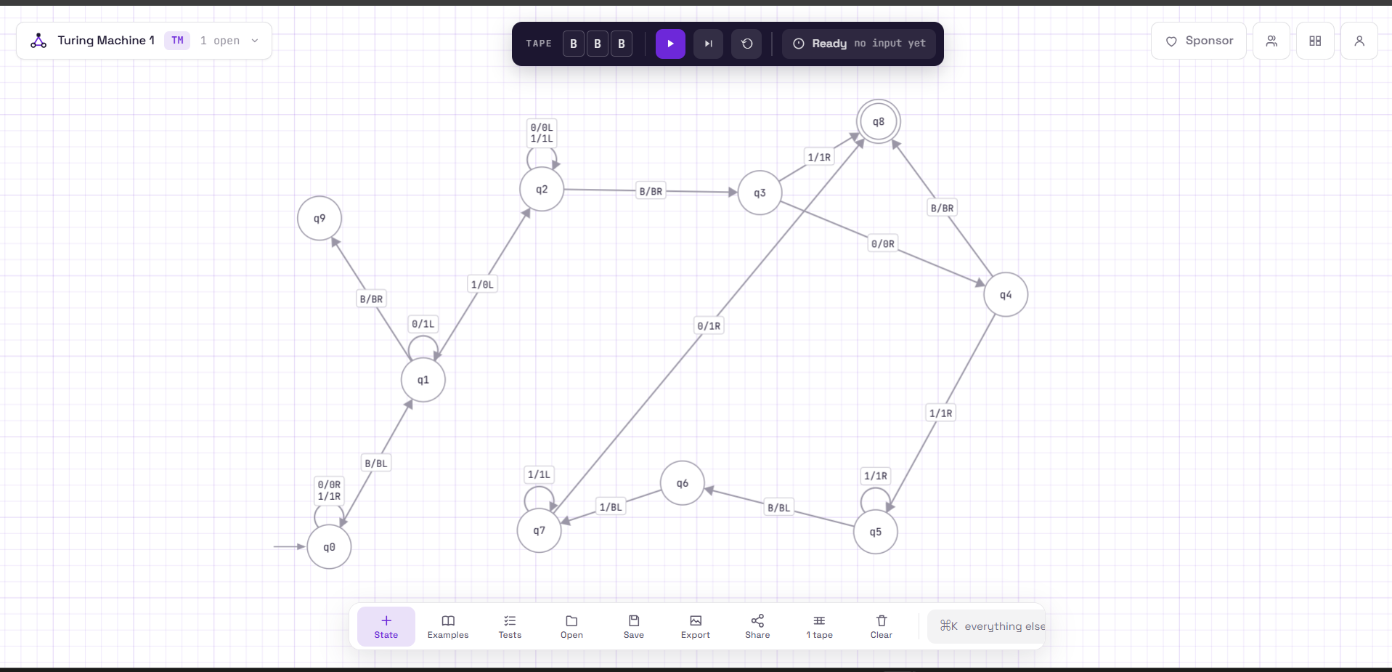
After: file name: q3_run1_B_after (png)
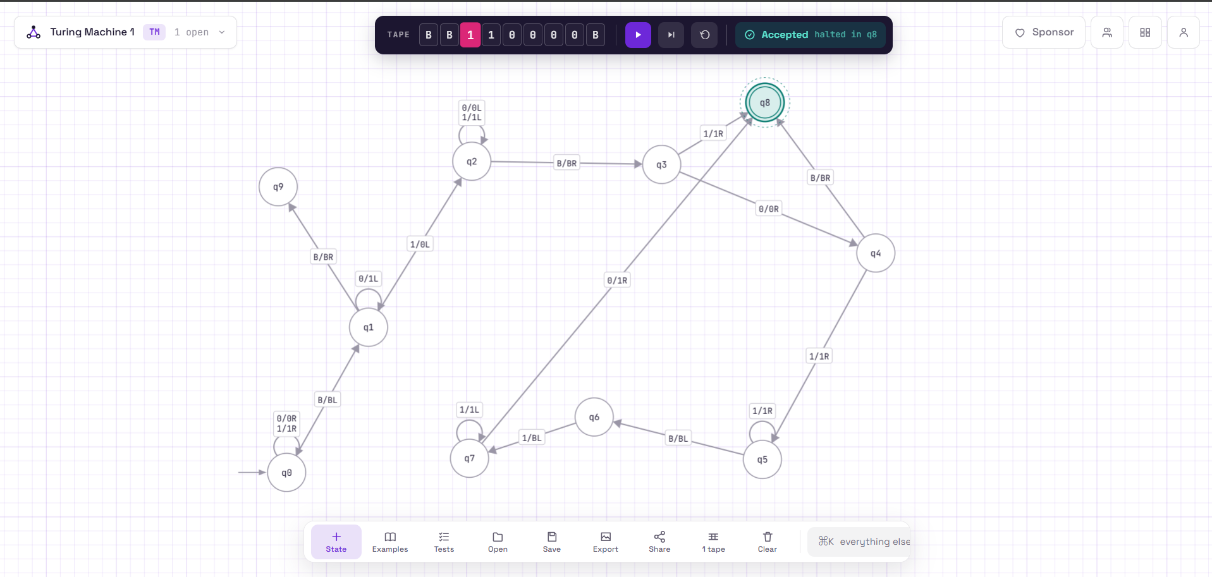
Task d: A naive attempt that only changes the leftmost bit fails because decrementing starts at the right end. The borrow has to travel left through every trailing 0, turning each into 1, until it finds the first 1, which becomes 0. In my machine, q1 does this borrowing. The real trouble comes when the input is a 1 followed only by zeros, like 1000: after borrowing the tape reads 0111, which has a leading zero that is not part of the answer. A leftmost-bit approach would leave that 0 there, or would flip the wrong bit entirely. My machine handles it in q3, which checks the leading bit. If it is 0, states q4 to q7 erase the last 1 and turn the leading 0 into 1, so the tape becomes exactly 111. The input 1 is a special case too, because its result is 0 and the leading 0 has to stay, which is why q4 accepts when it sees a blank right after the 0.

Question 4

Task A: My machine matches symbols from the outside in. It reads the leftmost unmarked symbol, remembers it by moving into a different state for a, b or c, and overwrites it with X. It then runs right to the end of the unmarked part of the tape and steps back onto the last unmarked symbol. If that symbol equals the one it remembered, it overwrites it with X too and sweeps back left to the marker at the start of the unmarked part, then repeats for the next pair. If the two symbols differ, there is no matching transition and the machine rejects. The machine accepts when it runs out of unmarked symbols: either a pass finds nothing left (even length), or the last remaining symbol is the one it just marked, which was the middle of an odd-length string. The empty string and single symbols are accepted because there is nothing to mismatch.

Task B:
Current State | Read | Write | Move | Next
q0 | a | X | R | q1
q0 | b | X | R | q2
q0 | c | X | R | q3
q0 | X | X | R | q8
q0 | ⊔ | ⊔ | R | q8
q1 | a | a | R | q1
q1 | b | b | R | q1
q1 | c | c | R | q1
q1 | X | X | L | q4
q1 | ⊔ | ⊔ | L | q4
q2 | a | a | R | q2
q2 | b | b | R | q2
q2 | c | c | R | q2
q2 | X | X | L | q5
q2 | ⊔ | ⊔ | L | q5
q3 | a | a | R | q3
q3 | b | b | R | q3
q3 | c | c | R | q3
q3 | X | X | L | q6
q3 | ⊔ | ⊔ | L | q6
q4 | a | X | L | q7
q4 | X | X | R | q8
q4 | b | b | R | q9
q4 | c | c | R | q9
q5 | b | X | L | q7
q5 | X | X | R | q8
q5 | a | a | R | q9
q5 | c | c | R | q9
q6 | c | X | L | q7
q6 | X | X | R | q8
q6 | a | a | R | q9
q6 | b | b | R | q9
q7 | a | a | L | q7
q7 | b | b | L | q7
q7 | c | c | L | q7
q7 | X | X | R | q0

Task C:
RUNS

1st run: https://www.automataverse.com/m/jVAWLdac

Input: abccbaabccba
Json file: q4.first
Screenshot file: q4.first
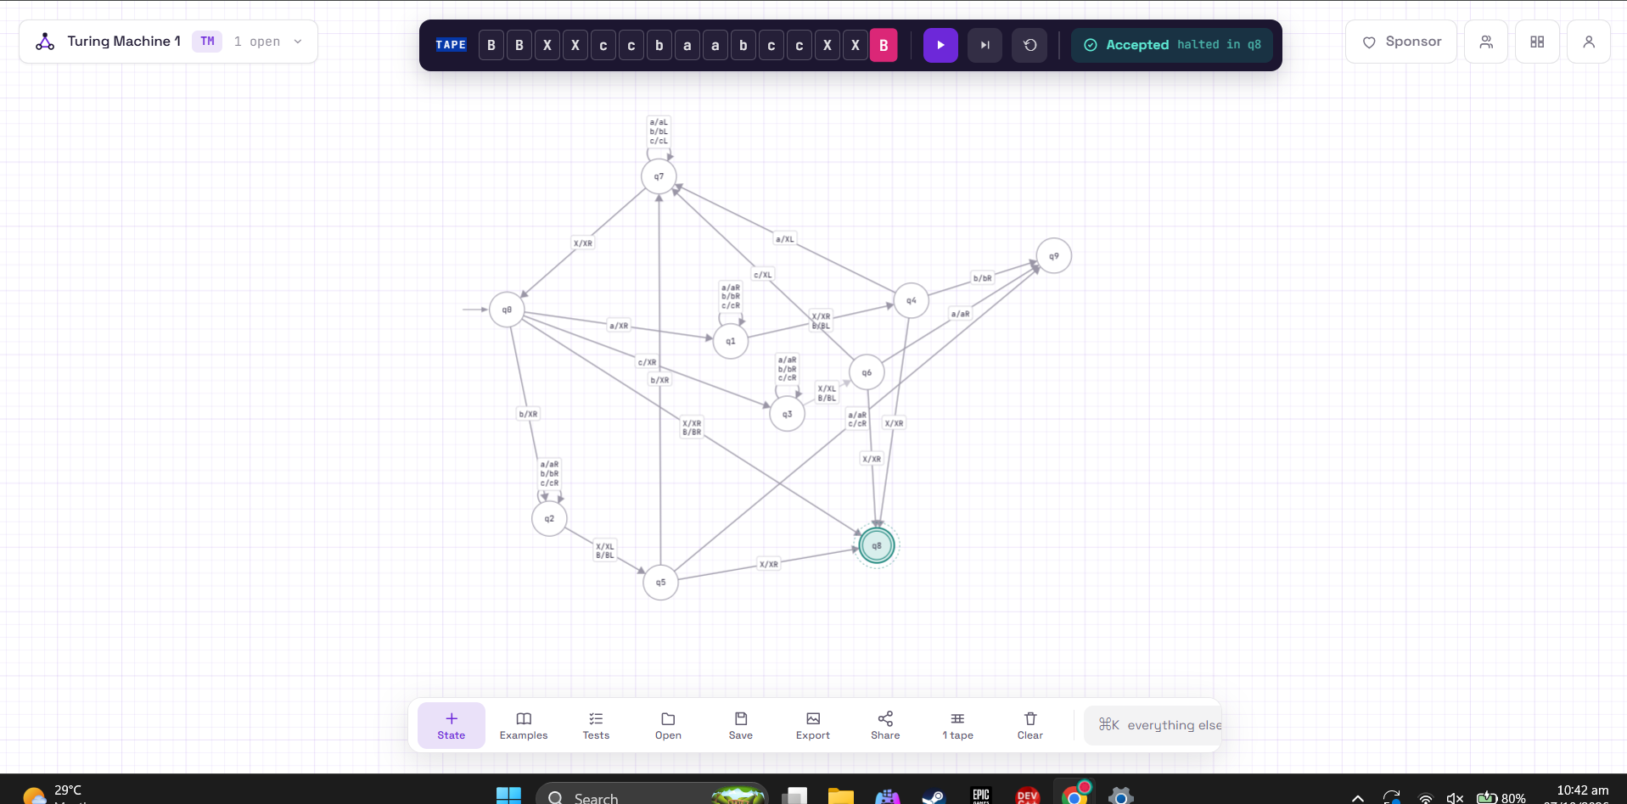

2nd run: https://www.automataverse.com/m/NhJMQFoi

Input: abccbaabccbb
Json file: q4.second
Screenshot file: q4.second

(screenshot below)
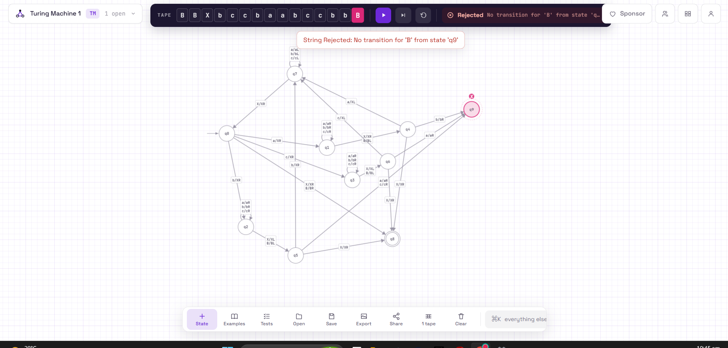

3rd run: https://www.automataverse.com/m/uYhGBx9a
Input: b
Json file: q4.third
Screenshot file: q4.third
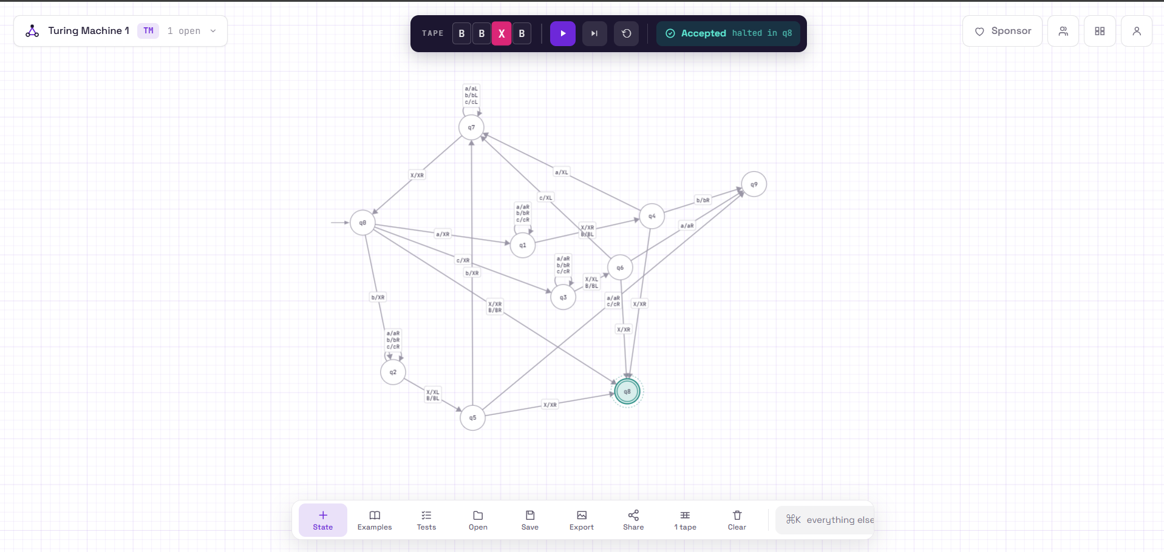
Task D;
A single left-to-right pass can't recognize palindromes, because the machine would have to remember the whole left half of the string to compare it with the right half. A Turing machine's states hold only a fixed, finite amount of information, so my machine can only carry one symbol at a time: q1, q2 and q3 mean "carrying an a, b or c". To compare the first symbol with the last, it marks the leftmost unmarked symbol as X, runs right to the end (q1, q2 or q3), steps back onto the last unmarked symbol and checks it (q4, q5 or q6), then sweeps all the way back left (q7) to start the next pair. That is one full sweep right and one sweep left for every pair, so the head has to travel back and forth several times. With only one pass, the machine would see the symbols one at a time with nothing to compare them against. A string like abcca shows why this matters: its first and last symbols match, but the second and fourth do not (b versus c), so only the repeated inward comparisons catch it and reject.

Question 5
Task A: My machine matches symbols from the outside in around the #. It reads the leftmost unmarked symbol before the #, remembers whether it was a 0 or a 1 by moving into a different state (q1 or q2), and overwrites it with X. It then runs right to the end of the tape, steps back, skips the Xs that are already marked, and checks that the last unmarked symbol is the same as the one it remembered. If it matches, it marks that symbol X too and sweeps left until it reaches an X from the left side, then steps right to start the next pair. If the symbols differ, or the right side runs out before the left side does, there is no matching transition and the machine rejects. When the next unmarked symbol on the left is the # itself, all pairs have matched, so the machine walks right and accepts only if everything after the # is also X, meaning the two sides had equal length.
Task b:
Current State | Read | Write | Move | Next
q0 | 0 | X | R | q1
q0 | 1 | X | R | q2
q0 | # | # | R | q6
q0 | X | X | R | q8
q0 | ⊔ | ⊔ | R | q8
q1 | 0 | 0 | R | q1
q1 | 1 | 1 | R | q1
q1 | # | # | R | q1
q1 | X | X | R | q1
q1 | ⊔ | ⊔ | L | q3
q2 | 0 | 0 | R | q2
q2 | 1 | 1 | R | q2
q2 | # | # | R | q2
q2 | X | X | R | q2
q2 | ⊔ | ⊔ | L | q4
q3 | X | X | L | q3
q3 | 0 | X | L | q5
q3 | 1 | 1 | R | q8
q3 | # | # | R | q8
q4 | X | X | L | q4
q4 | 1 | X | L | q5
q4 | 0 | 0 | R | q8
q4 | # | # | R | q8
q5 | 0 | 0 | L | q5
q5 | 1 | 1 | L | q5
q5 | # | # | L | q5
q5 | X | X | R | q0
q5 | ⊔ | ⊔ | R | q0
q6 | X | X | R | q6
q6 | ⊔ | ⊔ | R | q7
q6 | 0 | 0 | R | q8
q6 | 1 | 1 | R | q8
q6 | # | # | R | q8

Task C
First input:110001#100011 : https://www.automataverse.com/m/xDZV8qNR
Json file: q5_first
Screenshot file: q5_first
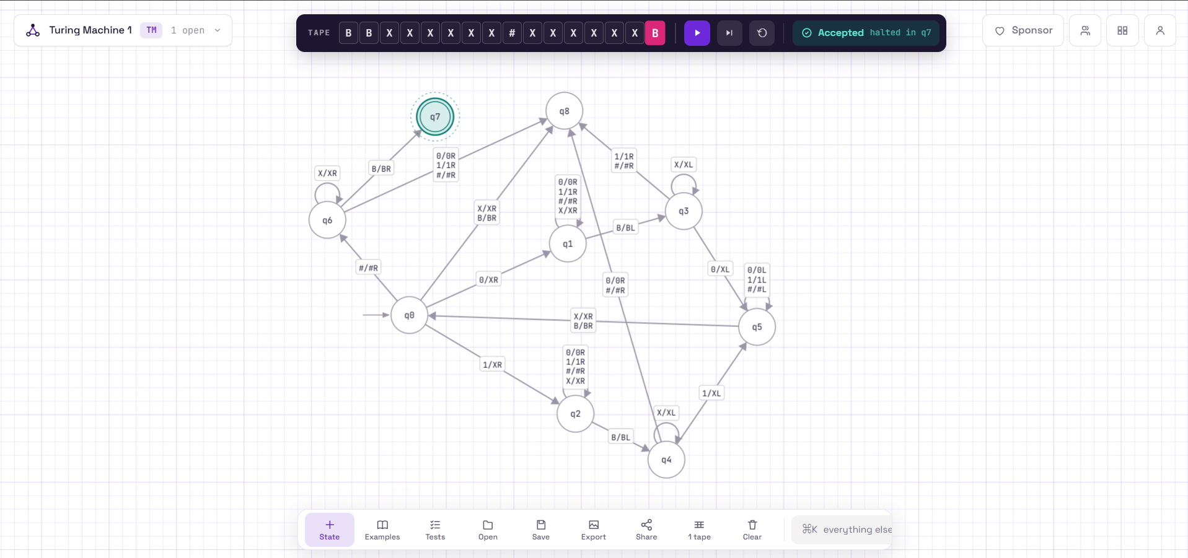

Second input: 110001#110001 : https://www.automataverse.com/m/WC2dyFFw

Json file: q5_second
Screenshot: q5_second
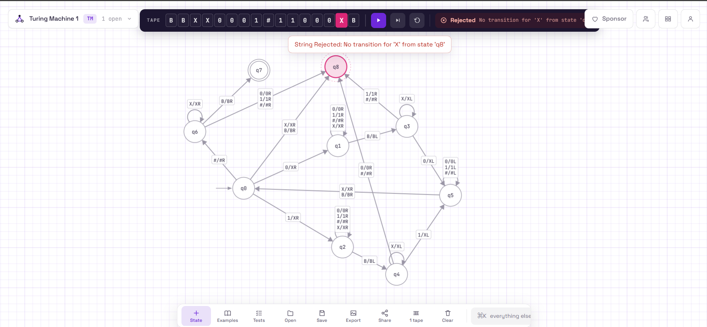

Task d: A single left-to-right pass can't recognize w#reverse(w), because by the time the head reaches the right side, it needs to compare every symbol there with the matching symbol on the left, in reverse order. The word w can be arbitrarily long, but my machine only has a fixed number of states, so it can't memorize w while scanning. It has to carry just one symbol at a time (q1 means "carrying a 0", q2 means "carrying a 1"), run to the far end, compare it with the last unmarked symbol (q3 or q4), and come back (q5) to pick up the next one. To check 110001#100011, for example, the first 1 has to be compared with the very last symbol of the tape, then the second 1 with the second-to-last, and so on. The head has to travel back and forth across the # once for every pair, and the X marks on the tape are the only record of which symbols have already been matched.

Question 6:
Task A:

(image below)
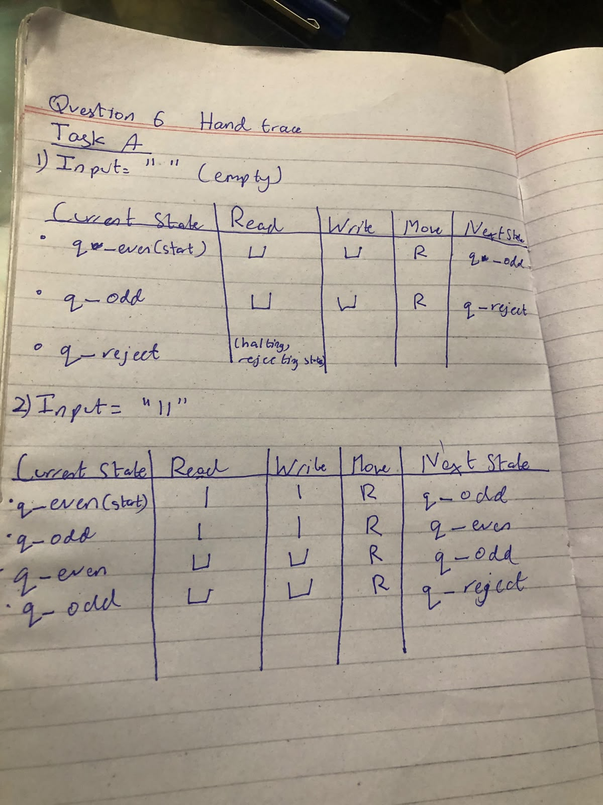

Task B:
From my hand traces, the issue I identified with this was that there is an error in Row#3
The state q_even is supposed to route to q_accept if the input is Blank, because if the input is blank that means the entire string has been inputted and has ended, however it instead routes it to q_odd, which then routes to q_reject(since the string has ended the input can only be blank), this causes the machine to reject all valid strings with an even count of 1’s. In the second input we can clearly see this flaw in the system, since the second input went to q_reject instead of q_accept, even though it has an even number of 1’s, since when the string ended due to the blank space being read and due to the error in row#3, it got routed to q_reject.

Task C:
Q6 broken, input=””: https://www.automataverse.com/m/URZnsF5c
Json file name: q6_broken_empty.json
Screenshot name: q6_broken_empty.webp
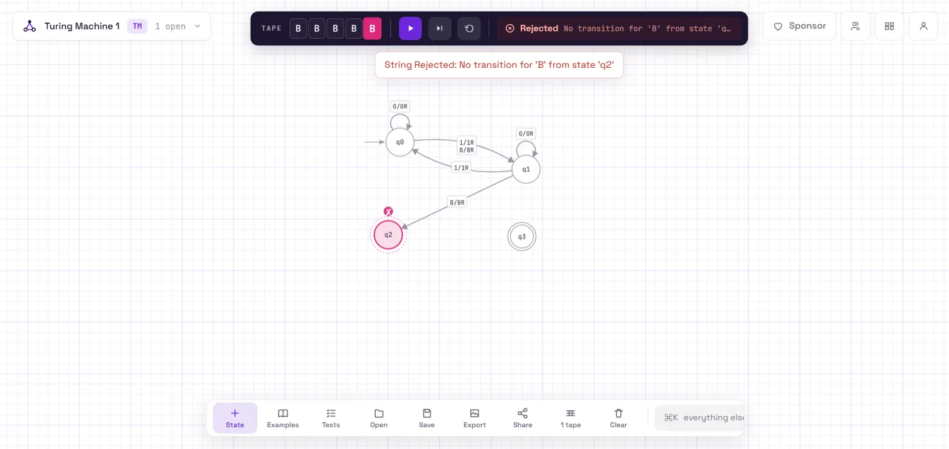
Q6 broken, input=”11”: https://www.automataverse.com/m/wYXY8Duf
Json file name= “q6_broken_11”
Screenshot name:q6_broken_11”(png file)

(image/screenshot below)
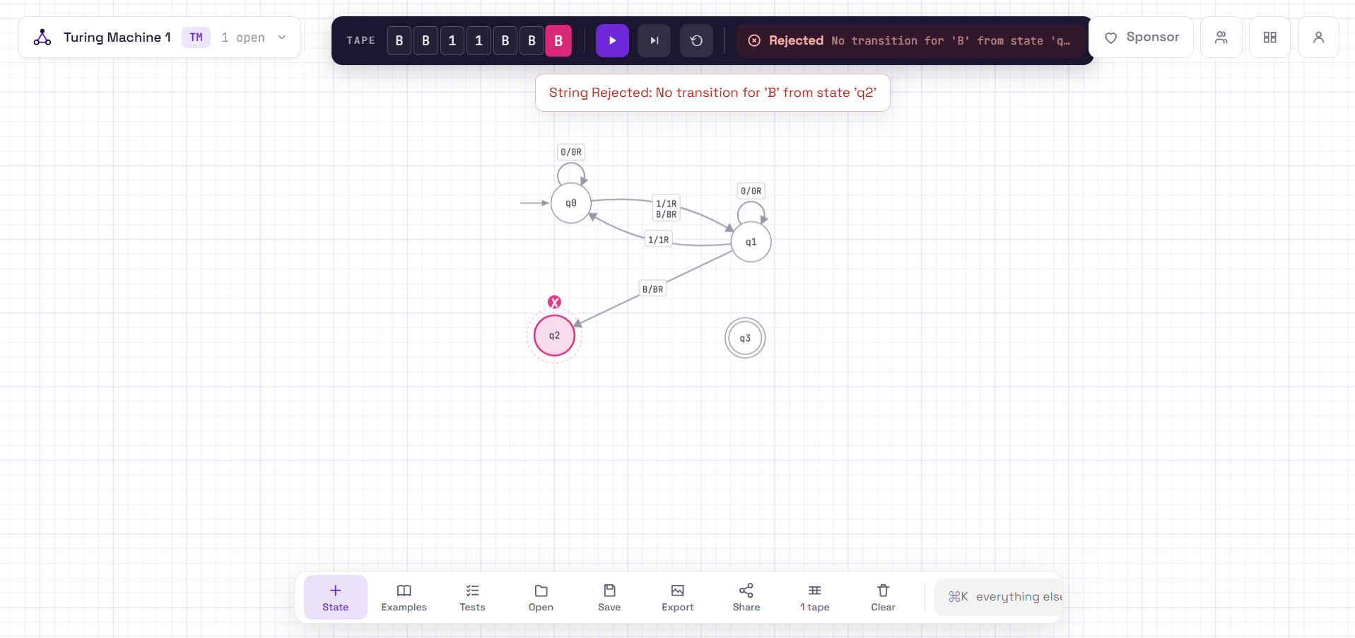
Q6 broken, input=”1”:https://www.automataverse.com/m/PRu5WEBE
Json file name= “q6_broken_1”
Screenshot name= “q6_broken_1”(png)
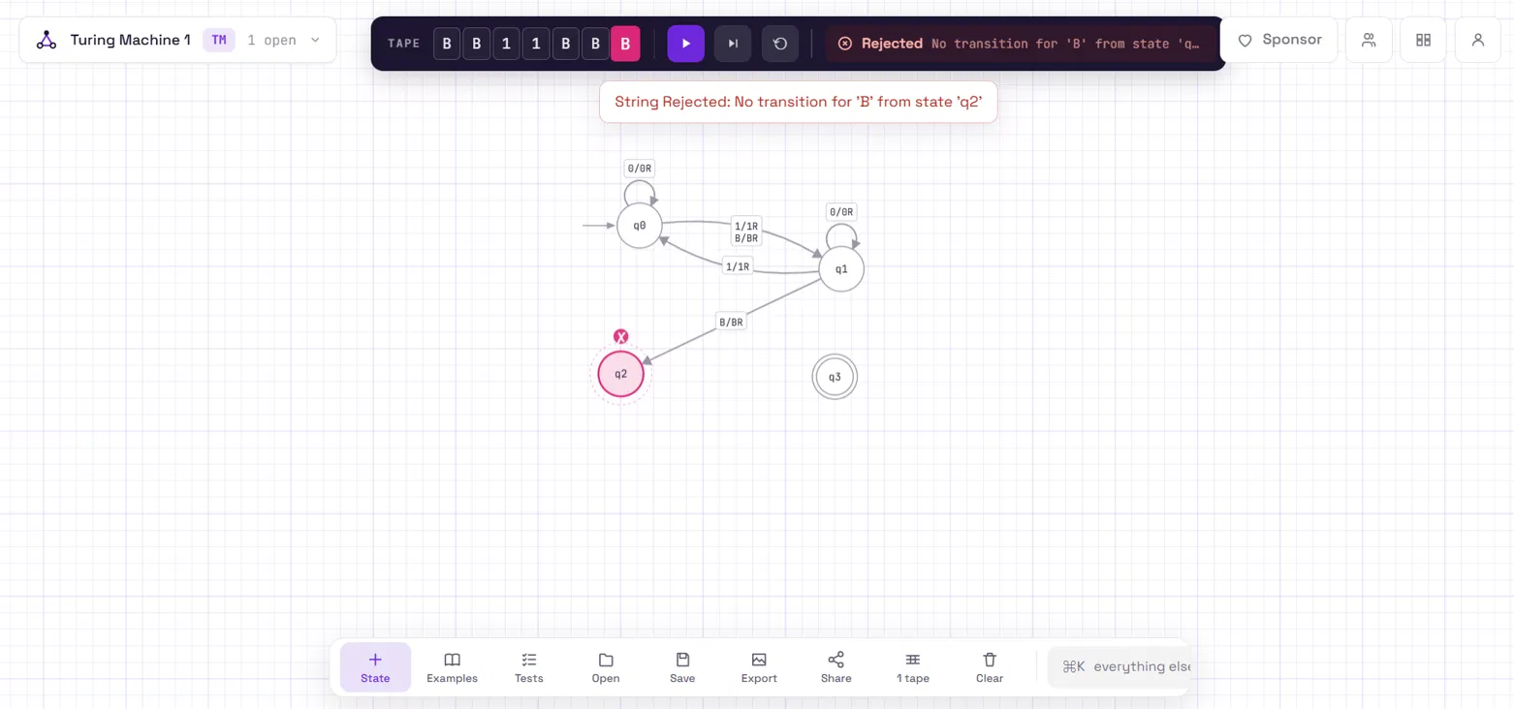

Q6 broken, input= “111”: https://www.automataverse.com/m/b6rnX7Ga

Json file= “q6_broken_111.json”
screenshot=”q6_broken_111”(png)
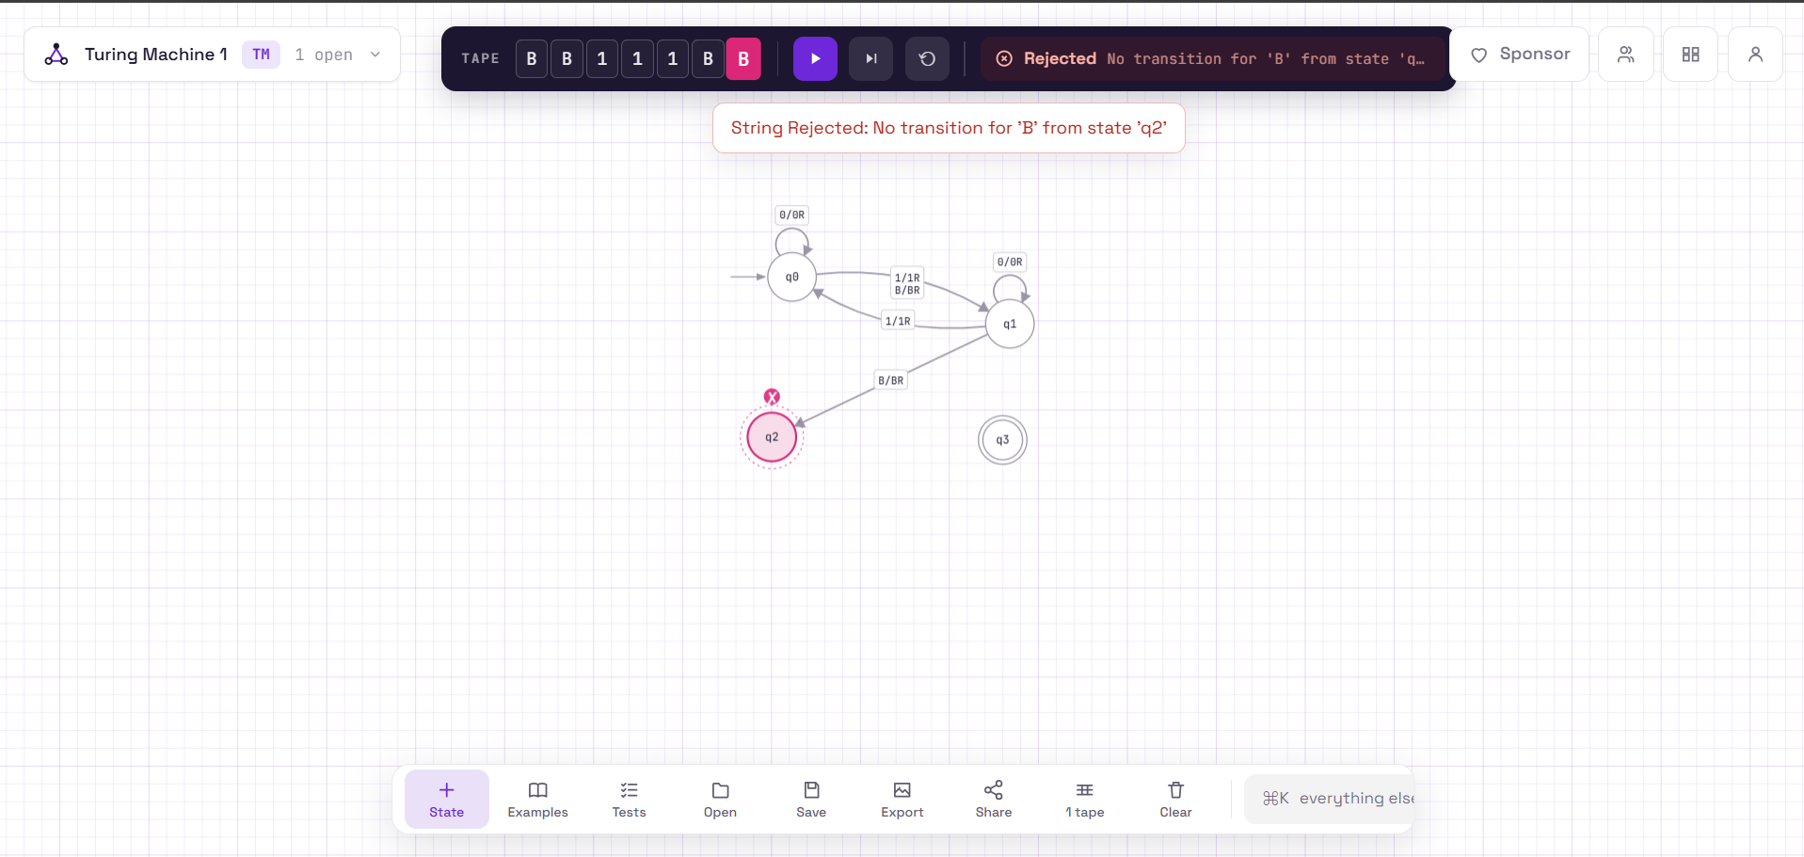
Q6 fixed, input= “”: https://www.automataverse.com/m/gRAuSPVU
Json file= “q6_fixed_empty”(json file)
screenshot=“q6_fixed_empty”(png)
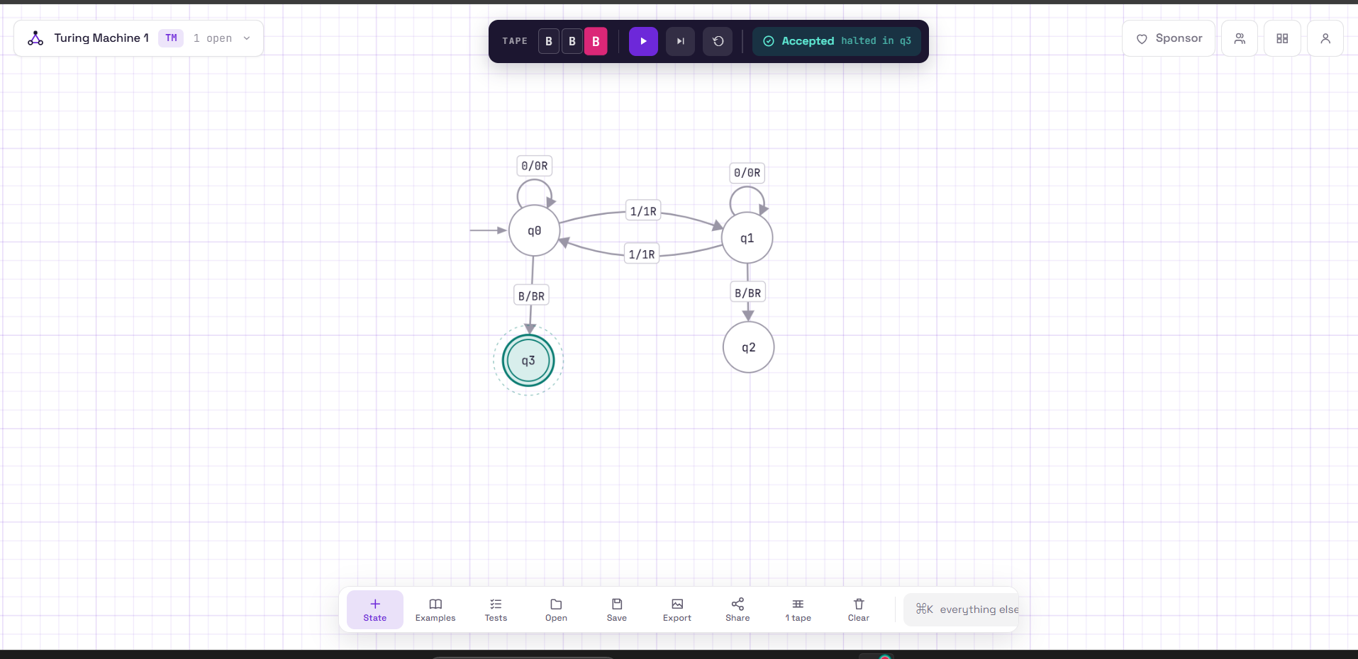

Q6 fixed, input= “11”: https://www.automataverse.com/m/NrbP4xLW
Json file= “q6_fixed_11”(json file)
screenshot=“q6_fixed_11”(png)
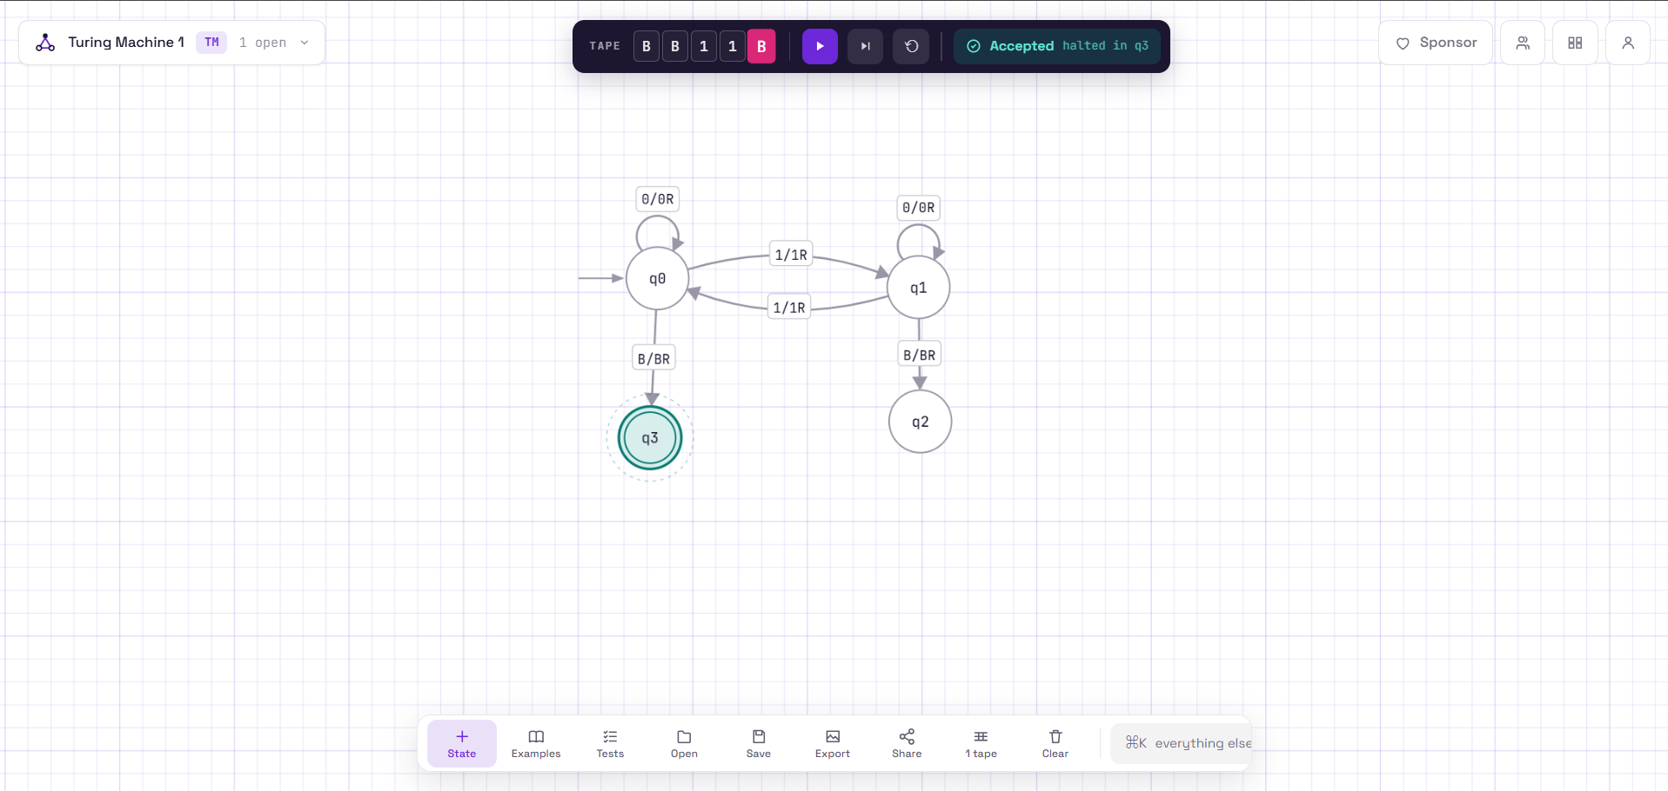
Q6 fixed , input=”1”:https://www.automataverse.com/m/PRu5WEBE
Json file name= “q6_fixed_1”
Screenshot name= “q6_fixed_1”(png)
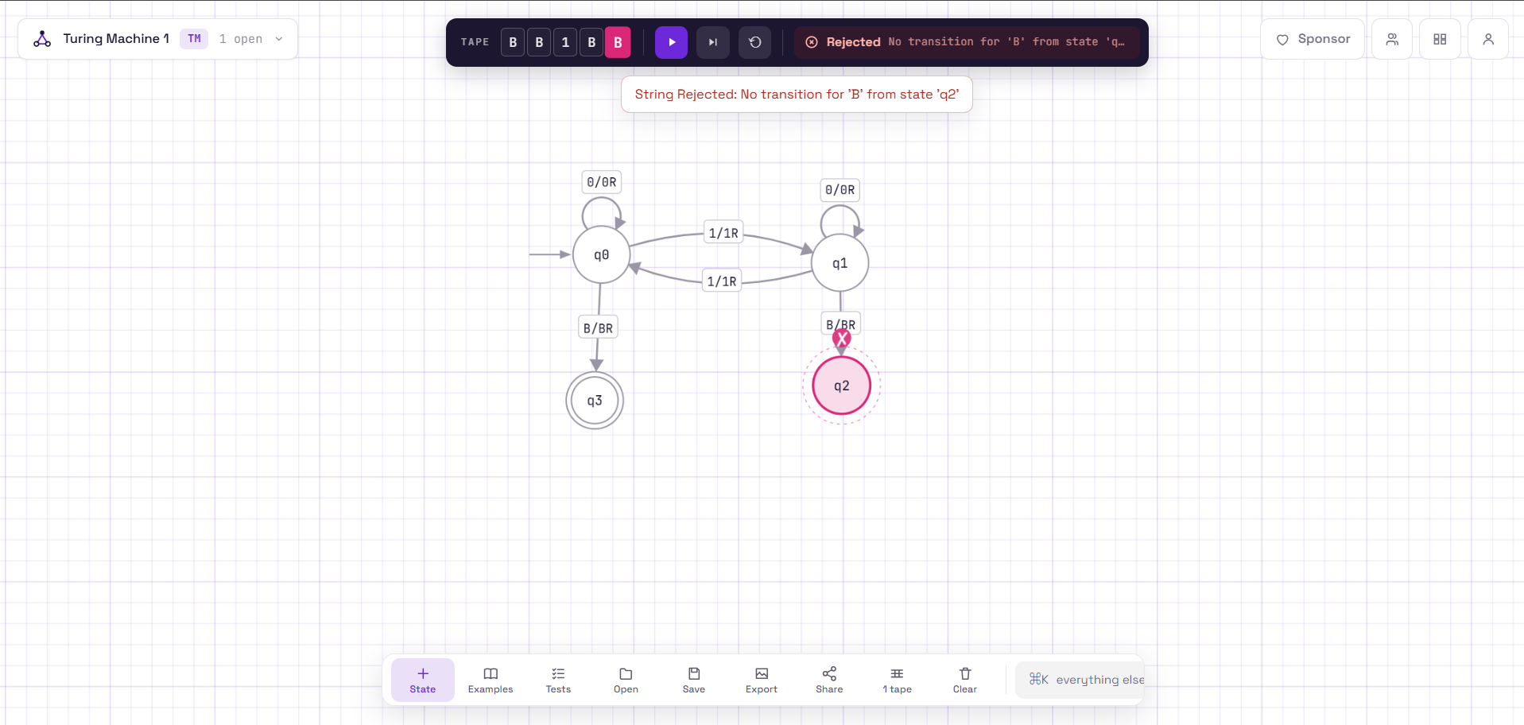

Q6 broken, input= “111”: https://www.automataverse.com/m/R79DhUmQ

Json file= “q6_fixed_111”
screenshot=”q6_fixed_111”(png)
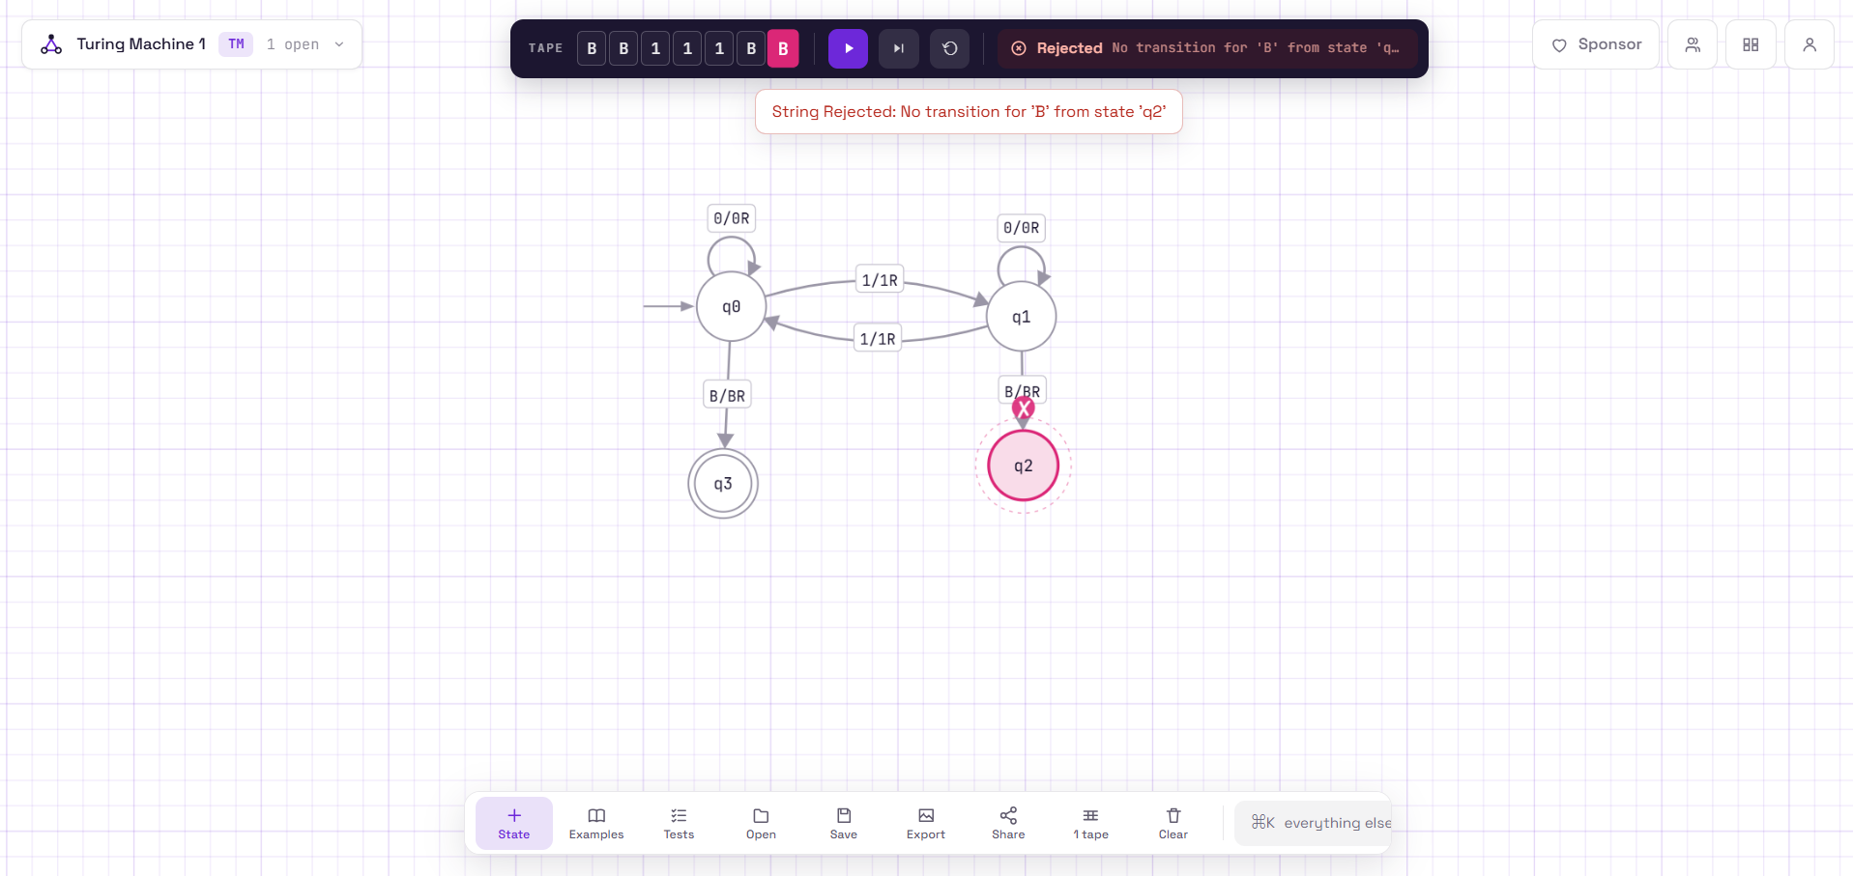

Input String | Expected Correct Answer | Broken Machine Result | Fixed Machine Result
“” | ACCEPT | REJECT | ACCEPT
"11" | ACCEPT | REJECT | ACCEPT
"1" | REJECT | REJECT | REJECT
"111" | REJECT | REJECT | REJECT

Task D:
Two of my four test strings, 1 and 111, would not have revealed the bug on their own. Both have an odd number of 1s, so the correct answer is reject, and my broken machine also rejects them, which makes it look correct on those inputs. Only "" and 11 have an even number of 1s and should be accepted, and the broken machine rejected both, so those two are the ones that exposed the problem. In particular, the empty string is a boundary case where the head reads a blank immediately in the start state, which is exactly where the faulty row sits. For my own machines, this means I should always test both strings that should be accepted and strings that should be rejected, and include the edge cases like the empty string, because a machine that rejects everything would pass any test set made up only of rejected strings.

