**ALREADY MADE (FUNCTIONALITIES & DESIGN)**

***FUNCTIONALITIES CREATED THIS MONTH (January)***

MAIN PAGE FOR ADMIN DASHBOARD

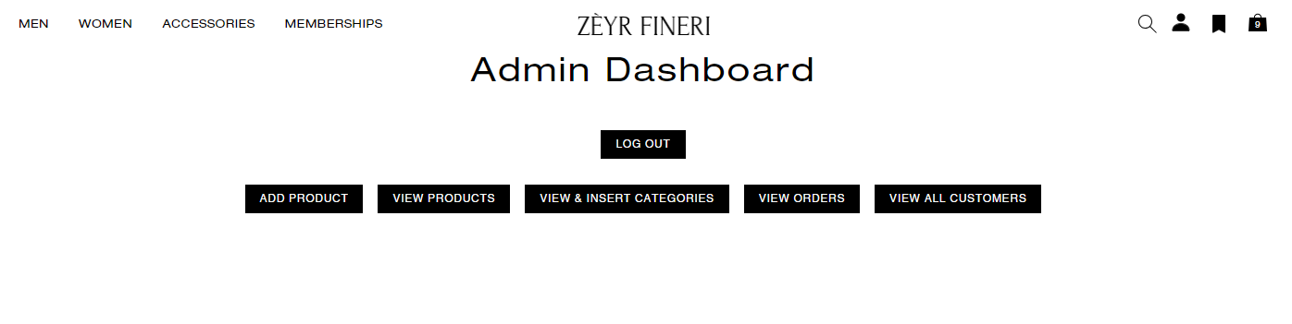

VIEW PRODUCTS LIST (ADMIN DASHBOARD)

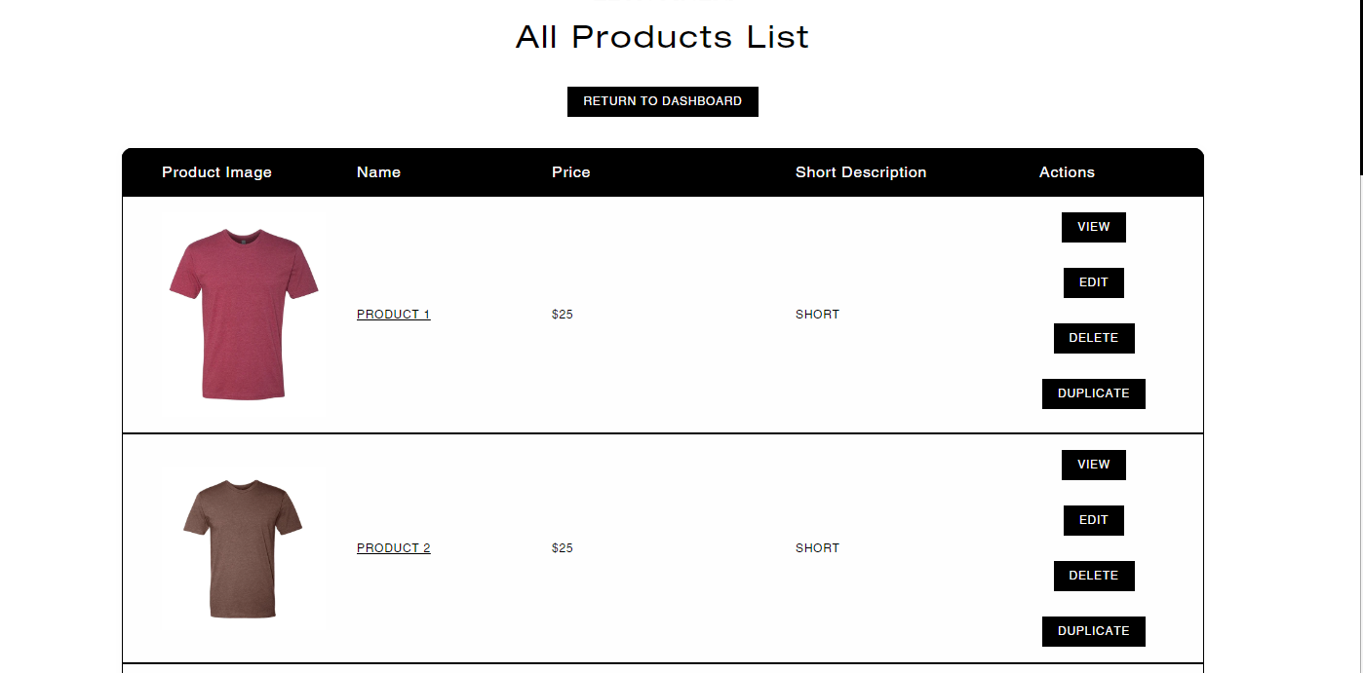

ADD PRODUCTS (ADMIN DASHBOARD)

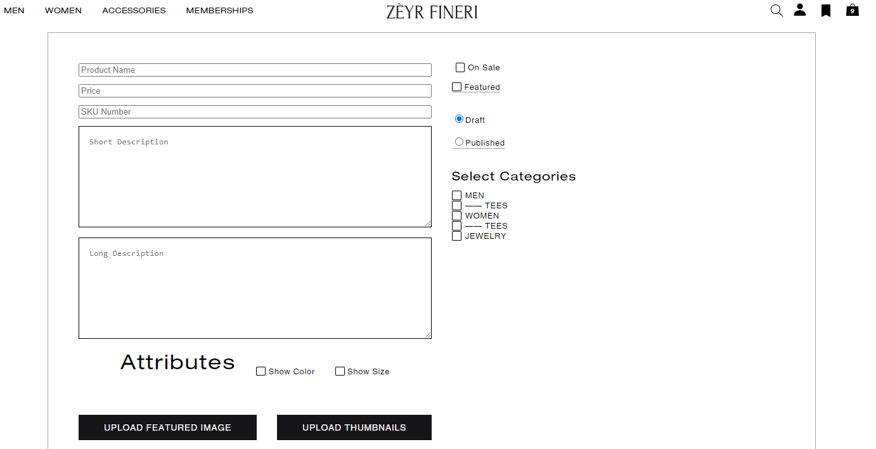

VIEW & INSERT CATEGORIES (ADMIN DASHBOARD)

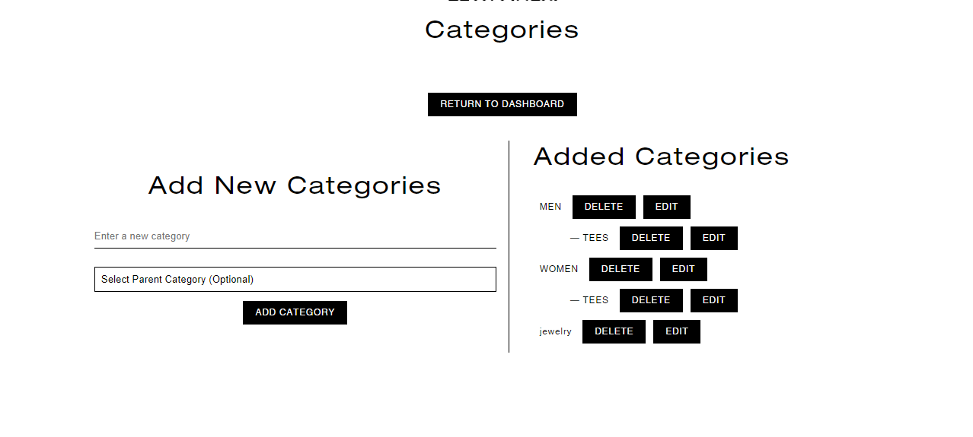

CREATED A MEMBERSHIP SHOPPING PAGE WHERE THE ALL THE MEMBERSHIPS WILL APPEAR AS INDIVIDUALS PRODUCT

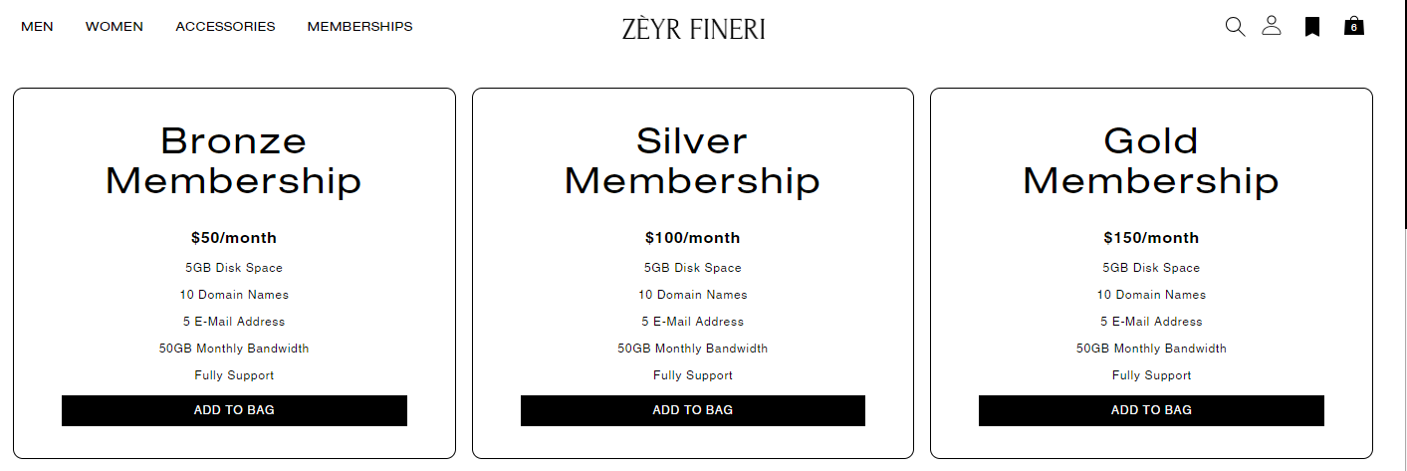

MEMBERSHIPS PRODUCTS CAN BE ADDED TO CART

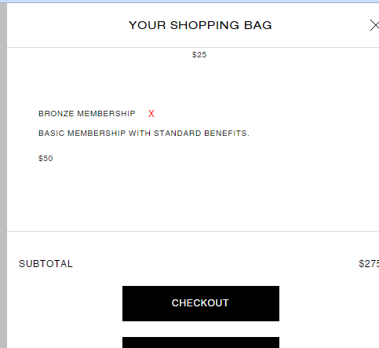

CHECKOUT PROCESS AND DESIGN SAME AS AMIRI (MADE SOME CONSISTENCY UPDATES AFTER TESTING THOROUGHLY)

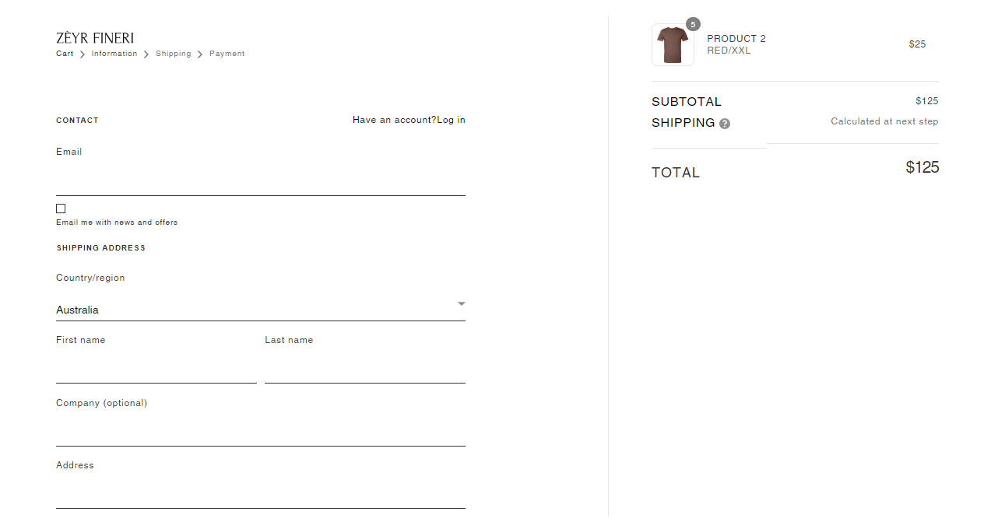

ORDER HISTORY SHOWN ON MY ACCOUNT PAGE

(ORDERS TABLE DESIGN)

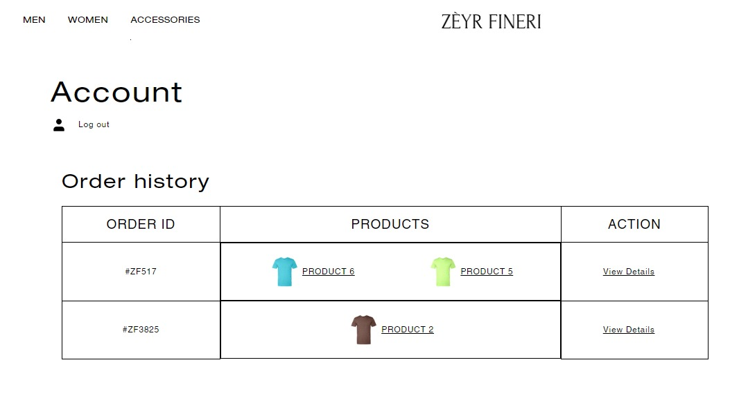

MY CARD DESIGN (FOR NOW)

CARD WILL ALSO HAVE A QRCODE (FOR NOW STATIC)

CARD PRINTABLE FUNCTIONALITY

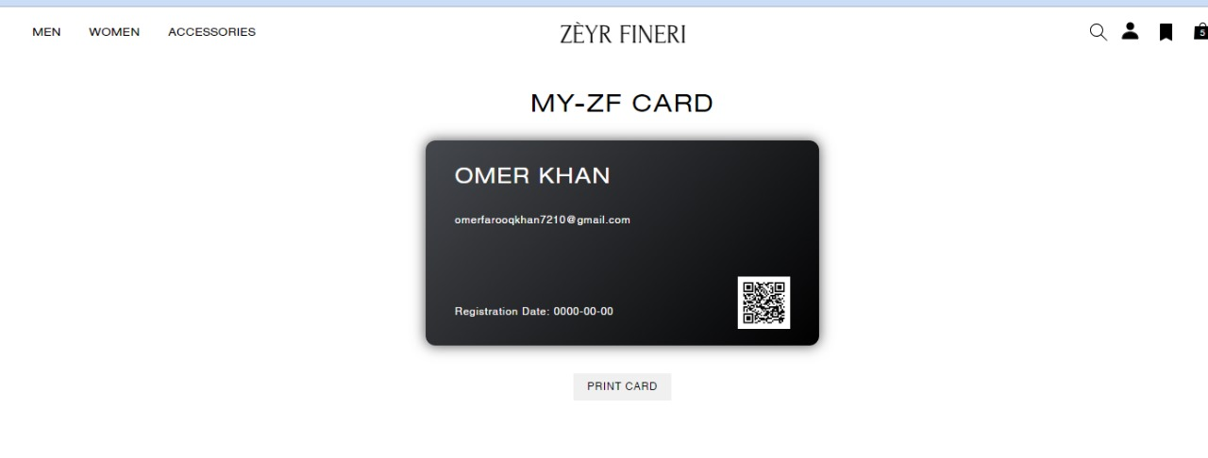

COUNTRY DETECTION THROUGH IP (ONLY IF USER GIVES CONSENT)

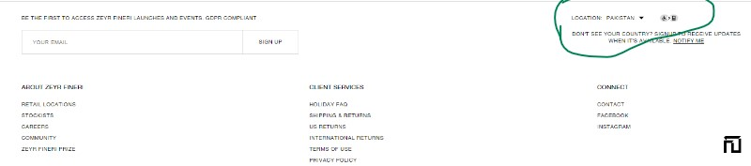

CURRENCY FORMAT CHANGING BASED ON SELECTED CURRENCY

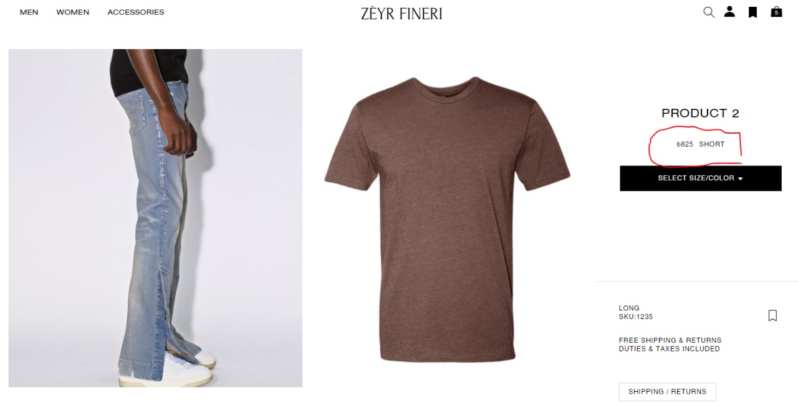

SELECT CURRENCY FOR DIFFERENT COUNTRIES FROM DROPDOWN

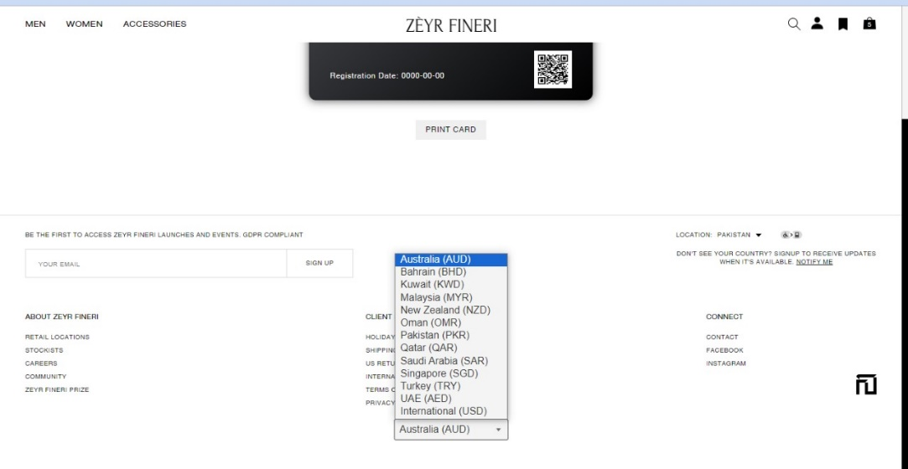

HAVE TO BUY ANY EXCHANGE RATE API FOR CURRENCY CONVERSION

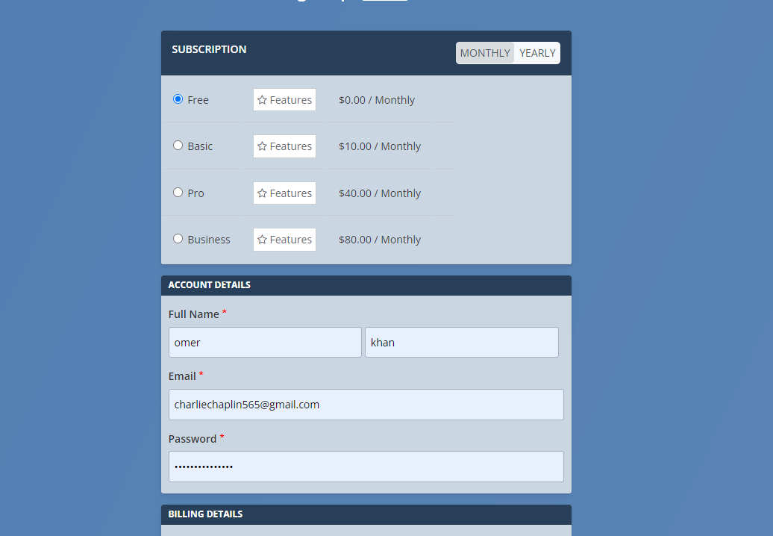

MEMBERSHIP SHOWN ON MY ACCOUNT PAGE (IF ANY BOUGHT)

MEMBERSHIP NAME WILL BE CLICKABLE WHICH WILL OPEN THE BOUGHT MEMBERSHIP DETAILS

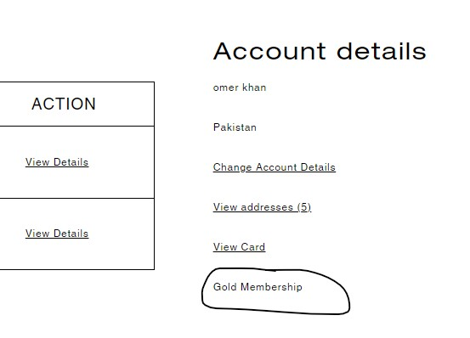

NEWSLETTER FUNCTIONALITY (USER SUBSCRIPTION)

DAILY EMAILS WILL BE SENT TO THE SUBSCRIBED USERS

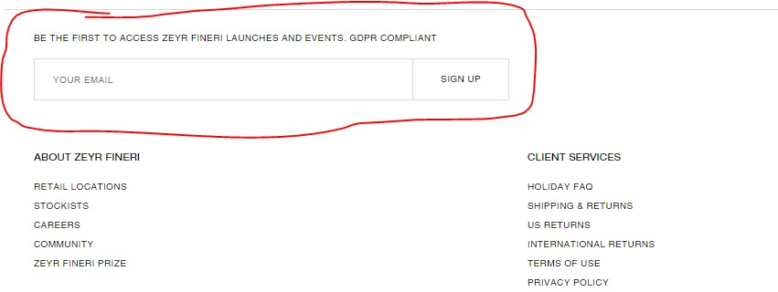

**ADMIN**

BARCODE GENERATION BASED ON ORDERS (REQUIRE CLARITY ON REQUIREMENTS)

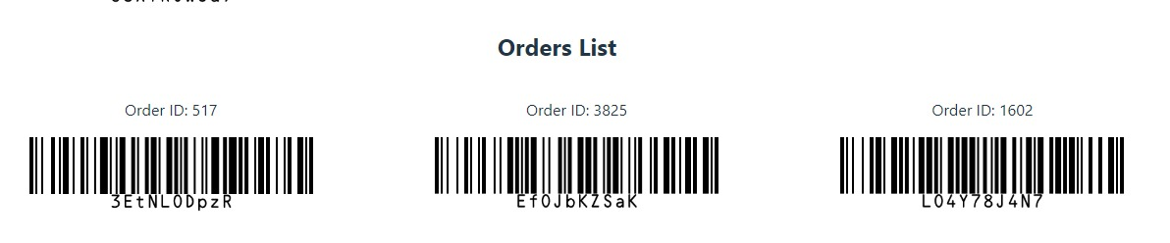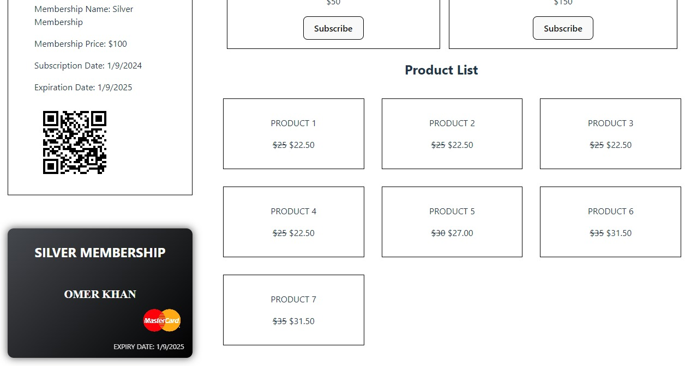

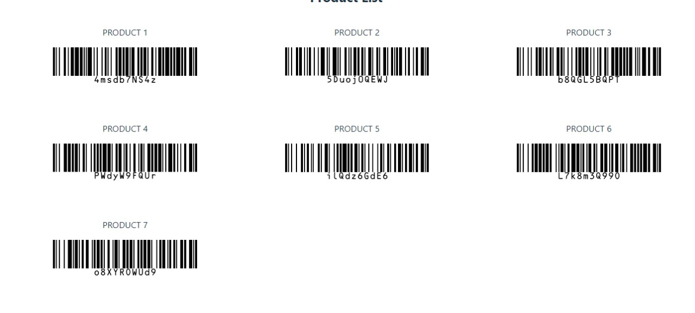

USER CAN UPDATE HIS/HER ACCOUNT DETAILS

EMAIL OTP WILL BE SENT AFTER THE UPDATION

EMAIL CONFIRMATION OTP WILL BE SENT IF THE USER TRIES TO CHANGE HIS/HER EMAIL

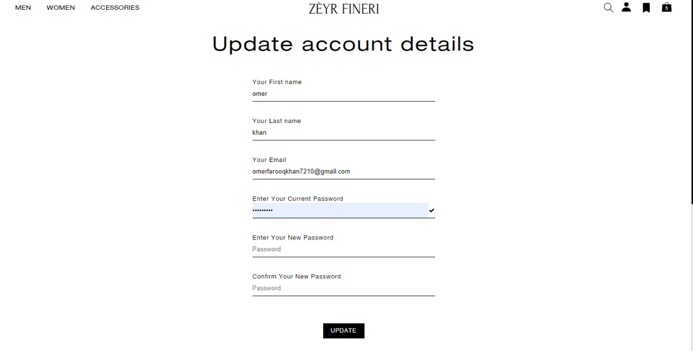

INDIVIDUAL ORDERS DETAILS PAGE

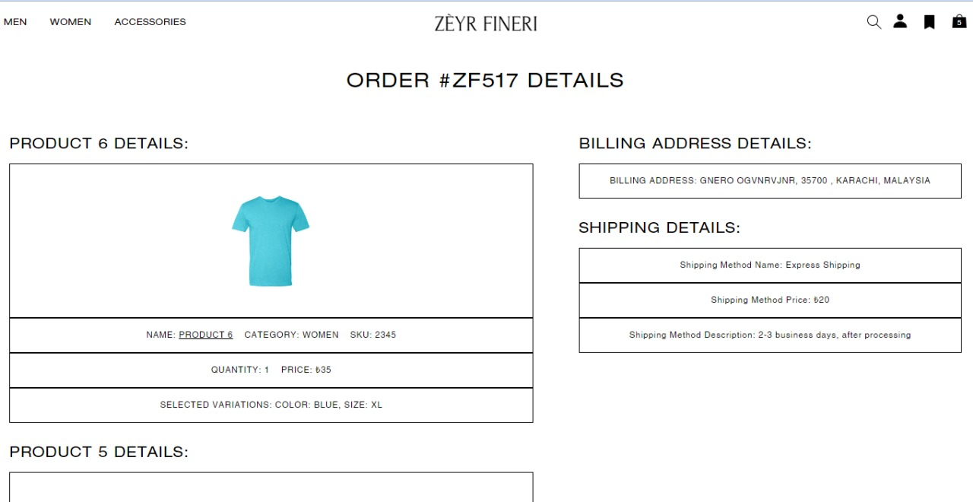

**PENDING TASKS**

1. After buying membership the user should be able to get the benefits (discount, gift cards etc.)
2. Dynamic qrcode functionality
3. Admin dashboard designing
4. Some other functionalities for admin dashboard (ideas taken from WordPress dashboard)
5. Load handling testing through simulating high traffic (through some tool)
6. Some consistency changes and updates in app
7. Content updation according to zeyr
8. Payment method integration
9. Paid apis integration like google geolocation api and currency conversion api
10. Mobile version of the app to be tested thoroughly
11. Google apis are to be used , after buying them
12. Email templates design (newsletter and contact) will be updated
13. Order tracking functionality
14. Order status updation in admin dashboard
15. Changes in frontend only where needed
16. at a time only one membership can be bought (quantity always 1)
17. a membership can also be updated
18. membership cost per month or annually (give choice)
19. define each membership benefits
20. product variations color images
21. barcode generation on adding a new product
22. qrcode generation on user registration
23. validation of address (right or wrong at checkout) using google api address validation
24. card sidebar quantity update problem
25. checkout (return to cart button) should not use Link