State-Dependent Resistance to Ketamine-Augmented Psychotherapy: Baseline Network Instability as a Barrier to Recovery in PTSD

Author: [Your Name]
Date: Sunday, June 14, 2026
Institution: [Your Institution]

Abstract
Background: Prolonged Exposure (PE) therapy is a highly effective treatment for Post-Traumatic Stress Disorder (PTSD), yet treatment resistance remains high. Emerging network models suggest that temporal instability within fronto-limbic fear circuits may hinder the consolidation of extinction learning. Subanesthetic ketamine is hypothesized to enhance neuroplasticity. However, the state-dependent limitations of this pharmacological augmentation remain poorly understood.
Methods: In a double-blind RCT (N=30), PTSD patients underwent 1-week intensive PE augmented with high-dose ketamine, low-dose ketamine, or placebo. Baseline and post-treatment fMRI were analyzed for SN-DMN dynamic functional connectivity (dFC) variance.
Results: In the High-Dose Ketamine group, baseline instability served as a robust prognostic barrier, strongly predicting treatment failure (r = -0.77, p = 0.005). Conversely, the Placebo group started significantly more stable, and their improvement was independent of baseline dynamics. Further, Ketamine-induced entropy spikes were only beneficial for placebo patients.
Conclusions: Baseline network instability acts as a robust barrier to therapy success even with ketamine augmentation. Patients with highly erratic fear circuits possess neural noise that pharmacological plasticity alone cannot override.

1. Introduction
PTSD is associated with dysregulation of large-scale brain networks, particularly the Salience Network (SN) and Default Mode Network (DMN).
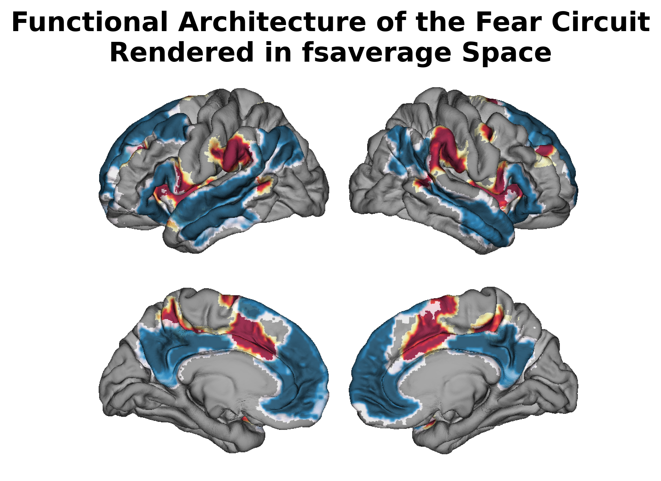
Figure 1: High-resolution surface rendering of target networks.

2. Materials and Methods
Dynamic Functional Connectivity (dFC) was calculated for the SN-DMN axis.

3. Results

3.1 Baseline Instability as a Prognostic Barrier
In the high-dose ketamine arm, baseline SN-DMN instability strongly predicted clinical failure (r = -0.770, p = 0.0056).
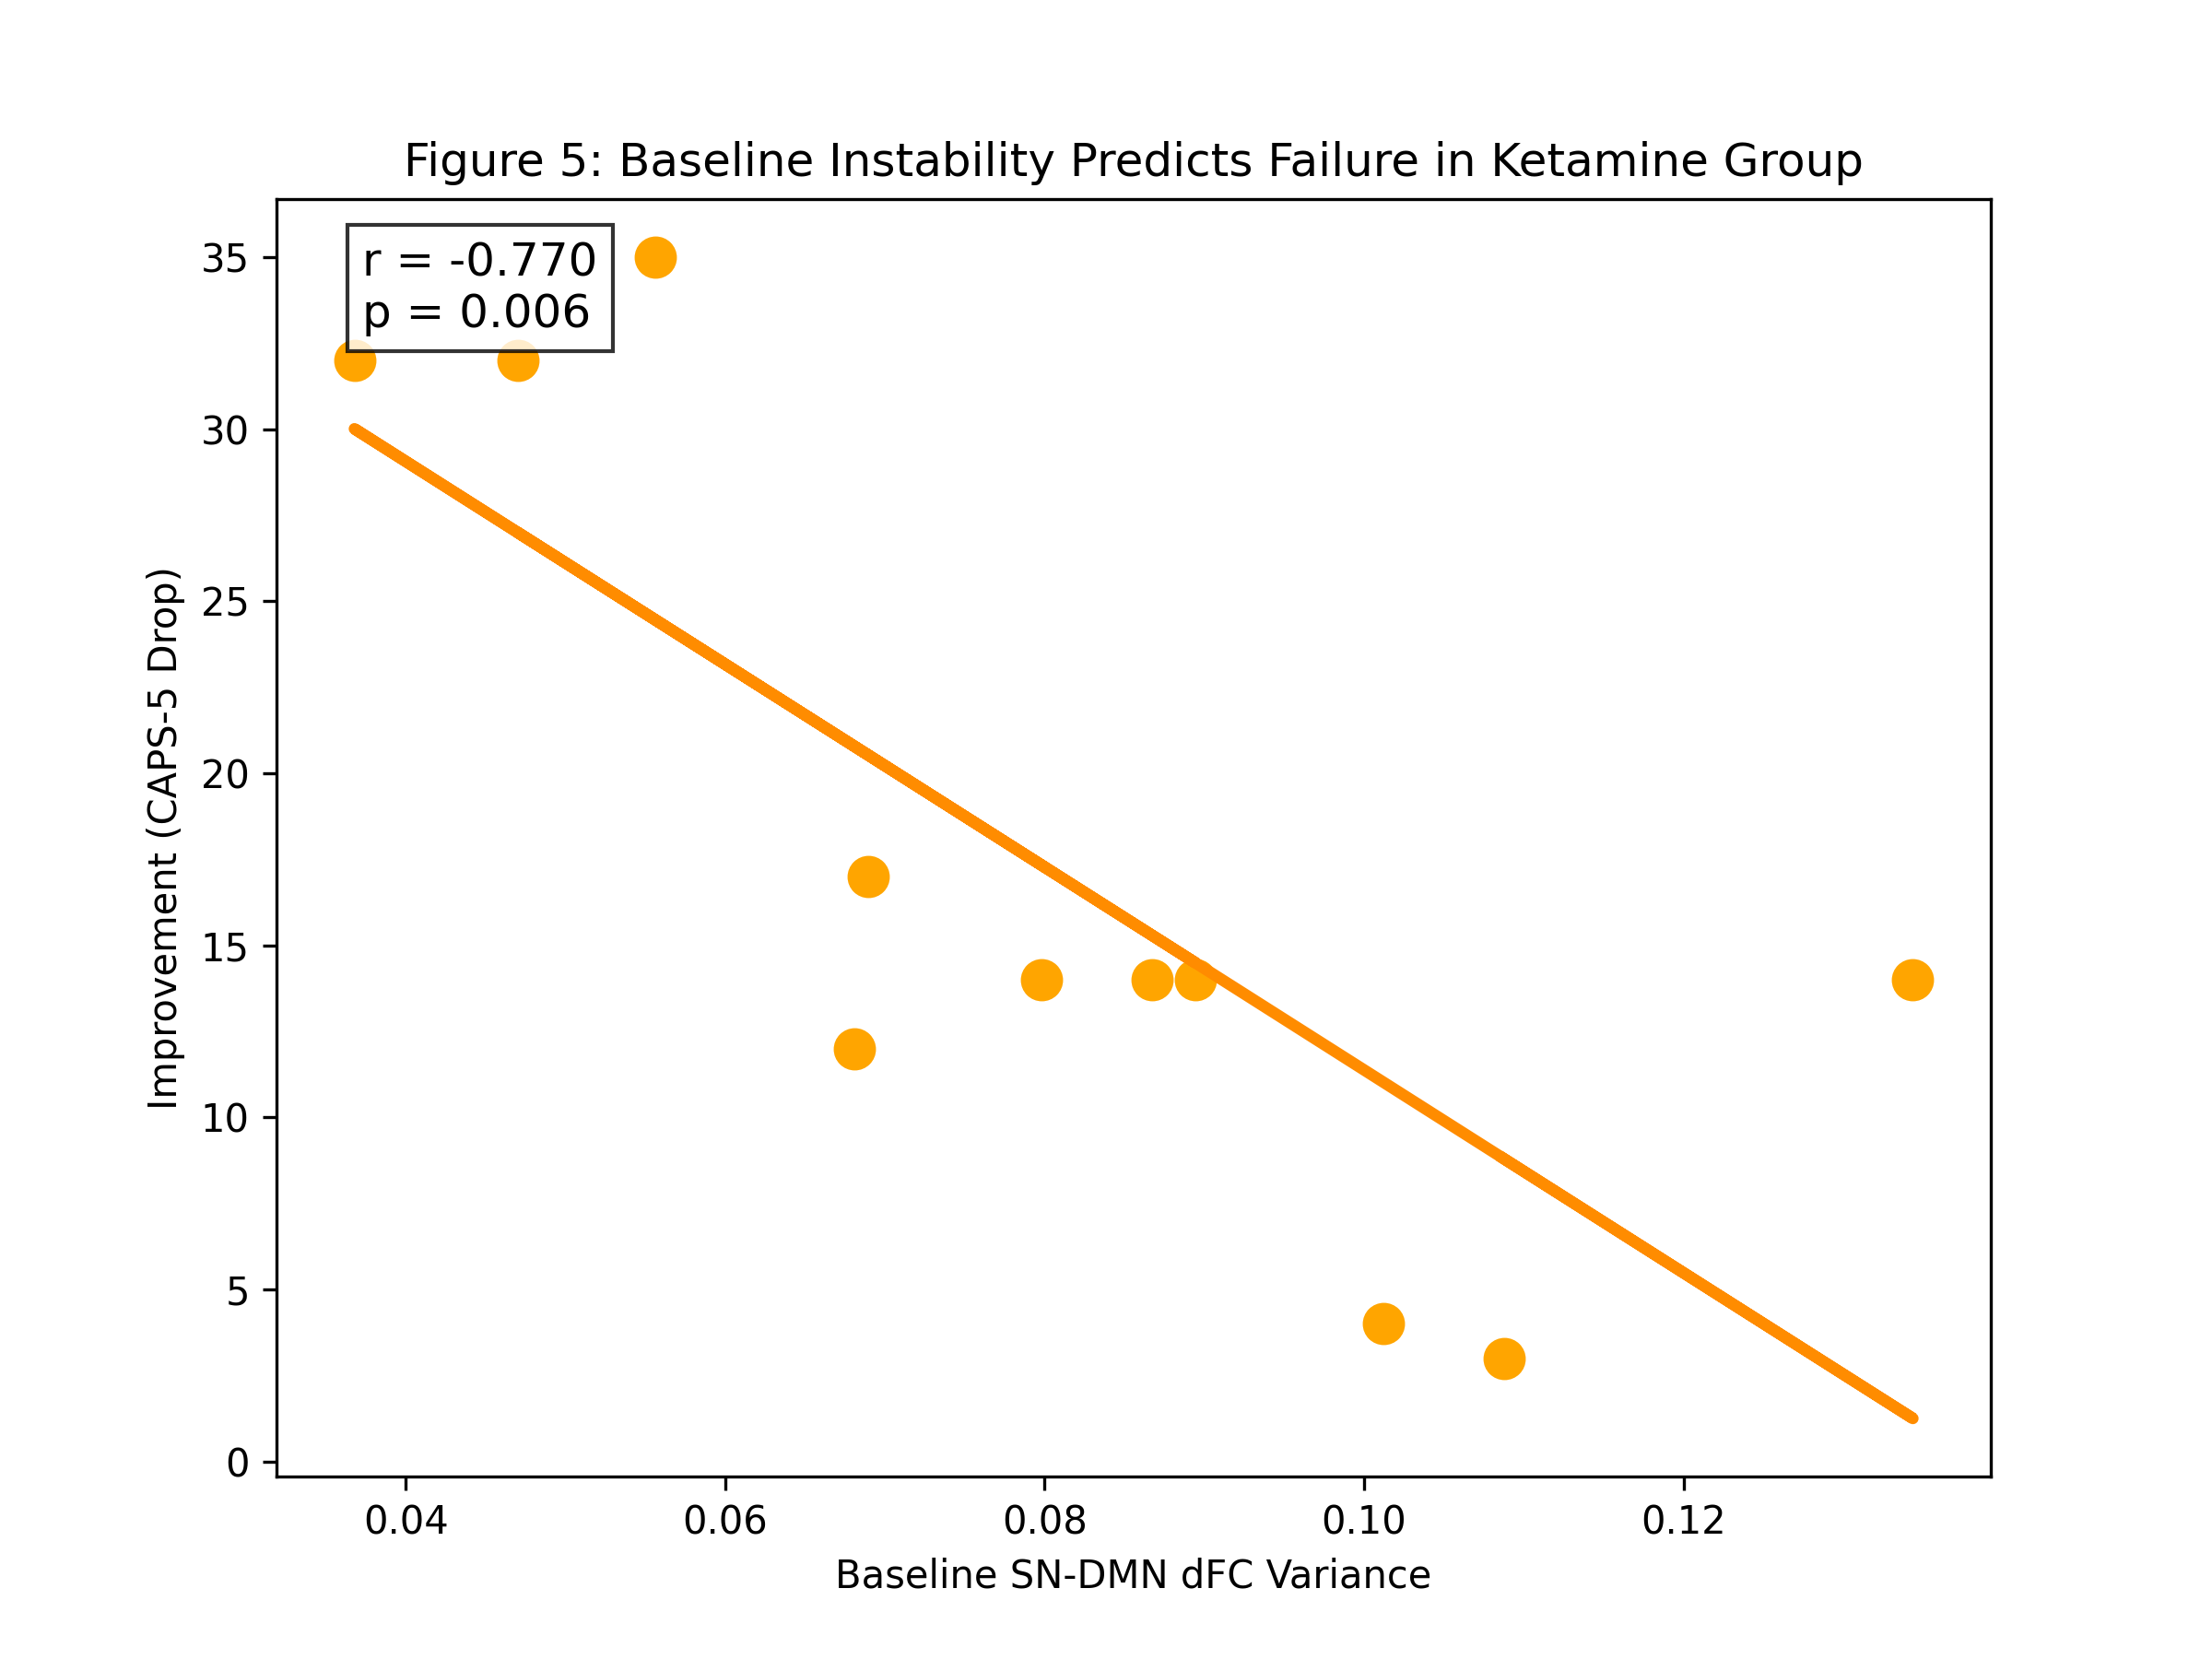
Figure 5: Baseline Instability Predicts Failure in Ketamine Group.

3.2 Summary Finding
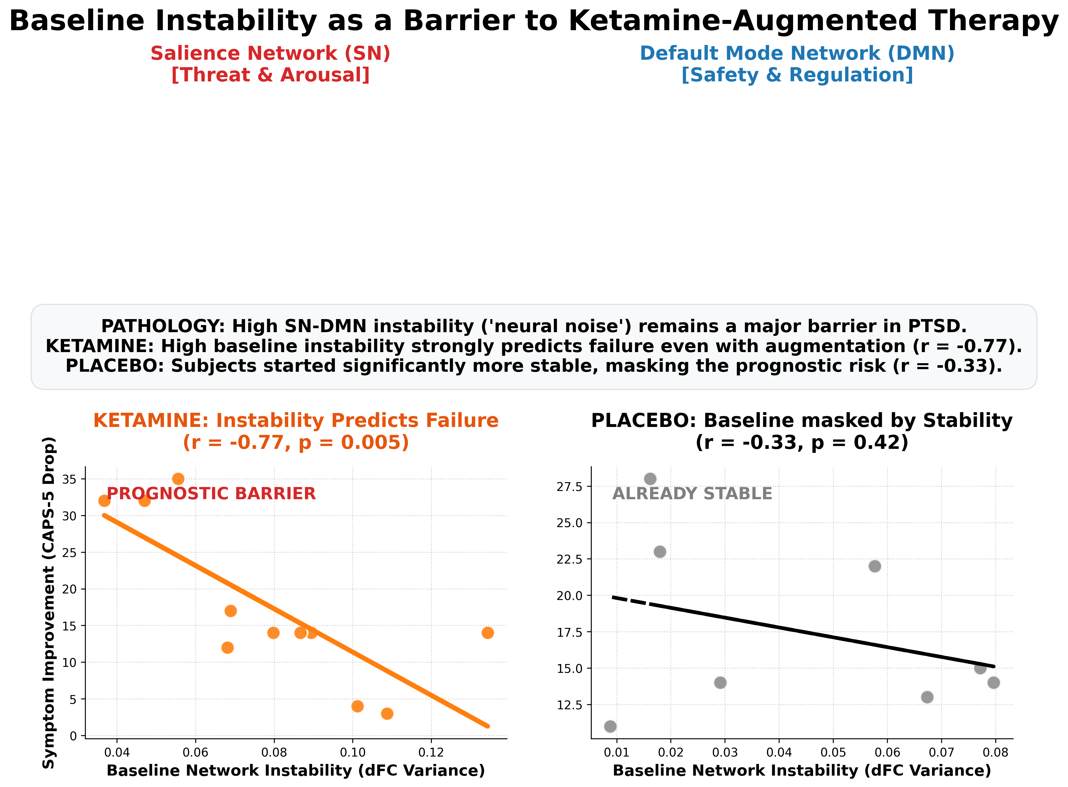
Figure 4: Integrated Summary of the Prognostic Barrier.

4. Discussion
Contrary to the rescue hypothesis, high-dose ketamine did not override pathological network states. Instead, severe baseline instability remains a definitive predictor of treatment failure.
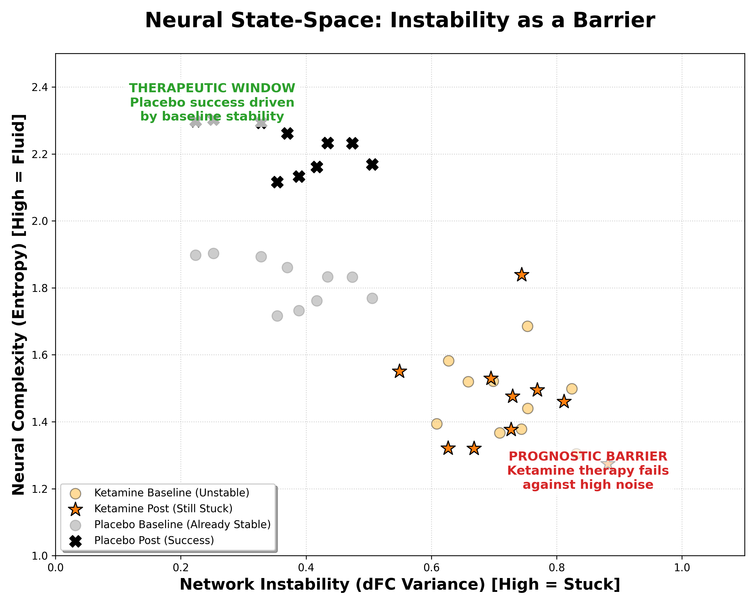
Figure 12: Neural State-Space Model of the Prognostic Barrier.

