**LAB 02**

**OBJECT:** To implement ArrayList and Vector.

# Lab Tasks

1. **Write a program that initializes Vector with 10 integers in it. Display all the integers and sum of these integers.**

***INPUT:***

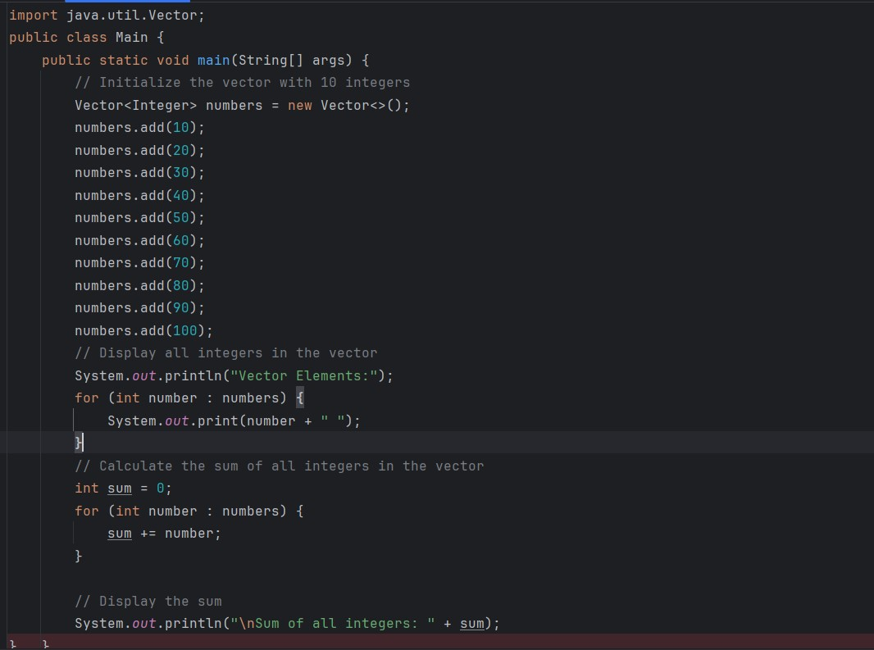

***OUTPUT:***

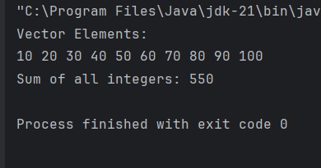

1. Create a ArrayList of string. Write a menu driven program which:
   1. Displays all the elements
   2. Displays the largest String

***INPUT:***

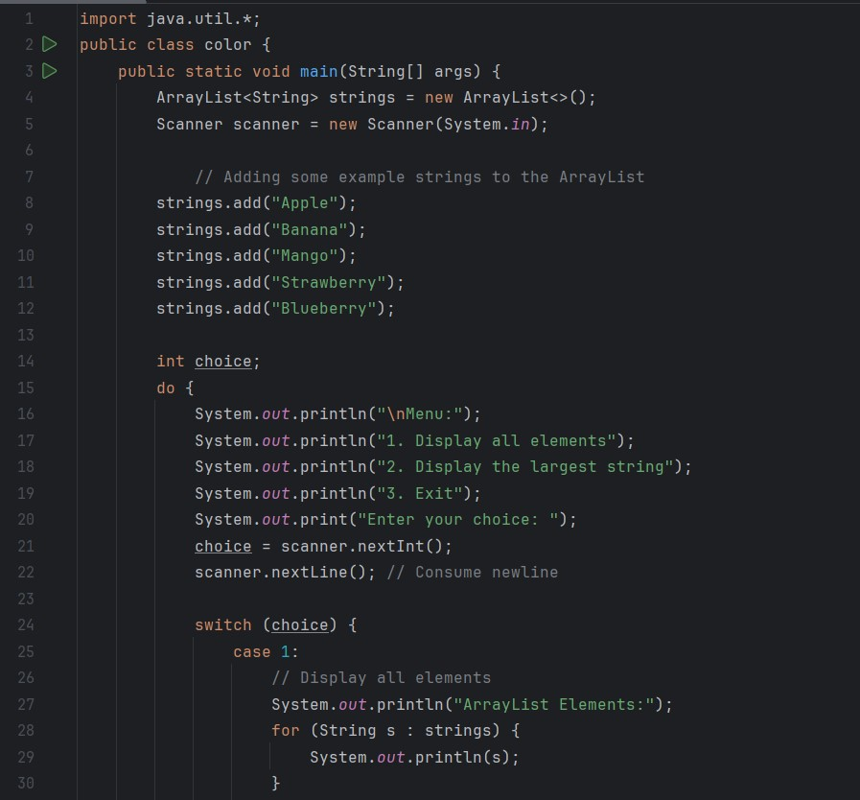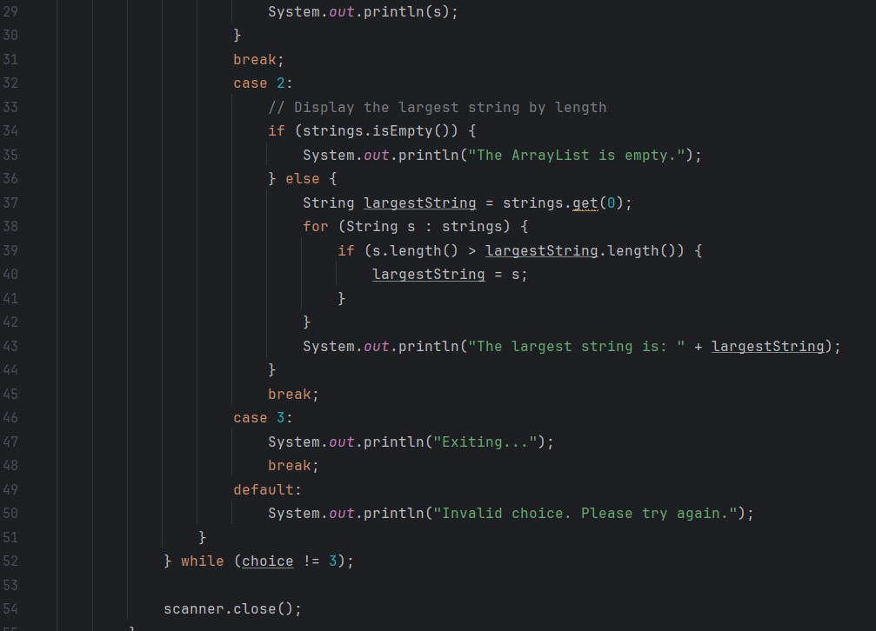

***OUTPUT:***

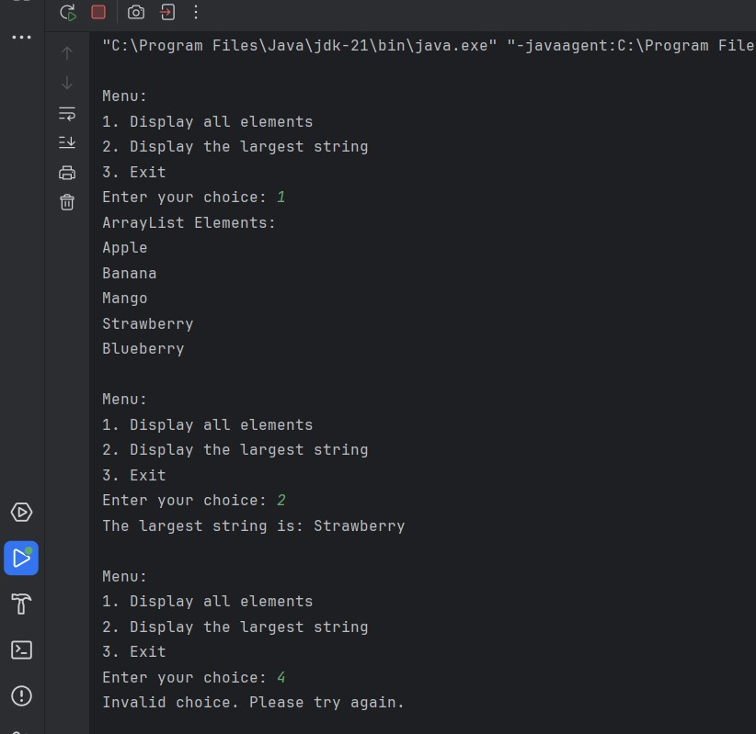

1. Create a Arraylist storing Employee details including Emp_id, Emp_Name, Emp_gender, Year_of_Joining (you can also add more attributes including these). Then sort the employees according to their joining year using Comparator and Comparable interfaces.

**INPUT:**

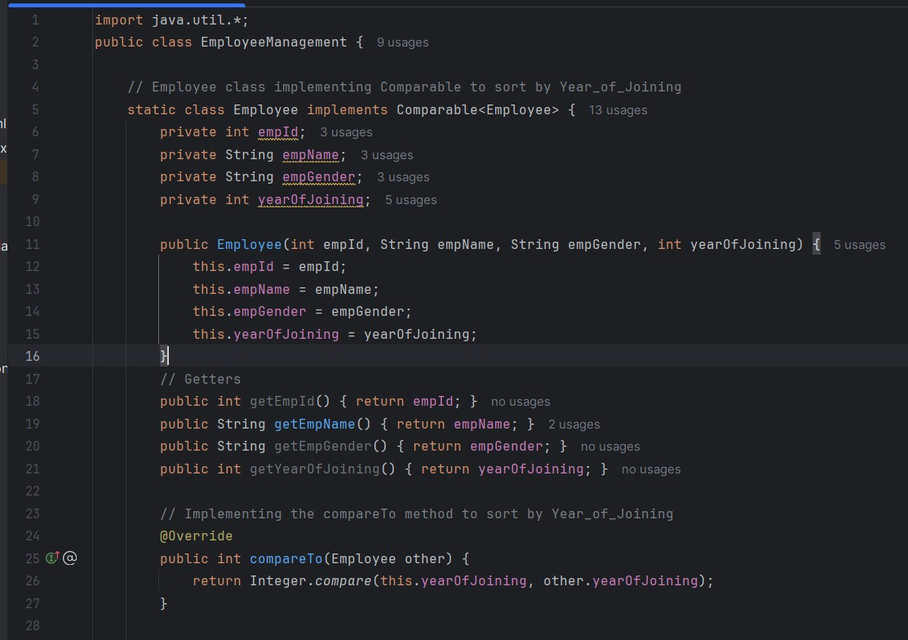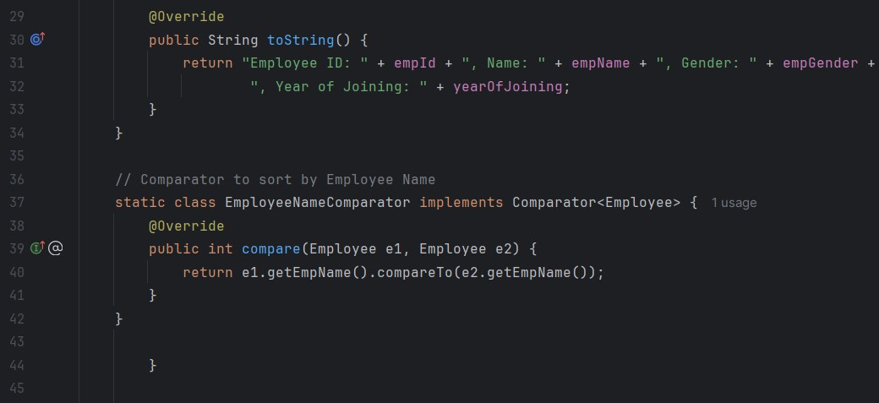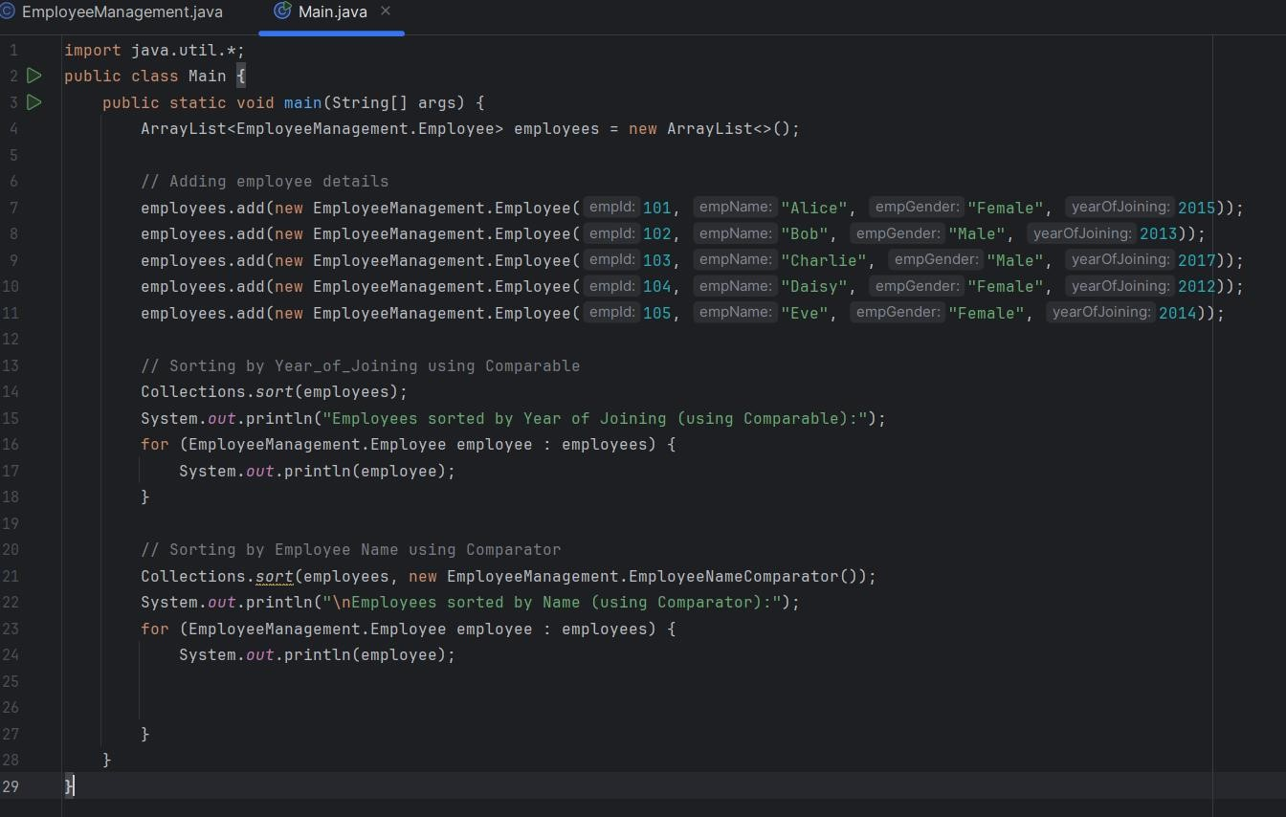

**OUTPUT:**

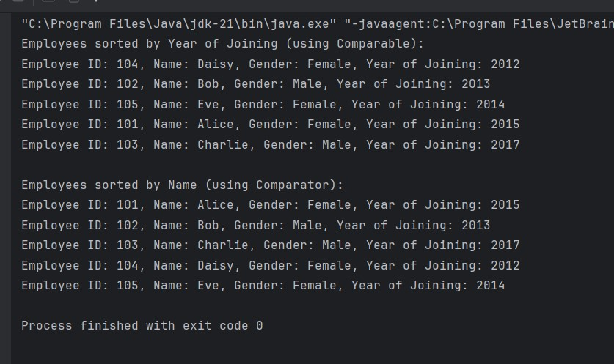

1. Write a program that initializes Vector with 10 integers in it.

* Display all the integers Sum of these integers.
* Find Maximum Element in Vector

•

**INPUT**

***:***

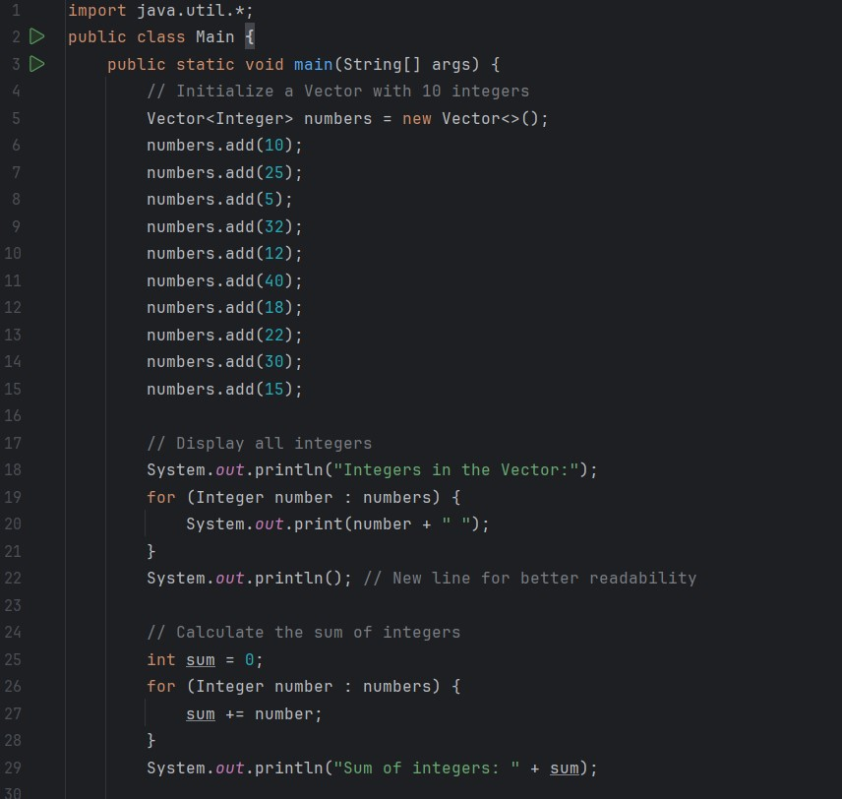

**OUTPUT**

***:***

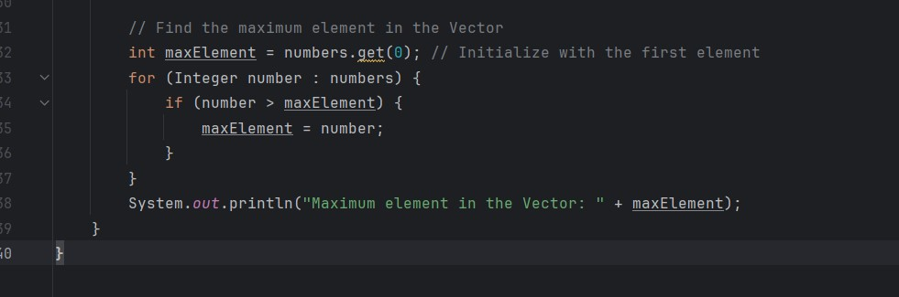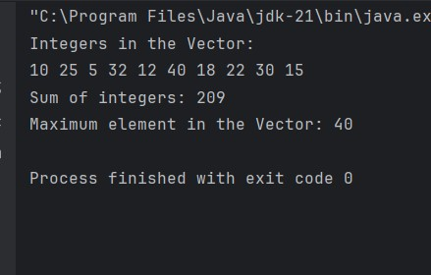

1. Find the k-th smallest element in a sorted ArrayList

**INPUT**

***:***

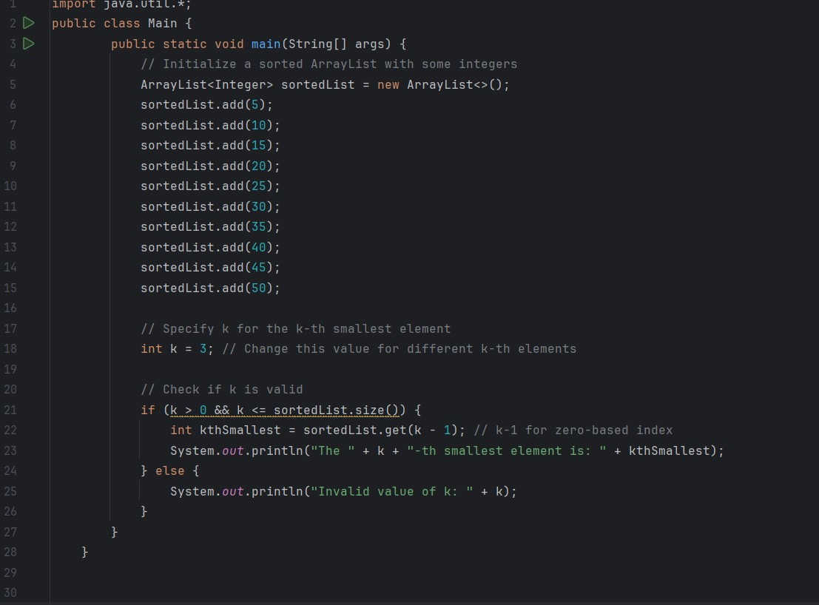

***OUTPUT:***

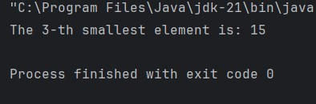

1. Write a program to merge two ArrayLists into one

**INPUT*:***

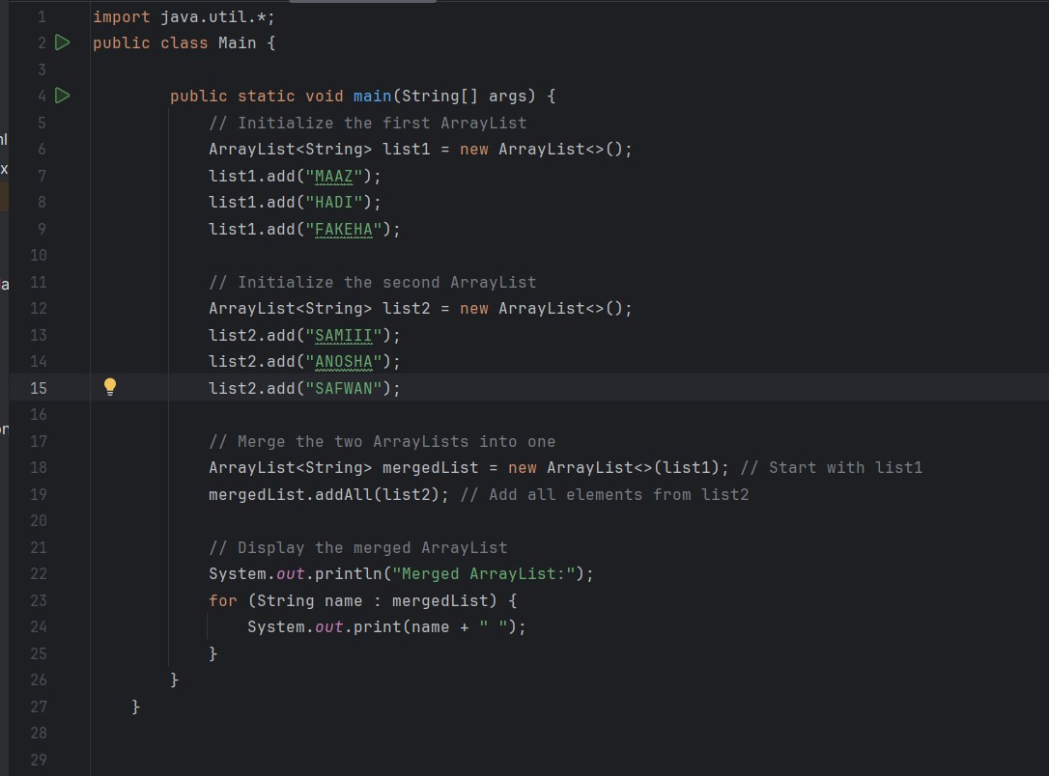

**OUTPUT*:***

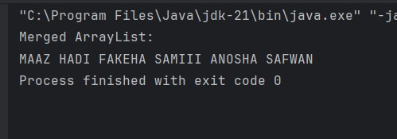

.

**Home Tasks**

* 1. Create a Vector storing integer objects as an input.
     1. Sort the vector
     2. Display largest number
     3. Display smallest number

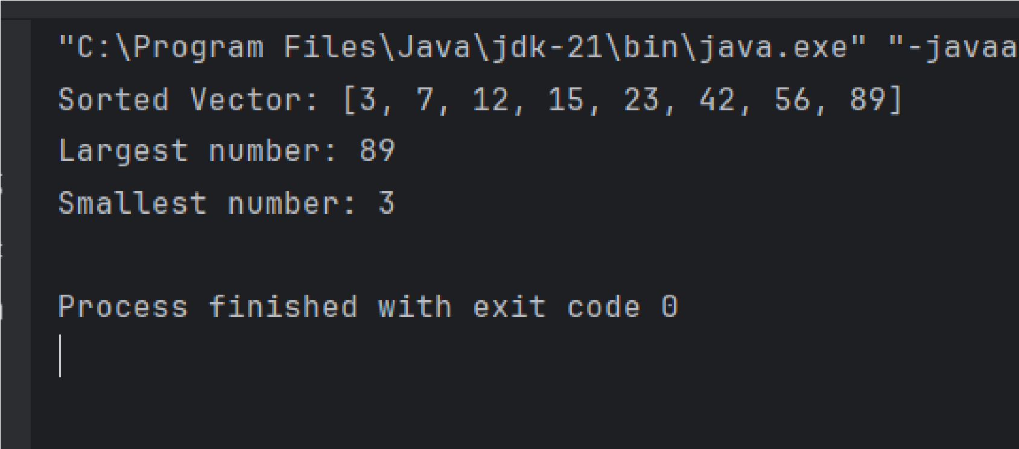

**INPUT**

***:***

***OUTPUT:***

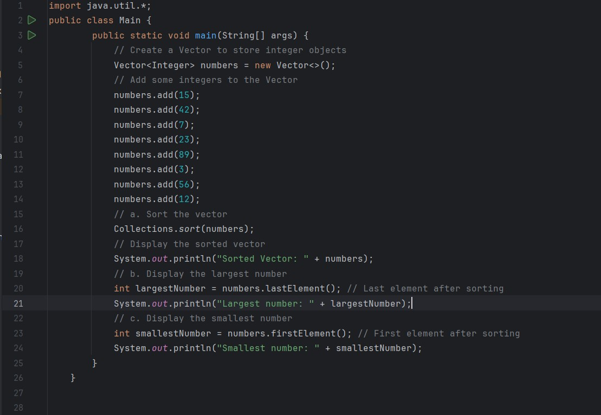

* 1. Write a java program which takes user input and gives hashcode value of those inputs using hashCode () method.

**I**

**N**

**PUT**

***:***

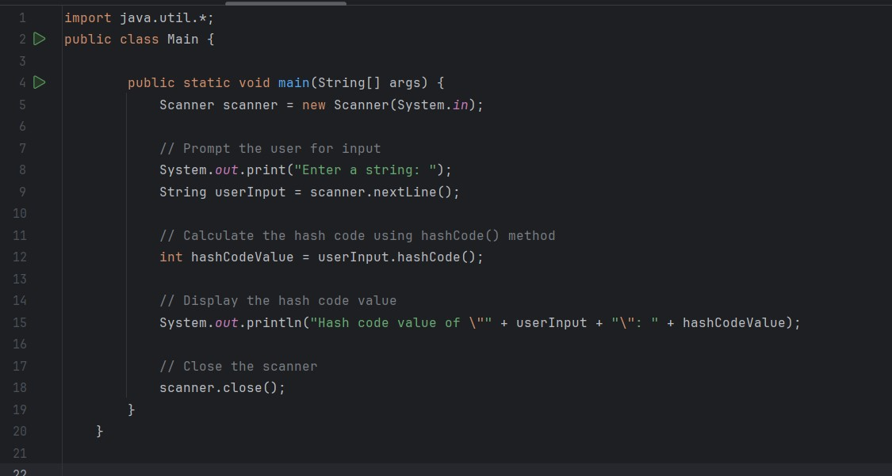

**OUTPUT**

***:***

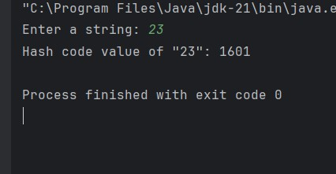

* 1. **Scenario based**

Create a java project, suppose you work for a company that needs to manage a list of employees. Each employee has a unique combination of a name and an ID. Your goal is to ensure that you can track employees effectively and avoid duplicate entries in your system.

Requirements

a. Employee Class: You need to create an Employee class that includes:

* + name: The employee's name (String).
  + id: The employee's unique identifier (int).
  + Override the hashCode() and equals() methods to ensure that two employees are considered equal if they have the same name and id.
  1. Employee Management: You will use a HashSet to store employee records.

This will help you avoid duplicate entries.

* 1. Operations: Implement operations to:
  + Add new employees to the record.
  + Check if an employee already exists in the records. Display all employees.

**INPUT*:***

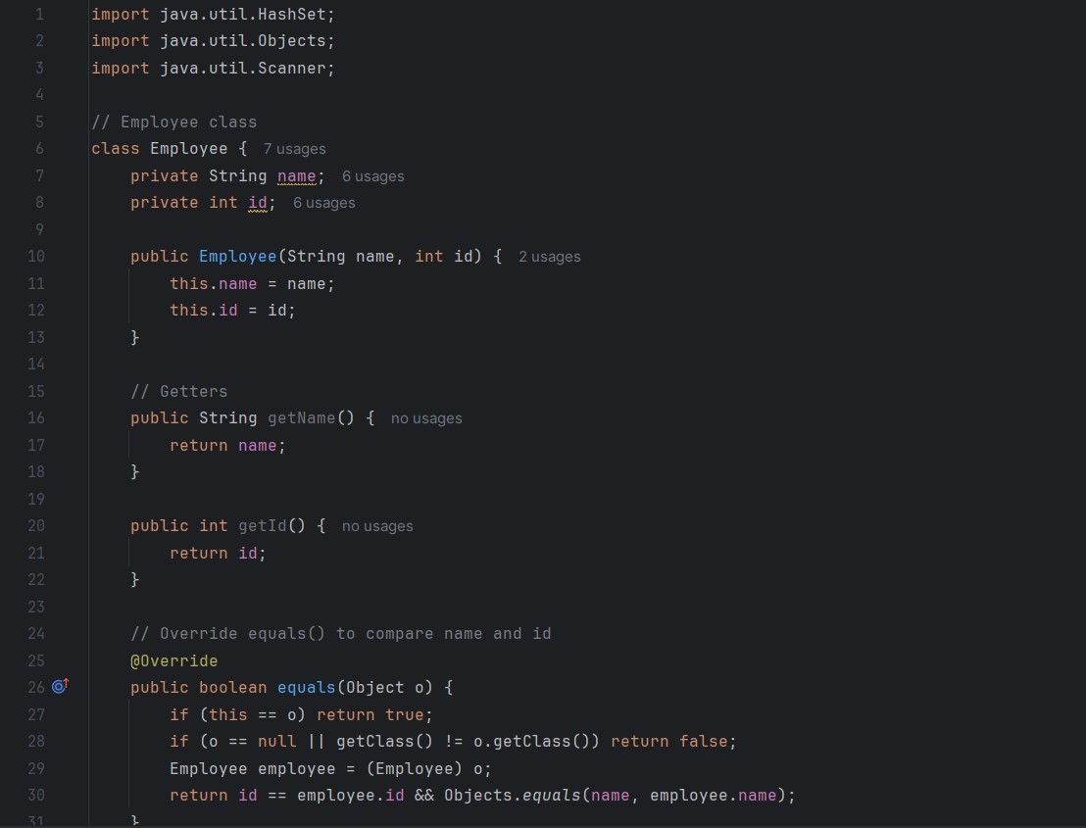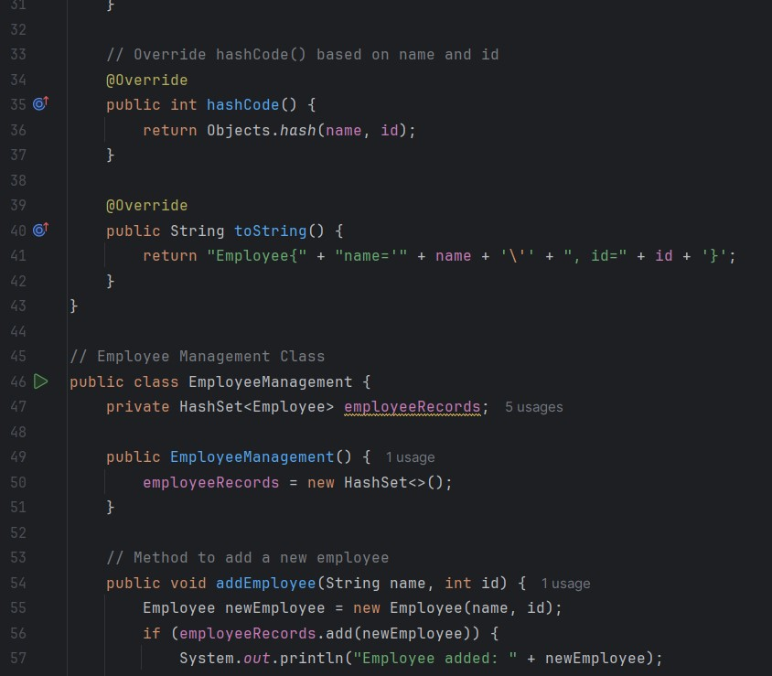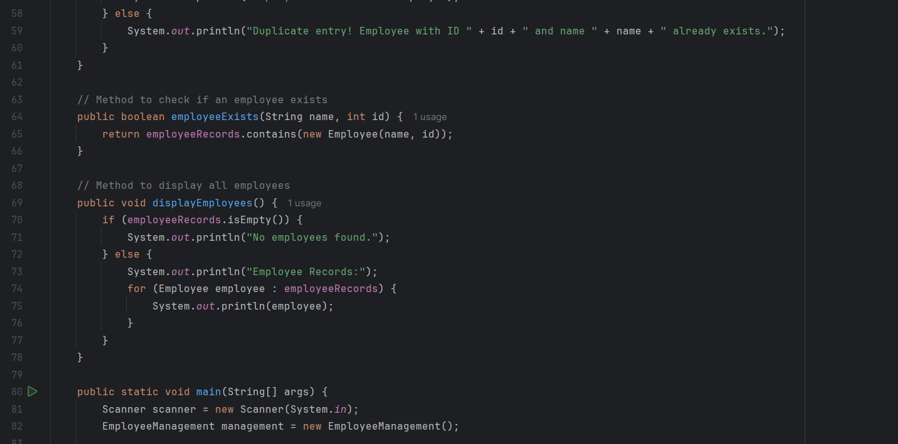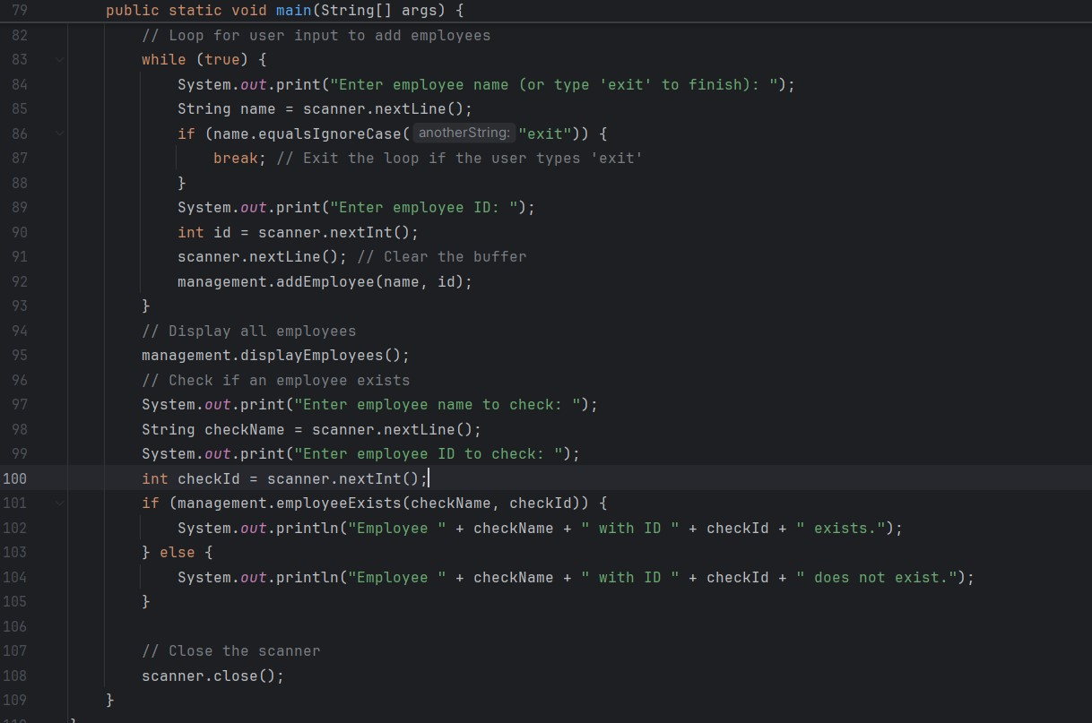

**OUTPUT*:***

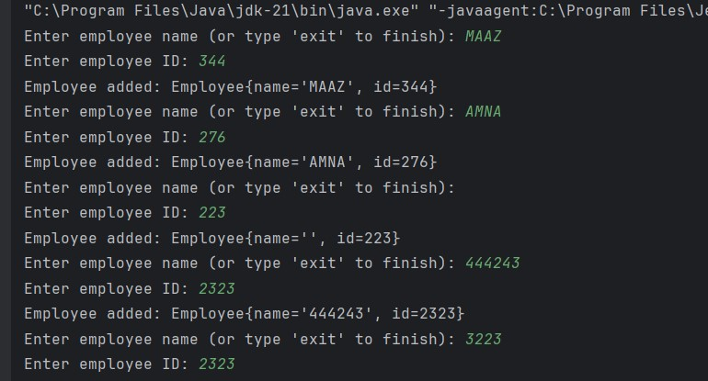

4.Create a Color class that has red, green, and blue values. Two colors are considered equal if their RGB values are the same

***INPUT:***

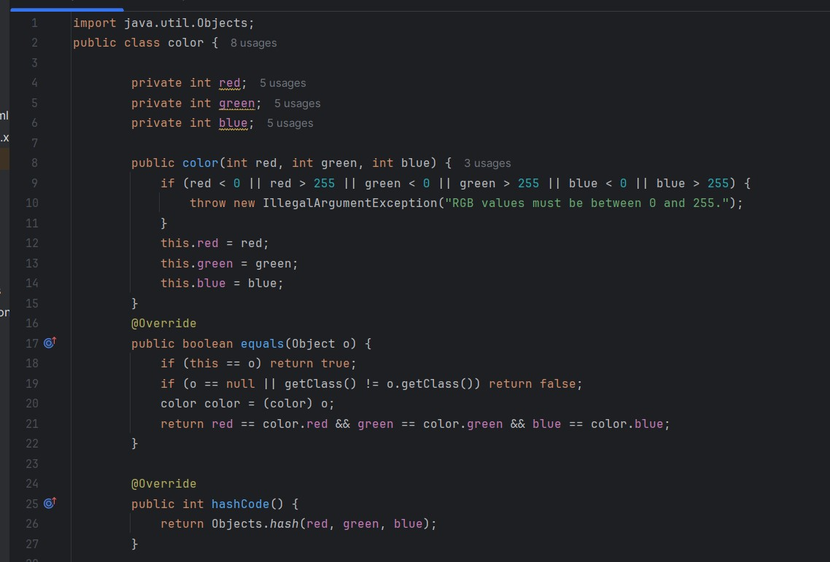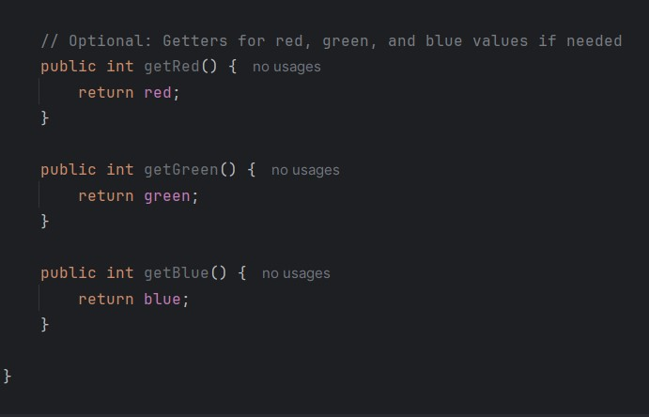

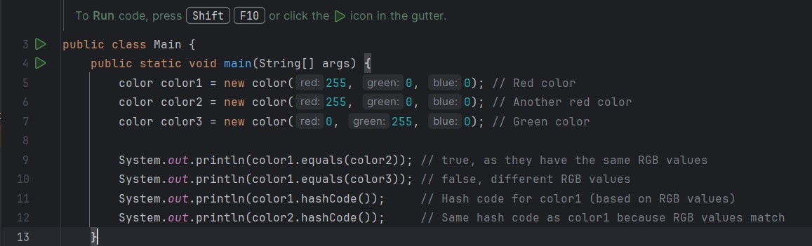

***OUTPUT:***

