DATA 605 - Discussion 11

Omer Ozeren

Table of Contents

Using R, build a regression model for data that interests you. Conduct residual analysis.  
Was the linear model appropriate? Why or why not?

### For this discussion, I will look at Kaggle’s Powerlifting Database dataset.

* It’s a dataset containing competitor results in powerlifting from the OpenPowerlifting Database and do residual analysis.

I will build a simple linear regression model of body weights vs best bench press for seniors to see if a linear relation exists between them.

* Dataset can be found here: <https://www.kaggle.com/open-powerlifting/powerlifting-database>
* Get the data and examine a preview

library(data.table)

## Warning: package 'data.table' was built under R version 3.5.3

powerlift <- read.csv('C:\\Users\\OMERO\\Documents\\GitHub\\DATA605\\openpowerlifting.csv')  
head(powerlift, n=5)

## Name Sex Event Equipment Age AgeClass Division BodyweightKg  
## 1 Abbie Murphy F SBD Wraps 29 24-34 F-OR 59.8  
## 2 Abbie Tuong F SBD Wraps 29 24-34 F-OR 58.5  
## 3 Ainslee Hooper F B Raw 40 40-44 F-OR 55.4  
## 4 Amy Moldenhauer F SBD Wraps 23 20-23 F-OR 60.0  
## 5 Andrea Rowan F SBD Wraps 45 45-49 F-OR 104.0  
## WeightClassKg Squat1Kg Squat2Kg Squat3Kg Squat4Kg Best3SquatKg Bench1Kg  
## 1 60 80 92.5 105 NA 105 45.0  
## 2 60 100 110.0 120 NA 120 55.0  
## 3 56 NA NA NA NA NA 27.5  
## 4 60 -105 -105.0 105 NA 105 67.5  
## 5 110 120 130.0 140 NA 140 70.0  
## Bench2Kg Bench3Kg Bench4Kg Best3BenchKg Deadlift1Kg Deadlift2Kg  
## 1 50.0 55.0 NA 55.0 110.0 120  
## 2 62.5 67.5 NA 67.5 130.0 140  
## 3 32.5 -35.0 NA 32.5 NA NA  
## 4 72.5 -75.0 NA 72.5 132.5 -140  
## 5 75.0 80.0 NA 80.0 150.0 160  
## Deadlift3Kg Deadlift4Kg Best3DeadliftKg TotalKg Place Wilks McCulloch  
## 1 130 NA 130.0 290.0 4 324.16 324.16  
## 2 145 NA 145.0 332.5 2 378.07 378.07  
## 3 NA NA NA 32.5 1 38.56 38.56  
## 4 -140 NA 132.5 310.0 3 345.61 345.61  
## 5 170 NA 170.0 390.0 3 321.25 338.91  
## Glossbrenner IPFPoints Tested Country Federation Date MeetCountry  
## 1 286.42 511.15 GPC-AUS 2018-10-27 Australia  
## 2 334.16 595.65 GPC-AUS 2018-10-27 Australia  
## 3 34.12 313.97 GPC-AUS 2018-10-27 Australia  
## 4 305.37 547.04 GPC-AUS 2018-10-27 Australia  
## 5 274.56 550.08 GPC-AUS 2018-10-27 Australia  
## MeetState MeetName  
## 1 VIC Melbourne Cup  
## 2 VIC Melbourne Cup  
## 3 VIC Melbourne Cup  
## 4 VIC Melbourne Cup  
## 5 VIC Melbourne Cup

library(dplyr)

## Warning: package 'dplyr' was built under R version 3.5.3

powerlift_senior <- powerlift %>% filter(Best3BenchKg > 0 & Division == 'Senior') %>%   
 select(BodyweightKg, Best3BenchKg)

### Visualize the data (EDA)

with(powerlift_senior, plot(BodyweightKg, Best3BenchKg, xlab = "Body Weight (Kg)",  
 ylab = "Best Bench Press (Kg)"))

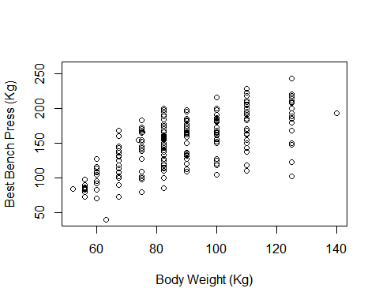

### Residual Analysis

lm_powerlift_senior <- lm(Best3BenchKg ~ BodyweightKg, data = powerlift_senior)  
with(powerlift_senior, plot(BodyweightKg, Best3BenchKg,xlab = "Body Weight (Kg)",  
 ylab = "Best Bench Press (Kg)"))  
abline(lm_powerlift_senior)

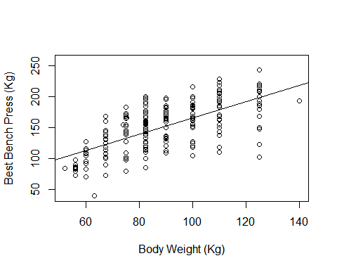

summary(lm_powerlift_senior)

##   
## Call:  
## lm(formula = Best3BenchKg ~ BodyweightKg, data = powerlift_senior)  
##   
## Residuals:  
## Min 1Q Median 3Q Max   
## -95.697 -20.860 4.566 20.359 57.206   
##   
## Coefficients:  
## Estimate Std. Error t value Pr(>|t|)   
## (Intercept) 34.0119 9.2492 3.677 0.000297 ***  
## BodyweightKg 1.3135 0.1023 12.838 < 2e-16 ***  
## ---  
## Signif. codes: 0 '***' 0.001 '**' 0.01 '*' 0.05 '.' 0.1 ' ' 1  
##   
## Residual standard error: 28.77 on 218 degrees of freedom  
## (12 observations deleted due to missingness)  
## Multiple R-squared: 0.4305, Adjusted R-squared: 0.4279   
## F-statistic: 164.8 on 1 and 218 DF, p-value: < 2.2e-16

* Equation of line is

$$\begin{matrix}\overset{ˆ}{bestbenchpress}=0.1376+1.2804*\overset{ˆ}{bodyweight}\end{matrix}$$

#### Residual plots

plot(fitted(lm_powerlift_senior), resid(lm_powerlift_senior),  
 main = "Fitted vs residuals", xlab = "", ylab = "")  
abline(h =0)

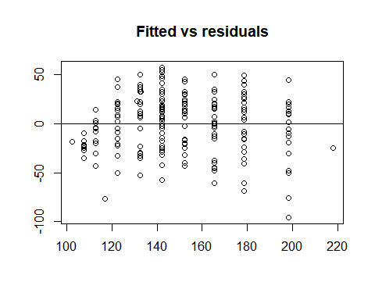

hist(resid(lm_powerlift_senior), xlab = "", main = "Histogram of Residuals")

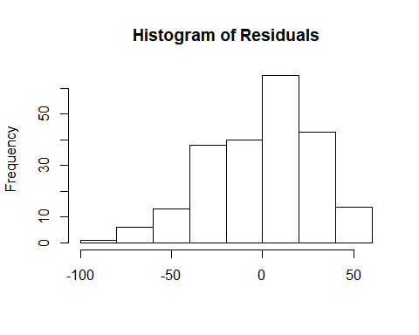

qqnorm(resid(lm_powerlift_senior))  
qqline(resid(lm_powerlift_senior))

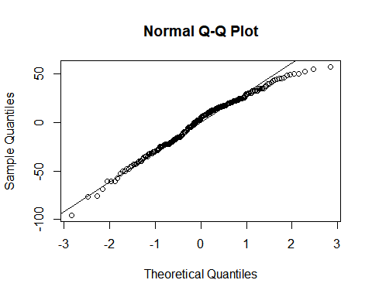 ### Summary

* We see that a linear model based on one explanatory variable doesn’t explain the

data well. The $R^{2}$ value is quite low which shows that the fitted model doesn’t

accuractely predict the values of Senior divisions competitiors bench press best based

on their weight.