DATA 605 - Discussion 13

Omer Ozeren

Table of Contents

## Chapter 7 Sec 4 Exercise 5

Find the arc length of the function on the given interval.

$f(x)=\frac{1}{3}x^{\frac{3}{2}}−x^{\frac{1}{2}}$ on $[0,1]$

### Define Function

func <- function(x) 1/3 * x^(3/2) - x^(1/2)

### Plot

x <- seq(0,1,0.01)  
plot(x,func(x), type="l",  
 xlab="x", ylab="f(x)", main="f(x) on [0,1]")

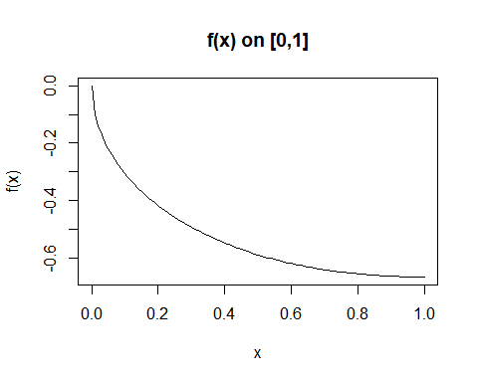

### Solution

$f′(x)=\frac{1}{3}×\frac{3}{2}x^{\frac{1}{2}}−\frac{1}{2}x^{−\frac{1}{2}}=\frac{\sqrt{x}}{2}−\frac{1}{2\sqrt{x}}=\frac{x−1}{2\sqrt{x}}$

$$\begin{matrix}L_{arc} & =\int_{0}^{1}{\sqrt{1+f′(x)^{2}}}dx= \\ & =\int_{0}^{1}{\sqrt{1+\frac{(x−1)^{2}}{4x}}}dx= \\ & =\int_{0}^{1}{\sqrt{\frac{4x+x^{2}−2x+1}{4x}}}dx= \\ & =\int_{0}^{1}{\sqrt{\frac{x^{2}+2x+1}{4x}}}dx= \\ & =\int_{0}^{1}{\sqrt{\frac{(x+1)^{2}}{4x}}}dx= \\ & =\int_{0}^{1}{\frac{x+1}{2\sqrt{x}}}dx= \\ & =\frac{4}{3}≈1.333\end{matrix}$$