DATA 605 - Final Exam

Omer Ozeren

Table of Contents

## Problem 1 :

Using R, generate a random variable X that has 10,000 random uniform numbers from 1 to N, where N can be any number of your choosing greater than or equal to 6. Then generate a random variable Y that has 10,000 random normal numbers with a mean of mean=std=(N+1)/2

#10,000 random uniform numbers from 1 to N  
N=9  
# 10,000 random uniform numbers from 1 to N  
X = runif(10000, 1,N)  
# 10,000 random normal numbers with a mean of mean=std=(N+1)/2  
mu <- (N+1)/2  
std <- (N+1)/2  
Y = rnorm(10000, mean = mu,sd = std)

### Probability

Calculate as a minimum the below probabilities a through c. Assume the small letter “x” is estimated as the median of the X variable, and the small letter “y” is estimated as the 1st quartile of the Y variable. Interpret the meaning of all probabilities

XY<- cbind(X,Y)  
var <- nrow(XY)  
x <- median(X)  
y <- quantile(Y, 0.25,names=FALSE)

### A:

XGy <- length(which(X>y))  
XGy_XGx <- length(which(X>y & X>x))  
XGy_XGx/XGy

## [1] 0.5425347

### B:

We know the statistics of half of the values in X are above the median, and 75% of the values in Y are above the first quartile

### C:

XGy <- length(which(X>y))  
XGy_xGX <- length(which(X>y & X<x))  
  
XGy_xGX/XGy

## [1] 0.4574653

## 5 points.

Investigate whether P(X>x and Y>y)=P(X>x)P(Y>y) by building a table and evaluating the marginal and joint probabilities**

tab <- c(sum(X<x & Y < y),  
 sum(X < x & Y == y),  
 sum(X < x & Y > y))  
tab <- rbind(tab,  
 c(sum(X==x & Y < y),  
 sum(X == x & Y == y),  
 sum(X == x & Y > y))  
   
 )  
tab <- rbind(tab,  
 c(sum(X>x & Y < y),  
 sum(X > x & Y == y),  
 sum(X > x & Y > y))  
 )  
tab <- cbind(tab, tab[,1] + tab[,2] + tab[,3])  
tab <- rbind(tab, tab[1,] + tab[2,] + tab[3,])  
colnames(tab) <- c("Y<y", "Y=y", "Y>y", "Total")  
rownames(tab) <- c("X<x", "X=x", "X>x", "Total")  
knitr::kable(tab)

|  |  |  |  |  |
| --- | --- | --- | --- | --- |
|  | Y<y | Y=y | Y>y | Total |
| X<x | 1263 | 0 | 3737 | 5000 |
| X=x | 0 | 0 | 0 | 0 |
| X>x | 1237 | 0 | 3763 | 5000 |
| Total | 2500 | 0 | 7500 | 10000 |

# P(X>x and Y>y)  
3747/10000

## [1] 0.3747

#P(X>x)P(Y>y)  
((5000)/10000)*(7500/10000)

## [1] 0.375

we can see that the condition holds since P(X>x and Y>y) = 0.3754 and P(X>x)P(Y>y) = 0.375 are approximately equal.

## 5 points.

Check to see if independence holds by using Fisher’s Exact Test and the Chi Square Test. What is the difference between the two? Which is most appropriate?

Fisher’s Exact Test

fisher.test(table(X>x,Y>y))

##   
## Fisher's Exact Test for Count Data  
##   
## data: table(X > x, Y > y)  
## p-value = 0.5637  
## alternative hypothesis: true odds ratio is not equal to 1  
## 95 percent confidence interval:  
## 0.9381439 1.1267272  
## sample estimates:  
## odds ratio   
## 1.028128

The p-value is greater than zero we don’t reject the null hypothesis. Two events are independent.

The Chi Square Test

chisq.test(table(X>x,Y>y))

##   
## Pearson's Chi-squared test with Yates' continuity correction  
##   
## data: table(X > x, Y > y)  
## X-squared = 0.33333, df = 1, p-value = 0.5637

The p-value is greeter than zero we don’t reject the null hypothesis. Two events are independent.

Fisher’s exact test the null of independence of rows and columns in a contingency table with fixed marginals.

Chi-squared test tests contingency table tests and goodness-of-fit tests.

Fisher’s exact test is appropriate here. Since the contingency table are fixed here in the table.

## Problem 2

You are to register for Kaggle.com (free) and compete in the House Prices: Advanced Regression Techniques competition. <https://www.kaggle.com/c/house-prices-advanced-regression-techniques> . I want you to do the following.

Load the libraries

library(readr)

## Warning: package 'readr' was built under R version 3.5.3

library(tidyverse)

## Warning: package 'tidyverse' was built under R version 3.5.3

## -- Attaching packages ----------------------------------------------------------------------------------------------------------------------- tidyverse 1.2.1 --

## v ggplot2 3.1.0 v purrr 0.3.0   
## v tibble 2.0.1 v dplyr 0.8.0.1  
## v tidyr 0.8.3 v stringr 1.3.1   
## v ggplot2 3.1.0 v forcats 0.4.0

## Warning: package 'ggplot2' was built under R version 3.5.3

## Warning: package 'tidyr' was built under R version 3.5.3

## Warning: package 'dplyr' was built under R version 3.5.3

## Warning: package 'forcats' was built under R version 3.5.3

## -- Conflicts -------------------------------------------------------------------------------------------------------------------------- tidyverse_conflicts() --  
## x dplyr::filter() masks stats::filter()  
## x dplyr::lag() masks stats::lag()

library(ggcorrplot)

## Warning: package 'ggcorrplot' was built under R version 3.5.3

### Load Data from Kaggle

# Load training data from GitHub  
path <- ('https://raw.githubusercontent.com/omerozeren/DATA605/master/Final_Exam/train.csv')  
con <- file(path, open="r")  
train <- read.csv(con, header=T, stringsAsFactors = F)  
close(con)  
  
# Load test data from GitHub  
path <- ('https://raw.githubusercontent.com/omerozeren/DATA605/master/Final_Exam/test.csv')  
con <- file(path, open="r")  
test <- read.csv(con, header=T, stringsAsFactors = F)  
close(con)

## 5 points.

Descriptive and Inferential Statistics.

Provide univariate descriptive statistics and appropriate plots for the training data set. Provide a scatterplot matrix for at least **two** of the independent variables and the dependent variable. Derive a correlation matrix for any **three** quantitative variables in the dataset. Test the hypotheses that the correlations between each pairwise set of variables is 0 and provide an 80% confidence interval. Discuss the meaning of your analysis. Would you be worried about familywise error? Why or why not?

**Summary of Train Data**

summary(train)

## Id MSSubClass MSZoning LotFrontage   
## Min. : 1.0 Min. : 20.0 Length:1460 Min. : 21.00   
## 1st Qu.: 365.8 1st Qu.: 20.0 Class :character 1st Qu.: 59.00   
## Median : 730.5 Median : 50.0 Mode :character Median : 69.00   
## Mean : 730.5 Mean : 56.9 Mean : 70.05   
## 3rd Qu.:1095.2 3rd Qu.: 70.0 3rd Qu.: 80.00   
## Max. :1460.0 Max. :190.0 Max. :313.00   
## NA's :259   
## LotArea Street Alley LotShape   
## Min. : 1300 Length:1460 Length:1460 Length:1460   
## 1st Qu.: 7554 Class :character Class :character Class :character   
## Median : 9478 Mode :character Mode :character Mode :character   
## Mean : 10517   
## 3rd Qu.: 11602   
## Max. :215245   
##   
## LandContour Utilities LotConfig   
## Length:1460 Length:1460 Length:1460   
## Class :character Class :character Class :character   
## Mode :character Mode :character Mode :character   
##   
##   
##   
##   
## LandSlope Neighborhood Condition1   
## Length:1460 Length:1460 Length:1460   
## Class :character Class :character Class :character   
## Mode :character Mode :character Mode :character   
##   
##   
##   
##   
## Condition2 BldgType HouseStyle OverallQual   
## Length:1460 Length:1460 Length:1460 Min. : 1.000   
## Class :character Class :character Class :character 1st Qu.: 5.000   
## Mode :character Mode :character Mode :character Median : 6.000   
## Mean : 6.099   
## 3rd Qu.: 7.000   
## Max. :10.000   
##   
## OverallCond YearBuilt YearRemodAdd RoofStyle   
## Min. :1.000 Min. :1872 Min. :1950 Length:1460   
## 1st Qu.:5.000 1st Qu.:1954 1st Qu.:1967 Class :character   
## Median :5.000 Median :1973 Median :1994 Mode :character   
## Mean :5.575 Mean :1971 Mean :1985   
## 3rd Qu.:6.000 3rd Qu.:2000 3rd Qu.:2004   
## Max. :9.000 Max. :2010 Max. :2010   
##   
## RoofMatl Exterior1st Exterior2nd   
## Length:1460 Length:1460 Length:1460   
## Class :character Class :character Class :character   
## Mode :character Mode :character Mode :character   
##   
##   
##   
##   
## MasVnrType MasVnrArea ExterQual ExterCond   
## Length:1460 Min. : 0.0 Length:1460 Length:1460   
## Class :character 1st Qu.: 0.0 Class :character Class :character   
## Mode :character Median : 0.0 Mode :character Mode :character   
## Mean : 103.7   
## 3rd Qu.: 166.0   
## Max. :1600.0   
## NA's :8   
## Foundation BsmtQual BsmtCond   
## Length:1460 Length:1460 Length:1460   
## Class :character Class :character Class :character   
## Mode :character Mode :character Mode :character   
##   
##   
##   
##   
## BsmtExposure BsmtFinType1 BsmtFinSF1 BsmtFinType2   
## Length:1460 Length:1460 Min. : 0.0 Length:1460   
## Class :character Class :character 1st Qu.: 0.0 Class :character   
## Mode :character Mode :character Median : 383.5 Mode :character   
## Mean : 443.6   
## 3rd Qu.: 712.2   
## Max. :5644.0   
##   
## BsmtFinSF2 BsmtUnfSF TotalBsmtSF Heating   
## Min. : 0.00 Min. : 0.0 Min. : 0.0 Length:1460   
## 1st Qu.: 0.00 1st Qu.: 223.0 1st Qu.: 795.8 Class :character   
## Median : 0.00 Median : 477.5 Median : 991.5 Mode :character   
## Mean : 46.55 Mean : 567.2 Mean :1057.4   
## 3rd Qu.: 0.00 3rd Qu.: 808.0 3rd Qu.:1298.2   
## Max. :1474.00 Max. :2336.0 Max. :6110.0   
##   
## HeatingQC CentralAir Electrical X1stFlrSF   
## Length:1460 Length:1460 Length:1460 Min. : 334   
## Class :character Class :character Class :character 1st Qu.: 882   
## Mode :character Mode :character Mode :character Median :1087   
## Mean :1163   
## 3rd Qu.:1391   
## Max. :4692   
##   
## X2ndFlrSF LowQualFinSF GrLivArea BsmtFullBath   
## Min. : 0 Min. : 0.000 Min. : 334 Min. :0.0000   
## 1st Qu.: 0 1st Qu.: 0.000 1st Qu.:1130 1st Qu.:0.0000   
## Median : 0 Median : 0.000 Median :1464 Median :0.0000   
## Mean : 347 Mean : 5.845 Mean :1515 Mean :0.4253   
## 3rd Qu.: 728 3rd Qu.: 0.000 3rd Qu.:1777 3rd Qu.:1.0000   
## Max. :2065 Max. :572.000 Max. :5642 Max. :3.0000   
##   
## BsmtHalfBath FullBath HalfBath BedroomAbvGr   
## Min. :0.00000 Min. :0.000 Min. :0.0000 Min. :0.000   
## 1st Qu.:0.00000 1st Qu.:1.000 1st Qu.:0.0000 1st Qu.:2.000   
## Median :0.00000 Median :2.000 Median :0.0000 Median :3.000   
## Mean :0.05753 Mean :1.565 Mean :0.3829 Mean :2.866   
## 3rd Qu.:0.00000 3rd Qu.:2.000 3rd Qu.:1.0000 3rd Qu.:3.000   
## Max. :2.00000 Max. :3.000 Max. :2.0000 Max. :8.000   
##   
## KitchenAbvGr KitchenQual TotRmsAbvGrd Functional   
## Min. :0.000 Length:1460 Min. : 2.000 Length:1460   
## 1st Qu.:1.000 Class :character 1st Qu.: 5.000 Class :character   
## Median :1.000 Mode :character Median : 6.000 Mode :character   
## Mean :1.047 Mean : 6.518   
## 3rd Qu.:1.000 3rd Qu.: 7.000   
## Max. :3.000 Max. :14.000   
##   
## Fireplaces FireplaceQu GarageType GarageYrBlt   
## Min. :0.000 Length:1460 Length:1460 Min. :1900   
## 1st Qu.:0.000 Class :character Class :character 1st Qu.:1961   
## Median :1.000 Mode :character Mode :character Median :1980   
## Mean :0.613 Mean :1979   
## 3rd Qu.:1.000 3rd Qu.:2002   
## Max. :3.000 Max. :2010   
## NA's :81   
## GarageFinish GarageCars GarageArea GarageQual   
## Length:1460 Min. :0.000 Min. : 0.0 Length:1460   
## Class :character 1st Qu.:1.000 1st Qu.: 334.5 Class :character   
## Mode :character Median :2.000 Median : 480.0 Mode :character   
## Mean :1.767 Mean : 473.0   
## 3rd Qu.:2.000 3rd Qu.: 576.0   
## Max. :4.000 Max. :1418.0   
##   
## GarageCond PavedDrive WoodDeckSF OpenPorchSF   
## Length:1460 Length:1460 Min. : 0.00 Min. : 0.00   
## Class :character Class :character 1st Qu.: 0.00 1st Qu.: 0.00   
## Mode :character Mode :character Median : 0.00 Median : 25.00   
## Mean : 94.24 Mean : 46.66   
## 3rd Qu.:168.00 3rd Qu.: 68.00   
## Max. :857.00 Max. :547.00   
##   
## EnclosedPorch X3SsnPorch ScreenPorch PoolArea   
## Min. : 0.00 Min. : 0.00 Min. : 0.00 Min. : 0.000   
## 1st Qu.: 0.00 1st Qu.: 0.00 1st Qu.: 0.00 1st Qu.: 0.000   
## Median : 0.00 Median : 0.00 Median : 0.00 Median : 0.000   
## Mean : 21.95 Mean : 3.41 Mean : 15.06 Mean : 2.759   
## 3rd Qu.: 0.00 3rd Qu.: 0.00 3rd Qu.: 0.00 3rd Qu.: 0.000   
## Max. :552.00 Max. :508.00 Max. :480.00 Max. :738.000   
##   
## PoolQC Fence MiscFeature   
## Length:1460 Length:1460 Length:1460   
## Class :character Class :character Class :character   
## Mode :character Mode :character Mode :character   
##   
##   
##   
##   
## MiscVal MoSold YrSold SaleType   
## Min. : 0.00 Min. : 1.000 Min. :2006 Length:1460   
## 1st Qu.: 0.00 1st Qu.: 5.000 1st Qu.:2007 Class :character   
## Median : 0.00 Median : 6.000 Median :2008 Mode :character   
## Mean : 43.49 Mean : 6.322 Mean :2008   
## 3rd Qu.: 0.00 3rd Qu.: 8.000 3rd Qu.:2009   
## Max. :15500.00 Max. :12.000 Max. :2010   
##   
## SaleCondition SalePrice   
## Length:1460 Min. : 34900   
## Class :character 1st Qu.:129975   
## Mode :character Median :163000   
## Mean :180921   
## 3rd Qu.:214000   
## Max. :755000   
##

**Plots of Train Data**

hist(train$MSSubClass, main="Distribution of MSSubClass",xlab="MSSubClass")

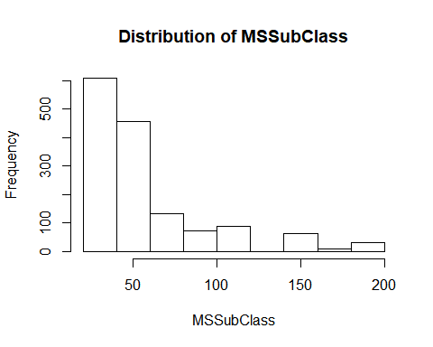

MSSubClass is left skewed.

barplot(table(train$MSZoning), main="MS Zoning")

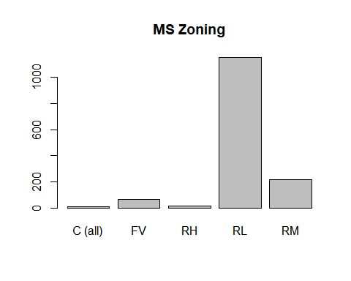 RL has the highest frequency , C lowest frequency.

hist(train$LotFrontage,main="Histogram of Lot Frontage",xlab="LotFrontage")

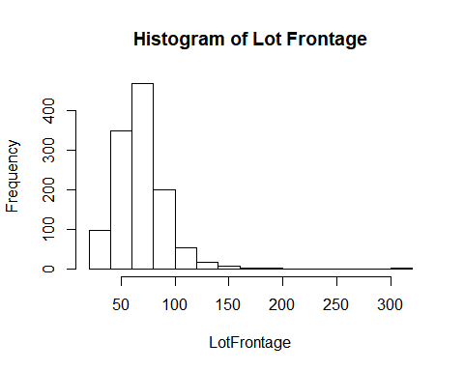 LotFrontage is left skewed.

hist(train$LotArea,main="Distribution of LotArea",xlab="Lot Area")

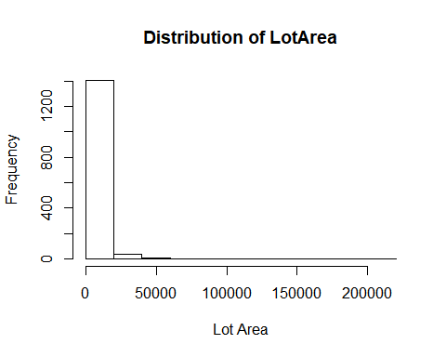

Lot Area is left skewed with very high small values.

hist(train$SalePrice,main="Distribution of Sale Price",xlab="Sale Price")

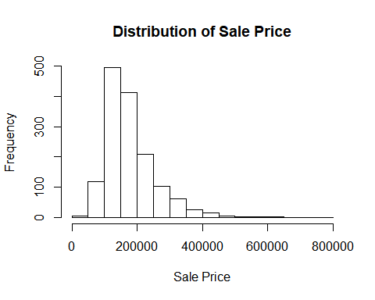

Sales price is slightly approximately normally distributed. .

hist(train$GrLivArea,main="Distribution of Ground Living Area",xlab="Ground Living Area")

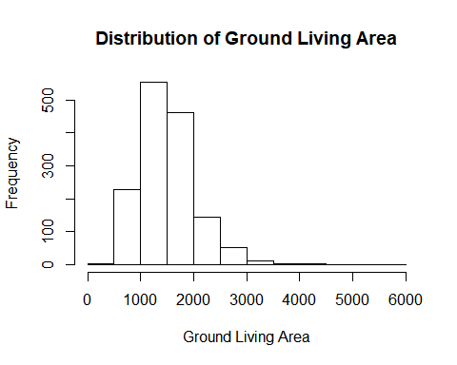

Ground Living Area is approximately normally distributed.

**Since the SalePrice column will be the target variable, we’ll start there and look at how it is distributed.**

# Plot SalePrice  
train %>% ggplot(aes(y=SalePrice)) +   
 geom_boxplot(outlier.color="blue", outlier.alpha = 0.2) +  
 scale_x_discrete() +  
 stat_boxplot(geom ='errorbar',width=.3) +  
 labs(title="Distribution of Sale Price",  
 subtitle="Homes", y="Price($)",  
 x="Homes") + theme_classic()

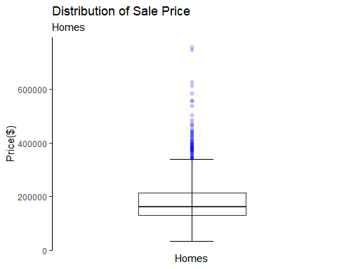

The Plot above displays that the mean price of houses below $200K and they are mostly evenly distributed with some significant outliers above $600K range.

### ScatterPlot

**Scatterplot matrix for “SalePrice”,“GrLivArea”,“LotFrontage”**

pairs(train[,c("SalePrice","GrLivArea","LotFrontage")])

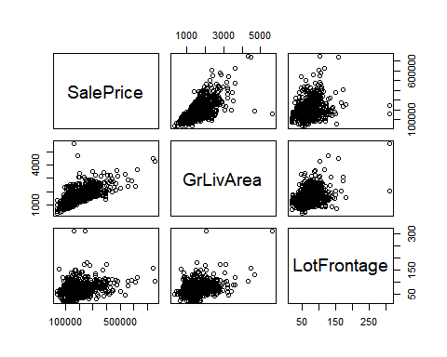

**From the scatter plot we can see that GrLiveArea and LotFrontage are positively correlated with Sale Price.** **Since Most of the sale prices are concentrated between 100k and 300k, while the lot sizes have much less spread.** **The larger lot sizes do not necessarily belong to the most expensive properties, which is why we do not see a stronger correlation.**

### Correlation matrix

cormat <- cor(train[,c("SalePrice","GrLivArea","TotalBsmtSF")])  
cormat

## SalePrice GrLivArea TotalBsmtSF  
## SalePrice 1.0000000 0.7086245 0.6135806  
## GrLivArea 0.7086245 1.0000000 0.4548682  
## TotalBsmtSF 0.6135806 0.4548682 1.0000000

# Subset of variables  
train_cor <- train %>% dplyr::select(SalePrice, GrLivArea, TotalBsmtSF)  
  
# Compute correlations  
corr <- cor(train_cor)  
ggcorrplot(corr,lab=TRUE, ggtheme = ggplot2::theme_classic) +  
 labs(title="Correlation",subtitle="All Houses")

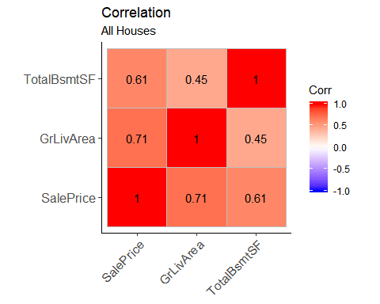

**The graph above displays that Sale Price shows strong positive correlation with “GrLivArea”" and moderate correlation with TotalBsmTSF.** **In Addition,“GrLivArea”" shows Strong positive correlation with SalePrice and weak positive correlation with “TotalBsmSF” and also** **“TotalBsmSF”" shows moderate positive correlation with SalePrice and weak positive correlation with “GrLivArea”.**

### Hypothesis and 80% confidence interval

Test the hypotheses that the correlations between each pairwise set of variables is 0 and provide an 80% confidence interval.Discuss the meaning of your analysis. Would you be worried about familywise error? Why or why not?

Null (Ho) Hypothesis: The correlation between GrLivArea and SalePrice is 0 Alternative(H1) Hypothesis: The correlation between GrLivArea and SalePrice is other than 0

cor.test(train$GrLivArea, train$TotalBsmtSF, conf.level = 0.8)

##   
## Pearson's product-moment correlation  
##   
## data: train$GrLivArea and train$TotalBsmtSF  
## t = 19.503, df = 1458, p-value < 0.00000000000000022  
## alternative hypothesis: true correlation is not equal to 0  
## 80 percent confidence interval:  
## 0.4278380 0.4810855  
## sample estimates:  
## cor   
## 0.4548682

Since the the p value of the test is less than 0.05 at 5% level of significance we reject the null hypothesis and conclude that the correlation between **GrLivArea** and **TotalBsmtSF** is other than 0.

80 percent confidence interval of the test is 0.4327076 0.4879552

cor.test(train$SalePrice, train$TotalBsmtSF, conf.level = 0.8)

##   
## Pearson's product-moment correlation  
##   
## data: train$SalePrice and train$TotalBsmtSF  
## t = 29.671, df = 1458, p-value < 0.00000000000000022  
## alternative hypothesis: true correlation is not equal to 0  
## 80 percent confidence interval:  
## 0.5922142 0.6340846  
## sample estimates:  
## cor   
## 0.6135806

Since the the p value of the test is less than 0.05 at 5% level of significance we reject the null hypothesis and conclude that the correlation between **SalePrice** and **TotalBsmtSF** is other than 0.

80 percent confidence interval of the test is 0.5922142 0.6340846

cor.test(train$SalePrice, train$GrLivArea, conf.level = 0.8)

##   
## Pearson's product-moment correlation  
##   
## data: train$SalePrice and train$GrLivArea  
## t = 38.348, df = 1458, p-value < 0.00000000000000022  
## alternative hypothesis: true correlation is not equal to 0  
## 80 percent confidence interval:  
## 0.6915087 0.7249450  
## sample estimates:  
## cor   
## 0.7086245

Since the the p value of the test is less than 0.05 at 5% level of significance we reject the null hypothesis and conclude that the correlation between **SalePrice** and **GrLivArea** is other than 0.

80 percent confidence interval of the test is 0.6915087 0.7249450

### Familywise Error

type I error is the rejection of a true null hypothesis (also known as a “false positive” finding or conclusion)

FWE <- 1 - (1 - .05)^2   
FWE

## [1] 0.0975

There is a 9.75% chance of type 1 error. Since the chance is low I will not be worried for family wise error .

## 5 points.

Linear Algebra and Correlation.

Invert your correlation matrix from above. (This is known as the precision matrix and contains variance inflation factors on the diagonal.) Multiply the correlation matrix by the precision matrix, and then multiply the precision matrix by the correlation matrix. Conduct LU decomposition on the matrix.

Invert your correlation matrix.This is known as the precision matrix and contains variance inflation factors on the diagonal.

# find inverse  
precision_mat <- solve(cormat)

Multiply the correlation matrix by the precision matrix, and then multiply the precision matrix by the correlation matrix.

# Multiply the correlation matrix by the precision matrix  
cor_prec <- cormat %*% precision_mat  
cor_prec

## SalePrice GrLivArea  
## SalePrice 1.00000000000000022204460 -0.00000000000000002081668  
## GrLivArea 0.00000000000000005551115 1.00000000000000000000000  
## TotalBsmtSF 0.00000000000000000000000 0.00000000000000005551115  
## TotalBsmtSF  
## SalePrice 0.0000000000000000000000  
## GrLivArea 0.0000000000000001110223  
## TotalBsmtSF 1.0000000000000000000000

# multiply the precision matrix by the correlation matrix  
prec_cor <- precision_mat %*% cormat  
prec_cor

## SalePrice GrLivArea  
## SalePrice 0.9999999999999997779554 -0.0000000000000001665335  
## GrLivArea 0.0000000000000002012279 1.0000000000000004440892  
## TotalBsmtSF 0.0000000000000000000000 0.0000000000000001110223  
## TotalBsmtSF  
## SalePrice -0.0000000000000001110223  
## GrLivArea 0.0000000000000001665335  
## TotalBsmtSF 1.0000000000000000000000

# LU Decomposistion  
library(pracma)

## Warning: package 'pracma' was built under R version 3.5.3

##   
## Attaching package: 'pracma'

## The following object is masked from 'package:purrr':  
##   
## cross

lu(cormat)

## $L  
## SalePrice GrLivArea TotalBsmtSF  
## SalePrice 1.0000000 0.00000000 0  
## GrLivArea 0.7086245 1.00000000 0  
## TotalBsmtSF 0.6135806 0.04031325 1  
##   
## $U  
## SalePrice GrLivArea TotalBsmtSF  
## SalePrice 1 0.7086245 0.6135806  
## GrLivArea 0 0.4978513 0.0200700  
## TotalBsmtSF 0 0.0000000 0.6227098

## Calculus-Based Probability & Statistics.

Many times, it makes sense to fit a closed form distribution to data. Select a variable in the Kaggle.com training dataset that is skewed to the right, shift it so that the minimum value is absolutely above zero if necessary. Then load the MASS package and run fitdistr to fit an exponential probability density function. (See <https://stat.ethz.ch/R-manual/R-devel/library/MASS/html/fitdistr.html> ). Find the optimal value of ??? for this distribution, and then take 1000 samples from this exponential distribution using this value (e.g., rexp(1000, ???)). Plot a histogram and compare it with a histogram of your original variable. Using the exponential pdf, find the 5th and 95th percentiles using the cumulative distribution function (CDF). Also generate a 95% confidence interval from the empirical data, assuming normality. Finally, provide the empirical 5th percentile and 95th percentile of the data. Discuss.

library(MASS)

## Warning: package 'MASS' was built under R version 3.5.3

##   
## Attaching package: 'MASS'

## The following object is masked from 'package:dplyr':  
##   
## select

### Univariate distribution of LotArea

(expdf <- fitdistr(train$LotArea, "exponential"))

## rate   
## 0.000095085704   
## (0.000002488507)

# get value of lambda from exponential distribution  
lambda <- expdf$estimate  
  
# expected value of lambda  
rate <- 1 / lambda  
rate

## rate   
## 10516.83

**Then, take 1000 samples from this exponential distribution using this value. (e.g., rexp(1000, some_val))((()))**

# 1000 samples from exponential distribution using lambda  
expdf_samp <- rexp(1000, lambda)

**Plot a histogram and compare it with a histogram of your original variable.**

# Actual vs simulated distribution  
hist(train$LotArea, breaks=50, prob=TRUE,col="royalblue", xlab="Actual Lot Area",  
 main="Lot Area Distribution")

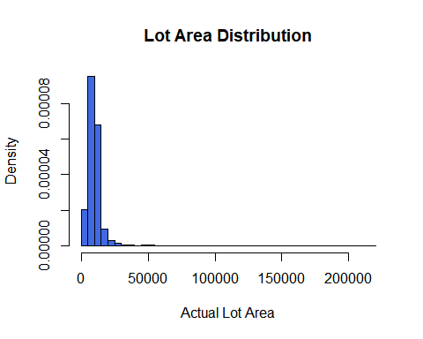

hist(expdf_samp, breaks=50, prob=TRUE,col="royalblue", xlab="Generated(Estimated) Data",  
 main="Generated(Estimated) Data's Distribution")

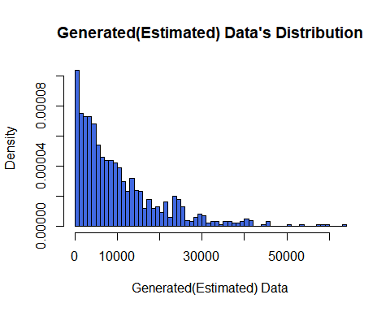

As we can see plots here that our Lot Area approximately fits a exponential distribution. The fit does not do good job here.Let’s look at the summary table to understand the details

# Actuals Data summary Table  
summary(expdf_samp)

## Min. 1st Qu. Median Mean 3rd Qu. Max.   
## 2.28 2977.46 7154.88 10147.36 14053.89 63968.07

# Generated Data summary Table  
summary(train$LotArea)

## Min. 1st Qu. Median Mean 3rd Qu. Max.   
## 1300 7554 9478 10517 11602 215245

## CDF

5th and 95th percentiles using the cumulative distribution function (CDF)

# 5 and 95 percentile of exponential pdf  
qexp(c(.05, .95), rate = lambda)

## [1] 539.4428 31505.6013

Also generate a 95% confidence interval from the empirical data, assuming normality

# 95% confidence interval for sample mean (assuming normality)  
func <- qnorm(0.95)  
a <- func * sd(train$LotArea)/sqrt(length(train$LotArea))  
paste("CI for Population Mean: ",round(mean(train$LotArea - a),2)," - ",  
 round(mean(train$LotArea + a),2),sep='')

## [1] "CI for Population Mean: 10087.16 - 10946.5"

## Modeling

In Model Data engineering part,I initiall start to find the variables with very large number of missing values.Below table show missing values in traindata

#Missing values table  
sapply(train, function(x){sum(is.na(x))})

## Id MSSubClass MSZoning LotFrontage LotArea   
## 0 0 0 259 0   
## Street Alley LotShape LandContour Utilities   
## 0 1369 0 0 0   
## LotConfig LandSlope Neighborhood Condition1 Condition2   
## 0 0 0 0 0   
## BldgType HouseStyle OverallQual OverallCond YearBuilt   
## 0 0 0 0 0   
## YearRemodAdd RoofStyle RoofMatl Exterior1st Exterior2nd   
## 0 0 0 0 0   
## MasVnrType MasVnrArea ExterQual ExterCond Foundation   
## 8 8 0 0 0   
## BsmtQual BsmtCond BsmtExposure BsmtFinType1 BsmtFinSF1   
## 37 37 38 37 0   
## BsmtFinType2 BsmtFinSF2 BsmtUnfSF TotalBsmtSF Heating   
## 38 0 0 0 0   
## HeatingQC CentralAir Electrical X1stFlrSF X2ndFlrSF   
## 0 0 1 0 0   
## LowQualFinSF GrLivArea BsmtFullBath BsmtHalfBath FullBath   
## 0 0 0 0 0   
## HalfBath BedroomAbvGr KitchenAbvGr KitchenQual TotRmsAbvGrd   
## 0 0 0 0 0   
## Functional Fireplaces FireplaceQu GarageType GarageYrBlt   
## 0 0 690 81 81   
## GarageFinish GarageCars GarageArea GarageQual GarageCond   
## 81 0 0 81 81   
## PavedDrive WoodDeckSF OpenPorchSF EnclosedPorch X3SsnPorch   
## 0 0 0 0 0   
## ScreenPorch PoolArea PoolQC Fence MiscFeature   
## 0 0 1453 1179 1406   
## MiscVal MoSold YrSold SaleType SaleCondition   
## 0 0 0 0 0   
## SalePrice   
## 0

By looking at the table, I will remove the columns that have large missings from train and test data sets

train <-train[, !colnames(train) %in% c("Id","Alley","PoolQC","Fence","MiscFeature","FireplaceQu","LotFrontage","YearBuilt","YearRemodAdd")]  
  
test <- test[, !colnames(test) %in% c("Alley","PoolQC","Fence","MiscFeature","FireplaceQu","LotFrontage","YearBuilt","YearRemodAdd")]

The next step is Encoding “converting categoricals to numerics”

# Encoding  
  
train <- train%>%  
 mutate_if(is.character, as.factor)%>%  
 mutate_if(is.factor, as.integer)  
  
test <- test %>%  
 mutate_if(is.character, as.factor)%>%  
 mutate_if(is.factor, as.integer)

# omit the missing values in train data and test  
train <- na.omit(train)  
# Replace numeric NAs with 0  
test <- test %>% mutate_if(is.numeric, ~replace(., is.na(.), 0))

### I’ll now do a stepwise regression based on ACI criterion

model_fit <- lm(SalePrice~., data = train)  
step_model <- step(model_fit, trace = 0)  
summary(step_model)

##   
## Call:  
## lm(formula = SalePrice ~ MSSubClass + MSZoning + LotArea + Street +   
## LotShape + LandContour + LandSlope + Condition2 + HouseStyle +   
## OverallQual + OverallCond + RoofStyle + RoofMatl + Exterior1st +   
## MasVnrType + MasVnrArea + ExterQual + Foundation + BsmtQual +   
## BsmtCond + BsmtExposure + BsmtFinType1 + BsmtFinSF1 + X1stFlrSF +   
## X2ndFlrSF + BsmtFullBath + FullBath + BedroomAbvGr + KitchenAbvGr +   
## KitchenQual + TotRmsAbvGrd + Functional + Fireplaces + GarageCars +   
## PavedDrive + WoodDeckSF + ScreenPorch + SaleCondition, data = train)  
##   
## Residuals:  
## Min 1Q Median 3Q Max   
## -441172 -13550 -957 13442 278991   
##   
## Coefficients:  
## Estimate Std. Error t value Pr(>|t|)   
## (Intercept) -68655.8503 38693.5272 -1.774 0.076239 .   
## MSSubClass -159.8789 27.4961 -5.815 0.000000007641103 ***  
## MSZoning -2503.0986 1534.7315 -1.631 0.103139   
## LotArea 0.3814 0.1060 3.597 0.000333 ***  
## Street 40806.0476 15627.6939 2.611 0.009128 **   
## LotShape -1310.5266 669.9525 -1.956 0.050662 .   
## LandContour 3914.9209 1436.8188 2.725 0.006522 **   
## LandSlope 6115.5394 4036.2642 1.515 0.129978   
## Condition2 -7336.6650 3325.0186 -2.207 0.027523 *   
## HouseStyle -1224.6140 616.7163 -1.986 0.047277 *   
## OverallQual 12959.5731 1248.8115 10.378 < 0.0000000000000002 ***  
## OverallCond 4247.8548 928.1763 4.577 0.000005179174355 ***  
## RoofStyle 2632.4405 1158.2961 2.273 0.023208 *   
## RoofMatl 4131.9524 1555.7715 2.656 0.008007 **   
## Exterior1st -614.3119 301.9824 -2.034 0.042128 *   
## MasVnrType 4335.1776 1582.5650 2.739 0.006241 **   
## MasVnrArea 30.2912 6.1226 4.947 0.000000850306146 ***  
## ExterQual -8542.1790 2043.1130 -4.181 0.000030972233573 ***  
## Foundation 3189.2880 1670.1013 1.910 0.056400 .   
## BsmtQual -8946.3960 1491.0981 -6.000 0.000000002557006 ***  
## BsmtCond 3202.5638 1404.1962 2.281 0.022727 *   
## BsmtExposure -3678.7800 901.4594 -4.081 0.000047592852072 ***  
## BsmtFinType1 -1168.7326 649.9609 -1.798 0.072384 .   
## BsmtFinSF1 5.8341 3.1549 1.849 0.064652 .   
## X1stFlrSF 45.5519 4.8433 9.405 < 0.0000000000000002 ***  
## X2ndFlrSF 45.2873 4.1751 10.847 < 0.0000000000000002 ***  
## BsmtFullBath 7523.9163 2355.1435 3.195 0.001434 **   
## FullBath 4197.5166 2518.4225 1.667 0.095810 .   
## BedroomAbvGr -4439.2566 1771.3141 -2.506 0.012325 *   
## KitchenAbvGr -21663.3923 6032.6496 -3.591 0.000342 ***  
## KitchenQual -8746.4950 1523.4941 -5.741 0.000000011699055 ***  
## TotRmsAbvGrd 3456.5692 1200.5186 2.879 0.004052 **   
## Functional 3843.4812 1016.0138 3.783 0.000162 ***  
## Fireplaces 4035.7108 1688.6046 2.390 0.016992 *   
## GarageCars 14425.7154 1972.8288 7.312 0.000000000000458 ***  
## PavedDrive 4949.3592 2348.8421 2.107 0.035296 *   
## WoodDeckSF 18.4401 7.5978 2.427 0.015359 *   
## ScreenPorch 41.4813 15.9000 2.609 0.009188 **   
## SaleCondition 2596.0989 873.9699 2.970 0.003028 **   
## ---  
## Signif. codes: 0 '***' 0.001 '**' 0.01 '*' 0.05 '.' 0.1 ' ' 1  
##   
## Residual standard error: 32290 on 1299 degrees of freedom  
## Multiple R-squared: 0.8373, Adjusted R-squared: 0.8326   
## F-statistic: 176 on 38 and 1299 DF, p-value: < 0.00000000000000022

### Residual Analysis

par(mfrow=c(2,2))  
plot(step_model)

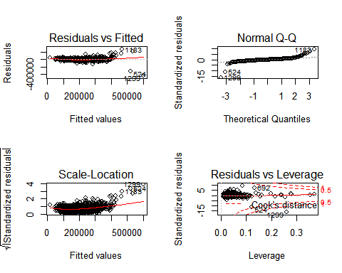 The residuals are approximately normally distributed. There is not heteroscedacity and pattern in the residuals.

forecast <- predict(step_model, test)  
results <- data.frame(Id = test$Id, SalePrice=forecast)

### Export submission

#Write to .csv for submission to Kaggle  
write.csv(results, file = "submission_omerozeren.csv", row.names = FALSE)

### Kaggle Submission

My Kaggle user name is **omerozeren**, and the resulting score on Kaggle.com from this model is **0.21620**.