DATA 605 - Homework 12

Omer Ozeren

Table of Contents

library(tidyverse)  
library(knitr)  
library(kableExtra)  
library(gvlma)  
library(gridExtra)

# Objective

1. Provide a scatterplot of LifeExp~TotExp, and run simple linear regression. Do not transform the variables. Provide and interpret the F statistics, R^2, standard error,and p-values only. Discuss whether the assumptions of simple linear regression met.
2. Raise life expectancy to the 4.6 power (i.e., LifeExp^4.6). Raise total expenditures to the 0.06 power (nearly a log transform, TotExp^.06). Plot LifeExp^4.6 as a function of TotExp^.06, and r re-run the simple regression model using the transformed variables. Provide and interpret the F statistics, R^2, standard error, and p-values. Which model is “better?”
3. Using the results from 3, forecast life expectancy when TotExp^.06 =1.5. Then forecast life expectancy when TotExp^.06=2.5.
4. Build the following multiple regression model and interpret the F Statistics, R^2, standard error, and p-values. How good is the model?  
   LifeExp = b0+b1 x PropMd + b2 x TotExp +b3 x PropMD x TotExp
5. Forecast LifeExp when PropMD=.03 and TotExp = 14. Does this forecast seem realistic? Why or why not?

## Question 1.

Provide a scatterplot of LifeExp~TotExp, and run simple linear regression. Do not transform the variables. Provide and interpret the F statistics, R^2, standard error,and p-values only. Discuss whether the assumptions of simple linear regression met.

### Scatterplot

library(knitr)  
url <- "C:/Users/OMERO/Desktop/who.csv"  
who_df <- read.csv(file = url, header = T, stringsAsFactors = F)  
summary(who_df)  
## Country LifeExp InfantSurvival Under5Survival   
## Length:190 Min. :40.00 Min. :0.8350 Min. :0.7310   
## Class :character 1st Qu.:61.25 1st Qu.:0.9433 1st Qu.:0.9253   
## Mode :character Median :70.00 Median :0.9785 Median :0.9745   
## Mean :67.38 Mean :0.9624 Mean :0.9459   
## 3rd Qu.:75.00 3rd Qu.:0.9910 3rd Qu.:0.9900   
## Max. :83.00 Max. :0.9980 Max. :0.9970   
## TBFree PropMD PropRN   
## Min. :0.9870 Min. :0.0000196 Min. :0.0000883   
## 1st Qu.:0.9969 1st Qu.:0.0002444 1st Qu.:0.0008455   
## Median :0.9992 Median :0.0010474 Median :0.0027584   
## Mean :0.9980 Mean :0.0017954 Mean :0.0041336   
## 3rd Qu.:0.9998 3rd Qu.:0.0024584 3rd Qu.:0.0057164   
## Max. :1.0000 Max. :0.0351290 Max. :0.0708387   
## PersExp GovtExp TotExp   
## Min. : 3.00 Min. : 10.0 Min. : 13   
## 1st Qu.: 36.25 1st Qu.: 559.5 1st Qu.: 584   
## Median : 199.50 Median : 5385.0 Median : 5541   
## Mean : 742.00 Mean : 40953.5 Mean : 41696   
## 3rd Qu.: 515.25 3rd Qu.: 25680.2 3rd Qu.: 26331   
## Max. :6350.00 Max. :476420.0 Max. :482750  
kable(head(who_df))

Country

LifeExp

InfantSurvival

Under5Survival

TBFree

PropMD

PropRN

PersExp

GovtExp

TotExp

Afghanistan

42

0.835

0.743

0.99769

0.0002288

0.0005723

20

92

112

Albania

71

0.985

0.983

0.99974

0.0011431

0.0046144

169

3128

3297

Algeria

71

0.967

0.962

0.99944

0.0010605

0.0020914

108

5184

5292

Andorra

82

0.997

0.996

0.99983

0.0032973

0.0035000

2589

169725

172314

Angola

41

0.846

0.740

0.99656

0.0000704

0.0011462

36

1620

1656

Antigua and Barbuda

73

0.990

0.989

0.99991

0.0001429

0.0027738

503

12543

13046

#scatter plot  
plot(who_df$LifeExp, who_df$TotExp, main="Scatterplot",   
 xlab="Life Expectancy ", ylab="Total Expenidutres ", pch=19)   
#simple linear regression  
lm_who_df <- lm(who_df$LifeExp ~ who_df$TotExp)  
abline(who_df, col = "red")

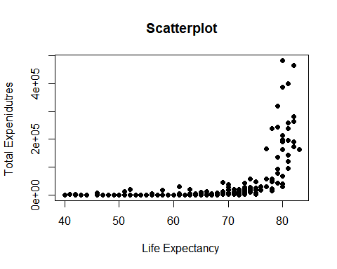

#residuals  
hist(resid(lm_who_df), main = "Histogram of Residuals", xlab = "residuals")

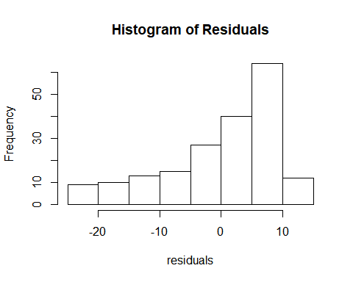

#summary  
summary(lm_who_df)  
##   
## Call:  
## lm(formula = who_df$LifeExp ~ who_df$TotExp)  
##   
## Residuals:  
## Min 1Q Median 3Q Max   
## -24.764 -4.778 3.154 7.116 13.292   
##   
## Coefficients:  
## Estimate Std. Error t value Pr(>|t|)   
## (Intercept) 6.475e+01 7.535e-01 85.933 < 2e-16 ***  
## who_df$TotExp 6.297e-05 7.795e-06 8.079 7.71e-14 ***  
## ---  
## Signif. codes: 0 '***' 0.001 '**' 0.01 '*' 0.05 '.' 0.1 ' ' 1  
##   
## Residual standard error: 9.371 on 188 degrees of freedom  
## Multiple R-squared: 0.2577, Adjusted R-squared: 0.2537   
## F-statistic: 65.26 on 1 and 188 DF, p-value: 7.714e-14

## Question 2.

Raise life expectancy to the 4.6 power (i.e., LifeExp^4.6). Raise total expenditures to the 0.06 power (nearly a log transform, TotExp^.06). Plot LifeExp^4.6 as a function of TotExp^.06, and r re-run the simple regression model using the transformed variables. Provide and interpret the F statistics, R^2, standard error, and p-values. Which model is “better?”

#simple linear regression  
x <- who_df$LifeExp^4.6  
y <- who_df$TotExp^0.06  
lm_who_df2 <- lm(x ~ y)  
#scatter plot  
plot(x, y, main="Scatterplot 2",   
 xlab="Life Expectancy ", ylab="Total Expenidutres ", pch=19)   
abline(lm_who_df2, col = "red")

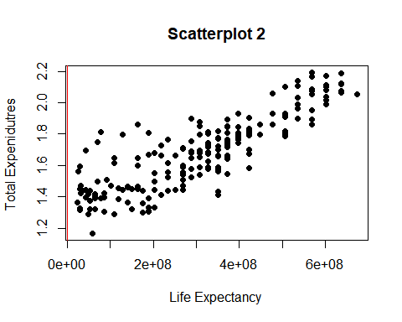

#residuals  
hist(resid(lm_who_df2), main = "Histogram of Residuals", xlab = "residuals")

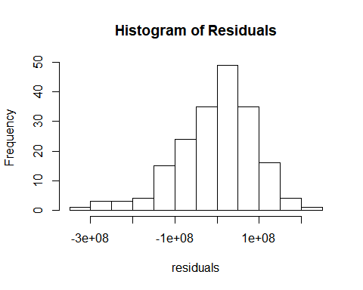

#summary  
summary(lm_who_df2)  
##   
## Call:  
## lm(formula = x ~ y)  
##   
## Residuals:  
## Min 1Q Median 3Q Max   
## -308616089 -53978977 13697187 59139231 211951764   
##   
## Coefficients:  
## Estimate Std. Error t value Pr(>|t|)   
## (Intercept) -736527910 46817945 -15.73 <2e-16 ***  
## y 620060216 27518940 22.53 <2e-16 ***  
## ---  
## Signif. codes: 0 '***' 0.001 '**' 0.01 '*' 0.05 '.' 0.1 ' ' 1  
##   
## Residual standard error: 90490000 on 188 degrees of freedom  
## Multiple R-squared: 0.7298, Adjusted R-squared: 0.7283   
## F-statistic: 507.7 on 1 and 188 DF, p-value: < 2.2e-16  
plot(fitted(lm_who_df2), resid(lm_who_df2))  
plot(fitted(lm_who_df2), resid(lm_who_df2))

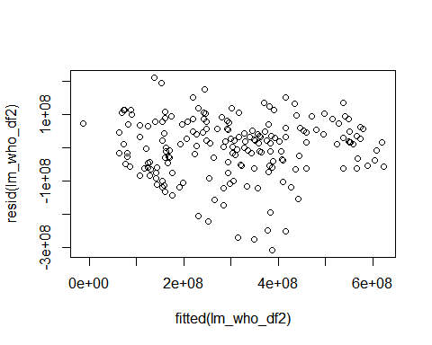

Model2 is highly different and better compared to Model1. Adjusted Rsquare is 72% whereas Model1 is only 25%. There seems to be a good correlation. p-value is less in Model2 compared to Model1. F-stat is 507 in model2 whereas only 65 in Model1. Residual standard error is high in Model2 and normally distributed in Model2.

## Question 3.

Using the results from 3, forecast life expectancy when TotExp^.06 =1.5. **Then forecast life expectancy when TotExp^.06=2.5.**

$$y=−736527910+620060216x$$

$$lifeexpectancy=y^{(}1/4.6)$$

le <- function(fc)  
{ y <- -736527910 + 620060216 * (fc)  
 y <- y^(1/4.6)  
 print(y)  
}  
#Life expectancy when TotExp^.06 =1.5  
le(1.5)  
## [1] 63.31153  
#Life expectancy when TotExp^.06 =2.5  
le(2.5)  
## [1] 86.50645

## Question 4.

Build the following multiple regression model and interpret the F Statistics, R^2, standard error, and p-values. How good is the model?

**LifeExp = b0+b1 x PropMd + b2 x TotExp +b3 x PropMD x TotExp**

lm_fit3 <- lm(who_df$LifeExp ~ who_df$PropMD + who_df$TotExp + who_df$PropMD*who_df$TotExp)  
summary(lm_fit3)  
##   
## Call:  
## lm(formula = who_df$LifeExp ~ who_df$PropMD + who_df$TotExp +   
## who_df$PropMD * who_df$TotExp)  
##   
## Residuals:  
## Min 1Q Median 3Q Max   
## -27.320 -4.132 2.098 6.540 13.074   
##   
## Coefficients:  
## Estimate Std. Error t value Pr(>|t|)   
## (Intercept) 6.277e+01 7.956e-01 78.899 < 2e-16 ***  
## who_df$PropMD 1.497e+03 2.788e+02 5.371 2.32e-07 ***  
## who_df$TotExp 7.233e-05 8.982e-06 8.053 9.39e-14 ***  
## who_df$PropMD:who_df$TotExp -6.026e-03 1.472e-03 -4.093 6.35e-05 ***  
## ---  
## Signif. codes: 0 '***' 0.001 '**' 0.01 '*' 0.05 '.' 0.1 ' ' 1  
##   
## Residual standard error: 8.765 on 186 degrees of freedom  
## Multiple R-squared: 0.3574, Adjusted R-squared: 0.3471   
## F-statistic: 34.49 on 3 and 186 DF, p-value: < 2.2e-16  
hist(resid(lm_fit3), main = "Histogram of Residuals", xlab = "residuals")

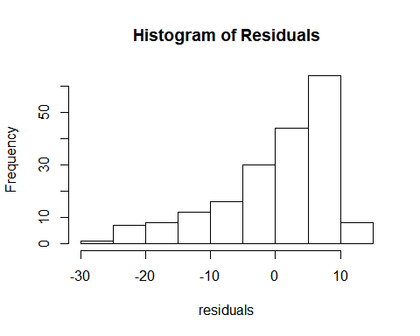

plot(fitted(lm_fit3), resid(lm_fit3))

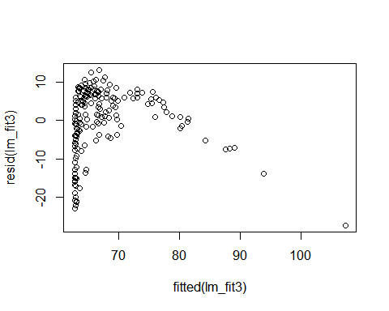

p-value is less than .05. model is statistically significant. F-statistic is 34.49 by adding 3 variables. Based on Rsquare only 35% of the variability can be explained by 3 variables. Correlation is moderate in this case. Residuals is right skewed. So, linear model is not valid.

### Question 5.

Forecast LifeExp when PropMD=.03 and TotExp = 14. Does this forecast seem realistic? Why or why not?

$$LifeExp=6.277*{10}^{1}+1.497*{10}^{3}*PropMD+7.233*{10}^{−}5TotExp−6.026*{10}^{−}3*PropMD*TotExp$$

LE <- ( (6.277*10^1) + (1.497*10^3)*.03 + (7.233*10^(-5))*14 - ((6.026*10^(-3))*0.03*14) )   
LE  
## [1] 107.6785

This prediction does not seem realistic, since the total personal and government expenditure is near the minimum, yet life expentancy exceeds that of any country in the dataset.Hence, The forecast age 107.6 is an outlier and seems to be unrealistic. The expenditure is also low.