HMW 2-Problem Set 1

Omer Ozeren

Table of Contents

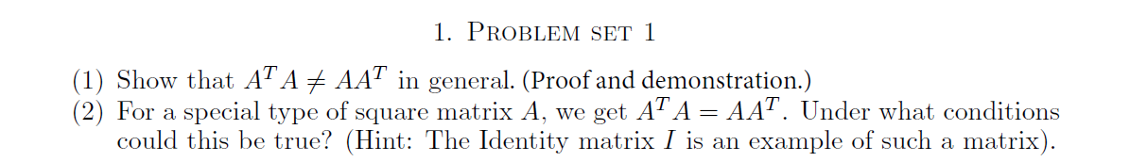

### Question 1 :

A = matrix(seq(1, 9), nrow=3, byrow = T)  
AT = matrix(seq(1, 9), nrow=3, byrow = F)

$$\left[\begin{matrix}1 & 2 & 3 \\ 4 & 5 & 6 \\ 7 & 8 & 9\end{matrix}\right]*\left[\begin{matrix}1 & 4 & 7 \\ 2 & 5 & 8 \\ 3 & 6 & 9\end{matrix}\right]=$$

A %*% AT

## [,1] [,2] [,3]  
## [1,] 14 32 50  
## [2,] 32 77 122  
## [3,] 50 122 194

$$\left[\begin{matrix}1 & 4 & 7 \\ 2 & 5 & 8 \\ 3 & 6 & 9\end{matrix}\right]*\left[\begin{matrix}1 & 2 & 3 \\ 4 & 5 & 6 \\ 7 & 8 & 9\end{matrix}\right]=$$

AT %*% A

## [,1] [,2] [,3]  
## [1,] 66 78 90  
## [2,] 78 93 108  
## [3,] 90 108 126

(AT %*% A) == (A %*% AT)

## [,1] [,2] [,3]  
## [1,] FALSE FALSE FALSE  
## [2,] FALSE FALSE FALSE  
## [3,] FALSE FALSE FALSE

### Question 2 :

$A^{T}A=AA^{T}$ is true if $A$ is a diagonal matrix.So An identity matrix when transposed and multiplied to itself, are equal to each other.

Let $A=\left[\begin{matrix}a & 0 & 0 \\ 0 & b & 0 \\ 0 & 0 & c\end{matrix}\right]$ then $A^{T}=\left[\begin{matrix}a & 0 & 0 \\ 0 & b & 0 \\ 0 & 0 & c\end{matrix}\right]$ therefore:

$$A^{T}A=\left[\begin{matrix}a & 0 & 0 \\ 0 & b & 0 \\ 0 & 0 & c\end{matrix}\right]\left[\begin{matrix}a & 0 & 0 \\ 0 & b & 0 \\ 0 & 0 & c\end{matrix}\right]=\left[\begin{matrix}a^{2} & 0 & 0 \\ 0 & b^{2} & 0 \\ 0 & 0 & c^{2}\end{matrix}\right]$$

$$AA^{T}=\left[\begin{matrix}a & 0 & 0 \\ 0 & b & 0 \\ 0 & 0 & c\end{matrix}\right]\left[\begin{matrix}a & 0 & 0 \\ 0 & b & 0 \\ 0 & 0 & c\end{matrix}\right]=\left[\begin{matrix}a^{2} & 0 & 0 \\ 0 & b^{2} & 0 \\ 0 & 0 & c^{2}\end{matrix}\right]$$

This gives a case when $A^{T}A=AA^{T}$ is true.

A = matrix(c(1, 0, 0, 1), nrow=2, byrow = T)  
AT = t(A)  
(A %*% AT) == (A %*% AT)

## [,1] [,2]  
## [1,] TRUE TRUE  
## [2,] TRUE TRUE