HMW 2-Problem Set 2

Omer Ozeren

Table of Contents

Write an R function to factorize a square matrix $A$ into LU or LDU, whichever you prefer. 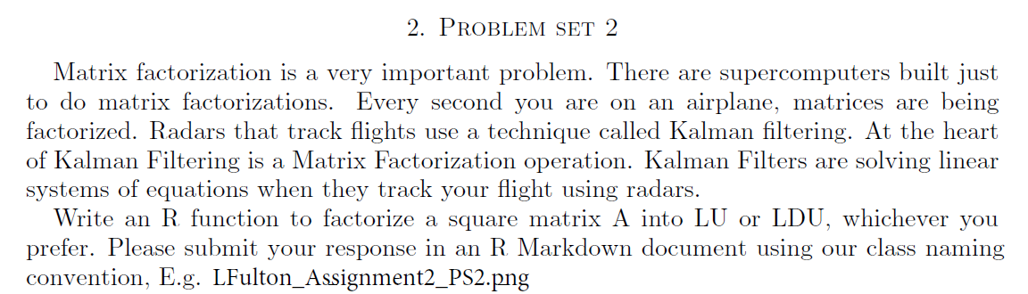

## Function Set-Up

lu_function <- function(m) {  
 mDims <- dim(m)  
   
 # check for square matrix  
 if (mDims[1] != mDims[2])   
 return(NA)  
   
 U <- m  
 n <- mDims[1]  
 L <- diag(n)  
   
 # if dim is 1, the U=A and L=[1]  
 if (n == 1)   
 return(list(L, U))  
   
 # loop through lower triangle determine multiplier  
 for (i in 2:n) {  
 for (j in 1:(i - 1)) {  
 multiplier <- -U[i, j]/U[j, j]  
 U[i, ] <- multiplier * U[j, ] + U[i, ]  
 L[i, j] <- -multiplier  
 }  
 }  
   
 return(list(L, U))  
}

## Function Example

m1 <- matrix(seq(1, 9), nrow = 3)  
m2 <- matrix(sample(1:100, 9, replace = T), nrow = 3)  
ms <- list(m1, m2)  
lus <- ms %>% map(lu_function) %>% print

## [[1]]  
## [[1]][[1]]  
## [,1] [,2] [,3]  
## [1,] 1 0 0  
## [2,] 2 1 0  
## [3,] 3 2 1  
##   
## [[1]][[2]]  
## [,1] [,2] [,3]  
## [1,] 1 4 7  
## [2,] 0 -3 -6  
## [3,] 0 0 0  
##   
##   
## [[2]]  
## [[2]][[1]]  
## [,1] [,2] [,3]  
## [1,] 1.0000000 0.000000 0  
## [2,] 1.3333333 1.000000 0  
## [3,] 0.6515152 -2.064935 1  
##   
## [[2]][[2]]  
## [,1] [,2] [,3]  
## [1,] 66 6.000000e+01 84.0000  
## [2,] 0 -1.400000e+01 -68.0000  
## [3,] 0 3.552714e-15 -139.1429

m1 == lus[[1]][[1]] %*% lus[[1]][[2]]

## [,1] [,2] [,3]  
## [1,] TRUE TRUE TRUE  
## [2,] TRUE TRUE TRUE  
## [3,] TRUE TRUE TRUE

m2 == lus[[2]][[1]] %*% lus[[2]][[2]]

## [,1] [,2] [,3]  
## [1,] TRUE TRUE TRUE  
## [2,] TRUE TRUE TRUE  
## [3,] TRUE TRUE TRUE