HMW 1- Data 621

OMER OZEREN

## INTRODUCTION

I have been given a dataset with 2276 records summarizing a major league baseball team’s season. All statistics have been adjusted to match the performance of a 162 game season. Each record represents a professional baseball team from the years 1871 to 2006 inclusive. Each record has the performance of the team for the given year, with all of the statistics adjusted to match the performance of a 162 game season. The objective is to build a linear regression model to predict the number of wins for a team.

This report covers an attempt to build a model to predict number of wins of a baseball team in a season based on several offensive and deffensive statistics. Resulting model explained about 39% of variability in the target variable and included most of the provided explanatory variables. Some potentially variables were not included in the data set due to missing values.I used KNN for variable missing values imputtion.

## DATA EXPLORATION

Each record in the data set represents the performance of the team for the given year adjusted to the current length of the season - 162 games. The data set includes 16 variables and the training set includes 2,276 records. Following Table show variable Statistical DEscriptions :

Min Median Mean SD Max Num_Zeros Num_NaN  
1 TARGET_WINS 0 82.0 81 16 146 1 0  
2 TEAM_BATTING_H 891 1454.0 1469 145 2554 0 0  
3 TEAM_BATTING_2B 69 238.0 241 47 458 0 0  
4 TEAM_BATTING_3B 0 47.0 55 28 223 2 0  
5 TEAM_BATTING_HR 0 102.0 100 61 264 15 0  
6 TEAM_BATTING_BB 0 512.0 502 123 878 1 0  
7 TEAM_BATTING_SO 0 750.0 736 249 1399 20 102  
8 TEAM_BASERUN_SB 0 101.0 125 88 697 2 131  
9 TEAM_BASERUN_CS 0 49.0 53 23 201 1 772  
10 TEAM_BATTING_HBP 29 58.0 59 13 95 0 2085  
11 TEAM_PITCHING_H 1137 1518.0 1779 1407 30132 0 0  
12 TEAM_PITCHING_HR 0 107.0 106 61 343 15 0  
13 TEAM_PITCHING_BB 0 536.5 553 166 3645 1 0  
14 TEAM_PITCHING_SO 0 813.5 818 553 19278 20 102  
15 TEAM_FIELDING_E 65 159.0 246 228 1898 0 0  
16 TEAM_FIELDING_DP 52 149.0 146 26 228 0 286

Some initial observations:

* The response variable (TARGET_WINS) looks to be normally distributed. This supports the working theory that there are good teams and bad teams. There are also a lot of average teams.
* There are also quite a few variables with missing values. I may need to deal with these in order to have the largest data set possible for modeling.
* A couple variables are bimodal (TEAM_BATTING_HR, TEAM_BATTING_SO TEAM_PITCHING_HR). This may be a challenge as some of them are missing values and that may be a challenge in filling in missing values.
* Some variables are right skewed (TEAM_BASERUN_CS, TEAM_BASERUN_SB, etc.). This might support the good team theory. It may also introduce non-normally distributed residuals in the model.

#### Correlations Matrix Table

Wins H 2B 3B HR BB SO SB CS HBP P-H P-HR  
Wins 1.00 0.39 0.29 0.14 0.18 0.23 -0.03 0.14 0.02 0.07 -0.11 0.19  
H 0.39 1.00 0.56 0.43 -0.01 -0.07 -0.46 0.12 0.02 -0.03 0.30 0.07  
2B 0.29 0.56 1.00 -0.11 0.44 0.26 0.16 -0.20 -0.10 0.05 0.02 0.45  
3B 0.14 0.43 -0.11 1.00 -0.64 -0.29 -0.67 0.53 0.35 -0.17 0.19 -0.57  
HR 0.18 -0.01 0.44 -0.64 1.00 0.51 0.73 -0.45 -0.43 0.11 -0.25 0.97  
BB 0.23 -0.07 0.26 -0.29 0.51 1.00 0.38 -0.11 -0.14 0.05 -0.45 0.46  
SO -0.03 -0.46 0.16 -0.67 0.73 0.38 1.00 -0.25 -0.22 0.22 -0.38 0.67  
SB 0.14 0.12 -0.20 0.53 -0.45 -0.11 -0.25 1.00 0.66 -0.06 0.07 -0.42  
CS 0.02 0.02 -0.10 0.35 -0.43 -0.14 -0.22 0.66 1.00 -0.07 -0.05 -0.42  
HBP 0.07 -0.03 0.05 -0.17 0.11 0.05 0.22 -0.06 -0.07 1.00 -0.03 0.11  
P-H -0.11 0.30 0.02 0.19 -0.25 -0.45 -0.38 0.07 -0.05 -0.03 1.00 -0.14  
P-HR 0.19 0.07 0.45 -0.57 0.97 0.46 0.67 -0.42 -0.42 0.11 -0.14 1.00  
P-BB 0.12 0.09 0.18 0.00 0.14 0.49 0.04 0.15 -0.11 0.05 0.32 0.22  
P-SO -0.08 -0.25 0.06 -0.26 0.18 -0.02 0.42 -0.14 -0.21 0.22 0.27 0.21  
E -0.18 0.26 -0.24 0.51 -0.59 -0.66 -0.58 0.51 0.05 0.04 0.67 -0.49  
DP -0.03 0.16 0.29 -0.32 0.45 0.43 0.15 -0.50 -0.21 -0.07 -0.23 0.44  
 P-BB P-SO E DP  
Wins 0.12 -0.08 -0.18 -0.03  
H 0.09 -0.25 0.26 0.16  
2B 0.18 0.06 -0.24 0.29  
3B 0.00 -0.26 0.51 -0.32  
HR 0.14 0.18 -0.59 0.45  
BB 0.49 -0.02 -0.66 0.43  
SO 0.04 0.42 -0.58 0.15  
SB 0.15 -0.14 0.51 -0.50  
CS -0.11 -0.21 0.05 -0.21  
HBP 0.05 0.22 0.04 -0.07  
P-H 0.32 0.27 0.67 -0.23  
P-HR 0.22 0.21 -0.49 0.44  
P-BB 1.00 0.49 -0.02 0.32  
P-SO 0.49 1.00 -0.02 0.03  
E -0.02 -0.02 1.00 -0.50  
DP 0.32 0.03 -0.50 1.00

#### Correlations Matrix Plots

Let’s take a look at the correlations. The following is the correlations from the complete cases only:

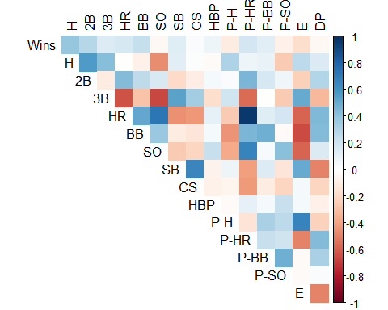

Anything over 0.5 or under -0.5 is highlighted in blue. The matrix was created using complete pairwise observations.

A few conclusions:

* Not surprisingly there is a very strong correlation between home runs batted in and home runs given up by pitching.
* There is a negative correlation between number of triples and home runs. A less powerful team may not have enough power to hit home runs, but they get a lot of triples.
* THere is a strong positive correlation between number of strikeouts and home runs. More swings of the bat results in more home runs.

#### Correlations: Endogenous and Exogenous Variables

Let’s take a look at how the Exogenous(Model Inputs) are correlated with the response variable(Endogenous):

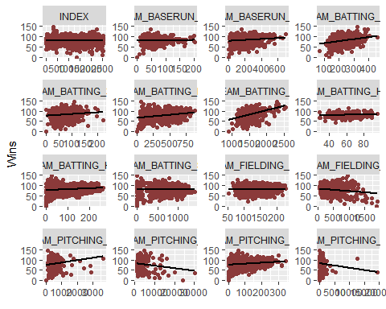

### Variable chacteristics

Each variable is presented below with corresponding basic statistics (minimum, median and maximum values, mean and standard deviation, number of records with missing values), boxplot, density plot with highlighted mean value, and scatterplot against outcome variable (TARGET_WINS) with best fit line. This information is used to check general validity of data and adjust as necessary.

#### TEAM_BATTING_H:

This variable represents number of team base hits:

Min Median Mean SD Max Num_Zeros Num_NaN  
2 891 1454 1469 145 2554 0 0

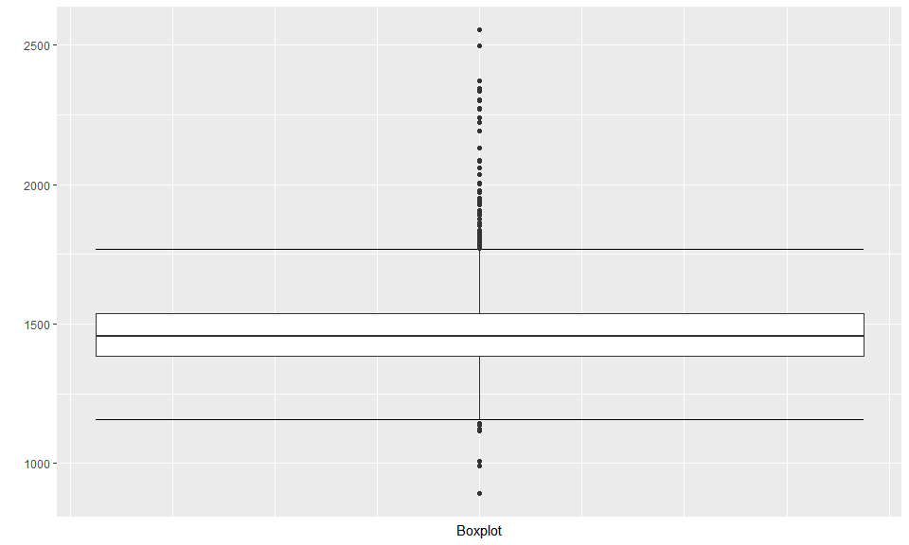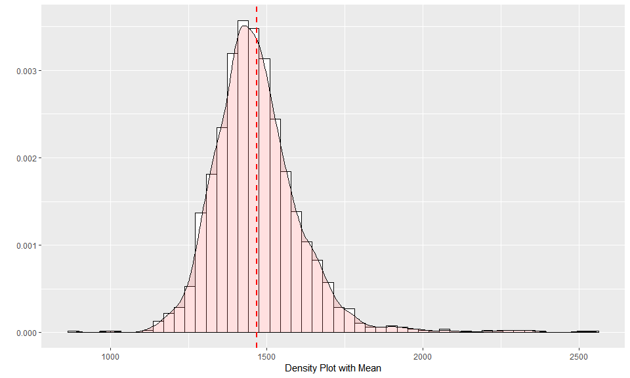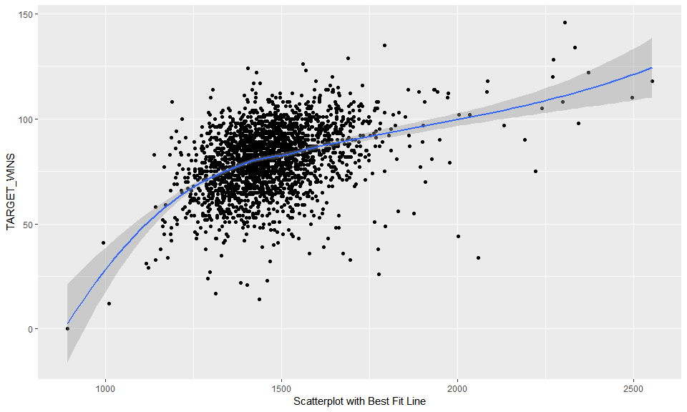

**Data Overview:** There are no missing values. The range and distribution are reasonable.

#### TEAM_BATTING_2B:

This variable represents number of team doubles:

Min Median Mean SD Max Num_Zeros Num_NaN  
3 69 238 241 47 458 0 0

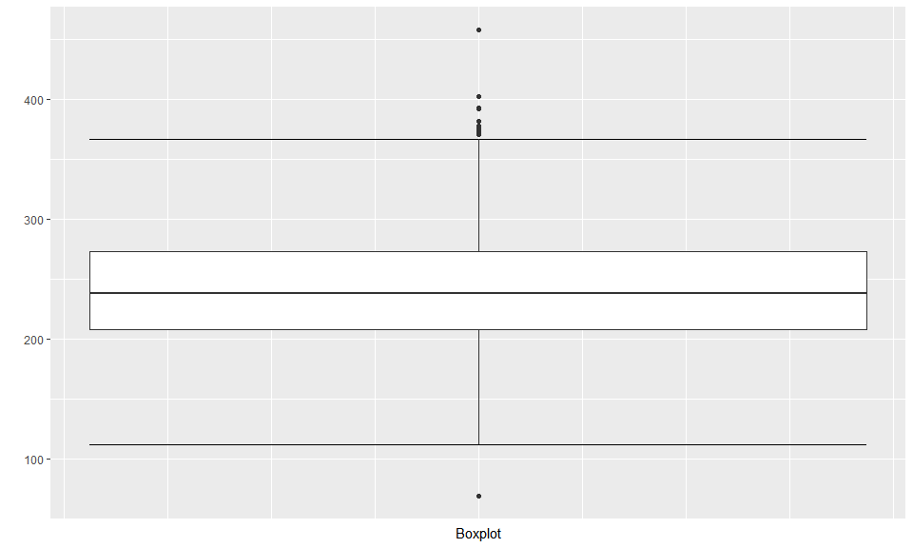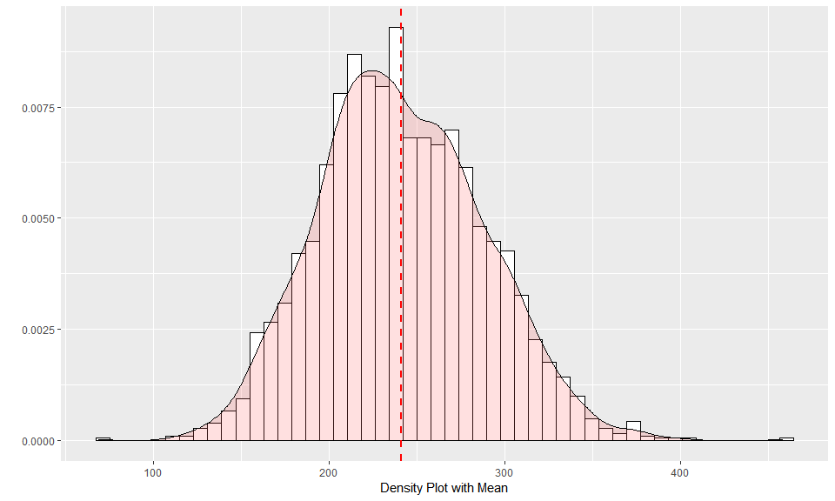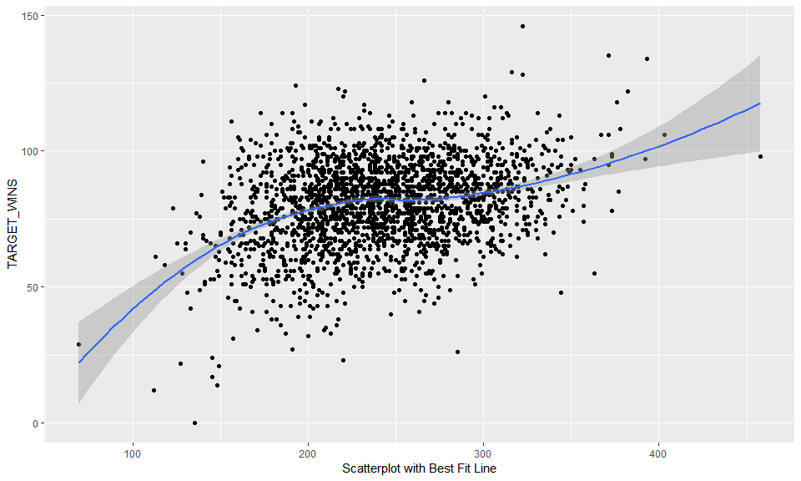

**Data Overview:** There are no missing values. The range and distribution are reasonable.

#### TEAM_BATTING_3B:

This variable represents number of team triples:

Min Median Mean SD Max Num_Zeros Num_NaN  
4 0 47 55 28 223 2 0

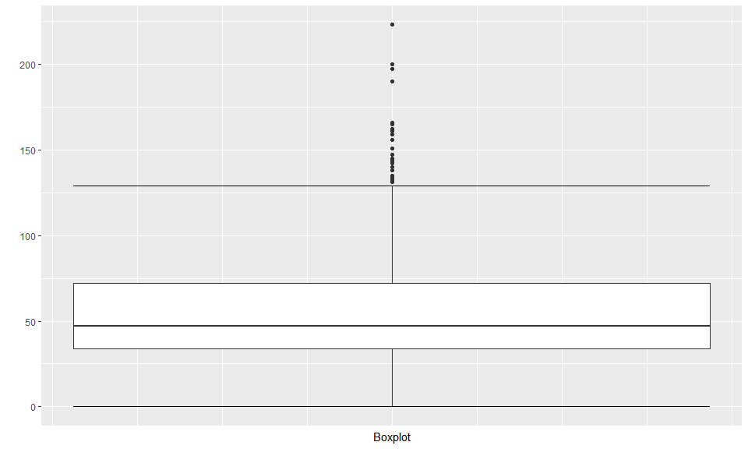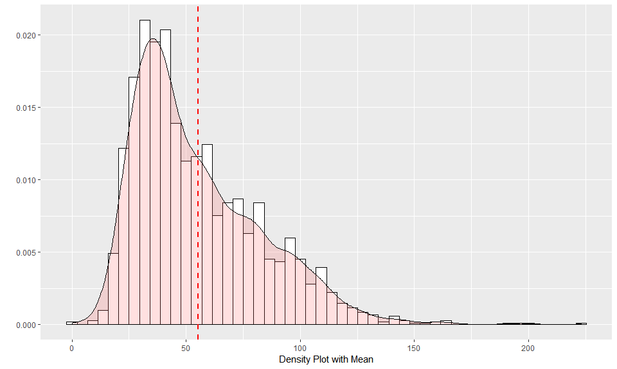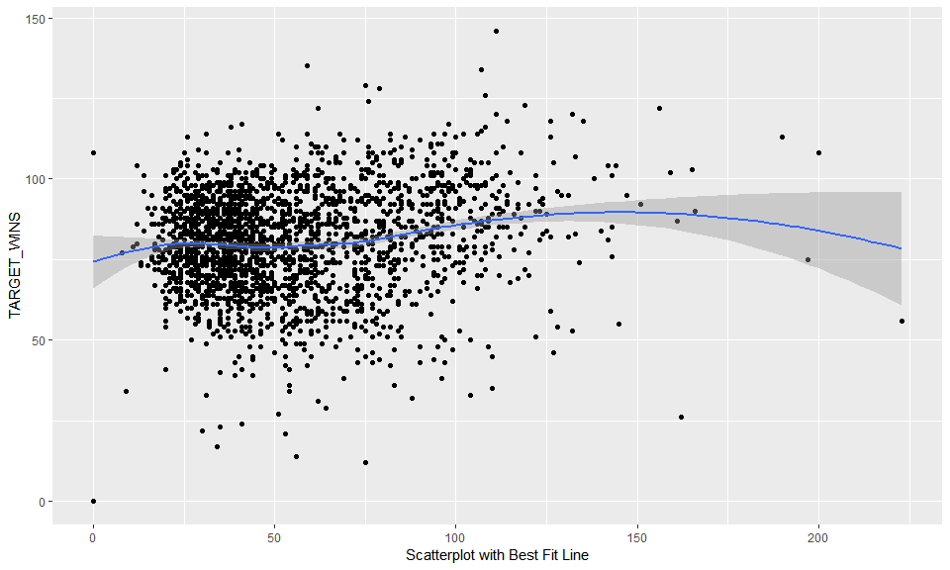

**Data Overview:**The range and distribution are reasonable. There are 2 records with zero values which is unrealistic for a team in a season. One record (index 1347) has 12 variables with missing values, including the outcome variable. This record will be deleted from the data set. Second record (index 1494) has 7 missing variables, but it does have some recorded values in all categories - batting, pitching and fielding. Zero value for TEAM_BATTING_3B can be replaced with the median (because the distribution is right-skewed, median value will provide more realistic estimate).

#### TEAM_BATTING_HR:

This variable represents number of team triples:

Min Median Mean SD Max Num_Zeros Num_NaN  
5 0 102 100 61 264 15 0

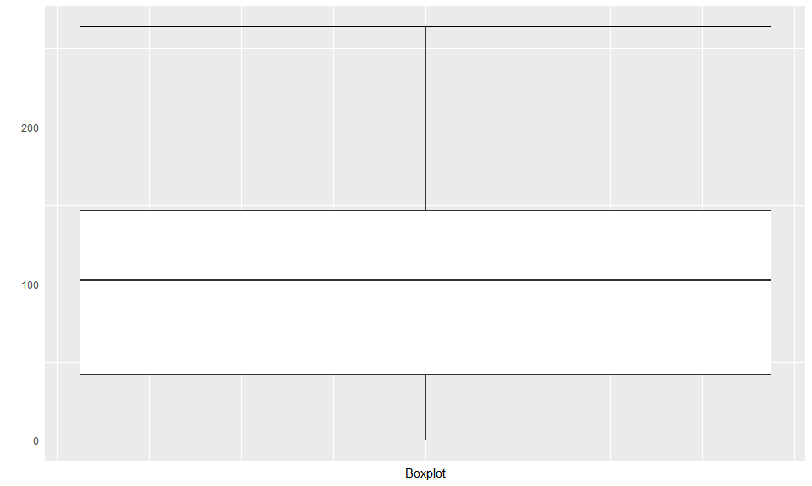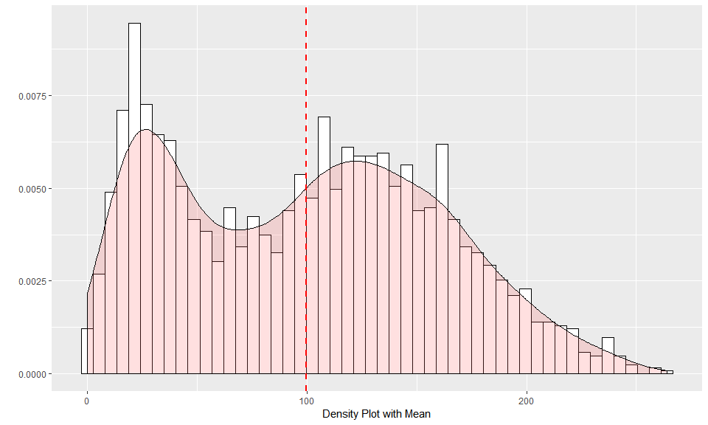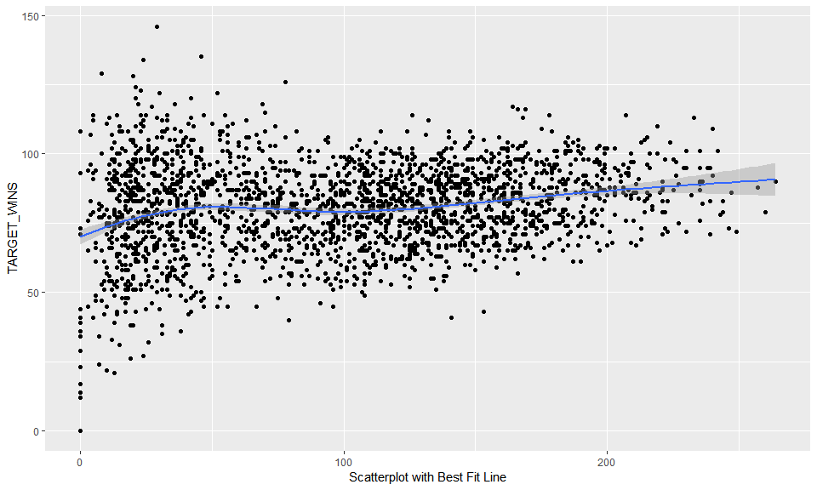

**Data Overview:**There are some low values in the data. So zero doesn’t seem too unusual here either.

#### TEAM_BATTING_BB:

This variable represents Number of team walks

Min Median Mean SD Max Num_Zeros Num_NaN  
6 0 512 502 123 878 1 0

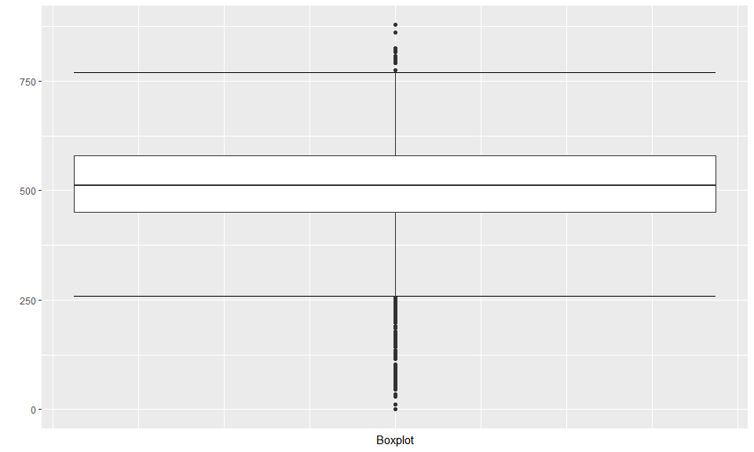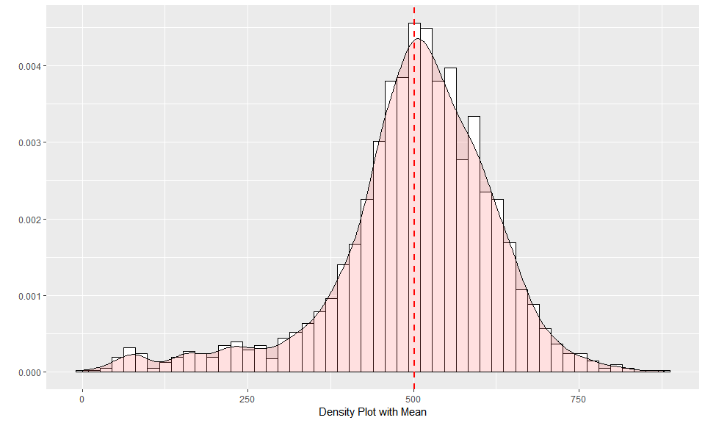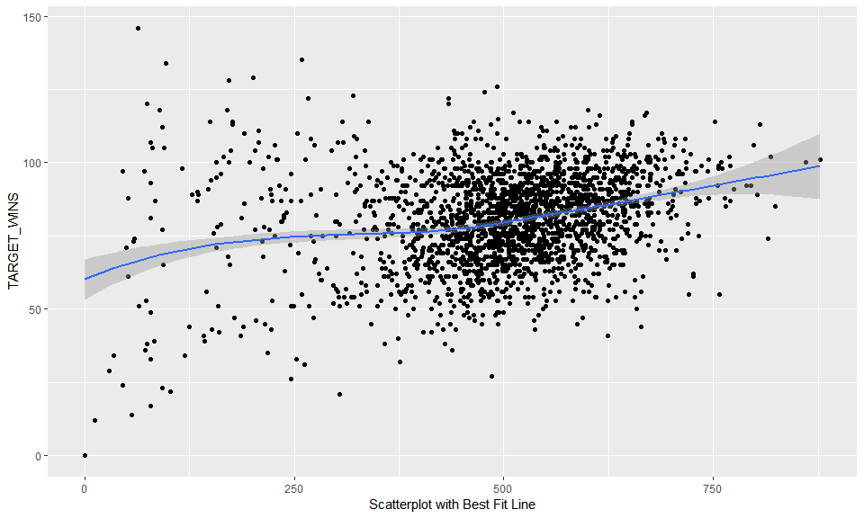

**Data Overview:** The range and distribution are reasonable. There is one record (index 1347) that has a zero value. This record was discussed above (under TEAM_BATTING_3B) and it will be deleted from the data set.

#### TEAM_BATTING_HBP:

This variable represents Number of team batters hit by pitch

Min Median Mean SD Max Num_Zeros Num_NaN  
10 29 58 59 13 95 0 2085

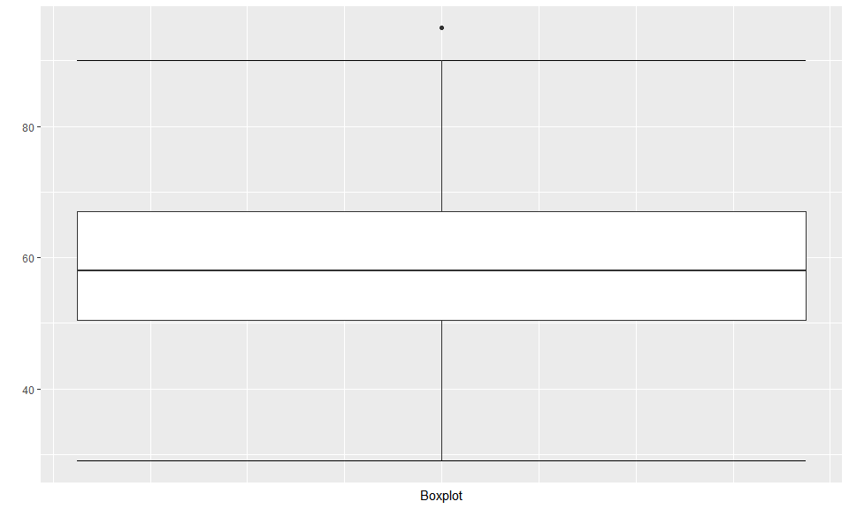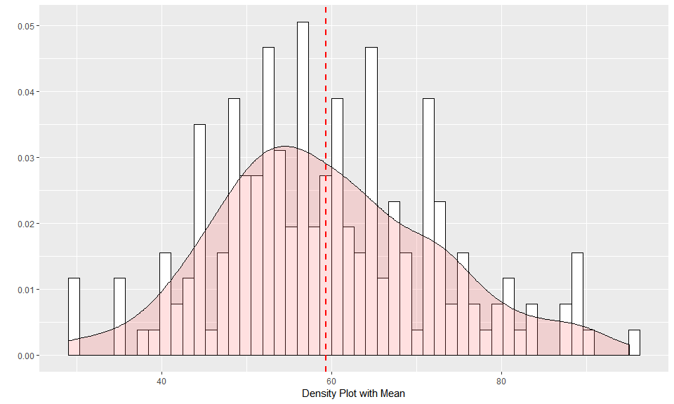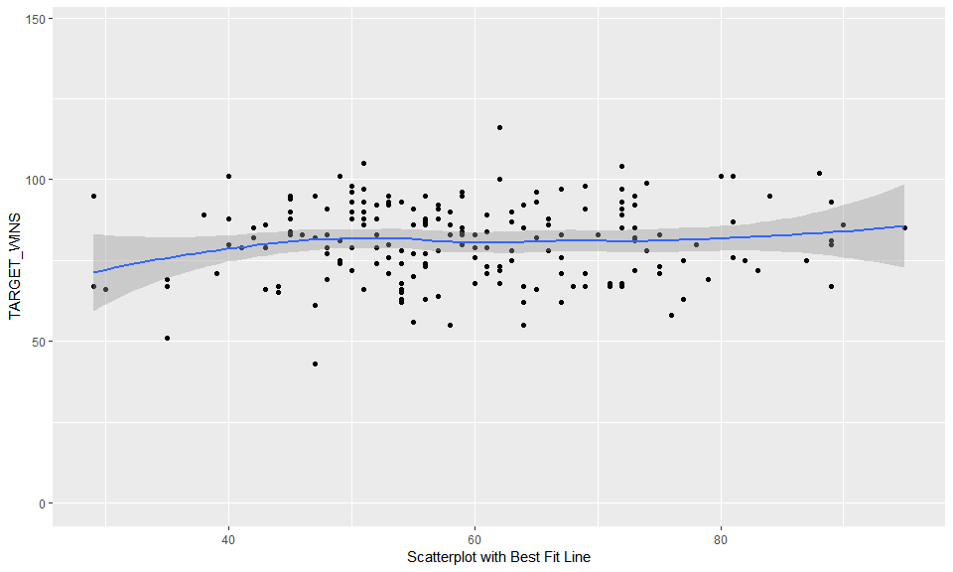

**Data Overview:** There are 2,085 records - 91.6% of data set - that are missing value. Because this variable is missing for majority of records, I wont consider this variable as input for regression model.

#### TEAM_BATTING_SO:

This variable represents Number of team strikeouts by batters

Min Median Mean SD Max Num_Zeros Num_NaN  
7 0 750 736 249 1399 20 102

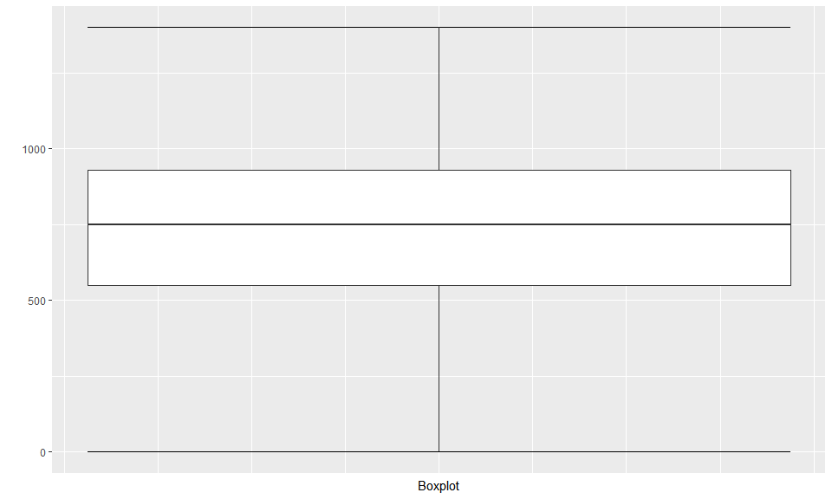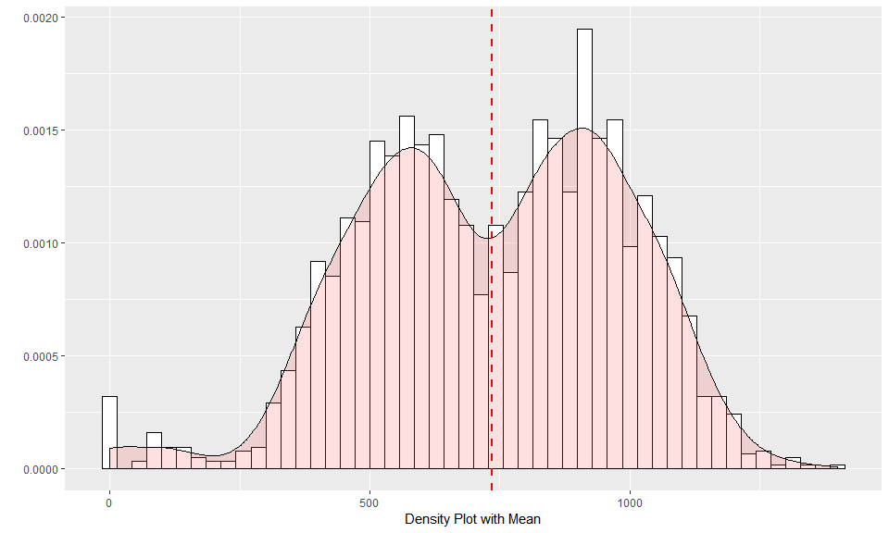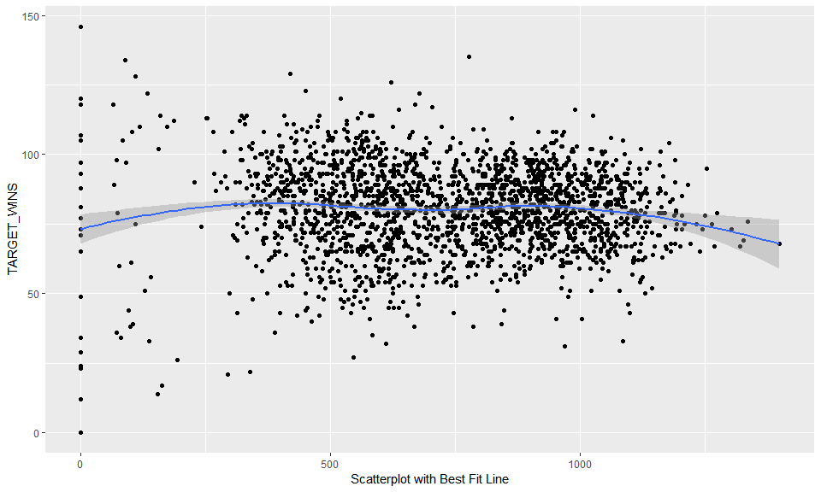

**Data Overview:** There are 122 records with missing or zero value (as wtih other variables a zero value is unrealistic). These values can be imputed. Similarly to homeruns, the distribution is multimodal, which is interesting enough for additional analysis. Another area of concern is a noticeable left tail. It is highly unlikely to have games without any strikeouts, so anything lower than 162 (average of 1 strikeout per game) is definitely suspect.

#### TEAM_BASERUN_SB:

This variable represents Number of team stolen bases

Min Median Mean SD Max Num_Zeros Num_NaN  
8 0 101 125 88 697 2 131

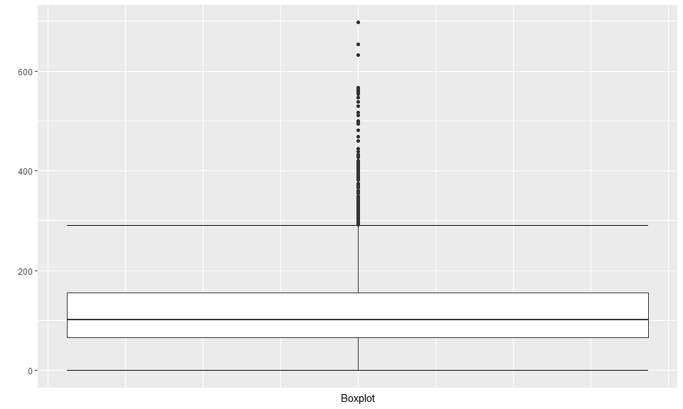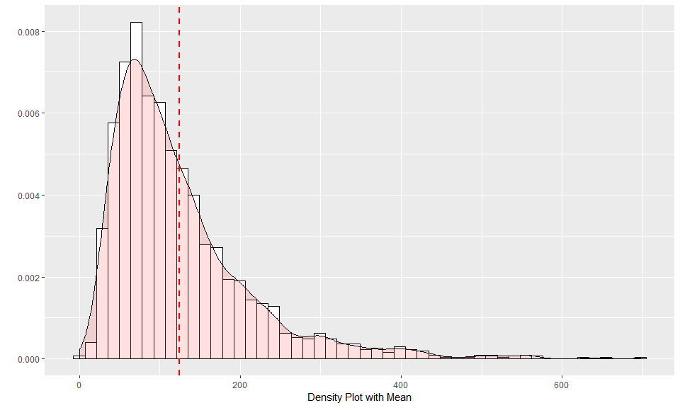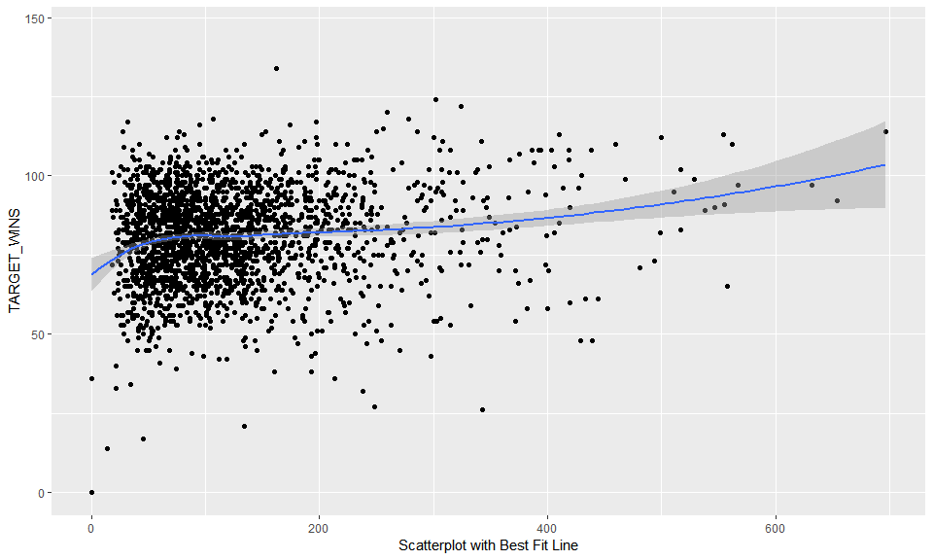

**Data Overview:** The range and distribution are reasonable. The only issue are 133 records with missing or zero value. These values can be imputed in order to use these records in model building.

#### TEAM_BASERUN_CS:

This variable represents Number of team runners caught stealing

Min Median Mean SD Max Num_Zeros Num_NaN  
9 0 49 53 23 201 1 772

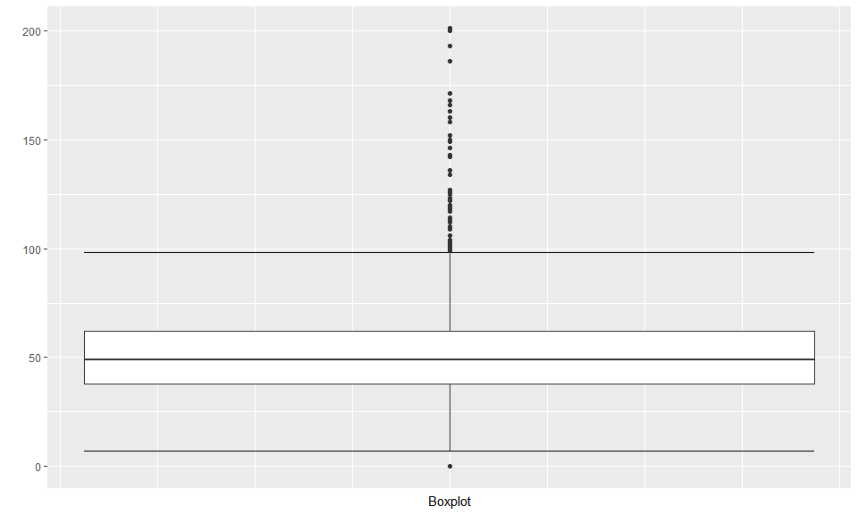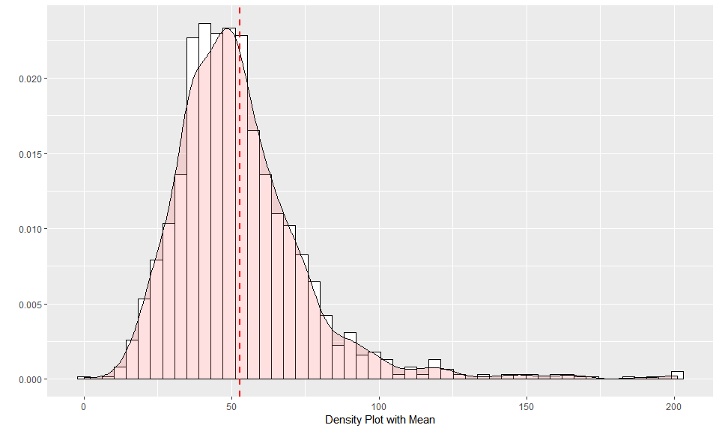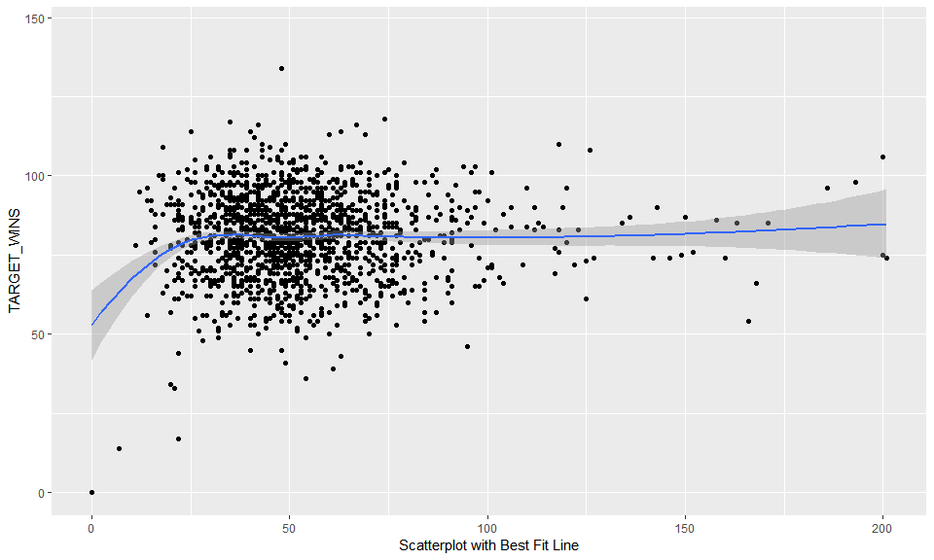

**Data Overview:** The range and distribution are reasonable; however, there is significant number of missing values - 773, including one zero value. This represents a third of the entire data set. It may be possible to impute this value, but it may be necessary to leave this variable out of model building.

#### TEAM_FIELDING_E:

This variable represents Number of team fielding errors

Min Median Mean SD Max Num_Zeros Num_NaN  
15 65 159 246 228 1898 0 0

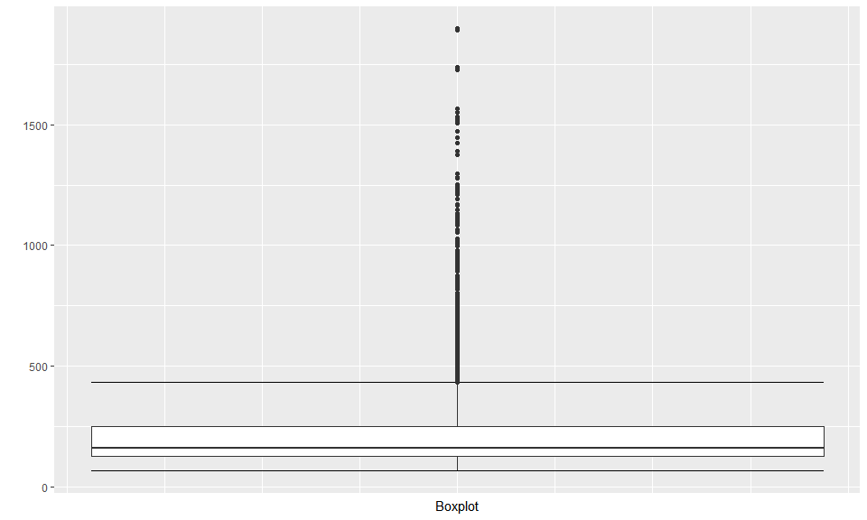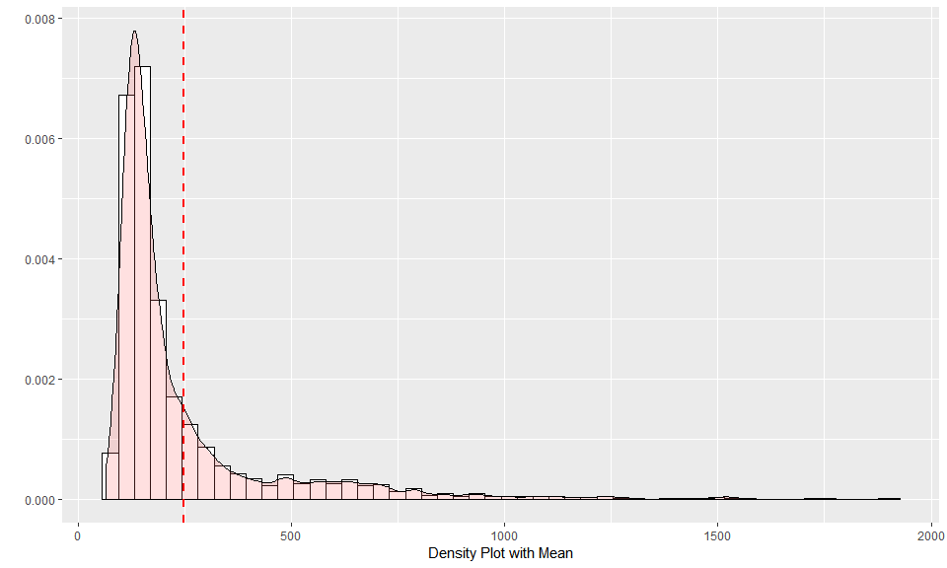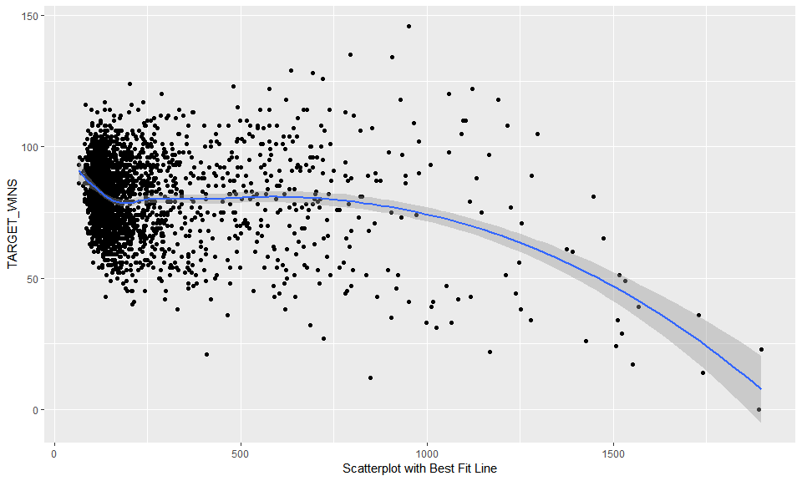

**Data Overview:** There are no missing values. Distribution has a very long right tail. Values in the 1,000 and above range are highly suspect. One of the highest historical number of errors is 867 errors by Washington in 1886 for 122 games. That is equal about 1,151 errors for 162 game season. There are multiple values above that number. This may unfavorably influence a model.

#### TEAM_FIELDING_DP:

This variable represents Number of team fielding double plays

Min Median Mean SD Max Num_Zeros Num_NaN  
16 52 149 146 26 228 0 286

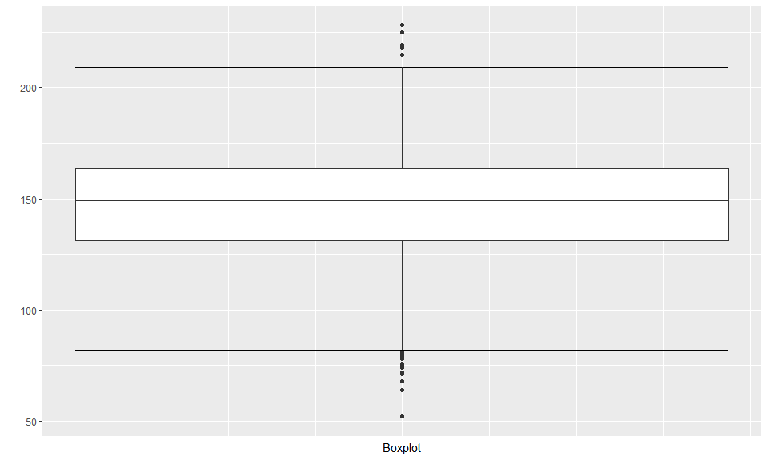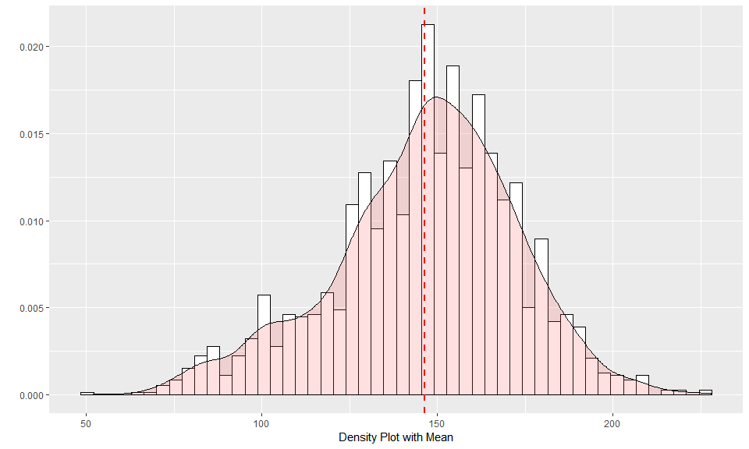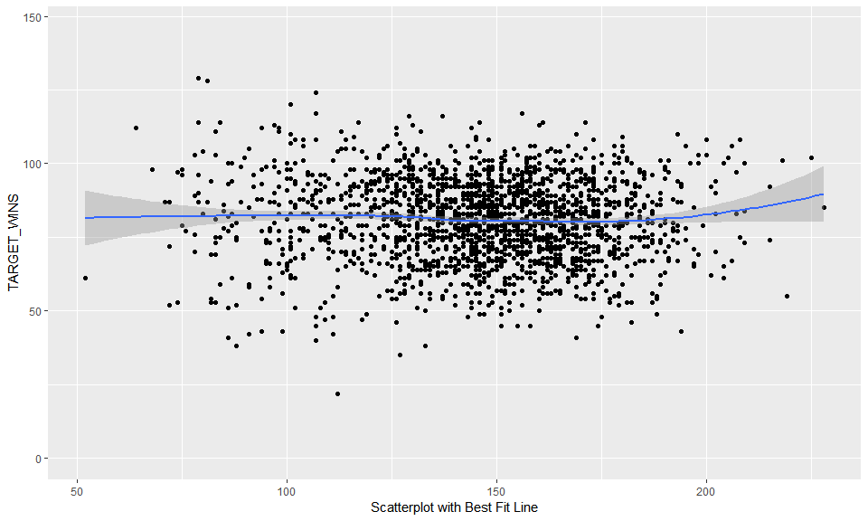

**Data Overview:** The range and distribution are reasonable. Similar to a few other variables there is a medium number off missing values - 286 records. This value can be imputed.

#### TEAM_PITCHING_BB:

This variable represents Number of walks given up by pitchers

Min Median Mean SD Max Num_Zeros Num_NaN  
13 0 536.5 553 166 3645 1 0

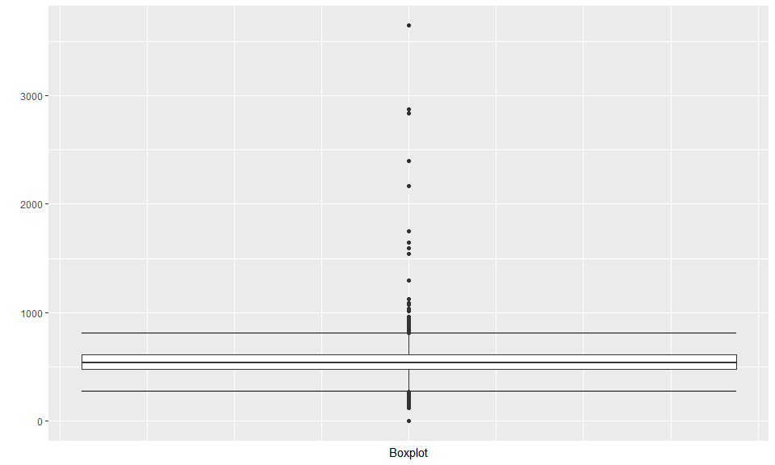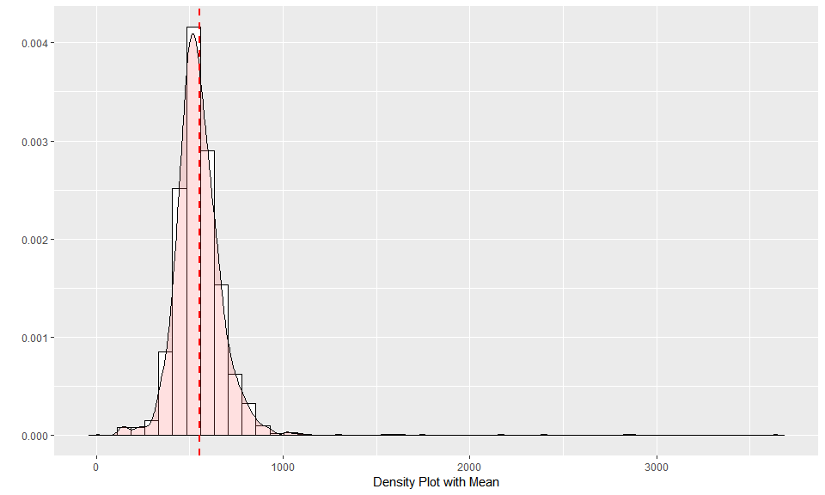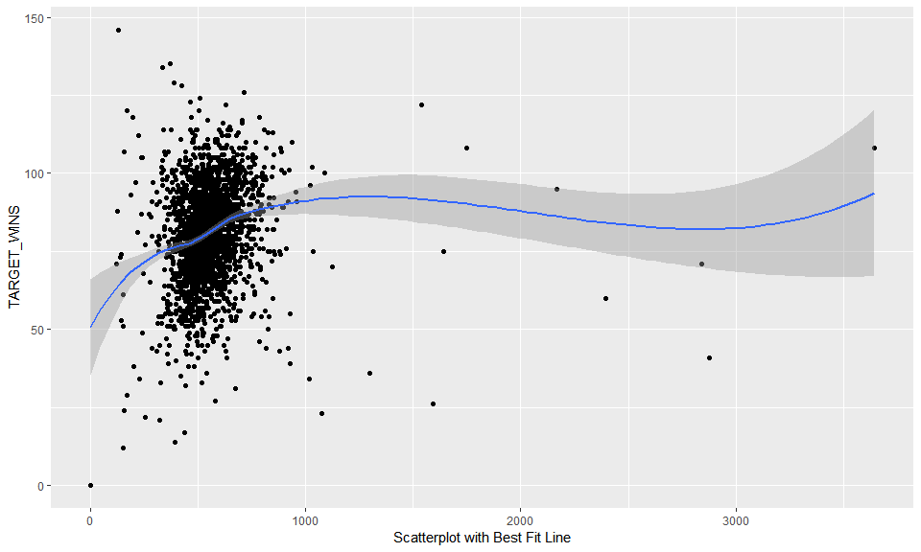

**Data Overview:** There are no missing values with the exception of record 1347 which will be deleted from model building. There are some unrealistic outliers.

#### TEAM_PITCHING_H:

This variable represents Number of base hits given up by pitchers

Min Median Mean SD Max Num_Zeros Num_NaN  
11 1137 1518 1779 1407 30132 0 0

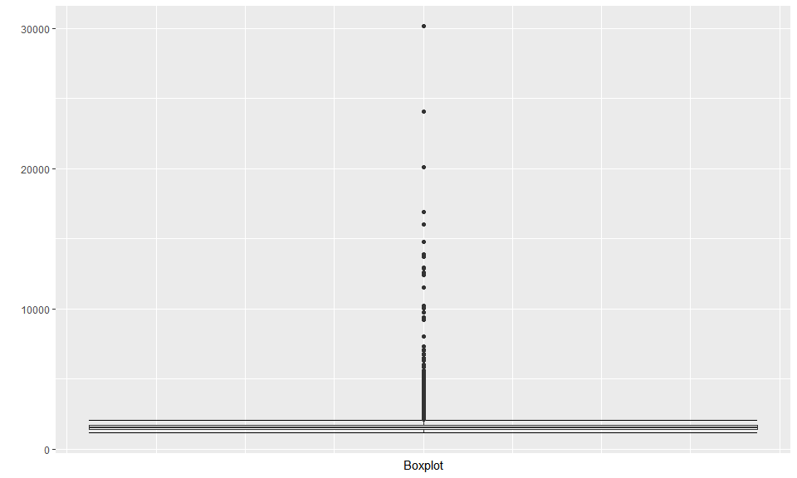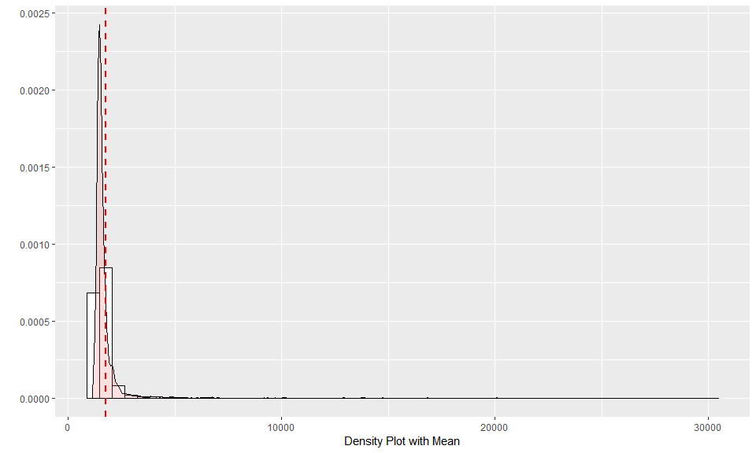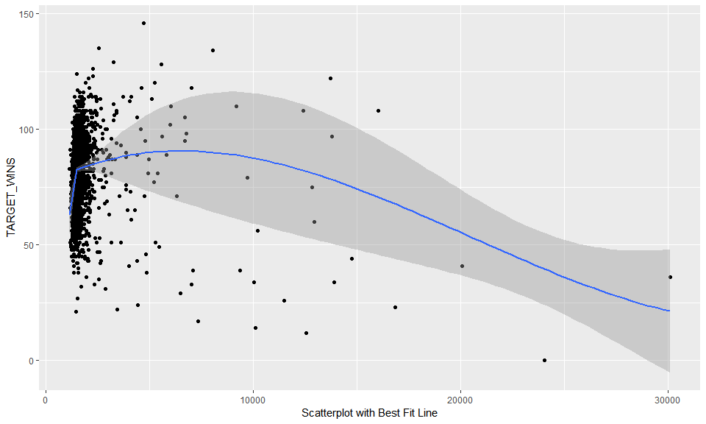

**Data Overview:** Similar to TEAM_PITCHING_BB above, there are no missing value, but there issues with outliers. Based on visualizations, this variable will be capped at 13,000 and any value over this will be set to this cap.

#### TEAM_PITCHING_SO:

This variable represents Number of strikeouts by pitchers

Min Median Mean SD Max Num_Zeros Num_NaN  
14 0 813.5 818 553 19278 20 102

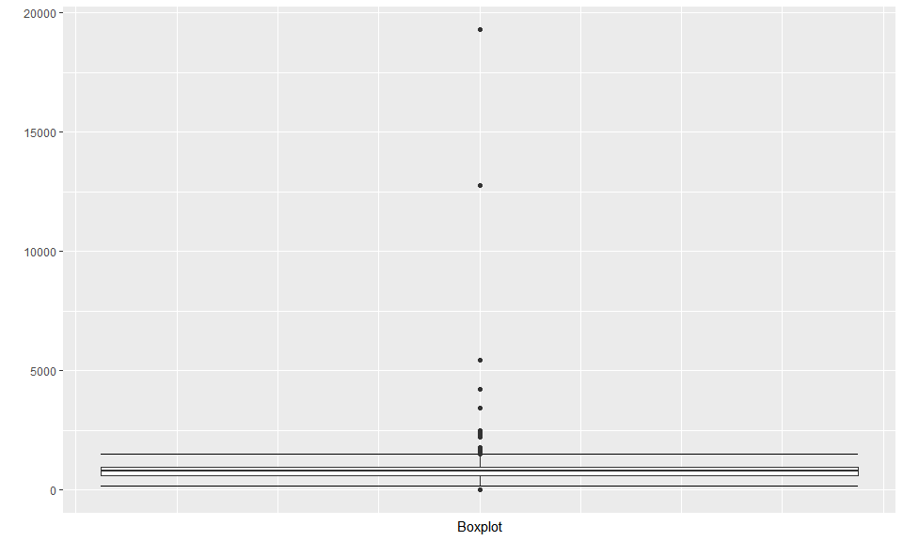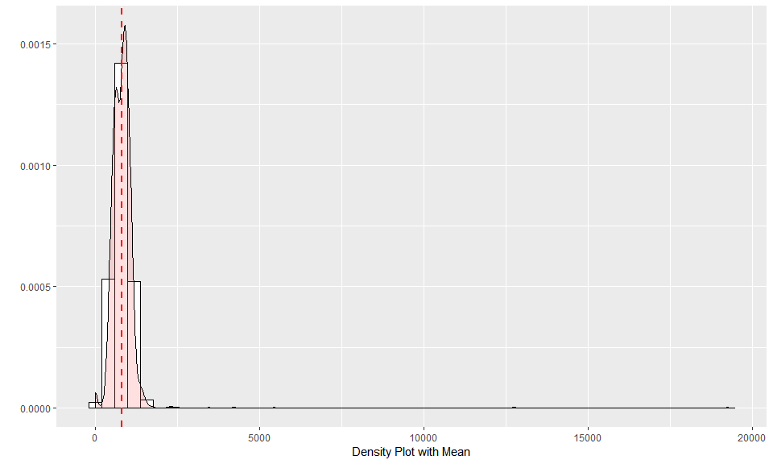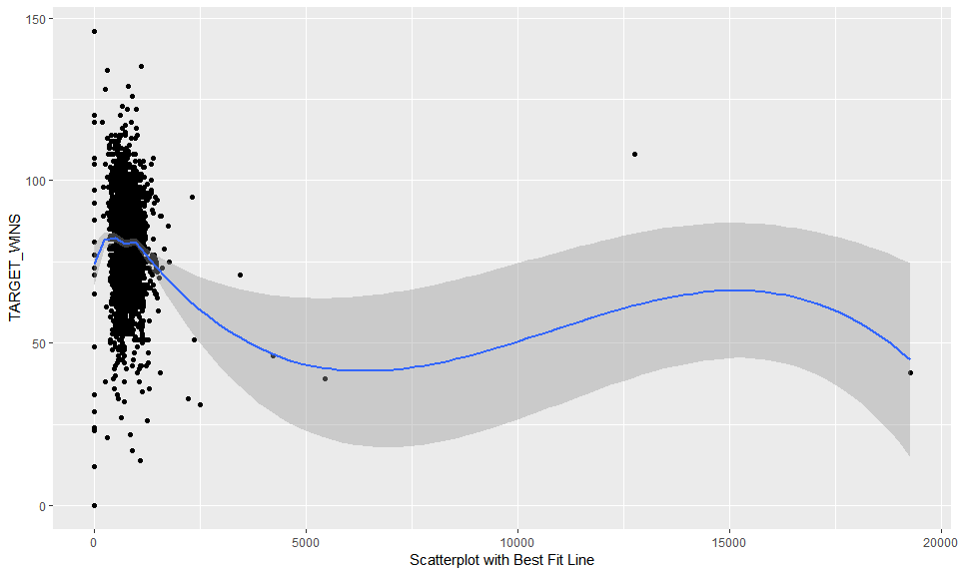

**Data Overview:** This variable has 122 missing or zero values. They can be imputed as needed. There is also an outlier issue as graph shows.

#### TARGET_WINS:

This variable represents Number of wins **(Outcome)**

Min Median Mean SD Max Num_Zeros Num_NaN  
1 0 82 81 16 146 1 0

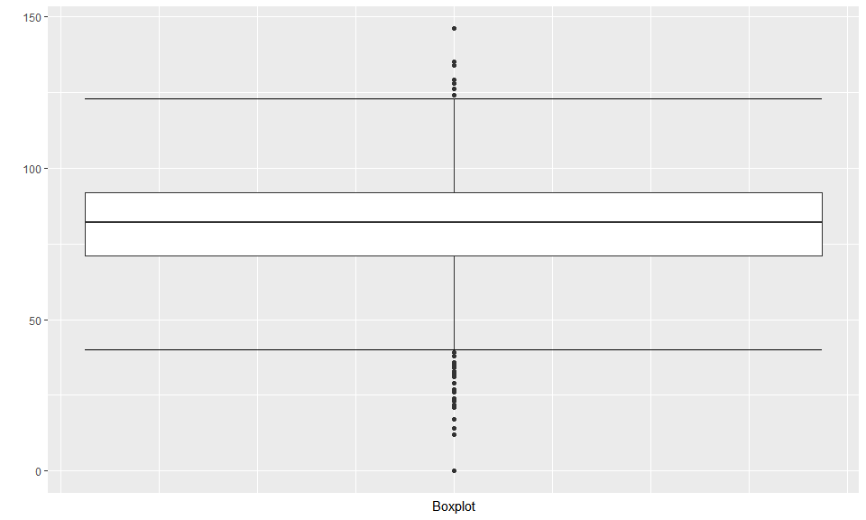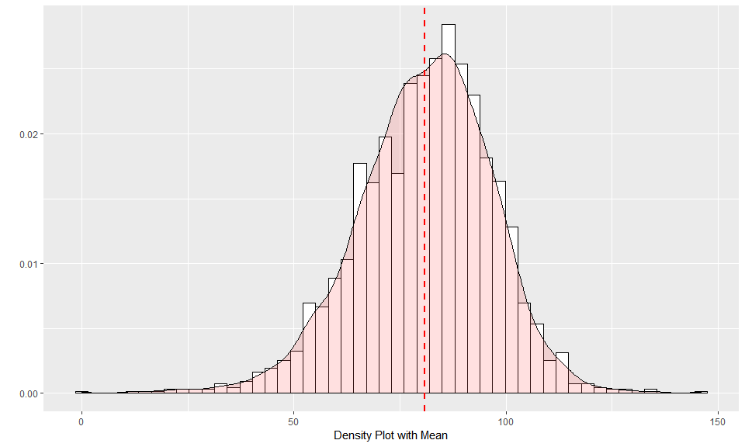

**Data Overview:** The range and distribution are reasonable. There are no missing values with the exception of record 1347.

## DATA PREPARATION

### Fixing Missing/Zero Values- TRAINING DATA

First I will remove the invalid data and prep it for imputation. I will drop the hit by pitcher variable from the dataset.

### KNN imputation - TRAINING DATA

### Feature Engineering - TRAINING DATA

The batting singles is not included but I can back it out of the hits.

### Model Data Look

Here’s what the data look like after imputation and correction:

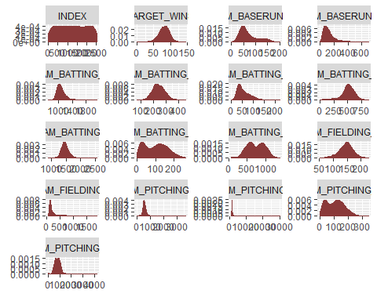

INDEX TARGET_WINS TEAM_BATTING_H TEAM_BATTING_2B  
 Min. : 1.0 Min. : 0.00 Min. : 891 Min. : 69.0   
 1st Qu.: 630.8 1st Qu.: 71.00 1st Qu.:1383 1st Qu.:208.0   
 Median :1270.5 Median : 82.00 Median :1454 Median :238.0   
 Mean :1268.5 Mean : 80.79 Mean :1469 Mean :241.2   
 3rd Qu.:1915.5 3rd Qu.: 92.00 3rd Qu.:1537 3rd Qu.:273.0   
 Max. :2535.0 Max. :146.00 Max. :2554 Max. :458.0   
 TEAM_BATTING_3B TEAM_BATTING_HR TEAM_BATTING_BB TEAM_BATTING_SO  
 Min. : 0.00 Min. : 0.00 Min. : 0.0 Min. : 66   
 1st Qu.: 34.00 1st Qu.: 42.00 1st Qu.:451.0 1st Qu.: 554   
 Median : 47.00 Median :102.00 Median :512.0 Median : 733   
 Mean : 55.25 Mean : 99.61 Mean :501.6 Mean : 735   
 3rd Qu.: 72.00 3rd Qu.:147.00 3rd Qu.:580.0 3rd Qu.: 925   
 Max. :223.00 Max. :264.00 Max. :878.0 Max. :1399   
 TEAM_BASERUN_SB TEAM_BASERUN_CS TEAM_PITCHING_H TEAM_PITCHING_HR  
 Min. : 0.0 Min. : 0.0 Min. : 1137 Min. : 0.0   
 1st Qu.: 67.0 1st Qu.: 43.0 1st Qu.: 1419 1st Qu.: 50.0   
 Median :104.0 Median : 58.0 Median : 1518 Median :107.0   
 Mean :124.7 Mean : 69.7 Mean : 1779 Mean :105.7   
 3rd Qu.:153.2 3rd Qu.: 89.0 3rd Qu.: 1682 3rd Qu.:150.0   
 Max. :697.0 Max. :201.0 Max. :30132 Max. :343.0   
 TEAM_PITCHING_BB TEAM_PITCHING_SO TEAM_FIELDING_E TEAM_FIELDING_DP  
 Min. : 0.0 Min. : 0.0 Min. : 65.0 Min. : 52.0   
 1st Qu.: 476.0 1st Qu.: 618.5 1st Qu.: 127.0 1st Qu.:130.0   
 Median : 536.5 Median : 797.0 Median : 159.0 Median :147.0   
 Mean : 553.0 Mean : 795.8 Mean : 246.5 Mean :145.4   
 3rd Qu.: 611.0 3rd Qu.: 957.0 3rd Qu.: 249.2 3rd Qu.:162.0   
 Max. :3645.0 Max. :4224.0 Max. :1898.0 Max. :228.0   
 TEAM_BATTING_1B   
 Min. : 709.0   
 1st Qu.: 990.8   
 Median :1050.0   
 Mean :1073.2   
 3rd Qu.:1129.0   
 Max. :2112.0

## BUILD MODELS

I split training dat 70 %training purposes and 30 % for testing purposes.

### Model 1

The first model includes several variables, selected manually, that have higher than average correlation to the target variable. They cover hitting, walking and fielding errors.

Call:  
lm(formula = TARGET_WINS ~ TEAM_BATTING_H + TEAM_BATTING_BB +   
 TEAM_FIELDING_E, data = train)  
  
Residuals:  
 Min 1Q Median 3Q Max   
-50.366 -9.091 -0.009 9.193 50.035   
  
Coefficients:  
 Estimate Std. Error t value Pr(>|t|)   
(Intercept) 0.191724 4.089763 0.047 0.963   
TEAM_BATTING_H 0.050059 0.002587 19.349 < 2e-16 ***  
TEAM_BATTING_BB 0.020486 0.003840 5.335 1.09e-07 ***  
TEAM_FIELDING_E -0.012959 0.002100 -6.170 8.64e-10 ***  
---  
Signif. codes: 0 '***' 0.001 '**' 0.01 '*' 0.05 '.' 0.1 ' ' 1  
  
Residual standard error: 13.82 on 1591 degrees of freedom  
Multiple R-squared: 0.2496, Adjusted R-squared: 0.2482   
F-statistic: 176.4 on 3 and 1591 DF, p-value: < 2.2e-16

All variables are significant, but the $R^{2}$ value is relatively small at 0.2427.

### Model 2

The second model expand the base hit variable, TEAM_BATTING_H, into its components - singles, doubles, triples and home runs.

Call:  
lm(formula = TARGET_WINS ~ TEAM_BATTING_1B + TEAM_BATTING_2B +   
 TEAM_BATTING_3B + TEAM_BATTING_HR + TEAM_BATTING_BB + TEAM_FIELDING_E,   
 data = train)  
  
Residuals:  
 Min 1Q Median 3Q Max   
-49.132 -8.827 0.021 8.908 58.695   
  
Coefficients:  
 Estimate Std. Error t value Pr(>|t|)   
(Intercept) 4.881325 4.207715 1.160 0.246   
TEAM_BATTING_1B 0.045001 0.003881 11.594 < 2e-16 ***  
TEAM_BATTING_2B 0.015157 0.008794 1.724 0.085 .   
TEAM_BATTING_3B 0.193543 0.018105 10.690 < 2e-16 ***  
TEAM_BATTING_HR 0.092140 0.009316 9.890 < 2e-16 ***  
TEAM_BATTING_BB 0.016433 0.003871 4.245 2.31e-05 ***  
TEAM_FIELDING_E -0.016851 0.002305 -7.309 4.23e-13 ***  
---  
Signif. codes: 0 '***' 0.001 '**' 0.01 '*' 0.05 '.' 0.1 ' ' 1  
  
Residual standard error: 13.52 on 1588 degrees of freedom  
Multiple R-squared: 0.2832, Adjusted R-squared: 0.2805   
F-statistic: 104.6 on 6 and 1588 DF, p-value: < 2.2e-16

All variables are still significant and $R^{2}$ is slightly improved at 0.2628.

### Model 3 :Higher Order Stepwise Regression

For the third model I will use a stepwise regression method using a backwards elimination process. I also introduce some higher order polynomial variables.

Call:  
lm(formula = poly_call[2], data = train)  
  
Residuals:  
 Min 1Q Median 3Q Max   
-38.548 -8.039 -0.351 7.703 63.122   
  
Coefficients:  
 Estimate Std. Error t value Pr(>|t|)   
(Intercept) 8.463e+01 1.803e+01 4.694 2.91e-06 ***  
TEAM_BATTING_2B 1.246e-01 5.604e-02 2.223 0.026354 *   
TEAM_BATTING_3B 1.562e-01 2.050e-02 7.619 4.39e-14 ***  
TEAM_BATTING_BB -2.367e-01 3.142e-02 -7.533 8.34e-14 ***  
TEAM_BATTING_SO 4.425e-02 1.087e-02 4.070 4.93e-05 ***  
TEAM_BASERUN_SB 2.578e-02 6.347e-03 4.061 5.12e-05 ***  
TEAM_PITCHING_H -7.289e-03 2.086e-03 -3.494 0.000490 ***  
TEAM_PITCHING_HR 1.645e-01 2.695e-02 6.104 1.30e-09 ***  
TEAM_PITCHING_BB 6.279e-02 1.525e-02 4.116 4.05e-05 ***  
TEAM_PITCHING_SO 1.107e-02 5.053e-03 2.191 0.028583 *   
TEAM_FIELDING_E -6.283e-02 7.523e-03 -8.352 < 2e-16 ***  
TEAM_FIELDING_DP -8.851e-02 1.647e-02 -5.375 8.83e-08 ***  
TEAM_BATTING_1B -4.447e-02 2.481e-02 -1.792 0.073251 .   
I(TEAM_BATTING_2B^2) -1.639e-04 1.102e-04 -1.487 0.137087   
I(TEAM_BATTING_HR^2) 4.864e-04 1.091e-04 4.456 8.92e-06 ***  
I(TEAM_BATTING_BB^2) 1.949e-04 2.279e-05 8.555 < 2e-16 ***  
I(TEAM_BATTING_SO^2) -3.712e-05 6.471e-06 -5.736 1.16e-08 ***  
I(TEAM_BASERUN_CS^2) 5.412e-04 1.051e-04 5.149 2.95e-07 ***  
I(TEAM_PITCHING_H^2) 2.052e-07 7.929e-08 2.588 0.009749 **   
I(TEAM_PITCHING_HR^2) -5.886e-04 1.109e-04 -5.309 1.26e-07 ***  
I(TEAM_PITCHING_BB^2) -1.309e-05 4.293e-06 -3.048 0.002338 **   
I(TEAM_PITCHING_SO^2) -2.983e-06 1.267e-06 -2.354 0.018713 *   
I(TEAM_FIELDING_E^2) 1.834e-05 5.211e-06 3.519 0.000446 ***  
I(TEAM_BATTING_1B^2) 4.353e-05 1.029e-05 4.231 2.46e-05 ***  
---  
Signif. codes: 0 '***' 0.001 '**' 0.01 '*' 0.05 '.' 0.1 ' ' 1  
  
Residual standard error: 12.41 on 1571 degrees of freedom  
Multiple R-squared: 0.4032, Adjusted R-squared: 0.3944   
F-statistic: 46.14 on 23 and 1571 DF, p-value: < 2.2e-16

This model has the highest adjusted R-squared value at 0.3944 .Some variables p-values are not in 95 % siginificant level but they are in 90 % significant level which is acceptable.

### Model 4

For the fourth model, Variables were selected either based on correlation information from the first section. The following model has $R^{2}$ values of 0.2606, which is relatively close to the fourth model; however, this model has fewer variables and may be preferential because of its simplicity.

Call:  
lm(formula = TARGET_WINS ~ TEAM_BATTING_SO + TEAM_BATTING_3B +   
 TEAM_BATTING_HR + TEAM_BASERUN_SB + TEAM_FIELDING_E_LOG *   
 TEAM_PITCHING_H, data = train)  
  
Residuals:  
 Min 1Q Median 3Q Max   
-67.376 -8.286 -0.003 8.323 75.209   
  
Coefficients:  
 Estimate Std. Error t value Pr(>|t|)   
(Intercept) 73.0506213 9.3014936 7.854 7.39e-15 ***  
TEAM_BATTING_SO -0.0190443 0.0024547 -7.758 1.53e-14 ***  
TEAM_BATTING_3B 0.1886994 0.0210281 8.974 < 2e-16 ***  
TEAM_BATTING_HR 0.1145298 0.0098324 11.648 < 2e-16 ***  
TEAM_BASERUN_SB 0.0461917 0.0049564 9.320 < 2e-16 ***  
TEAM_FIELDING_E_LOG -3.5210552 1.4774803 -2.383 0.0173 *   
TEAM_PITCHING_H 0.0312198 0.0049147 6.352 2.76e-10 ***  
TEAM_FIELDING_E_LOG:TEAM_PITCHING_H -0.0043771 0.0006843 -6.397 2.09e-10 ***  
---  
Signif. codes: 0 '***' 0.001 '**' 0.01 '*' 0.05 '.' 0.1 ' ' 1  
  
Residual standard error: 13.55 on 1587 degrees of freedom  
Multiple R-squared: 0.2813, Adjusted R-squared: 0.2781   
F-statistic: 88.73 on 7 and 1587 DF, p-value: < 2.2e-16

## SELECT MODELS

In order to select which model is the “best” I will test it against a validation (test) set. I will examine the difference between the predicted and actual values.

### Model 1 Results

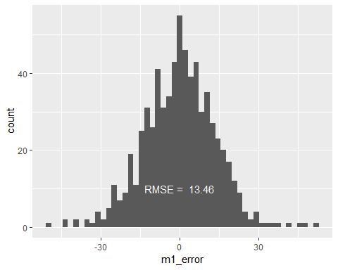

Min. 1st Qu. Median Mean 3rd Qu. Max.   
-49.65700 -8.58739 0.01945 -0.10902 8.50826 52.08518

### Model 2 Results

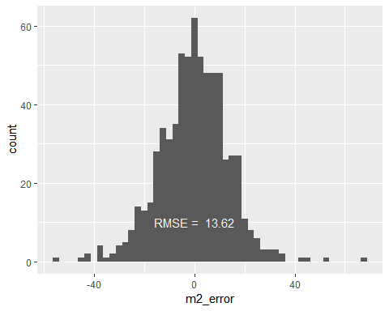

Min. 1st Qu. Median Mean 3rd Qu. Max.   
-55.27014 -8.12926 0.26431 -0.00126 8.53172 67.37311

### Model 3 Results

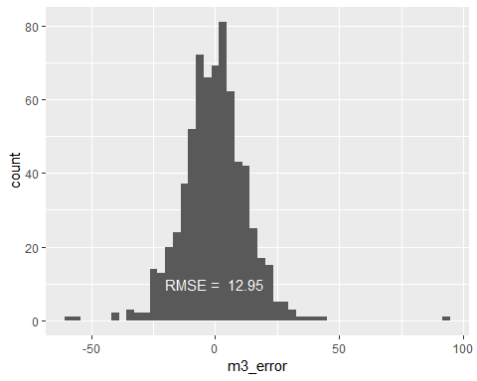

Min. 1st Qu. Median Mean 3rd Qu. Max.   
-59.70232 -7.77596 -0.03296 -0.27844 7.16360 92.51153

### Model 4 Results

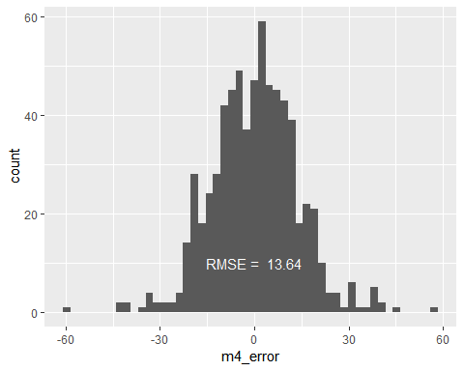

Min. 1st Qu. Median Mean 3rd Qu. Max.   
-59.8164 -8.4904 0.6244 0.1682 8.7404 56.9616

**Based on $R^{2}$ value and RMSE results, the third model (M3) was selected for further analysis. This model also has the lowest AIC score.**

df AIC  
m1 5 12910.59  
m2 8 12843.45  
m3 25 12585.36  
m4 9 12849.71

Call:  
lm(formula = poly_call[2], data = train)  
  
Residuals:  
 Min 1Q Median 3Q Max   
-38.548 -8.039 -0.351 7.703 63.122   
  
Coefficients:  
 Estimate Std. Error t value Pr(>|t|)   
(Intercept) 8.463e+01 1.803e+01 4.694 2.91e-06 ***  
TEAM_BATTING_2B 1.246e-01 5.604e-02 2.223 0.026354 *   
TEAM_BATTING_3B 1.562e-01 2.050e-02 7.619 4.39e-14 ***  
TEAM_BATTING_BB -2.367e-01 3.142e-02 -7.533 8.34e-14 ***  
TEAM_BATTING_SO 4.425e-02 1.087e-02 4.070 4.93e-05 ***  
TEAM_BASERUN_SB 2.578e-02 6.347e-03 4.061 5.12e-05 ***  
TEAM_PITCHING_H -7.289e-03 2.086e-03 -3.494 0.000490 ***  
TEAM_PITCHING_HR 1.645e-01 2.695e-02 6.104 1.30e-09 ***  
TEAM_PITCHING_BB 6.279e-02 1.525e-02 4.116 4.05e-05 ***  
TEAM_PITCHING_SO 1.107e-02 5.053e-03 2.191 0.028583 *   
TEAM_FIELDING_E -6.283e-02 7.523e-03 -8.352 < 2e-16 ***  
TEAM_FIELDING_DP -8.851e-02 1.647e-02 -5.375 8.83e-08 ***  
TEAM_BATTING_1B -4.447e-02 2.481e-02 -1.792 0.073251 .   
I(TEAM_BATTING_2B^2) -1.639e-04 1.102e-04 -1.487 0.137087   
I(TEAM_BATTING_HR^2) 4.864e-04 1.091e-04 4.456 8.92e-06 ***  
I(TEAM_BATTING_BB^2) 1.949e-04 2.279e-05 8.555 < 2e-16 ***  
I(TEAM_BATTING_SO^2) -3.712e-05 6.471e-06 -5.736 1.16e-08 ***  
I(TEAM_BASERUN_CS^2) 5.412e-04 1.051e-04 5.149 2.95e-07 ***  
I(TEAM_PITCHING_H^2) 2.052e-07 7.929e-08 2.588 0.009749 **   
I(TEAM_PITCHING_HR^2) -5.886e-04 1.109e-04 -5.309 1.26e-07 ***  
I(TEAM_PITCHING_BB^2) -1.309e-05 4.293e-06 -3.048 0.002338 **   
I(TEAM_PITCHING_SO^2) -2.983e-06 1.267e-06 -2.354 0.018713 *   
I(TEAM_FIELDING_E^2) 1.834e-05 5.211e-06 3.519 0.000446 ***  
I(TEAM_BATTING_1B^2) 4.353e-05 1.029e-05 4.231 2.46e-05 ***  
---  
Signif. codes: 0 '***' 0.001 '**' 0.01 '*' 0.05 '.' 0.1 ' ' 1  
  
Residual standard error: 12.41 on 1571 degrees of freedom  
Multiple R-squared: 0.4032, Adjusted R-squared: 0.3944   
F-statistic: 46.14 on 23 and 1571 DF, p-value: < 2.2e-16

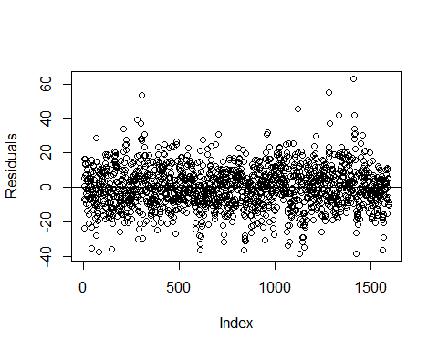

## Prediction

In order to make prediction, I need to impute missing values on “evalution” dataset by using the same as training imputation.

### Fixing Missing/Zero Values

First I will remove the invalid data and prep it for imputation. I will drop the hit by pitcher variable from the dataset.

### KNN imputation

### Feature Engineering

The batting singles is not included but I can back it out of the hits.

### Prediction

Index Predicted Wins CI Lower CI Upper  
1 9 59 56 62  
2 10 62 59 64  
3 14 71 69 73  
4 47 86 84 87  
5 60 76 69 82  
6 63 70 67 74  
7 74 72 68 75  
8 83 74 71 76  
9 98 69 66 71  
10 120 71 70 73  
11 123 67 65 69  
12 135 83 81 85  
13 138 84 81 86  
14 140 81 79 83  
15 151 82 80 84  
16 153 77 75 79  
17 171 71 69 73  
18 184 78 76 79  
19 193 68 65 70  
20 213 87 84 90  
21 217 80 78 82  
22 226 85 83 87  
23 230 85 83 87  
24 241 72 70 73  
25 291 82 81 84  
26 294 86 84 88  
27 300 46 38 54  
28 348 72 70 74  
29 350 79 77 82  
30 357 71 69 74  
31 367 97 95 100  
32 368 88 86 89  
33 372 92 89 94  
34 382 96 93 99  
35 388 81 79 82  
36 396 87 85 89  
37 398 76 75 78  
38 403 91 89 94  
39 407 92 88 96  
40 410 91 88 93  
41 412 83 81 85  
42 414 92 90 94  
43 436 30 20 41  
44 440 114 109 120  
45 476 90 87 93  
46 479 85 82 88  
47 481 92 90 95  
48 501 81 79 83  
49 503 67 65 69  
50 506 79 77 82  
51 519 75 73 77  
52 522 81 79 83  
53 550 75 74 77  
54 554 75 74 77  
55 566 74 73 75  
56 578 80 78 81  
57 596 87 85 90  
58 599 76 73 78  
59 605 56 51 60  
60 607 76 74 78  
61 614 83 80 85  
62 644 84 81 88  
63 692 87 86 89  
64 699 85 82 89  
65 700 85 83 88  
66 716 88 84 92  
67 721 76 74 77  
68 722 81 78 83  
69 729 74 71 76  
70 731 90 87 92  
71 746 81 78 84  
72 763 68 65 70  
73 774 80 78 82  
74 776 89 86 92  
75 788 83 80 85  
76 789 82 80 85  
77 792 86 85 88  
78 811 81 80 83  
79 835 72 70 74  
80 837 75 73 77  
81 861 79 76 82  
82 862 88 85 90  
83 863 94 90 98  
84 871 74 72 77  
85 879 90 88 91  
86 887 78 76 80  
87 892 81 79 83  
88 904 85 84 87  
89 909 90 87 92  
90 925 90 88 93  
91 940 73 70 76  
92 951 60 42 78  
93 976 63 60 66  
94 981 85 82 88  
95 983 82 79 84  
96 984 81 79 83  
97 989 99 96 103  
98 995 104 101 107  
99 1000 86 84 88  
100 1001 87 84 89  
101 1007 78 76 80  
102 1016 69 67 71  
103 1027 84 82 85  
104 1033 85 83 87  
105 1070 71 68 75  
106 1081 74 71 78  
107 1084 47 43 51  
108 1098 74 72 77  
109 1150 87 85 89  
110 1160 56 52 59  
111 1169 86 84 88  
112 1172 85 83 88  
113 1174 92 90 94  
114 1176 92 90 94  
115 1178 84 83 86  
116 1184 79 77 81  
117 1193 86 84 88  
118 1196 82 80 83  
119 1199 74 72 76  
120 1207 68 65 71  
121 1218 79 76 82  
122 1223 63 60 66  
123 1226 68 65 70  
124 1227 67 62 71  
125 1229 67 64 69  
126 1241 84 81 86  
127 1244 86 83 88  
128 1246 76 74 77  
129 1248 88 86 90  
130 1249 92 90 94  
131 1253 85 83 87  
132 1261 77 75 79  
133 1305 76 74 78  
134 1314 80 77 83  
135 1323 85 83 87  
136 1328 68 65 72  
137 1353 77 75 78  
138 1363 77 76 79  
139 1371 90 88 93  
140 1372 82 80 84  
141 1389 67 64 70  
142 1393 69 66 73  
143 1421 88 86 90  
144 1431 72 71 74  
145 1437 73 71 75  
146 1442 74 73 76  
147 1450 76 75 77  
148 1463 79 78 81  
149 1464 79 77 81  
150 1470 83 82 85  
151 1471 84 82 86  
152 1484 79 78 81  
153 1495 15 -10 40  
154 1507 71 68 73  
155 1514 74 72 76  
156 1526 67 65 70  
157 1549 87 85 90  
158 1552 61 58 64  
159 1556 88 85 91  
160 1564 67 64 70  
161 1585 110 107 113  
162 1586 123 119 127  
163 1590 96 94 99  
164 1591 114 110 117  
165 1592 108 105 111  
166 1603 93 91 95  
167 1612 85 83 87  
168 1634 81 79 83  
169 1645 72 70 73  
170 1647 80 79 81  
171 1673 86 84 89  
172 1674 88 86 90  
173 1687 78 76 80  
174 1688 87 84 89  
175 1700 80 78 82  
176 1708 75 73 77  
177 1713 84 81 86  
178 1717 71 69 73  
179 1721 75 73 76  
180 1730 79 78 80  
181 1737 91 88 94  
182 1748 87 85 89  
183 1749 85 84 87  
184 1763 86 84 88  
185 1768 90 81 100  
186 1778 85 80 90  
187 1780 83 80 86  
188 1782 52 46 57  
189 1784 54 51 57  
190 1794 108 104 113  
191 1803 64 61 67  
192 1804 78 75 80  
193 1819 82 79 84  
194 1832 75 73 77  
195 1833 77 75 79  
196 1844 61 59 63  
197 1847 75 74 77  
198 1854 92 89 94  
199 1855 82 80 83  
200 1857 86 85 88  
201 1864 72 69 74  
202 1865 78 77 80  
203 1869 73 71 76  
204 1880 98 94 101  
205 1881 81 79 82  
206 1882 86 84 87  
207 1894 79 77 81  
208 1896 76 75 78  
209 1916 74 72 77  
210 1918 63 60 66  
211 1921 96 92 99  
212 1926 85 82 88  
213 1938 82 79 84  
214 1979 64 63 66  
215 1982 70 67 72  
216 1987 85 83 87  
217 1997 81 79 83  
218 2004 97 95 100  
219 2011 78 76 79  
220 2015 79 77 81  
221 2022 77 75 79  
222 2025 73 71 75  
223 2027 80 78 81  
224 2031 74 72 76  
225 2036 95 86 103  
226 2066 75 73 76  
227 2073 81 79 82  
228 2087 76 74 78  
229 2092 82 81 84  
230 2125 63 59 67  
231 2148 71 68 75  
232 2162 95 92 97  
233 2191 84 82 86  
234 2203 88 86 90  
235 2218 80 78 81  
236 2221 73 71 74  
237 2225 80 78 82  
238 2232 78 77 80  
239 2267 82 79 85  
240 2291 71 68 74  
241 2299 87 86 89  
242 2317 86 84 88  
243 2318 80 79 82  
244 2353 82 80 84  
245 2403 59 57 62  
246 2411 85 83 87  
247 2415 81 79 82  
248 2424 85 84 87  
249 2441 73 71 74  
250 2464 83 80 85  
251 2465 78 76 80  
252 2472 66 61 71  
253 2481 90 87 92  
254 2487 54 37 71  
255 2500 68 66 70  
256 2501 82 79 84  
257 2520 80 78 82  
258 2521 81 79 83  
259 2525 77 74 80

## APPENDIX: R Script

# Read in the training data

training <- read.csv(“<https://raw.githubusercontent.com/omerozeren/DATA621/master/moneyball-training-data.csv>”) # Read in the evaluation data evaluation <- read.csv(“<https://raw.githubusercontent.com/omerozeren/DATA621/master/moneyball-evaluation-data.csv>”)

sumtable = data.frame(Variable = character(), Min = integer(), Median = integer(), Mean = double(), SD = double(), Max = integer(), Num_Zeros = integer(), Num_NaN = integer()) for (i in 2:17) { sumtable <- rbind(sumtable, data.frame(Variable = colnames(training)[i], Min = min(training[,i], na.rm=TRUE), Median = median(training[,i], na.rm=TRUE), Mean = round(mean(training[,i], na.rm=TRUE)), SD = round(sd(training[,i], na.rm=TRUE)), Max = max(training[,i], na.rm=TRUE), Num_Zeros = length(which(training[,i]==0)), Num_NaN = sum(is.na(training[,i]))) ) } colnames(sumtable) <- c(“”, “Min”, “Median”, “Mean”, “SD”, “Max”,“Num_Zeros”, “Num_NaN”) sumtable

cm <- cor(training, use=“pairwise.complete.obs”) cm <- cm[2:17,2:17] names <- c(“Wins”, “H”, “2B”, “3B”, “HR”, “BB”, “SO”, “SB”, “CS”, “HBP”, “P-H”, “P-HR”, “P-BB”, “P-SO”, “E”, “DP”) colnames(cm) <- names; rownames(cm) <- names round(cm,2)

cm <- cor(training, use=“pairwise.complete.obs”) cm <- cm[2:17,2:17] names <- c(“Wins”, “H”, “2B”, “3B”, “HR”, “BB”, “SO”, “SB”, “CS”, “HBP”, “P-H”, “P-HR”, “P-BB”, “P-SO”, “E”, “DP”) colnames(cm) <- names; rownames(cm) <- names corrplot(cm, method = “color”, type = “upper”, tl.col = “black”, diag = FALSE)

training %>% gather(variable, value, -TARGET_WINS) %>% ggplot(., aes(value, TARGET_WINS)) + geom_point(fill = “indianred4”, color=“indianred4”) + geom_smooth(method = “lm”, se = FALSE, color = “black”) + facet_wrap(~variable, scales =“free”, ncol = 4) + labs(x = element_blank(), y = “Wins”)

sumtable[sumtable[,1]==“TEAM_BATTING_H”,2:8]

# Boxplot

ggplot(training, aes(x = 1, y = TEAM_BATTING_H)) + stat_boxplot(geom =‘errorbar’) + geom_boxplot() + xlab(“Boxplot”) + ylab(“”) + theme(axis.text.x=element_blank(), axis.ticks.x=element_blank())

# Density plot

ggplot(training, aes(x = TEAM_BATTING_H)) + geom_histogram(aes(y=..density..), colour=“black”, fill=“white”,bins=50) + geom_density(alpha=.2, fill=“#FF6666”) + ylab(“”) + xlab(“Density Plot with Mean”) + geom_vline(aes(xintercept=mean(TEAM_BATTING_H, na.rm=TRUE)), color=“red”, linetype=“dashed”, size=1)

# Scatterplot

ggplot(data=training, aes(x=TEAM_BATTING_H, y=TARGET_WINS)) + geom_point() + geom_smooth(method = “loess”) + xlab(“Scatterplot with Best Fit Line”)

#### TEAM_BATTING_2B:

sumtable[sumtable[,1]==“TEAM_BATTING_2B”,2:8] # Boxplot ggplot(training, aes(x = 1, y = TEAM_BATTING_2B)) + stat_boxplot(geom =‘errorbar’) + geom_boxplot() + xlab(“Boxplot”) + ylab(“”) + theme(axis.text.x=element_blank(), axis.ticks.x=element_blank()) # Density plot ggplot(training, aes(x = TEAM_BATTING_2B)) + geom_histogram(aes(y=..density..), colour=“black”, fill=“white”,bins=50) + geom_density(alpha=.2, fill=“#FF6666”) + ylab(“”) + xlab(“Density Plot with Mean”) + geom_vline(aes(xintercept=mean(TEAM_BATTING_2B, na.rm=TRUE)), color=“red”, linetype=“dashed”, size=1) # Scatterplot ggplot(data=training, aes(x=TEAM_BATTING_2B, y=TARGET_WINS)) + geom_point() + geom_smooth(method = “loess”) + xlab(“Scatterplot with Best Fit Line”)

#### TEAM_BATTING_3B:

sumtable[sumtable[,1]==“TEAM_BATTING_3B”,2:8] # Boxplot ggplot(training, aes(x = 1, y = TEAM_BATTING_3B)) + stat_boxplot(geom =‘errorbar’) + geom_boxplot() + xlab(“Boxplot”) + ylab(“”) + theme(axis.text.x=element_blank(), axis.ticks.x=element_blank()) # Density plot ggplot(training, aes(x = TEAM_BATTING_3B)) + geom_histogram(aes(y=..density..), colour=“black”, fill=“white”,bins=50) + geom_density(alpha=.2, fill=“#FF6666”) + ylab(“”) + xlab(“Density Plot with Mean”) + geom_vline(aes(xintercept=mean(TEAM_BATTING_3B, na.rm=TRUE)), color=“red”, linetype=“dashed”, size=1) # Scatterplot ggplot(data=training, aes(x=TEAM_BATTING_3B, y=TARGET_WINS)) + geom_point() + geom_smooth(method = “loess”) + xlab(“Scatterplot with Best Fit Line”)

#### TEAM_BATTING_HR:

sumtable[sumtable[,1]==“TEAM_BATTING_HR”,2:8] # Boxplot ggplot(training, aes(x = 1, y = TEAM_BATTING_HR)) + stat_boxplot(geom =‘errorbar’) + geom_boxplot() + xlab(“Boxplot”) + ylab(“”) + theme(axis.text.x=element_blank(), axis.ticks.x=element_blank()) # Density plot ggplot(training, aes(x = TEAM_BATTING_HR)) + geom_histogram(aes(y=..density..), colour=“black”, fill=“white”,bins=50) + geom_density(alpha=.2, fill=“#FF6666”) + ylab(“”) + xlab(“Density Plot with Mean”) + geom_vline(aes(xintercept=mean(TEAM_BATTING_HR, na.rm=TRUE)), color=“red”, linetype=“dashed”, size=1) # Scatterplot ggplot(data=training, aes(x=TEAM_BATTING_HR, y=TARGET_WINS)) + geom_point() + geom_smooth(method = “loess”) + xlab(“Scatterplot with Best Fit Line”)

#### TEAM_BATTING_BB:

This variable represents Number of team walks

sumtable[sumtable[,1]==“TEAM_BATTING_BB”,2:8] # Boxplot ggplot(training, aes(x = 1, y = TEAM_BATTING_BB)) + stat_boxplot(geom =‘errorbar’) + geom_boxplot() + xlab(“Boxplot”) + ylab(“”) + theme(axis.text.x=element_blank(), axis.ticks.x=element_blank()) # Density plot ggplot(training, aes(x = TEAM_BATTING_BB)) + geom_histogram(aes(y=..density..), colour=“black”, fill=“white”,bins=50) + geom_density(alpha=.2, fill=“#FF6666”) + ylab(“”) + xlab(“Density Plot with Mean”) + geom_vline(aes(xintercept=mean(TEAM_BATTING_BB, na.rm=TRUE)), color=“red”, linetype=“dashed”, size=1) # Scatterplot ggplot(data=training, aes(x=TEAM_BATTING_BB, y=TARGET_WINS)) + geom_point() + geom_smooth(method = “loess”) + xlab(“Scatterplot with Best Fit Line”)

#### TEAM_BATTING_HBP:

sumtable[sumtable[,1]==“TEAM_BATTING_HBP”,2:8] # Boxplot ggplot(training, aes(x = 1, y = TEAM_BATTING_HBP)) + stat_boxplot(geom =‘errorbar’) + geom_boxplot() + xlab(“Boxplot”) + ylab(“”) + theme(axis.text.x=element_blank(), axis.ticks.x=element_blank()) # Density plot ggplot(training, aes(x = TEAM_BATTING_HBP)) + geom_histogram(aes(y=..density..), colour=“black”, fill=“white”,bins=50) + geom_density(alpha=.2, fill=“#FF6666”) + ylab(“”) + xlab(“Density Plot with Mean”) + geom_vline(aes(xintercept=mean(TEAM_BATTING_HBP, na.rm=TRUE)), color=“red”, linetype=“dashed”, size=1) # Scatterplot ggplot(data=training, aes(x=TEAM_BATTING_HBP, y=TARGET_WINS)) + geom_point() + geom_smooth(method = “loess”) + xlab(“Scatterplot with Best Fit Line”)

#### TEAM_BATTING_SO:

sumtable[sumtable[,1]==“TEAM_BATTING_SO”,2:8] # Boxplot ggplot(training, aes(x = 1, y = TEAM_BATTING_SO)) + stat_boxplot(geom =‘errorbar’) + geom_boxplot() + xlab(“Boxplot”) + ylab(“”) + theme(axis.text.x=element_blank(), axis.ticks.x=element_blank()) # Density plot ggplot(training, aes(x = TEAM_BATTING_SO)) + geom_histogram(aes(y=..density..), colour=“black”, fill=“white”,bins=50) + geom_density(alpha=.2, fill=“#FF6666”) + ylab(“”) + xlab(“Density Plot with Mean”) + geom_vline(aes(xintercept=mean(TEAM_BATTING_SO, na.rm=TRUE)), color=“red”, linetype=“dashed”, size=1) # Scatterplot ggplot(data=training, aes(x=TEAM_BATTING_SO, y=TARGET_WINS)) + geom_point() + geom_smooth(method = “loess”) + xlab(“Scatterplot with Best Fit Line”)

#### TEAM_BASERUN_SB:

sumtable[sumtable[,1]==“TEAM_BASERUN_SB”,2:8] # Boxplot ggplot(training, aes(x = 1, y = TEAM_BASERUN_SB)) + stat_boxplot(geom =‘errorbar’) + geom_boxplot() + xlab(“Boxplot”) + ylab(“”) + theme(axis.text.x=element_blank(), axis.ticks.x=element_blank()) # Density plot ggplot(training, aes(x = TEAM_BASERUN_SB)) + geom_histogram(aes(y=..density..), colour=“black”, fill=“white”,bins=50) + geom_density(alpha=.2, fill=“#FF6666”) + ylab(“”) + xlab(“Density Plot with Mean”) + geom_vline(aes(xintercept=mean(TEAM_BASERUN_SB, na.rm=TRUE)), color=“red”, linetype=“dashed”, size=1) # Scatterplot ggplot(data=training, aes(x=TEAM_BASERUN_SB, y=TARGET_WINS)) + geom_point() + geom_smooth(method = “loess”) + xlab(“Scatterplot with Best Fit Line”)

#### TEAM_BASERUN_CS:

sumtable[sumtable[,1]==“TEAM_BASERUN_CS”,2:8] # Boxplot ggplot(training, aes(x = 1, y = TEAM_BASERUN_CS)) + stat_boxplot(geom =‘errorbar’) + geom_boxplot() + xlab(“Boxplot”) + ylab(“”) + theme(axis.text.x=element_blank(), axis.ticks.x=element_blank()) # Density plot ggplot(training, aes(x = TEAM_BASERUN_CS)) + geom_histogram(aes(y=..density..), colour=“black”, fill=“white”,bins=50) + geom_density(alpha=.2, fill=“#FF6666”) + ylab(“”) + xlab(“Density Plot with Mean”) + geom_vline(aes(xintercept=mean(TEAM_BASERUN_CS, na.rm=TRUE)), color=“red”, linetype=“dashed”, size=1) # Scatterplot ggplot(data=training, aes(x=TEAM_BASERUN_CS, y=TARGET_WINS)) + geom_point() + geom_smooth(method = “loess”) + xlab(“Scatterplot with Best Fit Line”)

#### TEAM_FIELDING_E:

sumtable[sumtable[,1]==“TEAM_FIELDING_E”,2:8] # Boxplot ggplot(training, aes(x = 1, y = TEAM_FIELDING_E)) + stat_boxplot(geom =‘errorbar’) + geom_boxplot() + xlab(“Boxplot”) + ylab(“”) + theme(axis.text.x=element_blank(), axis.ticks.x=element_blank()) # Density plot ggplot(training, aes(x = TEAM_FIELDING_E)) + geom_histogram(aes(y=..density..), colour=“black”, fill=“white”,bins=50) + geom_density(alpha=.2, fill=“#FF6666”) + ylab(“”) + xlab(“Density Plot with Mean”) + geom_vline(aes(xintercept=mean(TEAM_FIELDING_E, na.rm=TRUE)), color=“red”, linetype=“dashed”, size=1) # Scatterplot ggplot(data=training, aes(x=TEAM_FIELDING_E, y=TARGET_WINS)) + geom_point() + geom_smooth(method = “loess”) + xlab(“Scatterplot with Best Fit Line”)

#### TEAM_FIELDING_DP:

sumtable[sumtable[,1]==“TEAM_FIELDING_DP”,2:8] # Boxplot ggplot(training, aes(x = 1, y = TEAM_FIELDING_DP)) + stat_boxplot(geom =‘errorbar’) + geom_boxplot() + xlab(“Boxplot”) + ylab(“”) + theme(axis.text.x=element_blank(), axis.ticks.x=element_blank()) # Density plot ggplot(training, aes(x = TEAM_FIELDING_DP)) + geom_histogram(aes(y=..density..), colour=“black”, fill=“white”,bins=50) + geom_density(alpha=.2, fill=“#FF6666”) + ylab(“”) + xlab(“Density Plot with Mean”) + geom_vline(aes(xintercept=mean(TEAM_FIELDING_DP, na.rm=TRUE)), color=“red”, linetype=“dashed”, size=1) # Scatterplot ggplot(data=training, aes(x=TEAM_FIELDING_DP, y=TARGET_WINS)) + geom_point() + geom_smooth(method = “loess”) + xlab(“Scatterplot with Best Fit Line”)

#### TEAM_PITCHING_BB:

sumtable[sumtable[,1]==“TEAM_PITCHING_BB”,2:8] # Boxplot ggplot(training, aes(x = 1, y = TEAM_PITCHING_BB)) + stat_boxplot(geom =‘errorbar’) + geom_boxplot() + xlab(“Boxplot”) + ylab(“”) + theme(axis.text.x=element_blank(), axis.ticks.x=element_blank()) # Density plot ggplot(training, aes(x = TEAM_PITCHING_BB)) + geom_histogram(aes(y=..density..), colour=“black”, fill=“white”,bins=50) + geom_density(alpha=.2, fill=“#FF6666”) + ylab(“”) + xlab(“Density Plot with Mean”) + geom_vline(aes(xintercept=mean(TEAM_PITCHING_BB, na.rm=TRUE)), color=“red”, linetype=“dashed”, size=1) # Scatterplot ggplot(data=training, aes(x=TEAM_PITCHING_BB, y=TARGET_WINS)) + geom_point() + geom_smooth(method = “loess”) + xlab(“Scatterplot with Best Fit Line”)

#### TEAM_PITCHING_H:

sumtable[sumtable[,1]==“TEAM_PITCHING_H”,2:8] # Boxplot ggplot(training, aes(x = 1, y = TEAM_PITCHING_H)) + stat_boxplot(geom =‘errorbar’) + geom_boxplot() + xlab(“Boxplot”) + ylab(“”) + theme(axis.text.x=element_blank(), axis.ticks.x=element_blank()) # Density plot ggplot(training, aes(x = TEAM_PITCHING_H)) + geom_histogram(aes(y=..density..), colour=“black”, fill=“white”,bins=50) + geom_density(alpha=.2, fill=“#FF6666”) + ylab(“”) + xlab(“Density Plot with Mean”) + geom_vline(aes(xintercept=mean(TEAM_PITCHING_H, na.rm=TRUE)), color=“red”, linetype=“dashed”, size=1) # Scatterplot ggplot(data=training, aes(x=TEAM_PITCHING_H, y=TARGET_WINS)) + geom_point() + geom_smooth(method = “loess”) + xlab(“Scatterplot with Best Fit Line”)

#### TEAM_PITCHING_SO:

sumtable[sumtable[,1]==“TEAM_PITCHING_SO”,2:8] # Boxplot ggplot(training, aes(x = 1, y = TEAM_PITCHING_SO)) + stat_boxplot(geom =‘errorbar’) + geom_boxplot() + xlab(“Boxplot”) + ylab(“”) + theme(axis.text.x=element_blank(), axis.ticks.x=element_blank()) # Density plot ggplot(training, aes(x = TEAM_PITCHING_SO)) + geom_histogram(aes(y=..density..), colour=“black”, fill=“white”,bins=50) + geom_density(alpha=.2, fill=“#FF6666”) + ylab(“”) + xlab(“Density Plot with Mean”) + geom_vline(aes(xintercept=mean(TEAM_PITCHING_SO, na.rm=TRUE)), color=“red”, linetype=“dashed”, size=1) # Scatterplot ggplot(data=training, aes(x=TEAM_PITCHING_SO, y=TARGET_WINS)) + geom_point() + geom_smooth(method = “loess”) + xlab(“Scatterplot with Best Fit Line”)

#### TARGET_WINS:

sumtable[sumtable[,1]==“TARGET_WINS”,2:8] # Boxplot ggplot(training, aes(x = 1, y = TARGET_WINS)) + stat_boxplot(geom =‘errorbar’) + geom_boxplot() + xlab(“Boxplot”) + ylab(“”) + theme(axis.text.x=element_blank(), axis.ticks.x=element_blank()) # Density plot ggplot(training, aes(x = TARGET_WINS)) + geom_histogram(aes(y=..density..), colour=“black”, fill=“white”,bins=50) + geom_density(alpha=.2, fill=“#FF6666”) + ylab(“”) + xlab(“Density Plot with Mean”) + geom_vline(aes(xintercept=mean(TARGET_WINS, na.rm=TRUE)), color=“red”, linetype=“dashed”, size=1)

clean_data <- function(df){ # Change 0’s to NA so they too can be imputed df <- df %>% mutate(TEAM_BATTING_SO = ifelse(TEAM_BATTING_SO == 0, NA, TEAM_BATTING_SO)) # Remove the high pitching strikeout values df[which(df$TEAM_PITCHING_SO > 5346),“TEAM_PITCHING_SO”] <- NA # Drop the hit by pitcher variable df %>% select(-TEAM_BATTING_HBP) } training <- clean_data(training)

set.seed(42) knn <- training %>% knnImputation() apply_func <- function(df, knn){ impute_me <- is.na(df$TEAM_BATTING_SO) df[impute_me,"TEAM_BATTING_SO"] <- knn[impute_me,"TEAM_BATTING_SO"] impute_me <- is.na(df$TEAM_BASERUN_SB) df[impute_me,“TEAM_BASERUN_SB”] <- knn[impute_me,“TEAM_BASERUN_SB”] impute_me <- is.na(df$TEAM_BASERUN_CS) df[impute_me,"TEAM_BASERUN_CS"] <- knn[impute_me,"TEAM_BASERUN_CS"] impute_me <- is.na(df$TEAM_PITCHING_SO) df[impute_me,“TEAM_PITCHING_SO”] <- knn[impute_me,“TEAM_PITCHING_SO”] impute_me <- is.na(df$TEAM_FIELDING_DP) df[impute_me,“TEAM_FIELDING_DP”] <- knn[impute_me,“TEAM_FIELDING_DP”] return(df) } training <- apply_func(training, knn)

add_features <- function(df){ df %>% mutate(TEAM_BATTING_1B = TEAM_BATTING_H - TEAM_BATTING_2B - TEAM_BATTING_3B - TEAM_BATTING_HR) } training <- add_features(training)

Here’s what the data look like after imputation and correction:

training %>% gather(variable, value) %>% ggplot(., aes(value)) + geom_density(fill = “indianred4”, color=“indianred4”) + facet_wrap(~variable, scales =“free”, ncol = 4) + labs(x = element_blank(), y = element_blank())

quick_summary <- function(df){ df %>% summary() } quick_summary(training)

set.seed(42) train_index <- createDataPartition(training$TARGET_WINS, p = .7, list = FALSE, times = 1) train <- training[train_index,] test <- training[-train_index,]

m1 <- lm(TARGET_WINS ~ TEAM_BATTING_H + TEAM_BATTING_BB + TEAM_FIELDING_E, data=train) summary(m1)

m2 <- lm(TARGET_WINS ~ TEAM_BATTING_1B + TEAM_BATTING_2B + TEAM_BATTING_3B + TEAM_BATTING_HR + TEAM_BATTING_BB + TEAM_FIELDING_E, data=train) summary(m2)

A full_formula <- “TARGET_WINS ~ TEAM_BATTING_2B + TEAM_BATTING_3B + TEAM_BATTING_HR + TEAM_BATTING_BB + TEAM_BATTING_SO + TEAM_BASERUN_SB + TEAM_BASERUN_CS + TEAM_PITCHING_H + TEAM_PITCHING_HR + TEAM_PITCHING_BB + TEAM_PITCHING_SO + TEAM_FIELDING_E + TEAM_FIELDING_DP + TEAM_BATTING_1B + I(TEAM_BATTING_2B^2) + I(TEAM_BATTING_3B^2) + I(TEAM_BATTING_HR^2) + I(TEAM_BATTING_BB^2) + I(TEAM_BATTING_SO^2) + I(TEAM_BASERUN_SB^2) + I(TEAM_BASERUN_CS^2) + I(TEAM_PITCHING_H^2) + I(TEAM_PITCHING_HR^2) + I(TEAM_PITCHING_BB^2) + I(TEAM_PITCHING_SO^2) + I(TEAM_FIELDING_E^2) + I(TEAM_FIELDING_DP^2) + I(TEAM_BATTING_1B^2)” full_model <- lm(full_formula, train) step_back <- MASS::stepAIC(full_model, direction=“backward”, trace = F) poly_call <- summary(step_back)$call m3 <- lm(poly_call[2], train) summary(m3)

# Create log fielding error

train $TEAM_{F}IELDING_{E_{L}}OG<−log(train$ TEAM_FIELDING_E) m4 <- lm(TARGET_WINS ~ TEAM_BATTING_SO + TEAM_BATTING_3B + TEAM_BATTING_HR + TEAM_BASERUN_SB + TEAM_FIELDING_E_LOG*TEAM_PITCHING_H, data=train) summary(m4)

test $m1<−predict(m1,test)test<−test$ m1_error^2)),2) ), color=“white” ) summary(test$m1_error)

test $m2<−predict(m2,test)test<−test$ m2_error^2)),2) ), color=“white” ) summary(test$m2_error)

test $m3<−predict(m3,test)test<−test$ m3_error^2)),2) ), color=“white” ) summary(test$m3_error)

# Create log fielding error

test $TEAM_{F}IELDING_{E_{L}}OG<−log(test$ TEAM_FIELDING_E) test $m4<−predict(m4,test)test<−test$ m4_error^2)),2) ), color=“white” ) summary(test$m4_error)

AIC(m1, m2, m3, m4) summary(m3)

plot(m3$residuals, ylab=“Residuals”) abline(h=0)

clean_data <- function(df){ # Change 0’s to NA so they too can be imputed df <- df %>% mutate(TEAM_BATTING_SO = ifelse(TEAM_BATTING_SO == 0, NA, TEAM_BATTING_SO)) # Remove the high pitching strikeout values df[which(df$TEAM_PITCHING_SO > 5346),“TEAM_PITCHING_SO”] <- NA # Drop the hit by pitcher variable df %>% select(-TEAM_BATTING_HBP) } evaluation <- clean_data(evaluation)

set.seed(42) knn <- evaluation %>% knnImputation() apply_func <- function(df, knn){ impute_me <- is.na(df$TEAM_BATTING_SO) df[impute_me,"TEAM_BATTING_SO"] <- knn[impute_me,"TEAM_BATTING_SO"] impute_me <- is.na(df$TEAM_BASERUN_SB) df[impute_me,“TEAM_BASERUN_SB”] <- knn[impute_me,“TEAM_BASERUN_SB”] impute_me <- is.na(df$TEAM_BASERUN_CS) df[impute_me,"TEAM_BASERUN_CS"] <- knn[impute_me,"TEAM_BASERUN_CS"] impute_me <- is.na(df$TEAM_PITCHING_SO) df[impute_me,“TEAM_PITCHING_SO”] <- knn[impute_me,“TEAM_PITCHING_SO”] impute_me <- is.na(df$TEAM_FIELDING_DP) df[impute_me,“TEAM_FIELDING_DP”] <- knn[impute_me,“TEAM_FIELDING_DP”] return(df) } evaluation <- apply_func(evaluation, knn)

add_features <- function(df){ df %>% mutate(TEAM_BATTING_1B = TEAM_BATTING_H - TEAM_BATTING_2B - TEAM_BATTING_3B - TEAM_BATTING_HR) } evaluation <- add_features(evaluation)

evaluation$PREDICT_WIN <- predict(m3, newdata=evaluation, interval="confidence") Forecast <- cbind(evaluation$INDEX, evaluation $PREDICT_{W}IN[,1],evaluation$ PREDICT_WIN[, 2], evaluation$PREDICT_WIN[, 3]) colnames(Forecast) <- c(“Index”, “Predicted Wins”, “CI Lower”, “CI Upper”) round(Forecast,0)