DATA 624 - Homework 10

OMER OZEREN

Table of Contents

## Introduction

Imagine 10000 receipts sitting on your table. Each receipt represents a transaction with items that were purchased. The receipt is a representation of stuff that went into a customer’s basket - and therefore ‘Market Basket Analysis’.

That is exactly what the Groceries Data Set contains: a collection of receipts with each line representing 1 receipt and the items purchased. Each line is called a transaction and each column in a row represents an item. The data set is attached.

Your assignment is to use R to mine the data for association rules. You should report support, confidence and lift and your top 10 rules by lift.

Extra credit: do a simple cluster analysis on the data as well. Use whichever packages you like.

## Import Data / Plot Features

I’ll use itemFrequencyPlot for plotting top to features.I found the documentation from <https://www.rdocumentation.org/packages/arules/versions/1.5-5/topics/itemFrequencyPlot>.

#data <- read.csv("https://raw.githubusercontent.com/omerozeren/DATA624/master/HMW10/GroceryDataSet.csv")  
#itemFrequencyPlot(data, topN=10, type="absolute", main="The top 10 features",col="#f2fbd2")  
data <- read.transactions("GroceryDataSet.csv", sep=",")  
itemFrequencyPlot(data, topN=10, type="absolute", main="The top 10 features",col="#f2fbd2")

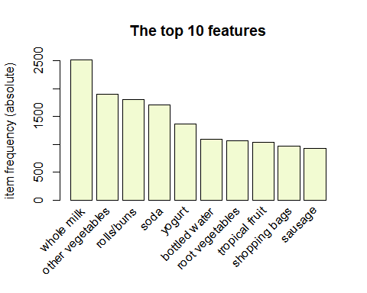

The graph above indicates that the most important feature is WholeMilk and other vegetables follows it

## Apriori Algorithm - Top 10 Rules

For Market Analyisis , I’ll implement Apriori algorithm. Mine frequent itemsets, association rules or association hyperedges using the Apriori algorithm. The Apriori algorithm employs level-wise search for frequent itemsets. Ref : <https://www.rdocumentation.org/packages/arules/versions/1.6-6/topics/apriori>

top_10_rules<- apriori(data, parameter=list(supp=0.001, conf=0.5) , control=list(verbose=FALSE))  
   
 top_10_rules %>%   
 DATAFRAME() %>%  
 arrange(desc(lift)) %>%  
 top_n(10) %>%  
 kable() %>%  
 kable_styling()

## Selecting by count

LHS

RHS

support

confidence

coverage

lift

count

{root vegetables,tropical fruit}

{other vegetables}

0.0123030

0.5845411

0.0210473

3.020999

121

{rolls/buns,root vegetables}

{other vegetables}

0.0122013

0.5020921

0.0243010

2.594890

120

{root vegetables,yogurt}

{other vegetables}

0.0129131

0.5000000

0.0258261

2.584078

127

{root vegetables,yogurt}

{whole milk}

0.0145399

0.5629921

0.0258261

2.203354

143

{domestic eggs,other vegetables}

{whole milk}

0.0123030

0.5525114

0.0222674

2.162336

121

{rolls/buns,root vegetables}

{whole milk}

0.0127097

0.5230126

0.0243010

2.046888

125

{other vegetables,pip fruit}

{whole milk}

0.0135231

0.5175097

0.0261312

2.025351

133

{tropical fruit,yogurt}

{whole milk}

0.0151500

0.5173611

0.0292832

2.024770

149

{other vegetables,yogurt}

{whole milk}

0.0222674

0.5128806

0.0434164

2.007235

219

{other vegetables,whipped/sour cream}

{whole milk}

0.0146416

0.5070423

0.0288765

1.984385

144

## Cluster Analysis

The basic Clustering graph is generated by using “hclust” from <https://www.r-graph-gallery.com/29-basic-dendrogram.html>. The graph below alligns with the Top 10 Associative Rules above which indicates Wholemilk and pther vegitables are most important cluster features.

dataframe <- read.transactions("GroceryDataSet.csv", sep=",")  
   
dataframe <- dataframe[ , itemFrequency(dataframe) > 0.05]  
d_jaccard <- dissimilarity(dataframe, which = "items")  
# plot dendrogram  
plot(hclust(d_jaccard, method = "ward.D2"),   
 main = "Features Clustering", sub = "", xlab = "")

