DATA 624 - Homework 7

OMER OZEREN

Table of Contents

Exercises 6.2 & 6.3

library(AppliedPredictiveModeling)  
library(caret)  
library(elasticnet)  
library(knitr)  
library(pls)  
library(ggplot2)  
library(tidyverse)  
library(kableExtra)  
library(RANN)  
library(corrplot)

## Question 6.2

Developing a model to predict permeability (see Sect. 1.4) could save significant resources for a pharmaceutical company, while at the same time more rapidly identifying molecules that have a sufficient permeability to become a drug:

### PART A

Start R and use these commands to load the data:

data(permeability)

The fingerprints matrix holds **165 unique compounds**; **1107 molecular fingerprints**

### Part B

the fingerprints predictors indicate the presense or absense of substructures of a molecule and are often sparse meaning that relatively few of the molecules contain each substructure. Filter out the predictors that have low frequencies using the nearZeroVar function from the caret package. How many are left for modeling?

fingerprints %>%  
 nearZeroVar() %>%  
 length()

## [1] 719

**There are 719 variables left after filtering out the near zero variables.**

### Part C

Split the data into a training and a test set, pre-process the data, and tune a PLS model. How many latent variables are optimal and what is the corresponding resampled estimate of R2?

I’m going to split the data 70% for training and 30% for testign.

data_clear <- as.data.frame(fingerprints[, nearZeroVar(fingerprints)]) %>%  
 mutate(y = permeability)  
set.seed(42)  
data_clear <- cbind(data.frame(permeability),data_clear)  
n <- floor(0.70 * nrow(data_clear))  
idx <- sample(seq_len(nrow(data_clear)), size = n)  
training_df <- data_clear[idx, ]  
testing_df <- data_clear[-idx, ]  
  
# build PLS model  
pls_model <- train(  
 y ~ ., data = training_df, method = "pls",  
 center = TRUE,  
 trControl = trainControl("cv", number = 10),  
 tuneLength = 25  
)  
#results  
plot(pls_model$results$Rsquared,  
 xlab = "ncomp",  
 ylab = "Rsquared"  
 )

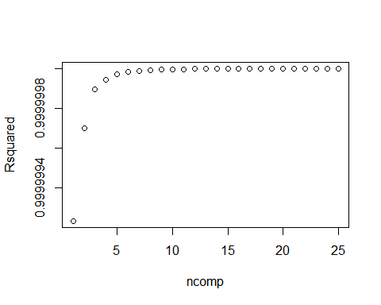

pls_model$results %>%  
 filter(ncomp == pls_model$bestTune$ncomp) %>%  
 select(ncomp, RMSE, Rsquared) %>%  
 kable() %>%  
 kable_styling()

ncomp

RMSE

Rsquared

25

6.15e-05

1

**As we can see above plot, the optimal components number in model is 25.In addition to that, the PLS model captures 100% of the permeability .**

### PART D

Predict the response for the test set. What is the test set estimate of R2?

# Make predictions  
pred <- predict(pls_model, testing_df)  
# Error Metric/Model Evaluation  
results <- data.frame(Model = "PLS Model",  
 RMSE = caret::RMSE(pred, testing_df$y),  
 Rsquared = caret::R2(pred, testing_df$y))  
results %>%  
 kable() %>%  
 kable_styling()

Model

RMSE

Rsquared

permeability

PLS Model

5.96e-05

1

**We got the the same $R^{2}$ which is 1.I actually also tried for 80/20 % split.However, I got the the same $R^{2}$.**

### Part E

Try building other models discussed in this chapter. Do any have better predictive performance?

**I’ll use Elastic Net Regression**

#### Elastic Net Regression

data_clear <- fingerprints[, -nearZeroVar(fingerprints)]  
data_clear <- cbind(data.frame(permeability),data_clear) #adding permeability  
number <- floor(0.70 * nrow(data_clear)) # 70/30 split  
idx <- sample(seq_len(nrow(data_clear)), size = number)  
train_df <- data_clear[idx, ]  
test_df <- data_clear[-idx, ]  
  
#train the Elastic Net model  
elastic_model <- train(x=train_df[,-1],  
 y=train_df$permeability,  
 method='enet',  
 metric='RMSE', # error mettric  
 tuneGrid=expand.grid(.fraction = seq(0, 1, by=0.2),   
 .lambda = seq(0, 1, by=0.2)),  
 trControl=trainControl(method='cv',number=10),  
 preProcess=c('center','scale'))

## Warning: model fit failed for Fold09: lambda=0.0, fraction=1 Error in if (zmin < gamhat) { : missing value where TRUE/FALSE needed

## Warning in nominalTrainWorkflow(x = x, y = y, wts = weights, info = trainInfo, :  
## There were missing values in resampled performance measures.

plot(elastic_model)

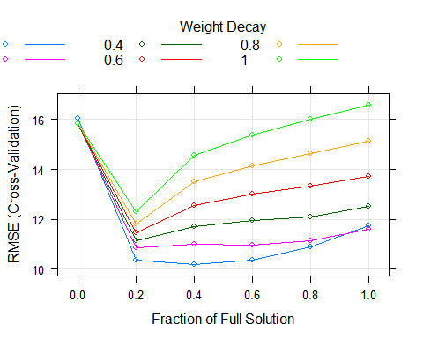

#best params  
elastic_model$bestTune

## fraction lambda  
## 3 0.4 0

#perf of best params  
getTrainPerf(elastic_model)

## TrainRMSE TrainRsquared TrainMAE method  
## 1 10.18728 0.6116537 7.391802 enet

**As we can see on graph on above $R^{2}$ declined from 1 to 0.55**

## PART F

Would you recommend any of your models to replace the permeability laboratory experiment?

**No, it is obvious that the predictive power from Elastic Net Regression is not as good as the laboratory experiment.**

## Question 6.3

A chemical manufacturing process for a pharmaceutical product was discussed in Sect. 1.4. In this problem, the objective is to understand the relationship between biological measurements of the raw materials (predictors), 6.5 Computing 139 measurements of the manufacturing process (predictors), and the response of product yield. Biological predictors cannot be changed but can be used to assess the quality of the raw material before processing. On the other hand, manufacturing process predictors can be changed in the manufacturing process. Improving product yield by 1% will boost revenue by approximately one hundred thousand dollars per batch:

### PART A

Start R and use these commands to load the data:

data(ChemicalManufacturingProcess)  
chem <- ChemicalManufacturingProcess  
head(chem)

## Yield BiologicalMaterial01 BiologicalMaterial02 BiologicalMaterial03  
## 1 38.00 6.25 49.58 56.97  
## 2 42.44 8.01 60.97 67.48  
## 3 42.03 8.01 60.97 67.48  
## 4 41.42 8.01 60.97 67.48  
## 5 42.49 7.47 63.33 72.25  
## 6 43.57 6.12 58.36 65.31  
## BiologicalMaterial04 BiologicalMaterial05 BiologicalMaterial06  
## 1 12.74 19.51 43.73  
## 2 14.65 19.36 53.14  
## 3 14.65 19.36 53.14  
## 4 14.65 19.36 53.14  
## 5 14.02 17.91 54.66  
## 6 15.17 21.79 51.23  
## BiologicalMaterial07 BiologicalMaterial08 BiologicalMaterial09  
## 1 100 16.66 11.44  
## 2 100 19.04 12.55  
## 3 100 19.04 12.55  
## 4 100 19.04 12.55  
## 5 100 18.22 12.80  
## 6 100 18.30 12.13  
## BiologicalMaterial10 BiologicalMaterial11 BiologicalMaterial12  
## 1 3.46 138.09 18.83  
## 2 3.46 153.67 21.05  
## 3 3.46 153.67 21.05  
## 4 3.46 153.67 21.05  
## 5 3.05 147.61 21.05  
## 6 3.78 151.88 20.76  
## ManufacturingProcess01 ManufacturingProcess02 ManufacturingProcess03  
## 1 NA NA NA  
## 2 0.0 0 NA  
## 3 0.0 0 NA  
## 4 0.0 0 NA  
## 5 10.7 0 NA  
## 6 12.0 0 NA  
## ManufacturingProcess04 ManufacturingProcess05 ManufacturingProcess06  
## 1 NA NA NA  
## 2 917 1032.2 210.0  
## 3 912 1003.6 207.1  
## 4 911 1014.6 213.3  
## 5 918 1027.5 205.7  
## 6 924 1016.8 208.9  
## ManufacturingProcess07 ManufacturingProcess08 ManufacturingProcess09  
## 1 NA NA 43.00  
## 2 177 178 46.57  
## 3 178 178 45.07  
## 4 177 177 44.92  
## 5 178 178 44.96  
## 6 178 178 45.32  
## ManufacturingProcess10 ManufacturingProcess11 ManufacturingProcess12  
## 1 NA NA NA  
## 2 NA NA 0  
## 3 NA NA 0  
## 4 NA NA 0  
## 5 NA NA 0  
## 6 NA NA 0  
## ManufacturingProcess13 ManufacturingProcess14 ManufacturingProcess15  
## 1 35.5 4898 6108  
## 2 34.0 4869 6095  
## 3 34.8 4878 6087  
## 4 34.8 4897 6102  
## 5 34.6 4992 6233  
## 6 34.0 4985 6222  
## ManufacturingProcess16 ManufacturingProcess17 ManufacturingProcess18  
## 1 4682 35.5 4865  
## 2 4617 34.0 4867  
## 3 4617 34.8 4877  
## 4 4635 34.8 4872  
## 5 4733 33.9 4886  
## 6 4786 33.4 4862  
## ManufacturingProcess19 ManufacturingProcess20 ManufacturingProcess21  
## 1 6049 4665 0.0  
## 2 6097 4621 0.0  
## 3 6078 4621 0.0  
## 4 6073 4611 0.0  
## 5 6102 4659 -0.7  
## 6 6115 4696 -0.6  
## ManufacturingProcess22 ManufacturingProcess23 ManufacturingProcess24  
## 1 NA NA NA  
## 2 3 0 3  
## 3 4 1 4  
## 4 5 2 5  
## 5 8 4 18  
## 6 9 1 1  
## ManufacturingProcess25 ManufacturingProcess26 ManufacturingProcess27  
## 1 4873 6074 4685  
## 2 4869 6107 4630  
## 3 4897 6116 4637  
## 4 4892 6111 4630  
## 5 4930 6151 4684  
## 6 4871 6128 4687  
## ManufacturingProcess28 ManufacturingProcess29 ManufacturingProcess30  
## 1 10.7 21.0 9.9  
## 2 11.2 21.4 9.9  
## 3 11.1 21.3 9.4  
## 4 11.1 21.3 9.4  
## 5 11.3 21.6 9.0  
## 6 11.4 21.7 10.1  
## ManufacturingProcess31 ManufacturingProcess32 ManufacturingProcess33  
## 1 69.1 156 66  
## 2 68.7 169 66  
## 3 69.3 173 66  
## 4 69.3 171 68  
## 5 69.4 171 70  
## 6 68.2 173 70  
## ManufacturingProcess34 ManufacturingProcess35 ManufacturingProcess36  
## 1 2.4 486 0.019  
## 2 2.6 508 0.019  
## 3 2.6 509 0.018  
## 4 2.5 496 0.018  
## 5 2.5 468 0.017  
## 6 2.5 490 0.018  
## ManufacturingProcess37 ManufacturingProcess38 ManufacturingProcess39  
## 1 0.5 3 7.2  
## 2 2.0 2 7.2  
## 3 0.7 2 7.2  
## 4 1.2 2 7.2  
## 5 0.2 2 7.3  
## 6 0.4 2 7.2  
## ManufacturingProcess40 ManufacturingProcess41 ManufacturingProcess42  
## 1 NA NA 11.6  
## 2 0.1 0.15 11.1  
## 3 0.0 0.00 12.0  
## 4 0.0 0.00 10.6  
## 5 0.0 0.00 11.0  
## 6 0.0 0.00 11.5  
## ManufacturingProcess43 ManufacturingProcess44 ManufacturingProcess45  
## 1 3.0 1.8 2.4  
## 2 0.9 1.9 2.2  
## 3 1.0 1.8 2.3  
## 4 1.1 1.8 2.1  
## 5 1.1 1.7 2.1  
## 6 2.2 1.8 2.0

The matrix ChemicalManufacturingProcess has the 57 explanatory variable

* 12 of 57 explanatory variable is biological material and
* 45 of 57 explanatory variable is the process variable for the 176 manufacturing purposes.

### Part B

A small percentage of cells in the predictor set contain missing values. Use an imputation function to fill in these missing values (e.g., see Sect. 3.8).

**I will imputer missing values with KNN to impute values.**

# Make this reproducible  
set.seed(42)  
knn_model <- preProcess(ChemicalManufacturingProcess, "knnImpute")  
df_no_missing <- predict(knn_model, ChemicalManufacturingProcess)

### PART C

Split the data into a training and a test set, pre-process the data, and tune a model of your choice from this chapter. What is the optimal value of the performance metric?

**I will split the data 70/30 the same as question 6.2 part c**

number <- floor(0.70 * nrow(df_no_missing)) # 70/30 split  
idx <- sample(seq_len(nrow(df_no_missing)), size = number)  
training_df <- df_no_missing[idx, ]  
testing_df <- df_no_missing[-idx, ]

I will buila PLS model since I got really good results for question 6.2

# build PLS model  
pls_model <- train(  
 Yield ~ ., data = training_df, method = "pls",  
 center = TRUE,  
 trControl = trainControl("cv", number = 10),  
 tuneLength = 25  
)  
#pls model results  
plot(pls_model$results$Rsquared,  
 xlab = "ncomp",  
 ylab = "Rsquared"  
 )

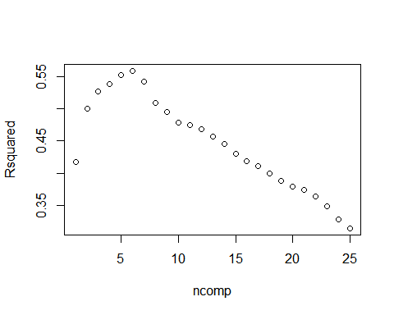

pls_model$results %>%  
 filter(ncomp == pls_model$bestTune$ncomp) %>%  
 select(ncomp, RMSE, Rsquared) %>%  
 kable() %>%  
 kable_styling()

ncomp

RMSE

Rsquared

3

0.702369

0.526431

**As we can see above plot, the optimal components number in model is 3.In addition to that, the PLS model captures 53% of the Yield .**

### PART D

Predict the response for the test set.What is the value of the performance metric and how does this compare with the resampled performance metric on the training set?

# Make predictions  
pred <- predict(pls_model, testing_df)  
# Error Metric/Model Evaluation  
results <- data.frame(Model = "PLS Model",  
 RMSE = caret::RMSE(pred, testing_df$Yield),  
 Rsquared = caret::R2(pred, testing_df$Yield))  
results %>%  
 kable() %>%  
 kable_styling()

Model

RMSE

Rsquared

PLS Model

0.5571291

0.6854267

**As we see above display, the error metric RMSE is lower and $R^{2}$ is higher with test data set.**

### Part E

Which predictors are most important in the model you have trained? Do either the biological or process predictors dominate the list?

pls_importance <- varImp(pls_model)$importance %>%  
 as.data.frame() %>%  
 rownames_to_column("Variable") %>%  
 filter(Overall >= 50) %>% # set a threshold for vairables importance  
 arrange(desc(Overall)) %>%  
 mutate(importance = row_number())  
varImp(pls_model) %>%  
 plot(., top = max(pls_importance$importance), main = "PLS Model Feature Importance")

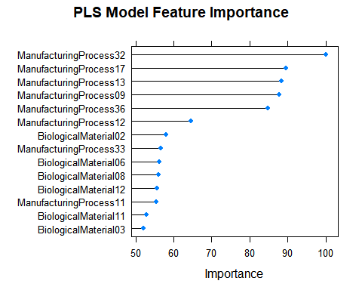

**The PLS Model Feature importances indicates that ManufacturingProcess32 is the most importance variable for the PL model.In order to move forward, We can set a threshold and only pass the variables that threshold.Here I set a threshold as at least 50 % importance for PLS model.**

### Part F

Explore the relationships between each of the top predictors and the response. How could this information be helpful in improving yield in future rounds of the manufacturing process?

important_vars <- df_no_missing %>%  
 select_at(vars(Yield, pls_importance$Variable))  
  
important_vars_p <- cor.mtest(important_vars)$p  
important_vars %>%  
 cor() %>%  
 corrplot(method = "color", type = "lower", order = "hclust",  
 tl.cex = 0.8, tl.col = "black", tl.srt = 45,  
 addCoef.col = "black", number.cex = 0.7,  
 p.mat = important_vars_p, sig.level = 0.05, diag = FALSE)

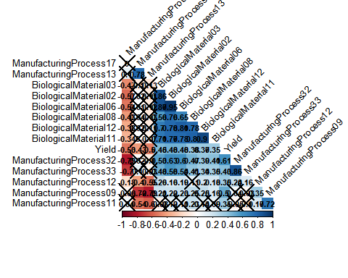

**The purpose of relationship between each of the top predictors and the response, I plotted the corrrelation relations for each important variable to respond variable.The correlation heat map shows that variables are positively correleted with Yield respond.The Manufacuring process 32 is the most correleted variable to respond variable.Some variables are negatively correleted to othe explanatory variable.For example, Manufacuring process 32 is negatively correlated with manufacturing process 13.**